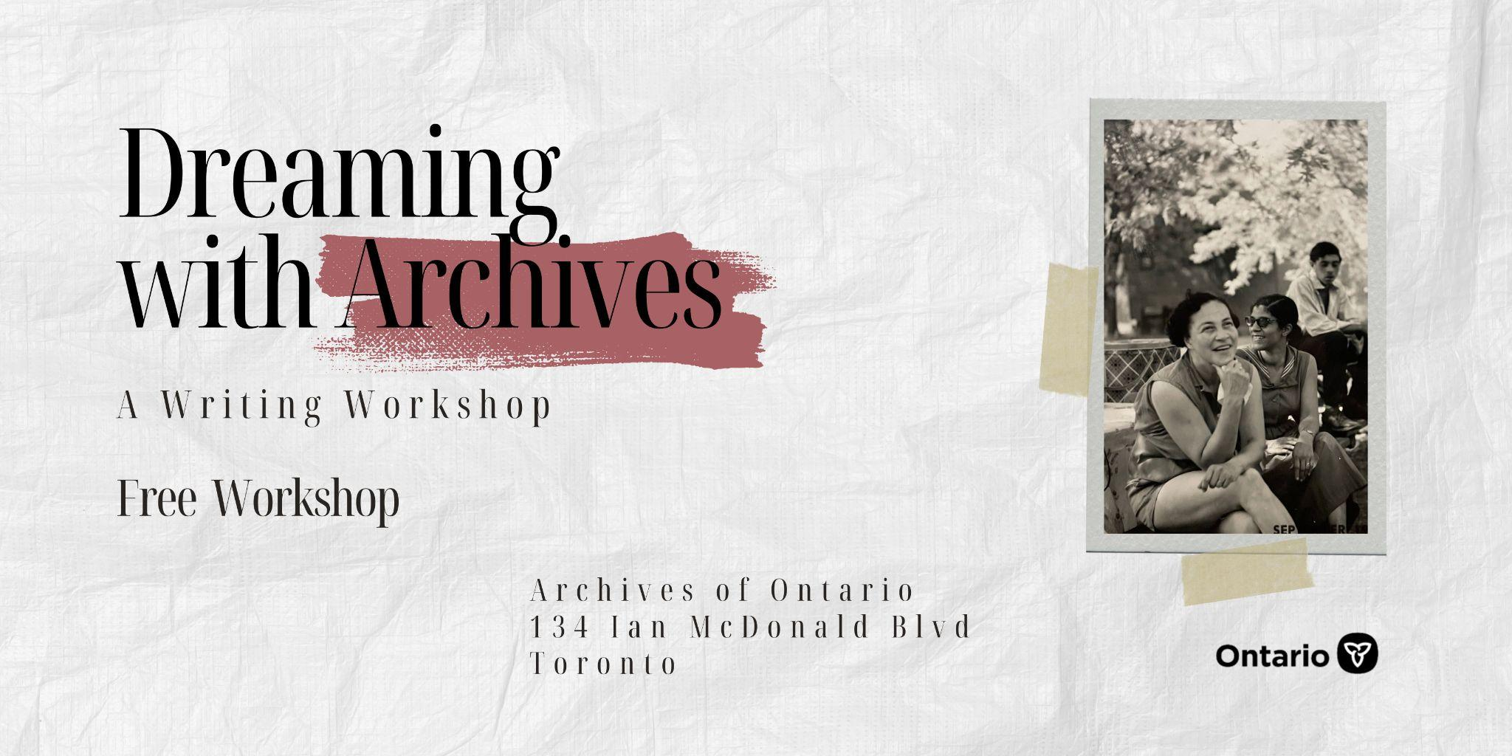

Dreaming with Archives: A Writing Workshop
Join archivist Melissa J. Nelson as she dreams of liberated Black futures with archives.

By Archives of Ontario

About the Workshop:
Black Dreams. What does it mean to dream while Black? How can we understand the dreams of our ancestors? How can we carry them with us? Black people have always dreamed in refusal of the colonial imagination. The past, present, and future are intertwined. Drawing from archival materials, archivist Melissa J. Nelson will guide participants in a creative writing workshop to connect with those who came before us and imagine a future for those yet to be born. This workshop will take place at the Archives of Ontario. Come view original archival materials, access ancestral memories, and dream of Black futurity. No writing experience is necessary – only your imagination. This workshop will include a short presentation with time for discussion.

Frequently asked questions
Who is this Workshop for?
This workshop is for anyone interested in storytelling, imagination, invention, and reflection. This workshop positions archives as a resource that can help us build a deeper connection with the past and imagine a better future. Black liberation is centred as a case study.
How many people can attend?
Minimum 4 people to a maximum of 20 people.
When does this workshop occur?
This workshop is available for private sessions. If you are part of a group or know people you would like to uncover your creative side with bring them along. To book, contact us at reference@ontario.ca with your availability.
Is this workshop offered in French?
This workshop is currently offered in English only.

About the Facilitator:
Melissa J. Nelson is an award-winning archivist, writer, and educator based in Toronto. Melissa is currently an Archivist for the Archives of Ontario. Her work and research interests are grounded in an ethics of care for the preservation of Black cultural heritage and anti-Black archival materials. She holds a Bachelor of Arts (Hons) in History, with a minor in Sociology, from Carleton University. She also completed a Master of Information Studies at McGill University.

