|  | Archives of Ontario |
| --- | --- |
| Visual Database User Guide |  |
| 234 Research Guide | Most Recent Update:October 2020 |

### What is the Archives of Ontario Visual Database?

The database is a selection of images drawn from the holdings of the Archives of Ontario which document the richness and diversity of the province's history and landscape.

### How do you access the Archives of Ontario Visual Database?

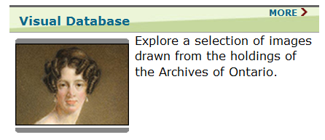

* [Click here to access the Visual Database through the Archives of Ontario Website](http://www.archives.gov.on.ca/).
* Reach the database by clicking on the ‘Accessing our Collection’ tab on the left hand side.
* Scroll down until you reach the ‘Visual Database’ box, and then click on it.

### How do you use the database?

Search options are on the right hand side of the page. Use of the database can be broken down into three sections: Keyword search, Subject search and Advanced search.

* When using the Keyword or Advanced search options, there is no need to put in the complete search term. Instead, use an asterisk (*) or the @ symbol at the end of your search term to find different forms of a word (so, for instance, search on architect* to find all hits on architect, architects, architecture, architectural, etc.). Sometimes entering more than one keyword can lead to getting fewer or no search results.

#### Keyword Search

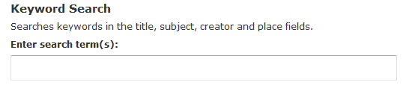

* To perform a general search of materials relating to your interest or inquiry, click on the text box located under “Enter search term(s)”. In this space you will be able to search through the database for any images related to your inquiry.
* The search term can be a single word, or a group of them (e.g. ‘Group of Seven’ or ‘Farm equipment’) – anything that you feel your topic reflects will be used by the database to find related images.

#### Subject Search

Image depicts how to search a broader topic or theme when images that might fall under your topic of interest may have not otherwise shown up in a keyword search, by providing a screenshot of the ‘Subject Search’ title one would click in order to find the letters of the alphabet that corresponds to broader search topics.


* The subject search allows for a search based on a broader topic or theme. This allows you to search for images that might fall under your topic of interest which might have not otherwise shown up in a keyword search.
* To begin a subject search, look underneath the ‘Subject Search’ title where you will find the letters of the alphabet. Click on the letter that corresponds to your broader search topic (e.g. if you want to search about artists, you would click on the letter ‘A’).
* After the new window appears, scroll through this list of topics and choose the topic that you wish to explore, or click on another letter to find other related topics.

.

#### Advanced Search

Image depicts the section of the Visual Databse one would need to access in order to perform an advanced search.


* An advanced search will search all the fields in the database and will allow you to combine two or more search terms together to narrow down your search results.
* Clicking on the button labelled ‘advanced search’ will take you to a new window from where you can search for images.
* You can enter search terms for up to three different subject fields and these terms can be separated by “and” “or” and “not”, depending on what terms you want to combine together and what terms you would like to exclude.
* You can also enter any information that you know relating to the creator, place, date range and the format type.

### Reviewing your Search Results

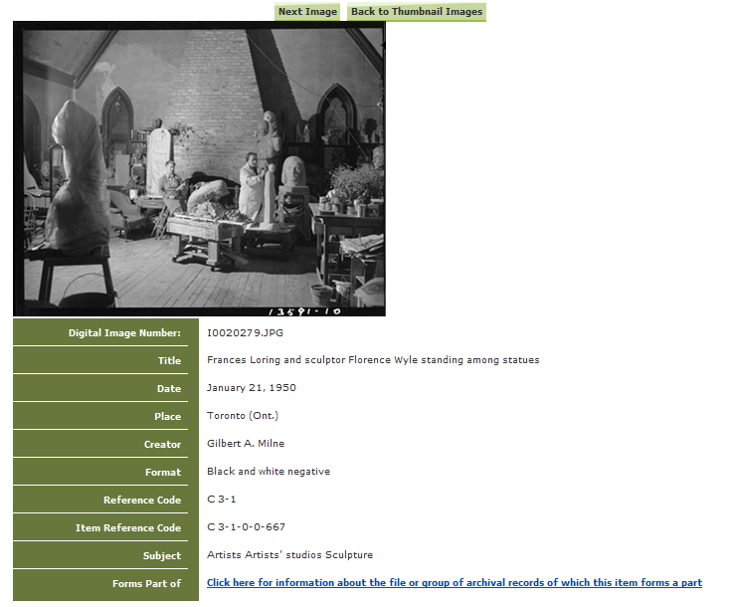

* If a search is successful, an image – or list of images – will be shown with their respective information listed beside the photo thumbnail.
* By clicking on the thumbnail image of a photo you will be able to see a larger picture of it.
* From this page, depending on the photo, you can see the group of archival records for which that image forms a part of. In those instances, a link will be present next to the tab “Forms a part of”.
* The Visual Database does not rank its results in order of importance the way Google does. Browse through your entire search results, or if you have a very long list of results, try narrowing your search with the addition of another word.

### Ordering Information and Copyright Terms of Use

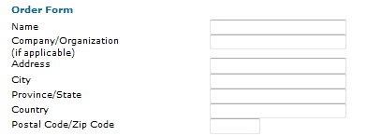

Reproductions of images found in the Visual Database can be ordered from the Archives of Ontario through the Visual Database’s ‘Ordering Information’ page.

* Go to the Visual Database homepage and click on “Ordering Information” at the left hand side of the page. [Click here to access a link to the order form where you can order a copy of the image](http://www.archives.gov.on.ca/en/db/vdb/vdb_order.aspx#order_form). All information relating to payments and costs can be found there too.
* Please be aware of the Archives of Ontario Conditions of Use section at the bottom of the order form. [Click here to access the Conditions of Use section from the Archives of Ontario website](http://www.archives.gov.on.ca/en/db/vdb/vdb_order.aspx#cond_use)
* If the intended use of images goes beyond research and private study, a Request for Permission to Publish, Exhibit, or Broadcast form must be filled out. [Click here to access this](http://www.archives.gov.on.ca/en/access/request-form.aspx) form.
* For more information, [click here to consult Customer Service Guide 108: Copyright and Your Research](http://www.archives.gov.on.ca/en/access/documents/customer_service_guide_108_copyright.pdf)

##### Ready and Willing

Although unable to do your research for you, our reference archivists are waiting to assist you. You may telephone or write to them by mail or email or — best of all — visit the Archives of Ontario.

##### Contact us

**Telephone: 416-327-1600 Toll free (Ontario): 1-800-668-9933**

**Email:** [Click here to email the Archives of Ontario](mailto:reference@ontario.ca)

**Address: Archives of Ontario, 134 Ian Macdonald Blvd., Toronto, ON M7A 2C5**

##### Website

For information about the Archives’ holdings, as well as access to research guides and other customer service materials available through the Archives of Ontario. [Click here to visit our website.](http://www.ontario.ca/archives).

##### Customer Service and Research Guides

The Archives of Ontario has published a series of in-depth research guides on a variety of specific topics. For more information, please see “Customer Service and Research Guides” under “Accessing Our Collection” on the home page of the Archives website.

______________________________________________________________________

© Queen's Printer for Ontario, 2019

This information is provided as a public service. Although we endeavour to ensure that the information is as current and accurate as possible, errors do occasionally occur. Therefore, we cannot guarantee the accuracy of the information. Readers should where possible verify the information before acting on it.