Archives of Ontario
Research Guide 300
Records Related to Black Communities in Ontario

Last Updated: February 2024

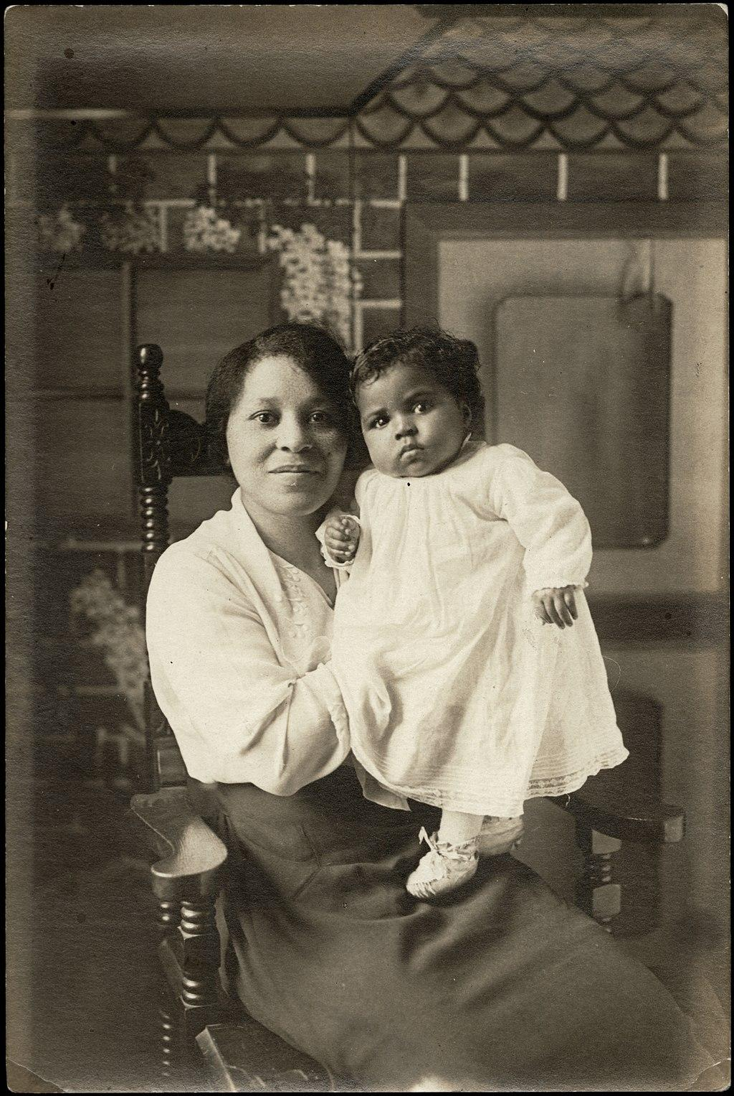

Woman holding a child, [between 1900 and 1920], I0024828, F 2076
Alvin D. McCurdy fonds

Table of Contents

In this Guide 3
Note on Historical Language 3
Searching our Collection 4
Key events, organizations, legislations 5
Accessing our Collection 7
The Records 7
1. Private Records – Created & Collected by Black Individuals 8
2. Private Records – Created & Collected by non-Black Individuals 12
3. Ontario Government Records – Community-Government Interactions 14
4. Records Relating to Slavery & Freedom 16
4.1 Records Relating to Slavery & Freedom – Government Records 16
4.2 Records Relating to Slavery & Freedom – Private Records 18
4.3 Records Relating to Slavery & Freedom – Library Materials 21
Further Research 22
How do I get to the online descriptions? 25
Contact us 27

In this Guide

This guide intends to highlight records held by the Archives of Ontario that pertain to the lives and experiences of Black populations across the province. This guide directs you to collections of government and private records that were created by and about Black communities. This guide identifies “government records” as records created by the Government of Ontario, and “private records” as records created by individuals, organizations, and businesses.

You will find further information about the records mentioned in this guide on our Records Related to Black History at the Archives of Ontario resource. This can be found in our resource page under “Access Our Collections.” This resource page directs you to online exhibits and educational resources that pertain to Black history in the province.

We recognize that there may be records in our collection that relate to Black Ontarians that are not listed in this research guide. Past descriptive practices have not always used accurate or community preferred language, resulting in descriptions that are not easily discoverable. We are working to rectify this issue. If you come across information in your research that you think would be of interest to other researchers studying Black histories, please contact us. We welcome comments and suggestions from users, researchers, community organizations and other stakeholders and hope to update and expand this guide over time.

The Archives of Ontario was built predominantly from settler colonial perspectives. We are dedicated to growing our community-related holdings. We are also committed to encouraging and supporting independent community archival collection and preservation initiatives across the province.

*Acknowledgements: This guide was written with assistance from Dr. Natasha Henry-Dixon, Assistant Professor of African Canadian History at York University.

*Please note: this guide contains links to information found in our archives catalogue. On our website, this catalogue is found under “Access Our Collections”. If you are using a print copy of this guide, go to page 24 for more information on how to find the online descriptions.

Note on Historical Language

Due to past collecting practices and the history of record creation in Ontario, many records that document Black histories were created by members of the historically dominant European/white societies in the province. These collections of records sometimes include language that is outdated, offensive, and harmful. The historical record reflects the attitudes and perspectives of those who created them.

We encourage you to engage at your own pace and seek support if you need to. The Ontario Ministry of Health provides mental health and crisis support resources. Black Mental Health Canada (1-866-302-7358) offers culturally safe, accessible, and affordable mental health care to Black communities across Canada.

Searching our Collection

To address harmful archival descriptions, the Archives of Ontario is revising descriptions that contain outdated and offensive language. This work involves research, consultation, and the addition of community preferred terminology in our descriptive practices. Problematic language may come from creators of records, previous stewards, or Archive staff. When we encounter problematic language that was written by staff, we update it. As part of our remediating practices, we capture a copy of the existing description. Captured descriptions can be requested by users and used to understand our past practices. Preserving existing descriptions is important to not erase our own harmful practices as archivists.

We add respectful language to minimize harm and improve discoverability, while still maintaining the original language that appears in the records to accurately convey historical attitudes and preserve the context in which the records were created. In doing so, we aim to better support research into the lives and experiences of Black people in Ontario. Our hope is that, in sharing these records and their context, we provide an accurate representation of the province’s history, encourage critical assessments of our records, and spark scholarship for a more liberated future. This work is an ongoing process. For more information, please refer to our Statement on Language and Description.

You can search for records about Black people in our catalogue using keyword terms such as:

Black/ Black Ontarians
Black Canadians
African Canadian
Slave/Enslaved/Captive
Fugitive from slavery
Freedom seeker
Self emancipated
Slavery

Key events, organizations, legislations

Some key events, organizations, and legislations that are relevant to the histories of Black communities in Ontario:

- 1760 the British conquered New France and slavery was expanded and institutionalized under British regimes.

- 1793 the Act to Limit Slavery in Upper Canada confirmed slavery as a legal practice and introduced gradual abolition, the first anti-slavery legislation in the British colonies.

- 1812 the Coloured Corps was initiated by Richard Pierpoint to support the War of 1812. Raised in Upper Canada (Ontario), it was composed of free and enslaved Black men.

- Between 1815 and 1865 Canada’s reputation as a safe haven for Black people grew and thousands of African-Americans sought refuge in Upper (Ontario) and Lower Canada (Quebec) through the Underground Railroad.

- 1 August 1834 the Slavery Abolition Act came into effect, abolishing slavery throughout the British Empire, including British North America.

- 1834 Black Canadians began to celebrate Emancipation Day in present day Ontario, Quebec and Nova Scotia.

- 1850 the Common Schools Act, the legislation governing education in Ontario, was amended to include a Separate Schools Clause. This clause authorized the creation of separate schools for Catholics, Protestants and Black people.

- 10 September 1850 the United States passed the Fugitive Slave Act, giving enslavers the right to recover escaped enslaved persons. The Act led to one of the largest migrations of African Americans into Canada (mostly present day Ontario) between 1850 and 1860. The Act was repealed 28 June 1864.

- 1 January 1851 Henry Bibb founded the Voice of the Fugitive, one of the first Black newspapers in Upper Canada (Ontario). Its target audience was freedom seekers and Black refugees from the United States.

- 26 February 1851 the Anti-Slavery Society of Canada was formed.

- 11 September 1851 First North American Convention of Colored Freemen held outside of the United States was held at St. Lawrence Hall in Toronto, Ontario.

- 24 March 1853 Mary Ann Shadd Cary founded the The Provincial Freeman newspaper to promote Black emigration to Canada.

- 31 January 1865 the Thirteenth Amendment was passed by Congress, abolishing slavery in the United States. With the end of slavery, many of the African Americans who settled in Canada returned to the United States to rejoin their families.

- 12 August 1911 Order-in-Council P.C. 1324 was approved by the Cabinet of Prime Minister Sir Wilfrid Laurier. Its purpose was to ban Black immigrants from coming to Canada for a period of one-year because, according to the order-in-council, “the Negro race” was “unsuitable to the climate and requirements of Canada.”

- 1916 the No. 2 Construction Battalion was created as a racially segregated battalion for the First World War.

- 1944 Racial Discrimination Act prohibited the publication and display of any symbol, sign, or notice that expressed ethnic, racial, or religious discrimination.

- 1948 the National Unity Association (NUA) was formed under the leadership of Hugh R. Burnett. The group’s aim to address racism led to the passage of Ontario’s Fair Employment Practices Act (1951) and Fair Accommodation Practices Act (1954), and laid the groundwork for subsequent human rights legislation in Ontario and across Canada.

- 1950 in the case of Noble and Wolf v. Alley, the Supreme Court of Canada ruled against restrictive covenants that restrict ownership of land to “persons of the white or Caucasian race.” This nationally significant ruling was followed by The Conveyancing and Law of Property Amendment Act, which was passed by the Legislative Assembly of Ontario and outlawed discriminatory covenants in the province.

- 1951 Fair Employment Practices Act prohibited discrimination in employment based on race, creed, colour, nationality, ancestry or place of origin.

- 1954 Fair Accommodation Practices Act prohibited discrimination in public places on racial, religious or ethnic grounds.

- 1958 Ontario Anti-Discrimination Commission Act created the Ontario Anti-Discrimination Commission, which became the Ontario Human Rights Commission in 1961.

- 1962 Human Rights Code was enacted to guarantee equality before the law. The Code became the first human rights law in Canada.

- 1962 as Minister of Citizenship and Immigration, Ellen Fairclough introduced new regulations that addressed racial discrimination in Canadian Immigration policy.
- 1962 following the reforms to the Immigration Act in 1962 and 1967, thousands of Caribbean people immigrated to Canada in the 1960s to 1970s.

- 1965 the last racially segregated school in Ontario, School Section No. 11 in Colchester, closed. This was done after Member of Provincial Parliament (MPP) Leonard Braithwaite pushed for the Separate Schools clause on segregated schools for Blacks to be officially removed from provincial education policy.

- 1967 Caribana is established in Toronto, Ontario with a deep connection to the abolition of slavery.

- 8 October 1971 Prime Minister Pierre Trudeau announced multiculturalism as an official government policy. This change in government policy ultimately affected the documentation of ethnocultural communities.

- 1978 the Ontario Black History Society (OBHS) was founded with Dr. Daniel Hill at the helm of the Society for several years. The Society is at the forefront of the study, preservation, and promotion of Black history in Ontario.

- 2009 Africentric Alternative School opens in Toronto, Ontario to better support and engage Black students.

- 24 March 2021 the House of Commons voted unanimously to nationally recognize and celebrate August 1 Emancipation Day as a federal holiday in Canada.

Accessing our Collection

The records mentioned in this guide can be found in the Archives of Ontario’s collection. In most cases, you will need to visit the Archives to view the materials. Please contact us in advance to request them. You can find more information about the records mentioned in this guide in our archives catalogue. This collections management system can also be used to view digital images for select records. Some of the records are on microfilm, which does not need to be ordered in advance (with some exceptions). Libraries that offer interloan services may also borrow some of the reels for you. Click here to view our Microfilm Interloan Catalogue.

The Records

The following is divided into four Sections. The first section highlights private records from our collection that document Black life from Black perspectives. The second section lists private records that capture the lives of Black people but were created by non-Black individuals. The third section identifies records created, received and managed by the various Ontario Government units while developing and administering policies and programs that address the needs of ethnic and cultural minority groups in the province. The fourth section identifies records from our collection that document the persistence of slavery in Upper Canada.

1. Private Records – Created & Collected by Black Individuals

These records are created or collected by Black individuals, and as such they demonstrate Black voices and perspectives. These records are arranged and displayed according to the organization or individual who created or collected them. Each entry contains the fonds or collection name, reference number, date range, and a short description of the scope. The order in which the entries are presented follows the Archives’ internal numbering system and does not reflect the records’ chronological order, scope, size or importance. Some entries include a note regarding restrictions on public access.

C 81-4 Osgoode Society Oral History Programme - Special Projects interview files
Dates: 1992-2011

The Osgoode Society is an organization that studies, researches and promotes public interest in the history of the law, the legal profession and the judiciary in Ontario and Canada. Fonds consists primarily of oral history interviews of lawyers, judges and others in the legal profession, relating to various aspects of legal history in Ontario and Canada. These interviews comprise the sole activity of the Osgoode Society's Oral History Programme. Most interview documentation consists of audio cassette recordings with accompanying transcripts, although one interview on videocassette is also included. Series consists of oral history interviews conducted by Osgoode Society as special or sponsored projects. Series contains records concerning the Black Lawyers and Judges Project (2010) and Attorney General and African Canadian Project (2008).

F 1405-5 Black Canadian photographs, part of the Multicultural History Society of Ontario fonds
Dates: 1890-1976
The Multicultural History Society of Ontario (MHSO) is a not-for-profit educational institution which collects, describes and maintains material related to the ethnic and cultural development of Ontario. Series consists of photographs documenting the Black Canadian community largely in Ontario, but also in Saint John, New Brunswick. Photographs depict individuals and families, recreational activities, religious life particularly in the African Methodist Episcopal (AME) Churches, military service and employment.

F 1409 Mary Ann Shadd Cary fonds
Dates: 1851-1889
Mary Ann Shadd Cary (1823-1893) was an educator, feminist, abolitionist, author, suffragette, journalist and lawyer. Shadd Cary was the first Black woman to publish, edit and run a newspaper in North America. Shadd Cary founded “The Provincial Freeman,” in which she advocated for present day Ontario and Canada as a safe place for the Black community to settle. Fonds consists of correspondence, articles, business records and lecture notes that relate to Shadd Cary’s work on the international anti-slavery movement, work which she continued to pursue while living in Ontario for a period of ten years. These records were transcribed on February 14, 2023 as part of Douglass Day. The event was recorded and can be viewed on the Douglass Day YouTube channel.

F 2076 Alvin D. McCurdy fonds
Dates: 1808 to 1986

Alvin D. McCurdy (1916-1989) was a historian, genealogist, and collector of Black historical materials who lived in Amherstburg, Ontario. Fonds includes personal correspondence and a genealogy of the McCurdy family as well as records pertaining to Black churches and various other Black organisations. This collection is the Archives' largest and most important source of information about the history of the Black community in Ontario. The McCurdy fonds was inscribed on the Canada Memory of the World Register in July 2021. The Archives of Ontario created a digital exhibit about the collection that can be explored. Digitized records can be viewed through Wikimedia Commons.

F 2096 Alvin Curling fonds
Dates: 1980-1996

Alvin Curling (1939- ) was a Provincial Legislature as Member of Provincial Parliament for Scarborough-Rouge River, previously Scarborough North. Fonds consists of records created and/or accumulated by Curling during his career. It documents his tenure as Minister of Housing, Minister of Skills Development, Liberal Housing Critic and Speaker of the House and includes material related to Curling's work with the Scarborough North Provincial Liberal Association in preparing for elections. It also contains material related to his pre-political career.

F 2130 Daniel G. Hill fonds
Dates: 1870 to 2003
Some access restrictions

Daniel Grafton Hill (1923-2003) was a sociologist, civil servant, human rights specialist, and Canadian Black historian. Fonds consists of personal records and records relating to Hill’s involvement with various associations including the Ontario Black History Society. The Archives of Ontario created a digital exhibit about Hill featuring records from the collection.

F 4585 Prieto-McTair Productions Fonds
Dates: 1939 to 2007 (predominant 1976 to 2007)
Some restrictions on access

Prieto-McTair Productions was a Toronto, Ontario based film production company that was in operation from 1982 to 2007 and produced a number of documentaries exploring Black history and culture. The fonds is arranged into eleven series primarily based on the films and documentaries produced by the company. Selected films can be viewed through the Archives of Ontario YouTube channel.

F 4646 Inez Elliston fonds
Dates: 1964-2010

Dr. Inez Elliston (1930-2017) was an educator, trainer, researcher, writer, consultant, and leader in community development. She was a pioneer in the field of race relations, conducting many studies and advocating especially for the education of children from diverse communities. Fonds consists of records that document Dr. Elliston’s professional life as it relates to intercultural education, anti-racism training, the management of diversity in the multicultural classroom and community, and the delivery of equitable educational policies.

F 4656 Congress of Black Women of Canada - Toronto Chapter fonds
Dates: 1982 to 1997
Some restrictions on access

The Congress of Black Women of Canada - Toronto Chapter, was formed in 1983 to provide a forum to ensure that Black women's needs and concerns are represented. Fonds consists of records created and accumulated by the organization with regard to the administration of the Chapter and records concerning the documentary movie Children Are Not the Problem.

F 4718 Coming to Voice fonds
Dates: 1994? to 1998?
Some restrictions on access

Fonds consists of records containing material that was included in or used to support the 1999 documentary Coming to Voice, produced by Anthony A. Browne and Glace W. Lawrence. This movie tells the story of the beginnings of Canada's Black film industry.

F 4721 Wilma Morrison fonds
Dates: 1899?-2019

Wilma Morrison (1929-2020) was a Black history and heritage activist. Morrison played a significant role in the preservation and recognition of Black history in Ontario. Fonds consists of material that documents Morrison's personal life as well as her career as a Black history and heritage activist in the Niagara Region.

F 4727 Ian Jones fonds
Dates: 1966-2019

Ian Jones (1942- ) is an artist, activist, musician and educator in the calypso and steelpan community, as well as a facilitator of Black community enhancement in Ontario. Fonds consists of material that documents Jones' involvement with pan in Canada as a player, arranger, composer, administrator and educator. This includes material related to his work with the Ontario Steelpan Association.

F 4747 Phyllis Marshall photograph album
Dates: 1959-1977

Phyllis (Irene Elizabeth) Marshall (1921-1996) was a singer and actress who is remembered as one of Canadian television's earliest stars, and as a pioneer among Black Canadian performers. The records consist of a photograph album maintained by Phyllis Marshall that documents her career between the years 1959 and 1977. It includes newspaper clippings, notes, photographs, mementos and other material.

N 531 Africa Speaks
Dates: 1965-1975
Africa Speaks newspaper was launched in Toronto in 1950. Its pages document Black cultural life in Toronto as well as contemporary events in Africa. It was released in English.

N 533 Mapou
Dates: 1977-1978
Mapou was a Creole/French literary magazine. It included interviews, poetry, reflections, and political analyses. It was launched in Ottawa in 1977.

N 547 Spear
Dates: 1973-1987

“Spear: Canada’s Truth and Soul Magazine” launched in Toronto in 1971. Its pages document Black middle class life in Toronto. For the final few issues, before it suspended publication in 1987, the magazine re-tagged itself as “Spear: Canada’s Black Family Magazine.”

2. Private Records – Created & Collected by non-Black Individuals

Some records document the lives of Black people from non-Black perspectives. These records contain information about the political, social, and cultural aspects of Black life in the province. The records reflect the attitudes and perspectives of those who created them. These records are arranged and displayed according to the organization or individual who created or collected them. Each entry contains the fonds or collection name, reference number, date range, and a short description of the scope. The order in which the entries are presented follows the Archives’ internal numbering system and does not reflect the records’ chronological order, scope, size or importance.

C 193 Julien LeBourdais fonds
Dates: 1963-2003

Fonds consists of photographs taken by Julien LeBourdais, a Toronto-based professional photographer. The photographs document a wide range of subjects including prominent sports figures, politicians, artists, entertainers, business leaders, and royalty. In addition to notable personalities, the photographs also cover political events including campaigns and elections, diplomatic visits to Ontario, activities of major labour unions, factories and workers, sporting events, protests, and various geographic regions throughout the province. While the vast majority of the photographs are of Ontario events and personalities, some have a wider national or international context. Fonds includes photographs of Dr. Martin Luther King Jr. Memorial Service at Toronto City Hall. Select photographs can be viewed on the Archives of Ontario Flickr.

F 794 Young Women's Christian Association of Metropolitan Toronto fonds
Dates: 1844-1973

Fonds consists of records created, accumulated, and used by the Young Women's Christian Association of Metropolitan Toronto (Y.W.C.A.). Fonds includes minutes from Board of Directors Meetings and meetings of various committees; annual reports of the Toronto Association and of various other Toronto area branches; files regarding fundraising and building campaigns, containing correspondence, clippings, and reference material; newsletters and scrapbooks; and photographs of various Y.W.C.A. activities and members (including photographs of Y.W.C.A. staff and executive members, promotional photographs, and photos arising from various Y.W.C.A. programs, such as camping, exercise classes, the Y.W.C.A. residence, and other services). Fonds also includes promotional films and films from the United Nations, and recorded interviews with various Y.W.C.A. staff and executive members. Some members were Black women. Select photographs can be viewed on the Archives of Ontario Flickr.

F 4695 Globe and Mail fonds
Dates: 1931-2000

Fonds consists of the business records of The Globe and Mail newspaper. Fonds consists primarily of the photography libraries maintained by The Globe and Mail to support the daily needs of the newspaper. The libraries consist of the numbered negative library; print libraries organized by Subject, Personal name, and Arts, TV, and Theatre stills, and an oversized print library; and smaller groupings of photography, such as those created by specific photographers, freelance photographs, photography for special sections of the newspaper, photography for special events, and unindexed "special collections" photography. Fonds includes photographs of Caribbean and Black political, social, and cultural life. Select photographs can be viewed on the Archives of Ontario Flickr.

F 4704 John McNeill fonds
Dates: 1928-1993

Fonds consists of the professional and personal records of press photographer, John M. McNeill. Fonds includes photography created by McNeill for the North Bay Nugget, North Bay, Ontario, as a freelance and staff photographer, as well as photography created as a staff photographer with The Globe and Mail in Toronto, Ontario. Fonds includes photographs of civil rights marches. Select photographs can be viewed on the Archives of Ontario Flickr.

3. Ontario Government Records – Community-Government Interactions

Government records can be a source of information about communities. They may document ways communities have advocated for change, responses from the Government of Ontario, or research accumulated by the government for policy making. As such, these records document community-government interactions. This section is divided according to archival series—groups of records that were created and maintained by the same government agency and in accordance with a particular subject, function or activity. The identified record series contains records relating to Black Ontarians.

These records are not always easily discoverable. The Archives of Ontario has been re-describing Government records series that contain relevant information about ethnic and cultural minority groups in Ontario. This work serves to highlight community-government interactions in order to make the histories of communities more visible. Each entry in this section contains the series name, reference number, the date range of the records included in the series, information about the series’ general scope, and a note regarding whether there are any restrictions on public access.

RG 2-42, Department of Education subject files
Dates: 1800?-1964, predominant 1885-1913

Series consists principally of files from the central correspondence registry of the Department of Education between 1885 and 1913, which included all incoming correspondence to the department, and typically also includes drafts of the outgoing responses. Series contains correspondence that document the staffing, operation, and administration of schools with Black students in Ontario between 1885 and 1913, which includes the following records:
- RG 2-42-0-580 Colchester S.S. #12 (colored school) - certificates for teachers: Rev. Josephus O. Banyoun (or O'Banyoun); Annie Keyes; Mary Griffin; Mrs. R. J. McCormick
- RG 2-42-0-5331 Colchester South Township, S.S. #11. Request for temporary certificate for Miss Elva Dixon. "This is a colored school for which we cannot get white, certificated teachers"
- RG 2-42-0-5495 Harwich Township, S.S. #9; S.S. #9 1/2 - "people in No. 9 wished to exclude from their school certain colored children." Section 9 1/2 formed, but school closed, leaving children without education
- RG 2-42-0-5890 Sandwich, Town of. Request for permit for teacher Miss Ella Gooderich for colored school. Also Tilbury West Township, S.S. #2 - request for permit for teacher Mr. Louis Dorais (able to teach English and French

RG 17-20 Archives of Ontario historical research files
Dates: 1903-1988
Series consists of files pertaining to Ontario's local and provincial history, as well as Canadian history, for use by Archives of Ontario staff when responding to reference inquiries. The files may contain correspondence between archivists and researchers, memoranda, notes, newspaper clippings, brochures, as well as copies of newspaper clippings, press clippings, and archival documents. See file subjects starting with the keyword “Blacks.”

RG 74-7 Multicultural grants correspondence
Dates: 1970 to 1976

Series consists of correspondence pertaining to grants provided by the Ontario Government to various multicultural groups. Records include grants inquiries, statistics, lists of grants, and background materials. The records detail recommendations, policies and criteria for funding, and program administration, evaluation, and budgets.

RG 74-45 Race relations training Program records
Dates: 1979 to 1993

Series consists of records relating to a race relations training program developed by the Ontario Government to assist employers, institutions, organizations and other groups in dealing with race relations issues. The program also provided support services to organizations wanting to develop public education projects designed to raise public awareness of racial issues/concerns. Records were created by the Ontario Human Rights Commission, the Race Relations Directorate, and the Ontario Anti-Racism Secretariat.

RG 74-52 Race relations projects grants records
Dates: 1986 to 1995

Series consists of records pertaining to financial grants provided by the Ontario government for community-based race relations projects such as public education initiatives, institutional policy and program development, race relations training, and community outreach. Records include case files which contain grant applications and other background information on the organization and programs as well as correspondence between the Ministry and the organization.

RG 76-6 Records of the Race Relations Division
Dates: 1969 to 1986
Restrictions on access

Series consists of the operational records of the Race Relations Division of the Ontario Human Rights Commission. Some of the records prior to the creation of the division in 1982 were created by the Committee on Race and Ethnic Relations and Public Education. The series is divided into four sub-series.

4. Records Relating to Slavery & Freedom

Our collections include records that document the enslavement and freedom of Black populations in Upper Canada. Enslaved people were treated as the property of those who enslaved them. As such, this history is largely recorded through the eyes of wealthy white enslavers. Any transactions or documentation relating to the enslavement of Black people are listed in government records such as wills and estate files, census records, court records, and land records; and private records such as cemetery records, church records, correspondence, diaries, financial records, and published materials. Each entry contains the fonds or collection name, reference number, date range, and a short description of the scope. The order in which the entries are presented follows the Archives’ internal numbering system and does not reflect the records’ chronological order, scope, size or importance.

4.1 Records Relating to Slavery & Freedom – Government Records

Estate files
Dates: 1785-1986

Estate files exist for all districts and counties in Upper Canada. The contents of these files vary, but typically include wills and codicils and letters probate in cases of probate, letters of administration and administration bonds in cases of administration, and appointments of guardianship in cases of guardianship. The files also frequently include petitions, inventories, affidavits, renunciations, and other supporting documents. Sometimes enslaved people were bequeathed as part of the probate of an estate. This transfer may be listed as a deed in probate records. The following records are estate files from known enslavers:

- RG 22-155-0-200 Butler, John, Esquire — Newark, Oxford County (these records are also digitized and available on FamilySearch)
- RG 22-155-0-696 Gray, Robert I.D., Esquire — Town of York (these records are also digitized and available on FamilySearch)
- RG 22-155-0-1207 Mclean, Neil, Esquire — Kingston, Frontenac County (these records are also digitized and available on FamilySearch)
- RG 22-159-0-7 Allen, Joseph — Frontenac County (these records are also digitized and available on FamilySearch)
- RG 22-179-0-211 Heck, Paul — Leeds and Grenville County (these records are also digitized and available on FamilySearch)
- RG 22-235-0-745 Krysler, Adam — Lincoln County (these records are also digitized and available on FamilySearch)
- RG 22-235-0-1438 Young, John Sr., Lincoln County (these records are also digitized and available on FamilySearch)
- RG 22-311-0-145 Girty, James — Essex County (these records are also digitized and available on FamilySearch)
- RG 22-311-0-199 Caldwell, William — Essex County (these records are also digitized and available on FamilySearch)
- RG 22-311-0-344 Labadie, Antoine — Essex County (these records are also digitized and available on FamilySearch)

Census Records

Enslaved people were sometimes listed with their enslaver’s family in early town censuses. The status of the enslaved Black person was identified, sometimes names and sex, but often not. The following census documents enslaved people:

- F 1721-28 District of Johnstown fonds. (Contains “The Elizabethtown Township Census Census and Assessment Assessment Special Assessment”) 1808-1809.

Minute Books
Dates: 1765-1970

Minute books contain information relating primarily to the judicial functions of civil and criminal assizes. Enslaved Black people may appear as plaintiffs and defendants in court cases. Sometimes jail was used as a form of punishment by enslavers. The following minute books document enslaved people:

- D 359 Upper Canada land board minutes and records diffusion material
- RG 22-54 Midland District Court of General Quarter Sessions of the Peace minutes. (Contains “Negro Jack v. John Croisdell Court of Quarter Sessions held at Kingston, April 9, 1794.”)
- RG 22-94 York County Court of General Sessions of the Peace minute books
- RG 22-134 Courts of Queen’s Bench assize minute books

Land Records
Dates: 1790-1867, 1960?

Land records consist of indexes, registers, and petitions relating to requests for land. Also includes correspondence and memoranda relating to surveys and land administration. Enslaved Black people were documented with their enslaver’s families in supplementary records such as returns and losses claims. In some cases, land records documented free or freed Black people who submitted land grant petitions and received land. The following land petition documents enslaved people:

- D 29 Upper Canada land petitions diffusion material (microfilm copies)

4.2 Records Relating to Slavery & Freedom – Private Records

F 24-2 Richard Cartwright original letterbook
Dates: 1793-1796
Richard Cartwright was a member of a slaveholding family, he also enslaved a man named Joseph Gutches, who was born in 1763 in the Schoharie Valley region of New York. Series consists of a single copybook containing 480 outgoing letters from Richard Cartwright, mostly written from Kingston, Ontario. A few letters are annotated as being written in Niagara or Queenston. The letters are directed to various individuals in Upper and Lower Canada, New York State, and the settlement of Detroit, Michigan.

F 46 Peter Russell fonds
Dates: 1720-1811

Peter Russell was an enslaver in Upper Canada. A free Black man named Pompadour worked for him, but Pompadour’s wife Peggy and their three children were enslaved by Russell. The children were named Jupiter, Amy and Milly. Fonds contains personal and business correspondence of Peter Russell, and includes some correspondence from other family members. Included are correspondence, memoranda and circulars, diaries, copies of wills, inventories of personal belongings, commissions, receipts, bills, accounts, bonds, a table of fees, and articles of agreements. Fonds also contains an account book of Peter Russell for the years 1793 to 1808. This information can be found in the following records:

- F 46-0-0-2350 Letter, Peter Russell to Capt. Elliott, Sandwich
- F 46-0-0-2351 Letter, Capt. M. Elliott to Peter Russell
- F 46-0-0-2357 Letter, Capt. M Elliot to Peter Russell
- F 46-0-0-2591 Account Book, Peter Russell

F 55 Wallbridge family fonds
Dates: 1786-1896

Fonds consists of correspondence and other records of various members of the Wallbridge family. Fonds also includes an indenture for the sale of land in Saratoga County, New York in 1786, a bill of sale for an enslaved Black woman and her child, certificates admitting Adam H. Wallbridge to various courts in Upper Canada, various commissions of Lewis Wallbridge, agreements, and articles of apprenticeship. Included is a bill of sale between Joseph Keeler and William H. Wallbridge.

F 280 William D. Reid collection
Dates: 1779-1932

Collection consists of copies of records accumulated by William D. Reid. Records include articles, land petitions, genealogical data, obituary notices, burial records, militia lists and assessment rolls that all relate to the United Empire Loyalists. In some cases, enslaved people were hired out by their enslavers. Enslaved people were included in return/victual lists that were counts of soldiers and their families and various encampments and also a list to issue rations (food and supplies). Free and freed Black people were documented as well, mainly Black Loyalists men who had recently gained their freedom for their military service. This information can be found in the following records:

- F 280-0-0-14 Haldimand papers (selected items)
- F 280-0-0-25 Richard Norton Wilkinson

F 493-1 Jean Baptiste Rousseau family personal and business correspondence
Dates: 1774-1868

Series consists of incoming and outgoing personal and business correspondence created and received primarily by Jean Baptiste Rousseau, his sons George and Joseph Brant Rousseau, and his wife, Margaret Rousseau. Included is the following record that mentions Black people Brant enslaved:

- F 493-1-0-53 [Statement of Captain Joseph Brant’s account with Jean Baptiste Rousseau]

F 499 MU 2885 David Barker Stevenson fonds
Dates: 1833-1858

Fonds consists of records relating to David Barker Stevenson's activities as a merchant and a politician. It includes incoming and outgoing correspondence, as well as accounts, promissory notes, a barter book, a day book, account books, and a ledger. Most correspondence is of a business nature, consisting of requests for credit, and discussing various business matters (such as prices of various items). Some letters concern local matters, such as schools, the Municipal Council, and the local church. Fonds contains “Letter dated Oct. 12, 1850 from S. Wickham warning of slave-catchers in the United States.” This record is digitized as part of an online exhibit.

F 977 Ontario Genealogical Society's Cemetery Recordings collection
Dates: 1973-2001

The cemetery records collection consists of transcriptions from Ontario cemetery records or tombstones, compiled by members of the Ontario Genealogical Society. Some enslaved Black people were recorded in burial entries with enslavers identified. This information can be found in the following records:

- F 977-0-0-930 St. John’s Anglican on Sandwich Street, Windsor
- F 977-0-0-2838 Negro Burial Ground in Niagara-on-the-Lake
- F 977-0-0-1183 Durham Cemetery in Grey County

F 978 Church records collection
Dates: 1749-1981

The Church Records Collection contains original manuscripts, xeroxed copies and microfilm copies of Ontario church records including minutes, annual reports, church registers, communion rolls, session rolls, birth records, baptismal records, marriage records, burial records, accounts, financial records, pew rent records, deeds, military records, church histories, and newspaper clippings. Almost all the churches within the collection are in Ontario, however some are out of province. There are entries in church records of baptisms, marriages, and burials for some enslaved Black people with their enslavers identified.

Original and Microfilmed Newspaper Collections in the Archives of Ontario

Local colonial newspapers hold traces of enslaved Black people. These newspapers published notices that alerted the public of enslaved runaways as well as advertisements that placed enslaved individuals for sale. The finding aid (L 23) contains a complete inventory of original newspaper holdings of the Archives of Ontario for newspapers published in the province of Ontario and its predecessors, Upper Canada and Canada West, which are not on microfilm. The following newspapers document enslaved people. Some advertisements form part of an online exhibit:

- N 31 Upper Canada Gazette, 1793-1845, 1846-1848 (numerous gaps, at times alternatively titled American Oracle or York Gazette)
- N 23, Niagara Herald, 1801-1886 (numerous gaps)
- N 18, Kingston Gazette, 1810-1818

F 4421-2 Adam Crysler (1732-1793) records
Dates: 1763-1796

Series consists of records related to the military activities of Adam Crysler, son of Jeronimus Crysler, as a lieutenant in Butler's Rangers during the Revolutionary War, as well as claims for compensation after his flight to Niagara from New York State. Series also includes bills of sale for two enslaved people, indicating that Adam Crysler brought captives from New York State to his new home in Niagara. This information can be found in the following record:

- F 4421-2-0-8 Account of events at Schoharie to gather forces against rebels by Adam Krysler (Crysler)

F 4536 Letter of Tom Elice [Ellis] to Mary Warner
Date: 1854

Item is a one-page letter in manuscript ink on blue wove paper from Tom Elice (or Ellis), a freedom seeker from Kentucky, to Mary Warner. Mr. Elice's letter expresses both the excitement of his freedom and the pain of leaving his loved one behind. Written from Chatham, Ontario, the letter appears to be a reassurance of safety after a journey via the 'underground railroad' through Ohio and Michigan, so-called 'free states' that nevertheless were bound by the Fugitive Slave Act of 1850, requiring all law enforcement officials to return fugitives from slavery. Bounties were posted on Tom and his six fellow fugitives, according to donor information. The misspelling of Ellis’ name suggests that the letter was written by someone else. This record is further examined in an online exhibit.

4.3 Records Relating to Slavery & Freedom – Library Materials

- An Act for the Abolition of Slavery throughout the British Colonies; for promoting the Industry of the manumitted slaves; and for compensating the Persons hitherto entitled to the Service of such Slaves, 3 & 4 Will.4 c.73, 1833, United Kingdom Parliamentary Archives (digitized copies can be found through the UK Parliament, digitized copies of the published format are also available via the Archives of Ontario’s website)

- An Act to Prevent the further Introduction of Slaves and to limit the Term of Contracts for Servitude, Statutes of Upper Canada Cap. 7, 33 George III, 1793 (digitized copies are available via the Archives of Ontario’s website)

- 973.7115 M58 Mitchell, William M. The underground railroad from slavery to freedom.

- PAMPH 1856 #42 Narrative of the Life and Sufferings of Rev. Richard Warren, 1856

- PAMPH 1855 #41 Map entitled: "Southwestern Counties of Canada West - showing the principal stations of the free colored population” In: Mission to the free colored population in Canada, 1855 (also digitized as part of an online exhibit)

- Provincial Freeman, Microfilm Reel N 40 (digitized copies can be found in Our Digital World’s Abolitionist Newspapers of the 1850s digital collection)

- Voice of the Fugitive, Microfilm Reel N 33 (digitized copies can be found in Our Digital World’s Abolitionist Newspapers of the 1850s digital collection)

Further Research

Other organizations across the province have contributed to the preservation and promotion of Black history related materials. Below you will find some organizations that can support your research, including other museums, archives, libraries and special collections:

A Different Booklist
This independent library promotes literature from across the African diaspora. Their books range from academic materials to children's literature. These books are connected to living stories, people, and places. The library’s goal is to advance literacy, encourage debate and critical inquiry, showcase new and emerging authors, and promote great books just for the simple joy of reading.

Amherstburg Freedom Museum
Previously known as “the Black Museum,” this museum is a community-based, non-profit museum that tells the story of African-Canadians' journey and contributions, by preserving and presenting artifacts that educate and inspire.

Black Canadian Veterans Stories
This website acts as a newsletter to share stories, articles, and archival materials that document the contributions made by Black Canadians who served in the Canadian Military during conflict and in peacetime.

Black Fashion Canada Database
This platform was created to preserve, document, and celebrate the contributions of pioneering Black talent in the Canadian fashion world. The database collects biographical profiles, photographs, media clips, and relevant archival materials.

Buxton National Historic Site & Museum
This museum was founded on the original site of the Elgin (Buxton) Settlement that served as a terminus on the Underground Railroad. The museum's main purpose is to collect, preserve, exhibit, and interpret historical artifacts related to the Elgin (Buxton) Settlement from its founding in 1849 to the late 19th century.

Canada Black Music Archives
This digital archive provides important evidence of past and continuing contributions of Black Canadian musicians. A key objective of the Canada Black Music Archives is to increase the sense of identity and belonging in a place where Black Canadians have lived and contributed to furthering Canada’s development for over 400 years.

City of Toronto Archives
This research guide provides guidance on how to find documentary evidence of Black populations in the City of Toronto Archives. From its early days as a settlement, Toronto has been inhabited by Black populations including enslaved women, men, and children, Black Loyalists, and African Americans escaping enslavement in the United States. It also included rural Black Canadians moving from Nova Scotia or South-Western Ontario, as well as people from the Caribbean and the African continent. Members of each of these groups have contributed to the growth and development of Toronto.

It’s About Time: Dancing Black in Canada 1900-1970
This exhibition highlights the unrecorded dance histories of Canada’s Black population from 1900-1970. It offers insight into representations of Blackness and media reception of Black people dancing — from the dance floor to dance lessons, from the stage to public protests and activism. You can explore the archival materials that make up the foundation of the It’s About Time exhibition. Materials are taken from institutional and personal collections.

Josiah Henson Museum of African-Canadian History
Formerly known as Uncle Tom’s Cabin, this museum was built on the site of the Black settlement that abolitionist Rev. Josiah Henson and his supporters founded in 1841. It consists of an interpretive centre, three historic buildings, two cemeteries and numerous artifacts that were preserved as a legacy to these early pioneers.

Library and Archives Canada
This resource provides guidance on searching and accessing records about Black Canadians at the Library and Archives Canada. They hold records relating to the genealogy and family history of Black Canadians including census records, immigration and citizenship records, military records, employment records, community newspapers, and more.

Northside Hip Hop Archive
This digital collection of Canadian hip-hop history and culture is an archive and a counter-archive. One that attempts to disrupt some of the traditional ways in which archiving has been imagined, to the benefit of Canadian culture and the global hip-hop community.

Ontario Black History Society
This society is a non-profit registered Canadian charity dedicated to the study, preservation and promotion of Black history and heritage. The society aims to grow its archival collection and build a museum and cultural centre in Toronto.

The Centre for the Study of Black Canadian Diaspora
The Centre aims to make visible and provide access to the works of contemporary Black artists, craftspeople, curators, and critics in Canada who have been historically erased from the imaginary of Canadian visual culture. Through the development of a dynamic online platform housing curatorial projects by/about Black Canadian producers, the Centre aims to expand our understanding of Canadian Black contemporary cultural production from the period spanning 1987 to the present.

The Jackson Park Project
This multi-platform project was created to explore, memorialize, and celebrate the history of the Emancipation Day celebrations that took place in Windsor, Ontario. The project focuses on the celebrations from the 1930s to the 1960s, through the development of educational resources, a digital archive and entertainment — a historical drama and documentary. Its aim is to encourage ongoing conversations about these celebrations, and their place within the larger landscape of Canadian history.

Toronto Public Library
Rita Cox Black and Caribbean Heritage Collection features over 18,000 books, DVDs, CDs, newspapers and magazines for adults, children, and teens. Materials focus on the Black and Caribbean historical and cultural experience, with a special emphasis on Canadian content. The Toronto Public Library Digital Archive also contains Black history materials, such as the Anderson Ruffin Abbott Archive.

Vintage Black Canada
This family archive contains photographs of Black families in Ontario with specific reference to the Kitchener-Waterloo region. The collection presents a counter-narrative to the negative representations of Black families in the media, such as themes of absence, poverty and despair.

Western University Archives & Special Collection
This guide is a central location for Black history related materials at Western University. These materials are primarily within the Canadian context. Topics within these materials include abolitionism, anti-slavery, settlements, the Buxton liberated slave colony / Elgin settlements, William King, Uncle Tom's Cabin, Oxford and Kent Counties, among others.

How do I get to the online descriptions?

- On our website’s main page, click on “Access Our Collections”, and click on “Archives and Information Management System”, as shown in the image below:
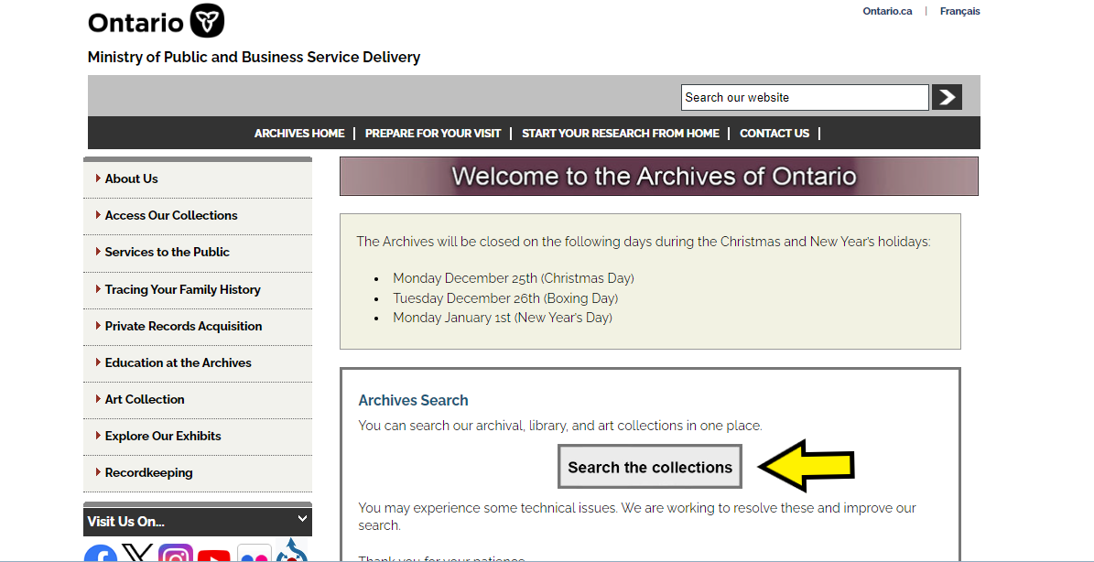

- In the Archives and Information Management System (AIMS), click on the “Archival search” button:
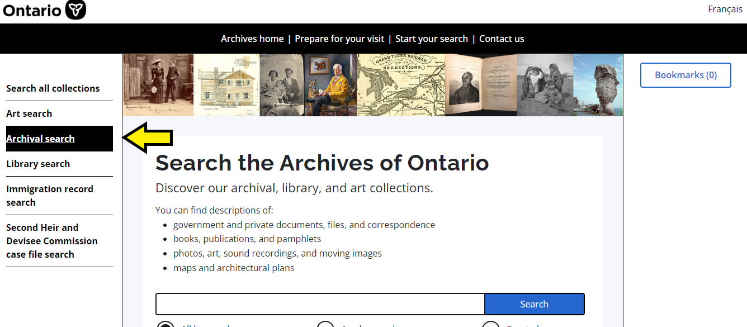

- On the “Search Archival Collection” search page, click “Archival Advanced”:

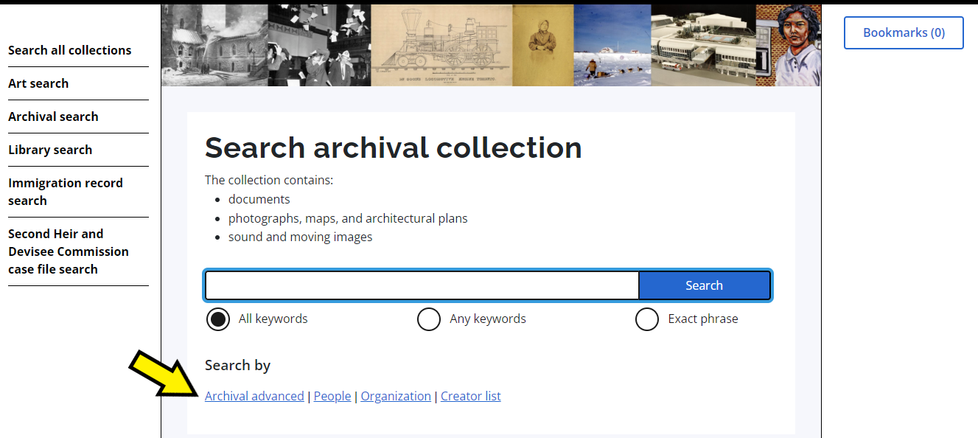

- On the “Archives Advanced Search” page enter the reference code (that’s the number starting with C, F or RG) in the Reference Code field and click “Search” (at the bottom of the page.

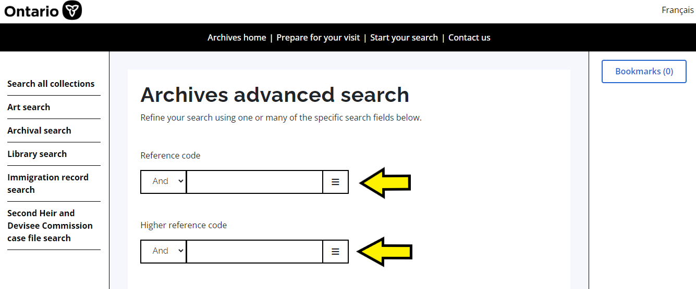

Contact us

Although unable to do your research for you, our reference archivists are waiting to assist you. You may call or write to them by mail or email or — best of all — visit the Archives of Ontario.

Telephone: 416-327-1600 Toll free (Ontario): 1-800-668-9933
Email: Click here to email the Archives of Ontario. The e-mail address is reference@ontario.ca
Address: Archives of Ontario, 134 Ian Macdonald Blvd., Toronto, ON M7A 2C5

Website
Visit our website for information about our collections and our services, our online exhibits and education programs, and links to our social media accounts. Click here to visit our website. The website is www.ontario.ca/archives.

Customer Service and Research Guides
Our guides contain information about our services, freelance researchers available to do research for you, and some of our most popular records. Click here to view our guides. To find the “Research Guides and Tools” on our website, click on “Access our Collections”.
______________________________________________________________________
© King's Printer for Ontario, 2023

This information is provided as a public service. Last update is shown at the beginning of this guide. Readers should where possible verify the information before acting on it.

A fonds is the records created, received or accumulated by a person, family, organization, business or office through their activities and operations.

