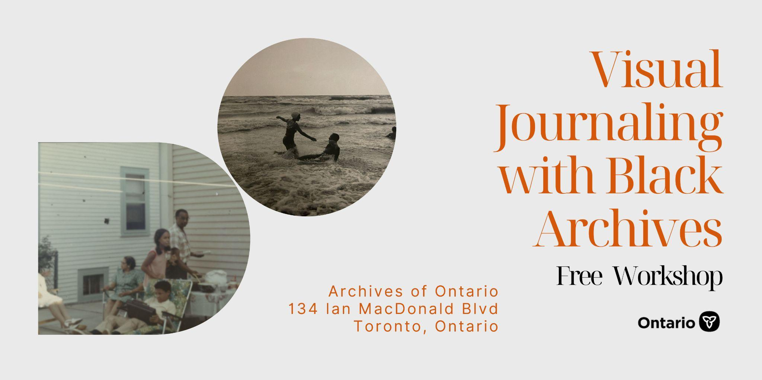

Visual Journaling with Black Archives Workshop
Join archivist Melissa J. Nelson and artist Anthony Gebrehiwot as they explore the potential of Black archives for Black artistic creation.

By Archives of Ontario

About the Workshop:
How can we reimagine the archive? Join archivist Melissa J. Nelson and artist Anthony Gebrehiwot as they explore the potential of Black archival collections for Black artistic creation. This workshop will take place at the Archives of Ontario. Come view original archival materials and develop your own artistic interpretations through visual journaling. Design a visual journal page with words, sketches, paint, or collage. Art supplies are provided to help you bring your creative ideas to life. The workshop will include a short presentation and discussion with time for reflection.

Frequently asked questions
Who is this Workshop for?
This workshop is intended for Black creatives. This workshop positions archives as a source of inspiration that can help Black creatives expand their practice. All creatives are welcome.
How many people can attend?
Minimum 4 people to a maximum of 20 people.
When does this workshop occur?
This workshop is available for private sessions. If you are part of a collective, artist-run centre, or know people you would like to uncover your creative side with bring them along. To book, contact us at reference@ontario.ca with your availability.
Is this workshop offered in French?
This workshop is currently offered in English only.

About the Facilitators:
Melissa J. Nelson is an award-winning archivist, writer, and educator based in Toronto. Melissa is currently an Archivist for the Archives of Ontario. Her work and research interests are grounded in an ethics of care for the preservation of Black cultural heritage and anti-Black archival materials. She holds a Bachelor of Arts (Hons) in History, with a minor in Sociology, from Carleton University. She also completed a Master of Information Studies at McGill University.
Anthony Gebrehiwot is a multiple award-winning visual artist, photographer and community leader whose creative lens re-visions photography as an ongoing dialogue of social change between subject and society. A self-taught artist and photographer, Gebrehiwot founded XvXy-photo in 2014 focusing on studio portraiture. To date, he has worked with several notable brands such as Nike, Royal Bank of Canada, Vice Canada, Absolute, Hudson Bay, The City of Toronto and Linkedin to name a few. His work has been featured in over forty local and international publications such as the Star, the Globe and Mail, PAPER Magazine, Elle UK and Yahoo Lifestyle.

