| **Archives of Ontario** | Government of Ontario logo |
| --- | --- |
| Research Guide 202  Vital Statistics Records  Last Updated: March 2023 | |

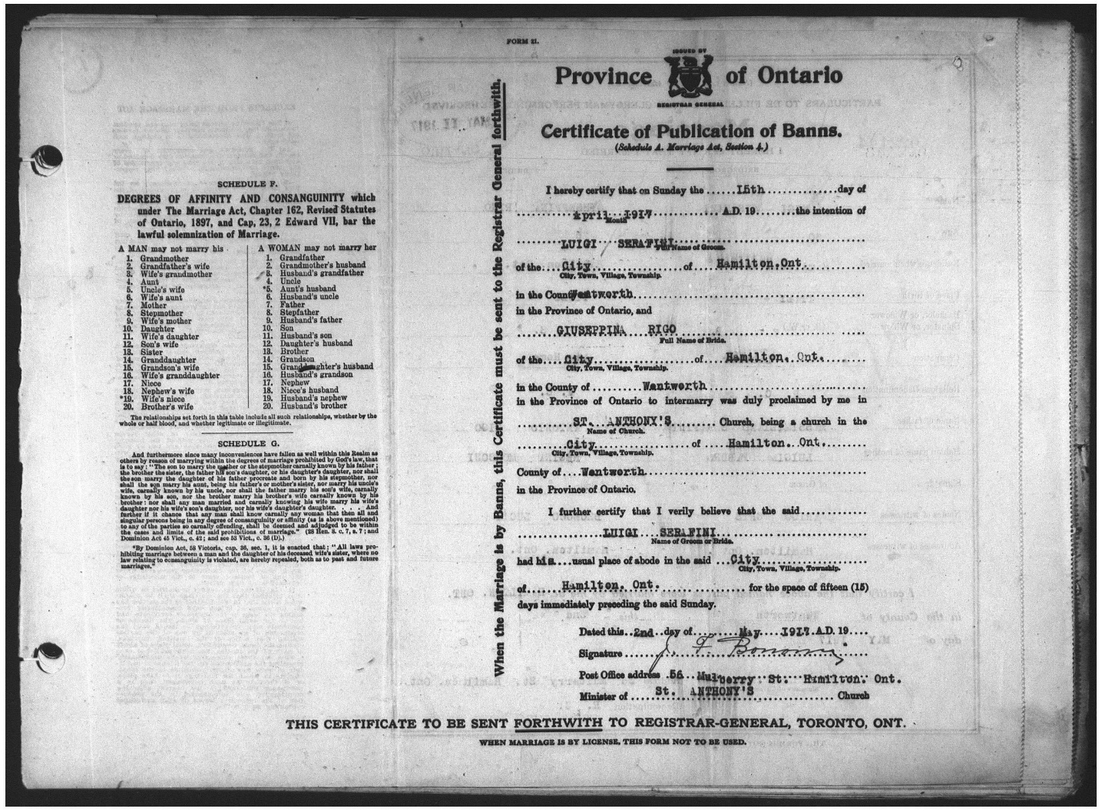

RG 80-5 Registrations of Marriages

MS 932 Reel 116

In this guide 2

Where do I find Vital Statistic records? 2

What do I need to get started? 3

The records 4

Birth, Marriage and Death Certificates 6

What if I need a birth or marriage certificate because the individual is still living? 6

Are there related records? 7

How do I get to the online descriptions? 7

Contact us 9

# In this guide

Vital statistics are the official information about important events in human life – births, marriages, and deaths – officially registered with the Government of Ontario. This research guide provides information on finding and using province of Ontario vital statistics records.

This guide provides information about the vital statistics records we hold, their contents, and how to access them. For more detailed information, and the resources mentioned in this guide, [click here to access our Vital Statistics Webpage](http://www.archives.gov.on.ca/en/tracing/vsmain.aspx" \o "Click to access webpage). To find this page on our website, click on “Tracing Your Family History”.

# 

# Where do I find Vital Statistic records?

Vital Statistics records for Ontario births, marriages, and deaths (Official Ontario government registrations) are in two places: the Archives of Ontario and the Office of the Registrar General of Ontario.

**1. Vital Statistics Records in the Archives of Ontario:**

The Archives of Ontario holds indexes (where they exist) and registrations for:

* Births – from ca. 1830 to 1917, predominantly 1869 to1917 (please note: delayed birth registrations also exist for a small number of pre-1869 births; these are available on [www.familysearch.org](http://www.familysearch.org/).
* Marriages – from ca. 1801 to 1941
* Deaths – from 1869 to 1951
* Ontario overseas deaths, 1939 to 1947, documenting Ontarians who died outside of the country during those years

Please note:Until the early 1900’s, many births, marriages and deaths were not registered with the provincial government. It was the responsibility of the people involved to register the event. Birth, marriages, and deaths not registered with the government may be recorded in church records. For more information on church records, [click here to access Research Guide 204: Sources for Birth, Marriage and Death Records](http://www.archives.gov.on.ca/en/access/documents/research_guide_204_birth_marriage_death.pdf). To find this guide on our website, clinic on “Access Our Collections” from our main page, then click on “Research Guides and Tools”.

**You can access the Vital Statistics records at the Archives of Ontario in one of two ways:**

1. On microfilm, in our Reading Room onsite and through our interloan program. To access the microfilm through our interloan program, ask your local public library to borrow the film from the Archives of Ontario. You may request up to three reels per researcher.
2. Online on [www.ancestry.ca](http://www.ancestry.ca/) or [www.familysearch.org](http://www.familysearch.org).

For detailed information on where to access these records, including the years available in each format, please see TABLE 1at the end of this guide.

**2. Vital Statistics Records at the Office of the Registrar General of Ontario:**

The Office of the Registrar general holds registrations for:

* Births – from 1918 to present
* Marriages – from 1942 to present
* Deaths – from 1952 to present

For information on how to access these records, their contact information is as follows:

**Office of the Registrar General**

Box 4600

Thunder Bay, ON  
P7B 6L8

[Click here to access Service Ontario's website.](http://www.serviceontario.ca/)

416-325-8305

1-800-461-2156 (toll-free, Ontario only)

# What do I need to get started?

You need the name of the individual(s), the year the event took place in, and the county in which the event happened in. You will also need to consult TABLE 1 for information on where to access the records.

# The records

**Finding Vital Statistic Registrations on microfilm:**

To find Vital Statistics registrations at the Archives of Ontario using microfilm, you will need to consult our Vital Statistics indexes. The listings of indexes on microfilm and related pathfinders to help you conduct your research are available in our Reading Room and on our online Vital Statistics webpage; [click here to access the Vital Statistics webpage](http://www.archives.gov.on.ca/en/tracing/vsmain.aspx). Also see the section on **Vital Statistics indexes on microfilm** below, for more information on using the indexes.

Please note: The Archives does not provide research services. If you wish to hire a genealogical researcher to undertake research for you, [click here to access Customer Service Guide 111: Genealogical Researchers in Ontario](http://www.archives.gov.on.ca/en/access/documents/customer_service_guide_111_genealogical_researchers.pdf). To find this guide on our website, clinic on “Access Our Collections” from our main page, then click on “Research Guides and Tools”.

**Vital Statistic indexes on microfilm:**

* Birth, death, and marriage registrations (except marriages before 1873):The indexes are available as microfilmed computer printouts. The computer printout Indexes are sorted in the following order:

Up to 1895 for births, 1910 for marriages, and 1925 for deaths, they are sorted:

* + First by surname initial
  + Then by year of event
  + Lastly alphabetically, by the person’s full name.

After the above dates, they are sorted:

* + First by year of event
  + Then alphabetically, by the person’s full name.

The Indexes have the full name, date and place of the event, registration number and registration year.

To request the correct registration microfilm, you must have the registration number and registration year. For more information, [click here to access Research Guide 203: Understanding the Vital Statistics Indexes](http://www.archives.gov.on.ca/en/access/documents/research_guide_203_understanding_vs_indexes.pdf). To find this guide on our website, clinic on “Access Our Collections” from our main page, then click on “Research Guides and Tools”.

* Marriages 1801 to June 1869: These registrations are recorded in theDistrict Marriage Registers 1801-1857 or the County Marriage Registers 1858-June 1869. The registers and corresponding Indexes (where they exist) were transferred to microfilm together. There are published indexes in the Reading Room and in some public libraries.
* Marriages July 1869 to December 1872: There was NO computer printout Index for these records. Two indexes are available:
  + Published indexes, available in the Reading Room and in some public libraries
  + The Original (hand-written) microfilmed Indexes (MS 938 Reel 1 for July to December 1869; MS 941 Reel 1 for 1870 to 1872). Each Index is sorted in the following order:
  + First by year
  + Then within year, by surname initial
  + Then lastly grouped by county/ district.

You need the Liber (volume) and Folio (page) numbers listed to order the correct Registration microfilm.

* Registrations of overseas deaths, 1939 to 1947: There is no index by the Office of the Registrar General for these records.
  + A published index is available in our Reading Room and in some libraries: Bruce Thornby (ed. By Clifford Collins), Index to overseas deaths of Ontario servicemen and servicewomen, 1939 to 1947 (Toronto: Ontario Genealogical Society, 2006), 2 vol.

**The following is what you can find within each type of vital statistic record:**

**BIRTHS:** Birth registrations include the year of birth, name, gender, father's name, mother's maiden name, father's rank or occupation, signature and residence of informant (usually a relative), accoucheur's name (the person assisting with the birth), registration date, registrar's signature, county / district of registration (an exact city, town or township is normally not given in the records for the earliest years).

**MARRIAGES (1801 to June 1869):**  There is a lot of variation in recorded information for marriages. It can be very limited in the early years (e.g., name of groom, bride, and clergy, location, date, and religious denomination of ceremony).

**MARRIAGES (July 1869 and after):**  There is information about each person and about the marriage. *About each person:* Name, age, place of residence and birth, marital status (bachelor/ widower, spinster / widow), occupation, father’s name, mother's maiden name, and religious denomination. *About the marriage:* Location and date marriage occurred, witnesses' names and residences, name of clergy conducting the marriage, whether marriage was by issuance of a marriage license or publication of banns and registration date.

**DEATHS:** The records *may* include the deceased person’s name, age, sex, religious affiliation, rank or profession, birthplace, cause of death, name and description of informant, registrar's name, date registered and county/ district of registration. Registrations after 1907 may also include the place of burial and the name of the parents.

Please note that all the above requested information *was not always recorded* in the registration. The data in the records can be incomplete, entered on the wrong line or incorrect. If the computer printout Index (see above) does not list a registration, try consulting the Original Index for that year.

# Birth, Marriage and Death Certificates

The Archives of Ontario:

* Does not issue birth, marriage, or death certificates, instead we **certify photocopies of registrations** in our holdings.
* When requesting a certified copy of a registration, please contact us including, far as you know:
  + the name of the person(s)
  + the location
  + the date (we will search a five-year range)
  + the parents’ names (for a birth).
* A certification fee of $33.00 (plus HST and postage and handling fees) applies. Please do not include payment with your request; we will invoice you only when a certified copy is found and ready for pick-up or delivery.

## What if I need a birth or marriage certificate because the individual is still living?

The Office of the Registrar General can produce certificates for birth and marriage records found in the Archives’ holdings for individuals who are still alive.

If you are seeking a copy of a pre-1918 birth or pre-1942 marriage certificate for someone who is still living, complete the Office of the Registrar General’s paper form available online at:

* Birth Certificate: <https://www.forms.ssb.gov.on.ca/mbs/ssb/forms/ssbforms.nsf/FormDetail?OpenForm&ACT=RDR&TAB=PROFILE&SRCH=&ENV=WWE&TIT=birth+certificate&NO=007-11076E>
* Marriage Certificate: <https://www.forms.ssb.gov.on.ca/mbs/ssb/forms/ssbforms.nsf/FormDetail?OpenForm&ACT=RDR&TAB=PROFILE&ENV=WWE&NO=007-11078E>

Once completed, mail the form with the appropriate fees to the following:

**Office of the Registrar General**

Box 4600

Thunder Bay, ON  
P7B 6L8

# Are there related records?

* The Archives holds various other records from government and non-government sources that document births, marriages, and deaths in the province. For more information, [click here to access Research Guide 204: Sources for Birth, Marriage and Death Records](http://www.archives.gov.on.ca/en/access/documents/research_guide_204_birth_marriage_death.pdf). To find this guide on our website, click on “Access Our Collections” from our main page, then click on “Research Guides and Tools”. The table below titled, “Other Government Sources for Vital Statistic Records” documents a few of these record groups.
* The Archives has other Registrar General records as well. The records listed below are available on microfilm only, in the Archives of Ontario Reading Room and through interloan. For microfilm lists, [click here to access our page listing other sources for Vital Statistics](http://www.archives.gov.on.ca/en/tracing/other_sources.aspx). To find this page on our website, click on “Tracing your Family History” then on “Ontario Vital Statistics”.

**Other Government Sources for Vital Statistic Records**

| **Records** | **Date Range** | **Reference Code** |
| --- | --- | --- |
| Roman Catholic Marriage Registers | 1828 to 1870 | RG 80-27-4 |
| Vital Statistics Files | 1838 to 1952 | RG 80-15 |
| Book of Marriages Not Registered, St. John the Evangelist Anglican Church, Toronto | 1858 to 1897 | RG 80-18 |
| Division Registrar Vital Statistics Records | 1858 to 1942 | RG 80-13 |
| Evidence for Delayed Registrations of Births | 1861 to 1907 | RG 80-19 |
| Direct Clergy Returns for Simcoe County Births Marriages and Deaths | 1892 to 1896 | RG 80-14 |
| Registers by Clergy | 1896 to 1948 | RG 80-27-3 |
| Marriage Licence Books | 1907 to 1910 | RG 80-22 |
| Miscellaneous Vital Statistics Registers | 1859 to 1931 | RG 80-27-5 |

# How do I get to the online descriptions?

1. On our website’s main page, click on “Access Our Collections”, and click on “Archives and Information Management System”, as shown in the image below:

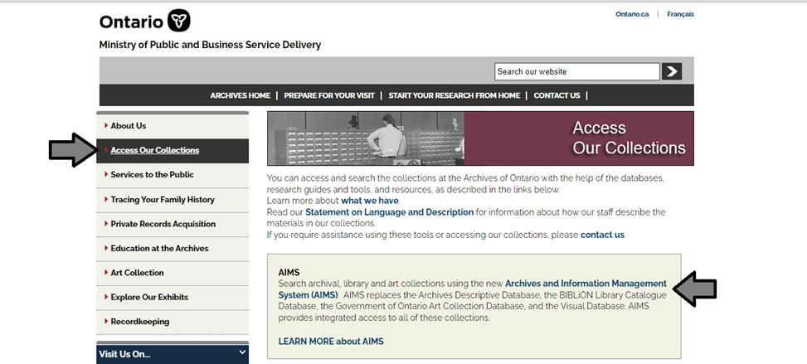

1. In the Archives and Information Management System (AIMS), click on “Archives repository (only)” button:

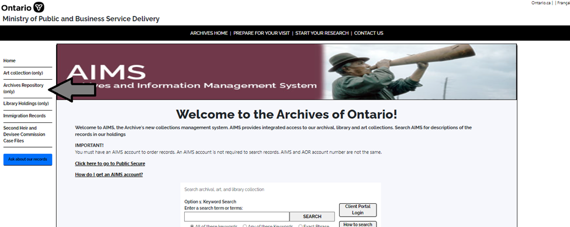

1. On the “Welcome to the Archival Collection” search page, click “Advanced Search”.

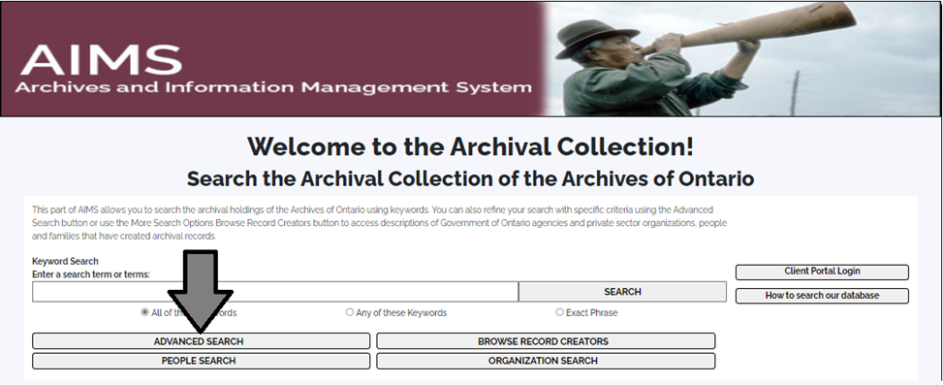

4. On the “Archives Advanced Search” page enter the reference code (that’s the number starting with C, F or RG) in the Reference Code field and click “Search” (at the bottom of the page.

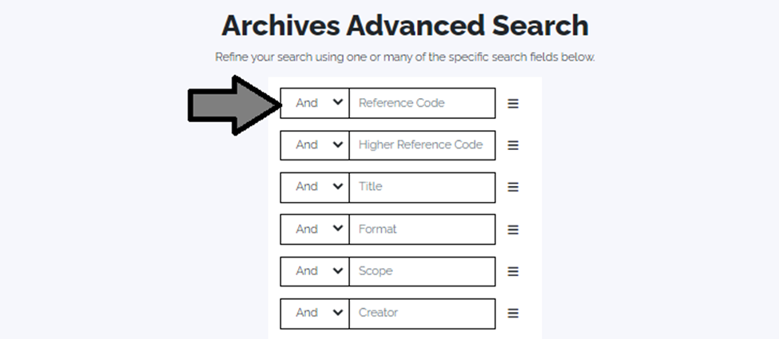

# Contact us

Although unable to do your research for you, our reference archivists are waiting to assist you.  You may phone or write to them by mail or email or — best of all — visit the Archives of Ontario.

**Telephone: 416-327-1600 Toll free (Ontario): 1-800-668-9933**

**Email:**[Click here to email the Archives of Ontario](mailto:reference@ontario.ca).  The e-mail address is [reference@ontario.ca](mailto:reference@ontario.ca)

**Address: Archives of Ontario, 134 Ian Macdonald Blvd., Toronto, ON M7A 2C5**

**Website**

Visit our website for information about our collections and our services, our online exhibits and education programs, and links to our social media accounts. [Click here to visit our website](https://www.ontario.ca/archives).  The website is <https://www.ontario.ca/archives>

**Customer Service and Research Guides**

Our guides contain information about our services, freelance researchers available to do research for you, and some of most popular records.  [Click here to view our guides](http://www.archives.gov.on.ca/en/access/research_guides.aspx).  To find the “Research Guides and Tools” on our website, click on “Access our Collections”.

______________________________________________________________________

© King’s Printer for Ontario, 2023

This information is provided as a public service.  Last update is shown at the beginning of this guide.  Readers should where possible verify the information before acting on it.

### 

### TABLE 1: Where to access Vital Statistic records

Use the tables below to find what Vital Statistics records are:

* available online on ancestry.ca; [click here to access ancestry.ca](http://www.ancestry.ca/)
* available online on the Family Search website, [click here to access the Family Search website](http://www.familysearch.org)
* available on microfilm, in the Archives of Ontario reading room and through interloan; [for microfilm lists and instructions, click here to access our Vital Statistics Webpage](http://www.archives.gov.on.ca/en/tracing/vsmain.aspx)
* at the Archives of Ontario, and closed for digitization
* held by the Office of the Registrar General (for contact information, go to page 2 of this research guide)

**Birth, marriage and death registrations and indexes**

| **Type of records** | **Available on ancestry.ca** | **Available on Family Search website** | **Available in the Reading Room and through Interloan** | **At the Archives of Ontario, closed for digitization** | **Held by the Office of the Registrar General** |
| --- | --- | --- | --- | --- | --- |
| Births | 1869 to1914 | ca. 1830 to 1912 (registrations ca. 1830-1868 are online only) | 1869 to 1917 | No records closed for digitization | 1918 to present |
| Marriages District Registers ([ca. 1801-1857]) | [ca. 1801 to 1857] | [ca. 1801 to 1857] | [ca. 1801 to 1857] | All records have been digitized | No records held by the Office of the Registrar General |
| Marriages County Registers ([ca. 1858-1869]) | [ca. 1858 to 1869] (transcriptions only, no image of the records) | [ca. 1858 to 1869] | [ca. 1858 to 1869] | All records have been digitized | No records held by the Office of the Registrar General |
| Marriages (July 1, 1869 and after) | 1869 to 1938 | 1869 to 1927 | 1869 to 1932 | 1939-1941 | 1942 to present |
| Deaths | 1869 to 1948 | 1869 to 1937 | 1869 to 1942 | 1949-1951 | 1952 to present |
| Deaths of Ontarians overseas | 1939-1947 | 1939-1947 | 1939-1947 | All records have been digitized | No records held by the Office of the Registrar General |