| **Archives of Ontario** |  | |
| --- | --- | --- |
| Research Guide 203  Understanding Vital Statistics Indexes    Last Updated:  March 2023 | |

 

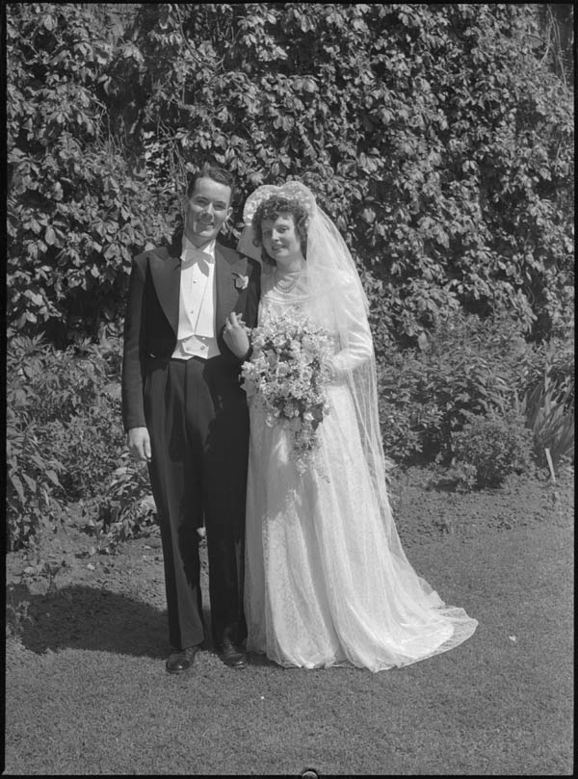

Bride and groom, Torges wedding

circa 1945

C 5-1-0-146-2

Gordon Powley photos

In this guide 2

What is in the indexes? 2

Contact us 4

Examples of index pages 5

Birth index page 5

Marriage index page 6

Death index page 7

# In this guide

This guide has information on how to understand the alphabetical indexes to vital statistics (birth, marriage and death records).

You will find these indexes and the corresponding birth, marriage and death registrations on microfilm in our reading room. Libraries that offer interloan services may also borrow the microfilm for you. For microfilm lists and instructions on how to find registrations on microfilm, [click here to view our Ontario Vital statistics webpage](http://www.archives.gov.on.ca/en/tracing/vsmain.aspx). This webpage is also accessible from our website (ontario.ca/archives), by clicking on “Tracing Your Family History”.

Please note: Most of the registrations are also available online. You do not need to use the indexes to search registrations online. For information on digitized registrations and where to find them, [click here to view our Ontario Vital statistics webpage](http://www.archives.gov.on.ca/en/tracing/vsmain.aspx).

# What is in the indexes?

The alphabetical indexes were created starting in the late 1950’s. They replaced previous handwritten original indexes. The format of the indexes varied over time, but the fields remained the same.

Below is an explanation of the main fields in the indexes and whether they are required to find the registration.

**Note*:** The number column corresponds with the numbers on the examples of the index pages at the end of this guide.

| **Number\*** | **Field Title** | **Explanation** | **Required to find registration?** |
| --- | --- | --- | --- |
| 1 | NAME | This is the name of the person on the registration, copied from the original registration. Only the name of the child (for a birth), the bride and groom, and the deceased were indexed. Women remarrying were indexed under their previous married surname. In addition, some marriage indexes included the maiden name of women who were re-marrying. | **Yes**, you need this information to find the registration. |
| 2 | PLACE OF EVENT | This is the town or township where the event was registered. For rural births and deaths, this may different from where the actual event took place. | You **may** need this information to find the registration |
| 3 | DATE OF EVENT | The usual format is month, day and year. For example, 06 12 01 equals June 12th 1901. Marriages for 1873-1881 were indexed with single digit for the months and O, N, and D for October, November and December. | You **may** need this information to find the registration |
| 4 | REGISTRATION NUMBER | This is the unique numbered given to each registration. | **Yes**, you needthis information to find the registration. |
| 5 | REGISTRATION YEAR | This is the year when the birth, the marriage or the death was registered. It may be different from the date of event. | **Yes**, you needthis information to find the registration. |
| 6 | *CONTROL NUMBER* | This number correspond to the type of registration (birth, marriage or death) and type of correction to the original registration (if any). It was likely included for data quality control**.** | **No**, you do not need this information to find the registration. |
| 7 | *CODE* | This is a list of the control numbers (see no. 6 above). This information appears on some index pages. | **No**, you do not need this information to find the registration. |
| 8 | *C.O.* | This code corresponds to the county, district or city where the event was registered. It was used for data control purposes. | **No**,you do not need this information to find the registration. |

.

# Contact us

Although unable to do your research for you, our reference archivists are waiting to assist you.  You may telephone or write to them by mail or email or — best of all — visit the Archives of Ontario.

**Telephone: 416-327-1600 Toll free (Ontario): 1-800-668-9933**

**Email:** [Click here to email the Archives of Ontario](mailto:reference@ontario.ca).  The e-mail address is [reference@ontario.ca](mailto:reference@ontario.ca)

**Address: Archives of Ontario, 134 Ian Macdonald Blvd., Toronto, ON M7A 2C5**

**Website**

Visit our website for information about our collections and our services, our online exhibits and education programs, and links to our social media accounts. [Click here to visit our website](https://www.ontario.ca/archives).  The website is [www.ontario.ca/archives](https://www.ontario.ca/archives)

**Customer Service and Research Guides**

Our guides contain information about our services, freelance researchers available to do research for you, and some of most popular records.  [Click here to view our guides](http://www.archives.gov.on.ca/en/access/research_guides.aspx).  To find the “Research Guides and Tools” on our website, click on “Access our Collections”.

______________________________________________________________________

© King’s Printer for Ontario, 2023

This information is provided as a public service.  Last update is shown at the beginning of this guide.  Readers should where possible verify the information before acting on it.

# Examples of index pages

## Birth index page

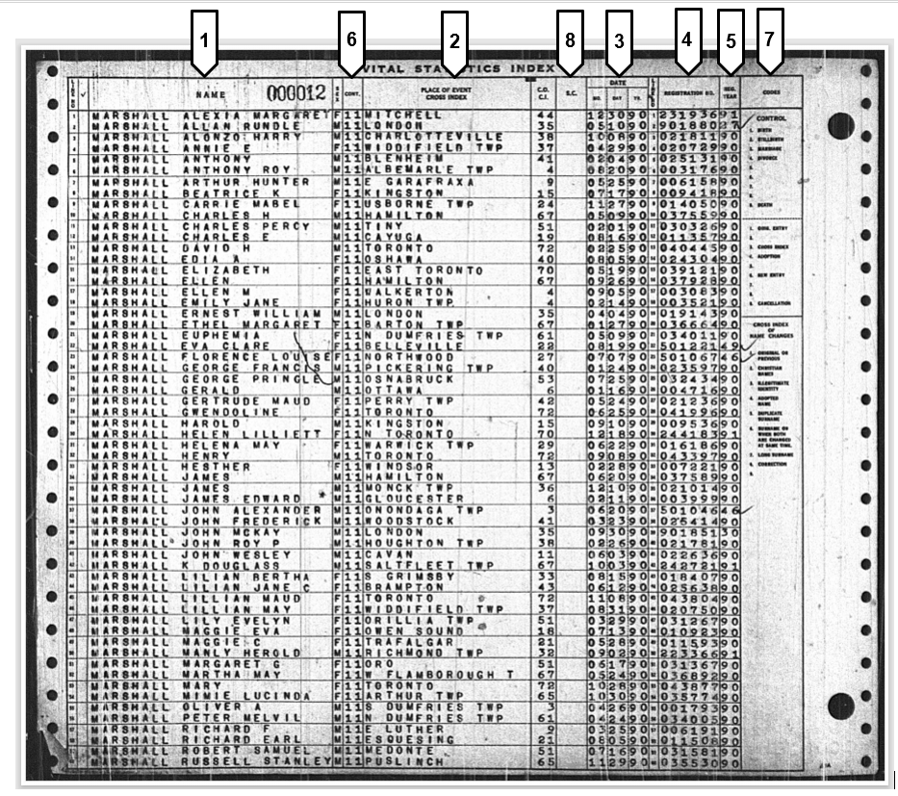

## Marriage index page

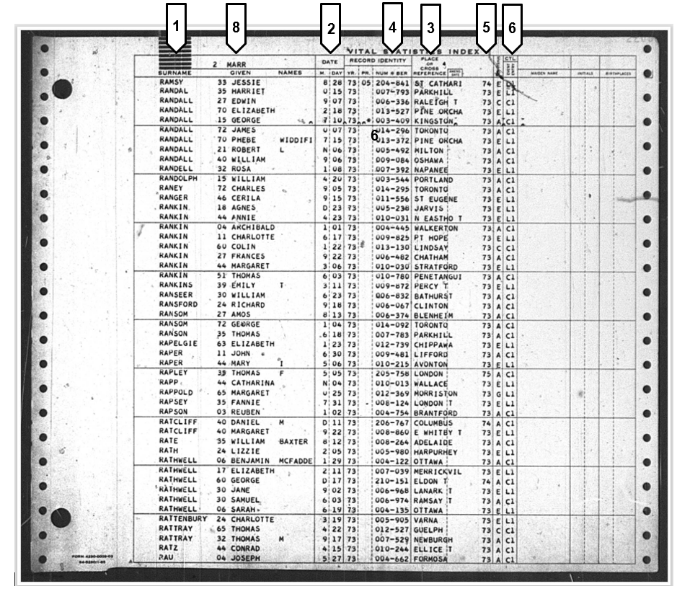

## Death index page

