| **Archives of Ontario** |  |
| --- | --- |
| Research Guide 204  Sources for Births, Marriages and Deaths  Last Updated: March 2023 | |

Image title is: Family group posing in front of house, C 130-5-0-0-105, Marsden Kempt fonds


Family group posing in front of house

C 130-5-0-0-105

Marsden Kempt fonds

In this guide 3

Where do I find these records? 3

Where do I find church records? 3

What do I need to get started? 4

The Records 4

1. Church records 4

1.1. Church records collection (F 978) 4

1.2. Marriage records collection (F 982) 5

1.3. Society of Friends (Quakers) records (F 997) 5

1.4. Muliticultural History Society of Ontario records (F 1405) 5

2. Ontario Genealogical Society’s cemetery recordings collection (F 977) 6

3. Municipal records 6

4. Records in local collections 7

4.1. Essex County 7

4.2. Frontenac County 8

4.3. Glengarry County 8

4.4. Grenville County 9

4.5. Lincoln County 9

4.6. Northumberland and Durham Counties 9

4.7. Peel County 10

4.8. Prince Edward County 10

4.9. York County 10

5. Court and government records 11

5.1. Court registers and returns of births marriages and deaths 11

5.2. Affidavits of bastardy and affiliation 11

5.3. Children of Unmarried Parents Act court records, 1921 to the 1980’s 12

5.4. Marriage bonds, 1803-1845, 1858-1861 12

5.5. Marriage license affidavits, Winchester Township, 1897 (RG 8-18) 13

Are there related records? 13

How do I get to the online descriptions? 13

Contact us 15

# In this guide

This guide has information on records about births, marriages and deaths at the Archives of Ontario, other than vital statistics records (Government of Ontario registrations of births, marriages and deaths). This guide includes both originals and copies.

Please note: This guide does not include birth, marriage and death records or information found in the private records of individuals or families,

*Please note: this guide contains links to information found in our online Archives Descriptive Database.  On our website, this database is found under “Access Our Collections”.  If you are using a print copy of this guide, go to page 13 for more information on how to find the online descriptions.

# Where do I find these records?

Most records in this guide are on microfilm, and you do not need to order them in advance to view them. Libraries that offer interloan services may also borrow some of the reels for you. [Click here to view our Microfilm Interloan Catalogue](http://www.archives.gov.on.ca/en/microfilm/index.aspx). To view the catalogue on our website, click on “Access Our Collections”. Some of the microfilms are also digitized and available on the FamilySearch website, [click here to access our Digitized Microfilm Collections webpage for more information](http://www.archives.gov.on.ca/en/access/digitized_microfilm_collections_on_familysearch.aspx). To find this information on our website, click on “Access our Collections” then click on the “Digitized Microfilm” page.  The FamilySearch website is [www.familysearch.org](http://www.familysearch.org).

Some of the records on microfilm that are part of municipal records are also available through Family Search, and local archives, museums or public libraries may have copies. Some of these reels have been digitized on [www.familysearch.org](http://www.familysearch.org).

You will need to visit the Archives to view the records that are not on microfilm.

# Where do I find church records?

We have a small quantity of records from churches or religious bodies. See this guide for more information about our records.

Most records from churches and religious bodies are:

* with the parish, congregation or religious body that created them,
* with a religious archive for the denomination (the religious group a person belonged to, for example: the Anglican Church, a Jewish Synagogue), or
* at local archives or historical society

Some records are available online.

Religious archives may be able to help you locate the records you are looking for.  [Click here for a list of religious archives in Ontario](http://www.archives.gov.on.ca/en/microfilm/ontario_religious_records.aspx). To find this list on our website, click on “Tracing Your Family History”, then click on “Ontario Vital Statistics”, then click on “Other Sources”.

Please note: In 1925, Methodist, Congregational and most Presbyterian congregations joined to form the United Church of Canada. Some Presbyterian congregations remained part of the Presbyterian Church in Canada.

# What do I need to get started?

You need to know where the event (birth, marriage or death) took place, when it took place, and the names of the person involved.

If you look for church records, you will also need to know the religious denomination of the people involved.

# The Records

## Church records

See the section on local collections below for additional church records with information about births, marriages and deaths.

### Church records collection (F 978)

Our church records collection contains records from various parishes congregations and itinerant preachers across Ontario, and a few records from outside the province. The Collection also includes marriage registers created by the clerks of the Peace for Johnstown and London districts, as well as records of the Holy Blossom Temple (Jewish faith), in Toronto.

These records may include:

* baptism, marriage and burial registers and records
* birth records
* minutes
* annual reports
* communion rolls
* session rolls
* financial records
* land deeds
* military records
* church histories
* newspaper clippings.

For information on these records, including a detailed list of the records, and how to view them, [click here to view the description for F 978](https://aims.archives.gov.on.ca/scripts/mwimain.dll/144/DESCRIPTION_WEB/WEB_DESC_DET?SESSIONSEARCH&exp=sisn%20797).

Some of the records in this collection are on microfilm, and you may borrow some of the microfilm through libraries that offer interloan services. For a list of the reels available through interloan, [click here to view the Microfilm Interloan Catalogue](http://www.archives.gov.on.ca/en/microfilm/index.aspx). Some of the microfilms are also digitized and available on the FamilySearch website, [click here to access our Digitized Microfilm Collections webpage for more information](http://www.archives.gov.on.ca/en/access/digitized_microfilm_collections_on_familysearch.aspx).  The FamilySearch website is [www.familysearch.org](http://www.familysearch.org).

### Marriage records collection (F 982)

The Marriage Records collection contains miscellaneous marriage certificates, licenses and registers in one place which cannot be assigned to any one specific church.

In addition to marriage records, these records may contain:

* marriage contracts
* baptism records
* cemetery transcripts
* data on births, marriages and deaths abstracted from newspapers and Old Age Pension applications
* instructions about the issuance of marriage licenses.

Most of the records in the collection document marriages performed in Ontario, but the collection also documents marriages performed in Alberta and in La Prairie, Quebec.

For information on these records and how to view them, [click here to view the description for F 982](https://aims.archives.gov.on.ca/scripts/mwimain.dll/144/DESCRIPTION_WEB/WEB_DESC_DET?SESSIONSEARCH&exp=sisn%20737).

### Society of Friends (Quakers) records (F 997)

These records are mostly minutes of meetings of local congregations of the Society of Friends (Quakers), with some records documenting births, marriages and deaths. In addition to Ontario, these records include congregations in Alberta, British Columbia and Saskatchewan, and national bodies.

These records are available on microfilm in our reading room. The Quaker Archives and Library of Canada has the original records. For information on these records and how to view them at the Archives of Ontario, [click here to view the description for F 997](https://aims.archives.gov.on.ca/scripts/mwimain.dll/144/DESCRIPTION_WEB/WEB_DESC_DET?SESSIONSEARCH&exp=sisn%2023687).

### Multicultural History Society of Ontario records (F 1405)

The Multicultural History Society of Ontario acquired records documenting the history of ethnic and cultural communities in Ontario. These include birth, baptism, marriage and burial of various Christian churches and Jewish synagogues throughout the province.

For information about these records and how to view them, [click here to search the Archives Collection, then enter the name of the church or synagogue, congregation or temple and the city in the keyword field, and F 1405-* in the Archival Reference Code field](https://aims.archives.gov.on.ca/scripts/mwimain.dll/144/DESCRIPTION_WEB/WEB_DESC_DET?SESSIONSEARCH&exp=sisn%201113). Hint: you may get better results if you do not include the words church, synagogue, congregation or temple in your search terms.

## Ontario Genealogical Society’s cemetery recordings collection (F 977)

Volunteers with the Ontario Genealogical Society (Ontario Ancestors) have transcribed information found on tombstones in cemeteries throughout Ontario. The transcription includes brief information and a plan of the cemetery.

We have microfilmed some of the transcriptions. You may view the microfilm in our reading room or request it through libraries that offer interloan services. [Click here to view a list of the microfilm in our Microfilm Interloan Catalogue](http://www.archives.gov.on.ca/en/microfilm/cemetery.aspx). There is a print finding aid listing the microfilm in our reading room.

Visit Ontario Ancestors’ website, [www.ogs.on.ca](http://www.ogs.on.ca), for information about cemetery transcriptions we do not have on microfilm.

#### 

## Municipal records

Some of the municipal records in our collections include birth, marriage and death registers, marriage returns and related correspondence. See table 1 for a list below for a list of these records.

Please note: Some of these records are governed by the Freedom of Information and Protection of Privacy Act. They are identified in the online descriptions. Contact us for information on how to request access to those records.

Table 1: Municipal records that contain birth, marriage and death records

| **Municipality** | **Records and Dates** | **Reference Code** |
| --- | --- | --- |
| Morrison Township | Registers of births, 1895 to 1947  Registers of marriages, 1895 to 1949  Registers of deaths, 1895 to 1949 | [Click here to view the description for F 1795](https://aims.archives.gov.on.ca/scripts/mwimain.dll/144/DESCRIPTION_WEB/WEB_DESC_DET?SESSIONSEARCH&exp=sisn%201592) |
| Town of Niagara | Registers of births, marriages, and deaths, 1848 to 1856  Correspondence and returns relating to vital statistics, 1848 to 1910 | [Click here to view the description for F 1805](https://aims.archives.gov.on.ca/scripts/mwimain.dll/144/DESCRIPTION_WEB/WEB_DESC_DET?SESSIONSEARCH&exp=sisn%201599) |
| Pittsburgh Township | Registers of births, 1872 to 1891  Registers of Deaths, 1872 to 1891  Registers of Marriages, 1869 to 1891 | [Click here to view the description for F 1867](https://aims.archives.gov.on.ca/scripts/mwimain.dll/144/DESCRIPTION_WEB/WEB_DESC_DET?SESSIONSEARCH&exp=sisn%201633) |
| Raleigh Township | Registers of Births, 1868 to 1948  Registers of Marriages, 1857 to 1948  Registers of Deaths, 1895 to 1948 | [Click here to view the description for F 1886](https://aims.archives.gov.on.ca/scripts/mwimain.dll/144/DESCRIPTION_WEB/WEB_DESC_DET?SESSIONSEARCH&exp=sisn%201645) |
| Ryde Township | Register of births, 1878 to 1884, 1914 to 1929  Registers of Marriages, 1879 to 1884, 1915 to 1928  Registers of Deaths, 1879 to 1884, 1914 to 1929 | [Click here to view the description for F 1897](https://aims.archives.gov.on.ca/scripts/mwimain.dll/144/DESCRIPTION_WEB/WEB_DESC_DET?SESSIONSEARCH&exp=sisn%201652) |
| South Walsingham Township | Registers of Births, 1860 to 1920  Registers of Deaths, 1869 to 1920  Registers of Marriages, 1869 to 1919  Marriage returns, 1910 to 1932 | [Click here to view the description for F 1933](https://aims.archives.gov.on.ca/scripts/mwimain.dll/144/DESCRIPTION_WEB/WEB_DESC_DET?SESSIONSEARCH&exp=sisn%201673) |

## Records in local collections

We have various fonds[1] and collections that contain records about births, marriages and deaths.

### Essex County

**Hiram Walker Historical Museum Collection (F 378)**: Collection consists of records from Essex County and the Windsor-Detroit area, that were collected by the Hiram Walker Museum (now Museum Windsor). It includes the church records below:

* + Rev. Hugh Cowan (Presbyterian) marriage registers, 1911-1929. To view, request F 378, B221130, item 20-54 in advance.
  + Church of the Assumption, Sandwich (Roman Catholic, French): Hand-written copy of vital statistics records, 1761 to 1786. To view, request F 378, box B294713, item 20-79, in advance.
  + St. Andrew's Church (Presbyterian), Amherstburg: Marriage certificate for Joel Doty and Lucenda Stockwell of Colchester Township, March 5, 1837. To view, request F 378, box B294726, item 20-202 in advance.
  + St. John's Church (Anglican), Sandwich Township: Photostat copy of register of marriages, christenings and burials, 1802 to 1827, and hand-written copy of records of marriages, baptisms, and burials, 1842 to 1860. To view, request F 378, box B294726, item 20-203 in advance.

For more information about this collection, contact us to get a copy (pdf) of inventory F 378.

**Stollman Family Fonds (F 688)**: The Stollman family was involved in local Jewish religious and political life in Detroit and Windsor in the 20th century. Records include marriage receipts, 1949 to 1986 and a marriage register, 1944 to 1964, of Rabbi Samuel S. Stollman of the Shaar Hashomayim Synagogue in Windsor.

To view these records, request [F 688-1](https://aims.archives.gov.on.ca/scripts/mwimain.dll/144/DESCRIPTION_WEB/WEB_DESC_DET?SESSIONSEARCH&exp=sisn%2023484), box B440684 in advance. For more information about these records, [click here to view the description for F 688.](https://aims.archives.gov.on.ca/scripts/mwimain.dll/144/DESCRIPTION_WEB/WEB_DESC_DET?SESSIONSEARCH&exp=sisn%20879)

**William Hands fonds (F 519):** William Hands was a local official in Essex County, between 1796 and 1851. His records include marriage returns for Essex County, 1842 to 1844. The fonds is on microfilm reel MS 788, in our reading room. Hand’s records are the fourth group of records on the reel.

For more information about these records, [click here to view the description for F 519 .](https://aims.archives.gov.on.ca/scripts/mwimain.dll/144/DESCRIPTION_WEB/WEB_DESC_DET?SESSIONSEARCH&exp=sisn%20376)

### Frontenac County

**Percy James Robinson Fonds (F 1080)**: Percy James Robinson was an historian of early Ontario. His records include photostat copies of birth and marriage records (Roman Catholic) from Fort Frontenac (now Kingston), 1747-1752. To view these records, request F 1080, box b924770 in advance.

For more information about Percy James Robinson’s records, [click here to view the description for F 1080](https://aims.archives.gov.on.ca/scripts/mwimain.dll/144/DESCRIPTION_WEB/WEB_DESC_DET?SESSIONSEARCH&exp=sisn%20866).

### Glengarry County

**Ewan Macdonald Fonds (F 970)**: Ewan Macdonald was a Roman Catholic priest and historian of Glengarry County. His records include the following from St. Raphael's Roman Catholic Church in Charlottenburgh Township:

* + Marriage promises, 1816 to 1849.
  + Transcriptions of birth, marriage, and death registers, 1802 to 1865.

To view these records, request F 970, box B299746 in advance. For more information about these records, contact us to get a copy (pdf) of inventory F 970.

The Church Records Collection includes original church registers for St. Raphael’s, 1805 to 1866. These records are on microfilm MS 269, reels 1 (1805 to 1828) and 2 (1828 to 1866) in our reading room. You may also borrow these reels through local libraries that offer interloan services. For more information about these records, [click here to view the description for F 978](https://aims.archives.gov.on.ca/scripts/mwimain.dll/144/DESCRIPTION_WEB/WEB_DESC_DET?SESSIONSEARCH&exp=sisn%20797).

**Hay Family Fonds (F 966)**:George Hay was a parish priest at St. Andrew's Roman Catholic Church in Glengarry County, from 1836 to 1876. The family records include notices of banns for marriages at St. Andrew’s, 1839 to 1845. These records are on microfilm MS 766, reel 2. These records are series 6-4 on the reel.

For information about these records and how to view them, contact us to get a copy (pdf) of inventory F 966.

### Grenville County

**Frederick John French Fonds (F 2040)**: Frederick John French was a lawyer, MPP and President of the Grenville County Historical Society. His records include

* + Return of Marriages for Grenville County, 1858 to 1865 (on microfilm MS 797, reel 2)
  + Miscellaneous marriage certificates and funeral notices, 1825 to 1872 (on microfilm MS 797, reel 3; for a chronological list of these and other records on the reel, see inventory F 2040, pages 11 to 24)

The microfilm is our reading room. Contact us to get a copy (pdf) of inventory F 2040.

[**Frederick Peter Smith Collection**](http://ao.minisisinc.com/scripts/mwimain.dll/144/ARCH_DESC_FACT/FACTSDESC/REFD+F+362?SESSIONSEARCH) **(F 362)**: Frederick Peter Smith was a teacher and secretary of the Grenville County Historical Society. The collection includes a transcription of burial records of the Blue Church (Anglican), near Prescott in Augusta Township, 1821 to 1828. To view these records, request F 362, box B296315 in advance. For information on this collection, contact us to get a copy (pdf) of inventory F 362.

**Robert Blakey Fonds (F 962)**: Robert Blakey was an Anglican pastor in Augusta Township, between 1821 and 1854. His records include a marriage register, 1821 to 1827, and a baptismal register, 1821 to 1841. To view this material request F 962, box B293835 in advance. For more information about these records, [click here to view the description for F 962](https://aims.archives.gov.on.ca/scripts/mwimain.dll/144/DESCRIPTION_WEB/WEB_DESC_DET?SESSIONSEARCH&exp=sisn%20258).

### Lincoln County

[**Niagara Historical Society Collection**](http://ao.minisisinc.com/scripts/mwimain.dll/144/ARCH_DESC_FACT/FACTSDESC/REFD+F+1138?SESSIONSEARCH) **(F 1138):** Collection includes the baptism, marriage and marriage registers of Rev. William Sampson, first Anglican rector of Grimsby, Lincoln County, 1817 to 1822. The registers are on microfilm MS 193, reel 3, in our reading room. For more information about this collection, [click here to view the description for F 1138.](https://aims.archives.gov.on.ca/scripts/mwimain.dll/144/DESCRIPTION_WEB/WEB_DESC_DET?SESSIONSEARCH&exp=sisn%20878)

### Northumberland and Durham Counties

[**B.K. van Buren Collection**](http://ao.minisisinc.com/scripts/mwimain.dll/144/ARCH_DESC_FACT/FACTSDESC/REFD+F+368?SESSIONSEARCH) **(F 368):** The collection consists of local records collection by B.K. van Buren of Port Hope, dating from 1818 to 1929. It includes marriage licenses from Northumberland County. For information on these records and how to view them, [click here to view the description for F 368.](https://aims.archives.gov.on.ca/scripts/mwimain.dll/144/DESCRIPTION_WEB/WEB_DESC_DET?SESSIONSEARCH&exp=sisn%201213)

[**Cobourg County Vital Statistics Collection**](http://ao.minisisinc.com/scripts/mwimain.dll/144/ARCH_DESC_FACT/FACTSDESC/REFD+F+417?SESSIONSEARCH) **(F 417):** The collection consists of a scrapbook of birth, marriage and death notices from the Cobourg Star, 1831 to 1849. To view these records, request F 417, box B287146 in advance.

[**Port Perry History Collection**](http://ao.minisisinc.com/scripts/mwimain.dll/144/ARCH_DESC_FACT/FACTSDESC/REFD+F+351?SESSIONSEARCH) **(F 351)**: The collection includes photocopies of two marriage certificates:

* James Holmes and S. Unger of Haldimand Township, Northumberland County, January 1, 1846
* J. Holman (?) of Ontario County and Flora MacQuarrie of Caledon Township, March 14, 1888.

To view this collection, request F 351, box B273524 in advance. For more information about this collection, [click here to view the description for F 351.](https://aims.archives.gov.on.ca/scripts/mwimain.dll/144/DESCRIPTION_WEB/WEB_DESC_DET?SESSIONSEARCH&exp=sisn%20585)

### Peel County

**William D. Reid Collection (F 280)**: William D. Reid was an historian and member of the staff of the Archives of Ontario. These records include transcriptions of headstones in Burlington, Oakville and Mississauga. To view them, request F 280-2, box B294738 in advance. For more information about the collection, [click here to view the description for F 280](https://aims.archives.gov.on.ca/scripts/mwimain.dll/144/DESCRIPTION_WEB/WEB_DESC_DET?SESSIONSEARCH&exp=sisn%201016).

**William Perkins Bull fonds (F 332)**: William Perkins Bull was a lawyer and local historian. His records include lists of inscriptions found in Peel County cemeteries. Entries on the lists include genealogical information from various sources, as well as plans of the cemeteries.

These records are on microfilm in our reading room. For a list of the cemeteries and microfilm reels, contact us to get a copy (pdf) of Inventory F 332.

Please note: The William Perkins Bull fonds is now with the Peel Art Gallery, Museum + Archives (PAMA). We only have microfilm copies of part of the fonds, including the lists of cemetery inscriptions. For information about the records at PAMA, visit [www.pama.peelregion.ca](http://www.pama.peelregion.ca).

### Prince Edward County

[**Prince Edward County History Collection**](http://ao.minisisinc.com/scripts/mwimain.dll/144/ARCH_DESC_FACT/FACTSDESC/REFD+F+379?SESSIONSEARCH) **(F 379)**: The collection includes photocopies of marriage certificates of the Allen family of Prince Edward County between the years 1791 and 1918. To view these records, request F 379, box B287440 in advance. For more information about this collection, [click here to view the description for F 379](https://aims.archives.gov.on.ca/scripts/mwimain.dll/144/DESCRIPTION_WEB/WEB_DESC_DET?SESSIONSEARCH&exp=sisn%201101).

### York County

[**Children of Peace Collection**](http://ao.minisisinc.com/scripts/mwimain.dll/144/ARCH_DESC_FACT/FACTSDESC/REFD+F+4177?SESSIONSEARCH) **(F 4177)**: The Children of Peace, a Quaker group, built a temple in Sharon, East Gwillimbury, between 1835 and 1831. Records include some marriage certificates 1821 to 1837. To view these records, request F 4177, box B272554 in advance. For more information about this collection [click here to view the description for F4177](https://aims.archives.gov.on.ca/scripts/mwimain.dll/144/DESCRIPTION_WEB/WEB_DESC_DET?SESSIONSEARCH&exp=sisn%20812).

[**Matthew Teefy Fonds**](http://ao.minisisinc.com/scripts/mwimain.dll/144/ARCH_DESC_FACT/FACTSDESC/REFD+F+502?SESSIONSEARCH) **(F 502)**: Matthew Teefy was merchant, local official and justice of the peace in Richmond Hill. His records include marriage affidavits (required before a license was issued), sworn before him, 1874 to 1884. To view these records, request F 502, box B273090 in advance. For more information about these records,  [click here to view the description for F 502.](https://aims.archives.gov.on.ca/scripts/mwimain.dll/144/DESCRIPTION_WEB/WEB_DESC_DET?SESSIONSEARCH&exp=sisn%20180)

## Court and government records

**Please note: Access to court records below that are less than 100 years ago is restricted, unless shown otherwise in the descriptions. Please contact us for information on how to request access to restricted records.**

### Court registers and returns of births marriages and deaths

**See table 2 below for information on court registers and returns of births, marriages and deaths, and information on how to view them.**

**Table 2: Court registers and returns of births, marriages and deaths**

| **Title** | **Dates** | **Reference Code** |
| --- | --- | --- |
| **Essex County Clerk of the Peace Birth, Baptism, Marriage and Burial Returns** | **1826 to 1858** | [**Click here to view the description for RG 22-1897**](https://aims.archives.gov.on.ca/scripts/mwimain.dll/144/DESCRIPTION_WEB/WEB_DESC_DET?SESSIONSEARCH&exp=sisn%206800) |
| **Johnstown District Clerk of the Peace Baptism, Marriage and Death Returns** | **1831 to 1862, 1870 to 1875** | [**Click here to view the description for RG 22-2986**](https://aims.archives.gov.on.ca/scripts/mwimain.dll/144/DESCRIPTION_WEB/WEB_DESC_DET?SESSIONSEARCH&exp=sisn%202506) |
| **Leeds and Grenville United Counties Clerk of the Peace Marriage Register** | **1950 to 1956** | [**Click here to view the description for RG 22-2985**](https://aims.archives.gov.on.ca/scripts/mwimain.dll/144/DESCRIPTION_WEB/WEB_DESC_DET?SESSIONSEARCH&exp=sisn%206801) |
| **Perth County Clerk of the Peace Baptism, Marriage and Death Records** | **1853 to 1871, 1896 to 1899** | [**Click here to view the description for RG 22-4286**](https://aims.archives.gov.on.ca/scripts/mwimain.dll/144/DESCRIPTION_WEB/WEB_DESC_DET?SESSIONSEARCH&exp=sisn%206799) |

### Affidavits of bastardy and affiliation

Unmarried mothers could swear an affidavit before local Justices of the Peace, requesting support from the father of the child. The father of the child is mentioned in the affidavits. We have affidavits for some counties, and they are arranged chronologically according to the date filed by the Clerk of the Peace.

See Table 3 below for information about these records and how to view them.

Table 3: Affidavits of bastardy and affiliations

| **Title** | **Dates** | **Reference Code** |
| --- | --- | --- |
| Grey County Clerk of the Peace Register of Officials, Naturalizations and Affidavits of Bastardy | 1853 to 1921 | [Click here to view the description for RG 22-2095](https://aims.archives.gov.on.ca/scripts/mwimain.dll/144/DESCRIPTION_WEB/WEB_DESC_DET?SESSIONSEARCH&exp=sisn%206651) |
| Leeds and Grenville United Counties Clerk of the Peace Affidavits of Affiliation and Bastardy | 1837 to 1921 | Contact us for information on how to view RG 22-2987 |
| Lincoln County Clerk of the Peace Affidavits of Affiliation | 1834 to 1916 | [Click here to see the description for RG 22-3188](https://aims.archives.gov.on.ca/scripts/mwimain.dll/144/DESCRIPTION_WEB/WEB_DESC_DET?SESSIONSEARCH&exp=sisn%2014059) |
| Northumberland and Durham United Counties Clerk of the Peace Affidavits of Bastardy and Affidavits of Affiliation | 1837 to 1861 | [Click here to view the description for RG 22-3789](https://aims.archives.gov.on.ca/scripts/mwimain.dll/144/DESCRIPTION_WEB/WEB_DESC_DET?SESSIONSEARCH&exp=sisn%206794) |
| Perth County Clerk of the Peace Affidavits of Bastardy | 1863 to 1902 | [Click here to view the description for RG 22-4258](https://aims.archives.gov.on.ca/scripts/mwimain.dll/144/DESCRIPTION_WEB/WEB_DESC_DET?SESSIONSEARCH&exp=sisn%206795) |
| Stormont, Dundas and Glengarry United Counties Affidavits of Affiliation | 1838-1921 | [Click here to view the description for RG 22-4983](https://aims.archives.gov.on.ca/scripts/mwimain.dll/144/DESCRIPTION_WEB/WEB_DESC_DET?SESSIONSEARCH&exp=sisn%2011182) |

### Children of Unmarried Parents Act court records, 1921 to the 1980’s

Under the Children of Unmarried Parents Act, 1921 disputes about the parentage of children born outside of marriage could be brought to the courts. We have the following records for some counties and districts:

* Registers: they provide basic information about the case
* Case files: they contain the full documentation from the file
* Order books: the judge issued orders to rule on matters of procedure, and to record the final disposition of the case

For information about these records, and how to view them, [click here to search the ArchivesCollection, using the name of the county or district and the title of the Act](https://aims.archives.gov.on.ca/).

### Marriage bonds, 1803-1845, 1858-1861

For a couple to get a marriage license in Upper Canada (today’s Ontario), the bridegroom and two friends or relative had to post a bond, with money. If there were something in law prevented or invalidated the marriage, they could lose the money. Couples who got married at their local Anglican or Roman Catholic church did not need to post a bond or to get a license.

Information in the bonds usually includes the names of the couple and the guarantors, their places of residence and the date and value of the bond.

We have some marriage bonds:

* for information on the Eastern District marriage bonds, 1806 to 1807 and how to view them, [click here to view the description for RG 22-4993](https://aims.archives.gov.on.ca/scripts/mwimain.dll/144/DESCRIPTION_WEB/WEB_DESC_DET?SESSIONSEARCH&exp=sisn%206803)
* for information on the Western District marriage bonds, 1826 to 1828 and 1835 and how to view them, 1826-1828, 1835, [click here to view the description for RG 1818](https://aims.archives.gov.on.ca/scripts/mwimain.dll/144/DESCRIPTION_WEB/WEB_DESC_DET?SESSIONSEARCH&exp=sisn%206804).

Library and Archives Canada has marriage bonds for 1803 to 1845 and 1858 to 1861, known as the Upper Canada marriage bound. There are three ways to view them:

* there is a database and digitized copies for all the bonds on the Library and Archives Canada website, [www.collectionscanada.gc.ca](https://www.bac-lac.gc.ca/eng/discover/vital-statistics-births-marriages-deaths/marriage-bonds/Pages/search.aspx)
* there is a microfilm copy of the bonds for 1803 to 1845 in in our reading room; for more information, [click here to view the description for D 354](https://aims.archives.gov.on.ca/scripts/mwimain.dll/144/DESCRIPTION_WEB/WEB_DESC_DET?SESSIONSEARCH&exp=sisn%208100)
* bonds for the years 1803 to 1834 are transcribed and indexed in Thomas A. Wilson, Marriage Bonds of Ontario, 1803-1834 (Lambertville, N.J.: Hunterden House, 1985); there is a copy of this book in our reading room.

### Marriage license affidavits, Winchester Township, 1897 (RG 8-18)

These records are affidavits sworn by couples wishing to be married in Winchester Township. Dundas County. Under an 1896 law, people who applied for a marriage license in Ontario had to swear an affidavit that the parties involved were not related and the intended marriage was lawful.

The affidavits have basic information about the parties, including their place of birth, age, and residence.

To view these records, request RG 8-18, box B224118 in advance. For more information on these records, [click here to view the description for RG 8-18](https://aims.archives.gov.on.ca/scripts/mwimain.dll/144/DESCRIPTION_WEB/WEB_DESC_DET?SESSIONSEARCH&exp=sisn%202200).

# Are there related records?

We have Ontario Vital Statistics records (official records of births, marriage and deaths). For information about these records, including the years we have, and how to view them, [click here to view our online Ontario Vital Statistics page](http://www.archives.gov.on.ca/en/tracing/vsmain.aspx). To view this page on our website, click on “Tracing Your Family History”.

For information about guardianship and adoption records, [click here to view our research guide 223, Guardianship and Adoption records](http://www.archives.gov.on.ca/en/access/documents/research_guide_223_guardianship_and_adoption.pdf). On our website, you will find this guide on the “Research Guides and Tools” page (under “Access Our Collections”.

# How do I get to the online descriptions?

1. On our website’s main page, click on “Access Our Collections”, and click on “Archives and Information Management System”, as shown in the image below:

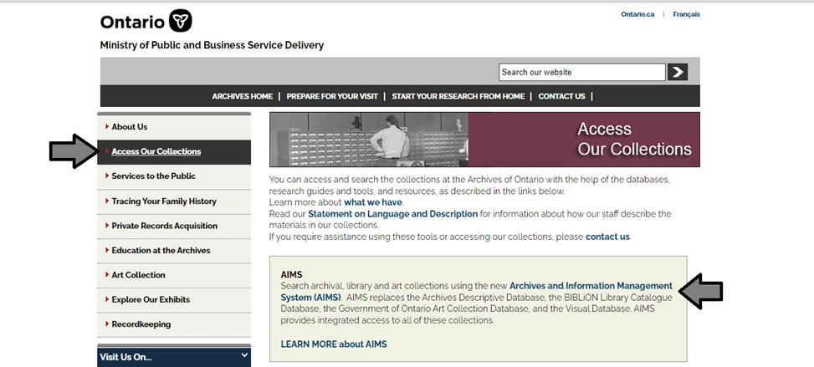

1. In the Archives and Information Management System (AIMS), click on “Archives repository (only)” button:

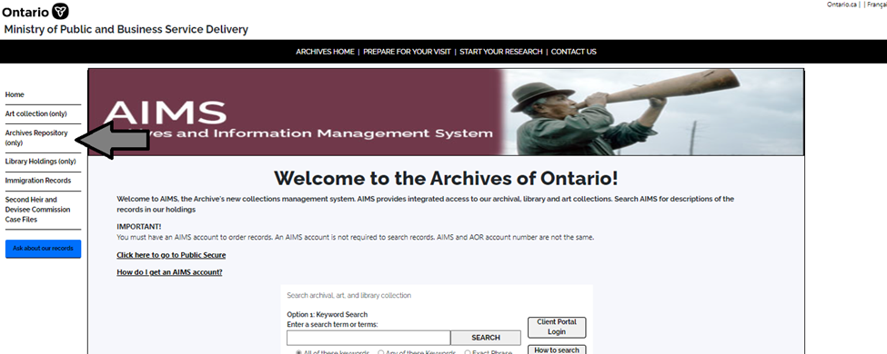

1. On the “Welcome to the Archival Collection” search page, click “Advanced Search”.

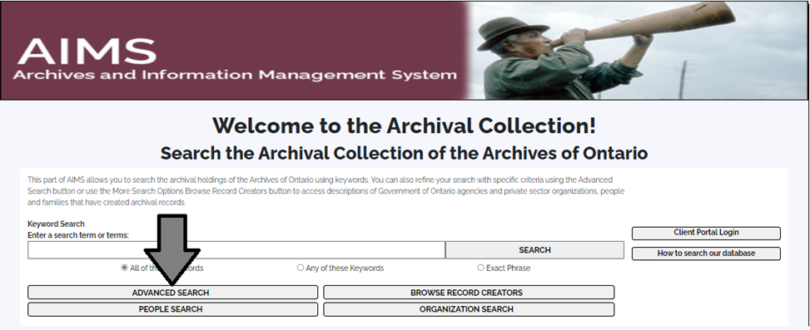

1. On the “Archives Advanced Search” page enter the reference code (that’s the number starting with C, F or RG) in the Reference Code field and click “Search” (at the bottom of the page.

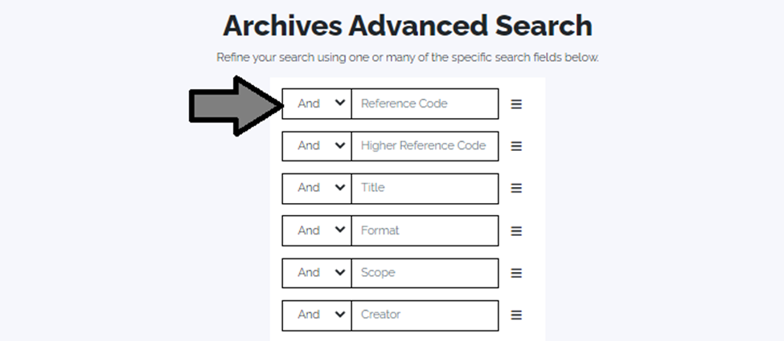

# Contact us

Although unable to do your research for you, our reference archivists are waiting to assist you.  You may call or write to them by mail or email or — best of all — visit the Archives of Ontario.

**Telephone: 416-327 to 1600 Toll free (Ontario): 1-800-668-9933**

**Email:** [Click here to email the Archives of Ontario](mailto:reference@ontario.ca).  The e-mail address is [reference@ontario.ca](mailto:reference@ontario.ca)

**Address: Archives of Ontario, 134 Ian Macdonald Blvd., Toronto, ON M7A 2C5**

**Website**

Visit our website for information about our collections and our services, our online exhibits and education programs, and links to our social media accounts. [Click here to visit our website](http://www.archives.gov.on.ca/).  The website is [www.archives.gov.on.ca/](http://www.archives.gov.on.ca/)

**Customer Service and Research Guides**

Our guides contain information about our services, freelance researchers available to do research for you, and some of most popular records.  [Click here to view our guides](http://www.archives.gov.on.ca/en/access/research_guides.aspx).  To find the “Research Guides and Tools” on our website, click on “Access our Collections”.

______________________________________________________________________

© King’s Printer for Ontario, 2023

This information is provided as a public service.  Last update is shown at the beginning of this guide.  Readers should where possible verify the information before acting on it.

1. A fonds is the records created, received or accumulated by a person, family, organization, business or office through their activities and operations.