| **Archives of Ontario** | Ontario Logo |
| --- | --- |
| Research Guide 207  Researching Bills and Statutes  Last Updated: February 2023 | |

Photograph is: Garden in front of Queen’s Park, 1952, RG 65-35-3, 11764-X2401-1, Tourism promotion photographs


Garden in front of Queen’s Park, 1952

RG 65-35-3, 11764-X2401-1

Tourism promotion photographs

In this guide 2

What are bills and statutes? 2

Where do I find these records? 3

What do I need to get started? 3

The Records 3

1. Statutes 4

1.1 Statutes, 2000 to present 4

1.2 Statutes before 2000 4

1.3 Revised Statutes 5

1.4 Office consolidations 6

2. Bills and related records 6

2.1 Finding bills 7

2.2 Original bills 8

2.3 Legislative Assembly records pertaining to bills 8

2.4 Cabinet records 10

2.5 Records of the Office of the Legislative Counsel 11

Are there related records? 11

How do I get to the online descriptions? 12

Contact us 13

# In this guide

This guide has information on how to search for bills and statutes (laws) for Ontario (from 1867 to present), the Province of Canada (1841 to 1867) and Upper Canada (1791 to 1841). It also includes information on how to find records with background information on bills.

*Please note: this guide contains links to information found in our online Archives Descriptive Database. On our website ontario.ca/archives, this database is found under “Access Our Collections”. If you are using a print copy of this guide, go to page 12 for more information on how to find the online descriptions.

## What are bills and statutes?

A **bill** is a proposed piece of legislation before the Legislative Assembly for consideration.

All bills must pass through three readings (votes) in the Legislative Assembly to become law. The legislative process often includes a review of the bill by a Standing Committee of the Legislature (for example, the Standing Committee on Social Policy). Bills are usually modified during the legislative process, and they do not always become law.

When a bill has received its third reading, it is sent to the Lieutenant-Governor to receive Royal Assent (the Lieutenant-Governor’s signature). Once that is done and the bill is enacted by the Government, it becomes a **statute** (or Act). Statutes are the official laws of the province.

**Revised Statutes of Ontario** (RSO) were periodical consolidations of all statutes.

For more information on how Ontario’s laws are created, visit the website of the Legislative Assembly, [www.ola.org](http://www.ola.org/); on the main page, click on “Legislative Business”.

E-law, the Ontario statutes website, has a glossary of terms related to statutes. Visit [www.ontario.ca/law](http://www.ontario.ca/law) and click on “e-laws definitions”.

# Where do I find these records?

Statutes, bills and most Legislative Assembly materials mentioned are available:

* online (not all years)
* in hardcopy format: in our library as well as some Ontario libraries (some years are available on microfilm)

See The Records section of this guide for information on how to access these materials in hardcopy or on microfilm.

Other Legislative Assembly records, and background records to bills in our collections are available for viewing in our reading room only, and you need to make arrangements in advance to view them. Some records are governed by the Freedom of Information and Protection of Privacy Act (FIPPA) and you will need to submit a freedom of information request; the records’ online descriptions will have more information about this process.

# What do I need to get started?

To find a bill or statute, you need the:

* title or topic
* the year
* the bill or statute number

The Records section below provides more detailed information on how to find a bill or statute.

# The Records

## Statutes

Statutes are arranged by year, then by chapter number. There are two formats for statute numbers and citations:

* by calendar year: for example, An Act to Consolidate and Amend the Public Schools Act. Statutes of Ontario, 1885. Chap. 49
* (for early statutes) by regnal year (year in the reign of the King or Queen): for example: An Act to Consolidate and Amend the Public Schools Act. Statutes of Ontario, 48 Vic. Chap. 49.  (for a table showing calendar years, Legislatures and regnal years, [click here to view our library finding aid L 14, Statutes of Ontario, 1867 to 1950)](http://www.archives.gov.on.ca/en/about/documents/L14-Statutes-of-Ontario.pdf); to find our library finding aids on our website, click on “Access Our Collections” and click on BiBLION, our library database.

### Statutes, 2000 to present

You will find Ontario statutes from 2000 to present on the e-law website, [www.ontario.ca/laws](http://www.ontario.ca/laws). This site includes:

* current consolidated law: current statutes, including all amendments from the original text
* source law: statutes as passed by the legislature, from 2000 to present
* “point-in-time” law: historical versions of statutes, from 2004 to present
* regulations, from 2000 to present: for information on regulations, [click here to view our research guide 219, Researching Ontario regulations, 1867 to present](http://www.archives.gov.on.ca/en/access/documents/research_guide_219_ontario_regulations.pdf); to view this and other research guides on our website, click on “Access Our Collections” and scroll down to the “Research Guides and Tools” page.

Statutes are also printed annually as bound volumes that include all new and modified statutes for that year. For information on how to access these volumes, see section 1.2 below.

Some statutes are also printed as office consolidations, that contain the most recent amendments. For information on how to access these publications, see section 1.4 below.

### Statutes before 2000

If you know the year of the statute, consult the annual statutes. Each annual volume includes a table of contents listing the statutes, and an index of subjects covered by the statutes.

If you do not know the year, see section 1.3 below for information on how to search the Revised Statutes.

If you are looking for a statute pertaining to a public body (municipality, some corporations, some church, charitable or educational organizations) before 1902, you will also find the title, chapter number and year in P.H. Beaudoin, *Index to Incorporated Bodies: Private and Local Law (1896)* and the *1901 Supplement* covering the years 1897 to 1901. Both books are on self-serve microfilm MS 292, reel 1 in our reading room. There is an online copy on the Internet Archives website, [www.archive.org](http://www.archive.org/).

Annual statutes online:

Annual statutes are available online:

* 1792 to 1867: on the Canadiana website, [www.canadiana.ca](http://www.canadiana.ca/)
  + 1792 to 1841: search “Statutes of her Majesty’s Province of Upper Canada” as the title
  + 1841 to 1851: search “Provincial Statutes of Canada” as the title
  + 1852 to 1867: search “Statutes of the Province of Canada” as the title
* 1970 to 1999: on the Osgoode Commons, York University Website, at <https://digitalcommons.osgoode.yorku.ca/ontario_statutes/>
  + This website will also include statutes from 1867 to 1969 once digitization is completde
* 2000 to present: see section 1.1 above.

There is also a searchable database for the contents of the statutes from 1792 to 1856: British North America Legislative Database, University of New Brunswick, at <https://bnald.lib.unb.ca/>.

Annual statutes in print and on microfilm:

We have the annual statutes of Upper Canada, the Province of Canada and Ontario from 1792 to present. Annual statutes for a given year are printed and a copy is transferred to us in the following year. Copies are also available at some Ontario libraries.

To view the annual statutes in print or on microfilm in our reading room:

* 1792 to 1866: to find a list of the self-serve microfilm, [click here to view our library finding aid L 12, Statutes of Upper Canada and the Province of Canada](http://www.archives.gov.on.ca/en/about/documents/L12-Statutes-of-upper-canada-and-province-of-canada.pdf); to find our library finding aids on our website, click on “Access Our Collections” and click on BiBLION, our library finding aid.
* 1867 to 1950: to find a list of the self-serve microfilm, [click here to view our library finding aid L 14, Statutes of Ontario, 1867 to 1950)](http://www.archives.gov.on.ca/en/about/documents/L14-Statutes-of-Ontario.pdf);
* 1951 to present: request the Statutes of Ontario, call number Govt Doc Statutes SO [the year you want]

### Revised Statutes

Revised Statutes are official periodical consolidations of all statutes. Bound volumes also include subject indexes, as well as tables listing changes to statutes since the previous edition of the Revised Statutes. This would help you find, for example, the year and chapter number for all statutes that amended the Education Act between the Revised Statutes of 1980 and 1990.

Revised Statutes were published in the following years:

* Upper Canada:1831 and 1843
* Province of Canada: 1859
* Ontario: 1877, 1887, 1897, 1914, 1927, 1937, 1950, 1970, 1980 and 1990

Revised Statutes are numbered by the year of the revision, and a number with that year (for example, Education Act, RSO 1990, chapter E-2).

Revised Statutes online:

Revised Statutes are available:

* 1831; on the Internet Archives, [www.archive.org](http://www.archive.org/) (search “Statutes Upper Canada 1831”)
* 1843: on the Canadiana website, [www.canadiana.ca](http://www.canadiana.ca/) (search “The Statutes of Upper Canada, to the time of the Union” as the title)
* 1859: on the Canadiana website (search “The consolidated statutes of Canada” as the title)
* 1914 to 1990: on the Osgoode Commons, York University website, at <https://digitalcommons.osgoode.yorku.ca/rso/>.

Revised Statutes in print and in microfilm:

We have all Revised Statutes of Upper Canada, the Province of Canada and Ontario from 1831 to present. Copies are also available at some Ontario libraries.

To view the annual statutes in print in our reading room:

* 1833 to 1950: to find a list of the self-serve microfilm, [click here to view our library finding aid L 9, Revised Statutes of Upper Canada, the Province of Canada and Ontario](http://www.archives.gov.on.ca/en/about/documents/L9-Revised-Statutes.pdf)
* 1970, 1980 and 1990: request the Revised Statutes of Ontario, call number Govt Doc Statutes RSO [the year you want]; if you are looking for a specific revised statute and you know its number, add this information.

### Office consolidations

Office consolidations are unofficial printed versions of statutes, with amendments and sometimes related regulations. These are not printed on a regular basis. To find if we have office consolidations for a statute, [click here to search our Library Holdings, and enter the title of the statute](https://aims.archives.gov.on.ca/scripts/mwimain.dll/566345078?unionqueryform&application=UNION_VIEW&language=144&aux_sessid=AO_SHARE&searchform=%5bAO_ASSETS%5dhtml/library.html&AUX_SESSID=AO_SHARE).

## Bills and related records

There are three kinds of bills.

* Government Bills are introduced in the Legislative Assembly by Cabinet ministers. They usually affect all of Ontario. These bills are part of the government’s legislative program.
* Private Members' Public Billsalso deal with issues of public concern. They are introduced by any member of provincial parliament (MPP) from any party, who is not in the Cabinet.
* Private Billsare normallyintroduced by the member who represents the provincial riding that the bill concerns. These bills usually affect a particular individual or corporation

### Finding bills

Journals of the Legislative Assembly To find a bill, you must first get the title, number and year from the Journals of the Legislative Assembly. The Journals are the permanent official record of the proceedings of the Legislative Assembly.

To find the **Journals for Upper Canada, 1792 to 1824**, follow these steps

1. [click here to view our library finding aid L 20, Journals of the Legislative Assembly](http://www.archives.gov.on.ca/en/about/documents/L20-Journals-of-the%20Legislative-Assembly.pdf); to find our library finding aids on our website, click on “Access Our Collections” and click on BiBLION, our library finding aid. This finding aid lists the reports of Bureau of Archives of Ontario that contains the Journals. These reports are available on microfilm in our reading room, and at some other libraries and online.
2. Write down the report number and year that match the Journal you want to view.
   1. To view the Journal on microfilm, write down the microfilm number.
   2. To view the Journals online, go the Internet Archive website, [www.internetarchive.org](http://www.internetarchive.org/) and search “Reports of the Ontario Bureau of Archives”

The Journals after 1824 are also online:

* 1825 to 1840: on the Canadiana website, [www.canadiana.org](http://www.canadiana.org/) (search “Journals of the House of Assembly of Upper Canada as the tile)
* 1841 to 1866: on the Canadiana website (search “Journals of the Legislative Assembly of the Province of Canada” as the title)
* 1867 to 2018: on the website of the Legislative Library, at <http://collections.ola.org/ser/23347>.
* 1975 to present: on the website of the Legislative Assembly, at <https://www.ola.org/en/legislative-business/house-documents>; click on “Legislative business”, then click on “House documents” and click on the link for the session you are interested in

For information about viewing the Journals in paper or microfilm format in our reading room,  [click here to view our library finding aid L 20, Journals of the Legislative Assembly](http://www.archives.gov.on.ca/en/about/documents/L20-Journals-of-the%20Legislative-Assembly.pdf). Other Ontario libraries may have copies of the Journal.

Once you find a reference to a bill in the Journals, write down:

* the kind of bill it is: (a government bill, a private member's public bill or a private bill)
* the number of the bill
* thedates of the bill's introduction, first reading, second reading, and third reading
* the name of the individual introducing the bill
* the number and year of the sessional paper, if any, tabled at the bill's first reading
* which committee, if any, the bill was assigned to, and when it reported
* whether the bill was carried over to the next session (you will need to check the Journals for the next session to find the new number)

Bills Ontario and online bills: Some bills before 1867 were printed and some may be available online.

Bills from 1867 to 1998 (with gaps) are available on the Internet Archives website, [www.archive.org](http://www.archive.org/) (search “Ontario Bills”). Bills from 1995 to present are on the Legislative Assembly website, [www.ola.org](http://www.ola.org/).

To view Bills in our reading room, request “Ontario Bills” from our library collection, with the year, the session and the bill number.

### Original bills

Original bills are drafts of the bills, prepared for each reading. They often include extended annotations that show changes as a bill went through the legislative process. We have original bills from 1867 to 1986. For information on these records and how to access them, [click here to view the description for RG 49-39](https://aims.archives.gov.on.ca/scripts/mwimain.dll/144/DESCRIPTION_WEB/WEB_DESC_DET?SESSIONSEARCH&exp=sisn%208117).

### Legislative Assembly records pertaining to bills

Hansard: The Hansard is the official is the official verbatim report of the debates in the Legislative Assembly of Ontario. It includes debates of the Committee of the Whole House. For bills, it includes the speech introducing the bills, and a transcription of the debates pertaining to the bill.

For debates before 1841, see the Journals of the Legislative Assembly (section 2.1) above). From 1841 to 1944, the Legislative Assembly produced the **Newspaper** (or **Scrapbook**) **Hansard**, a compilation of articles from major newspapers (mostly in Toronto) reporting on the previous day’s debates.

The Newspaper Hansard before 1867 is not available online. The Hansard (or Newspaper Hansard) is online:

* 1867 to 1946: at [https://vitacollections.ca/Ontario-Scrapbook-Hansard/](https://vitacollections.ca/Ontario-Scrapbook-Hansard/about/a241)
* 1945 to 1980: on the Internet Archives, [www.archive.org](http://www.archive.org/) (search “Ontario Hansard”)
* 1975 to present: on the website of the Legislative Assembly, at <https://www.ola.org/en/legislative-business/house-documents>; click on “Legislative business”, then click on “House documents” and click on the link for the session you are interested in

For information about viewing the Hansard and related indexes in paper or microfilm format in our reading room,  [click here to view our library finding aid L 21, Debates (Hansard) of the Legislative Assembly](http://www.archives.gov.on.ca/en/about/documents/L21-Debates-hansard.pdf). Other Ontario libraries may hold copies of the Hansard.

Broadcasts of Legislative Assembly debates: Debates have been recorded and broadcasted since 1986. To access the debates, you will need to know the date and time by using the Journals or the Hansard. We have these records from 1986 to 2007. For information on these records and how to access them, [click here to view the description for RG 49-9](https://aims.archives.gov.on.ca/scripts/mwimain.dll/144/DESCRIPTION_WEB/WEB_DESC_DET?SESSIONSEARCH&exp=sisn%205854).

Sessional papers: Sessional papers are documents tabled in the Legislative Assembly. In the case of government bills, sessional papers may contain background information on the purpose of the bill. They are arranged by the session of the Legislative Assembly, then by a sequential number. Some, but not all papers were printed. Until 1948, printed sessional papers were bound together; since then they are printed as separate documents.

To find if a sessional paper number and title, and whether it was printed or not, use the Journals of the Legislative Assembly (see section 2.1 of this guide).

Sessional papers before 1860 are part of the appendices to the Journals of the Legislative Assembly (see section 2.1 of this guide).

Printed sessional papers are available online:

* 1860 to 1866: on the Canadiana website, [www.canadiana.org](http://www.canadiana.org/) (search “Sessional Papers of the Province of Canada” as the title)
* 1867 to 1948, on the Internet Archives, [www.archive.org](http://www.archive.org/) (search “Ontario Sessional Papers”).
* 1948 to present: some sessional papers have been digitized; search using the tile.

For information about viewing the printed sessional papers in our reading room,  [click here to view our library finding aid L 10, Session Papers](http://www.archives.gov.on.ca/en/about/documents/L10_Sessional-Papers.pdf). Other Ontario libraries may hold copies of these sessional papers.

For information on un-printed sessional papers, 1867 to 2018, and how to access them, [click here to view the description for RG 49-19](https://aims.archives.gov.on.ca/scripts/mwimain.dll/144/DESCRIPTION_WEB/WEB_DESC_DET?SESSIONSEARCH&exp=sisn%208107).

For information on how access sessional papers after 2018, contact the Legislative Library. You will find contact information on the Legislative Asssembly website, [www.ola.org](http://www.ola.org/).

Committee records: Records of committees of the Legislative Assembly that review bills may include committee debates, submissions, presentations and exhibits, background materials and correspondence. You will find which committee reviewed a bill in the Journals of the Legislative Assembly (see section 2.1 of this guide).

We have records for some committees. For information about these records and how to access them, [click here to search the Archives Collection by group of archival records, enter the name of the committee in the title field, and enter reference code RG 49-*](https://aims.archives.gov.on.ca/scripts/mwimain.dll/266305038/1/0?SEARCH&DATABASE=DESCRIPTION_WEB&ERRMSG=%5bAO_INCLUDES%5derror/norecordArchives.htm).

Transcripts of committee debates from 1990 to present are available on the Legislative Assembly website, [www.ola.org](http://www.ola.org/). Click on “Committee Documents”.

### Cabinet records

Cabinet submissions: Cabinet submissions are policy proposals submitted by ministries for approval by the Cabinet. They may include draft of bills, background information and reports, and comments by other ministries or Cabinet. Cabinet started the use of submissions in 1971, as a way to formalize decision-making.

You will need to know the name of the ministry responsible for the bill. The bill itself, or the Journal of the Legislative Assembly, has this information.

For information on Cabinet submissions, 1971 to 1991 and how to access them, [click here to view the description for RG 75-18](https://aims.archives.gov.on.ca/scripts/mwimain.dll/144/DESCRIPTION_WEB/WEB_DESC_DET?SESSIONSEARCH&exp=sisn%2010477).

Cabinet and Cabinet committee minutes: Minutes are the official records of decisions by Cabinet and its committees regarding policy issues, including bills. They may also include meeting agendas and background documentation.

For information on Cabinet minutes,1968 to 1988 and how to access them, [click here to view the description for RG 75-14](https://aims.archives.gov.on.ca/scripts/mwimain.dll/144/DESCRIPTION_WEB/WEB_DESC_DET?SESSIONSEARCH&exp=sisn%2010981).

For information on minutes of Cabinet committees, 1957 to 1989 and how to access them, [click here to view the description for RG 75-7](https://aims.archives.gov.on.ca/scripts/mwimain.dll/144/DESCRIPTION_WEB/WEB_DESC_DET?SESSIONSEARCH&exp=sisn%2010966).

For information on accessing Cabinet records after the years we have, contact:

Cabinet Office  
Freedom of Information and Privacy Coordinator  
Room 4500, Whitney Block  
99 Wellesley Street  
Toronto, Ontario  
M7A 1A1

### Records of the Office of the Legislative Counsel

The Office of the Legislative Counsel provides drafting services for bills and statutes, It also provides legislative advice and services to the Government and its agencies, Ministers and members of the Legislative Assembly, and people and organizations applying for private bills.

Records mentioned below include draft bills, correspondence, background documentation, and solicitors’ notes on proposed legislation and legal background.

For information on Legislative Counsel drafting and advice files on government legislation, 1940 to 1997, and how to access them, [click here to view the description for RG 4-33](https://aims.archives.gov.on.ca/scripts/mwimain.dll/144/DESCRIPTION_WEB/WEB_DESC_DET?SESSIONSEARCH&exp=sisn%205500).

For information on Legislative Counsel proposed private bills files, 1976 to 1998, [click here to view the description for RG 4-34](https://aims.archives.gov.on.ca/scripts/mwimain.dll/144/DESCRIPTION_WEB/WEB_DESC_DET?SESSIONSEARCH&exp=sisn%203184).

For information on Legislative Counsel drafting and advice files on private bills, 1970 to 1999, [click here to view the description for RG 4-35](https://aims.archives.gov.on.ca/scripts/mwimain.dll/144/DESCRIPTION_WEB/WEB_DESC_DET?SESSIONSEARCH&exp=sisn%205530).

For information on accessing Legislative Counsel records after the years we have, visit the Webpage of the Freedom of Information and Privacy Office, Ministry of the Attorney General, <https://www.mcscs.jus.gov.on.ca/english/about_min/foi/foi.html>.

# Are there related records?

Regulations: A regulation is law that is created under the authority of a statute. It gives effect to the policy established by the statute. One example is the Ontario Building Code, enacted under the Building Code Act.

For information on searching regulations from 1867 to present, [click here to view Research Guide 219](http://www.archives.gov.on.ca/en/access/documents/research_guide_219_ontario_regulations.pdf). On our website, you will find this and other research guides under “Access Our Collections”, in the “Research Guides and Tools” page.

Ministry and Office of the Premier’s records: Policy and Minister’s records from the ministry responsible for a bill or statute may include information about its background or implementation. For major legislation, records of the Office of the Premier may include similar information.

For information on records we have from individual ministries and the Premier’s Office, [click here to search the Archives Collections by Records Creators](https://aims.archives.gov.on.ca/scripts/mwimain.dll/666358049?unionqueryform&application=UNION_VIEW&language=144&aux_sessid=AO_SHARE&searchform=%5bAO_ASSETS%5d/html/archival.html&AUX_SESSID=AO_SHARE).

Records of private individuals, organizations and corporations: Records of individuals, organizations and corporations that were the topic of private bills may include background information and records documenting the tabling and passing of the bill. To find whether we have the records of a given individual, organization or corporation, [click here to search the Archives Collection by Records Creators](https://aims.archives.gov.on.ca/scripts/mwimain.dll/666358049?unionqueryform&application=UNION_VIEW&language=144&aux_sessid=AO_SHARE&searchform=%5bAO_ASSETS%5d/html/archival.html&AUX_SESSID=AO_SHARE).

# How do I get to the online descriptions?

1. On our website’s main page, click on “Access Our Collections”, and click on “Archives and Information Management System”, as shown in the image below:

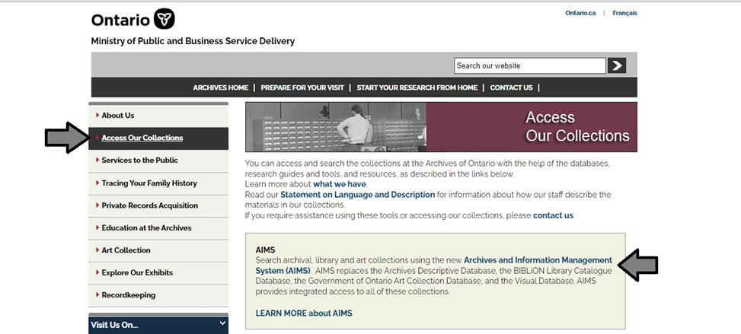

1. In the Archives and Information Management System (AIMS), click on “Archives repository (only)” button:

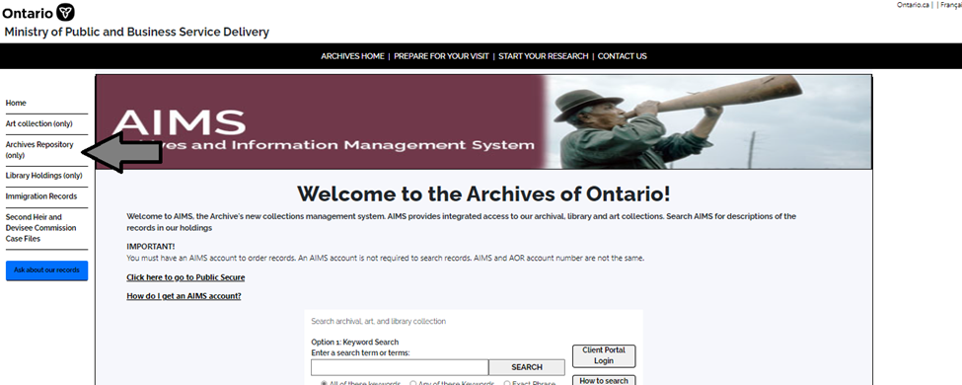

1. On the “Welcome to the Archival Collection” search page, click “Advanced Search”.

.

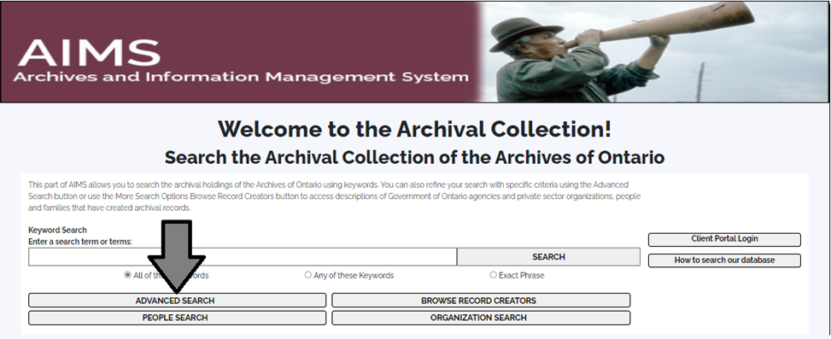

1. On the “Archives Advanced Search” page enter the reference code (that’s the number starting with C, F or RG) in the Reference Code field and click “Search” (at the bottom of the page.

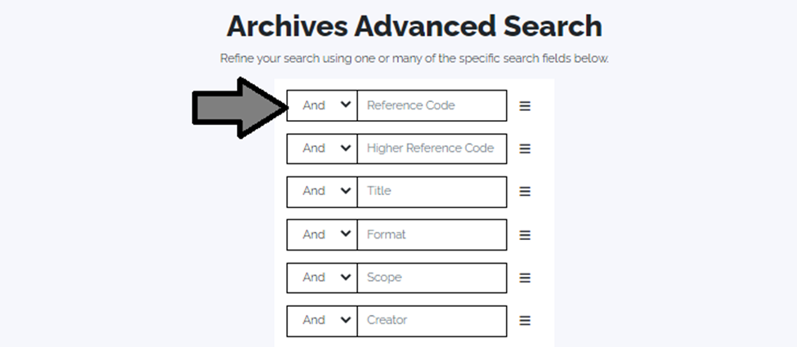

# Contact us

Although unable to do your research for you, our reference archivists are waiting to assist you.  You may call or write to them by mail or email or — best of all — visit the Archives of Ontario.

**Telephone: 416-327-1600 Toll free (Ontario): 1-800-668-9933**

**Email:** [Click here to email the Archives of Ontario](mailto:reference@ontario.ca).  The e-mail address is [reference@ontario.ca](mailto:reference@ontario.ca)

**Address: Archives of Ontario, 134 Ian Macdonald Blvd., Toronto, ON M7A 2C5**

**Website**

Visit our website for information about our collections and our services, our online exhibits and education programs, and links to our social media accounts. [Click here to visit our website](http://www.archives.gov.on.ca).  The website is [www.archives.gov.on.ca](http://www.archives.gov.on.ca).

**Customer Service and Research Guides**

Our guides contain information about our services, freelance researchers available to do research for you, and some of most popular records.  [Click here to view our guides](http://www.archives.gov.on.ca/en/access/research_guides.aspx).  To find the “Research Guides and Tools” on our website, click on “Access our Collections”.

______________________________________________________________________

© King's Printer for Ontario, 2023

This information is provided as a public service.  Last update is shown at the beginning of this guide.  Readers should where possible verify the information before acting on it.