| **Archives of Ontario** |  |
| --- | --- |
| Research Guide 208  Records of Ontario Municipal Board Hearings  Last Updated: March 2023 | |

Photograph is: Man standing on front steps of the Howard Township Municipal Hall at 57 Main Street East, F 4700-0-0-0-121, J.C. Smith Fonds


Man standing on front steps of the Howard Township Municipal Hall at 57 Main Street East

F 4700-0-0-0-121

J.C. Smith Fonds

In this guide 2

What was the Ontario Municipal Board? 2

Where do I find these records? 2

What do I need to get started? 3

The Records 3

1. Indexes to Procedure Books, 1906-1952 (RG 37-3) 3

2. Procedure Books, 1906-1988 (RG 37-2) 3

3. Application and Appeal Files, 1925-1993 (RG 37-6) 4

4. Order Books, 1906-1993 (RG 37-4) 4

5. Decision Books, 1957-1984, 1987-1988, 1990-1993 (RG 37-5) 4

6. Published Decisions 5

Are there related records? 5

How do I get to the online descriptions? 6

Contact us 7

# In this guide

This guide has information on how to access records created during hearings of the Ontario Municipal Board.

*Please note: this guide contains links to information found in our online Archives Descriptive Database. On our website, this database is found under “Access Our Collections”. If you are using a print copy of this guide, go to page 4 for more information on how to find the online descriptions.

## What was the Ontario Municipal Board?

The Ontario Municipal Board (OMB) was created in 1906. It heard applications and appeals on municipal and planning matters. These included zoning by-laws, subdivision plans, property assessments and taxation issues and municipal annexations or amalgamations. Until 1932, it was called the Ontario Railway and Municipal Board. The OMB ceased to exist in 2018, when the Local Planning Appeal Tribunal replaced it. That Local Planning Appeal Tribunal was replaced by the Ontario Land Tribunal in 2021.

# Where do I find these records?

We have the records of OMB hearings from 1906 to 1993. For records after 1993, please contact the Ontario Land Tribunal. Contact information is:

Ontario Land Tribunal

655 Bay Street, Toronto, Ontario M5G 1E5

(416) 212-6349 or toll free (866) 448-2248

E-mail: [OLT.General.Inquiry@ontario.ca](mailto:OLT.General.Inquiry@ontario.ca)

Website: <https://olt.gov.on.ca/>

You will need to visit the Archives to view the records we have. Please contact us in advance to request them. You may also hire a freelance researcher to view these records for you. If you have enough information for us to find the records you are looking for, you can also order copies.

# What do I need to get started?

You need to know:

* Municipality involved
* Year of the hearing
* What it was about (for example: zoning by-law or municipal annexation)
* Who was involved

You may first need to look at the **procedure books** or the **indexes to the procedure books**. They provide basic information about each case and the numbers you need to find for records during and after the hearings. See below for information about these records.

# The Records

When the OMB received an application or an appeal, it first made an entry in a procedure book and created an **application or appeal file**. After the hearing, the Board issued an **order**, which contained the final disposition of a case. If the case was important or raised issues that needed to be explained or clarified, the Board could also issue a **decision**.

## Indexes to Procedure Books, 1906-1971 (RG 37-3)

Indexes to Procedure Books contain the case file number.

For information about the indexes and how to find them, [click here to view the description for RG 37-3](https://aims.archives.gov.on.ca/scripts/mwimain.dll/144/DESCRIPTION_WEB/WEB_DESC_DET?SESSIONSEARCH&exp=sisn%201383). Once you found the entry for the case you are looking for, write down the case file number and see below for information on the procedure books.

## Procedure Books, 1906-1988 (RG 37-2)

Procedure Books contain:

* Case file number
* Decision and/or order book and folio number
* Basic information about the case and its disposition

For information about the procedure books for 1906-1988 and how to find them, [click here to view the description for RG 37-2](https://aims.archives.gov.on.ca/scripts/mwimain.dll/144/DESCRIPTION_WEB/WEB_DESC_DET?SESSIONSEARCH&exp=sisn%201387).

Once you have found the entry for the case you are looking for, write down:

* Municipality
* Year
* Case file number
* Decision and/or order book and folio number

See below for information on finding the application or appeal file, the order or the decision.

The Land Planning Appeal Tribunal has the procedure books for 1989-1993. Contact them to get the file number and the decision and/or order book and folio number. Contact information can be found at the beginning of this guide in **Where do I find these records?** Then, see below for information on finding the application or appeal file, the order or the decision.

## Application and Appeal Files, 1925-1993 (RG 37-6)

Application and appeal files contain:

* Application and supporting documents
* Responses and objections from interested parties
* Material related to the scheduling of hearings

Application and Appeal files usually include copies of any orders and decisions. These include a list of the exhibits submitted but the exhibits themselves may not be in the file.

The Archives has the files for 1925-1949 (except for capital expenditures and municipal finance files) and all files for 1950-1993. For information about these records and how to find them, [click here to view the description for RG 37-6](https://aims.archives.gov.on.ca/scripts/mwimain.dll/144/DESCRIPTION_WEB/WEB_DESC_DET?SESSIONSEARCH&exp=sisn%201386).

The Archives has records pertaining to the approval of telephone service applications to the Ontario Telephone Authority for 1915-1983. [Click here to view the description for RG 14-42 Telephone Act approval order files](https://aims.archives.gov.on.ca/scripts/mwimain.dll/144/DESCRIPTION_WEB/WEB_DESC_DET?SESSIONSEARCH&exp=sisn%201249).

*Please note that the OMB destroyed all application and appeal files from 1906-1925, and all files relating to capital expenditures and municipal finance for 1925-1949.

## Order Books, 1906-1993 (RG 37-4)

Orders are the key legal documents on the disposition of a case. The orders are arranged into order books. For information about these records and how to find them, [click here to view the description for RG 37-4](https://aims.archives.gov.on.ca/scripts/mwimain.dll/144/DESCRIPTION_WEB/WEB_DESC_DET?SESSIONSEARCH&exp=sisn%201384).

## Decision Books, 1957-1984, 1987-1988, 1990-1993 (RG 37-5)

The OMB issued a decision if there were significant issues in dispute or when there was disagreement about the evidence submitted to the hearing. The decisions are usually written while some were oral decisions.

Until 1957, decisions are found in the application or appeal file, and sometimes attached to the order. The OMB started filing decisions in decision books in 1957, and in separate oral decisions books in 1984.

*Please note that we do not have the decision books for 1985, 1986, 1989 and after 1993. If the application or appeal file does not contain a copy, contact the Land Planning Appeal Tribunal with the name of the municipality, the year, and the decision book and folio number. You can find the Tribunal’s contact information at the beginning of this guide in **Where do I find these records?**

For information about the decision books at the Archives and how to find them, [click here to view the description for RG 37-5](https://aims.archives.gov.on.ca/scripts/mwimain.dll/144/DESCRIPTION_WEB/WEB_DESC_DET?SESSIONSEARCH&exp=sisn%201385) .

## Published Decisions

The OMB published some of its major decisions. They are available at the Archives and some libraries.

For information about published decisions, [click here to view the description for RG 37-5](https://aims.archives.gov.on.ca/scripts/mwimain.dll/144/DESCRIPTION_WEB/WEB_DESC_DET?SESSIONSEARCH&exp=sisn%201385). For information on how to find the published decisions at the Archives, [click here to search Library Holdings](https://aims.archives.gov.on.ca/scripts/mwimain.dll/273264008?unionqueryform&application=UNION_VIEW&language=144&aux_sessid=AO_SHARE&searchform=%5bAO_ASSETS%5dhtml/library.html&AUX_SESSID=AO_SHARE). To find this database on the Archives’ website, click on “Access Our Collection”.

# Are there related records?

Municipal records may contain bylaws approved by or appealed to the OMB. They may also include information about the hearings. For information about municipal records at the Archives, [click here to view Research Guide 208, Finding Municipal Records](http://www.archives.gov.on.ca/en/access/documents/research_guide_209_municipal_records.pdf). On our website, you will find the “Research Guides and Tools” page under “Access Our Collection”.

# How do I get to the online descriptions?

1. On our website’s main page, click on “Access Our Collections”, and click on “Archives and Information Management System”, as shown in the image below:

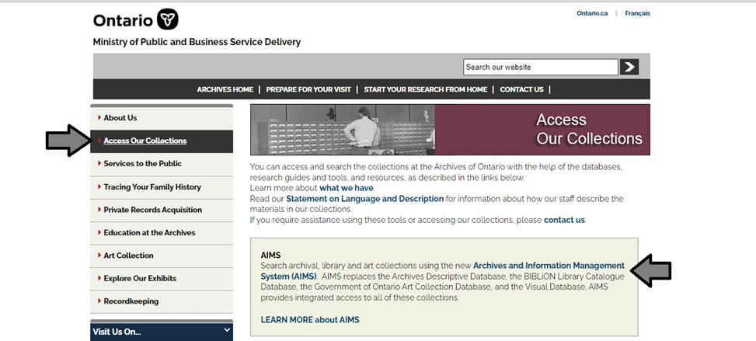

1. In the Archives and Information Management System (AIMS), click on “Archives repository (only)” button:

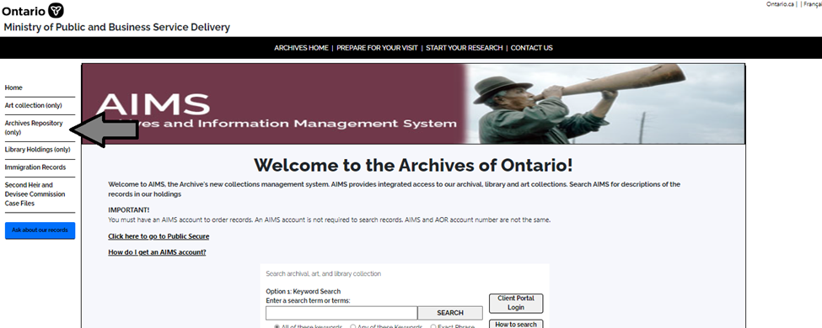

1. On the “Welcome to the Archival Collection” search page, click “Advanced Search”.

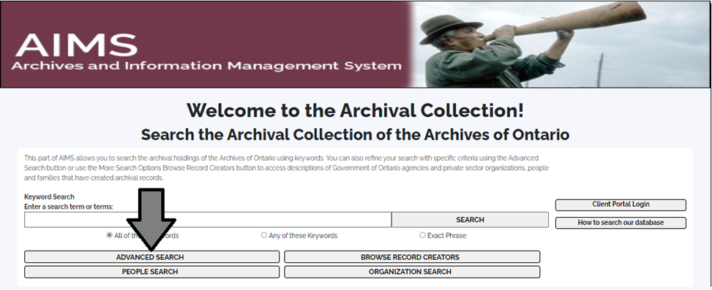

1. On the “Archives Advanced Search” page enter the reference code (that’s the number starting with C, F or RG) in the Reference Code field and click “Search” (at the bottom of the page.

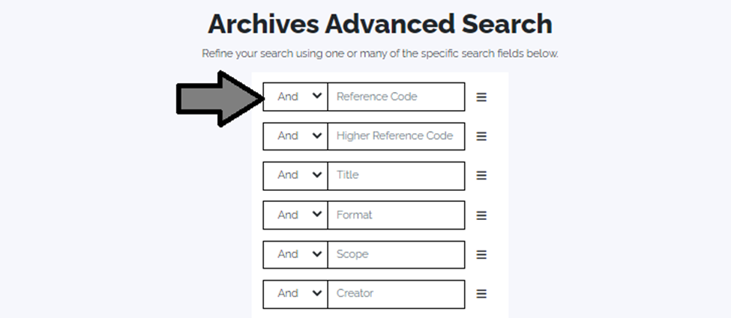

# Contact us

Although unable to do your research for you, our reference archivists are waiting to assist you. You may call or write to them by mail or email or — best of all — visit the Archives of Ontario.

**Telephone: 416-327-1600 Toll free (Ontario): 1-800-668-9933**

**Email:** [Click here to email the Archives of Ontario](mailto:reference@ontario.ca). The e-mail address is [reference@ontario.ca](mailto:reference@ontario.ca)

**Address: Archives of Ontario, 134 Ian Macdonald Blvd., Toronto, ON M7A 2C5**

##### Website

Visit our website for information about our collections and our services, our online exhibits and education programs, and links to our social media accounts. [Click here to visit our website](http://www.archives.gov.on.ca/). The website is [www.archives.gov.on.ca/](http://www.archives.gov.on.ca/).

##### Customer Service and Research Guides

Our guides contain information about our services, freelance researchers available to do research for you, and some of most popular records. [Click here to view our guides](http://www.archives.gov.on.ca/en/access/research_guides.aspx). To find the “Research Guides and Tools” on our website, click on “Access Our Collections”.

______________________________________________________________________

© King's Printer for Ontario, 2023

This information is provided as a public service. Last update is shown at the beginning of this guide. Readers should where possible verify the information before acting on it.