| **Archives of Ontario** | Ontario Logo |
| --- | --- |
| Research Guide 213  War of 1812 Records  Last Updated: March 2023 | |

This image is a painting from the Government of Ontario Art Collection: The Death of Brock at Queenston Heights, [ca. 1908], C. W. Jefferys
Government of Ontario Art Collection, 619871

The Death of Brock at Queenston Heights, [ca. 1908], C. W. Jefferys  
Government of Ontario Art Collection, 619871

In this guide 3

What was the War of 1812? 3

Where do I find these records? 4

The Records 4

1. The Participants 5

2. General Collections 9

3. Remembering the War of 1812 10

4. Government 11

4.1 Treason Trials 11

4.2 Alien Act 12

4.3 Land Grants 13

4.4 Remembering the War 14

5. Illustrating the War of 1812 14

5.1 Government of Ontario Art Collection 15

5.2 Documentary Art Collections 15

5.3 Photographic Records 16

5.4 Architectural Plans and Drawings 16

6. Archives of Ontario Library 17

How do I get to the online descriptions? 18

Contact us 19

# In this guide

This guide has information about original records at the Archives of Ontario that document the War of 1812.  It does not include information about records from other institutions that are available on microfilm at the Archives.

*Please note: this guide contains links to information found in our online Archives Descriptive Database.  On our website, this database is found under “Access our Collections”.  If you are using a print copy of this guide, go to page 15 for more information on how to find the online descriptions.

## What was the War of 1812?

The United States declared war on Great Britain in June 1812. Between 1812 and 1814, Upper Canada (today’s Ontario) was the major theatre of operations. Most of the land battles were fought in Upper Canada or along the American side of the St. Lawrence, Niagara and Detroit Rivers.  The war ended in 1814 with the Treaty of Ghent, with no border changes.

The War of 1812 damaged the limited infrastructure of the province and disrupted the mostly agricultural economy for three years. It also led to the development of a provincial patriotism and nationalism. Many people who played important roles in the government and economy of the province in later years first came to prominence during the war, including John Beverley Robinson and Bishop John Strachan.  To learn more about the war, [click here to view the Archives' War of 1812 resource page](http://www.archives.gov.on.ca/en/1812/index.aspx).  On our website, you will find the resource page under “Access our Collections”.

# Where do I find these records?

We have all the records mentioned in this guide.  You will need to visit the Archives to view most of them.  Please contact us in advance to request them.  Some of the records are on microfilm, and you do not need to order them in advance (with some exceptions). Libraries that offer interloan services may also borrow some of the reels for you. [Click here to view our Microfilm Interloan Catalogue](http://www.archives.gov.on.ca/en/microfilm/index.aspx). On our website, you will find the catalogue under “Access our Collections”.

The Archives’ special collections include photographs, documentary art, architectural drawings and maps, which you can view in-person in the Archives' Reading Room. Both private individuals and the Government of Ontario created and collected these documents. They date from the 16*th* to the 21*st* century. You can access descriptions of these collections and some digital images for these collections in our online [Archives Management and Information System (AIMS)](https://aims.archives.gov.on.ca/scripts/mwimain.dll/570916050?unionqueryform&application=UNION_VIEW&language=144&aux_sessid=AO_SHARE&searchform=%5bAO_ASSETS%5d/html/art.html&AUX_SESSID=AO_SHARE), using the Archives repository (only) section. Records that are digitized will have a Media icon and the image can be accessed through the archival description.

[Click here to access AIMS online](https://aims.archives.gov.on.ca/scripts/mwimain.dll/570916050?unionqueryform&application=UNION_VIEW&language=144&aux_sessid=AO_SHARE&searchform=%5bAO_ASSETS%5d/html/art.html&AUX_SESSID=AO_SHARE), which you can also find on our website under ‘Access our Collections’. To refine your search to a specific type of special collection record, select the Archives Repository (only) catalogue Advanced Search option and use the "Format" field in your search.

[Click here to view the Government of Ontario Art Collection](https://aims.archives.gov.on.ca/scripts/mwimain.dll/570916050?unionqueryform&application=UNION_VIEW&language=144&aux_sessid=AO_SHARE&searchform=%5bAO_ASSETS%5d/html/art.html&AUX_SESSID=AO_SHARE) . On our website, you will find both databases under “Access our Collections”.

Some of the records appear in our online War of 1812 exhibit. They are identified in the guide. [Click here to view the War of 1812 exhibit](http://www.archives.gov.on.ca/en/explore/online/1812/index.aspx). On our website, you will find this and other exhibits under “Explore Our Exhibits”.

You may also hire a freelance researcher to search these records for you.  If you have enough information for us to find the records you are looking for, you may also be able to order copies.

# The Records

Archives of Ontario records related to the War of 1812 include:

* original private correspondence and diaries
* official records relating to the administration of justice in wartime
* documents describing how later generations perceived the war
* published materials from the Archives' library.

You will find information about these records below. The collections are arranged into the following categories:

* The Participants
* General Collections
* Remembering the War of 1812
* Government
* Illustrating the War of 1812
* Archives of Ontario Library.

## 1. The Participants

Most of the War of 1812 material in the Archives of Ontario’s collection is original correspondence, written by the people who lived through the conflict. The records are in the fonds[1] and collections below.

###### Jacques Duperon Baby Family Fonds – F 2128

Jacques (James) Duperon Baby (1763 to 1833) was a public servant, office holder, judge, landowner and a militia officer. The records include accounts of his experiences during the War of 1812 and claims for compensation for damage to his property. Correspondence is on microfilm **MS 498, reel 1**. For a detailed list of these records, [click here to view the description for F 2128](https://aims.archives.gov.on.ca/scripts/mwimain.dll/144/DESCRIPTION_WEB/WEB_DESC_DET?SESSIONSEARCH&exp=sisn%20610).

###### William Baldwin Family Fonds – F 17

William Baldwin (1775 to 1844) was a lawyer and businessman. Most of his correspondence on the War of 1812 is about the war’s effect on the state of business in the province. His correspondence for the years 1812 to 1815 is on microfilm **MS 88, reel 1**. For a detailed list of these records, [click here to view the description for F 17](https://aims.archives.gov.on.ca/scripts/mwimain.dll/144/DESCRIPTION_WEB/WEB_DESC_DET?SESSIONSEARCH&exp=sisn%20143).

###### Battle of Lundy's Lane Letter – F 4140

This single document is a letter dated March 30, 1815 from an American Lieutenant, C. Blake, to his brother, about the Battle of Lundy’s Lane. To view this letter, request F 4140, container 1. **Featured on the Archives’ War of 1812 online exhibit**.

###### Henry John Boulton Fonds – F 20

Henry John Boulton (1790 to 1870) was a member of the Legislative Assembly and served as Solicitor General and Attorney General for Upper Canada. The records include correspondence on life during the war. His correspondence for the years 1812 to 1815 is on microfilm **MS 525, reel 1**. For a detailed list of these records, [click here to view the description for F 20](https://aims.archives.gov.on.ca/scripts/mwimain.dll/144/DESCRIPTION_WEB/WEB_DESC_DET?SESSIONSEARCH&exp=sisn%20146).

###### William Marr Button Family Fonds – F 902

The William Marr Button family lived in Markham Township, York County during the 19th century and was involved in politics, the military and land development. The records include York Militia orders dating from 1812 to 1815. To view these records, request F 902, container B293877. [Click here to view the description for F 902](https://aims.archives.gov.on.ca/scripts/mwimain.dll/144/DESCRIPTION_WEB/WEB_DESC_DET?SESSIONSEARCH&exp=sisn%20232).

###### Duncan Clark Fonds – F 429

Duncan Clark (1785 to 1862) was a militia officer and fur trader who served during the War of 1812. These records describe the battle of Lundy's Lane and the siege of Fort Erie. They are on microfilm reel **MS 10727**. For a detailed list of these records, [click here to view the description for F 429](https://aims.archives.gov.on.ca/scripts/mwimain.dll/144/DESCRIPTION_WEB/WEB_DESC_DET?SESSIONSEARCH&exp=sisn%20498).

###### George Crookshank Fonds – F 549

George Crookshank (1773 to 1859) was a businessman, office holder and politician in York (Toronto) during the early 19th century. He served as the Assistant Commissary General during the war. These records include several letters on the supply issue in the Northwest. There is also correspondence on rumours of peace (1813) and speculation on the actual peace talks at Ghent in the fall of 1814. These records are on microfilm reel MS 6. [Click here to view a description for F 549.](https://aims.archives.gov.on.ca/scripts/mwimain.dll/144/DESCRIPTION_WEB/WEB_DESC_DET?SESSIONSEARCH&exp=sisn%20385)

###### Crysler Family Fonds – F 4421

The Crysler family was one of the first Loyalist families in the Niagara peninsula. The family is related to the owners of Crysler’s Farm, the location of one of the major battles of the war. The records of Captain John Crysler (1765 to 1838) includes an account of the war, regimental orders and field returns for the 2nd Lincoln. To view these records, request F 4421-3, container B407684. For a detailed list of these records, [click here to view the description for F 4421](https://aims.archives.gov.on.ca/scripts/mwimain.dll/144/DESCRIPTION_WEB/WEB_DESC_DET?SESSIONSEARCH&exp=sisn%2011784).

###### Gordon Drummond Fonds – F 955

General Sir Gordon Drummond (1772 to 1854) served as the senior British military commander in Upper Canada during the last year of the War of 1812. In the absence of the Lieutenant Governor, he was also the acting President of the Executive Council (or head of the government).

These records are copies of outgoing correspondence sent by Drummond’s civil secretary, R.R. Loring, mostly about civil government but also militia orders and related issues. To view these records, request F 955, container D356937. **Featured in the War of 1812 online exhibit**. [Click here to view a description for F 955.](https://aims.archives.gov.on.ca/scripts/mwimain.dll/144/DESCRIPTION_WEB/WEB_DESC_DET?SESSIONSEARCH&exp=sisn%201178)

###### Ford Family Fonds – F 483

Nathan Ford (1795 to 1891) was an American citizen who lived in Ogdensburg, New York during the War of 1812. His family correspondence comments on the insecurity of civilian life in wartime and on the activities of his neighbours in providing supplies to the British Army in Upper Canada.

These records are on microfilm reel **MS 7695**. For a detailed list of these records, [click here to view the description for F 483](https://aims.archives.gov.on.ca/scripts/mwimain.dll/144/DESCRIPTION_WEB/WEB_DESC_DET?SESSIONSEARCH&exp=sisn%20774). **Featured in the War of 1812 online exhibit**.

###### John Galt Fonds – F 1107

John Galt (1779 to 1839) was a novelist and a founder of the Canada Company. The records include correspondence about Galt’s claims for compensation for damage to his property during the War of 1812. For information about these records and how to view them, [click here to view the description for F 1107](https://aims.archives.gov.on.ca/scripts/mwimain.dll/144/DESCRIPTION_WEB/WEB_DESC_DET?SESSIONSEARCH&exp=sisn%20671).

###### Gilkison Family Fonds – F 515

William Gilkison (1777 to 1833) served as an assistant quartermaster-general with the rank of Captain in the War of 1812. These records include militia documents relating to his service during the war. They are on microfilm **MS 947, reel 1**. Contact us to get a PDF finding aid with a detailed list of these records. [Click here to view the description for F 515.](https://aims.archives.gov.on.ca/scripts/mwimain.dll/144/DESCRIPTION_WEB/WEB_DESC_DET?SESSIONSEARCH&exp=sisn%20785)

###### David Kinnear Fonds – F 917

Lieutenant David Kinnear was a British Army officer who served in Spain, France and Bermuda during the Napoleonic Wars and in North America during the War of 1812. His diary makes references to the Napoleonic Wars and the War of 1812, including the burning of Washington. To view these records, request F 917, container B415166. **Featured in the War of 1812 online exhibit**.

###### John Macdonell Fonds – F 548

John Macdonell (1768 to 1850) was a fur trader and militia officer. These records include a few militia orders and some correspondence relating to the American attack on York (Toronto) in 1813. These records are on microfilm reel **MS 851.** Contact us to get a PDF finding aid with a detailed list of these records.

###### Mackenzie-Lindsay Family Fonds – F 37

William Lyon Mackenzie (1795 to 1861) was a newspaperman and politician in Upper Canada and leader of the Rebellion of 1837. A few letters in his records tell about the destruction of the original Brock’s Monument in 1840, during the final stages of the rebellion. His correspondence from 1839 to 1841 is on microfilm **MS 516, reel 6**. For a detailed list of this correspondence, [click here to view the description for F 37](https://aims.archives.gov.on.ca/scripts/mwimain.dll/144/DESCRIPTION_WEB/WEB_DESC_DET?SESSIONSEARCH&exp=sisn%20162). **Featured in the War of 1812 online exhibit**.

###### William Hamilton Merritt Family Fonds – F 662

William Hamilton Merritt (1793 to 1862) served as a Captain in the Company of Provincial Dragoons (cavalry) during the War of 1812. His correspondence includes the letters he exchanged with his future wife, Catherine Prendergast, while he was a prisoner of war in the United States after the Battle of Lundy’s Lane.

The records also include material relating to the construction and rededication of the new Brock’s Monument at Queenston Heightsin the 1840s and 1850s. As a leading businessman of the province and a veteran, Merritt played a major role in the project.

Wartime correspondence is in packages 42 and 43, on microfilm **MS 74, reel 5.** Records relating to Brock’s Monument are in package 8, on microfilm **MS 74, reel 2**. Contact us to get a PDF finding aid with a detailed list of these records. **Featured in the War of 1812 online exhibit**.

###### Abraham Nelles Family Fonds – F 543

Abraham Nelles (1775 to 1839) was a surveyor, militia officer and member of the Legislative Assembly. His correspondence is about issues such as obtaining supplies for the British and Canadian troops, damage to his property and the administration of the local militia. There are also records of his work as a Commissioner under the Alien Act after the war. Correspondence is on microfilm **MS 502, reel 1.** For a detailed list of these records, [click here to view the description for F 543](https://aims.archives.gov.on.ca/scripts/mwimain.dll/144/DESCRIPTION_WEB/WEB_DESC_DET?SESSIONSEARCH&exp=sisn%20751). **Featured in the War of 1812 online exhibit**.

###### Robert Nelles Family Fonds – F 542

Robert Nelles (1761 to 1842) was a local official and landowner in the Niagara area. Most of the war-related records are about his son Captain Henry Nelles, who was a prisoner of war in the United States after the Battle of Lundy’s Lane. Correspondence is on microfilm **MS 503, reel 1**. Contact us to get a PDF finding aid with a detailed list of these records. **Featured in the War of 1812 online exhibit**.

###### John Norton Fonds – F 440

John Norton (1790 to 1821) was a leader of the Mohawks of the Grand River during the War of 1812. Norton achieved the rank of Major in the conflict. Most of the documents relating to the war are testimonials to his service. Correspondence is on microfilm **MS 94, reel 1**. For a detailed list of these records, [click here to view the description for F 440](https://aims.archives.gov.on.ca/scripts/mwimain.dll/144/DESCRIPTION_WEB/WEB_DESC_DET?SESSIONSEARCH&exp=sisn%20501).

###### Ely Playter Fonds – F 556

Ely Playter (fl. 1801 to 1853) was a farmer and militia officer near York (Toronto) during the War of 1812. His diary details much of the day-to-day life during the war, and provides information on the impact of the 1813 American raid on York on the town’s population. Eli Playter’s diary is on microfilm **MS 87, reel 1**. You can read it on Twitter, at <https://twitter.com/ElyPlayter1812>. **Featured in the War of 1812 online exhibit**.

###### Thomas Ridout Family Fonds – F 43

###### Thomas G. Ridout (1754 to 1829) served as a militia officer throughout the War of 1812, primarily in the commissariat (or supply) department. His correspondence includes first-hand descriptions of the battles at Queenston Heights and at Crysler’s Farm. His correspondence for the years 1812 to 1815 is on microfilm MS 537, reel 1. For a detailed list of this correspondence, [click here to view the description for F 43-1](https://aims.archives.gov.on.ca/scripts/mwimain.dll/144/DESCRIPTION_WEB/WEB_DESC_DET?SESSIONSEARCH&exp=sisn%2017660). Featured in the War of 1812 online exhibit.

###### John Beverley Robinson Family Fonds – F 44

John Beverley Robinson (1791 to 1863) served as a militia officer during the War of 1812 and as the Acting Attorney General through most of the conflict. He served as the lead in the prosecution of those accused of treason in 1814 for aiding the American invaders. His correspondence document the general administration of justice and the investigation of treason.

Robinson’s Correspondence for the years 1812 to 1815 is on microfilm **MS 4, reel 1**. Contact us to get a PDF finding aid with a detailed list of these records. **Featured in the War of 1812 online exhibit**.

###### Joel Stone Family Fonds – F 536

Joel Stone (1749 to 1833) was a businessman and militia officer in Gananoque, Upper Canada. After the war, he worked as a Commissioner under the Alien Act. The correspondence and reports in these records are about supply and defense along the St. Lawrence River. Correspondence is on microfilm **MS 519, reel 1.** For a detailed list of these records, [click here to view the description for F 536](https://aims.archives.gov.on.ca/scripts/mwimain.dll/144/DESCRIPTION_WEB/WEB_DESC_DET?SESSIONSEARCH&exp=sisn%20767). **Featured in the War of 1812 online exhibit**.

###### John Strachan Fonds – F 983

John Strachan (1778 to 1867) was the first Anglican Bishop of Toronto, took a leading part in promoting the defense of the province during the War of 1812. These records document his efforts to raise morale and promote the defense of the province during the war, and his work for militiamen and their families through the Loyal and Patriotic Society of Upper Canada.

###### Strachan’s correspondence is on microfilm MS 35, reel 1. His letterbook is on microfilm MS 35, reel 10. For detailed lists of these records, [click here to view the description for F 983](https://aims.archives.gov.on.ca/scripts/mwimain.dll/144/DESCRIPTION_WEB/WEB_DESC_DET?SESSIONSEARCH&exp=sisn%20522).

###### Samuel Street Fonds – F 547

Samuel Street (1775 to 1844) was a lawyer and moneylender in the Niagara area. The records include material documenting the damage to Street’s property during the American occupation of the Niagara region in 1813 and 1814. Correspondence is on microfilm **MS 500, reel** 1. For a detailed list of these records, [click here to view the description for F 547](https://aims.archives.gov.on.ca/scripts/mwimain.dll/144/DESCRIPTION_WEB/WEB_DESC_DET?SESSIONSEARCH&exp=sisn%20755).

###### Urquhart Family Fonds – F 504

The Urquhart owned a farm in Glengarry County, Upper Canada in the early 19th century. Their records include documents about militia service during the War of 1812. To view these records, request F 504, container B273217.

## 2. General Collections

We hold many general collections that contain records collected by organizations or individuals interested in a specific geographic area or subject. We have also created several miscellaneous collections to organize single items with related subjects. Some of these collections include records relating to the War of 1812.

###### Hiram Walker Museum Collection – F 378

The Hiram Walker Museum Collection contains records about the history of South western Ontario**,** from the Hiram Walker Museum in Windsor. To view documents related to the War of 1812, request **F 378, microfiche 20-231**. Contact us to get a PDF finding aid with a detailed list of all records in the collection. **Featured on the Archives’ War of 1812 online exhibit**.

###### Military History Collection – F 895

###### This collection includes a journal of a staff officer involved in most of the major military actions in the Niagara area in 1813 to 1814. Another item is a prize list for militiamen who participated in the capture of Fort Detroit in 1812.

To view these records, first contact us to get a PDF finding aid with a detailed list of the records. [Click here to view the description for F 895.](https://aims.archives.gov.on.ca/scripts/mwimain.dll/144/DESCRIPTION_WEB/WEB_DESC_DET?SESSIONSEARCH&exp=sisn%20485)

**Featured on the Archives’ War of 1812 online exhibit**.

**Miscellaneous Collection – F 775**

This collection includes documents about the surrender of Fort Detroit to General Brock in 1812 and some militia documents. To view these records, request F 775, boxes MU 2102 and MU 2143. Contact us to get a PDF finding aid with a detailed list of these records. **Featured on the Archives’ War of 1812 online exhibit**.

###### Lee Pritzker Collection – F 992

This is a scrapbook with many newspaper clippings relevant to the War of 1812 and the Napoleonic wars. To view these records, request F 992, container MU 2635.

## 3. Remembering the War of 1812

Some records document the work of historians and organizations with an interest in the War of 1812.

###### Brock Monument Committee Fonds – F 1151

###### The Brock Monument Committee was established in 1840 to organize the reconstruction of Brock’s Monument. The original monument had been destroyed in the aftermath of the 1837 Rebellion. The new tower was completed in the 1850's. The records include financial records, correspondence, minutes and resolutions and material on design ideas for the new tower. For information about these records and how to view them, [click here to view the description for F 1151](https://aims.archives.gov.on.ca/scripts/mwimain.dll/144/DESCRIPTION_WEB/WEB_DESC_DET?SESSIONSEARCH&exp=sisn%20371). Featured on the Archives’ War of 1812 online exhibit.

**William Kirby Fonds – F 1076**

William Kirby (1817 to 1906) was a novelist, historian and preservationist. The fonds includes correspondence between Kirby and historical organizations, participants in the war, and historians about the war and efforts to preserve sites associated with it.

Correspondence is on microfilm **MS 542, reels 1, 3 and 4**. Contact us to get a PDF finding aid with a detailed list of these records.

###### Lundy’s Lane Historical Society Fonds – F 1137

The Lundy’s Lane Historical Society was created in to commemorate the War of 1812 and the Niagara area through historical publications and markers. These records include posters, pamphlets and other materials concerned with events and programs that the Society organized. To view them, request F 1137, container B272854. **Featured on the Archives’ War of 1812 online exhibit**.

###### C.H.J. Snider Fonds – F 1194

C.H.J. Snider (1879 to 1971) was a journalist and historian who wrote articles for the Toronto Telegram on Great Lakes marine topics and the general history of Ontario. His columns, “Schooner Days” and “Faded Flag of Fadeless Fame”, include many accounts of incidents from the War of 1812.

For information on how to access these columns, [click here for the description for F 1194-3](https://aims.archives.gov.on.ca/scripts/mwimain.dll/144/DESCRIPTION_WEB/WEB_DESC_DET?SESSIONSEARCH&exp=sisn%2022953). A searchable index to Snider’s “Schooner Days” is available through the website of the Marine Museum of the Great Lakes, <http://www.marmuseum.ca/>.

**Ferdinand Brock Tupper Fonds – F 1081**

Ferdinand Brock Tupper (born in 1795), Sir Isaac Brock’s nephew, wrote biographies of General Brock. These records include correspondence with participants in the war and original materials he collected. Correspondence is on microfilm **MS 496, reel 1**. For a detailed list of these records, [click here to view the description for F 1081](https://aims.archives.gov.on.ca/scripts/mwimain.dll/144/DESCRIPTION_WEB/WEB_DESC_DET?SESSIONSEARCH&exp=sisn%20867). **Featured on the Archives' War of 1812 online exhibit**.

## 4. Government

Overall responsibility for managing the war effort fell on the imperial government in London, and senior officials and officers in the Canadas. The role of the civil authorities in Upper Canada was to support the commissariat (supply) department and maintain the militia. Investigating and punishing disloyalty was another important government role during and after the war.

After the war, the province rewarded those who had supported the war effort, in particular militia veterans, by granting land. Later, particularly in the 1930s, the government of Ontario supported the commemoration of the war by creating battlefield parks, markers and memorials (for example, Fort Erie).

### 4.1 Treason Trials

The American army occupied Niagara in the spring and summer of 1813 and the Western District in the fall of the same year. Some individuals provided direct support to the invaders. Fifteen men were tried for treason after the withdrawal of American troops. The main trials were held in Ancaster, in May and June 1814. Eight men were executed. The records below document the trials.

###### Assize Minute Books – RG 22-134

These minute books document Court of Queen's Bench civil and criminal assizes. Volume 4 contains the minutes of the Ancaster Treason Trials. It is on [microfilm MS 530, reel 1.](https://aims.archives.gov.on.ca/MEDIA/RG%2022-0134.pdf)

###### Court of King's Bench Records of High Treason Trial of 1814 – RG 22-143

These records are about individuals who were accused of treason but never captured and the confiscation of lands of individuals charged under the Alien Act. These records are on microfilm reel **MS 7237**.

###### High Treason Register – F 907

This register documents people connected with high treason in the War of 1812. A special clerk at the Department of Public Records and Archives (now the Archives of Ontario) compiled this information in 1926. For a detailed list of these records and information on how to view them, [click here to view the description for F 907](https://aims.archives.gov.on.ca/scripts/mwimain.dll/144/DESCRIPTION_WEB/WEB_DESC_DET?SESSIONSEARCH&exp=sisn%2023691).

###### Pre-Confederation Records of the Attorney General – RG 4-1

These records include correspondence on the conduct of the Treason Trials at Ancaster in 1814. They are on microfilm reel **MS 8752**. **Featured on the Archives' War of 1812 online exhibit**. [Click here to view the description for RG 4-1.](https://aims.archives.gov.on.ca/scripts/mwimain.dll/144/DESCRIPTION_WEB/WEB_DESC_DET?SESSIONSEARCH&exp=sisn%205391)

### 4.2 Alien Act

The Legislative Assembly passed the Alien Act in March of 1814. Persons found guilty of leaving the province for the United States during the war were declared aliens. Their land was seized and they could no longer own land in the province. The records below document this process.

###### Alien Act Commissions, Inquisitions and Related Records – RG 22-144

These records contain commissions with attached inquisitions (investigations), some correspondence of the Clerk of the Alien Act Commission, J.B. Macaulay, and the proceedings of the Home District Alien Act Commission at York (Toronto) in May and November of 1822. These records are on microfilm reel **MS 8751.**

###### Home District Marriage Register, 1816 to 1830 – RG 80-27-1, volume 6

###### This register contains abstracts of Alien Act inquisitions regarding 22 people who owned land in Home District. The inquisitions occurred in 1819, 1822 and 1826. This register also contains an oath of allegiance made and signed by Colonel Richard Beasley and men of the 2nd Regiment of York Militia, dated 1812. The entries are at the end of the register. The register is on microfilm MS 248, reel 1.

###### Johnstown District Alien Act Inquisition Extract Register – RG 22-678

The Clerk of the Peace in Johnstown District kept a register of inquisitions made under the Alien Act. It is on microfilm reel **MS 8751**.

###### Newcastle District Clerk of the Peace High Treason in War of 1812 Poster – RG 22-3782

This broadsite (an advertisement or public notice printed on one side of a large sheet of paper) is titled "Names of Persons who have been attained of High Treason committed in Upper Canada, or who have been returned as having absconded from the Province during the late War with the United States of America". To view this document, request RG 22-3782. **Featured on the Archives' War of 1812 online exhibit**.

###### Newcastle District Clerk of the Peace Inquisition to Declare Certain Persons Alien – RG 22-3768

These records are two abstracts of inquisitions held in Newcastle District under the authority of the Alien Act. These records are on microfilm reel **MS 8751**.

### 4.3 Land Grants

After the war, the Legislative Assembly of Upper Canada made provisions for the granting of land to veterans of the militia. At least part of the land distributed to the veterans had been seized under the Alien Act.

The records listed below are about the granting of Crown Land to veterans of the War of 1812. For more information about Crown Land records, [click here to view Research Guide 225, Researching Crown Land Records](http://www.archives.gov.on.ca/en/access/documents/research_guide_225_resources_for_researching_land_records.pdf). On the Archives’ website, the “Research Guides and Tools” page is located under “Access our Collections”.

###### Crown Land Administration Subject Files – RG 1-9

These records include general correspondence related to the administration of the Crown Lands system, which was received in the office of the Commissioner of Crown Lands. It includes a file of correspondence about requests for land grants for militia service during the War of 1812. The file is on microfilm **MS 892, reel 6**.

###### Petitions Relating to Land Received by the Crown Lands Department – RG 1-54

Petitions from veterans of the War of 1812 may give details on military service. The petitions are arranged alphabetically. For information on these records and how to view them, [click here to view the description for RG 1-54](https://aims.archives.gov.on.ca/scripts/mwimain.dll/144/DESCRIPTION_WEB/WEB_DESC_DET?SESSIONSEARCH&exp=sisn%206178).

###### Registers of Militia Grants – RG 1-152

These registers contain the names of people who received land grant certificates from the provincial government. The grants were in recognition of their service in the militia, provincial dragoons or provincial marine during the War of 1812. The registers record the individual’s name, rank, unit and the acreage to which he was entitled. These registers are on microfilm **MS 693, reel 40**. **Featured on the Archives' War of 1812 online exhibit**.

### 4.4 Remembering the War

The provincial government has been involved in the preservation of historic sites since the late 19th century. The records described below provide information on Ontario’s efforts to remember the War of 1812 through parks, memorials and historic sites.

###### Administrative Records of the St. Lawrence Parks Commission – RG 5-54

The Commission was responsible for the planning, construction, management and operation of Ontario’s parks and historic sites. These records include information on the Cryslers Farm Battlefield Park at Upper Canada Village. For a detailed list of these records and information on how to view them, [click here to view the description for RG 5-54](https://aims.archives.gov.on.ca/scripts/mwimain.dll/144/DESCRIPTION_WEB/WEB_DESC_DET?SESSIONSEARCH&exp=sisn%201862).

###### Correspondence of the Minister of Tourism and Information – RG 5-4

###### These records document provincial involvement in the promotion of historical tourism and the development of sites, including those related to the War of 1812. For a detailed list of these records and information on how to view them. [click here to view the description for RG 5-4](https://aims.archives.gov.on.ca/scripts/mwimain.dll/144/DESCRIPTION_WEB/WEB_DESC_DET?SESSIONSEARCH&exp=sisn%201814).

###### Niagara Parks Commission Historical Records – RG 38-17

###### These records include reports and original documents on early preservation efforts for War of 1812 sites located along or near the Niagara River. For a detailed list of these records and information on how to view them, [click here to view the description for RG 38-17](https://aims.archives.gov.on.ca/scripts/mwimain.dll/144/DESCRIPTION_WEB/WEB_DESC_DET?SESSIONSEARCH&exp=sisn%201969).

###### Subject Correspondence of the Niagara Parks Commission General Manager – RG 38-3

These records include correspondence on the development of War of 1812 historic sites and reconstructions along the Niagara River. For a detailed list of these records and information on how to view them, [click here to view the description for RG 38-3](https://aims.archives.gov.on.ca/scripts/mwimain.dll/144/DESCRIPTION_WEB/WEB_DESC_DET?SESSIONSEARCH&exp=sisn%201403). Search by a name or location for best results, for example Fort Erie.

###### Tourism Promotion Photographs – RG 65-35

###### The Department of Travel and Publicity established a photo library in the late 1940s and early 1950s. These photographs were created and used to market, advertise and promote tourism in Ontario. They include many photographs of historic War of 1812 sites. For information on these records and how to view them, [click here to view the description for RG 65-35](https://aims.archives.gov.on.ca/scripts/mwimain.dll/144/DESCRIPTION_WEB/WEB_DESC_DET?SESSIONSEARCH&exp=sisn%203156).

## 5. Illustrating the War of 1812

### 5.1 Government of Ontario Art Collection

In the 19th century, George Theodore Berthon (1806 to 1892) was commissioned to paint official portraits of long-dead lieutenant governors and administrators who had been directly involved in the war. Berthon’s subjects included senior military officers Sir Isaac Brock, Sir Gordon Drummond and Sir George Prevost. Other artists were commissioned to create portraits and busts of such figures as Tecumseh and Laura Secord.

The Art Collection also includes paintings and drawings by Charles William Jefferys (1869 to 1951). They illustrate battles and incidents like Laura Secord’s journey to warn the British.

You can search a selection of images from the collection using the Government of Ontario Art Collection Database, on the Archives Website. [Click here to view the Government of Ontario Art Collection](https://aims.archives.gov.on.ca/scripts/mwimain.dll/322051039?unionqueryform&application=UNION_VIEW&language=144&aux_sessid=AO_SHARE&searchform=%5bAO_ASSETS%5d/html/art.html&AUX_SESSID=AO_SHARE)  . On our website, you will find this database under “Access our Collections”. For an overview and catalogue of the artworks in the collection, please refer to Fern Bayer’s The Ontario Collection, Toronto: Fitzhenry and Whiteside, 1984. This book is available in our library, call number 708.113 B39.

**Featured on the Archives' War of 1812 online exhibit**.

### 5.2 Documentary Art Collections

###### Attack on Fort Oswego, on Lake Ontario, North America – F 4516 and F 4517

These two engravings illustrate the battle for Fort Oswego on May 6, 1814, drawn by Captain Steel and engraved by R. Havell and Son. They were produced shortly after the war, in 1817. To view these records, request container B411759.

###### Thomas Burrowes Fonds – C 1

Captain Thomas Burrowes (born ca. 1796) served as an engineering officer during the building of the Rideau Canal and during its operation between 1826 and 1846. During this period, he painted many watercolours of the Rideau Canal and the St. Lawrence River, including locations that played a part in the War of 1812. All of Burrowes’ watercolours in the Archives’ collection are in our Visual Database. **Featured on the Archives' War of 1812 online exhibit**.

###### Thomas Glegg Fonds – F 596

Captain Thomas Glegg (born ca. 1825) was an engineer in the British army. He was in Canada West (Upper Canada) in 1841 and 1842 to assist in the construction of the New Fort in Toronto. He sketched a number of scenes of the province, including Brock’s monument following the explosion that ruined the original structure. These sketches are our Database. **Featured on the Archives' War of 1812 online exhibit**.

###### Simcoe Family Fonds – F 47

Elizabeth Posthuma Simcoe (1766 to 1850), the wife of Upper Canada’s first Lieutenant Governor, was a prolific and talented. Her watercolours and sketches of the province in the 1790s are the earliest graphic images of many of the locations that became famous during the War of 1812, including Queenston Heights, Kingston and York (Toronto). All of her work in the Archives’ collection is in our Visual Database. **Featured on the Archives' War of 1812 online exhibit**.

### 5.3 Photographic Records

###### Eric Arthur Fonds – C 57

Eric Arthur (1896 to 1982) was an architect and photographer. He took photographs of many of the surviving buildings from the War of 1812 era. Some of his photographs are in our Visual Database. Contact us to get a PDF finding aid with a detailed list of these records. **Featured on the Archives' War of 1812 online exhibit**.

###### John Boyd Fonds – C 7

John Boyd (1865 to 1941) was a railway employee and amateur historian. He took many photographs around Ontario in the first decades of the 20th century, including at sites related to the War of 1812 and the defence of Upper Canada. Some of Boyd’s photographs are in our Visual Database. For information about these records and how to view them, [click here to view the description for F 7](https://aims.archives.gov.on.ca/scripts/mwimain.dll/144/DESCRIPTION_WEB/WEB_DESC_DET?SESSIONSEARCH&exp=sisn%20135). **Featured on the Archives' War of 1812 online exhibit**.

###### M.O. Hammond Fonds – F 1075

M.O. Hammond (1876 to 1934) was a journalist and amateur historian. He photographed many of the battlefields and monuments of the War of 1812. Hammond also made photographic portraits of artists C.W. Jefferys and G.T. Berthon. Hammond kept diaries that give insights into his historical interests and travels.

Hammond’s photographs are in our Visual Database. For a detailed list of the diaries, [click here to view the description for F 1075-5](https://aims.archives.gov.on.ca/scripts/mwimain.dll/144/DESCRIPTION_WEB/WEB_DESC_DET?SESSIONSEARCH&exp=sisn%2011770). **Featured on the Archives' War of 1812 online exhibit**.

### 5.4 Architectural Plans and Drawings

Few original drawings or plans dating from the War of 1812 are available to researchers. The records described below include some material related to the war and to the efforts to reconstruct some of the historic sites associated with the war.

###### Mrs. Edward Kemp Collection – F 360

###### This collection of miscellaneous records includes drawings of a bateau and of what is believed to be one of the vessels built at the Kingston Naval Yard in 1814. To view these records, request F 360, container B289508. Contact us to get a PDF finding aid with a detailed list of these records. Featured on the Archives' War of 1812 online exhibit.

###### McMurrich and Oxley Fonds – C 23

These records include drawings and plans by the McMurrich and Oxley architectural firm for the reconstruction of Fort George and Fort Erie in the Niagara area. To view these records, request C 23, Project 409, Fort George and Fort Erie restorations. **Featured on the Archives' War of 1812 online exhibit**.

## 6. Archives of Ontario Library

Our library holds many publications relating to the War of 1812. These include works by historians, pamphlets, compilations of documents concerning the war and biographies of participants. Topics include the war as a whole and in various regions, and specific campaigns, battles and individuals. The library also has information on many historic plaques in Ontario.

Some of the publications in the Archives' library collection are listed in the online War of 1812 exhibit. To search the library collections, [click here to view the Archives of Ontario library holdings](https://aims.archives.gov.on.ca/scripts/mwimain.dll/122027065?unionqueryform&application=UNION_VIEW&language=144&aux_sessid=AO_SHARE&searchform=%5bAO_ASSETS%5dhtml/library.html&AUX_SESSID=AO_SHARE). On our website, you will find this database under “Access our Collections”.

# 

# How do I get to the online descriptions?

1. On our website’s main page, click on “Access Our Collections”, and click on “Archives and Information Management System”, as shown in the image below

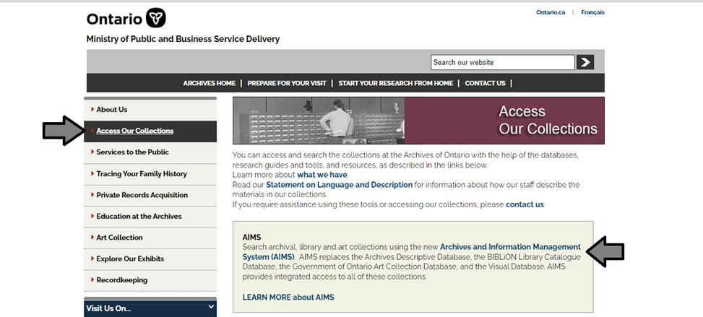

1. In the Archives and Information Management System (AIMS), click on “Archives repository (only)” button:

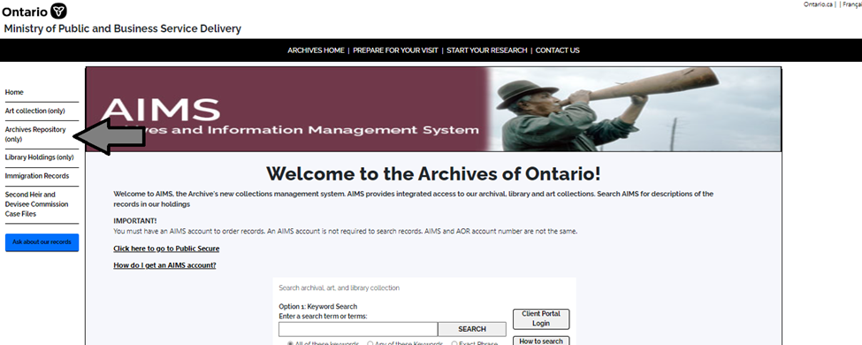

1. On the “Welcome to the Archival Collection” search page, click “Advanced Search”.

.

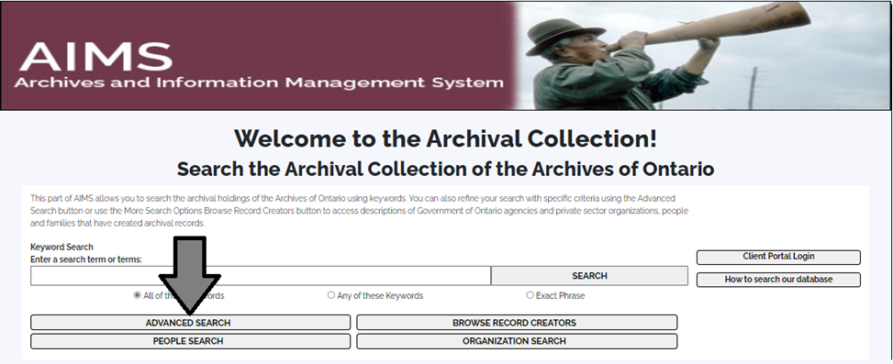

1. On the “Archives Advanced Search” page enter the reference code (that’s the number starting with C, F or RG) in the Reference Code field and click “Search” (at the bottom of the page.

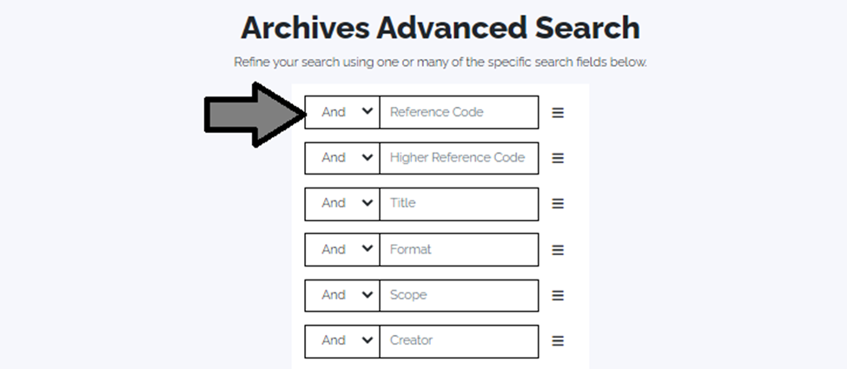

# Contact us

Although unable to do your research for you, our reference archivists are waiting to assist you.  You may call or write to them by mail or email or — best of all — visit the Archives of Ontario.

**Telephone:416-327-1600 Toll free (Ontario): 1-800-668-9933**

**Email:** [Click here to email the Archives of Ontario](mailto:reference@ontario.ca).  The e-mail address is [reference@ontario.ca](mailto:reference@ontario.ca)

**Address: Archives of Ontario, 134 Ian Macdonald Blvd., Toronto, ON M7A 2C5**

**Website**

Visit our website for information about our collections and our services, our online exhibits and education programs, and links to our social media accounts. [Click here to visit our website](http://www.archives.gov.on.ca/).  The website is [www.archives.gov.on.ca/](http://www.archives.gov.on.ca/).

**Customer Service and Research Guides**

Our guides contain information about our services, freelance researchers available to do research for you, and some of most popular records.  [Click here to view our guides](http://www.archives.gov.on.ca/en/access/research_guides.aspx).  To find the “Research Guides and Tools” on our website, click on “Access our Collections”.

______________________________________________________________________

© King's Printer for Ontario, 2023

This information is provided as a public service.  Last update is shown at the beginning of this guide.  Readers should where possible verify the information before acting on it.

1. A fonds is the records created, received or accumulated by a person, family, organization, business or office through their activites and operations.