| **Archives of Ontario** |  |
| --- | --- |
| Research Guide 227  Loyalist Records  Last Updated: March 2023 | |

The image is: Loyalists drawing lots for the Land, painting by Charles William (C.W.) Jeffreys, Acc.. 623328, Government of Ontario Art Collection


Loyalists drawing lots for the Land

Charles William (C.W.) Jeffreys

Acc.. 623328

Government of Ontario Art Collection

In this guide 3

Who were the Loyalists? 3

Where do I find these records? 3

What do I need to get started? 4

The Records 4

1. Civil Government records 4

1.1 Simcoe family fonds 4

1.2 Governors-General diffusion material 4

1.3 Upper Canada Sundries 5

1.4 Sir Frederick Haldimand records 5

2. Military records 5

2.1 Military records collection 5

2.2 British military records 5

3. Loyalist Claims Commission records 6

3.1 Official Commission records 6

3.2 Original evidence books 7

4. Loyalist lists 8

4.1 District Loyalist rolls 8

4.2 Executive Council Loyalist list 8

4.3 Inspector General’s Loyalist registers 8

5. Land records 8

6. Records on Indigenous Loyalists 9

7. Miscellaneous records 10

7.1 William D. Reid Collection 10

7.2 Family, individual and organization records 10

7.3 Library material 10

How do I get to the online descriptions? 10

Contact us 12

# In this guide

This guide has information on records at the Archives of Ontario about Loyalists. These include original records we old, microfilm copies of records from other institutions, and published materials.

*Please note: this guide contains links to information found in our online Archives and Information Management System (AIMS).  On our website, this database is found under “Access Our Collections”.  If you are using a print copy of this guide, go to page 10 for more information on how to find the online descriptions.

# Who were the Loyalists?

The term “Loyalist” (or “United Empire Loyalist”) designates people who:

* resided, at the start of the American Revolution, in the Thirteen British colonies that become the United States
* remained loyal to the Crown by fighting on the British side or supporting the British cause in other ways
* moved to British territories during or at the end of the war

The term also includes members of the Haudenosaunee Confederacy who sided with the British and received land on the Grand River and at the Bay of Quinte.

In Upper Canada (current-day Southern Ontario), Loyalists and their children had administrative fees waved when they applied for a free grant of land. Also, they and their descendants received the right to add the initial U.E. (for “Unity of the Empire”) to their name.

Loyalists do not include military claimants, who had served in the British Army but had not resided in the Thirteen Colonies. They received the same type of land privileges as the Loyalists.

People who moved from the United States to Upper Canada during the 1790’s were sometimes called “Late Loyalists”. Some met the official definition of a Loyalist.

# Where do I find these records?

Most of these records are available on microfilm in our reading room, and you do not need to request them in advance. Libraries that offer interloan service can order some of the microfilm for you. You may need to request some records before viewing them in our reading room. You may be able to order copies from a distance if there enough information in some cases.

You can view our copies of publications and our copies of microfilm from other institutions in our reading room only. These materials may also be available at other libraries or archives, and some have been digitized.

# What do I need to get started?

You need to know the name of the persons you are looking for, and where and when they settled in Upper Canada (today’s Ontario). It may help if you also know where in the United States they or their family came from.

# The Records

Records about United Empire Loyalist include:

* Civil Government records
* Military records
* Loyalist Claim Commission records
* Loyalist lists
* Land records
* Records on Indigenous Loyalists
* Miscellaneous records

## Civil Government records

The area that is now southern Ontario was part of the Province of Quebec (from 1774 to 1791) then Upper Canada (from 1791 to 1840). The government of these colonies was involved in providing assistance to incoming Loyalists, helping them to get land, and setting policies to identify and reward Loyalists.

### 1.1 Simcoe family fonds

John Graves Simcoe was the first Lieutenant-Governor of Upper Canada, from 1791 to 1796. His records as Lieutenant-Governor include information about Loyalists and land grants to them. For information about his records and those of his family, and how to access them, [click here to view the description for F 47](https://aims.archives.gov.on.ca/scripts/mwimain.dll/144/DESCRIPTION_WEB/WEB_DESC_DET?SESSIONSEARCH&exp=sisn%20841).

### 1.2 Governors-General diffusion material

We have microfilm copies of records from the office of the Governor-General, which includes the official records of the offices of the Governor of the Province of Quebec and the Lieutenant-Governor of Upper Canada. The originals are with Library and Archives Canada. You may view the microfilm and a finding aid to these records in our reading room.

For information about these records, [click here to view the description for D 2](https://aims.archives.gov.on.ca/scripts/mwimain.dll/144/DESCRIPTION_WEB/WEB_DESC_DET?SESSIONSEARCH&exp=sisn%208124). For information on how to view these records at Library and Archives Canada, visit their website, [www.collectionscanada.gc.ca](http://www.collectionscanada.gc.ca).

### 1.3 Upper Canada Sundries

We have microfilm copies of these records, which were created and received by the Provincial Secretary for Upper Canada. The originals are with Library and Archives Canada. You may view the microfilm and a finding aid to these records in our reading room.

For information about these records, [click here to view the description for D 23](https://aims.archives.gov.on.ca/scripts/mwimain.dll/144/DESCRIPTION_WEB/WEB_DESC_DET?SESSIONSEARCH&exp=sisn%208326). For information on how to view these records at Library and Archives Canada, visit their website, [www.collectionscanada.gc.ca](http://www.collectionscanada.gc.ca). To view these records online, visit [www.heritage.canadiana.ca](http://www.heritage.canadiana.ca).

### 1.4 Sir Frederick Haldimand records

Sir Frederick Haldimand was Governor of the Province of Quebec from 1776 to 1784. His records contain information about Loyalist military units during the war and assistance to Loyalists after the war. We have a copy of the microfilm of his records, filmed by Library and Archives Canada. The originals are with the British Library. You may view the microfilm and a finding aid to these records in our reading room.

For information about these records, [click here to view the description for D 7](https://aims.archives.gov.on.ca/scripts/mwimain.dll/144/DESCRIPTION_WEB/WEB_DESC_DET?SESSIONSEARCH&exp=sisn%208146). For information on how to view these records at Library and Archives Canada, visit their website, [www.collectionscanada.gc.ca](http://www.collectionscanada.gc.ca). To search these records online, visit [www.heritage.canadiana.ca](http://www.heritage.canadiana.ca).

.

## Military records

In addition to the records listed below, see the information about the Sir Frederick Haldimand records, above.

### 2.1 Military records collection

This collection contains muster rolls for some Loyalist military units. You need to request these records in advance to view them in our reading room. For information about these records and an item list, [click here to view the description for F 895](https://aims.archives.gov.on.ca/scripts/mwimain.dll/144/DESCRIPTION_WEB/WEB_DESC_DET?SESSIONSEARCH&exp=sisn%20485).

### 2.2 British military records

These records include muster rolls, dispatches and other records about Loyalist military units, both during and after the war. The originals are with Library and Archives Canada. We have a microfilm copy of these records and an index to them. You may view the microfilm and a finding aid to these records in our reading room.

For information about these records, [click here to view the description for D2](https://aims.archives.gov.on.ca/scripts/mwimain.dll/144/DESCRIPTION_WEB/WEB_DESC_DET?SESSIONSEARCH&exp=sisn%208124). For information on how to view these records at Library and Archives Canada, visit their website, [www.collectionscanada.gc.ca](http://www.collectionscanada.gc.ca).

## Loyalist Claims Commission records

The British Government gave financial assistance to Loyalist refugees. It also gave limited compensation for property lost by Loyalists in what became the United States.

The main body that carried this responsibility was the Loyalist Claims Commission, created in 1783. Two commissioners sent to British colonies in North America in 1785 to hear claims not previously received. The commissioners heard evidence until the end of 1786, but their work continued until 1790.

Only a small number of Loyalists, approximately 2000 in total, submitted claims.

We hold microfilm copies of the Commission’s records. You may view the microfilm, in our reading room. See below for more information. For records about other forms of assistance to Loyalists, see section 1, Civil government records, above.

### Official Commission records

The official records of the Loyalist Claims Commissions are with the National Archives (United Kingdom). They arranged into three groups of records;

Audit Office 12 records; These are the bound records of the Commission. They include:

* evidence books: the claimant’s memorials (submissions) stating the basis for their claims, and schedules of the evidence submitted; they are arranged by claimants’ American state of origin, and one book for New York State was lost
* decision books, recording the Commissioners’ decision on each case, arranged by claimants’ American state of origin
* various administrative records and correspondence
* records from other boards and commissions dealing with Loyalist claimants

Audit Office 13 records: These are the unbound commission volumes. These may include:

* testimonies and documentation on claimants’ support for the British cause
* copies of land deeds, wills and other documents on claimants’ lost properties and assets
* copies of confiscation and eviction orders from American authorities.

Treasury records (T 50): These records document compensation and support payments.

How can I view these records?:

* On microfilm: We have a microfilm copy of these records, and a finding aid, from Library and Archives Canada. The finding aid includes an index by name. For information about these records in our reading room, [click here to view the description for D 12](https://aims.archives.gov.on.ca/scripts/mwimain.dll/144/DESCRIPTION_WEB/WEB_DESC_DET?SESSIONSEARCH&exp=sisn%207855). For information about viewing the microfilm at Library and Archives Canada, visit [www.collectionscanada.gc.ca](http://www.collectionscanada.gc.ca).
* Online: To view an online copy of the Audit 12 and Audit 13 records, visit [www.heritage.canadiana.ca](http://www.heritage.canadiana.ca).

For more information about the Audit Office 12 records, including a breakdown of the contents by volume, and information about the Loyalist Claims Commission and related boards and commission, see: Antliff, William Bruce, *An Inventory of Audit Office 12I* (Kingston, and Kamloops: Antliff Publishers, 2011). We have a copy (call number: 971.024 A58).

For information about the original records, visit [www.nationalarchives.gov.uk](http://www.nationalarchives.gov.uk).

### Original evidence books

We have a microfilm copy of the original evidence books of the two commissioners sent to North America. Jeremy Pemberton and Thomas Dundas. The evidence in these books is arranged by the date the commissioners received it. Some volumes are lost.

Originals are with the Library of Congress (United States). You may view these records in our reading room on microfilm MS 721, reels 1 to 4. There is a finding aid at the start of reel 1.

For information on these records, [click here to view the description for D 357](https://aims.archives.gov.on.ca/scripts/mwimain.dll/144/DESCRIPTION_WEB/WEB_DESC_DET?SESSIONSEARCH&exp=sisn%208283). For information on viewing these records at the Library of Congress, visit [www.loc.org](http://www.loc.org).

You will find a partial transcript of these records in the Second report of the Bureau of Archives for Ontario (now the Archives of Ontario), published in 1905. This transcript only includes the claims that were accepted. You may view a copy of this report in our reading room, on microfilm B74, reel 1.

You will find a transcript of the rejected claims in: *Loyalist settlements, 1783-1789: new evidence of Canadian Loyalist claims / research and transcription by W. Bruce Antliff* (Toronto: Ministry of Citizenship and Culture, 1985). This book also includes claims missing from the original evidence books but are found in the official Commission records (see section 3.1 above). A copy is in our reading room (call number: 971.024 L68).

## Loyalist lists

Various government offices prepared lists of Loyalists. Each list served different purposes, and there is no definite list. Names were added to or removed from lists. Some people who met the criteria for and were recognized do not appear on any official list.

In addition to the records below, you may find lists in the British military records (see section 3.2 above) and the Sir Frederick Haldimand records (see section 1.4 above).

### District Loyalist rolls

In 1796, John Graves Simcoe, Lieutenant-Governor of Upper Canada, directed all Loyalists who have received a land certificate or ticket to appear before a District Court magistrate to exchange it for a land patent (official record of ownership). The names of the Loyalists who did it were compelled in rolls.

We have a microfilm transcript of these rolls in our reading room, on reel MS 803. The original rolls are with Library and Archives Canada. For information on viewing these records at Library and Archives Canada, visit [www.cllectionscanada.gc.ca](http://www.cllectionscanada.gc.ca).

### Executive Council Loyalist list

This list was likely based on the District rolls. It was compiled from 1796 to the 1840’s. Names were ruled out or added during that time.

We have a microfilm copy of this list, on reel C-2222. The original list is with Library and Archives Canada. The microfilm also has a partial transcript of one of the Inspector General’s lists (see below). For information about viewing these records at Library and Archives Canada, visit [www.collectionscanada.gc.ca](http://www.collectionscanada.gc.ca).

### Inspector General’s Loyalist registers

The office of the Inspector General was responsible for the examination and inspection of the public accounts. We have three registers listing Loyalists, which were created by this office between 1802 and 1875. These records are on microfilm, in our reading room and through interloan. For information about these records and how to view them, [click here to view the description for RG 1-515](https://aims.archives.gov.on.ca/scripts/mwimain.dll/144/DESCRIPTION_WEB/WEB_DESC_DET?SESSIONSEARCH&exp=sisn%207511).

## Land records

Loyalists, as well as their sons and daughters, had administrative fees waved when they applied for and received a free grant of land.

We hold records from the Office of the Surveyor General and the Crown Land Department that document land grants made to Loyalists. These records date from 1789 to 1865. These records are on microfilm, in our reading room and through interloan. For information about these records and how to view them, [click here to view the description for RG 1-149](https://aims.archives.gov.on.ca/scripts/mwimain.dll/144/DESCRIPTION_WEB/WEB_DESC_DET?SESSIONSEARCH&exp=sisn%206511).

Other Crown Land records include information about Loyalists and their sons and daughters. For more information on Land Records, see the following research guides:

* [click here to view research guide 205, Ontario Land Records Index](http://www.archives.gov.on.ca/en/access/research_guides.aspx)
* [click here to view research guide 215, Early Land Records, from the 1780s to the 1850s](http://www.archives.gov.on.ca/en/access/research_guides.aspx)
* [click here to view research guide 225, Researching Crown Land Records](http://www.archives.gov.on.ca/en/access/research_guides.aspx)

On our website, you will find the “Research Guides and Tools page” under “Access Our Collection”.

## Records on Indigenous Loyalists

Members of the Haudenosaunee Confederacy sided with the British during the American Revolution and were forced to leave their land. In recognition for their support, Governor Sir Frederick Haldimand granted them land on the Grand River, in 1784. Land was also granted in the Bay of Quinte area. Most of the land granted to the Haudenosaunee was later sold or transferred to white settlers without the Haudenosaunee’s consent.

We have copies of Library and Archives Canada’s microfilm of records of the federal Department of Indian and Northern Affairs and its predecessors. These records document the grants and relations between the Crown and the Haudenosaunee and other Indigenous nations. You may view the microfilm and a finding aid to these records in our reading room. For information about these records, [click here to view the description for the Department of Indian Affairs diffusion material (D 9)](https://aims.archives.gov.on.ca/scripts/mwimain.dll/144/DESCRIPTION_WEB/WEB_DESC_DET?SESSIONSEARCH&exp=sisn%208096)

For information about viewing these records at Library and Archives Canada, visit [www.collectionscanada.gc.ca](http://www.collectionscanada.gc.ca).

The Sir Frederick Haldimand records also have information about the grants. For more information, see section 1.4 of this guide.

We also have microfilm copies of records from various agencies of the United States Government, pertaining to Ontario Indigenous peoples. The originals are with the National Archives (United States). You may view the microfilm and a finding aid in our reading room. For information about these records, [click here to view the description for D 489](https://aims.archives.gov.on.ca/scripts/mwimain.dll/144/DESCRIPTION_WEB/WEB_DESC_DET?SESSIONSEARCH&exp=sisn%2017734). For information about viewing these records at the National Archives (United States), visit [www.archives.gov](http://www.archives.gov).

## Miscellaneous records

### 7.1 William D. Reid Collection

This collection includes land petitions, militia lists and other documents about Loyalist. William D. Reid, a former Archives staff, accumulated these records. For information about these records and how to access them, [click here to view the description for F 280](https://aims.archives.gov.on.ca/scripts/mwimain.dll/144/DESCRIPTION_WEB/WEB_DESC_DET?SESSIONSEARCH&exp=sisn%201016).

We also have a copy of Reid’s book The Loyalists in Ontario: the sons and daughters of the American Loyalists of Upper Canada (Lambertville, N.J.: Hunterdon House, c1973). This book is a list of Loyalists based on Orders-in-Council issued as part of the land granting process. Call number is 929 R45.

### 7.2 Family, individual and organization records

We have records from various Loyalist families, individuals and organizations. To find if we have records from a given family, individual or organization, [click here to search the Archives and Information Management System (AIMS), Archives Repository for groups of archival records](http://aims.archives.gov.on.ca).

### 7.3 Library material

Our library has published books on Loyalists, as well as Loyalist individuals and families. [Click here to search the Library Holdings](http://aims.archives.gov.on.ca). On our website, you will find this database under “Access Our Collections”.

# How do I get to the online descriptions?

1. On our website’s main page, click on “Access Our Collections”, and click on “Archives and Information Management System”, as shown in the image below:

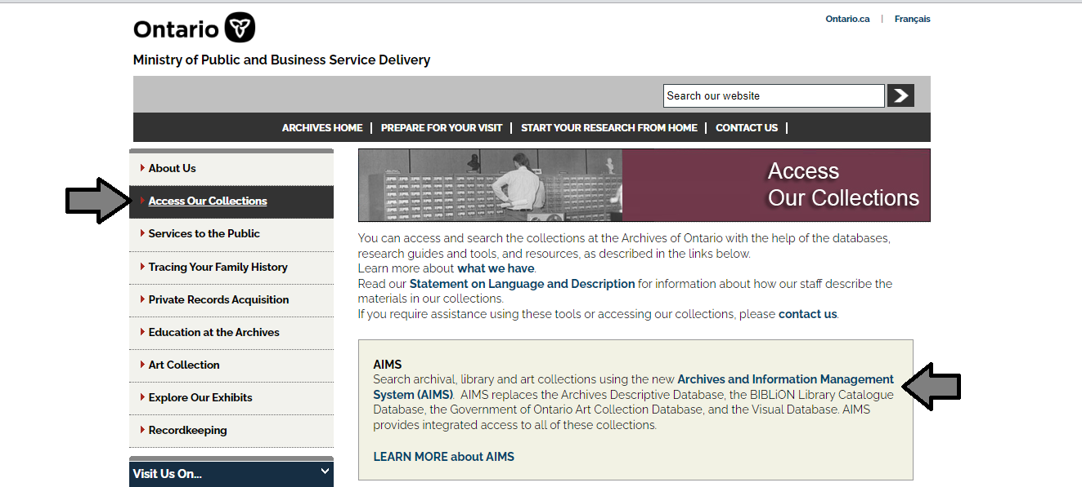

1. In the Archives and Information Management System (AIMS), click on “Archives repository (only)” button:

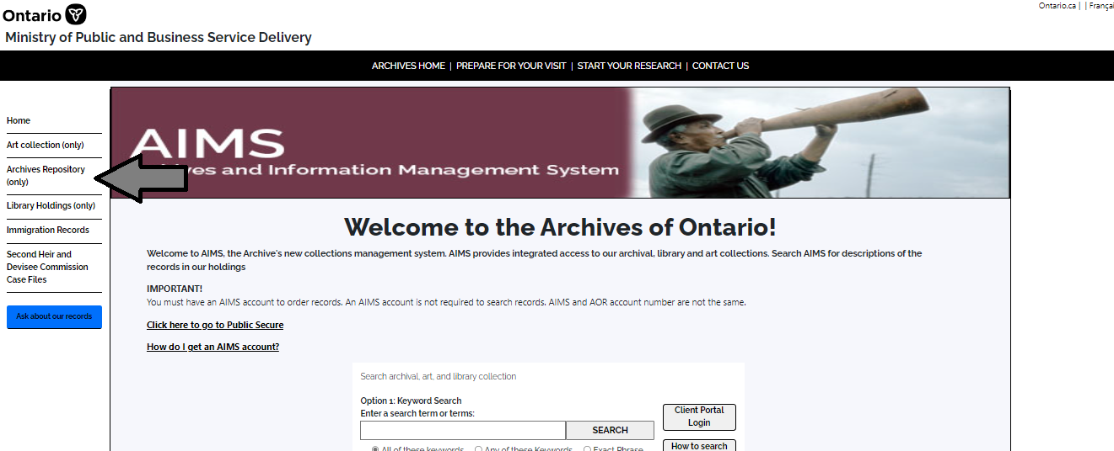

1. On the “Welcome to the Archival Collection” search page, click “Advanced Search”:

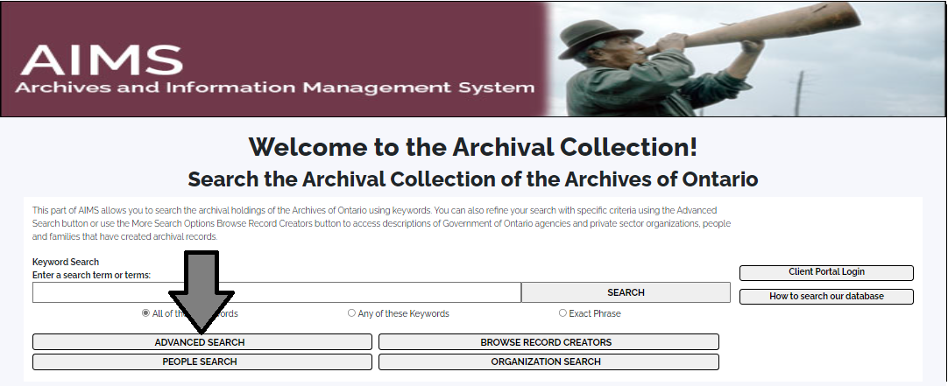

1. On the “Archives Advanced Search” page enter the reference code (that’s the number starting with C, F or RG) in the Reference Code field and click “Search” (at the bottom of the page.

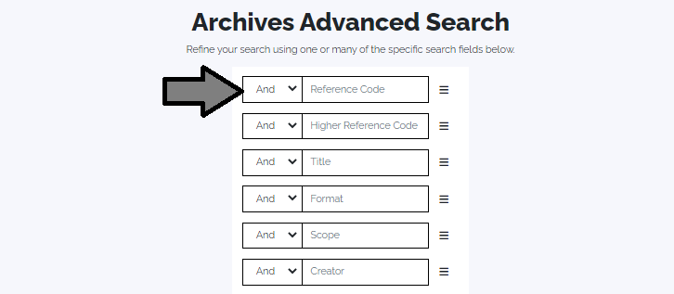

# Contact us

Although unable to do your research for you, our reference archivists are waiting to assist you.  You may call or write to them by mail or email or — best of all — visit the Archives of Ontario.

**Telephone: 416-327-1600 Toll free (Ontario): 1-800-668-9933**

**Email:** [Click here to email the Archives of Ontario](mailto:reference@ontario.ca).  The e-mail address is [reference@ontario.ca](mailto:reference@ontario.ca)

**Address: Archives of Ontario, 134 Ian Macdonald Blvd., Toronto, ON M7A 2C5**

**Website**

Visit our website for information about our collections and our services, our online exhibits and education programs, and links to our social media accounts. [Click here to visit our website](http://www.ontario.ca/archives).  The website is [www.ontario.ca/archives](http://www.ontario.ca/archives).

**Customer Service and Research Guides**

Our guides contain information about our services, freelance researchers available to do research for you, and some of most popular records.  [Click here to view our guides](http://www.archives.gov.on.ca/en/access/research_guides.aspx).  To find the “Research Guides and Tools” on our website, click on “Access our Collections”.

______________________________________________________________________

© King's Printer for Ontario, 2023

This information is provided as a public service.  Last update is shown at the beginning of this guide.  Readers should where possible verify the information before acting on it.