|  |  |
| --- | --- |
| **Archives of Ontario** |  |
| Research Guide 228  Immigration and Citizenship Records  Last Updated: March 2023 | |

Image is: Potential emigrants viewing poster for the Ontario Air Immigration Plan, 1947, RG 9-7-4-1-1, Ontario Air Immigration Plan photographs


Potential emigrants viewing poster for the Ontario Air Immigration Plan, 1947

RG 9-7-4-1-1

Ontario Air Immigration Plan photographs

In this guide 2

Where do I find these records? 2

What do I need to get started? 3

The Records 3

1. Immigration records 3

1.1 Provincial government immigration records 3

1.2 Federal immigration records 5

1.3 Home Children records 6

2. Naturalization and citizenship records 7

2.1 Naturalization records, 1828 to 1850 7

2.2 Court naturalization records, 1850 to 1977 8

2.3 Federal government naturalization records, 1854 to present 8

How do I get to the online descriptions? 8

Contact us 10

# In this guide

This guide has information on how to find records pertaining to immigration and citizenship at the Archives of Ontario. It also includes records available at other institution.

Please note: this guide contains links to information found in our online Archives and Information Management System (AIMS).  On our website, this database is found under “Access Our Collections”.  If you are using a print copy of this guide, go to page 8 for more information on how to find the online descriptions.

# Where do I find these records?

Most of our records mentioned in this guide are available on microfilm in our reading room, and you do not need to request them in advance. Libraries that offer interloan services can borrow most of those reels for you. [Click here to view our Microfilm Interloan Catalogue](http://www.archives.gov.on.ca/en/microfilm/index.aspx). On our website, you will find this catalogue under “Access Our Collections”. Some of the microfilmed records are available online.

You will need to request some of our records in advance to view them in our reading room. In some cases, you may be able to request copies from a distance.

We have microfilm copies of some of the records from other institutions mentioned in this guide. You can view those microfilm copies in our reading room. Some of those records are available online. In some cases, you may need to submit a request in writing to the institution that has the records.

# What do I need to get started?

To find immigration or citizenship records, you need to know the name of the person, and when they immigrated or became citizens. For some records, you may need to know where they lived in Ontario.

If you are not sure when the person immigrated or became citizen, information found in census records, city directories, land records and birth, marriage and death records may help you narrow your search down. [Click here to view research guides and tools on how to search these records](http://www.archives.gov.on.ca/en/access/research_guides.aspx). On our website, you will find the Research Guides and Tools page under “Access Our Collection”.

# The Records

## Immigration records

The Government of Upper Canada opened an Emigrant (sic) Office in Toronto in 1833. Its main role was to promote immigration to the colony and provide financial assistance to some immigrants, Offices and agents were later added elsewhere in Ontario, in Quebec City and in some European cities.

After Confederation (1867), the Ontario and federal governments were jointly responsible for immigration. The provincial government continued to provide financial assistance to immigrants to the province, through the Immigration Branch (later Department of Immigration and Colonization Bureau) between 1867 and 1910. Since 1910, various offices in the provincial government have been responsible for assistance and settlement programs for immigrants.

Please note: In many records before 1900, people immigrating to Canada are referred to as emigrants.

### 1.1 Provincial government immigration records

Records of the Emigrant Office and the provincial Department of Immigration (1831 to 1902) document the arrival of immigrants in the province, financial assistance provided to some immigrants, health services and various administration and financial issues. Note: immigrants who did not receive government assistance may not appear in these records.

The Toronto Emigrant Office assisted emigration registers (1863 to 1885) contain information about immigrants who received government assistance to travel to or settle in Ontario. Information may include the name of ship, date of arrival, assistance provided and destination in Ontario.

These records are available on microfilm, and local libraries that offer interloan services may borrow the film for you. For a transcription and an index, and more information about these records, [click here to search our Toronto Emigrant Office Assisted Immigration Registers Database](http://www.archives.gov.on.ca/en/db/hawke.aspx). On our website, you will find this database under “Access Our Collection”.

Most other provincial records from 1831 to 1902 are available on microfilm in our reading room, and libraries that offer interloan services may borrow them for you. Table 1 below is a list of provincial immigration records from 1831 to 1902.

Some of the microfilm are also digitized and available on the FamilySearch website, [click here to access our Digitized Microfilm Collections webpage for more information.](http://www.archives.gov.on.ca/en/access/digitized_microfilm_collections_on_familysearch.aspx)To find this information on our website, click on “Access our Collections” then click on the “Digitized Microfilm” page.  The FamilySearch website is [www.familysearch.org](http://www.familysearch.org).

Table 1: Provincial government immigration records, 1831 to 1902

| **Title and Dates** | **Reference Code** | **How to access** |
| --- | --- | --- |
| Applications for refund bonuses from emigrants to Ontario, 1872 to 1876 | [Click here to view the description for RG 11-23](https://aims.archives.gov.on.ca/scripts/mwimain.dll/144/DESCRIPTION_WEB/WEB_DESC_DET?SESSIONSEARCH&exp=sisn%208010) | On microfilm and digitized |
| Chief Emigrant Agent’s letterbooks, 1835 to 1859 | [Click here to view the description for RG 11-1](https://aims.archives.gov.on.ca/scripts/mwimain.dll/144/DESCRIPTION_WEB/WEB_DESC_DET?SESSIONSEARCH&exp=sisn%206395) | On microfilm |
| Daily journals of the Secretary of the Toronto Emigration Office, 1873 to 1902 | [Click here to view the description for RG 11-9](https://aims.archives.gov.on.ca/scripts/mwimain.dll/144/DESCRIPTION_WEB/WEB_DESC_DET?SESSIONSEARCH&exp=sisn%207868) | Request the originals |
| Department of Immigration accounting records, 1870 to 1901 | [Click here to view the description for RG 11-19](https://aims.archives.gov.on.ca/scripts/mwimain.dll/144/DESCRIPTION_WEB/WEB_DESC_DET?SESSIONSEARCH&exp=sisn%208018) | Request the originals |
| Department of Immigration letter registers, 1867 to 1883 | [Click here to view the description for RG 11-12](https://aims.archives.gov.on.ca/scripts/mwimain.dll/144/DESCRIPTION_WEB/WEB_DESC_DET?SESSIONSEARCH&exp=sisn%208015) | Request the originals |
| Department of Immigration numbered correspondence files, 1873 to 1897 | [Click here to view the description for RG 11-8-1](https://aims.archives.gov.on.ca/scripts/mwimain.dll/144/DESCRIPTION_WEB/WEB_DESC_DET?SESSIONSEARCH&exp=sisn%207861) | On microfilm and digitized |
| Department of Immigration Secretary’s correspondence files, 1891 to 1899 | [Click here to view the description for RG 11-8-3](https://aims.archives.gov.on.ca/scripts/mwimain.dll/144/DESCRIPTION_WEB/WEB_DESC_DET?SESSIONSEARCH&exp=sisn%207863) | Request the originals |
| Department of Immigration unnumbered correspondence files, 1869 to 1892 | [Click here to view the description for RG 11-8-2](https://aims.archives.gov.on.ca/scripts/mwimain.dll/144/DESCRIPTION_WEB/WEB_DESC_DET?SESSIONSEARCH&exp=sisn%207862) | On microfilm and digitized |
| Emigrant arrival and destination records, 1862 to 1881 | [Click here to view the description for RG 11-17](https://aims.archives.gov.on.ca/scripts/mwimain.dll/144/DESCRIPTION_WEB/WEB_DESC_DET?SESSIONSEARCH&exp=sisn%207862) | On microfilm and digitized |
| Emigrant assisted passage certificates, 1872 to 1873 | [Click here to view the description for RG 11-16](https://aims.archives.gov.on.ca/scripts/mwimain.dll/144/DESCRIPTION_WEB/WEB_DESC_DET?SESSIONSEARCH&exp=sisn%208020) | On microfilm and digitized |
| Emigrant railway pass records, 1873 to 1875 | [Click here to view the description for RG 11-18](https://aims.archives.gov.on.ca/scripts/mwimain.dll/144/DESCRIPTION_WEB/WEB_DESC_DET?SESSIONSEARCH&exp=sisn%208017) | Request the originals |
| Emigrant six dollar bonus certificates, 1875 | [Click here to view the description for RG 11-24](https://aims.archives.gov.on.ca/scripts/mwimain.dll/144/DESCRIPTION_WEB/WEB_DESC_DET?SESSIONSEARCH&exp=sisn%208011) | On microfilm and digitized |
| Expense account for immigration agent at Toronto, 1869 | [Click here to view the description for RG 11-21](https://aims.archives.gov.on.ca/scripts/mwimain.dll/144/DESCRIPTION_WEB/WEB_DESC_DET?SESSIONSEARCH&exp=sisn%208019) | Request the originals |
| Immigration bonus certificates and advance bonus list, 1872 to 1874 | [Click here to view the description for RG 11-15](https://aims.archives.gov.on.ca/scripts/mwimain.dll/144/DESCRIPTION_WEB/WEB_DESC_DET?SESSIONSEARCH&exp=sisn%208013) | On microfilm and digitized |
| Immigration Commissioner’s letterbook, 1874 to 1875 | [Click here to view the description for RG 11-13](https://aims.archives.gov.on.ca/scripts/mwimain.dll/144/DESCRIPTION_WEB/WEB_DESC_DET?SESSIONSEARCH&exp=sisn%208022) | Request the original |
| Immigration refund bonus certificates, 1873 to 1874 | [Click here to view the description for RG 11-22](https://aims.archives.gov.on.ca/scripts/mwimain.dll/144/DESCRIPTION_WEB/WEB_DESC_DET?SESSIONSEARCH&exp=sisn%208009) | On microfilm and digitized |
| Kingston Emigrant Agent’s letterbook, 1849 to 1874 | [Click here to view the description for RG 11-2](https://aims.archives.gov.on.ca/scripts/mwimain.dll/144/DESCRIPTION_WEB/WEB_DESC_DET?SESSIONSEARCH&exp=sisn%207634) | On microfilm |
| Letterbooks of Ontario Immigration Agents, 1869 to 1901 | [Click here to view the description for RG 11-11](https://aims.archives.gov.on.ca/scripts/mwimain.dll/144/DESCRIPTION_WEB/WEB_DESC_DET?SESSIONSEARCH&exp=sisn%207998) | Request the originals |
| List of emigrants receiving refund bonus, 1872 to 1875 | [Click here to view the description for RG 11-14](https://aims.archives.gov.on.ca/scripts/mwimain.dll/144/DESCRIPTION_WEB/WEB_DESC_DET?SESSIONSEARCH&exp=sisn%208014) | On microfilm and digitized |
| Miscellaneous records of the Department of Immigration, 1869 to 1899 | [Click here to view the description for RG 11-20](https://aims.archives.gov.on.ca/scripts/mwimain.dll/144/DESCRIPTION_WEB/WEB_DESC_DET?SESSIONSEARCH&exp=sisn%208021) | On microfilm and digitized |
| Passage bonus receipts for emigrants, 1873 to 1875 | [Click here to view the description for RG 11-10](https://aims.archives.gov.on.ca/scripts/mwimain.dll/144/DESCRIPTION_WEB/WEB_DESC_DET?SESSIONSEARCH&exp=sisn%208008) | On microfilm and digitized |
| Registers of applications for emigrant passage warrants, 1872 to 1888 | [Click here to view the description for RG 11-25](https://aims.archives.gov.on.ca/scripts/mwimain.dll/144/DESCRIPTION_WEB/WEB_DESC_DET?SESSIONSEARCH&exp=sisn%208012) | On microfilm and digitized |
| Reports of inspection of Home Children, 1875 and 1886 | [Click here to view the description for RG 11-7](https://aims.archives.gov.on.ca/scripts/mwimain.dll/144/DESCRIPTION_WEB/WEB_DESC_DET?SESSIONSEARCH&exp=sisn%207638) | On microfilm |
| Toronto Convalescent and Fever Hospital admission and discharge register, 1847 to 1848 | [Click here to view the description for RG 11-6](https://aims.archives.gov.on.ca/scripts/mwimain.dll/144/DESCRIPTION_WEB/WEB_DESC_DET?SESSIONSEARCH&exp=sisn%207637) | On microfilm |
| Toronto Emigrant Office financial records, 1831 to 1879 | [Click here to view the description for RG 11-5](https://aims.archives.gov.on.ca/scripts/mwimain.dll/144/DESCRIPTION_WEB/WEB_DESC_DET?SESSIONSEARCH&exp=sisn%207636) | On microfilm |
| Toronto Emigrant Office arrival and destination registers, 1857 to 1892 | [Click here to view the description for RG 11-4](https://aims.archives.gov.on.ca/scripts/mwimain.dll/144/DESCRIPTION_WEB/WEB_DESC_DET?SESSIONSEARCH&exp=sisn%207635) | On microfilm |

For information about records on provincial government assistance programs for immigrants after World War II, see our research guide 235, Records Related to Multiculturalism and Ethno-Cultural Communities in Ontario.

### 1.2 Federal immigration records

**Passenger lists (ships’ manifests) and border entry lists**

**Ship captains were required to submit a list of their passengers at the first Canadian port they arrived at. Lists of passengers whose final destination was in Canada were also submitted to consular authorities in American ports.**

**Information in passenger lists** varies. Often, it is limited to information about the head of the household and the number of family members. The lists may also include the traveller’s name, age, country of origin (which in some cases is the port of departure), occupation, and intended destination. Few lists before 1865 still exist; in some cases, local newspapers at the port of arrival listed passengers.

Beginning in 1908, immigrants’ entering Canada through the land border with the United States at entry ports (official entry points). were recorded on border entry lists. Between 1919 and 1925, these lists were replaced with forms all immigrants were required to fill. Information included may include the name, age, occupation, birthplace and citizenship, race and religion, and destination.

You may view microfilm copies of passenger lists, 1865 to 1920 and border entry lists, 1908 to 1919, in our reading room. The originals are with Library and Archives Canada. For more information about these records*.* [click here to view the description for the Ship passenger lists diffusion material (D 20)](https://aims.archives.gov.on.ca/scripts/mwimain.dll/144/DESCRIPTION_WEB/WEB_DESC_DET?SESSIONSEARCH&exp=sisn%208079)*.*

**Library and Archives Canada has ship passenger lists from 1750 (mostly 1865) to 1935, border entry lists from 1908 to 1919 and 1925 to 1935, and border entry forms from 1920 to 1924. Visit the Library and Archives Canada website.** [www.collectionscanada.gc.ca](http://www.collectionscanada.gc.ca)**, for digitized copies and indexes for some of these records, as well as other immigration-related records in their collections.**

**Ship passenger lists from 1865 to 1935 and border entry records from 1908 to 1935 are also digitized on** [www.ancestry.ca](http://www.ancestry.ca)**. Passenger lists for some ports, 1881 to 1922, are also digitized on** [www.familysearch.org](http://www.familysearch.org)

**For information on how to access records of immigrants’ entrance after 1935, visit** <https://atip-aiprp.apps.gc.ca/atip/welcome.do>.

##### Central registry files of the Department of Immigration, 1873 to-1979**:**

We hold microfilm copies of the Central registry files of the Department of Immigration. These records may include correspondence between immigrants and the Department, lists of immigrants, reports and other records about Home Children (also see below), and records on various topics related to immigration. For more information about these records [click here to view the description for the Federal Immigration Branch diffusion material (D 8)](https://aims.archives.gov.on.ca/scripts/mwimain.dll/144/DESCRIPTION_WEB/WEB_DESC_DET?SESSIONSEARCH&exp=sisn%208105) . For information on how to access these records through Library and Archives Canada, visit its website, [www.collectionscanada.gc.ca](http://www.collectionscanada.gc.ca).

### 1.3 Home Children records

Between 1869 and the 1930’s, more than 100000 orphaned, abandoned and poor children were sent from the British Isles to work on Canadian farms. Churches and philanthropic organizations were responsible recruiting, transporting and placing these children, which are referred to as Home Children.

We have records of inspections of Home Children, done in 1875 and 1886. These inspections contain personal information about the children, their placement, and their living and working conditions. You may view these records on microfilm in our reading room, and libraries that offer interloan services may borrow the reels for you. For more information about these records, [click here to view the description for RG 11-7](https://aims.archives.gov.on.ca/scripts/mwimain.dll/144/DESCRIPTION_WEB/WEB_DESC_DET?SESSIONSEARCH&exp=sisn%207638)

You may also view microfilm copies of records from Library and Archives about Home Children, 1878 to 1920, in our reading room. For more information about these records, [click here to check the description for the Juvenile immigration records diffusion material (D 10) for more information about these records](https://aims.archives.gov.on.ca/scripts/mwimain.dll/144/DESCRIPTION_WEB/WEB_DESC_DET?SESSIONSEARCH&exp=sisn%208088).

Visit the Library and Archives Canada website, [www.collectionscanada.gc.ca](http://www.collectionscanada.gc.ca) for information about accessing these and other records about Home Children, searchable a database to Home Children records, and resources on researching Home Children.

Some records from the private agencies that organized juvenile immigration still exist. They may contain information on children’s dates and places of birth and their families. Most of these agencies are located in Great Britain and you will need to contact them directly.

## Naturalization and citizenship records

A formal naturalization process was instituted in 1828. Before that year, all people applying for a grant of land from the Crown had to swear an oath of allegiance to the King. Those who were not born British subjects were deemed to be subjects once they had sworn that oath.

You may find some of these oaths in the land petitions or the township papers. For information about land records, [click here to see our Research Guide 225, Researching Crown land records](http://www.archives.gov.on.ca/en/access/research_guides.aspx). On our website, you will find this and other research guides on the “Research Guide and Tools” page, under “Access Our Collections”.

Note: Until 1947, Canadian citizens were legally British subjects. Immigrants who were already British subjects (immigrants from the United Kingdom, British colonies and Commonwealth countries) did not need to be naturalized.

### 2.1 Naturalization records, 1828 to 1850

We have an oath of allegiance book for the years 1837 to 1842, recording the names of people who swore on oath of allegiance as a condition to be naturalized. For information on this book and how to access it, [click here to view the description for RG 22-771](https://aims.archives.gov.on.ca/scripts/mwimain.dll/144/DESCRIPTION_WEB/WEB_DESC_DET?SESSIONSEARCH&exp=sisn%203023).

We also have microfilm copies of naturalization registers. Between 1828 and 1850, naturalization registers were maintained for each county. Registers originally included the person’s name, residence, signature, registry dare and an entry number. Other information was included in later entries.

You may view these registers in our reading room, on microfilm reels C-15692 and C-15693. The originals are with Library and Archives Canada. Visit the Library and Archives Canada website, [www.collectionscanada.gc.ca](http://www.collectionscanada.gc.ca), for a database listing these records and to view digitized copies.

These registers are indexed in Donald A. McKenzie’s series of articles entitled Upper Canada naturalization records 1828-1850 (published in Families, vol. 18, no. 3 to vol. 20, no. 1; 1979-1981). There is a copy in our reading room.

### 2.2 Court naturalization records, 1850 to 1977

Between 1850 and 1977, the naturalization process involved swearing an oath before a judge. This has been replaced by citizenship ceremonies presided by citizenship judges appointed by the Governor in Council.

We have records documenting some of these oaths. Records may include registers and lists of people swearing the oath, correspondence, and background files on the applicants. For information about these records and how to access them, [click here to search the Archives and Information Management System (AIMS), "Archives Repository", Advanced search by group of records, subject "citizenship" and the name of the county or district.](http://aims.archives.gov.on.ca).

Minute books of the Courts of General Sessions of the Peace may include the name of the people swearing the oath, and the date. For information about these records and how to access them, [click here to search the Archives and Information Management System (AIMS), "Archives Repository" by group of records, then by subject "minutes", "sessions" and "peace" and the name of the county or district.](http://aims.archives.gov.on.ca).

### 2.3 Federal government naturalization records, 1854 to present

Library and Archives Canada has a database of people naturalized in Canada between 1915 and 1951. To search this database, visit [www.collectionscanada.gc.ca](http://www.collectionscanada.gc.ca).

Citizenship and Immigration Canada holds a surname card index for naturalizations that took place between 1854 and 1917, as well as case files created after 1917*.* These case files may include application forms, oaths of allegiance sworn before County or District Court judges, and supporting documentation on applicants, their families and their length of stay in the country. **For information on how to access the card index and the case files, visit** <https://atip-aiprp.apps.gc.ca/atip/welcome.do>.

# How do I get to the online descriptions?

1. On our website’s main page, click on “Access Our Collections”, and click on “Archives and Information Management System”, as shown in the image below:

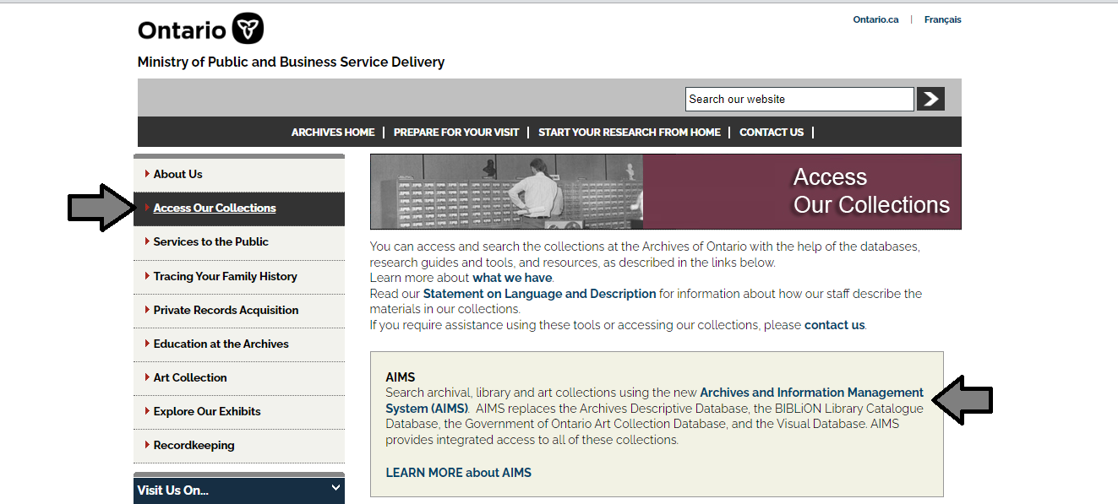

1. In the Archives and Information Management System (AIMS), click on “Archives repository (only)” button:

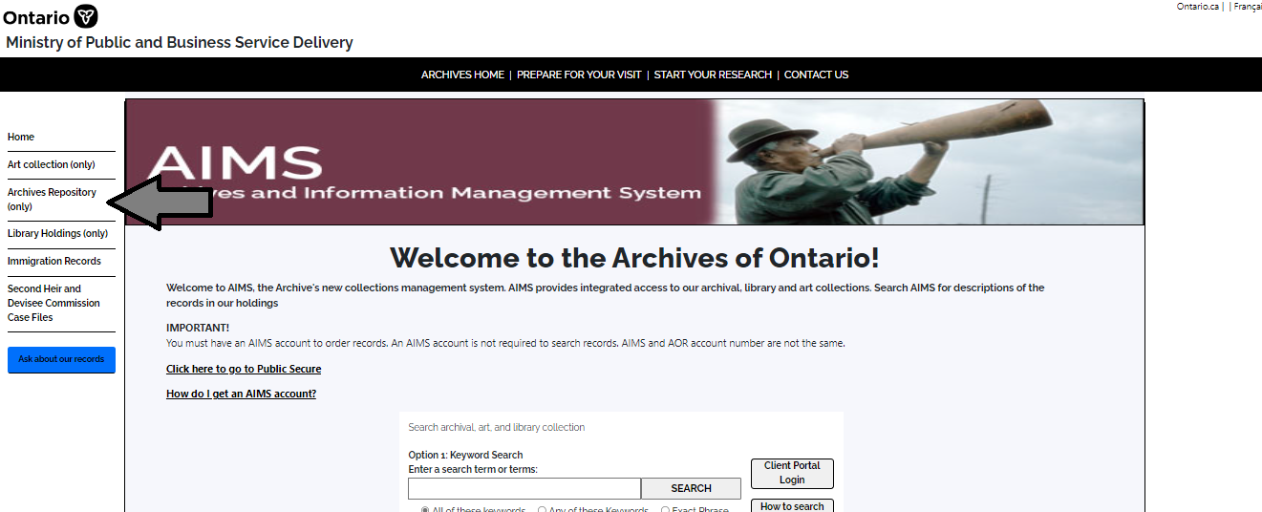

1. On the “Welcome to the Archival Collection” search page, click “Advanced Search”:

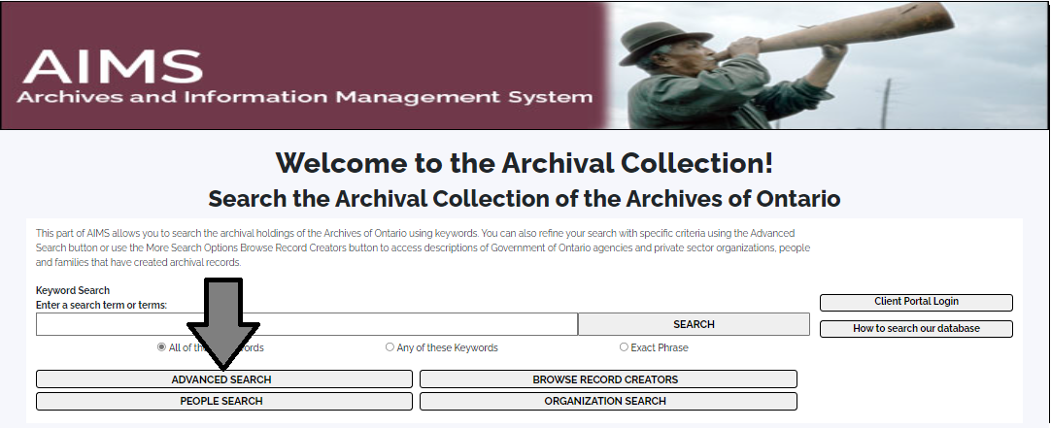

1. On the “Archives Advanced Search” page enter the reference code (that’s the number starting with C, F or RG) in the Reference Code field and click “Search” (at the bottom of the page.

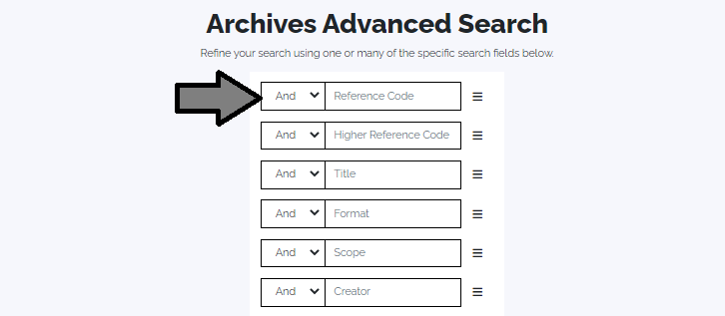

# Contact us

Although unable to do your research for you, our reference archivists are waiting to assist you.  You may call or write to them by mail or email or — best of all — visit the Archives of Ontario.

**Telephone: 416-327-1600 Toll free (Ontario): 1-800-668-9933**

**Email:** [Click here to email the Archives of Ontario](mailto:reference@ontario.ca).  The e-mail address is [reference@ontario.ca](mailto:reference@ontario.ca)

**Address: Archives of Ontario, 134 Ian Macdonald Blvd., Toronto, ON M7A 2C5**

**Website**

Visit our website for information about our collections and our services, our online exhibits and education programs, and links to our social media accounts. [Click here to visit our website](http://www.ontario.ca/archives).  The website is [www.ontario.ca/archives](http://www.ontario.ca/archives).

**Customer Service and Research Guides**

Our guides contain information about our services, freelance researchers available to do research for you, and some of most popular records.  [Click here to view our guides](http://www.archives.gov.on.ca/en/access/research_guides.aspx).  To find the “Research Guides and Tools” on our website, click on “Access our Collections”.

______________________________________________________________________

© King's Printer for Ontario, 2023

This information is provided as a public service.  Last update is shown at the beginning of this guide.  Readers should where possible verify the information before acting on it.