| **Archives of Ontario** |  |
| --- | --- |
| Research Guide 229  Change of Name Records  Last Updated: March 2023 | |

Photograph is: Wentworth County Courthouse, RG 65-35-3, 11764-X3552, Tourism promotion photographs


Wentworth County Courthouse

RG 65-35-3, 11764-X3552

Tourism promotion photographs

In this guide 2

Where do I find these records? 2

What do I need to get started? 3

The Records 3

1. Change of name deed polls, before 1939 3

2. Change of name records, 1939 to 1986 3

2.1 Change of name court files 4

2.2 Office of the Registrar General’s change of name orders 4

How do I get to the online descriptions? 5

Contact us 7

# In this guide

This guide has information on how to find change of name records at the Archives of Ontario.

*Please note: this guide contains links to information found in our online Archives and Information Management System (AIMS), the “Archives Repository Only”.  On our website, this database is found under “Access Our Collections”.  If you are using a print copy of this guide, go to page 5 for more information on how to find the online descriptions.

# Where do I find these records?

We have:

* Court records documenting changes of name, up to 1986 (few records before 1939 still exist, and for some counties and districts our holdings end before 1986). Court records after 1939 include a copy of the change of name order.
* Change of name orders filed with the Office of the Registrar General, from 1939 to 1973.

You may view court records in our reading room. You will first need to consult an index, either in our reading room or (for some counties and years) at the local courthouse. In some cases, you may also be able to get a copy from a distance. In some cases, you will need to submit a Freedom of Information request to get a copy of the court order.

The Ontario Court of Justice in some counties or districts have change of name court files before 1986. For courthouse addresses, visit the Ministry of the Attorney General’s website, <https://www.attorneygeneral.jus.gov.on.ca/>.

The Office of the Registrar General has a copy of change of name orders from 1973 to present. See this guide for more information. Requests to the Registrar General for change of name orders must be made in writing:

Office of the Registrar General  
P.O. Box 3000  
189 Red River Rd,  
Thunder Bay, Ontario, P7B 5W0

# What do I need to get started?

To find change of name records, you need the person’s former and new name, where in Ontario the change of name took place, and the year it took place.

# The Records

## Change of name deed polls, before 1939

Before 1939, there was no mandatory process to change one’s name in Ontario. Individuals could file and swear a dead poll (a written declaration of their intent to change name) in court. They could also simply start using a new name, if there was no intent to defraud or avoid the law or creditors. Courts did not need to keep a copy or a record of the deed polls, and in most cases the only record was the copy kept by the individual.

We have some deed polls from across the province, that were sworn in by the Supreme Court of Ontario for York County, Toronto. To find these, you first need to search the Supreme Court Central Office matter index, on microfilm in our reading room. The indexes for 1850-1946, are available on self-serve microfilm MS 4006.

There is more than one volume on the reel, each covering a few years. The entries are arranged first by the first letter of the individuals’ previous name, then in order by date. Not all entries are for changes of name. When you find the name you are looking for, request RG 22-5801, with the person’s previous and new name and the docket number and year found in the index.

For more information about these records, [click here to view the description for the York Supreme Court matter files, RG 22-5801](https://aims.archives.gov.on.ca/scripts/mwimain.dll/144/DESCRIPTION_WEB/WEB_DESC_DET?SESSIONSEARCH&exp=sisn%201315) or [click here to view the description for the Supreme Court Central Office matter index, RG 22-5808](https://aims.archives.gov.on.ca/scripts/mwimain.dll/144/DESCRIPTION_WEB/WEB_DESC_DET?SESSIONSEARCH&exp=sisn%201390).

## Change of name records, 1939 to 1986

In 1939, Ontario passed the Change of Name Actallowing adults and married male British citizens living in Ontario to change their name through the courts (note that under the federal *Citizenship Act* of 1946, British citizenship was replaced with Canadian citizenship).  Under the revised *Change of Name Act* of 1972, all adult Ontario residents could apply for a change of name, regardless of their citizenship status.

Under the Act, County or District Court judges held formal hearings into any proposed name change and required the following information:

* Applicant’s (and, if married, family’s) current address, birth date, and birthplace
* Names of parents, including maiden name (plus spouse’s parents, if married)
* Proof of British (later, Canadian) citizenship or naturalization
* Occupation
* Whether the applicant had ever been convicted, with the offence
* New name the applicant wanted to use
* Statement for the reasons behind the change

If all requirements were met, the judge issued an order changing the person’s name. A copy of court order was also sent to the Office of the Registrar General.

### 2.1 Change of name court files

We have the change of name court files up to 1986 for all countries and districts, with a few exceptions. The files contain the person’s application, the court order changing the name, and documents submitted in support of the application.

To get a change of name court file, you will need to know the courthouse, file number and year. If you do not have the file number and year, you will need to look at an index. To find the indexes, follow these steps:

* [Click here to search the Archives and Information Management System (AIMS), and the "Archives Repository", then in the "Advance Search" by Groups of Archival Records](http://aims.archives.gov.on.ca)
* Enter “change of name” in the “keyword(s)” field
* Enter the name of the county or district in the “keyword(s)” field.
* Enter the “Search Dates”. If the year you are looking for is more recent, the files may still be held by the courthouse.
* To find where and how to access the indexes, follow the instructions under the *How to order these records* section. Please note: Some courthouses still have the indexes, and you will need to contact them to obtain the file number and year.

Once you have the file number and year, contact us with that information, the city where the change of name took place, and the person’s former and new name.

### 2.2 Office of the Registrar General’s change of name orders

We have the Registrar General’s copy of the change of name orders for the years 1939 to 1973, and the Office of the Registrar General has them for the years after 1973.

If you cannot find a court record, or you are not sure where the change of name took place, please contact the Office of the Registrar General at the address at the beginning of this guide to obtain the file number.

For changes of name after 1973, the Office of the Registrar General will contact you with the procedure to follow to obtain a copy.

For changes of name from 1939 to 1973: Once you have the file number from the Registrar General, submit a Freedom of Information request to the Information and Privacy Unit, Archives of Ontario.

[Click here to find the online or print Freedom of Information request form](http://www.forms.ssb.gov.on.ca/mbs/ssb/forms/ssbforms.nsf/FormDetail?OpenForm&ACT=RDR&TAB=PROFILE&SRCH=&ENV=WWE&TIT=on00089&NO=ON00089E). Include the person’s former and new name, the year and file number, and reference code RG 80-1. There is a $5 application fee.

If you send your request by mail, include a cheque or money order made payable to the Minister of Finance. Instead of the form, you can send a letter with the information mentioned above and the application fee; mention that you are submitting a freedom of information request. Mail the request to:

Senior Manager, Information and Privacy  
Customer Service and Preservation Services, Archives of Ontario  
134 Ian Macdonald Blvd  
Toronto, ON M7A 2C5

For more information about these records. [click here to view the description for the Change of Name court orders: RG 80-1](https://aims.archives.gov.on.ca/scripts/mwimain.dll/144/DESCRIPTION_WEB/WEB_DESC_DET?SESSIONSEARCH&exp=sisn%202337).

# How do I get to the online descriptions?

1. On our website’s main page, click on “Access Our Collections”, and click on “Archives and Information Management System”, as shown in the image below:

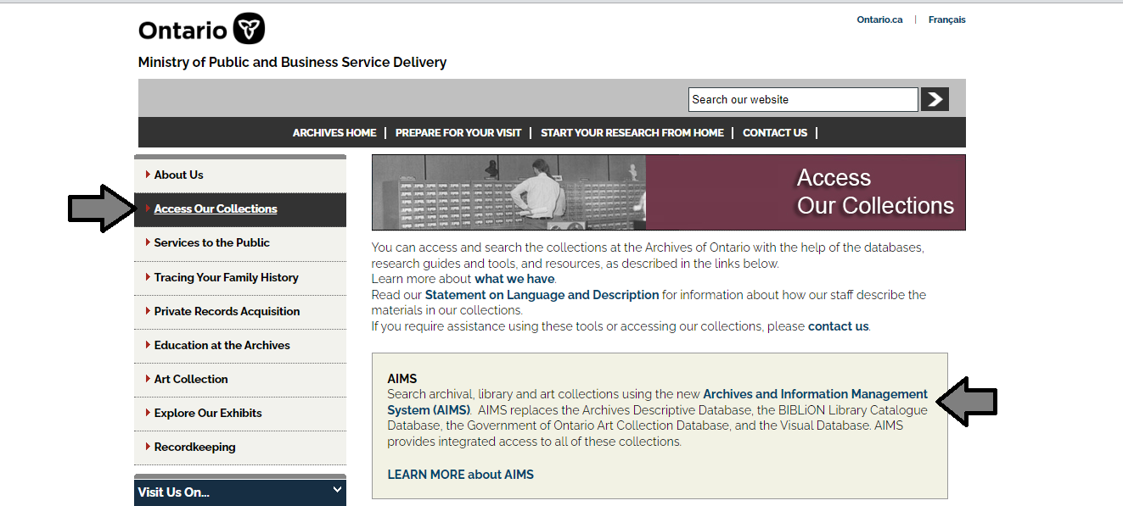

1. In the Archives and Information Management System (AIMS), click on “Archives repository (only)” button:

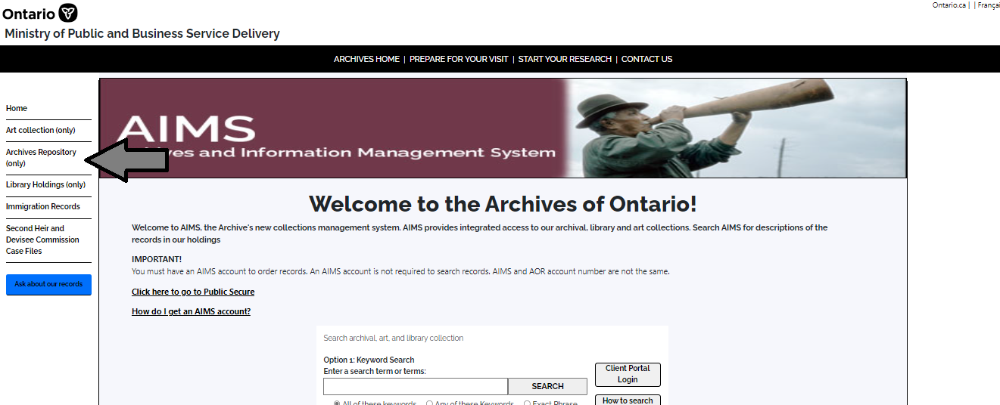

1. On the “Welcome to the Archival Collection” search page, click “Advanced Search”:

.

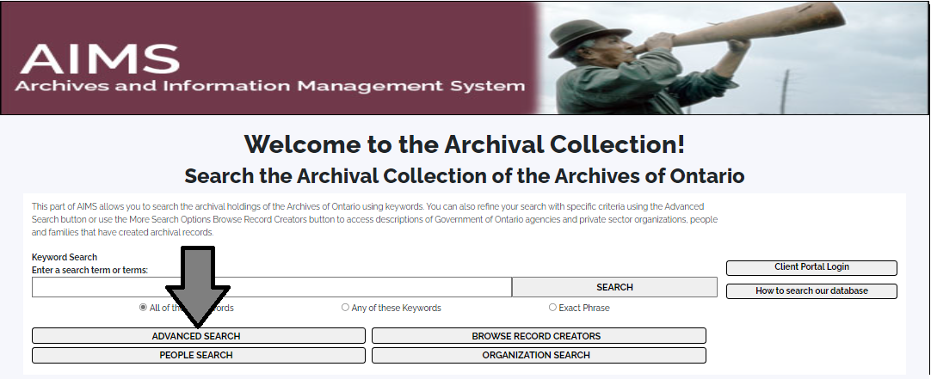

1. On the “Archives Advanced Search” page enter the reference code (that’s the number starting with C, F or RG) in the Reference Code field and click “Search” (at the bottom of the page.

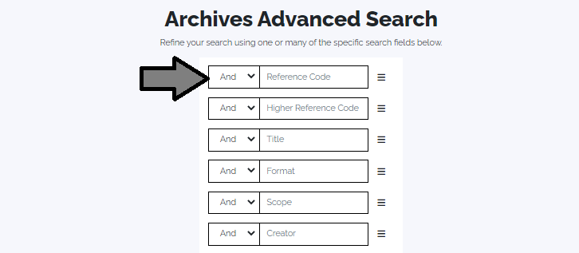

# Contact us

Although unable to do your research for you, our reference archivists are waiting to assist you.  You may call or write to them by mail or email or — best of all — visit the Archives of Ontario.

**Telephone: 416-327-1600 Toll free (Ontario): 1-800-668-9933**

**Email:** [Click here to email the Archives of Ontario](mailto:reference@ontario.ca).  The e-mail address is [reference@ontario.ca](mailto:reference@ontario.ca)

**Address: Archives of Ontario, 134 Ian Macdonald Blvd., Toronto, ON M7A 2C5**

**Website**

Visit our website for information about our collections and our services, our online exhibits and education programs, and links to our social media accounts. [Click here to visit our website](http://www.ontario.ca/archives).  The website is [www.ontario.ca/archives](http://www.ontario.ca/archives).

**Customer Service and Research Guides**

Our guides contain information about our services, freelance researchers available to do research for you, and some of most popular records.  [Click here to view our guides](http://www.archives.gov.on.ca/en/access/research_guides.aspx).  To find the “Research Guides and Tools” on our website, click on “Access our Collections”.

______________________________________________________________________

© King's Printer for Ontario, 2023

This information is provided as a public service.  Last update is shown at the beginning of this guide.  Readers should where possible verify the information before acting on it.