# Lesson Kit: The War of 1812: Who Has the Advantage?

Grade 7: 1800–1850: Conflict and Challenges

## Introduction

In this lesson, students will decide who holds the advantage at the beginning of the War of 1812 by evaluating the conditions of both the United States and Great Britain during this period.

## Topic

The War of 1812

## Source

Archives of Ontario’s War of 1812 online exhibit - [Click here to view the War of 1812 online exhibit.](http://www.archives.gov.on.ca/en/explore/online/1812/index.aspx)

Use the Archives of Ontario’s online exhibit on the War of 1812:

* As a learning resource for yourself
* As a site to direct your students for inquiry projects
* As a place to find and use primary sources related to the curriculum

## Themes that can be addressed

* Use of Primary Sources
* Major battles
* Alliances between First Nations and British forces
* The role of Loyalists
* Important individuals (ie. Tecumseh, Laura Secord, General Issac Brock)

## Curriculum Links

**Strand B. Canada, 1800-1850: Conflict and Challenges**

| Overall Expectations | Historical Thinking Concepts | Specific Expectations |
| --- | --- | --- |
| **B1. Application:** Changes and Challenges | Continuity and Change;  Historical Perspective | B1.1, B1.2 |
| **B2. Inquiry:** Perspectives in British North Americans | Historical Perspective;  Historical Significance | B2.1, B2.2, B2.4, B2.5, B2.6 |
| **B3. Understanding Historical Context:** Events and Their Consequence | Historical Significance;  Cause and Consequence | B3.1, B3.2, B3.3, B3.4, B3.5 |

# Assignment & Activity Ideas

This lesson is designed to take place over two classes. However, it can be abbreviated and completed in one class or expanded and completed across multiple classes.

## Getting Organized

* Review the resources at the end of this plan
* Print out a copy of the Who Has the Advantage? Fact Cards for each group of students and a Who has the Advantage? chart andDecision Time! worksheet for either each student or each group, depending on how you want to run the activity.
* Acquire one pair of scissors for each group of students.
* For the following class, prepare copies of the Chronology of War handout and the Advantage Follow-up Questions for either each student or each group of students

## Lesson Outline

In small groups, give students the Who Has the Advantage? Fact Cards and ask them to cut them into twenty-one individual cards.

* Ask the students to sort the cards into three categories using the Who has the Advantage? chart as a guide. The three categories are: British Advantage, American Advantage, and Neutral. Ask students to pick two to three cards per category and write notes as to why they think the fact would provide an advantage.
* Using the Decision Time! worksheet, invite students to make a decision, based on their categorizing, on which side would have the advantage at the beginning of the War of 1812. Remind them to give detailed reasons for their choices. Ask students to either hand in this worksheet at the end of class or to make a presentation as to who they felt had an advantage at the beginning of the War of 1812 and for what reasons.
* In the following class, give students a chance to reconsider their position by reading the student handout, Chronology of War, and answering the questions on the Advantage: Follow-up Questionsworksheet.
* As a class, discuss the different positions and what factors led to advantages for both sides.

## Extension / Accommodation

* Students could use the fact cards as a beginning point for a larger, research-based project and presentation on the politics and economy of the War of 1812.
* Discussion could take the form of a debate, with each student assigned a specific position.
* Students could be asked to create a graphic narrative, such as a comic strip, to illustrate the advances both sides had before, during, and after the War of 1812.

# Handouts & Worksheets

Introduction to Primary Sources 6

Who Has the Advantage? Fact Cards 7

Student Handout: Who has the Advantage? Chart 9

Student Worksheet: Decision Time! 10

Student Handout: Detailed Chronology of War 11

Student Worksheet: Advantage Follow-up Questions 15

Marking Rubric 16

## Introduction to Primary Sources

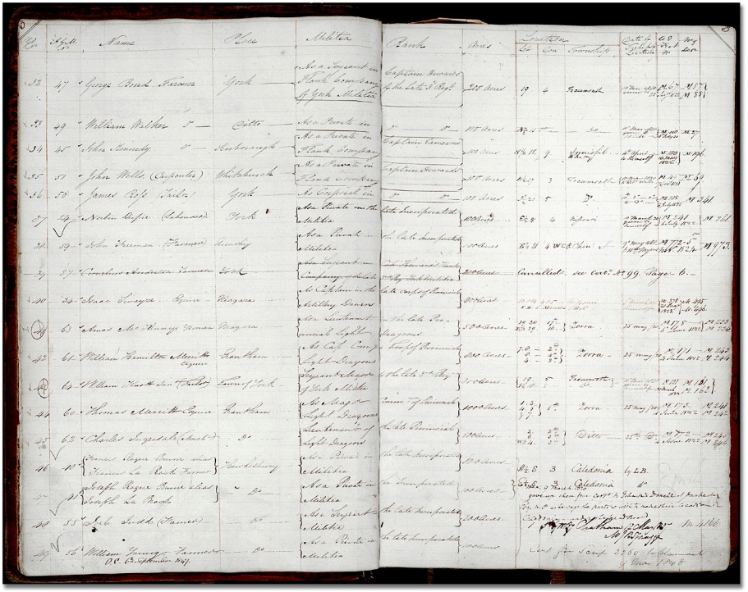

Register of militia grant, 1820-1850  
Reference Code: RG 1-152-0-1  
Archives of Ontario

A **primary source** is a document or object from the past created by people who lived during that time. Primary sources provide a view into an event or experience that only people living during that time could have experienced.

Archives collect and preserve primary sources so that students can learn history from the experiences of people who were there. In an archive, primary sources are called records. In a museum, primary sources are called artifacts.

| **Primary Sources** | **Secondary Sources** |
| --- | --- |
| Original material from the past | Material people today write about the past |
| **Example:**  Letters  Diaries  Photographs  Paintings and other art work  Graphs  Maps | **Example:**  Textbooks  Reference books  Websites such as Wikipedia  Current news articles  Documentaries and films |

**What are some other examples of primary and secondary sources?**

**Can sources be both primary and secondary?**

## Who Has the Advantage? Fact Cards

Cut out the following fact cards, and arrange them on the “Who has the Advantage?” Chart as showing British Advantage, Neutral, or American Advantage.

| **Cut out each fact card!** | **Cut out each fact card!** |
| --- | --- |
| Most of the people who lived in Upper Canada were **United Empire Loyalists** or people who had recently moved there from the United States. | The Americans were **facing uprisings** from Native groups upset with American settlers moving westward into their territories. |
| The economy of British North America and Upper Canada was agricultural. Almost all manufactured **goods were imported.** | Great Britain was unsure of the **loyalty of the French Canadians** in Lower Canada and that of settlers who had newly arrived from the United States. |
| Many of the younger American officers and regular troops had **no experience with fighting.** | Most of the top military leaders in the United States were older and only had **experience fighting** during the Revolutionary War over thirty years earlier. |
| Great Britain had approximately **6,000 regular troops** in British North America with 1,500 in Upper Canada. | General Brock, the leader of the British troops, had been **in charge of the military** in Upper Canada for 10 years. |
| The population of all of British North America was approximately 500,000. About **100,000 lived in Upper Canada.** | The economy of the United States was both **agricultural and industrial.** |
| The voluntary militias in both the United States and British North America were **very poorly fed**, clothed and equipped. | Great Britain had a **much larger** and better trained navy than the United States in 1812. |
| The American military was made up of approximately **7,000 regular troops.** | The United States had a population of more than **four million** in 1812. |
| Not all Americans supported the idea of war. Many New Englanders, in fact, **openly opposed the war.** | The **United States had factories** that could produce military weapons located quite close to the borders of British North America. |
| Most of the British officers and regular army soldiers had at least **some war experience.** | **Great Britain was already at war** with France in Europe. Most of Great Britain’s navy was involved in the blockade in Europe in 1812. |
| **An American militia with 50,000 volunteers** was set up in 1812. | All military stores and equipment for British North America had to be **imported from Great Britain.** |
| All men in British North America were **technically part of the militia** and could be called upon in time of war. Only a few had any training. | Great Britain is **approximately 5,250 km west of the Great Lakes** region in North American, where much of the fighting occurred during the War of 1812. |

## Student Handout: Who has the Advantage? Chart

Arrange the Who has the Advantage? Fact Cards in either British Advantage, Neutral, or American Advantage*.*

| **British Advantage**  MC900129223[1] |
| --- |

| **Neutral** |
| --- |

| **American Advantage**  MC900015889[2] |
| --- |

## Student Worksheet: Decision Time!

**Who do you think would have the advantage at the beginning of the War of 1812?**

(Write your answer on the line provided below)

**What are your reasons?**

Reason 1:

Evidence for Reason 1:

Reason 2:

Evidence for Reason 2:

Reason 3:

Evidence for Reason 3:

# 

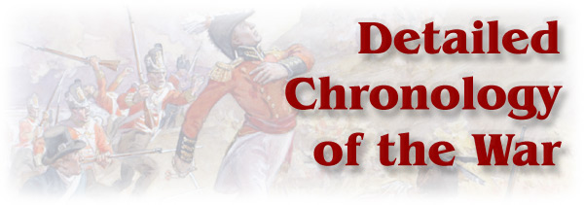

## Student Handout: Detailed Chronology of War

This on-line exhibit can be found on the Archives of Ontario’s website: [Click here to access 1812 online exhibit](http://www.archives.gov.on.ca/english/on-line-exhibits/1812/index.aspx). **Note:** in the list below, victories are indicated by the flags of the winning side.

| **1812** | **Winning Side** |
| --- | --- |
| June 18: United States Declares War on Great Britain. | Clip art image of the Star-Spangled Banner American Flag, with 15 stars, initially sewn by Mary Pickersgill in 1813. |
| July 12: General Hull invades Upper Canada at Sandwich (Detroit River) | Union Jack flag |
| July 17: Captain Charles Roberts captures Fort Michilimackinac from the United States (Lake Huron) | Union Jack |
| August 15: Americans evacuate Fort Dearborn (Chicago), post destroyed by First Nations | Union Jack |
| August 16: General Brock and Tecumseh capture Detroit with combination of militia, First Nations and British regulars | Union Jack |
| September 21: Americans raid Gananoque destroy military depot | Clip art image of the Star-Spangled Banner American Flag, with 15 stars, initially sewn by Mary Pickersgill in 1813. |
| October 13: Americans defeated at Queenston Heights (Niagara), Brock killed | Union Jack |
| November: an American army approaches Lower Canada from the south but withdraws without attempting to capture the city or engage British troops. | Union Jack |
| November 29: Americans cross Niagara River at Frenchman’s Creek, withdraw after counter attack by British and militia. | Union Jack |

| **1813** | **Winning Side** |
| --- | --- |
| January 19: Battle of Frenchtown - Colonel Proctor with mixed force of regulars: militia and First Nations defeats U.S. General Winchester and compels surrender | Union Jack |
| February 22: Lieutenant-Colonel George Macdonnel raids Ogdensburg, New York | Union Jack |
| April 27: Dearborn's forces raid York (Toronto), British forces retreat on Kingston | Clip art image of the Star-Spangled Banner American Flag, with 15 stars, initially sewn by Mary Pickersgill in 1813. |
| April 28-May 10: Siege of Fort Meigs on the Maumee (Ohio) fails to capture the American post | Clip art image of the Star-Spangled Banner American Flag, with 15 stars, initially sewn by Mary Pickersgill in 1813. |
| May 25-27: Dearborn captures Fort George (Niagara), British forces under General Vincent retreat to Burlington | Clip art image of the Star-Spangled Banner American Flag, with 15 stars, initially sewn by Mary Pickersgill in 1813. |
| May 29: British raid on Sackets Harbor (Lake Ontario), fail to destroy American naval base | Clip art image of the Star-Spangled Banner American Flag, with 15 stars, initially sewn by Mary Pickersgill in 1813. |
| June 6: Battle of Stoney Creek: American forces withdraw to Fort George | Union Jack |
| June 24: Battle of Beaver Dams: American detachment: surrounded by First Nation warriors: forced to surrender to Colonel Fitzgibbon following warnings by Laura Secord | Union Jack |
| August 2: Attack on Fort Stephenson on the Sandusky River (Ohio) repulsed with heavy losses: Proctor retreats to Detroit | Clip art image of the Star-Spangled Banner American Flag, with 15 stars, initially sewn by Mary Pickersgill in 1813. |
| September 10: Battle of Lake Erie: British squadron captured. Proctor decides to evacuate Detroit and eventually withdraws completely from the area due to failing supplies | Clip art image of the Star-Spangled Banner American Flag, with 15 stars, initially sewn by Mary Pickersgill in 1813. |
| October 5: Battle of the Thames: British defeated, Tecumseh killed, General Proctor retreats on Burlington | Clip art image of the Star-Spangled Banner American Flag, with 15 stars, initially sewn by Mary Pickersgill in 1813. |
| October 26: Battle of Châteauguay in Lower Canada, American army under Wade Hampton retreats back over the border. | Union Jack |
| November 11: Battle of Chrysler's Farm: U.S. forces repulsed: American army retreats after word of the defeat at Châteauguay in Lower Canada | Union Jack |
| December 10: General McClure burns Niagara and retreats to American side of the Niagara River | Clip art image of the Star-Spangled Banner American Flag, with 15 stars, initially sewn by Mary Pickersgill in 1813. |
| December 19: British Capture Fort Niagara, destroy American settlements along the Niagara in retaliation for Niagara | Union Jack |

| **1814** | **Winning Side** |
| --- | --- |
| March 4: Battle of Long Woods or Battle Hill near Thamesville - American raiders from Detroit repulse attack by British regulars and Upper Canadian militia. | Clip art image of the Star-Spangled Banner American Flag, with 15 stars, initially sewn by Mary Pickersgill in 1813. |
| Spring and Summer: Royal Navy raids communities and shipping along Virginia and North Carolina coastline. Economic blockade of the United States tightened. | No flag |
| May 6: British capture Oswego: New York: destroy depot | Union Jack |
| May 23-June 21: Treason Trials at Ancaster Upper Canada (Hamilton) | No flag |
| July 3: General Jacob Brown captures Fort Erie | Clip art image of the Star-Spangled Banner American Flag, with 15 stars, initially sewn by Mary Pickersgill in 1813. |
| July 5: Battle of Chippewa: British defeated under General Rial, retreat on Queenston | Clip art image of the Star-Spangled Banner American Flag, with 15 stars, initially sewn by Mary Pickersgill in 1813. |
| July 25: Battle of Lundy's Lane: British under General Drummond: Americans withdraw to Fort Erie next day | Union Jack |
| August 4-5: Successful British defence of Michilimackinac | Union Jack |
| August 12: British naval and army personnel capture two American war vessels off Fort Erie: the Ohio and the Sommers. | Union Jack |
| August 14: British supply ship Nancy destroyed in engagement in Nottawasaga Bay. | Clip art image of the Star-Spangled Banner American Flag, with 15 stars, initially sewn by Mary Pickersgill in 1813. |
| August 15: British attack Fort Erie, repulsed with heavy loss. | Clip art image of the Star-Spangled Banner American Flag, with 15 stars, initially sewn by Mary Pickersgill in 1813. |
| August 24: Battle of Bladensburg: British defeat U.S. forces and destroy part of Washington in retaliation for York. | Union Jack |
| August 31: Castine and other coastal towns in Maine captured in joint action by British army and Royal Navy. | Union Jack |
| September 3: American war vessel Tigress captured off Mackinaw Island by British gunboats (renamed the Surprise) | Union Jack |
| September 5: American war vessel Scorpion captured by Tigress (renamed the Confiance) | Union Jack |
| September 11: Battle of Lake Champlain: British squadron defeated: General Prevost retreats without attacking American garrison at Plattsburg | Clip art image of the Star-Spangled Banner American Flag, with 15 stars, initially sewn by Mary Pickersgill in 1813. |
| September 17: Americans attack British siege positions: destroy Battery | Clip art image of the Star-Spangled Banner American Flag, with 15 stars, initially sewn by Mary Pickersgill in 1813. |
| October 19: Battle of Cooks Mills: last fight in Upper Canada | No flag |
| November 5: American forces evacuate the Niagara Peninsula | No flag |
| December 25: Treaty of Ghent signed, ending the War of 1812 | No flag |

| **1815** | **Winning Side** |
| --- | --- |
| January 8: Battle of New Orleans: British defeated: two weeks after the preliminary terms of the peace treaty were signed | Clip art image of the Star-Spangled Banner American Flag, with 15 stars, initially sewn by Mary Pickersgill in 1813. |

## Student Worksheet: Advantage Follow-up Questions

After looking at the Detailed Chronology of the War handout, determine if the side you thought had the advantage at the beginning of the war really did have an advantage. Did that advantage remain throughout the war?

Answer the following questions to think about who had the advantage during the War of 1812.

1. Who won the most battles in 1812?
2. Did your prediction hold true? Was there any pattern to which side won when?
3. What was the most significant battle fought in 1812? Why did you choose that particular battle?
4. Did any change occur to the pattern of victories in 1813? Why do you think that did or did not happen?
5. What was the most significant battle fought in 1813? Why did you choose that particular battle?
6. Did any change occur to the pattern of victories in 1813? Why do you think that did or did not happen?
7. In 1814 the British war with France ended with the defeat of Napoleon. Why would this have a significant impact on the War in North America?
8. By 1814 both sides were ready to negotiate a peace settlement. Why do most historians argue that no one won this war?
9. While the Treaty of Ghent was signed on December 25, 1814, ending the war, the Battle of New Orleans occurred January 8th, 1815. Why would the fighting continue after the war was over?

## Marking Rubric

| Category | Level 1 | Level 2 | Level 3 | Level 4 |
| --- | --- | --- | --- | --- |
| Analysis, Synthesis, Evaluation | Had difficulty  categorizing  facts  appropriately | Categorized  obvious facts  appropriately | Categorized all  facts  appropriately | Categorized  and organized  facts effectively |
| Communication | Evidence used  to back up  decision is  incomplete or  lacking in detail | Evidence used  to back up  decision  provides some  detail | Evidence used  to back up  decision is  adequate and  provides some  detail and  evidence of  thought | Categorized  and organized  facts effectively |