# Lesson Kit: The War of 1812: Interpreting Evidence

Grade 7: 1800-1850: Conflict and Challenges

Map of the Chrysler's Field, 1869


Map of the Chrysler's Field, 1869  
Benson J. Lossing, The Pictorial Field-Book of the War of 1812  
Reference Code: 971 .034 LOS, page 654  
Archives of Ontario

## Introduction

In this two-part lesson, students will interpret primary and secondary sources to learn more about a specific battle and then apply these skills to learning about another battle of their choice.

A computer lab will be needed for the second part of the lesson or you can print off the needed documents from the website ahead of time.

## Topic

The War of 1812

## Source

The Archives of Ontario’s online War of 1812 exhibit - [Click here to view the exhibit.](http://www.archives.gov.on.ca/en/explore/online/1812/index.aspx)

Use the Archives of Ontario’s online exhibit on the War of 1812:

* As a learning resource for yourself
* As a site to direct your students for inquiry projects
* As a place to find and use primary sources related to the curriculum

## Themes that can be addressed

* Use of Primary Sources
* Major battles
* Alliances between First Nations and British forces
* Important individuals

## Curriculum Links

**Strand B. Canada, 1800-1850: Conflict and Challenges**

| Overall Expectations | Historical Thinking Concepts | Specific Expectations |
| --- | --- | --- |
| **B1. Application:** Changes and Challenges | Continuity and Change;  Historical Perspective | B1.2 |
| **B2. Inquiry:** Perspectives in British North Americans | Historical Perspective;  Historical Significance | B2.1, B2.2, B2.3, B2.4, B2.5, B2.6 |
| **B3. Understanding Historical Context:** Events and Their Consequence | Historical Significance;  Cause and Consequence | B3.1, B3.2, B3.3, B3.4, B3.5 |

# Assignment & Activity Ideas

This lesson is designed to take place over two classes. However, it can be abbreviated and completed in one class or expanded and completed across multiple classes.

## Getting Organized

* Review the resources at the end of this plan
* Print out a set of primary sources for each student or for each group of students
* Print out copies of the *Interpreting Evidence* and *Reflection* handouts and the *Examining Evidence* handout for the following class
* Book a computer lab or print out materials from the Archives of Ontario’s online exhibit [which you can click on, called The War of 1812](http://www.archives.gov.on.ca/en/explore/online/1812/index.aspx) for the Class 2 period

## Lesson Outline

### Class 1

Introduce the War of 1812 and determine what questions the students would like to ask about the various battles. As a class or individually, have the students use a W5H strategy to formulate questions that could be used to focus on one of the battles.

* With a copy of the four primary sources provided, encourage students to use the *Interpreting Evidence* handout to take notes related to their research question. Emphasize the importance of referencing the material they are using.
* After discussing the results of their research, ask students to fill out the *Reflecting on Interpreting Evidence* handout to reflect on their learning

### Class 2

In class 2, students will use the skills they developed in the previous class to research another battle in the War of 1812

* Book a computer lab or print out materials from the Archives of Ontario’s online exhibit [which you can click on, called The War of 1812](http://www.archives.gov.on.ca/en/explore/online/1812/index.aspx)
* You will notice that under “["Battlegrounds", from the clicked on online exhibit The War of 1812,](http://www.archives.gov.on.ca/en/explore/online/1812/battlegrounds.aspx) four geographic areas are identified: Detroit Frontier, Niagara Frontier and York, Kingston and the St. Lawrence, and The War Beyond Upper Canada. It is here where students will be able to find the battles they can use to complete the next part of the assignment.
* You may want to encourage students to concentrate on the higher profile battles such as the Battle of Queenston Heights (Death of General Brock), the Battle of Lundy’s Lane, the Battle of Beaver Dams (Laura Secord), the burning of York, the Battle of Bladensburg (burning of the White House) and the Battle of New Orleans.
* Using the handout *Interpreting Evidence, Battle of [student is to fill in the blank to represent the Battle name]* to assist students in the task of researching one of the battles using sources from the on-line exhibit and at least one or two other sources. [Click here to access The Canadian Encyclopedia site](http://www.thecanadianencyclopedia.com/) which is a good source for secondary information.
* Once their research is complete, have the students prepare a presentation that could be submitted for assessment or presented to the class. The finished product could be a written or oral eyewitness account of the battle by a soldier or a reporter and should include an explanation of why the battle was significant.

### Extension/Accommodation

* The lesson can be abbreviated to one class with a specific battle of your choice. This battle could reflect your local area.
* Students could work in small, preformed groups for each part of the activity to mix visual learners with textual learners and strong readers with progressing readers.
* All student research could be mapped on a large class map to create their own exhibit of War of 1812 battles.

# Handouts & Worksheets

Interpreting Evidence 6

Primary Source 1: Map of the Chrysler’s Field, 1869 8

Primary Source 2: Letter from Nathan Ford to his brother David Ford 10

Primary Source 3: Letter from Thomas G. Ridout to his father Thomas Ridout 11

Source 4: “Chrysler’s Farm” 13

Reflecting on Interpreting Evidence 14

Examining the Evidence 15

## Interpreting Evidence

Examine each of the research sources answer the questions on the workseet provided.

### Primary Source 1: Map of the Chrysler’s Field, 1869

Map of the Chrysler's Field, 1869


The Pictorial Field-Book of the War of 1812

Benson J. Lossing

Reference Code: 971 .034 LOS, page 654

Archives of Ontario

## **Source 1:**

| **Question** | **Your Answer** |
| --- | --- |
| What is the record’s reference code? |  |
| Is this a primary source or secondary source? |  |
| Who created it? |  |
| When was it created? |  |
| Why do you think it was created, and for whom? |  |
| What point of view / side does the creator represent? |  |
| What does this source tell us about this battle at Chrysler’s Farm? |  |
| What does it not tell us? What questions do you still have about the battle? |  |

### Primary Source 2: Excerpt from a Letter from Nathan Ford to his brother David Ford

“Gen[era]l Boyd with 2500 men was ordered to disperse the pursuing army which Gen[era]l Wilkinson estimated at 900 men. Wilkinson with the raiders prepared to decend (sic) the Long Sault. Gen[era]l Boyd found the British drawn up in or sides for three hours & an half. When our troops gave way and retreated, our loss is stated by the officers to be 500 killed, wounded & missing.”

-Nathan Ford

Extract from an original letter from Nathan Ford (Ogdensburg)

to his brother David Ford, November 13, 1813

Ford family fonds

Reference Code: F483, box MU 1054

Archives of Ontario

### Source 2:

| **Question** | **Your Answer** |
| --- | --- |
| What is the record’s reference code? |  |
| Is this a primary source or secondary source? |  |
| Who created it? |  |
| When was it created? |  |
| Why do you think it was created, and for whom? |  |
| What point of view / side does the creator represent? |  |
| What does this source tell us about this battle at Chrysler’s Farm? |  |
| What does it not tell us? What questions do you still have about the battle? |  |

### Primary Source 3: Letter from Thomas G. Ridout to his father Thomas Ridout

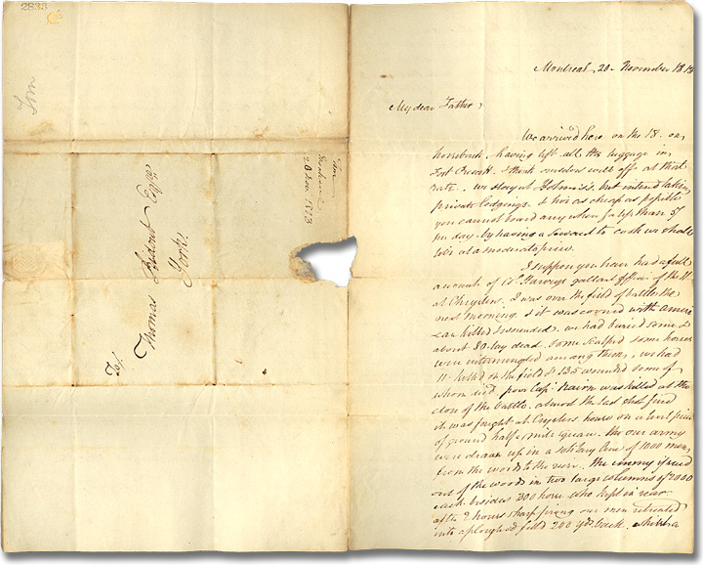

November 20, 1813

Thomas Ridout family fonds

Reference Code: F 43, box MU 2390

Archives of Ontario

Excerpt from this letter:

“My dear father, … I suppose you have had a full account of Col. Harvey’s gallant affair of the 11 at Chrysler. I was on the field of battle the next morning & it was covered with American killed & wounded. We had buried some & about 80 lay dead, some scalped some horses were intermingled among them. We had 11 killed on the field and 135 wounded some of them whom died. Poor Capt. Naime was killed at the close of the battle almost the last shot fired. It was fought at Chrysler’s house on a burnt piece of ground half a mile square. Our army were drawn up in a solitary line of 1,000 men from the woods to the river. The enemy is send out of the woods in two large columns of 2,000 each besides 300 horses…” - Thomas G. Ridout

### Source 3:

| **Question** | **Your Answer** |
| --- | --- |
| What is the record’s reference code? |  |
| Is this a primary source or secondary source? |  |
| Who created it? |  |
| When was it created? |  |
| Why do you think it was created, and for whom? |  |
| What point of view / side does the creator represent? |  |
| What does this source tell us about this battle at Chrysler’s Farm? |  |
| What does it not tell us? What questions do you still have about the battle? |  |

### Source 4: “Chrysler’s Farm” Entry from the Canadian Encyclopaedia

The Battle of Chrysler’s Farm was fought in a farmer's field on the banks of the St Lawrence River near Morrisburg, Ont, on 11 November 1813. An American force under the command of Major General James Wilkinson had sailed down the St Lawrence River with plans to capture Montréal and thereby complete the conquest of Upper Canada. A small corps of British regulars, Mohawk warriors and Canadian militia under Lieutenant-Colonel Joseph Wanton Morrison of the 89th Regiment harassed the Americans as they moved downriver, forcing Wilkinson to land over 3000 men on the Canadian shore to attack Morrison's smaller force of 1169 men.

While the Canadian militia and Mohawk warriors guarded the woods on either side of John Chrysler's field, the British regulars were drawn up in 2 lines to await the American assault. The Americans attacked the British lines without success and were forced to retreat from the battlefield after suffering severe losses. Wilkinson continued down the St Lawrence with the remnant of his demoralized army but before reaching Montréal he learned of a similar defeat of American General Hampton’s army, at the Battle of Châteauguay a few weeks earlier. The Americans were forced to call off the attack on Montréal.

Ronald J. Dale

The Canadian Encyclopaedia

The Historica-Dominion Institute, 2009

### Source 4:

| **Question** | **Your Answer** |
| --- | --- |
| What is the record’s reference code? |  |
| Is this a primary source or secondary source? |  |
| Who created it? |  |
| When was it created? |  |
| Why do you think it was created, and for whom? |  |
| What point of view / side does the creator represent? |  |
| What does this source tell us about this battle at Chrysler’s Farm? |  |
| What does it not tell us? What questions do you still have about the battle? |  |

## Reflecting on Interpreting Evidence

Reflect upon your learning using the questions provided.

1. Why is it important to use more than one source when researching a topic?
2. Why is it important to record the sources you use?
3. What can you learn from primary sources that you can’t learn from secondary sources?
4. When the Archives of Ontario provided extracts from their original documents they typed the text exactly as it was originally written (e.g. not correcting any spelling and grammar errors). How does this help us understand the event and time period?
5. We use the W5H [who / what / when / where / why / how] to help us focus our research. Go back over your research findings to determine if all of these types of questions were answered. Circle each type of question answered adequately.

Who? What? When? Where? Why? How?

1. What other sources might you search out to answer any unanswered questions and/or learn even more about the battle?
2. Why was this battle significant (important) during the War of 1812? Is it still important today? Why?

## Rubric: Presentation Evaluation

**1 – limited 2 – some 3 – good 4 – thorough, superior**

| **Category** | **Level & Comments** |
| --- | --- |
| **Thinking**  Demonstrates skills of inquiry and research   * uses and documents a variety of sources * uses analysis, synthesis and evaluation * presentation is organized and demonstrates planning * presentation shows unity and coherence * presentation includes one or more   connections/comparisons/conclusions about the significance of their battle | 1 2 3 4  (circle one) |
| **Communication**  Demonstrates through effective presentation a clear understanding of his/her topic | 1 2 3 4  (circle one) |