# Lesson: The War of 1812: Should I Stay or Should I Go?

Grade 7: Canada, 1800–1850: Conflict and Challenges

Image of a letter from Thomas G. Ridout (Kingston) to his father Thomas Ridout, November 1, 1813


## Introduction

In this lesson, students will use primary sources to investigate the War of 1812.

By using a chart to keep track of details, students will outline the hardships faced by soldiers during the War of 1812 and use this information to write a first-person letter about whether they would desert the army if they were in the soldiers’ place.

## Topic

The War of 1812

## Source

The Archives of Ontario’s War of 1812 online exhibit - [click here to view the online exhibit](http://www.archives.gov.on.ca/en/explore/online/1812/index.aspx).

Use the Archives of Ontario’s online exhibit on the War of 1812:

* As a learning resource for yourself
* As a site to direct your students for inquiry projects
* As a place to find and use primary sources related to the curriculum

## Themes that can be addressed

* Use of Primary Sources
* Perspective taking
* Life as a solider during the War of 1812

## Curriculum Links

**Strand B. Canada, 1800-1850: Conflict and Challenges**

| Overall Expectations | Historical Thinking Concepts | Specific Expectations |
| --- | --- | --- |
| **B1. Application:** Changes and Challenges | Continuity and Change; Historical Perspective | B1.1, B1.2, B1.3 |
| **B2. Inquiry:** Perspectives in British North Americans | Historical Perspective; Historical Significance | B2.1, B2.2, B2.4, B2.5, B2.6 |
| **B3. Understanding Historical Context:** Events and Their Consequence | Historical Significance; Cause and Consequence | B3.3, B3.5 |

# Assignment & Activity Ideas

## Lesson Plan

This lesson can be abbreviated and completed in one class or expanded and completed across five classes.

## Getting Organized

* Review the resources at the end of this plan
* Make overheads or create a PowerPoint with the introductory information found on: Slide 1: Research Questionand Directions
* Print out a set of primary sources for each student or for each group of students
* Print out copies of the Primary Source Chart, Letter handout, Vocabulary handout, and Reflection sheet for each student

## Lesson Outline

* Using Slide 1 tointroduce the following class activity: Use primary sources to learn about conditions of war during the War of 1812 and make a judgement in the form of a first-person letter as to whether they would stay or go based on their findings.
* Using the Should I Stay or Should I Go handout, encourage students to read the primary sources provided to fill out the chart.
* Encourage students to keep track of vocabulary they may not be familiar with.

A vocabulary handout is also available for distribution.

* Using the information found in the Should I Stay or Should I Go chart, ask students to write a letter incorporating hardships in a first person narrative on the Write a Letter handout.
* Share these letters as a class, read them aloud, put them up on display, have each student mail a letter to a peer, or even mail the letters to the Archives of Ontario and we’ll display them in our classroom space!
* Following the completion of the letters, hold a discussion about what the conditions of war can tell us about the conditions of life in early nineteenth century Upper Canada and how it compares to life in Ontario today. Examples could include:
  + Clothes were not plentiful or readily available. Many people had a set of clothes for the summer, another for the winter, and a third for church. Clothes had to be specially made for weather conditions.
  + People drove wagons with horses and there were few bodies (such as city governments) to take care of the roads.
  + Travel was difficult and time consuming.
  + Wounds were not easily cleaned or disinfected, meaning that many people died from wounds that today would not be serious.
  + As entertainment in the evening, men could relax by the fire and play cards.
  + Adequate accommodations could include a barn and it was not uncommon for travellers to ask a farmer if they could stay in his barn for the night.
  + Farming was an important part of life for most people. If they did not plant seeds each year they could starve
  + Letter writing was the most efficient way of communicating needs and wants.
* We have also provided a Reflection handout so that students can reflect on their own learning following the task.

## Extension/Accomodation

* The task can be undertaken individually, in small groups, as a jigsaw with primary source stations, or even as a class, complete with a presentation on primary sources.
* Instead of an individual chart, students in the class could complete a ‘graffiti’ activity by walking around the classroom, reading the primary sources, and writing down their thoughts about the content on a large piece of paper. The combined responses can form the basis of a class letter determining whether a solider should ‘stay or go.’ This would encourage a more affective and kinaesthetic engagement with the material.
* Instead of letter writing, the chart can form the basis of a class debate or trial for a soldier who deserted.
* Students can illustrate the conditions of a soldier who is thinking of deserting. A comic strip instead of a letter can still express the hardships of war in a format that may be more interesting to certain students.

# Handouts & Worksheets

Overhead 1: Exploration through the Archives! 6

Introduction to Primary Sources 7

Slide 1 - Research Question and Directions 8

Primary Source 1: 9

Primary Source 2: 10

Primary Source 3: 11

Primary Source 4: 12

Primary Source 5: 13

Primary Source 6: 14

Primary Source 7: 15

Should I Go or Should I Stay? 16

War of 1812 Vocabulary 17

Write a Letter 18

Reflection 19

## 

### Overhead 1: Exploration through the Archives!

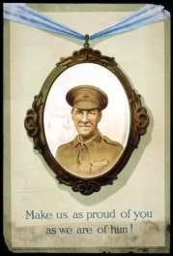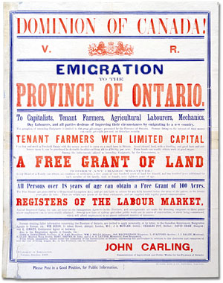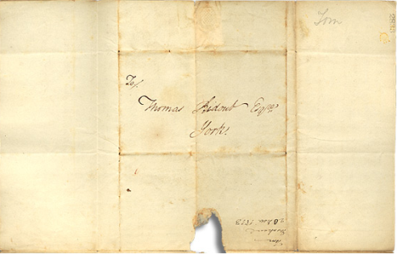

Over the course of a lifetime, most people accumulate a variety of records.

Taken together, these records can provide a fascinating view into someone’s life and into the past.

Like a detective investigating a case, a researcher using these records can get a sense of what a place looked like, what people were thinking, what life was like, and what happened and why.

Some examples of records that a historian may look at are:

* Birth, death, and marriage records
* letters or diaries
* photographs, sketches, and paintings
* court records
* audio, video and film records

An **archive** is a place where these records and historical documents are preserved. The **Archives of Ontario** collects and preserves records with relevance to the history of Ontario.

Using primary sources from the Archives of Ontario’s collections, you too can be an investigator exploring the past and understanding the present.

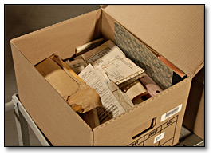 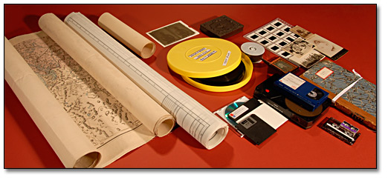 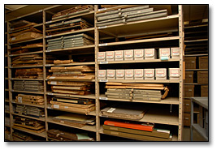

### Introduction to Primary Sources

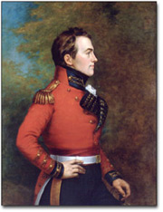

Major-General Sir Isaac Brock, KB [President and Administrator of Upper Canada, 1811-12], George Theodore Berthon, c. 1883

Government of Ontario Art Collection, 694158

A Primary Source is a document or object from the past created by people who lived during that time. Primary Sources provide a view into an event or experience that only people living during that time could have experienced.

Archives collect and preserve Primary Sources so that students can learn history from the experiences of people who were there. At Archives, Primary Sources are called Records. At Museums, Primary Sources are called Artefacts.

**Have you ever used a primary source before?**

| Primary Sources  (Original material from the past) | Secondary Sources  (Material people today write about the past) |
| --- | --- |
| Example:  Letters  Diaries  Photographs  Paintings and other art work  Graphs  Maps | Example:  Textbooks  Reference books  Websites such as Wikipedia  Current news articles  Documentaries and films |

**What are some other examples of primary and secondary sources?**

**Can sources be both primary and secondary?**

### Slide 1 - Research Question and Directions

It is best to begin with a research question before you start researching at an archive. For this lesson, your research question could be:

Why did soldiers desert the British army or militia during the War of 1812?

In the primary sources found at the Archives of Ontario, you will discover:

* What soldiers from the War of 1812 said to their loved ones about conditions of life during the war.
* Why the conditions of life were such that people deserted during wartime.
* If you were in their place, would you stay or would you go?

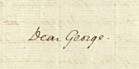

“Desertion has come to such height that 8 or 10 men go off daily” - Thomas G. Ridout

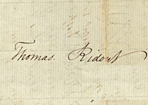

Extract from an original letter from Thomas G. Ridout to his brother George Ridout,

September 16, 1813

Thomas Ridout family fonds

Reference Code: F 43, box MU 2390

Desertion: To quit one’s post without permission especially with the intention of remaining away permanently.

Directions:

1. Read the 7 primary sources found in the Archives of Ontario collection
2. Fill out the chart about the Hardships expressed in the primary source.
3. Use the information on your chart to write a letter from the point of view of an 1812 solider. In this letter, inform a family member of the hardships of war. Share with them why you are thinking about the question “Should you stay or Should you go?” Have you made a decision?

### Primary Source 1:

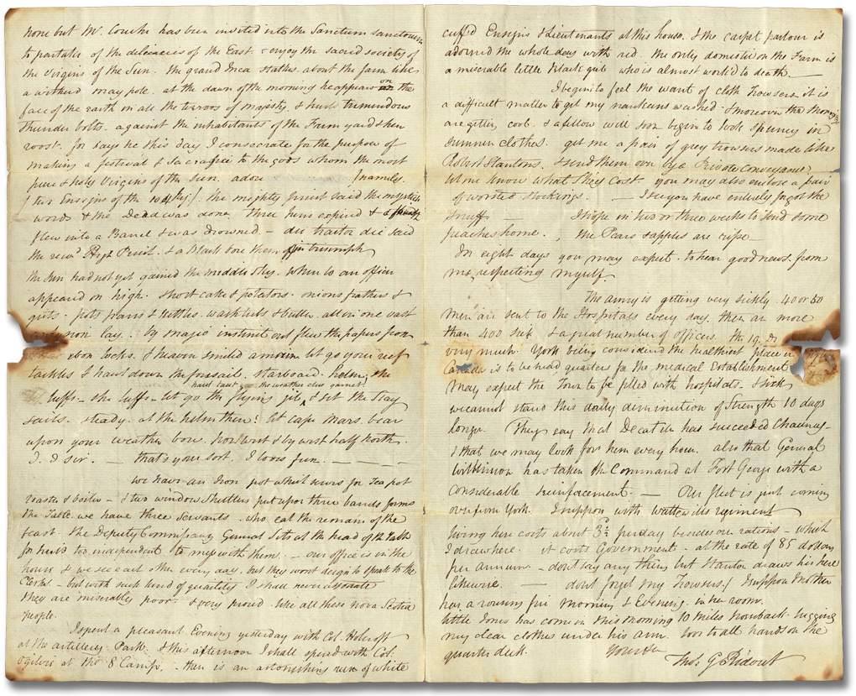

Letter from Thomas G. Ridout to his brother George Ridout, September 4, 1813 (Pages 2 and 3). Thomas Ridout family fonds,

Reference Code: F 43, box MU 2390, Archives of Ontario

“(…) I begin to feel the want of cloth trousers it is a difficult matter to get my nakedness washed. And moreover the mornings are getting cool. And a fellow will soon begin to look funny in summer clothes. Get me a pair of grey trousers made like Robert Stanton’s.”

- Thomas G. Ridout

### Primary Source 2:

“I have furnished barracks for one hundred and twenty men and they are all on the spot, including the Rifle Company now on duty here. And all are in the greatest want of almost every necessary. And I have this day received a letter from Col. Vincent referring me to you for stoves, blankets, etc. and I must observe that we are in as great want of shoes, pantaloons, jackets, and watch coats for the Guard”

- Colonel Joel Stone

Extract from an original letter from Colonel Joel Stone to  
Colonel Lethbridge, October 25, 1812  
Joel Stone family fonds  
Reference Code: F 536, MU 2892  
Archives of Ontario

### Primary Source 3:

Image: Photograph of a letter from Thomas G. Ridout (Kingston) to his father Thomas Ridout, November 1, 1813


“We have had a most harassing journey of 10 days to this place when we arrived last night in a snow storm. It has been snowing all day & is now half a foot deep. … Frequently I had to go middle deep in a mud hole & unload the wagon & carry heavy trunks 50 yards waist deep in the mire & reload the wagon. Sometimes put my shoulder to the fore wheel & raise it up. One night the wagon [upset] going up a steep hill in the woods in one of the worst places I ever saw.”

- Thomas G. Ridout

Extract from an original letter from Thomas G. Ridout (Kingston) to his father Thomas Ridout, November 1, 1813  
Thomas Ridout family fonds  
Reference Code: F 43, box MU 2390  
Archives of Ontario

### **Primary Source 4:**

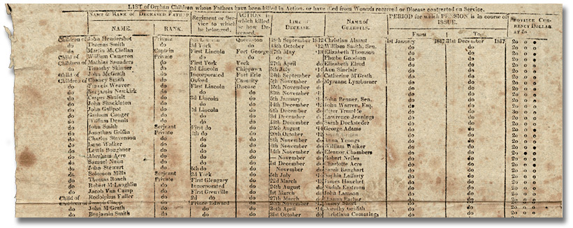

**Pension poster­Orphans (details), 1817**

**Robert Nelles family fonds**

**Reference Code: F 542, box MU 2192**

**Archives of Ontario**

The extract above is from a poster printed in 1817 that shows the pensions payable to minors left orphans by the war, war widows and militiamen disabled on active service.

Of interest is to note how many people died from disease and not battle wounds.

Overall 171 men serving in the militia were listed on this document as having died on service during the war. Of these 137 died of various diseases contracted while on duty; 25 were killed in action; and 9 from wounds received in battle or through an accident while on duty.

### Primary Source 5:

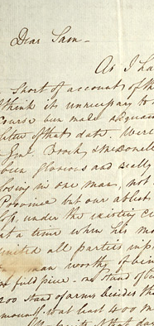

“I am very anxious to know how things go on in your part of the world. … I will remember the many happy evenings I spent by your fireside, when we had nothing to think of but play cards, drink whiskey & watch the old horse by the window. … But these days are gone perhaps never to return.”

– Thomas G. Ridout

Excerpt from a Letter from Thomas G. Ridout to his brother Samuel Ridout, December 3, 1813

Thomas Ridout family fonds

Reference Code: F 43, box MU 2390, Archives of Ontario

### Primary Source 6:

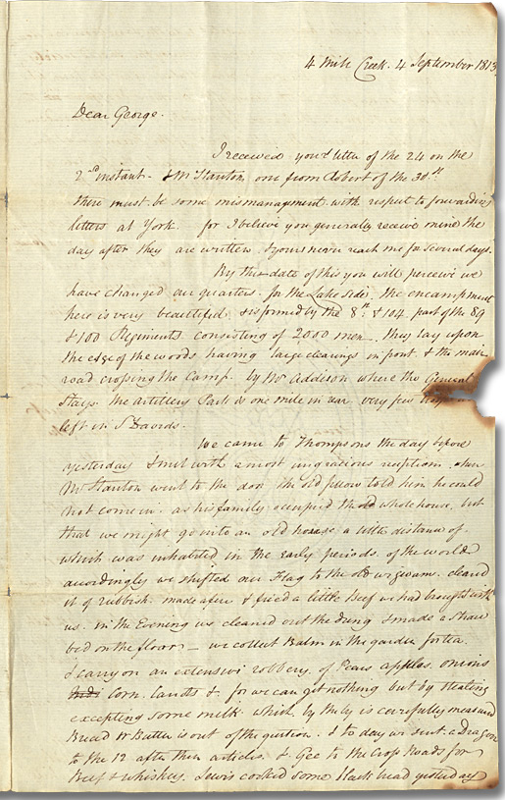

“We came to Thompson’s the day before yesterday. I met with a most ungracious reception when Mr. Stanton went to the don. The old fellow told him he could not come in as his family occupied the whole house but that we might go into an old house a little distance of which was inhabited in the early periods of the world. Accordingly we shifted our Flag to the old wigwam, cleared it of rubbish, made a fire & fried a little Beef we had brought with us. In the Evening we cleaned out the dung & made a straw bed on the floor. We collect balm in the garden for tea. I carry on an extensive robbery of pears, apples, onions, corn, carrots [etc.] for we can get nothing but by stealing excepting some milk, which by the by is carefully measured. Bread & butter is out of the question.”

- Thomas G. Ridout

Excerpt from a letter from Thomas G. Ridout to his brother George Ridout, September 4, 1813 (Pages 2 and 3)

Thomas Ridout family fonds

Reference Code: F 43, box MU 2390

Archives of Ontario

### Primary Source 7:

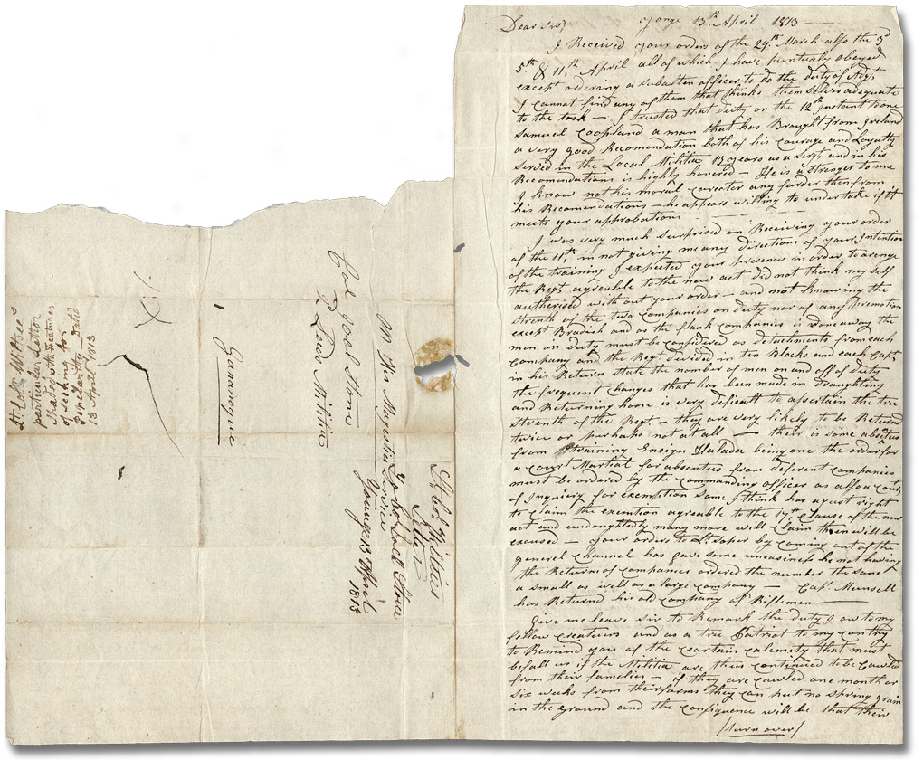

“Give me leave Sir to remark the duty I owe to my fellow creatures and as a true patriot to my country to remind you at the certain calamity that must befall us if the Militia are thus continued to be [called] from their families. If they are [called] one month or six weeks from their farms they can put no spring grain in the ground and the consequence will be that their families must inevitably suffer the famine even threatens before the ensuing harvest when there is but little sown that can be [reaped] if the farmers are prevented from putting in spring grain the famine will undoubted be dreadful.”

- Colonel Benoni Wiltse

Letter from Lieutenant Colonel Benoni Wiltse to Colonel Joel Stone, April 13, 1813

Joel Stone family fonds

Reference Code: F 536, MU 2892

Archives of Ontario

### Should I Go or Should I Stay?

Read each of the primary sources provided. In the chart below, give each hardship an appropriate label and then provide details about why this hardship would be difficult for the soldiers.

| **Source** | **Hardship** | **Details** | **Reference Information** | **Vocabulary Words** |
| --- | --- | --- | --- | --- |
| 1 |  |  |  |  |
| 2 |  |  |  |  |
| 3 |  |  |  |  |
| 4 |  |  |  |  |
| 5 |  |  |  |  |
| 6 |  |  |  |  |
| 7 |  |  |  |  |

### War of 1812 Vocabulary

Check this list for any words you may not have been familiar with when reading the primary sources. Can you add any others?

| **Vocabulary Word** | **Definition** |
| --- | --- |
| Archive | A place in which public records or historical documents are preserved |
| Balm | Resin from small evergreen trees |
| Barracks | A building or group of buildings in which soldiers live |
| Calamity | Deep distress or misery |
| Desertion | To quit one’s post without permission especially with the intention of remaining away permanently |
| Don | Head of household |
| Dung | Waste matter of an animal |
| Ensuing | To come at a later time or as a result |
| Extract | To choose and take out for separate use |
| Famine | An extreme general shortage of food |
| Fonds | Collection of papers that originate from the same source |
| Fore | In, toward, or near the front |
| Harass | To tire out by continual efforts; to annoy persistently |
| Militia | A body of citizens with some military training who are called to active duty only in an emergency |
| Mire | Heavy often deep mud or slush |
| Pantaloon | Close-fitting trousers usually with straps passing under the insteps |
| Predominant | Greater in importance, strength, influence, or authority |
| Primary Sources | Original, first-hand accounts created at the time of an event, or very soon after something has happened. These sources are often rare or one-of-a-kind. |
| Sown | To plant seed for growth |
| Ungracious | Rude or disagreeable |
| Unsanitary | State of filth, infection, or dangers to health |

### Write a Letter

Put yourself in the place of a soldier during the War of 1812. Write a letter to a friend or family member telling them of the hardships of being a soldier and why you are thinking of the question, ‘**Should I Go OR Should I Stay’**?

Keep in mind that the purpose of your letter is to make sure the audience understands the hardships of being a soldier.

### Reflection

1. Place a check on the line provided to show how valuable the extracts from the original letters were in helping you understand what it was like to be a soldier during the War of 1812.

Extremely valuable _______________________ Not valuable

1. Explain why you placed your checkmark where you did:
2. What are the advantages of using Primary Sources to learn about history?
3. List some of the disadvantages of using Primary Sources when studying history.
4. List three questions you would have liked Mr. Ridout or Mr. Stone to have answered about military life during of the War of 1812? Explain why you would like to learn more about each of these topics:

| **Question** | **Why You Would Like to Learn**  **More About This Topic?** |
| --- | --- |
| Blank space for student answer | Blank space for student answer |
| Blank space for student answer | Blank space for student answer |
| Blank space for student answer | Blank space for student answer |

1. How has the archival material helped you answer your research question?