Teaching Resource Kit:
David Thompson – Fur Trade and Exploration
Grade 7: New France and British North America, 1713–1800
Canada, 1800–1850: Conflict and Challenges
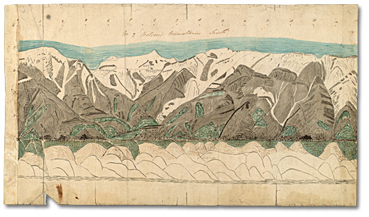
Sketches of elevations or mountains, [ca. 1809]
Thompson (David) Papers, Ms. Coll. 21, item 5
Thomas Fisher Rare Book Library
University of Toronto

Introduction
Designed to fit into teachers’ practice, this resource kit provides links, activity suggestions, primary source handouts and worksheets to assist you and your students in applying, inquiring, and understanding Canada between 1713 and 1850.

Topics
- Early New France
- British North America trade and exploration

Source
The Archives of Ontario’s online exhibit about David Thompson - click here to visit the online exhibit "David Thompson, Map Maker, Explorer and Visionary".
Use the Archives of Ontario’s online exhibit on David Thompson:
- As a learning resource for yourself
- As a site to direct your students for inquiry projects
- As a place to find and use primary sources related to the curriculum

Themes that can be addressed
- Use of Primary Sources
- Fur trade companies and British fur traders
- British fur traders and First Nations allies
- Families of British fur traders
- Mapping the fur trade
- Significance of geographers for defining British North America, especially related to the Treaty of Ghent

Curriculum Links
Strand A. New France and British North America, 1713–1800
Overall Expectations | Historical Thinking Concepts | Specific Expectations
A1. Application: Colonial and Present-day Canada | Continuity and Change; Historical Perspective | A1.1, A1.2
A2. Inquiry: From New France to British North America | Historical Perspective;  Historical Significance | A2.4
A3. Understanding Historical Context: Events and Their Consequences | Historical Significance;  Cause and Consequence | A3.3, A3.4, A3.5, A3.6

Strand B. Canada, 1800–1850: Conflict and challenges
Overall Expectations | Historical Thinking Concepts | Specific Expectations
B1. Application: Changes and Challenges | Continuity and Change;  Historical Perspective | B1.1
B2. Inquiry: Perspectives in British North Americans | Historical Perspective;  Historical Significance | B2.3, B2.4
B3. Understanding Historical Context: Events and Their Consequence | Historical Significance;  Cause and Consequence | B3.4, B3.5

Assignment & Activity Ideas

Inquiring into the Fur Trade
- Drawing on the 2013 revised History curriculum, the historical inquiry process involves five steps:
- Formulating a question
- Gathering and organizing information or evidence
- Interpreting and analysing information or evidence
- Evaluating information or evidence and drawing conclusions
- Communicating findings
- The curriculum highlights that these steps do not have to be completed sequentially nor together. You may wish to explore specific steps based on your students’ readiness and prior knowledge or your own resources and time. See pages 22-24 in the 2013 revised Ontario Social Studies and History curriculum for more details.
- Using a primary source handout from this Kit, introduce your students to the topic of David Thompson and the fur trade. Ask students to ask questions of the image, Thompson and his experience, or the general topic of the fur trade. Use these questions as jumping off points to explore these historical issues in more depth.
- Use the David Thompson, Map Maker, Explorer and Visionary online exhibit as a source to point your students for their own inquiry project. Here, they can view primary sources and secondary information to gather and organize historical information that they can interpret, evaluate, and communicate for different end products.

One Source, Many Questions
- Using one of the primary source handouts found in this Teaching Kit, ask students to identify the 5Ws (who, what, where, why, and when?) profiling the source. The Identifying My Primary Source worksheet can help in this task.
- Ask students to zoom in on one of the aspects of the source they found strange, familiar, or interesting and identify them to the class. Write these things on the board and group them according to theme.
- Use one or more of these themes as an introduction to an inquiry-based assignment. Have students work in collaborative groups, individually, or as a class as a short or long term project researching the historical context of the primary source.

Mapping David Thompson
- Map David’s Thompson’s travels. Include primary sources found in this kit and on the online exhibit as markers on places of significance.
- Alternatively, create a map of Upper and Lower Canada using David Thompson records and modern pictures of the same place.
- Alternatively, ask students to create a Google map of the same area originally mapped by David Thompson. Comparing and contrasting the two maps, discuss changes in mapping methods. Do modern maps tell us new or different information?

Is David Thompson Significant?
- Ask students to develop criteria as to what makes someone or something significant enough for a memorial.
- Using the Ways to Remember David Thompson handout, ask students to create another memorial for David Thompson.
- Alternatively, ask students to use the David Thompson memorial as a model to create a stamp and plaque for another figure in Canadian history or an explorer person from today, such as Chris Hadfield.

Handouts & Worksheets

Introduction to Primary Sources 6
Identifying My Primary Source 7
Trading Posts: Hudson’s Bay Company and Northwest Company (1820) 8
David Thompson’s Sketch of Mountains (1809) 9
David Thompson’s Travels 10
David Thompson’s Notebook 11
Treaty of Ghent Survey 12
Map of the North-West Territory of the Province of Canada (1814) 13
Ways to Remember David Thompson 14

Introduction to Primary Sources
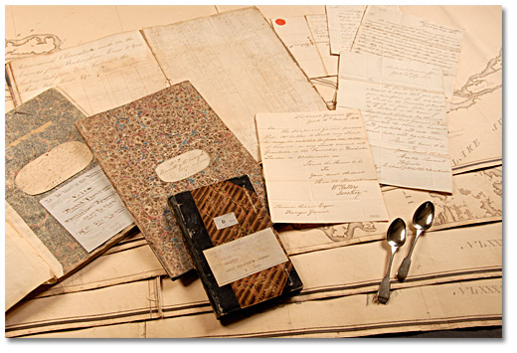
A selection of items from the David Thompson fonds,
Carrie McGillivray fonds, and Cartographic Records Collection
Archives of Ontario

A Primary Source is a document or object from the past created by people who lived during that time. Primary Sources provide a view into an event or experience that only people living during that time could have experienced.
Archives collect and preserve primary sources so that students can learn history from the experiences of people who were there. At an archive, primary sources are called records. At a museums, primary sources are called artifacts.
Have you ever used a primary source before?
Primary Sources | Secondary Sources
Original material from the past | Material people today write about the past
Example:  Letters  Diaries  Photographs  Paintings and other art work  Graphs  Maps | Example:  Textbooks  Reference books  Websites such as Wikipedia  Current news articles  Documentaries and films

What are some other examples of primary and secondary sources?
Can sources be both primary and secondary?

Identifying My Primary Source
Name of primary source:_________________________________________________
What type of primary source is it?__________________________________________
What is happening in this primary source?____________________________________
______________________________________________________________________
Who created it? _________________________________________________________
Why was it created?_____________________________________________________
When was it created?____________________________________________________
Where was it created?____________________________________________________
What when you look at this source, is there anything strange about it?
______________________________________________________________________
______________________________________________________________________
When you look at this source, is there anything familiar about it?
______________________________________________________________________
______________________________________________________________________
What do you want to know about this primary source?
______________________________________________________________________
______________________________________________________________________
What do you want to know about the people in the primary source?
______________________________________________________________________
______________________________________________________________________
What is the most interesting thing about this primary source?
______________________________________________________________________
______________________________________________________________________

Trading Posts: Hudson’s Bay Company and Northwest Company (1820)
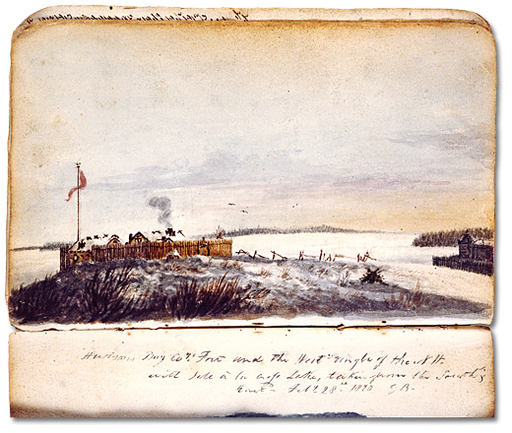
Hudson’s Bay Company and Northwest Company
Forts at Île-à-la-Crosse, February 28, 1820
Watercolour by George Back
Acc. No. 1994-254-1.40R
Library and Archives Canada

David Thompson’s Sketch of Mountains (1809)
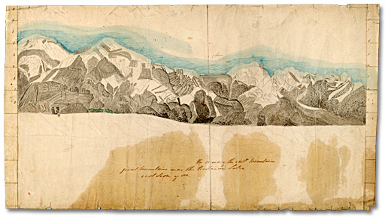
Sketches of elevations or mountains, [ca. 1809]
Thompson (David) Papers, Ms. Coll. 21, item 5 (?)
Thomas Fisher Rare Book Library, University of Toronto

David Thompson’s Travels
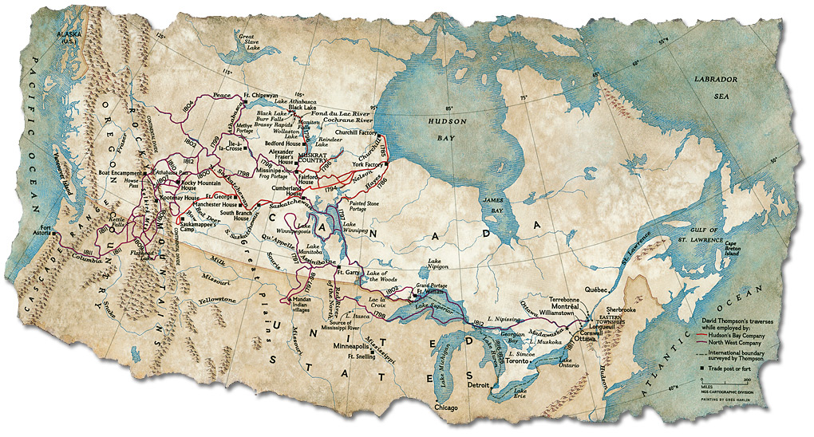
Map Showing Thompson’s Travels
Cartographic Computer Lab, #503802, National Geographic Image Collection

David Thompson’s Notebook
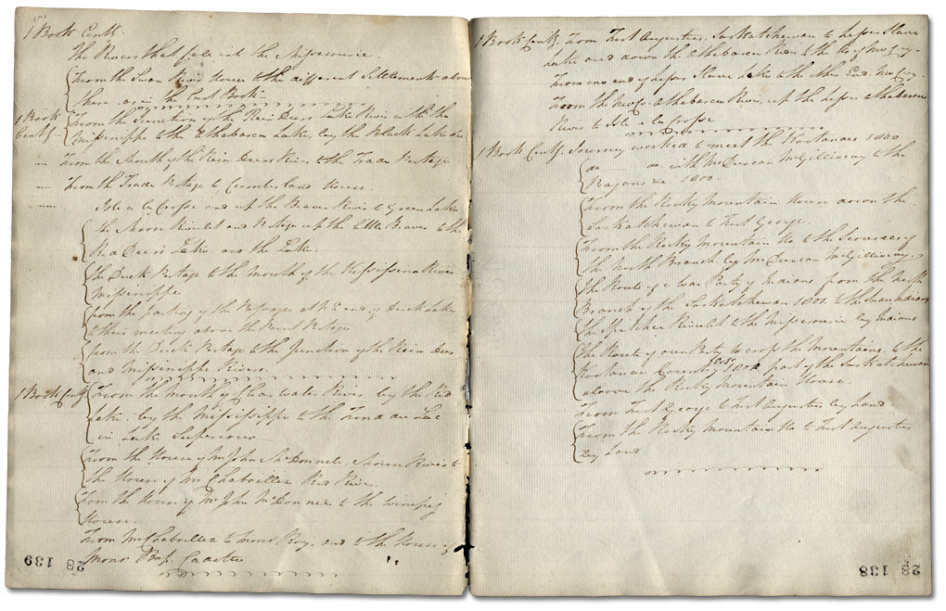
Journal No. 28, pp. 138-139 (1803-1831)
David Thompson’s notebooks and journals, Reference Code: F 443-1
Archives of Ontario
How would you keep track of your travels today?

Treaty of Ghent Survey
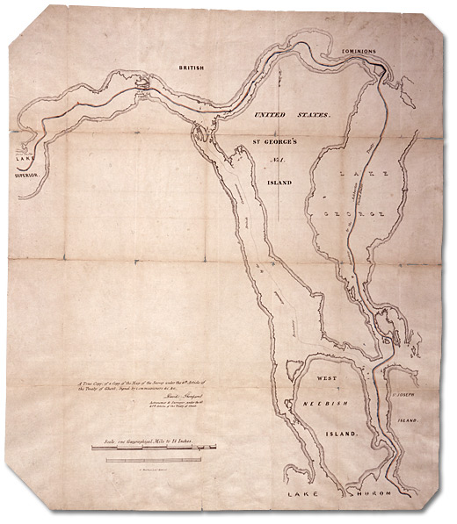
A Map of the Survey under the 6th Article of the Treaty of Ghent, signed by the Commissioners & c. & c., David Thompson, Astronomer & Surveyor.
G. Matthews’ Lith., Montreal, [ca. 1826]
Cartographic Records Collection, Reference Code: B-40-03
Archives of Ontario

Map of the North-West Territory of the Province of Canada (1814)
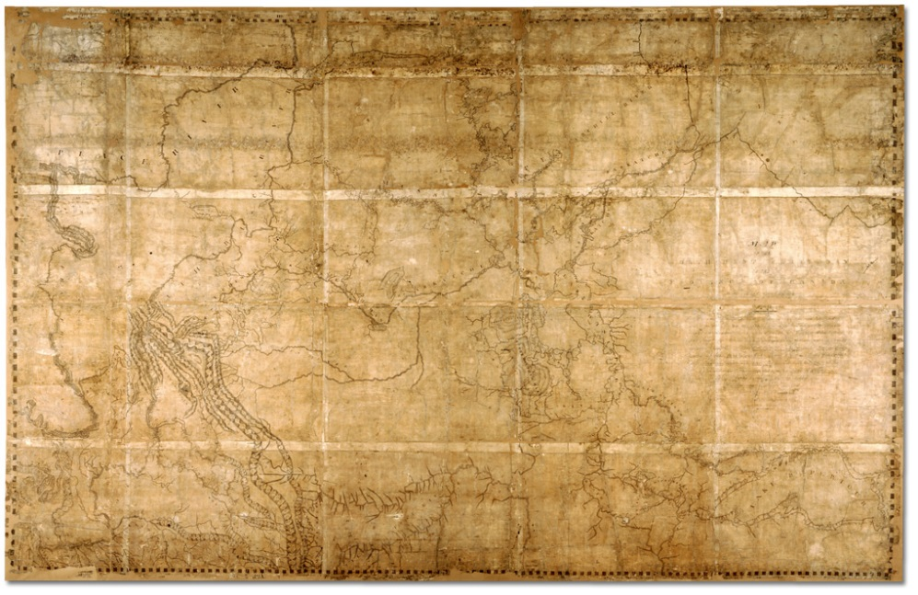
Map of the North-West Territory of the Province of Canada (1814)
David Thompson fonds, Reference Code: F 443, R-C(U), AO 1541
Archives of Ontario, I0030317

Ways to Remember David Thompson

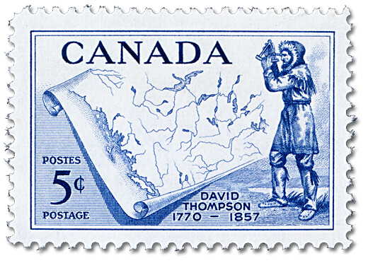
David Thompson (1770-1857), issued 5 June 1957
Designed by George Gundersen, engraved by Yves Baril
Canadian Postal Archives, POS-424
Library and Archives Canada

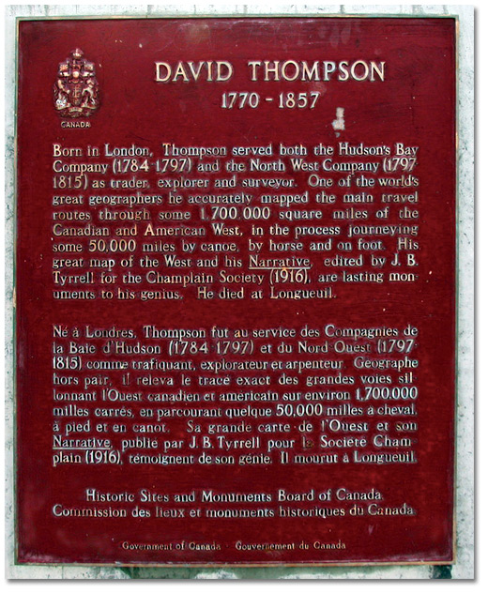
David Thompson 1770-1857
Historic Sites and Monuments Board of Canada plaque
Parks Canada, 2006

