Lesson Resource Kit: Enslaved Africans in Upper Canada
Grade 7: New France and British North America, 1713–1800
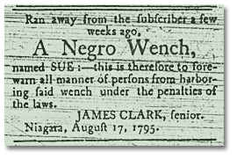
Upper Canada Gazette, 19 August 1795
N31, Archives of Ontario

Introduction
Designed to fit into teachers’ practice, this resource kit provides links, activity suggestions, primary source handouts and worksheets to assist you and your students in applying, inquiring, and understanding Canada between 1713 and 1800.

Topic
Slavery in British North America

Source
The Archives’ Enslaved Africans in Upper Canada online exhibit - click here to view.
Use the Archives of Ontario’s online exhibit on Enslaved Africans in Upper Canada:
- As a learning resource for yourself
- As a site to direct your students for inquiry projects
- As a place to find and use primary sources related to the curriculum

Themes that can be addressed
- Use of Primary Sources
- The forced migration of African slaves to New France and British North America
- Restrictions on rights and freedoms of slaves
- An Act to Prevent the Further Introduction of Slaves (1793)

Curriculum
Strand A. New France and British North America, 1713–1800
Overall Expectations | Historical Thinking Concepts | Specific Expectations
A1. Application: Colonial and Present-day Canada | Continuity and Change; Historical Perspective | A1.1, A1.2, A1.3
A2. Inquiry: From New France to British North America | Historical Perspective;  Historical Significance | A2.1, A2.2, A2.3, A2.4, A2.5, A2.6
A3. Understanding Historical Context: Events and Their Consequences | Historical Significance;  Cause and Consequence | A3.1, A3.2, A3.3, A3.4, A3.5, A3.6

Assignment & Activity Ideas

Inquiring into Slavery in Upper Canada
- The historical inquiry process involves five steps:
- Formulating a question
- Gathering and organizing information or evidence
- Interpreting and analysing information or evidence
- Evaluating information or evidence and drawing conclusions
- Communicating findings
- The curriculum highlights that these steps do not have to be completed sequentially nor together. You may wish to explore specific steps based on your students’ readiness and prior knowledge or your own resources and time. See pages 22-24 in the 2013 revised Ontario Social Studies and History curriculum for more details.
- Using a primary source handout from this kit, introduce your students to the topic of slavery in Canada. Ask students to ask questions of the primary source provided. Use these questions as a jumping off point to explore these historical issues in more depth.
- Click here to view Enslaved Africans in Upper Canada online exhibit and use this as a source to point your students for their own inquiry project. Here, they can view primary sources and secondary information to gather and organize historical information that they can interpret, evaluate, and communicate for different end products.

Imagining First-Hand Accounts
- We have very few first-hand accounts of slavery from the words of the people who were enslaved. We can encourage our students to research and imagine the words of those who were enslaved from the primary source left behind.
- For example, we are able to learn about Chloe Cooley through the words of others (see Chloe Cooley and Slavery in Upper Canada). While we don’t know what happened to Chloe, we know that in reporting her struggle at being sold, we have an account of how this woman actively resisted the actions done to her without her consent.
- Have your students write a first-hand account from the perspective of an enslaved person using the newspaper clippings provided on handouts Advertisements for Slaves (1795-1802) or Advertisements Regarding Escaped Slaves (1793-1795).

Memorializing Significance
- Using an imagined perspective of someone who was featured in the newspaper clippings on Advertisements for Slaves (1795-1802) or Advertisements Regarding Escaped Slaves (1793-1795), have your students create a memorial plaque, such as the one found on the Marking Significance handout, a sketch of a statue, a postage stamp, or another form of memorialization to mark the significance of someone who was lost to history.

Examining Primary Sources
- Have your students read the Chloe Cooley and Slavery In Upper Canada handout. Ask them what they think happened following that incident. They may say that slavery was completely abolished in Canada following that incident. Highlight that this is a secondary source about slavery in British North America.
- Have students explore An Act to Prevent the Further Introduction of Slaves that resulted from the Chloe Cooley incident. See if they can figure out that the Act prevents the further introduction of slaves to British North America without infringing on others’ “private property,” or current slave holdings.
- Discuss with your students the importance of using primary sources to get a full account of the past. If you only read a secondary source, you might think slavery was completely abolished. As an extension, have your students research when slavery was completely abolished in British North America as well as New France.

Handouts & Worksheets

Introduction to Primary Sources 6
Organizing Your Thoughts 7
Chloe Cooley and Slavery in Upper Canada 8
Advertisements, 1795-1802 9
Unidentified Women (1875) 10
Advertisements Regarding Escaped Slaves (1793-1795) 11
Marking Significance 12
An Act to Prevent the Further Introduction of Slaves (1793) 13
An Act for the Abolition of Slavery throughout the British Colonies (1833) 14
Matthew Elliott Homestead 15
Henry Lewis’ letter to William Jarvis 16

Introduction to Primary Sources
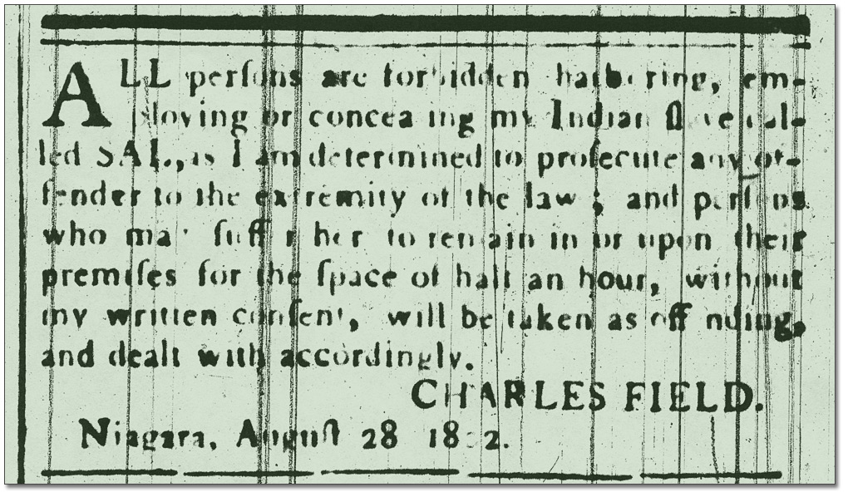
Advertisement, Niagara Herald, 28 August, 1802
Reference Code: N23
Archives of Ontario
A primary source is a document or object from the past created by people who lived during that time. Primary sources provide a view into an event or experience that only people living during that time could have experienced.
Archives collect and preserve primary sources so that students can learn history from the experiences of people who were there. At an archive, primary sources are called records. At a museums, primary sources are called artifacts.
Have you ever used a primary source before?
Primary Sources | Secondary Sources
Original material from the past | Material people today write about the past
Example:  Letters  Diaries  Photographs  Paintings and other art work  Graphs  Maps | Example:  Textbooks  Reference books  Websites such as Wikipedia  Current news articles  Documentaries and films
What are some other examples of primary and secondary sources?
Can sources be both primary and secondary?

Organizing Your Thoughts
What you know

What you want to know

What you are going to research

Chloe Cooley and Slavery in Upper Canada
March 14, 1793, Queenston, ON - William Vrooman, a Canadian slave owner, takes a woman slave by force across the river and sells her to an American buyer.
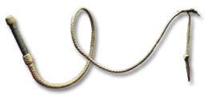
Whip, ca. 1850
Uncle Tom's Historic site
© Ontario Heritage Trust
Chloe Cooley does not go quietly. It takes three men to tie her up and throw her in a boat. Once on the American side, she screams and resists - they bind her once more and hand her over to a new owner.
Chloe Cooley has no rights. She is considered property that can be bought and sold, or bequeathed in her owner’s will. Most of 18th-century society condones slavery as a normal condition and an economic necessity; few people are willing to assist slaves to escape their servitude.
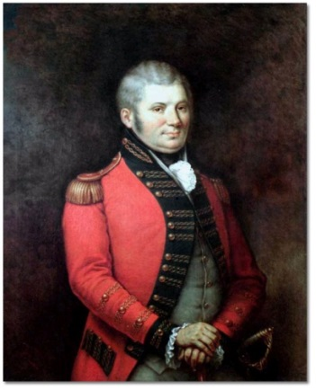
Colonel John Graves Simcoe, George Theodore Berthon, c. 1881
Government of Ontario
Art Collection, 694156
Peter Martin, a free Black man, brought William Grisley, a witness to the Chloe Cooley’s struggle, to make an official report about this incident to John Graves Simcoe, the Lieutenant-Governor of Upper Canada. Together, they recounted the story at the Executive Council meeting on March 21, 1793.
Simcoe, a supporter of the movement to abolish slavery even before coming to Upper Canada, used the Chloe Cooley incident as a catalyst for enacting legislation against slavery.

Advertisements, 1795-1802
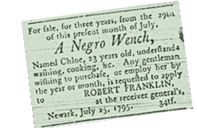 | For Sale, a Negro Wench,  Upper Canada Gazette,  19 August 1795  Reference Code: N 31  Archives of Ontario
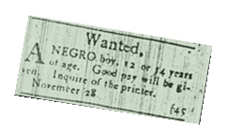 | Wanted, A Negro Boy,  Niagara Herald, 18 November 1801 to 9 January 1802  Reference Code: N 23  Archives of Ontario
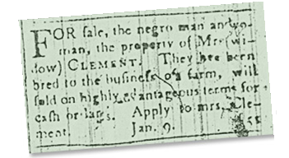 | For Sale, The Negro Man and Woman  Niagara Herald, 9 January  to 13 February, 1802  Reference Code: N 23  Archives of Ontario

Unidentified Women (1875)
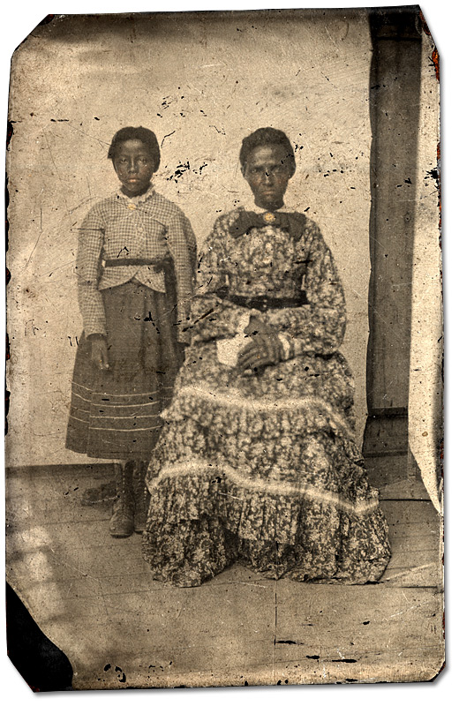
Unidentified women, ca. 1875
Alvin D. McCurdy fonds
Reference Code: F 2076-16-4-7
Archives of Ontario, I0028819

Advertisements Regarding Escaped Slaves (1793-1795)

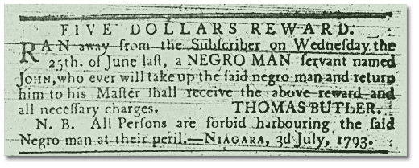
Upper Canada Gazette, 4 July 1793
N31, Archives of Ontario
Upper Canada Gazette, 19 August 1795
N31, Archives of Ontario

Marking Significance
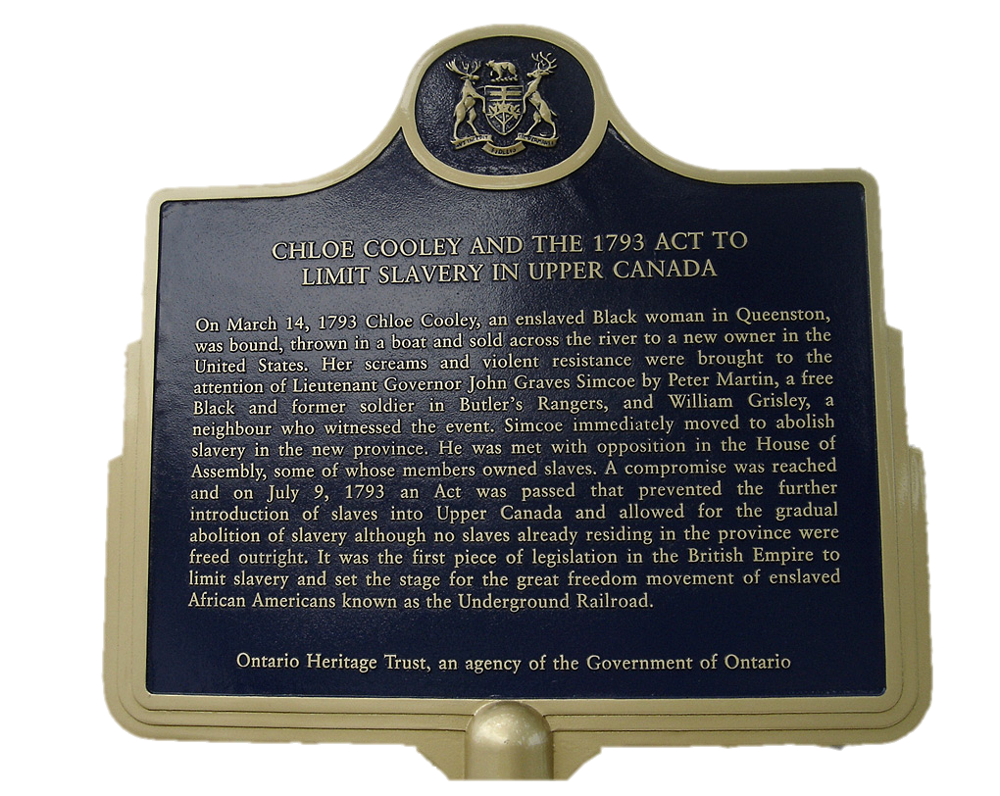
This plaque, located on Niagara Parkway in Niagara-on-the-Lake, marks the spot where Chloe Cooley was forced across the river to be sold.
© Ontario Heritage Trust

An Act to Prevent the Further Introduction of Slaves (1793)
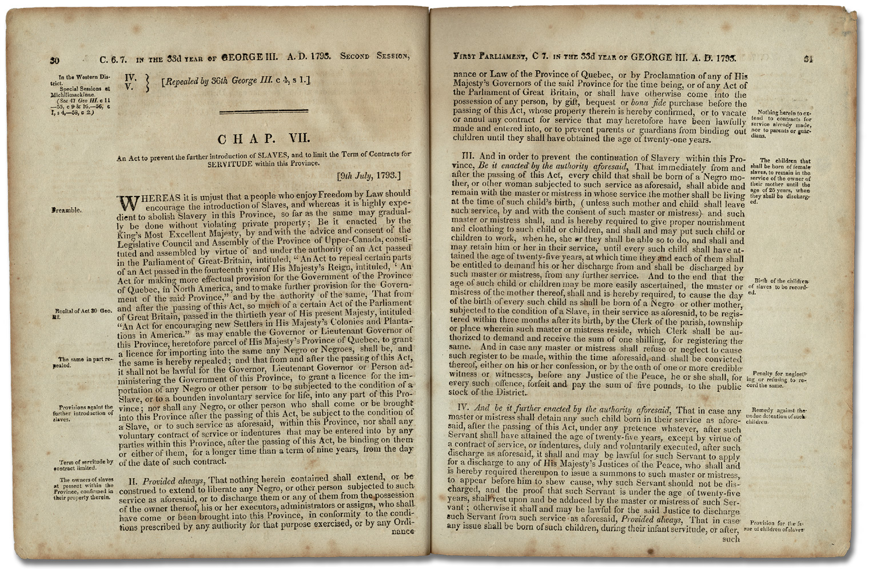
An Act to Prevent the further Introduction of Slaves and to limit the Term of Contracts for Servitude
Statutes of Upper Canada 33 George III, Cap. 7, 1793
Archives of Ontario

An Act for the Abolition of Slavery throughout the British Colonies (1833)
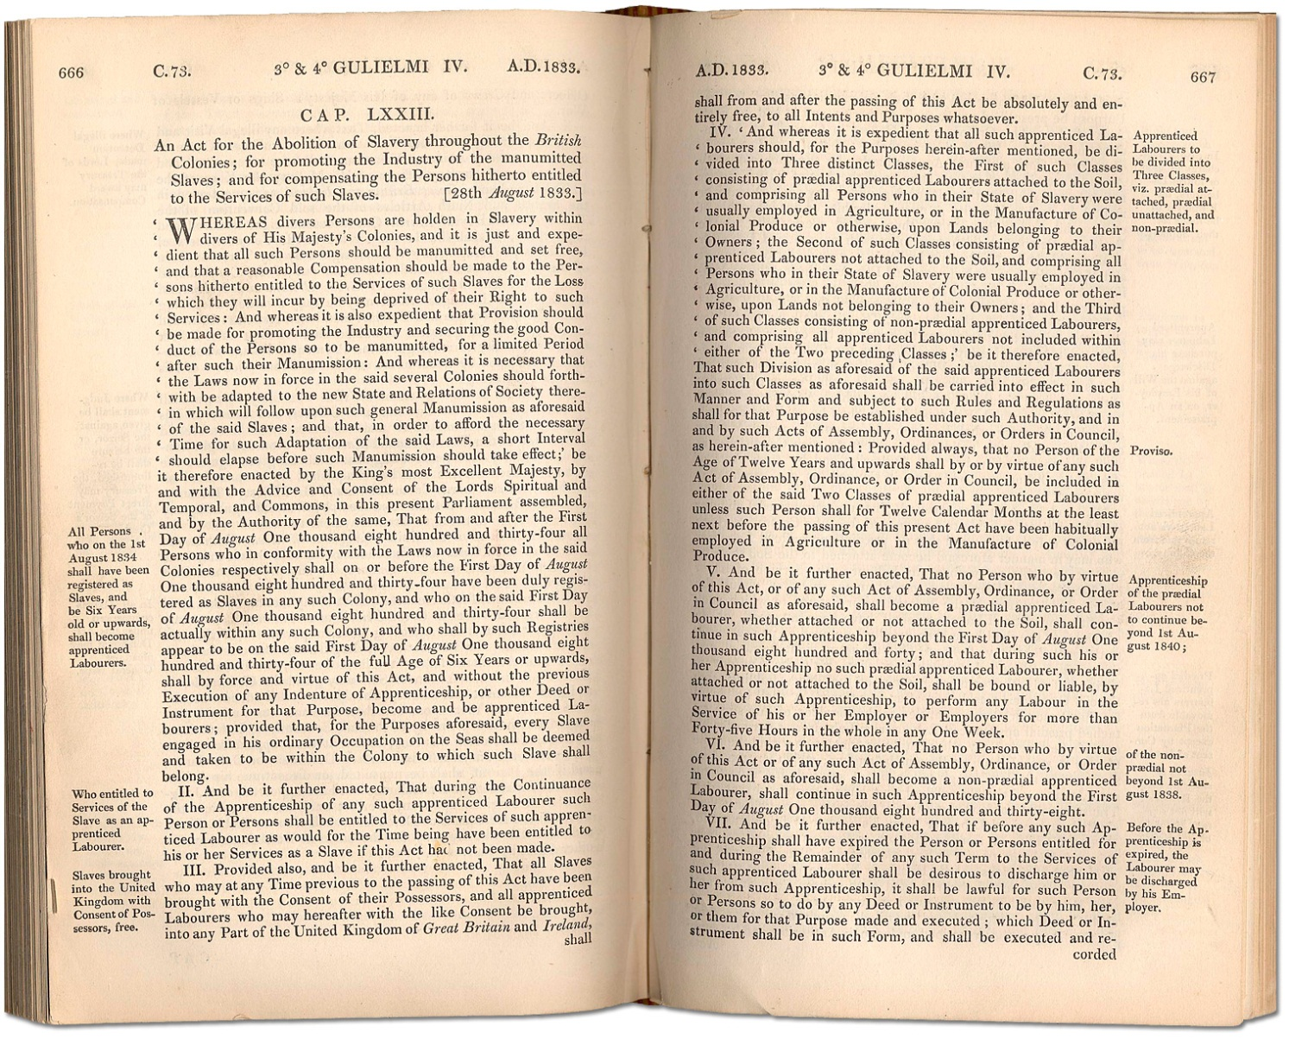
1833 British Imperial Act Passed in 1833
Courtesy of Parliamentary Archives, U. K

Matthew Elliott Homestead
Matthew Elliot, a Loyalist who came from Virginia during the American Revolution, probably had as many as sixty slaves living in the huts behind his home in Fort Malden (now Amherstburg).
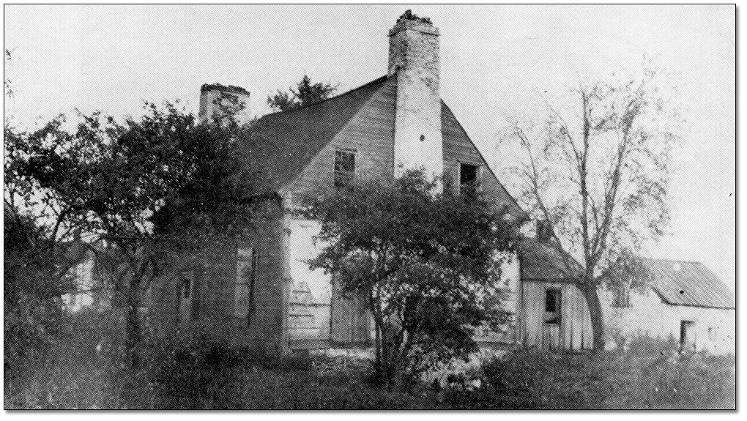
Matthew Elliott homestead built in 1784 (from a photo taken in 1912), Parks Canada Agency, Fort Malden National Historic Site of Canada

Henry Lewis’ letter to William Jarvis
Henry Lewis escaped from his owner in Newark (Niagara-on-the-Lake), Upper Canada by fleeing to Schenectady, New York. Sometime later he wrote to his ex-owner, William Jarvis, to request he be allowed to buy his own freedom from Jarvis.
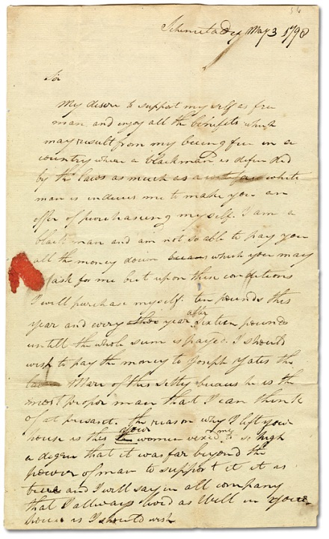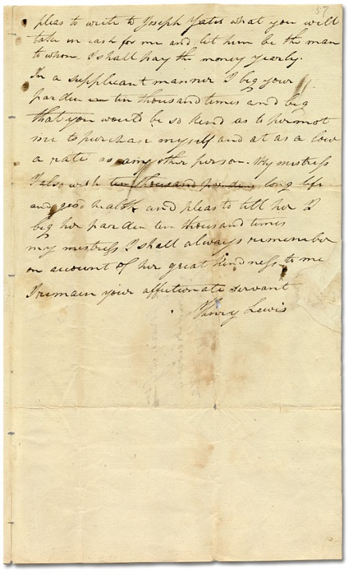
Henry Lewis letter to William Jarvis, 1798, William Jarvis Papers, Reference Code: S109 B55 PP. 56-57, Toronto Public Library (TRL)
Special Collections, Archive & Digital Collections, Baldwin Room

Henry Lewis's letter of 1794 provides some indication of his motives:
“My desired to support myself as free man and enjoy all the benefits which may result from my being free in a country where a Blackman is defended by the laws as much as a white man is induce me to make you an offer of purchasing myself . . . .the reason why I left your house is this your [wife Hannah] vexed me to so high a degree that it was far beyond the power of man to support it is true and I will say in all company that I always lived as well in your house as I should wish.”
-Henry Lewis

