Lesson Resource Kit: French Ontario in the 17th and 18th Centuries
Grade 7: New France and British North America, 1713–1800
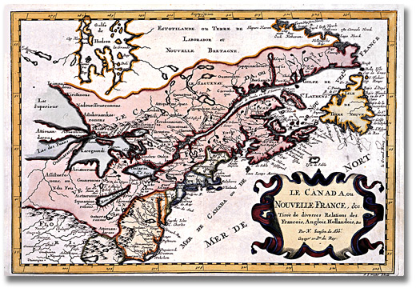
Sanson, Nicolas.
Le Canada ou Nouvelle France, & Tirée de diverses
Relations des François, Anglois, Hollandois, &c. [ca. 1660]
Reference Code: C 78, A0 4943
Archives of Ontario

Introduction
Designed to fit into teachers’ practice, this resource kit provides links, activity suggestions, primary source handouts and worksheets to assist you and your students in applying, inquiring, and understanding Canada between 1713 and 1800.

Topic
The history of the French in Ontario

Source
Click here to access the French Ontario in the 17th and 18th Centuries online exhibit
Use the Archives of Ontario’s online exhibits on French Ontario:
- As a learning resource for yourself
- As a site to direct your students for inquiry projects
- As a place to find and use primary sources related to the curriculum

Themes that can be addressed
- Use of Primary Sources
- Perspective taking
- Determining significance
- Legal and territorial change and development
- Attitudes of French and British missionaries, traders, soldiers and settlers and explorers towards First Nations
- Using maps

Curriculum
Strand A. New France and British North America, 1713–1800
Overall Expectations | Historical Thinking Concepts | Specific Expectations
A1. Application: Colonial and Present-day Canada | Continuity and Change; Historical Perspective | A1.1, A1.2
A2. Inquiry: From New France to British North America | Historical Perspective;  Historical Significance | A2.1, A2.2, A2.3, A2.4, A2.5, A2.6
A3. Understanding Historical Context: Events and Their Consequences | Historical Significance;  Cause and Consequence | A3.1, A3.2, A3.3, A3.4, A3.5, A3.6

Assignment & Activity Ideas

Inquiring into the Early French Ontario
- Drawing on the 2013 revised History curriculum, the historical inquiry process involves five steps:
- Formulating a question
- Gathering and organizing information or evidence
- Interpreting and analysing information or evidence
- Evaluating information or evidence and drawing conclusions
- Communicating findings
- The curriculum highlights that these steps do not have to be completed sequentially nor together. You may wish to explore specific steps based on your students’ readiness and prior knowledge or your own resources and time. Click here to see pages 22-24 in the 2013 revised Ontario Social Studies and History curriculum for more details.
- Using a primary source handout from this Kit, introduce your students to the topic of French exploration and settlement in Canada. Ask students to share their observations or questions of the primary source and use these questions as jumping off points to explore the historical issues in more depth.
- Click here to see and use the French Ontario in the 17th and 18th Centuries online exhibit as a source to point your students for their own inquiry project. Here, they can view primary sources and secondary information to gather and organize historical information that they can interpret, evaluate, and communicate for different end products.

One Source, Many Questions
- Using one of the primary source handouts found in this Teaching Kit, ask students to identify the 5Ws profiling the source. The Identifying My Primary Source worksheet can help in this task.
- Ask students to zoom in on one of the aspects of the primary source they found strange, familiar, or interesting and identify them to the class. Write these things on the board and group them according to theme.
- Use one or more of these themes as an introduction to an inquiry-based assignment. Have students work in collaborative groups, individually, or as a class as a short or long term project researching the historical context of the primary source.

Handouts & Worksheets
Introduction to Primary Sources 5
Identifying My Primary Source 6
The French Presence in Ontario: Primary Sources 7
Voyages of Samuel de Champlain 8
Appointment of Jacques Baby to the Legislative Council for Upper Canada (1792) 9
Land Deed (1776) 10
The Falls of Niagara 11
The Falls of Niagara 12
Le Canada ou Nouvelle France (1660) 13
Carte Particulière du Fleuve Saint Louis (1719) 14

Introduction to Primary Sources
Sanson, Nicolas.
Le Canada ou Nouvelle France, & Tirée de diverses
Relations des François, Anglois, Hollandois, &c. [ca. 1660]
Reference Code: C 78, A0 4943
Archives of Ontario

A primary source is a document or object from the past created by people who lived during that time. Primary sources provide a view into an event or experience that only people living during that time could have experienced.
Archives collect and preserve primary sources so that students can learn history from the experiences of people who were there. At an archive, primary sources are called records. At a museum, primary sources are called artifacts.
Have you ever used a primary source before?
Primary Sources | Secondary Sources
Original material from the past | Material people today write about the past
Example:  Letters  Diaries  Photographs  Paintings and other art work  Graphs  Maps | Example:  Textbooks  Reference books  Websites such as Wikipedia  Current news articles  Documentaries and films

What are some other examples of primary and secondary sources?
Can sources be both primary and secondary?

Identifying My Primary Source

Name of primary source: _________________________________________________
What type of primary source is it? __________________________________________
What is happening in this primary source? ___________________________________
______________________________________________________________________
Who created it? _________________________________________________________
Why was it created? ____________________________________________________
When was it created? ____________________________________________________
Where was it created? ___________________________________________________
What when you look at this source, is there anything strange about it? __________________________________________________________________________________________________________________________________________________________________________________________________________________
When you look at this source, is there anything familiar about it?
____________________________________________________________________________________________________________________________________________
What do you want to know about this primary source?
____________________________________________________________________________________________________________________________________________
What do you want to know about the people in the primary source?
____________________________________________________________________________________________________________________________________________
What is the most interesting thing about this primary source?
______________________________________________________________________
______________________________________________________________________

The French Presence in Ontario: Primary Sources
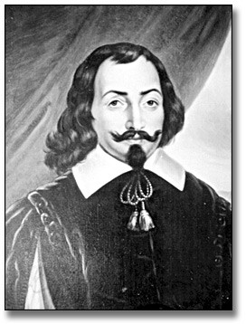
Portrait painting of Samuel de Champlain, painted c. 1945,
Artist unknown, Ministry of Tourism
RG 65-35-1, 30-J-45, AO 4587
Archives of Ontario, I0014666
In the summer of 1604, a group of settlers, which included Samuel de Champlain, founded a French settlement in North America on Sainte-Croix Island, Sainte-Croix River (Bay of Fundy). Champlain founded Quebec four years later and, in 1610, the first French explorers came to what is now Ontario.
Over the following century and a half, the French continued to explore our province and the lands beyond and many of them chose to settle here.
Questions:
- What do you think are some primary sources that you could use to learn about these French Explorers and the First Nations people they met here?
- Do you think all these primary sources would have survived to today?
  - Why or Why not?

Voyages of Samuel de Champlain
Œuvres de Champlain by Samuel de Champlain
Desbarats, 1870. vol. 4, facing page 25.
Archives of Ontario Library, 971.011 CHB
The illustrations above depict men from the “Cheveux Reléves” (High Hair) band. Champlain met these men while travelling the French River in July of 1615. Sketches A and C represent clothing to wear for war; sketches B and D represent everyday dress.
“We met with three hundred men of a tribe name by us the Cheveux-réleves because they had their hair elevated and arranged very high and better combed than our courtiers, and there is no comparison, in spite of the irons and methods they have at their disposal. This seems to give them a fine appearance.
They wear no breech cloths, and are much carved about the body in divisions of various patterns. They paint their faces with different colours and have their nostrils pierced and their ears fringed with beads. When they leave their homes they carry a club.”
Excerpt From Voyages of Samuel de Champlain, 2nd edition, vol. 4. (1870)
Archives of Ontario Library, 971.011 CHB
Pretend that you are a member of the “Cheveux Reléves” (High Hair) band.
Describe how surprised you would be to see Champlain and his men.

Appointment of Jacques Baby to the Legislative Council for Upper Canada (1792)
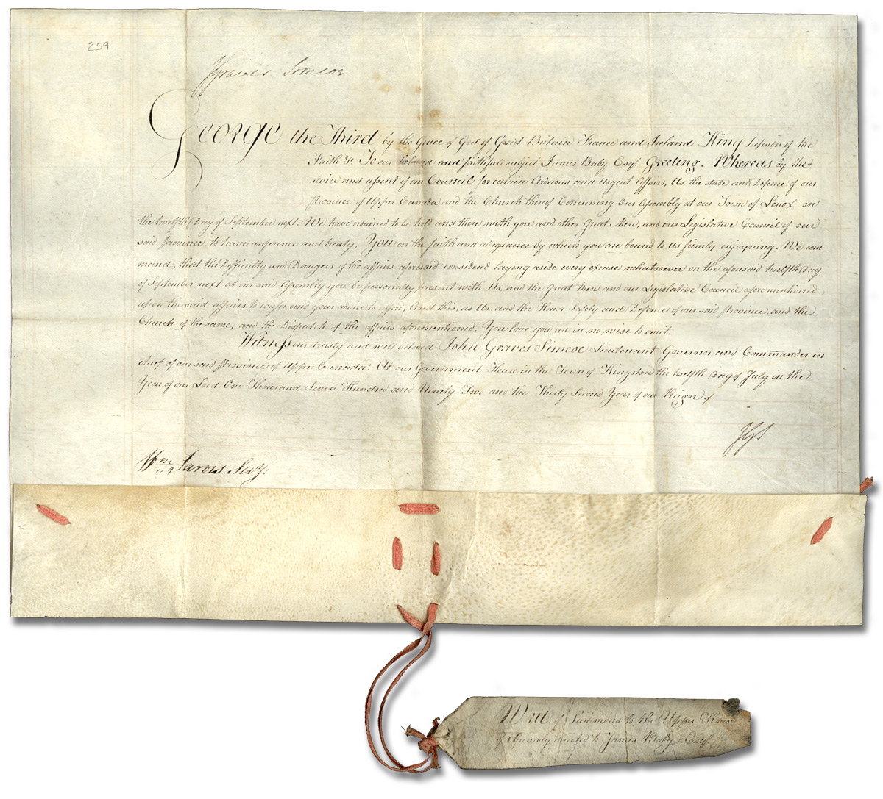
Appointment of Jacques Duperon Baby to the Legislative Council for Upper Canada, 1792
Jacques Duperon Baby family fonds
Reference Code: F 2128, MU 18
Archives of Ontario
Did you know that the Constitutional Act of 1791 called for a Legislative Council appointed by the governor? This council shared the responsibility of making and passing laws with the House of Assembly prior to Confederation.
What does it mean that Jacques Baby was not elected to the Legislative Council?
How would government then be different than government today?

Land Deed (1776)
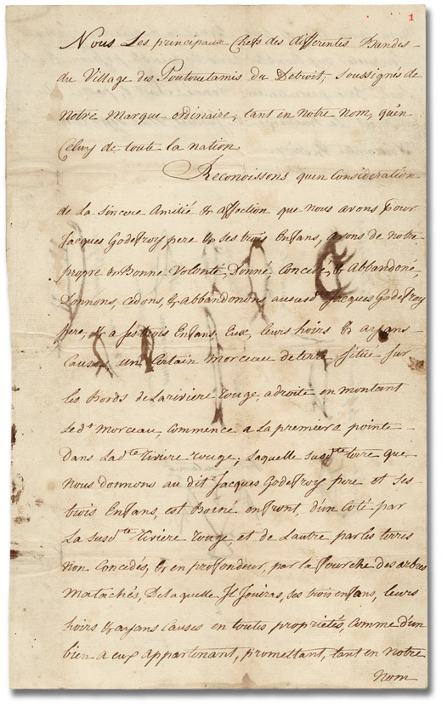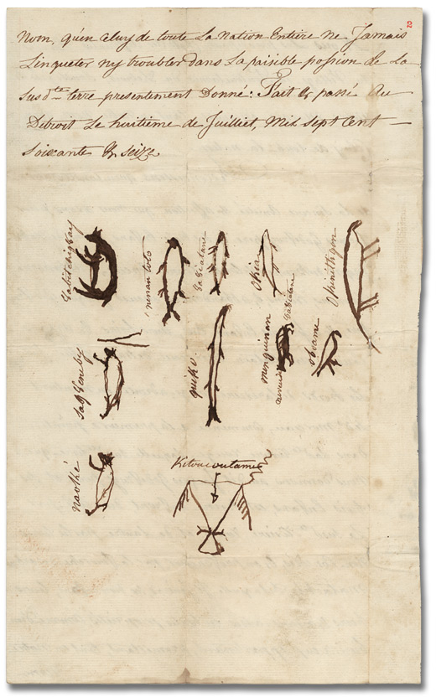
Land deed, Pottawatomi Nation to Jacques Godefroy, 1776
Hiram Walker Museum Collection, Reference Code: F 378, 20-100
Archives of Ontario

The Falls of Niagara
“(…) we found a great Lake nearly two hundred leagues [800 kilometres] ; it is formed by the discharge of the Fresh-water Sea and throws itself over a waterfall of a dreadful height into a third Lake, named Ontario, which we call Lake Saint-Louis” Paul Reguenau, “Relation de ce qui... c’est passé en la Nouvelle-France, ès année 1647-1648.”
The Jesuit Relations and Allied Documents. (translation)
Archives of Ontario Library, 271.7 THW

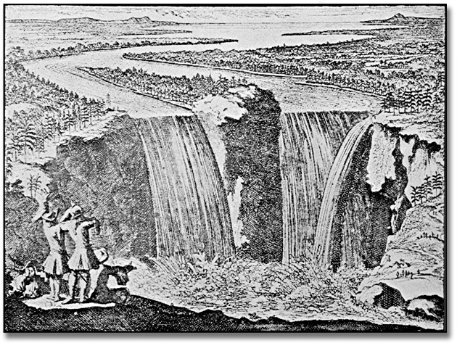
Niagara Falls, depicting Champlain’s first visit to the falls as described by Father Louis Hennepin in 1604
In Spencer, Joseph William Winthrop. The Falls of Niagara.
Archives of Ontario Library. 971.339 SPE

The Falls of Niagara
What do you think it would have been like to see Niagara Falls for the first time?
Provide some text between these three observers that demonstrate their perspectives in this illustration.
Niagara Falls, with Father Louis Hennepin. In Spencer, Joseph William Winthrop. The Falls of Niagara.
Archives of Ontario Library. 971.339 SPE

Le Canada ou Nouvelle France (1660)
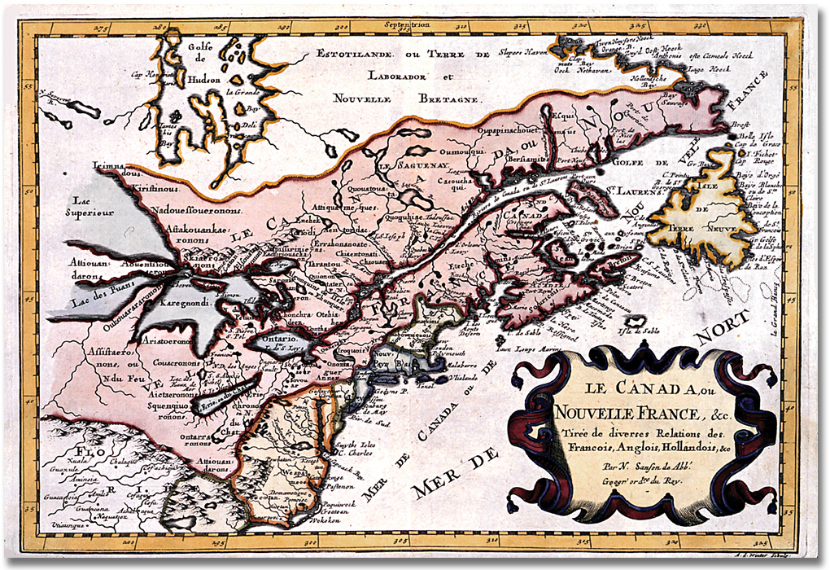
Le Canada ou Nouvelle France by Nicolas Sanson, ca. 1660
Reference Code: C 78, A0 4943
Archives of Ontario

Carte Particulière du Fleuve Saint Louis (1719)
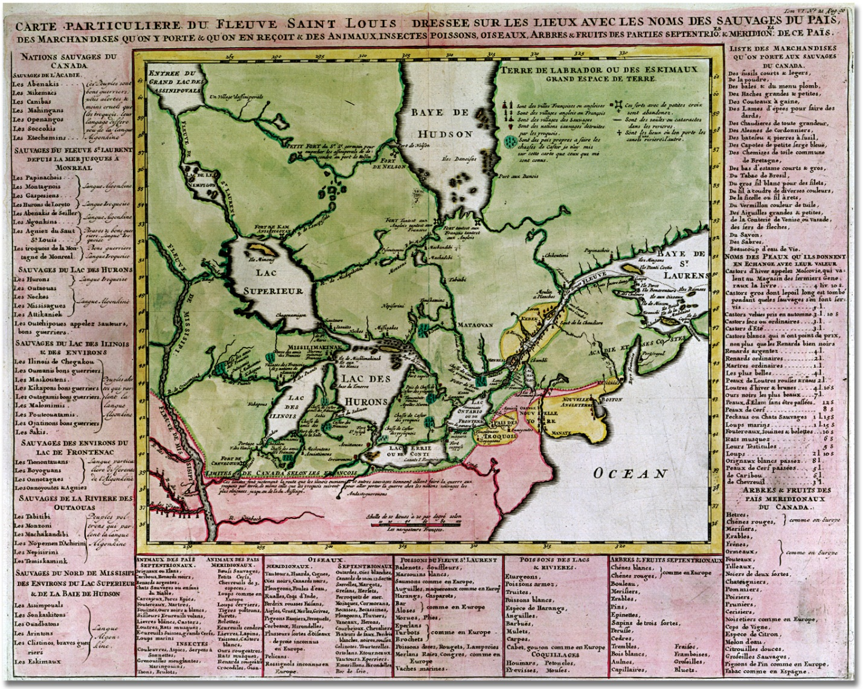
Carte particulière du Fleuve Saint Louis by Henri Châtelain, 1719
Archives of Ontario map collection, C 279-0-0-0-10
Reference Code: AO 2419, Archives of Ontario, I004754

