Lesson Resource Kit: Building the Rideau Canal
Grade 7: 1800–1850: Conflict and Challenges
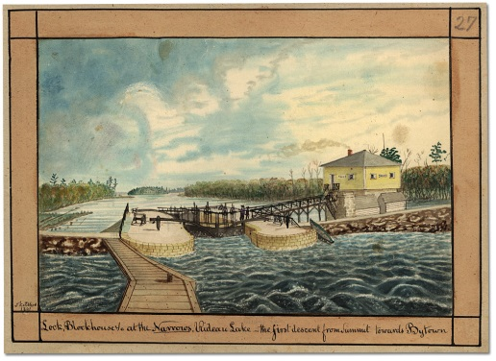
Lock, Blockhouse at the Narrows, Rideau Lake - the first descent from Summit towards Bytown, painted by Thomas Burrowes, 1841
Thomas Burrowes fonds
Reference Code: C 1-0-0-0-27
Archives of Ontario, I0002146

Introduction
Designed to fit into teachers’ practice, this resource kit provides links, activity suggestions, primary source handouts and worksheets to assist you and your students in applying, inquiring, and understanding Canada between 1800 and 1850.

Topic
Settlement, trade, and the development of the Rideau Canal

Source
Click here to visit the Eyewitness: Thomas Burrowes on the Rideau Canal online exhibit
Use the Archives of Ontario’s online exhibit:
- As a learning resource for yourself
- As a site to direct your students for inquiry projects
- As a place to find and use primary sources related to the curriculum

Themes that can be addressed
- Use of Primary Sources
- Transportation infrastructure, industrialization and trade in early nineteenth century Upper and Lower Canada
- Immigration and settlement of Upper and Lower Canada in the early nineteenth century
- The War of 1812

Curriculum
Strand B. Canada, 1800–1850: Conflict and challenges
Overall Expectations | Historical Thinking Concepts | Specific Expectations
B1. Application: Changes and Challenges | Continuity and Change;  Historical Perspective | B1.2
B2. Inquiry: Perspectives in British North Americans | Historical Perspective;  Historical Significance | B2.4, B2.6
B3. Understanding Historical Context: Events and Their Consequence | Historical Significance;  Cause and Consequence | B3.3, B3.5

Assignment & Activity Ideas

Inquiring into the Building of the Rideau Canal
- The historical inquiry process involves five steps:
- Formulating a question
- Gathering and organizing information or evidence
- Interpreting and analysing information or evidence
- Evaluating information or evidence and drawing conclusions
- Communicating findings
- The curriculum highlights that these steps do not have to be completed sequentially nor together. You may wish to explore specific steps based on your students’ readiness and prior knowledge or your own resources and time. See pages 22-24 in the 2013 revised Ontario Social Studies and History curriculum for more details by clicking here.
- Using a primary source handout from this kit, introduce your students to the topic of the Rideau Canal and its place in building Canada. Ask students to ask questions of the primary source provided. Use these questions as a jumping off point to explore these historical issues of life in rural communities during this time period in more depth.
- Access the Eyewitness: Thomas Burrowes on the Rideau Canal online exhibit by clicking here and use the online exhibit as a source to point your students for their own inquiry project. Here, they can view primary sources and secondary information to gather and organize historical information that they can interpret, evaluate, and communicate for different end products.

The Locks: Changes and challenges
- Learning about the Rideau Cancel is an excellent way to introduce your students to the concepts of continuity and change and cause and consequence
- Use the primary sources included in this kit to illustrate the historical context of this undertaking and to discuss how different the landscape looked then versus now.
- Have students discuss a comparable public undertaking and create their own watercolours to compare and contrast.
- Alternatively, ask students to find modern pictures of the sites that Burrows painted. How have things changed and stayed the same over the years?

Picture Yourself at the Locks
- Using one of the Burrows’ watercolour primary sources, ask your students to picture themselves at the locks and write a letter describing the causes and consequences of creating the canal system OR the changes and continuity of the landscape following construction
- Alternatively, ask students to draw a picture connected to one of the primary sources demonstrating the landscape before and after lock construction.

Handouts & Worksheets

Introduction to Primary Sources 6
Rideau Canal: National Historic Site of Canada 7
The Need for a Safe Route to Upper Canada 7
Lower Bytown and Sappers’ Bridge (1845) 9
Eastern End of Rideau Canal (1830) 10
Dam at Jones’ Falls (1841) 11
Opinicon Lake (1840) 12
Honourable Thomas McKay’s Mills (1845) 13
Canoe Heading Towards Bytown 14
Rocky cut at the Isthmus to join Rideau Lake 15
The last ascent to the Summit Water of Canal from Lake Ontario 16
Lock at Chaffey’s Mills 17
Brewer’s Lower Mill 18

Introduction to Primary Sources

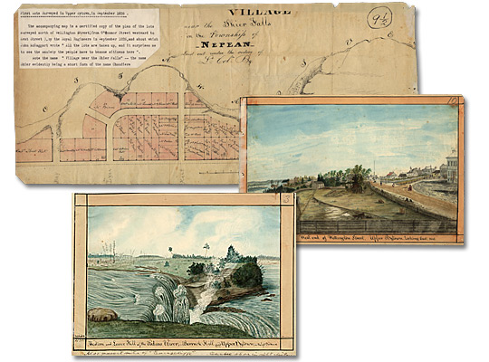
A primary source is a document or object from the past created by people who lived during that time. Primary sources provide a view into an event or experience that only people living during that time could have experienced.
Archives collect and preserve primary sources so that students can learn history from the experiences of people who were there. At an archive, primary sources are called records. At a museum, primary sources are called artifacts.
Have you ever used a primary source before?
Primary Sources | Secondary Sources
Original material from the past | Material people today write about the past
Example:  Letters  Diaries  Photographs  Paintings and other art work  Graphs  Maps | Example:  Textbooks  Reference books  Websites such as Wikipedia  Current news articles  Documentaries and films

What are some other examples of primary and secondary sources?
Can sources be both primary and secondary?

Rideau Canal: National Historic Site of Canada

The Need for a Safe Route to Upper Canada
The American Revolution created a hostile country to the south of Great Britain's Canadian colonies. For many decades after the establishment of the United States, Americans believed that the conquest of Canada was a piece of unfinished business left over from the revolutionary war. In the event of war, the colony of Upper Canada (present-day Ontario) was at particular risk along the St. Lawrence River from Montreal to Kingston. The river route, vital for the transportation of goods and people to and from the Great Lakes area, was easily cut off because much of the southern shore of the river was in American possession.
Planning the Rideau Canal System
Following the War of 1812, surveys were carried out to identify a second, safe, route from Montreal to the Great Lakes. The decision was to follow the Ottawa River from Montreal to the mouth of the Rideau River, at present day Ottawa, then travel south along the Rideau and through a series of small lakes to the Cataraqui River which emptied into Lake Ontario at Kingston. Unfortunately, the route selected was navigable only in parts and to use it for boats larger than a canoe necessitated the construction of a series of locks between Ottawa to Kingston. Given the expense of such an undertaking, the project met with little enthusiasm with the British authorities.
A champion of the building of a canal arose in the person of the Duke of Wellington, famous as the victor over Napoleon at the battle of Waterloo and an influential voice in British politics. The result of his support was the appointment of Lieutenant-Colonel John By of the Royal Engineers to oversee the task of making the Rideau-Cataraqui route into a navigable waterway.
Lieutenant-Colonel John By of the Royal Engineers arrived in Canada in 1826 and set up his headquarters near the mouth of the Rideau River. The overall design involved a series of dams and associated locks which would enable boats to travel without impediment from Bytown to Kingston. The original plan for the canal called for the construction of locks that could handle small barges. With considerable foresight, Colonel By boldly advocated a system of much larger locks. He finally persuaded his superiors to authorize the construction of locks with a minimum size of 134 feet long and 33 feet wide, large enough to accommodate the new steamboats which were beginning to appear on the Great Lakes.

Achievement
The Rideau Canal was officially opened in the summer of 1832. It was an amazing achievement. For most of its length of 202 km, the new canal passed through an unsettled wilderness where By and his workers managed to create forty-seven locks, some of them posing a considerable engineering challenge. Because of its military role, the canal also included defences in the form of fortified lock masters’ houses and substantial blockhouses at the lock stations most exposed to possible enemy attack.
After its opening in 1832, the new Rideau Canal became a busy commercial artery from Montreal to the Great Lakes. But its glory days were short-lived. By 1849, the rapids of the St. Lawrence had been tamed by a series of locks and commercial shippers were quick to switch to this more direct route.
*Abridged from “Rideau Canal National Historic Site of Canada.” Date modified Aug. 7 2012. Click here to access Parks Canada’s website to learn more.

Lower Bytown and Sappers’ Bridge (1845)
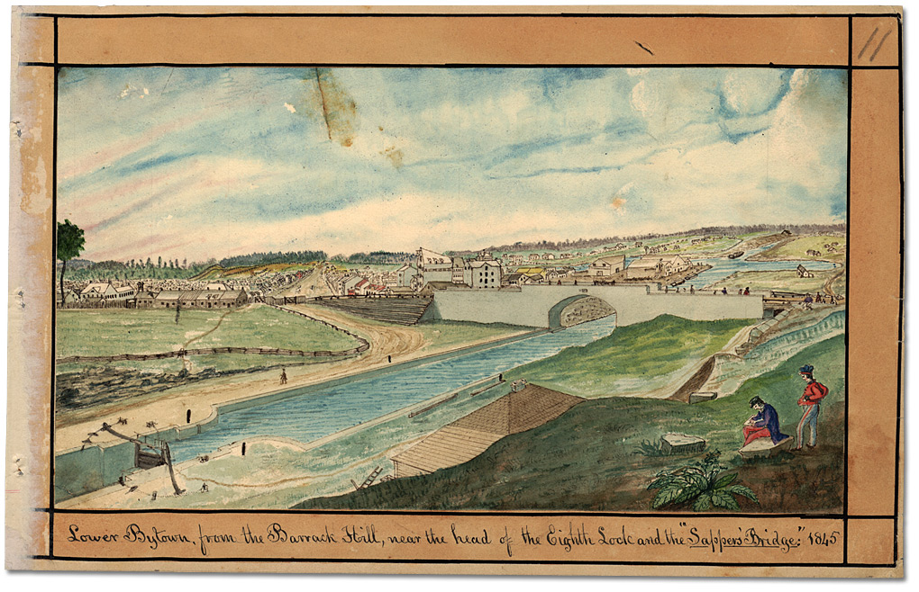
Lower Bytown, from the Barrack Hill, near the head of the Eighth Lock and the “Sappers’ Bridge,” 1845
Thomas Burrowes fonds, Reference Code: C 1-0-0-0-11, Archives of Ontario, I0002129

Eastern End of Rideau Canal (1830)
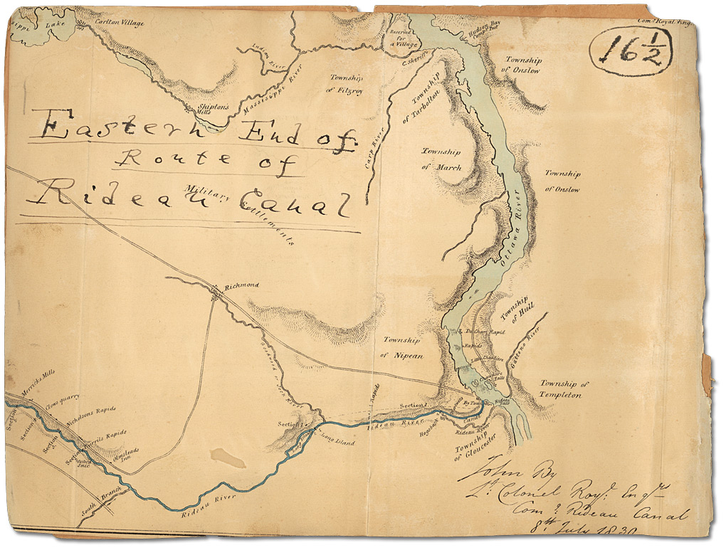
Map of Eastern End of Rideau Canal, 1830
Thomas Burrowes fonds, Reference Code: C 1-0-0-0-115, Archives of Ontario, I0002234

Dam at Jones’ Falls (1841)
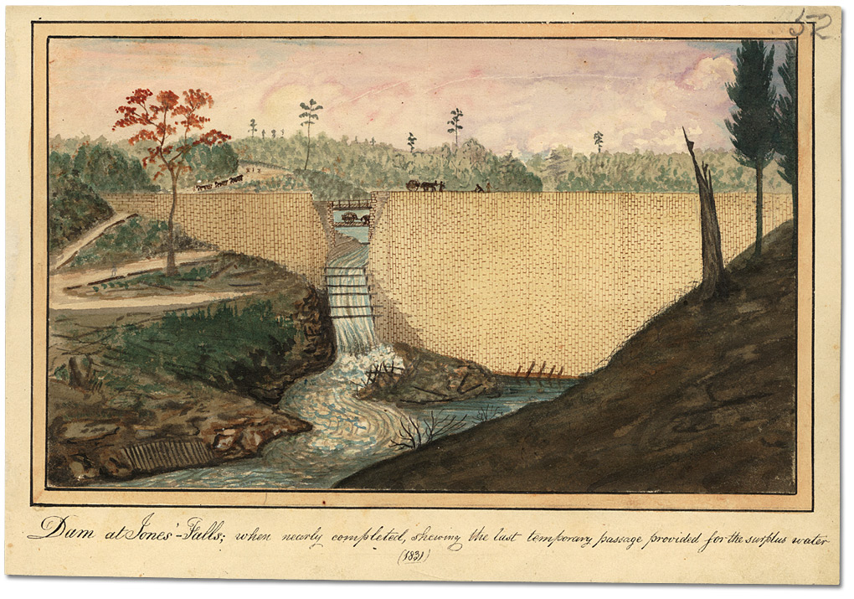
Dam at Jones’ Falls; when nearly completed, showing the last temporary passage provided for the surplus water, 1841
Thomas Burrowes fonds, Reference Code: C 1-0-0-0-52, Archives of Ontario, I0002171

Opinicon Lake (1840)
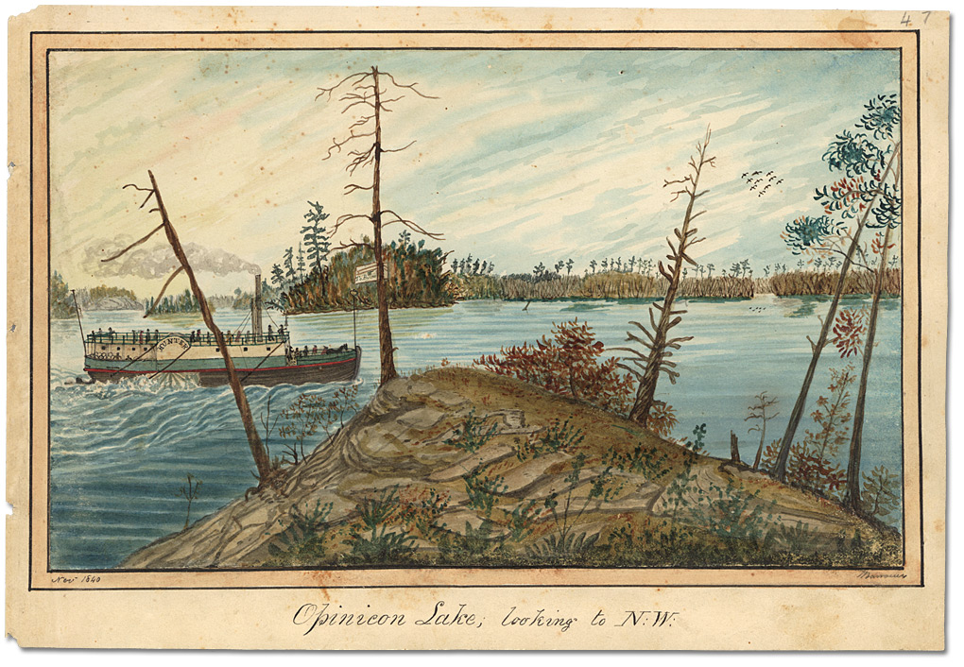
Opinicon Lake looking to the northwest by Thomas Burrowes, 1840
Thomas Burrowes fonds, Reference Code: C 1-0-0-0-47
Archives of Ontario, I0002166

Honourable Thomas McKay’s Mills (1845)
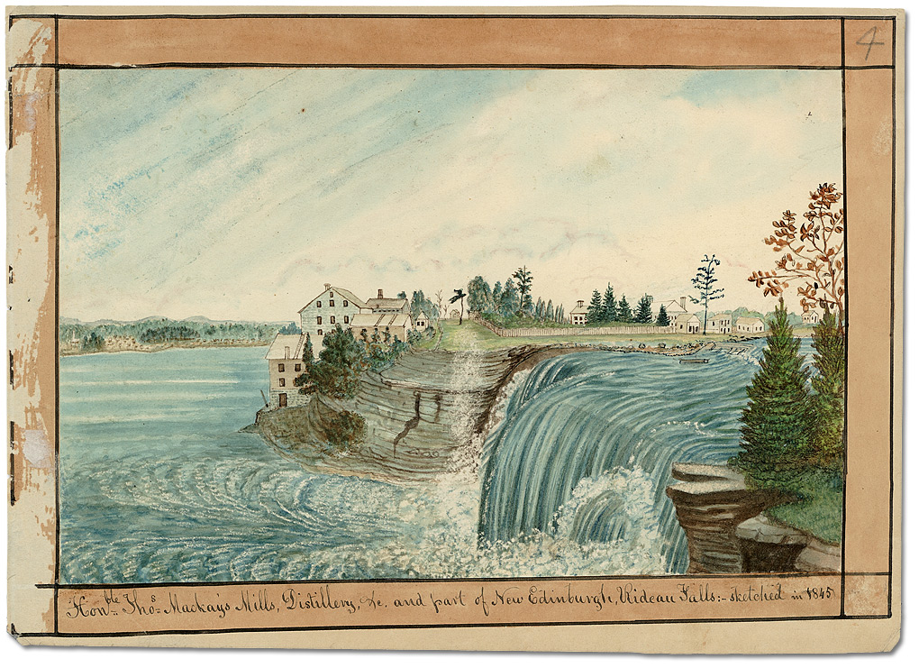
Honourable Thomas McKay's Mills, Distillery, etc. and part of New Edinburgh, Rideau Falls, by Thomas Burrowes, 1845
Thomas Burrowes fonds, Reference Code: C 1-0-0-0-4
Archives of Ontario, I0002121

Canoe Heading Towards Bytown
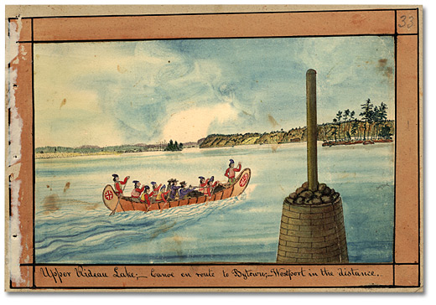
Upper Rideau Lake; Canoe en route to Bytown; Westport in the Distance, by Thomas Burrowes
Watercolour
Thomas Burrowes fonds, Reference Code: C 1-0-0-0-33, Archives of Ontario, I0002152

Rocky cut at the Isthmus to join Rideau Lake
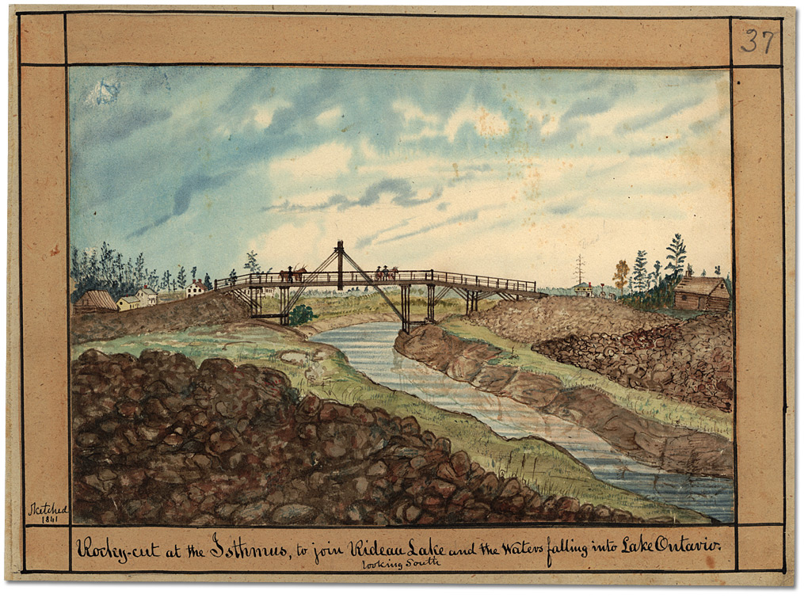
Rocky cut at the Isthmus to join Rideau Lake and the Waters falling into Lake Ontario, looking South, by Thomas Burrowes, 1841
Thomas Burrowes fonds
Reference Code: C 1-0-0-0-37
Archives of Ontario, I0002156

The last ascent to the Summit Water of Canal from Lake Ontario
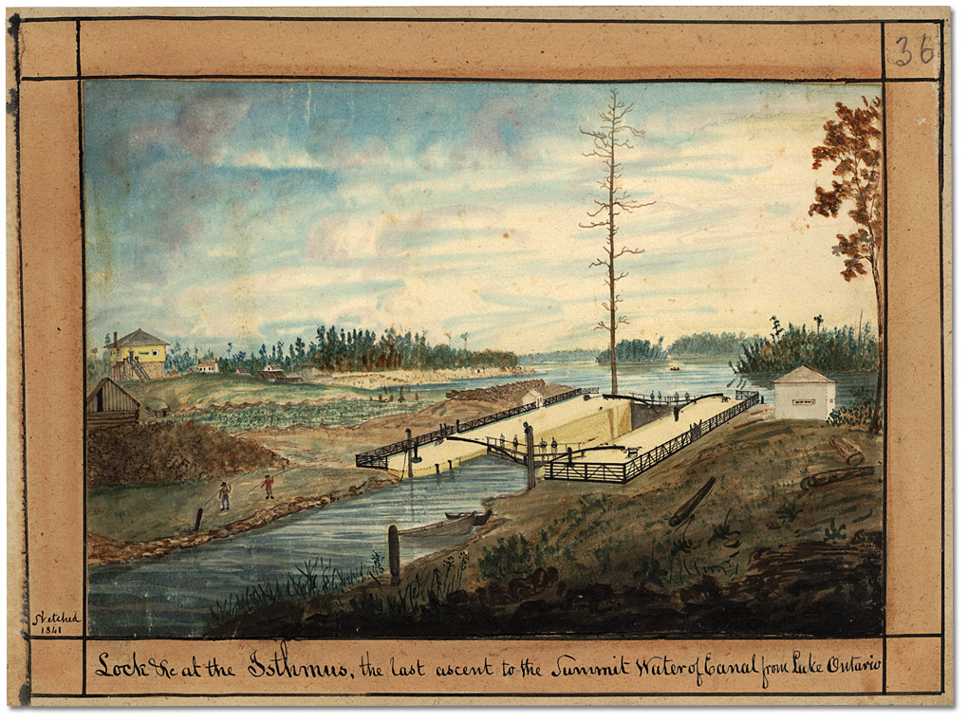
Locks at the Istmus, the last ascent to the Summit Water of Canal from Lake Ontario, by Thomas Burrowes, 1841
Thomas Burrowes fonds, Reference Code: C 1-0-0-0-36, Archives of Ontario, I0002155

Lock at Chaffey’s Mills
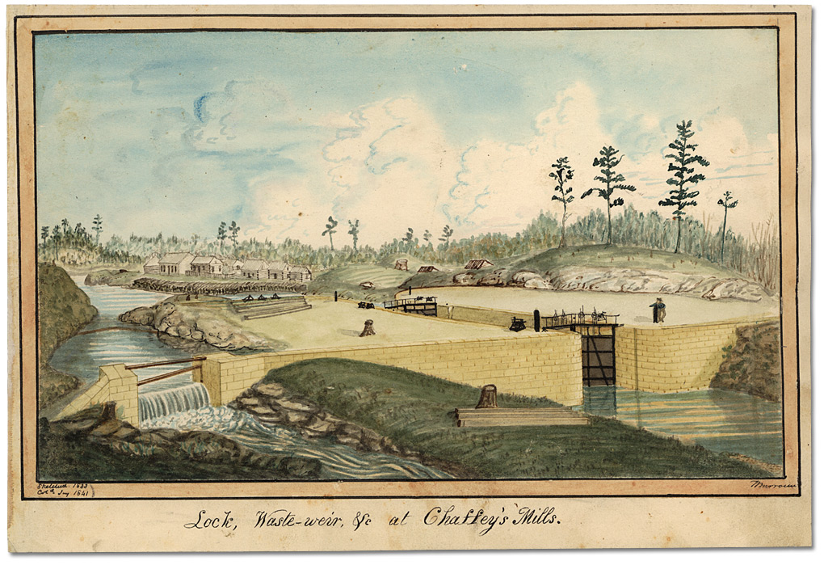
Lock, Waste-weir at Chaffey's Mills, by Thomas Burrowes, 1833
Thomas Burrowes fonds, Reference Code: C 1-0-0-0-44, Archives of Ontario, I0002163

Brewer’s Lower Mill
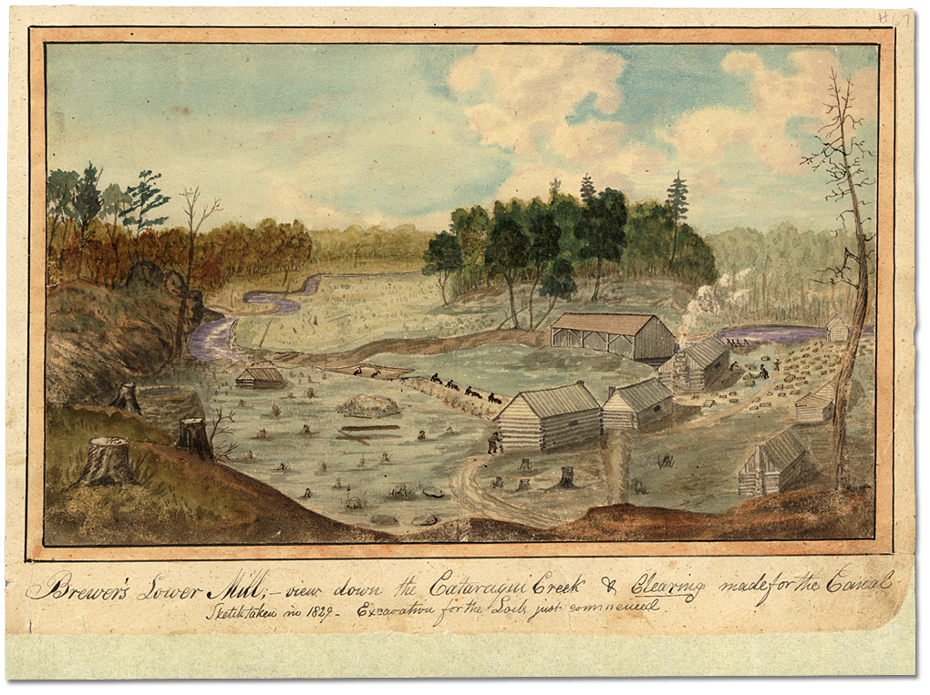
Brewer's Lower Mill; View down the Cataraqui Creek, & Clearing made for the Canal. Excavation for the Lock just commenced, by Thomas Burrowes, 1829
Thomas Burrowes fonds, Reference Code: C 1-0-0-0-67
Archives of Ontario, I0002186

