Teaching Resource Kit: War of 1812
Grade 7: 1800–1850: Conflict and Challenges
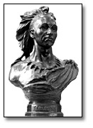
Tecumseh [Shawnee Indian Chief, ally of British in War of 1812], 1896
Hamilton Plantagenet MacCarthy
Government of Ontario Art Collection, 619883

Introduction
Designed to fit into teachers’ practice, this resource kit provides links, activity suggestions, primary source handouts and worksheets to assist you and your students in applying, inquiring, and understanding Canada between 1800 and 1850.

Topic
The War of 1812

Source
War of 1812 online exhibit - Click here to view the War of 1812 online exhibit.
Use the Archives of Ontario’s online exhibit on the War of 1812:
- As a learning resource for yourself
- As a site to direct your students for inquiry projects
- As a place to find and use primary sources related to the curriculum

Themes that can be addressed in the online exhibit
- Use of Primary Sources
- Causes of the War of 1812
- Major battles
- Important individuals (ie. Tecumseh, Laura Secord, General Issac Brock)
- The Treaty of Ghent
- Displacements resulting from damage to property

Curriculum Links
Strand B. Canada, 1800–1850: Conflict and challenges
Overall Expectations | Historical Thinking Concepts | Specific Expectations
B1. Application: Changes and Challenges | Continuity and Change;  Historical Perspective | B1.1, B1.2, B1.3
B2. Inquiry: Perspectives in British North Americans | Historical Perspective;  Historical Significance | B2.1, B2.2, B2.3, B2.4, B2.5, B2.6
B3. Understanding Historical Context: Events and Their Consequence | Historical Significance;  Cause and Consequence | B3.1, B3.2, B3.3, B3.4, B3.5

Assignment & Activity Ideas

Inquiring into the War of 1812
- The historical inquiry process involves five steps:
- Formulating a question
- Gathering and organizing information or evidence
- Interpreting and analysing information or evidence
- Evaluating information or evidence and drawing conclusions
- Communicating findings
- The curriculum highlights that these steps do not have to be completed sequentially nor together. You may wish to explore specific steps based on your students’ readiness and prior knowledge or your own resources and time. See pages 22-24 in the 2013 revised Ontario Social Studies and History curriculum for more details by clicking here.
- Using one of the primary source handouts found within this kit, introduce your students to the topic of the War of 1812. Ask students to ask questions of the source and use these questions as jumping off points for exploring these historical issues in more depth.
- Click here to access the War of 1812 online exhibit to use as a source to point your students for their own inquiry project. Here, they can view primary sources and secondary information to gather and organize historical information to interpret, evaluate, and communicate for different end products.

One Source, Many Questions
- Using one of the primary source handouts found in this teaching kit, ask students to identify the 5Ws (what, where, when, why, and who?) profiling the source. The Identifying My Primary Source worksheet can help in this task.
- Ask students to zoom in on one of the aspects of the primary source they found strange, familiar, or interesting and identify them to the class. Write these things on the board and group them according to theme.
- Use one or more of these themes as an introduction to an inquiry-based assignment. Have students work in collaborative groups, individually, or as a class as a short or long term project researching the historical context of the primary source.

Handouts & Worksheets

Introduction to Primary Sources…………………………………………………………….5
Identifying My Primary Source 6
The Battle of Fort George (1817) 7
Pension Poster (1817) 9
Letter from Cathe Lyons to Mrs. Thomas Ridout (1814) 10
Treason Poster (1821) 11
Brock’s Monument (1841) 12

Introduction to Primary Sources
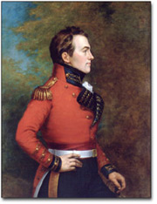
Major-General Sir Isaac Brock, KB
[President and Administrator of Upper Canada, 1811-12], c. 1883
George Theodore Berthon
Government of Ontario Art Collection, 694158

A primary source is a document or object from the past created by people who lived during that time. Primary sources provide a view into an event or experience that only people living during that time could have experienced.
Archives collect and preserve primary sources so that students can learn history from the experiences of people who were there. In an archive, primary sources are called records. In a museum, primary sources are called artifacts.

Primary Sources | Secondary Sources
Original material from the past | Material people today write about the past
Example:  Letters  Diaries  Photographs  Paintings and other art work  Graphs  Maps | Example:  Textbooks  Reference books  Websites such as Wikipedia  Current news articles  Documentaries and films

What are some other examples of primary and secondary sources?
Can sources be both primary and secondary?

Identifying My Primary Source
Name of primary source: _________________________________________________
______________________________________________________________________
What type of primary source is it?__________________________________________
What is happening in this primary source?____________________________________
______________________________________________________________________
Who created it? _________________________________________________________
Why was it created?_____________________________________________________
When was it created?____________________________________________________
Where was it created?____________________________________________________
What when you look at this source, is there anything strange about it?
______________________________________________________________________
______________________________________________________________________
When you look at this source, is there anything familiar about it?
______________________________________________________________________
______________________________________________________________________
What do you want to know about this primary source?
______________________________________________________________________
______________________________________________________________________
What do you want to know about the people in the primary source?
______________________________________________________________________
______________________________________________________________________
What is the most interesting thing about this primary source?
______________________________________________________________________

The Battle of Fort George (1817)
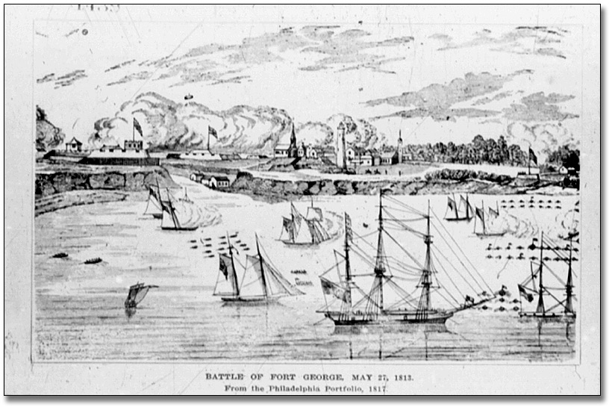
The Battle of Fort George from the Philadelphia Portfolio, 1817
Archives of Ontario Photographic Collection, Reference Code: S 1439 Archives of Ontario
Lithograph

Plan of Fort Detroit (1812)
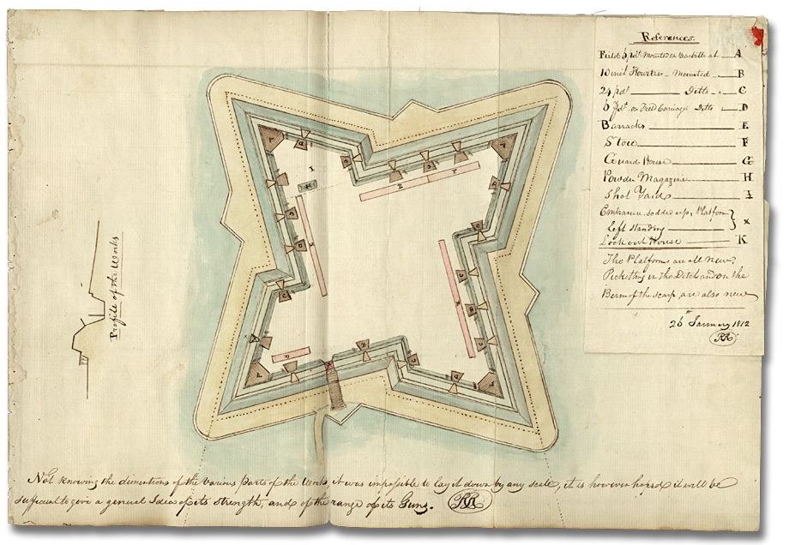
Plan of Fort Detroit, January 26, 1812
Artist unknown
Miscellaneous collection, Reference Code: F 775, box MU 2102, Archives of Ontario

Pension Poster (1817)

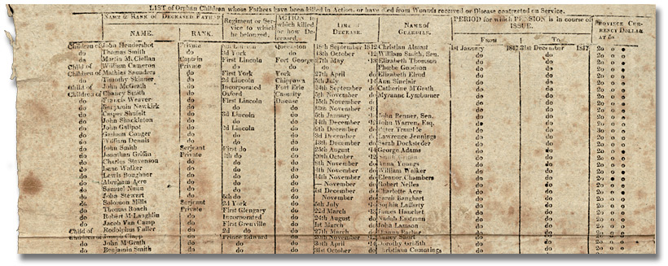
Pension poster – Orphans, 1817
Robert Nelles family fonds
Reference Code: F 542, box MU 2192
Archives of Ontario

Letter from Cathe Lyons to Mrs. Thomas Ridout (1814)

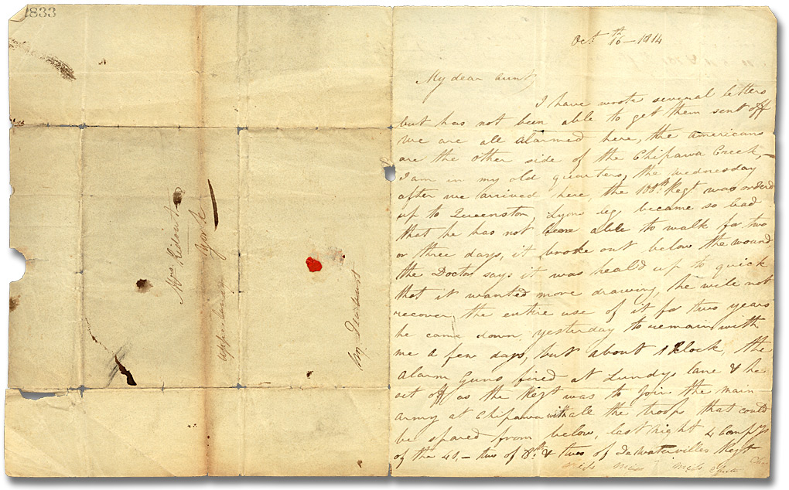
Letter from Cathe Lyons (Chippewa) to Mrs. Thomas Ridout,
October 16, 1814
Thomas Ridout family fonds
Reference Code; F 43, box MU 2391
Archives of Ontario

Read an extract from this letter:
“We are all alarmed here, the Americans are the other side of the Chippawa Creek, I am in my old quarters. … Appearances are very much against us here, if the fleet does not come, there is not a man to defend this place should the enemy attempt to cross at the same time they make an attack above, which is not unlikely & is expected every moment. Perhaps as soon as you receive this you may hear of dreadful battle, for dreadful it must be if our army stands it out. I cannot get even a place to put my things in near the Forts every one is so full, if the enemy is successful, I shall loose everything.… ”

Treason Poster (1821)
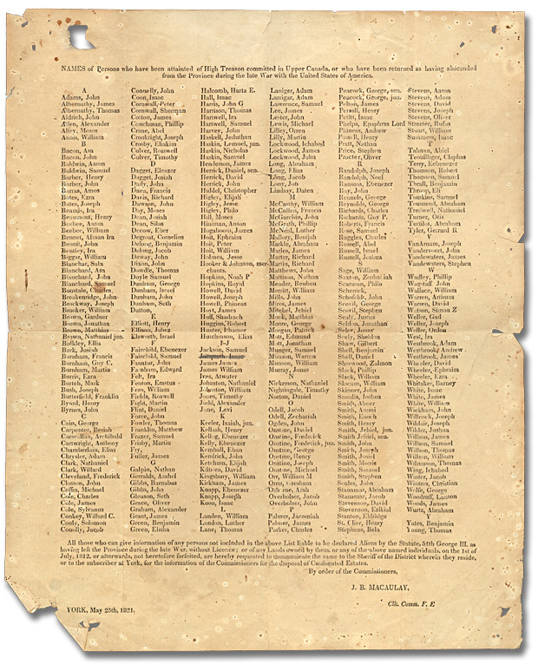
Treason Poster, 1821
Newcastle District Clerk of the Peace
Broadsheet
Reference Code: RG 22-3782
Archives of Ontario

Brock’s Monument (1841)

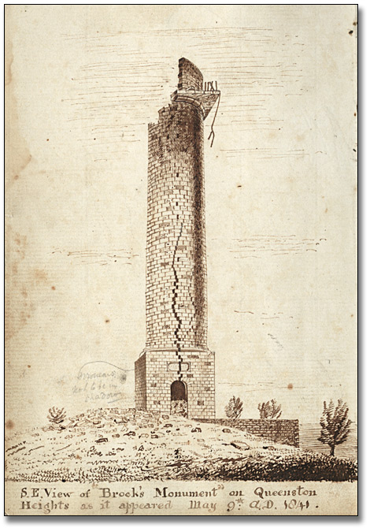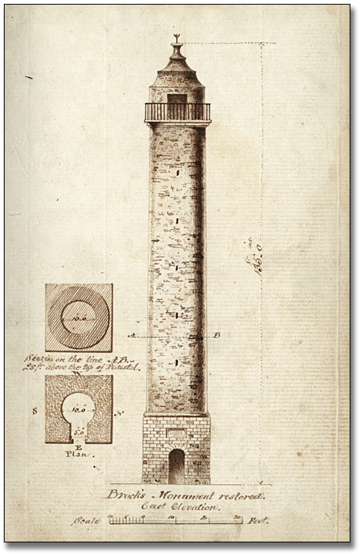

At left:
Southeast view of Brock’s Monument on Queenstown Heights
as it appeared on May 9th, 1841
Thomas Glegg fonds
Reference Code: F 596
Archives of Ontario

At right:
Brock’s Monument restored,
East elevation, 1841
Thomas Glegg fonds
Reference Code: F 596
Archives of Ontario

