Teaching Resource Kit: The American Civil War and Fenian Raids in the 1860s
  - Grade 8: Creating Canada, 1850–1890

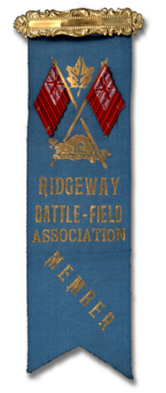
Fenian Raid Ribbon, 1866
Henry Bull Wallis fonds
Reference Code: F 923
Archives of Ontario

Introduction
Designed to fit into teachers’ practice, this resource kit provides links, activity suggestions, primary source handouts and worksheets to assist you and your students in applying, inquiring, and understanding Canada between 1850 and 1890.

Topics
Understanding the effects of the American Civil War and the Fenian Raids on British North America.

Source
Documents from the Front: The American Civil War and the Fenian Raids in the 1860s online exhibit (Click here to access the online exhibit).

Use the online exhibit on The American Civil War and the Fenian Raids:
- As a learning resource for yourself
- As a site to direct your students for inquiry projects
- As a location to find and use primary sources related to the curriculum

Themes that can be addressed:
- Use of primary sources
- The American Civil War
- Fenian raids

Curriculum Links
Strand A. Creating Canada, 1850-1890
Overall Expectations | Historical Thinking Concepts | Specific Expectations
A1. Application: the New Nation and its Peoples | Cause and Consequence, Historical Perspective | A1.1
A2. Inquiry: Perspectives in the New Nation | Historical Perspective, Historical Significance | A2.4, A2.6
A3. Understanding Historical Context: Events and Their Consequences | Historical Significance, Cause and Consequence | A3.1, A3.2, A3.3, A3.4, A3.5

Assignment & Activity Ideas

Inquiring into the Fenian Raids
- The historical inquiry process involves five steps:
  - Formulating a question
  - Gathering and organizing information or evidence
  - Interpreting and analysing information or evidence
  - Evaluating information or evidence and drawing conclusions
  - Communicating findings
- The curriculum highlights that these steps do not have to be completed sequentially nor together. You may wish to explore specific steps based on your students’ readiness and prior knowledge or your own resources and time. See pages 22-24 in the 2013 revised Ontario Social Studies and History curriculum (click here to view the 2013 Ontario Social Studies, History, and Geography Curriculum document).
- Using one of the primary source handouts found in this kit, introduce your students to the topics of the American Civil War and the Fenian Raids. Ask students to ask questions of the primary sources provided. Use these questions as jumping off points to explore the Fenian Raids and the American Civil War in more depth.
- Use the Documents from the Front: The American Civil War and the Fenian Raids in the 1860s online exhibit as a source to point your students for their own inquiry project (click here to view the online exhibit). Here, they can view primary sources and secondary information to gather and organize historical evidence to interpret, evaluate, and communicate.

One Source, Many Questions
- Using one of the primary source handouts found in this Teaching Kit, ask students to identify the 5Ws (who, what, where, when, and why?). The Identifying My Primary Source worksheet can help in this task.
- Ask students to zoom in on one of the aspects of the source they found strange, familiar, or interesting and identify them to the class. Write these things on the board and group them according to theme.
- Use one or more of these themes as an introduction to an inquiry-based assignment. Have students work in collaborative groups, individually, or as a class on short or long term project(s) researching the historical context of the primary source.

Letters from the Front
- Using the primary source letters found in this kit, introduce how important letters were for communicating with loved ones during the nineteenth century. Compare with different communication methods we use today.
- Using the Letter from Rose Goble handout in this kit, ask students to identify questions they would want to pose to a family member fighting in or living through the American Civil War or the Fenian Raids.
- Extension: Have students look for answers to these questions and present these answers on a poster size letter.

“Common Brotherhood”: Canadian/American relations
- In thinking about the growth and development of Canada before and after Confederation, use the Letter Referencing President Lincoln’s Assignation (1865) handout in this kit as a starting point for discussing the similarities and differences of the Canadian/American relationship today and in the past

Experiences of War Comic Strip
- Students to take the perspective of someone other than the letter writer to tell the story. Options could include the recipient of the letter, a (fictional) news reporter, or a soldier from the other side.

Handouts & Worksheets

Introduction to Primary Sources 5
Identifying My Primary Source 6
Fenian Raid Ribbon (1866) 7
Letter from Referencing President Lincoln’s Assignation (1865) 8
Letter about Experience Fighting in the American Civil War (1864) 9
Letter from Referencing Fenians (1865) 10
Imagining a Letter from Rose Goble 11
Land Grant Offered to Charles Bonnycastle (1905) 12
Alonzo Wolverton’s Discharge Certificate (1865) 13
Comic Strip Cells 14
Salem Band who played during the Fenian Raids (ca. 1865) 15

Introduction to Primary Sources
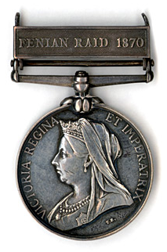
Canadian General Service Medal,1899 (front)
Henry Bull Wallis fonds
Reference Code: F 923
Archives of Ontario

A primary source is a document or object from the past created by people who lived during that time. Primary sources provide a view into an event or experience that only people living during that time could have experienced.
Archives collect and preserve primary sources so that students can learn history from the experiences of people who were there. In an archive, primary sources are called records. In a museum, primary sources are called artifacts.

Primary Sources | Secondary Sources
Original material from the past | Material people today write about the past
Example:  Letters  Diaries  Photographs  Paintings and other art work  Graphs  Maps | Example:  Textbooks  Reference books  Websites such as Wikipedia  Current news articles  Documentaries and films

What are some other examples of primary and secondary sources?
Can sources be both primary and secondary?

Identifying My Primary Source

Name of Primary Source: ____________________________________________________
What type of Primary Source is it? ______________________________________________
What is happening in this Primary Source? ___________________________________________________________________________
Who created it? ____________________________________________________
Why was it created? ____________________________________________________
When was it created? ____________________________________________________
Where was it created? ____________________________________________________
What when you look at this source, do you find anything strange about it?
___________________________________________________________________________
___________________________________________________________________________
___________________________________________________________________________
When you look at this source, do you find anything familiar about it?
___________________________________________________________________________
___________________________________________________________________________
___________________________________________________________________________
What do you want to know about this Primary Source?
___________________________________________________________________________
___________________________________________________________________________
What do you want to know about the people in the Primary Source?
___________________________________________________________________________
___________________________________________________________________________
What is the most interesting thing about this Primary Source?
___________________________________________________________________________

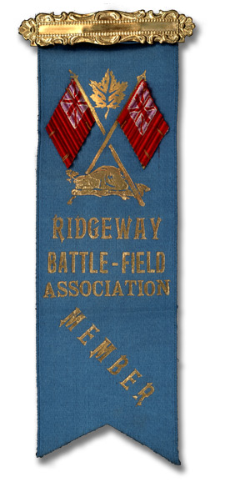
Fenian Raid Ribbon, 1866
Henry Bull Wallis fonds
Reference Code: F 923
Archives of Ontario

As a veteran of the Fenian Raids, Henry Bull Wallis of Richmond Hill, Ontario received this ribbon for service in the militia at the Battle of Ridgeway, near Fort Erie, in 1866.

Letter Referencing President Lincoln’s Assignation (1865)
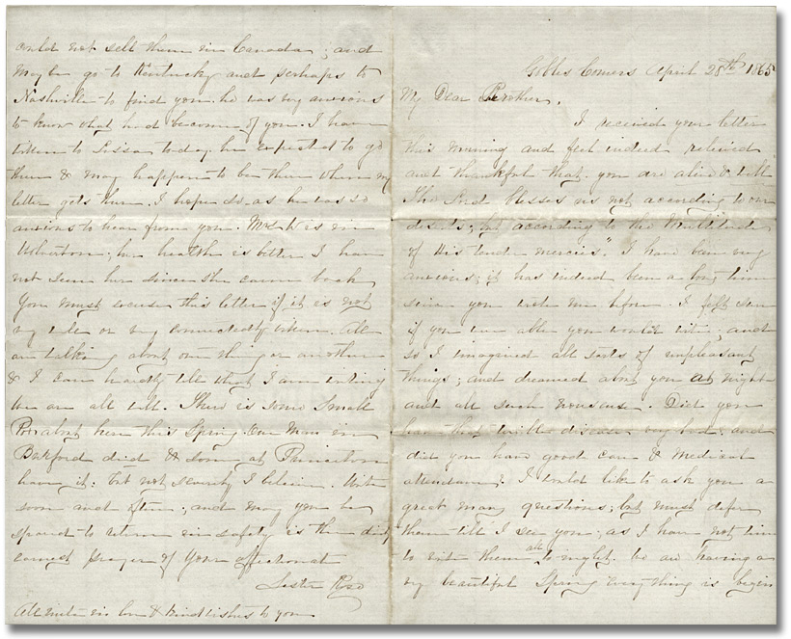
Letter from Rose Goble in Gobles Corners to
brother Alonzo Wolverton in Nashville, Tennessee, 28 April 1865
Reference Code: F 4354-6
Archives of Ontario

Excerpt from this letter:

“The funeral day in Washington was observed throughout Canada. Business was suspended from 12 till 2 and funeral services in all the towns and cities… I hope the strong sympathy expressed by Canada in this their time of grief may be a means of binding the two nations together in a common brotherhood.”

Questions about this source:

- What important funeral in Washington D.C. would have taken place in 1865?
- Why would Canada have observed this day?
- Is there an event today that would bring the “common brotherhood” between Canada and another country together?

Letter about Experience Fighting in the American Civil War (1864)

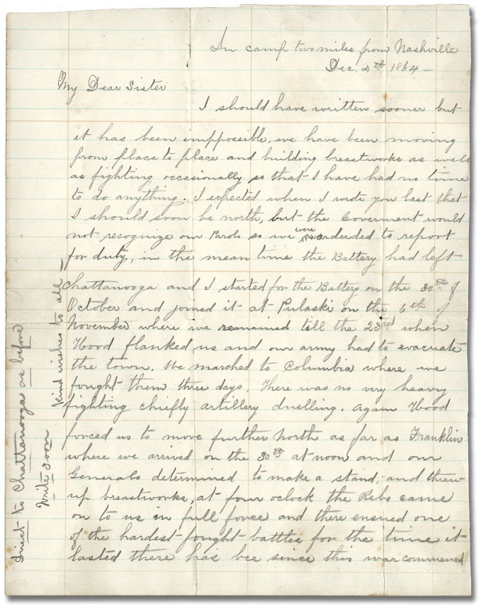
Letter, Alonzo Wolverton to his sister Roseltha Wolverton Goble, December 4, 1864
Lois Darroch fonds
Reference Code: F 4354-6
Archives of Ontario

Excerpt from this letter:
“Our Battery was in the centre the very hottest of the fight – we lost nearly half of our men and came out of the battle commanded by a sergeant. I never dreamed that men would fight with such desperation. I never expected to come out alive but was fortunate….I never realized before what a battle was, the roar of musketry and thunder of artillery was deafening, it was full as dark ten minutes after the battle commenced as when it ceased. The only way we could tell when night came was by the stars.”

Letter Referencing the Fenians (1865)

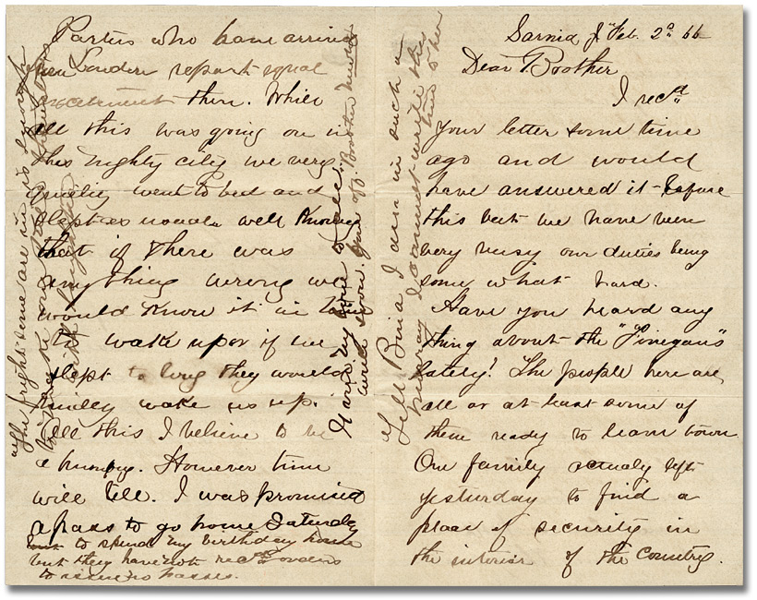Letter from Newton Wolverton at Sarnia, Ont. to
brother Alonzo Wolverton at Wolverton, Ont., February 2, 1866
Lois Darroch fonds
Archives Reference Code F 4354-6
Archives of Ontario

An Excerpt from this letter:

“Have you heard anything about the ‘Finegans’ lately? The people here are all or at least some of them ready to leave town….Rumours of every kind were rife in the town and a great many changed their silver at the brokers for bills in order to facilitate a precipitate retreat – before the advance of our imaginary foe….All this I believe to be humbug. However time will tell.”

Imagining a Letter from Rose Goble
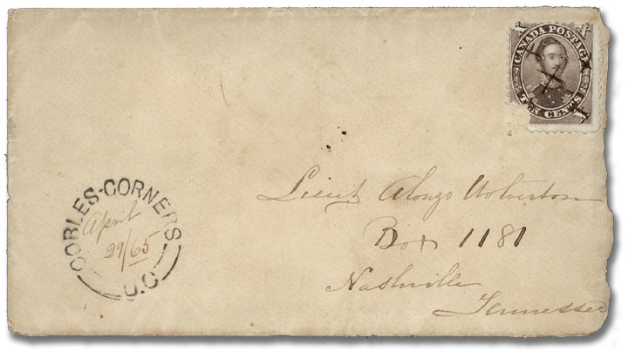
Letter from Rose Goble in Gobles Corners to
brother Alonzo Wolverton in Nashville, Tennessee, 28 April 1865
Reference Code: F 4354-6
Archives of Ontario

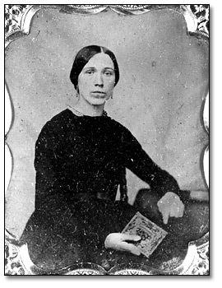
Rose Wolverton Goble (1835-1919) lived in Woodstock, ON and was the chief correspondent with her brothers during the Civil War.

If you were Rose, what questions would you have for your brother fighting the Civil War across the border?

Land Grant Offered to Charles Bonnycastle (1905)
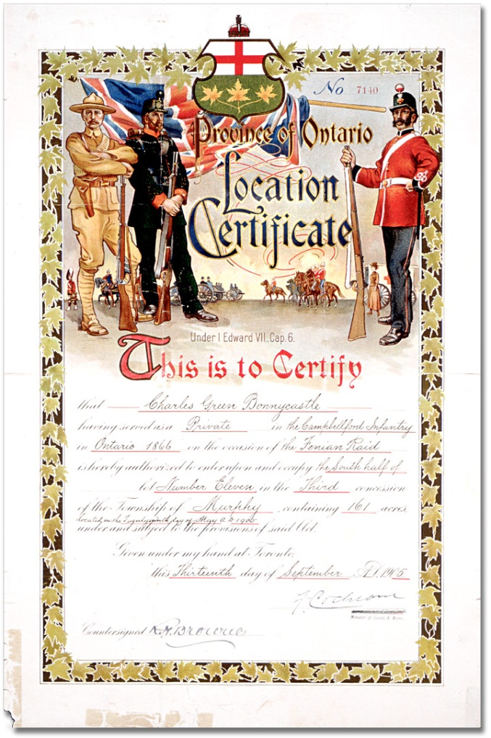
Land grant offered to Charles Bonnycastle,
a volunteer in the Canadian militia during the Fenian Raids, 1905
Archives of Ontario Poster Collection
Reference Code: C 233-1-3-2159
Archives of Ontario

Alonzo Wolverton’s Discharge Certificate (1865)

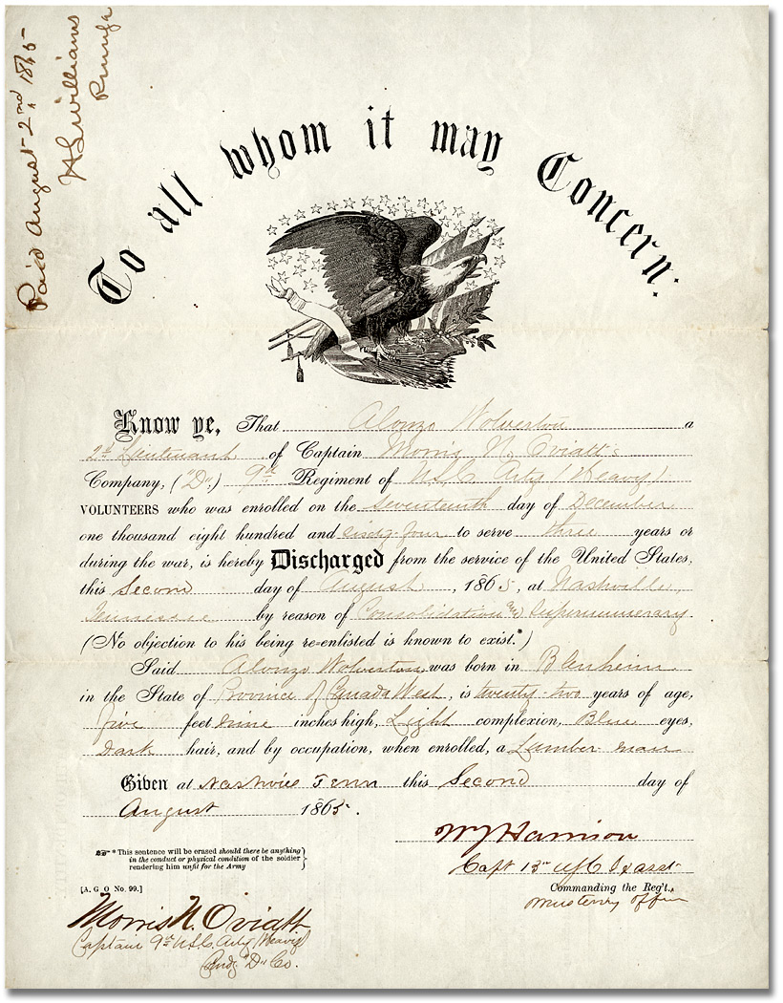

Alonzo Wolverton Discharge Certificate, 1865
Lois Darroch fonds
Reference Code: F 4354-6-0-0
Archives of Ontario

Salem Band who played during the Fenian Raids (ca. 1865)
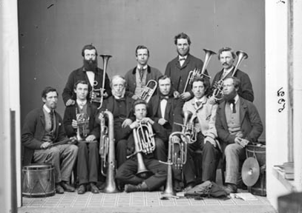
Studio portrait of the Salem Band, who played for the Elora Volunteer Rifle Company at the time of the Fenian Raids, ca. 1865
Creator: Thomas Connon
Item Reference Code: C 286-1-0-6-2
Archives of Ontario, I0011533

