Lesson Resource Kit: Ontario Farm Life

Grade 8: Creating Canada, 1850–1890
Canada, 1890–1914: A Changing Society

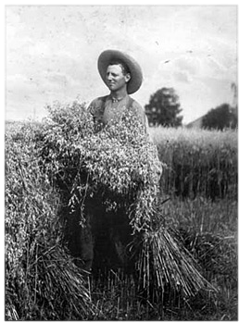
William Elsley in field with harvest, ca. 1910
Reuben R. Sallows
Ministry of Agriculture and Food
Reference Code: RG 16-276-10, 2374
Archives of Ontario, I0016113

Introduction
Designed to fit into teachers’ practice, this resource kit provides links, activity suggestions, primary source handouts and worksheets to assist you and your students in applying, inquiring, and understanding Canada between 1850 and 1914.

Topic
Ontario’s agricultural history

Source
The Archives of Ontario Celebrates our Agricultural Past online exhibit (click here to access the online exhibit).

Use the Archives of Ontario’s online exhibit on agriculture:
- As a learning resource for yourself
- As a site to direct your students for inquiry projects
- As a place to find and use primary sources related to the curriculum

Themes that can be addressed
- Use of primary sources
- Immigration and settlement
- Developments in science and technology
- Community organizations

Curriculum Links
Strand A. Creating Canada, 1850–1890
Overall Expectations | Historical Thinking Concepts | Specific Expectations
A1. Application: The New Nation and Its Peoples | Cause and Consequence; Historical Perspective | A1.3
A2. Inquiry: Perspectives in the New Nation | Historical Perspective; Historical Significance | A2.1, A2.2, A2.4, A2.5, A2.6
A3. Understanding Historical Context: Events and Their Consequences | Historical Significance; Cause and Consequence | A3.3, A3.4, A3.5

Strand B. Canada, 1890–1914: A Changing Society
Overall Expectations | Historical Thinking Concepts | Specific Expectations
B1. Application: Canada – Past and Present | Continuity and Change; Historical Perspective | B1.1, B1.2, B1.3
B2. Inquiry: Perspectives on a Changing Society | Historical Perspective; Historical Significance | B2.1, B2.2, B2.4, B2.5, B2.6
B3. Understanding Historical Context: Events and Their Consequences | Historical Significance; Cause and Consequence | B3.3, B3.4, B3.5

Assignment & Activity Ideas

Inquiring into Farm Life in Ontario
- The historical inquiry process involves five steps:
- Formulating a question
- Gathering and organizing information or evidence
- Interpreting and analysing information or evidence
- Evaluating information or evidence and drawing conclusions
- Communicating findings
- The curriculum highlights that these steps do not have to be completed sequentially nor together. You may wish to explore specific steps based on your students’ readiness and prior knowledge or your own resources and time. See pages 22-24 in the 2013 revised Ontario Social Studies and History curriculum for more details (Click here to access the Ontario Social Studies and History curriculum).
- Using a primary source handout from this kit, introduce your students to the topic of the farm life in Ontario. Ask students to ask questions of the primary source provided. Use these questions as jumping off points to explore the historical topic of life in rural communities in more depth.
- Use The Archives of Ontario Celebrates our Agricultural Past online exhibit as a source to point your students for their own inquiry project. Here, they can view primary sources and secondary information to gather and organize historical evidence to interpret, evaluate, and communicate (Click here to access the online exhibit).

A Changing Canada
- After understanding some major themes of a “Changing Canada” from 1890 to 1914, ask students to use one primary source image contained in this kit as inspiration to talk about changes to people’s lives during this period.
- Based on what they know about industrialization, changes to rights and/or increase in immigration, would the people in the photograph still be working on a farm 10 years later? Would they be farming a different or new harvest? Would they have moved? Would they have been the same ethnicity as a generation before? Would they be using the same methods or equipment?

Creating or Changing Canada Graffiti
- Before either the “Creating Canada” or “Changing Canada” unit, post the primary source images around the classroom and ask students to write impressions of life during these time periods on chart paper poster nearby (Graffiti strategy)
- Following the unit, revisit these initial impressions to ask how the themes you have discussed during the unit would have affected the people in these pictures.

Handouts & Worksheets

Introduction to Primary Sources 6
Farmhouse and Pumpkins (1905) 8
Women and Children in Farm Yarn (1900) 9
Ploughing Match With Judges (1916) 10
Frost and Wood Farm Hardware Store (1900) 11
Farmers Moving Hay into Barn 12
Woman Feeding a Calf (1910) 14
Alexander MacDonell’s farm (1903) 15
Girl with Carrot Harvest (1910) 16

Introduction to Primary Sources
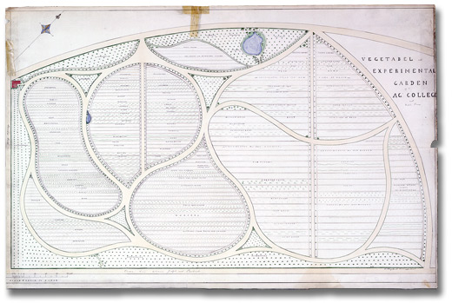
Vegetable and experimental garden of the Agricultural College and Model Farm in Guelph, [ca. 1874]
H. A. Engelhardt
Ontario Agricultural College Landscape plans
Reference Code: RG 16-267
Archives of Ontario

A primary source is a document or object from the past created by people who lived during that time. Primary sources provide a view into an event or experience that only people living during that time could have experienced.
Archives collect and preserve primary sources so that students can learn history from the experiences of people who were there. In an archive, primary sources are called records. In a museum, primary sources are called artifacts.
Have you used a primary source before?
Primary Sources | Secondary Sources
Original material from the past | Material people today write about the past
Example:  Letters  Diaries  Photographs  Paintings and other art work  Graphs  Maps | Example:  Textbooks  Reference books  Websites such as Wikipedia  Current news articles  Documentaries and films
What are some other examples of primary and secondary sources?
Can sources be both primary and secondary?

Farmhouse and Pumpkins (1905)
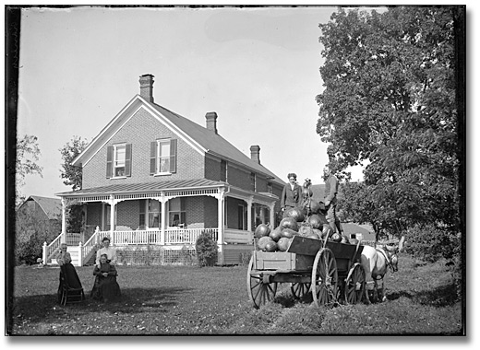
Farmhouse and load of pumpkins, September 1905
Marsden Kemp
Glass Plate Negative
Reference Code: C 130-6-0-12-2
Archives of Ontario, I0013550

Women and Children in Farm Yard (1900)
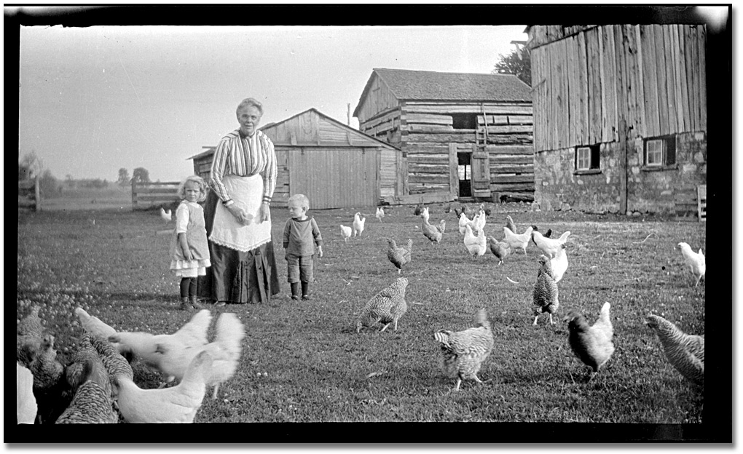

Woman and two young children standing in a farm yard, with chickens, ca. 1900
Photographer unknown
Black and white negative
Rowley Murphy collection
Reference Code: C 59-2-0-0-2
Archives of Ontario, I0013795

Ploughing Match with Judges (1916)
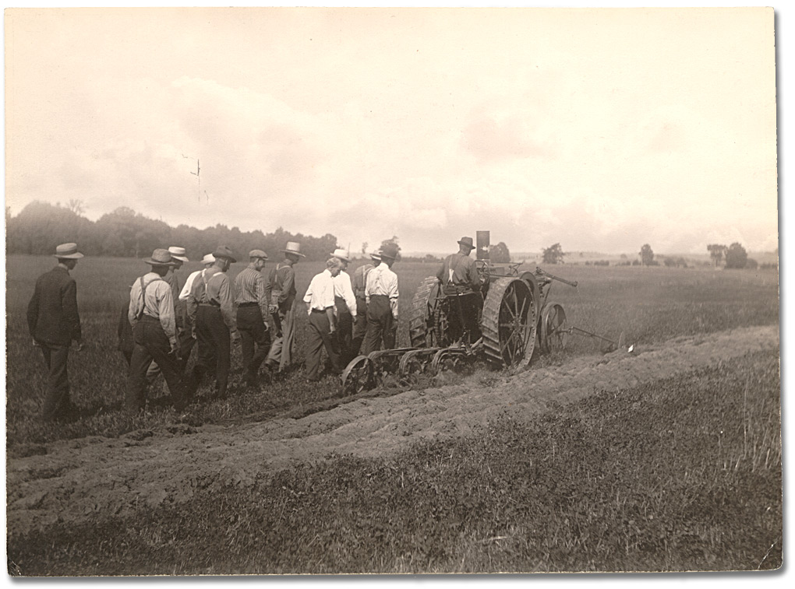
Ploughing match contestant with judges, 1916
Reuben Sallows
Black and white print
Reference Code: C 223-3-0-0-16
Archives of Ontario, I0002277

Frost and Wood Farm Hardware Store (1900)
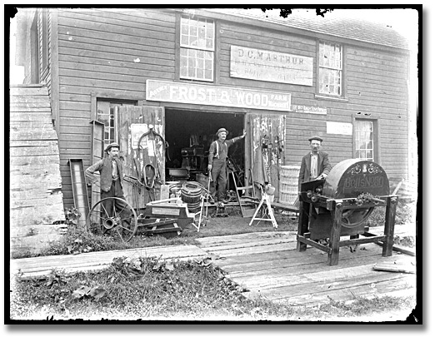
Frost and Wood farm hardware store, ca. 1900
Bartle Brothers
Glass plate negative
Reference Code: C 2-10232-1611
Archives of Ontario, I0002505

Farmers Moving Hay into Barn
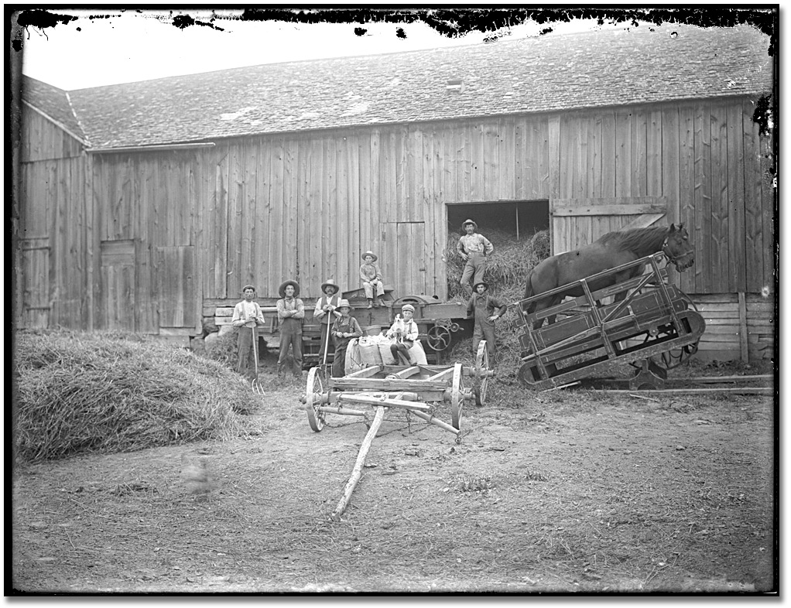

Farmers moving hay into a barn, ca. 1900
Bartle Brothers
Glass plate negative
Reference Code: C 2-10232-1729
Archives of Ontario, I0002526
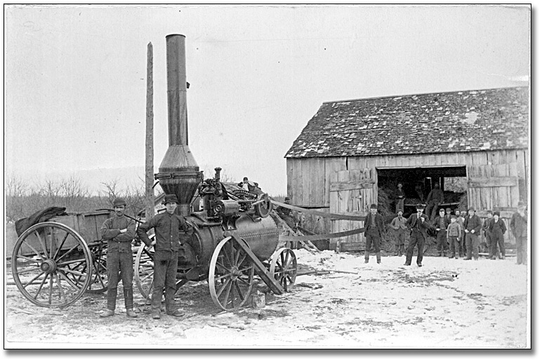Threshing Machine with Steam Engine (1914)

Threshing machine with steam engine, ca. 1914
Photographer unknown
Elsie Dawson collection
Black and white print
Reference Code: C 224-0-0-34
Archives of Ontario, I0007460

Woman Feeding a Calf (1910)
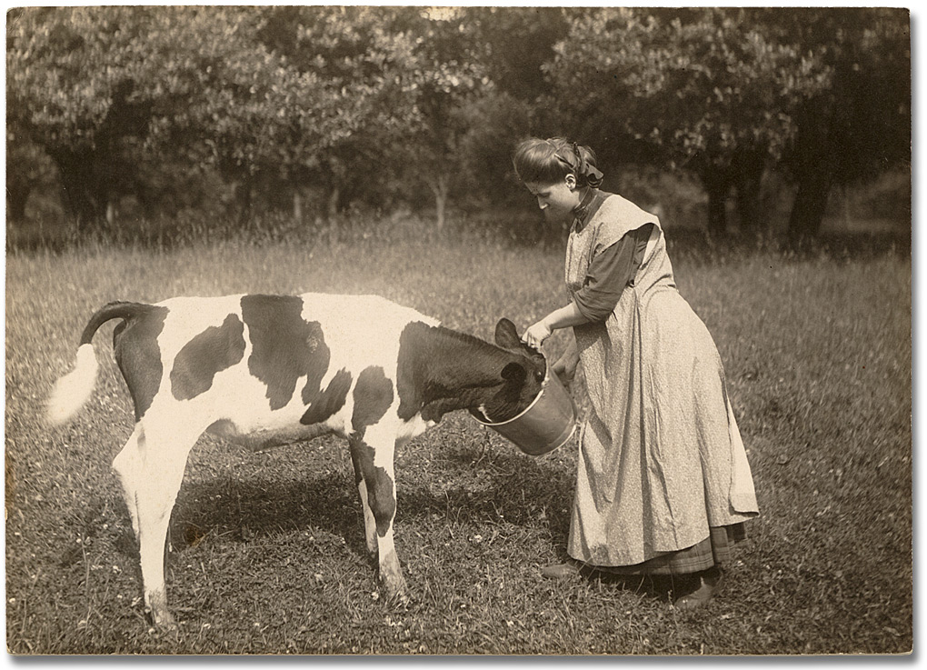
Woman feeding a calf, 1910
Reuben Sallows
Black and white print
Reference Code: C 223-2-0-0-5
Archives of Ontario, I0002255

Alexander MacDonell’s farm (1903)
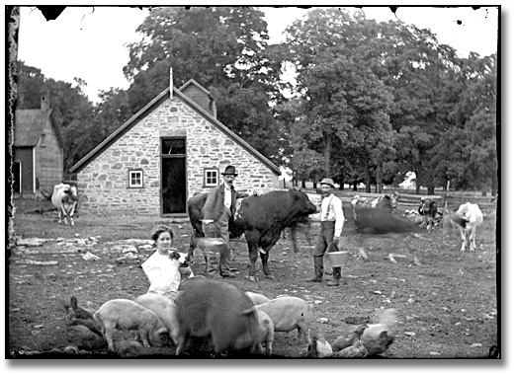

Alexander MacDonell’s stone building and farm, 1903
Marsden Kemp
Black and white print
Reference Code: C 130-1-0-25-5
Archives of Ontario, I0013124

Girl with Carrot Harvest (1910)
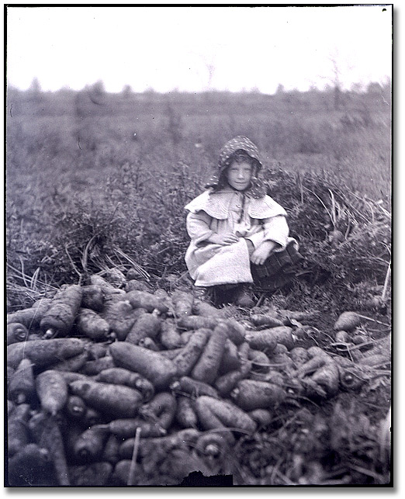
Girl with carrot harvest, Clarkson, 1910
M. O. Hammond
Black and white negative
Reference Code: F 1075 H474
Archives of Ontario, I0000984

