Lesson Resource Kit: Healthy Living in Ontario

  - Grade 8: Creating Canada, 1850-1890
  - Canada, 1890–1914: A Changing Society

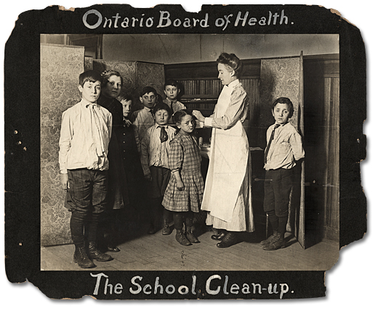
Children being washed by a nurse at school, ca. 1905
Public Health Nursing Branch
Reference Code: RG 10-30-2
Archives of Ontario, I0005195

Introduction
Designed to fit into teachers’ practice, this resource kit provides links, activity suggestions, primary source handouts and worksheets to assist you and your students in applying, inquiring, and understanding Canada between 1850 and 1914.

Topic
The development of Ontario’s public health system

Source
Promotion of Healthy Living in Ontario online exhibit (click here to access online exhibit)
Use the Archives of Ontario’s online exhibit on the promotion of healthy living in Ontario:
- As a learning resource for yourself
- As a site to direct your students for inquiry projects
- As a place to find and use primary sources related to the curriculum

Themes that can be addressed
- Use of primary sources
- The development of urban centres
- Technological advances
- Social reform movements

Curriculum Links
Strand A. Creating Canada, 1850-1890
Overall Expectations | Historical Thinking Concepts | Specific Expectations
A1. Application: the New Nation and its Peoples | Cause and Consequence, Historical Perspective | A1.3
A2. Inquiry: Perspectives in the New Nation | Historical Perspective, Historical Significance | A2.1, A2.2, A2.4, A2.5, A2.6
A3. Understanding Historical Context: Events and Their Consequences | Historical Significance, Cause and Consequence | A3.1, A3.2, A3.3, A3.4, A3.5

Strand B. Canada, 1890–1914: A Changing Society
Overall Expectations | Historical Thinking Concepts | Specific Expectations
B1. Application: Changes and Challenges | Continuity and Change;  Historical Perspective | B1.1, B1.2, B1.3
B2. Inquiry: Perspectives in British North Americans | Historical Perspective;  Historical Significance | B2.1, B2.2, B2.4, B2.5, B2.6
B3. Understanding Historical Context: Events and Their Consequence | Historical Significance;  Cause and Consequence | B3.1, B3.2, B3.3, B3.4

Assignment & Activity Ideas

Inquiring into Healthy Living
- The historical inquiry process involves five steps:
- Formulating a question
- Gathering and organizing information or evidence
- Interpreting and analysing information or evidence
- Evaluating information or evidence and drawing conclusions
- Communicating findings
- The curriculum highlights that these steps do not have to be completed sequentially nor together. You may wish to explore specific steps based on your students’ readiness and prior knowledge or your own resources and time. See pages 22-24 in the 2013 revised Ontario Social Studies and History curriculum for more details. (click here for the revised curriculum)
- Using a primary source handout from this kit, introduce your students to the topic of the life at the turn of the century. Ask students to ask questions of the primary source provided. Use these questions as a jumping off point to explore these historical issues of life in rural communities during this time period in more depth.
- Use The Promotion of Healthy Living in Ontario online exhibit as a source to point your students for their own inquiry project. Here, they can view primary sources and secondary information to gather and organize historical evidence to interpret, evaluate, and communicate. (click here to access the online exhibit)

One Source, Many Questions
- Using one of the primary source handouts found in this teaching kit, ask students to identify the 5Ws (who, what, where, when, and why). The Identifying My Primary Source worksheet in this kit can help in this task.
- Ask students to zoom in on one of the aspects of the source they found strange, familiar, or interesting and identify them to the class. Write these things on the board and group them according to theme.
- Use one or more of these themes as an introduction to an inquiry-based assignment. Have students work in collaborative groups, individually, or as a class on short or long term project(s) researching the historical context of the primary source.

Health and Life: Urbanization and industrialization
- Starting with the Caricature of Charles Hastings primary source found in this kit, discuss with your students themes related to industrialization and the ‘cleaning up’ of urban centres during the turn of the century. Also discuss the conditions of life for many urban poor in Ontario during this time.
- Use the other primary sources to go further into a discussion of actions taken by various groups and/or individuals in Canada to improve their health and lives during this period. This can invite a discussion of cause and consequence of growth, urban development, and health promotion

A Changing Canada: Health Promotion
- Using primary sources found in this kit as well as the online exhibit The Promotion of Healthy Living in Ontario, have students create a brochure warning someone about the health dangers of urban centres at the turn of the century. (click here to access the online exhibit)
- Encourage students to use a blend of images, text, fact and fiction to create a product they can present in a fictionalized 19th century “Health Fair”

Treating Illness: Similarities and differences
- Using the primary sources provided, have a discussion about similarities or differences between health care today and in the early 1900s.
- Ask students if they think if something like the flu would have been treated the same or different now. Gathering options can be done actively using a Four Corners approach, by secret ballot to be revealed following the unit, or by a tally on the board
- Using the Influenza Poster primary source, found in this kit ask students to fill out the corresponding worksheet Treating the Flu in the 1900s and Today: Similarities and differences.
- Ask students to vote on whether the evidence shows that the flu would have been treated the same or different now as in the past. Compare this vote to the vote at the beginning of the lesson.
- Have a discussion about expectations of the past: Do we think of the past as “backward”? Why do we think this? Is it always true? Are there lessons from the past we use today?
- Extension: Continue the activity with a different illness or health concern that may not be as prominent today.

Handouts & Worksheets

Introduction to Primary Sources 6
The Sale of ‘Unsanitary’ Ice Cream (1905) 7
Influenza Poster (1918) 13
A Caricature of Charles Hastings (1910) 9
Children Being Measured at the School Clinic (1905) 10
Breathing Exercises at Muskoka Cottage Sanatorium 11
Disinfecting Railway Cars (1908) 12

Introduction to Primary Sources
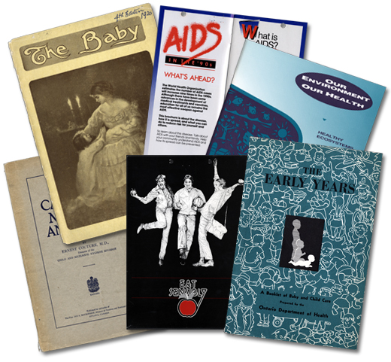
A primary source is a document or object from the past created by people who lived during that time. Primary sources provide a view into an event or experience that only people living during that time could have experienced.
Archives collect and preserve primary sources so that students can learn history from the experiences of people who were there. In an archive, primary sources are called records. In a museum, primary sources are called artifacts.

Primary Sources | Secondary Sources
Original material from the past | Material people today write about the past
Example:  Letters  Diaries  Photographs  Paintings and other art work  Graphs  Maps | Example:  Textbooks  Reference books  Websites such as Wikipedia  Current news articles  Documentaries and films

What are some other examples of primary and secondary sources?
Can sources be both primary and secondary?

Identifying My Primary Source

Name of primary source: ______________________________________________________________________
What type of primary source is it? ______________________________________________________________________
What is happening in this primary source? ____________________________________________________________________________________________________________________________________________
Who created it? _________________________________________________________
Why was it created? _____________________________________________________
When was it created? ____________________________________________________
Where was it created?____________________________________________________
What when you look at this source, do you find anything strange about it? ______________________________________________________________________
______________________________________________________________________
______________________________________________________________________
When you look at this source, do you find anything familiar about it?
______________________________________________________________________
______________________________________________________________________
______________________________________________________________________
What do you want to know about this primary source?
______________________________________________________________________
______________________________________________________________________

What do you want to know about the people in the primary source?
______________________________________________________________________
______________________________________________________________________
What is the most interesting thing about this primary source?
______________________________________________________________________
______________________________________________________________________

The Sale of ‘Unsanitary’ Ice Cream (1905)
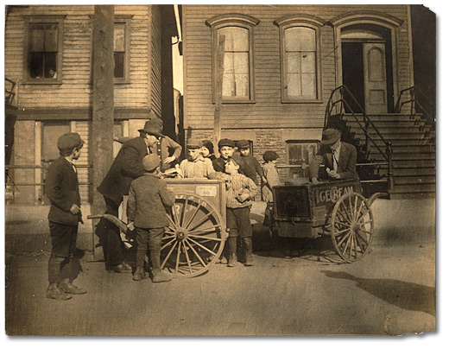
The sale of ‘unsanitary’ ice cream, ca. 1905
Public Health Nursing Branch
Reference Code: RG 10-30-2, 3.02.5
Archives of Ontario, I0005187

Questions to think about:
What does “unsanitary” mean?
What would make ice cream “unsanitary”?
Do you think the children buying the ice cream
think there is anything wrong with it?

A Caricature of Charles Hastings (1910)
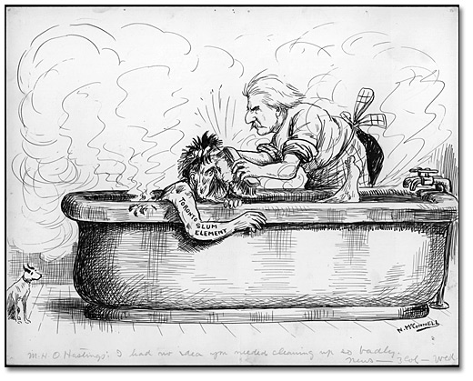
“M. H. O Hastings: I had no idea you needed cleaning up so badly”.
A caricature of Charles Hastings, Toronto’s Medical Health Officer,
and commentary on his attempts to make Toronto cleaner and healthier, ca. 1910-14
Newton McConnell fonds
Reference Code: 301, 61
Archives of Ontario, I0006074

Children Being Measured at the School Clinic (1905)
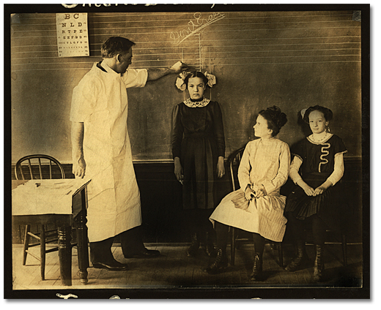
Children being measured at the school clinic, ca. 1905
Public Health Nursing Branch
Reference Code: RG 10-30-2, 3.03.2
Archives of Ontario, I0005191

Breathing Exercises, Male Patients, Muskoka Cottage Sanatorium
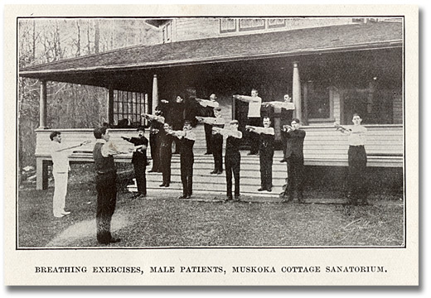
Breathing Exercises, Male Patients, Muskoka Cottage Sanatorium
Reference Code: F 1369-1-0-1
Archives of Ontario

Disinfecting railway cars for foot and mouth disease, 1908
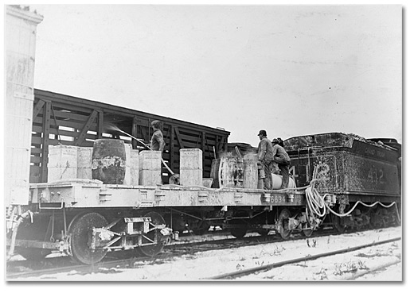
Disinfecting railway cars for foot and mouth disease, 1908
John Boyd fonds
Reference Code: C 7-3-1672
Archives of Ontario, I0003363

Influenza Poster, 1918

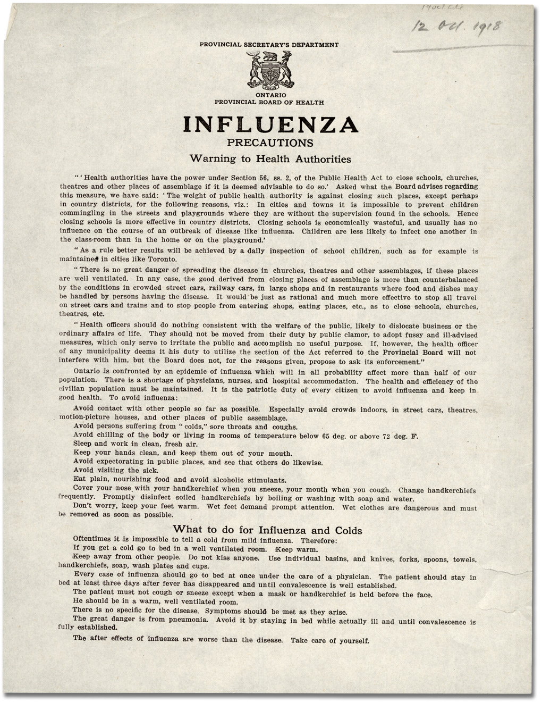
Influenza poster, 1918
Secretary of the Board of Health and Chief
Medical Officer of Health subject files
Reference Code: RG 62-4-9-450a.1
Archives of Ontario
Treating the Flu in the 1900s and Today:

Similarities and Differences

Looking at the primary source Influenza Poster published in 1918. List each piece of advice in the columns provided.
Similarities | Differences
Space left blank for activity purposes | Space left blank for activity purposes

Looking at the evidence,
do you think treating the flu has changed much since the 1900s?

