Lesson Resource Kit: The Great Toronto Fire
Grade 8: Creating Canada, 1850–1890
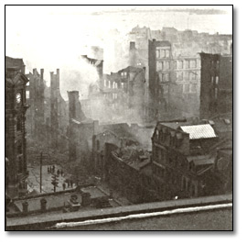
Toronto, 1904
Alexander Thurtell Brown fonds
Reference Code: C 302-3-0-44S 15008
Archives of Ontario, I0016404

Introduction
Designed to fit into teachers’ practice, this resource kit provides links, activity suggestions, primary source handouts and worksheets to assist you and your students in applying, inquiring, and understanding Canada between 1850 and 1890.

Topic
Urban development and the Great Toronto Fire

Source
The Great Toronto Fire online exhibit (to access the online exhibit, click here).
Use the Archives of Ontario’s online exhibit on the Great Toronto Fire:
- As a learning resource for yourself
- As a site to direct your students for inquiry projects
- As a place to find and use primary sources related to the curriculum

Themes that can be addressed
- Use of primary sources
- Industrialization and technological improvement
- Urban development and improvements in infrastructure

Curriculum Links
Strand A. Creating Canada, 1850–1890
Overall Expectations | Historical Thinking Concepts | Specific Expectations
A1. Application: The New Nation and Its Peoples | Cause and Consequence; Historical Perspective | A1.2, A1.3
A2. Inquiry: Perspectives in the New Nation | Historical Perspective; Historical Significance | A2.1, A2.2, A2.3, A2.4, A2.5, A2.6
A3. Understanding Historical Context: Events and Their Consequences | Historical Significance; Cause and Consequence | A3.1, A3.3, A3.4, A3.5

Assignment & Activity Ideas

Inquiring into the Great Toronto Fire of 1904
- The historical inquiry process involves five steps:
- Formulating a question
- Gathering and organizing information or evidence
- Interpreting and analysing information or evidence
- Evaluating information or evidence and drawing conclusions
- Communicating findings

- The curriculum highlights that these steps do not have to be completed sequentially nor together. You may wish to explore specific steps based on your students’ readiness and prior knowledge or your own resources and time. See pages 22-24 in the 2013 revised Ontario Social Studies and History curriculum for more details. To access the revised curriculum, click here.
- Using a primary source handout from this kit, introduce your students to the topic of the 1905 Toronto fire. Ask students to ask questions of the source, the fire, or life during this time. Use these questions as jumping off points for exploring these historical issues in more depth.
- Use The Great Toronto Fire online exhibit as a source to point your students for their own inquiry project. Here, they can view primary sources and secondary information to gather and organize historical evidence to interpret, evaluate, and communicate. To access the online exhibit, click here.

Collecting Sources
- After looking through the primary sources in this kit and understanding a little bit about the cause and effect of the 1904 Toronto fire, have your students create a list of questions they have about the Toronto fire. Discuss if the answers are possible to find and where they might go finding them.
- Have students begin a local research project in which they look into fires or other disasters in your local area.
- Have students create a primary source kit of their own, which include comparable sources in this kit: i.e. a floor plan, a depiction of this fire, information about the fire brigade, etc.
- Have students attempt to answer their earlier questions during this research.

Life Then and Now: Are we any more ready for a disaster?
- Have a discussion with your students about what type of disaster could devastate a large city today. Ask your students what they think the effects of such a disaster could be. Ask your students if the same things would be disastrous now than in the past. Have your students weigh in on whether or not we’d be more prepared for a disaster now compared to 100 years ago.
- Using the primary sources attached to this kit or the entire The Great Toronto Fire online exhibit, have students learn more about the Great Toronto Fire of 1904. To access the online exhibit, click here.
- Using a similar disaster now, have students compare and contrast the causes, effects, responses, and aftermath of the two disasters. Have students weigh in if we are more prepared or less prepared for a disaster now than in the past

Reporting on Modernization
- Ask students to go through the primary sources from this kit or the entire The Great Toronto Fire online exhibit, like a newspaper reporter from 1904. Have students identify who, where, when, how, and why, and find out some interesting or intriguing things about the fire. To access the online exhibit, click here.
- Ask students to vote on whether they think Toronto was a modern city in 1904.
- Using the primary sources available to them, ask the students to write a position piece from the position of a newspaper reporter to argue either:
  - that Toronto in 1904 was very modern and advanced and had little significant damage after the fire OR
  - that Toronto in 1904 needed to update its building construction methods to better prevent an equally significant fire in the future.

Mapping the Fire, Assessing its Significance
- Using the Area Affected by the Toronto Fire handout found at the back of this kit, ask students to label the streets affected by the 1904 fire with contemporary Toronto landmarks.
- Based on sources identifying which buildings were most badly devastated, have students create an “after” map that highlights what contemporary buildings would be most badly affected if the 1904 fire happened today.
- Using these two maps as a guide, have students weigh in on whether or not the 1904 fire was a significant moment in Toronto history.
- Alternative: Do a local history project in which students create a map that is comparable in size and/or significance to what Toronto would have been like in 1904. Using the 1904 Toronto fire as a guide, ask your students to create an “after” map that shows which local buildings would have been destroyed in the fire happened in your area. Use these maps as have students assess whether or not the 1904 fire was a significant moment in history.

Handouts & Worksheets

Introduction to Primary Sources 7
Messrs Kilgour Bros. Premises (1904) 8
Aftermath of the Toronto Fire (1904) 10
The Queens Hotel 11
Front Street after the Toronto Fire (1904) 12
Area Affected by the Toronto Fire 13
Parkdale’s First Fire Brigade (1888) 14

Introduction to Primary Sources
Toronto, 1904
Alexander Thurtell Brown fonds
Black and White Photograph
Reference Code: C 302-3-0-44S 15008
Archives of Ontario, I0016404

A primary source is a document or object from the past created by people who lived during that time. Primary sources provide a view into an event or experience that only people living during that time could have experienced.
Archives collect and preserve primary sources so that students can learn history from the experiences of people who were there. In an archive, primary sources are called records. In a museum, primary sources are called artifacts.

Primary Sources | Secondary Sources
Original material from the past | Material people today write about the past
Example:  Letters  Diaries  Photographs  Paintings and other art work  Graphs  Maps | Example:  Textbooks  Reference books  Websites such as Wikipedia  Current news articles  Documentaries and films

What are some other examples of primary and secondary sources?
Can sources be both primary and secondary?

Messrs Kilgour Bros. Premises (1904)
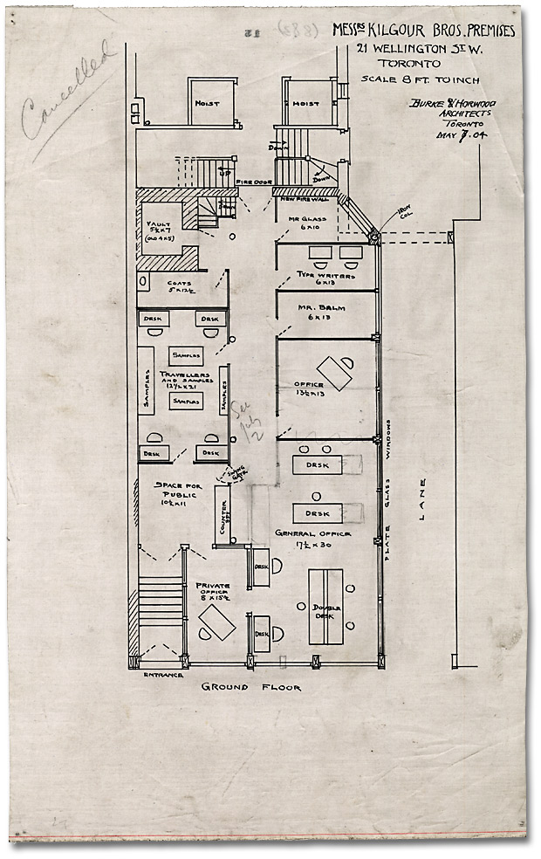
Messrs Kilgour Bros. Premises, 21 Wellington St. W., Toronto, May 7, 1904
Burke & Horwood Architects
J. C. B. & E. C. Horwood Collection
Reference Code: C 11-1102 (883) 15
Archives of Ontario

Aftermath of the Toronto Fire (1904)
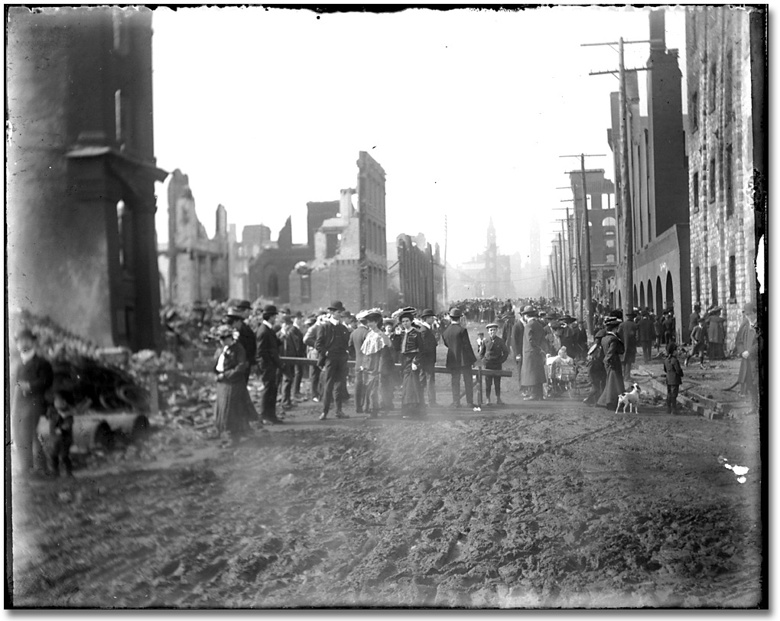

Aftermath of the Toronto Fire, 1904
John Lane fonds
Glass Plate Negative
Reference Code: C 127-1-0-1-5
Archives of Ontario, I0016405

The Queens Hotel

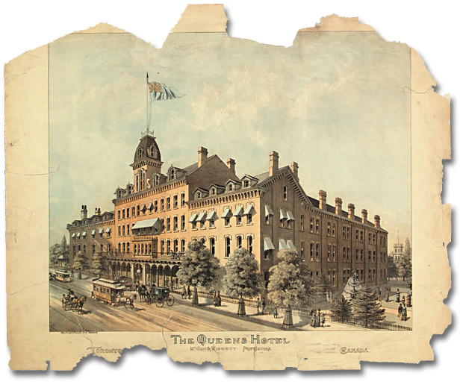

The Queens Hotel, Toronto
Lithograph
J. C. B. & E. C. Horwood Collection
Reference Code: C 11-142-0-1 (356) 1
Archives of Ontario

Front Street after the Toronto Fire (1904)

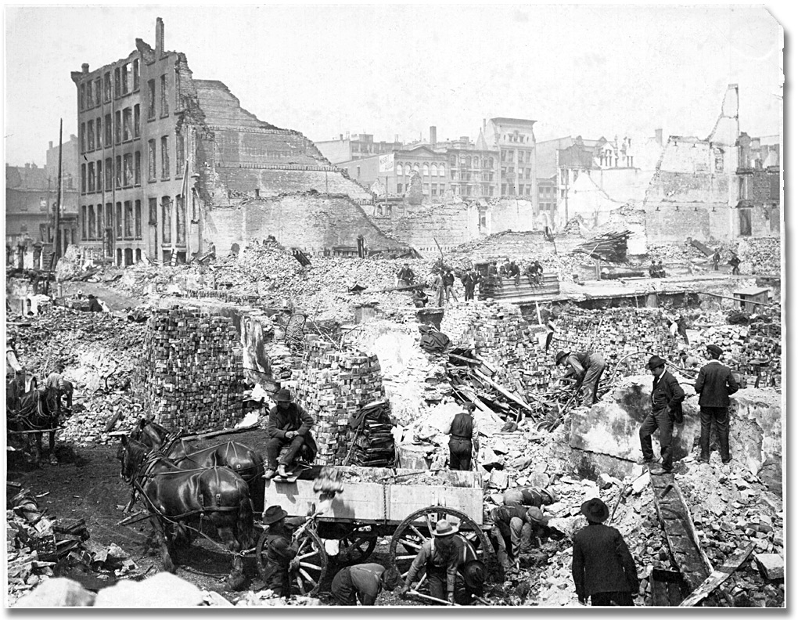

Front Street after the Toronto Fire, April 19, 1904
Photographer unknown
Black and white print
Edwin C. Guillet collection
Reference Code: F 2178-1-0-22, S 5198
Archives of Ontario, I0006700

Area Affected by the Toronto Fire

Tatton, R. J. The Great Fire of Toronto, 1904.
In: IAO Inspector, vol. 17, no. 3, 1981.
Archives of Ontario Library Call Number: PAMPH 1981 #105

Parkdale’s First Fire Brigade (1888)
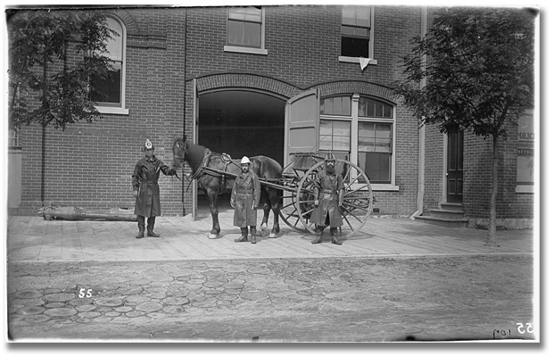
Parkdale’s first fire brigade, Toronto, 1888
John Boyd
Black and white print
Reference Code: C 7-1-0-0-63
Archives of Ontario, I0003

