Teaching Resource Kit: Five Women and Their Diaries
Grade 8: Creating Canada, 1850–1890
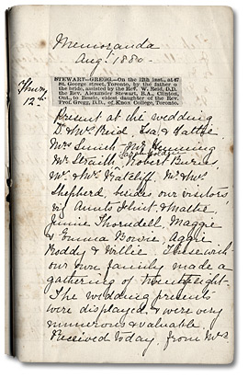
Bessie Stewart's First Diary Entry, 1880, Gregg family fonds,
Reference Code: F 712, MU 1158
Archives of Ontario

Introduction
Designed to fit into teachers’ practice, this resource kit provides links, activity suggestions, primary source handouts and worksheets to assist you and your students in applying, inquiring, and understanding Canada between 1850 and 1890.

Topic
Women’s experiences in the late-nineteenth century

Source
A Lifetime – Day by Day: Five Women and their Diaries online exhibit – click here to view this exhibit.
Use the Archives of Ontario’s online exhibit on women’s diaries:
- As a learning resource for yourself
- As a site to direct your students for inquiry projects
- As a place to find and use primary sources related to the curriculum

Themes that can be addressed
- Use of primary sources
- The lives of women, differences in socioeconomic class
- Understanding historical perspective
- Identifying historical significance

Curriculum Links

Strand A. Creating Canada, 1850 - 1890
Overall Expectations | Historical Thinking Concepts | Specific Expectations
A1. Application: The New Nation and Its Peoples | Cause and Consequence; Historical Perspective | A1.2
A2. Inquiry: Perspectives in the New Nation | Historical Perspective; Historical Significance | A2.2, A2.2, A2.2, A2.5, A2.6
A3. Understanding Historical Context: Events and Their Consequences | Historical Significance; Cause and Consequence | A3.5

Assignment & Activity Ideas

Inquiring into Women’s Lives
- The historical inquiry process involves five steps:
- Formulating a question
- Gathering and organizing information or evidence
- Interpreting and analysing information or evidence
- Evaluating information or evidence and drawing conclusions
- Communicating findings
- The curriculum highlights that these steps do not have to be completed sequentially nor together. You may wish to explore specific steps based on your students’ readiness and prior knowledge or your own resources and time. See pages 22-24 in the 2013 revised Ontario Social Studies and History curriculum for more details.
- Using one of the primary source handouts found within this kit, introduce your students to the topic of women’s lives in the late nineteenth century. Ask students to ask questions of the source and use these questions as jumping off points in exploring these historical issues in more depth.
- A Lifetime – Day by Day: Five Women and their Diaries online exhibit as a source to point your students for their own inquiry project. Here, they can view primary sources and secondary information to gather and organize historical evidence to interpret, evaluate, and communicate.

One Source, Many Questions
- Using one of the primary source handouts found in this Teaching Kit, ask students to identify the 5Ws. The Identifying My Primary Source worksheet can help in this task.
- Ask students to zoom in on one of the aspects of the source they found strange, familiar, or interesting and identify them to the class. Write these things on the board and group them according to theme.
- Use one or more of these themes as an introduction to an inquiry-based assignment. Have students work in collaborative groups, individually, or as a class on short or long term project(s) researching the historical context of the primary source.

Challenging Significance, Looking at Perspective
- After covering some major or significant historical events in late-1800s Canada, give students one of the primary source handouts found in this kit.
- Use the Looking for Evidence worksheet for one of the primary source photographs to identify a person or perspective to engage with.
- Ask students to think about what those historical events would have meant for the person who created or who was represented in the primary source. What would their perspective have been? Would that person have found that event significant to their own lives? Would it have changed their life dramatically? A discussion of historical significance would be relevant here, if not already discussed in the class.
- Have students create a mind map identifying the connections between the perspective of the person in the primary source and one or more of the significant historical events previously discussed in the class.
- Ask students if the person would have thought other things that happened during this period was significant. Ask students to add those events to their map.
- Extension: Ask students to use their imagination: if you are using one of the diary entries written by the young girls, ask your own students what events were significant in their own lives. Using this discussion, ask students to write a diary entry describing this event from the perspective of one of the original diary writers.

Recording a Life
- Using one of the diary primary sources found in this kit, introduce how diary writing is a personal record that we can use as a primary source for understanding the past.
- Ask students to identify what has changed and stayed the same in ways we currently record daily events and feelings, such as the introduction of Facebook, Twitter, or Instagram.
- Using a contemporary method for recording personal events and feelings, ask students to imagine the day-in-the-life of one person represented in one of the primary source photographs found in this kit. Use the Day-by-Day Facebook Page handout as a template.

Handouts & Worksheets
Introduction to Primary Sources 6
Identifying My Primary Source 7
Page with Sketch from Marty Hastie’s Diary (1884) 8
Marty Hastie’s Diary (1884) 9
Page from Pheobe Gregg's Diary (1849) 10
Beatrice with Lady Edgar and Marjorie Edgar (1880) 11
Two Girls (1900) 12
Phoebe Gregg (1855) 13
Family Portrait (1900) 14
Beatrice Ironing (1906) 15
The Canadian Pocket Diary (1866) 16
Martha Hastie’s Diary 17
Bessie Gregg with Senior Class in Mission School (1880) 18
Four Young Women on a Porch (1900) 19
Murphy Family and Friends on Toronto Island (ca. 1900) 20
Looking for Evidence 21
Day-by-Day Facebook Page 22

Introduction to Primary Sources

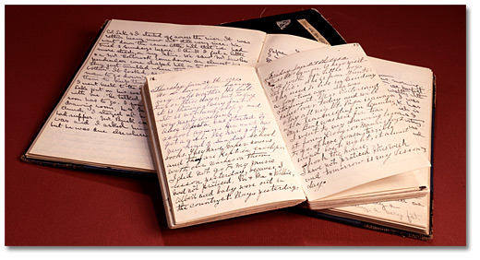

A primary source is a document or object from the past created by people who lived during that time. Primary sources provide a view into an event or experience that only people living during that time could have experienced.
Archives collect and preserve primary sources so that students can learn history from the experiences of people who were there. In an archive, primary sources are called records. In a museum, primary sources are called artifacts.

Primary Sources | Secondary Sources
Original material from the past | Material people today write about the past
Example:  Letters  Diaries  Photographs  Paintings and other art work  Graphs  Maps | Example:  Textbooks  Reference books  Websites such as Wikipedia  Current news articles  Documentaries and films

What are some other examples of primary and secondary sources?

Can sources be both primary and secondary?

Identifying My Primary Source

Name of primary source: _________________________________________________
What type of primary source is it? __________________________________________
What is happening in this primary source? ___________________________________
______________________________________________________________________
Who created it? _________________________________________________________
Why was it created? _____________________________________________________
When was it created? ____________________________________________________
Where was it created? ___________________________________________________
What when you look at this source, do you find anything strange about it?
______________________________________________________________________
______________________________________________________________________
When you look at this source, do you find anything familiar about it?
______________________________________________________________________
______________________________________________________________________
What do you want to know about this primary source?
______________________________________________________________________
______________________________________________________________________
What do you want to know about the people in the primary source?
______________________________________________________________________
What is the most interesting thing about this primary source?
_____________________________________________________________________

Page with Sketch from Marty Hastie’s Diary (1884)
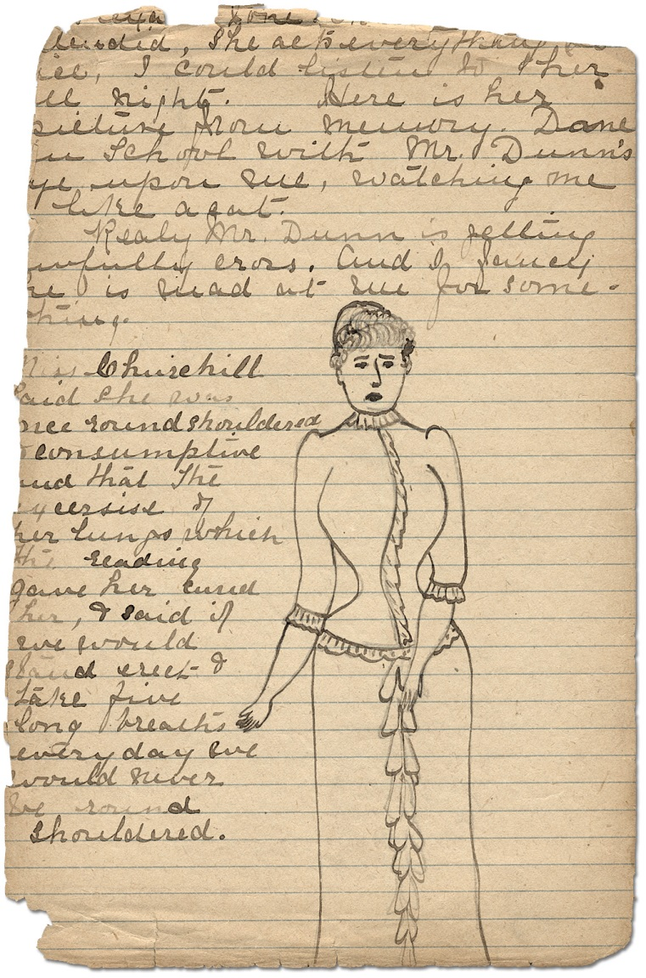
Page with Sketch from Marty Hastie’s diary, 1884
William Mack family fonds
Reference Code: F 40 Series C, MU 3300
Archives of Ontario

Marty Hastie’s Diary (1884)

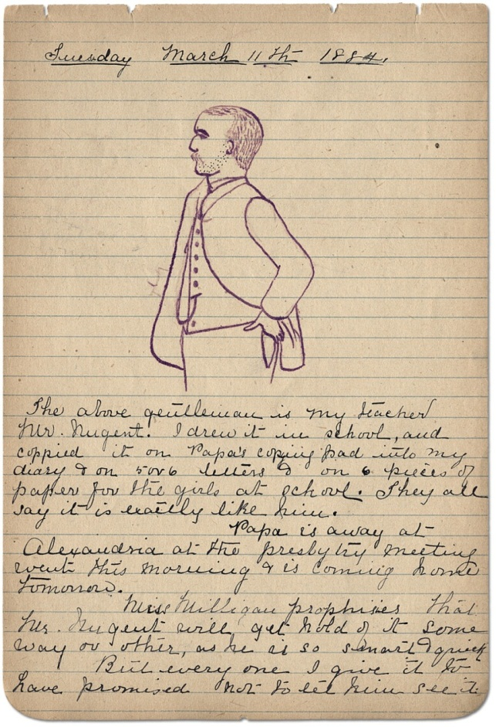
Page from Marty Hastie’s diary, March 11, 1884
William Mack family fonds
Reference Code: F 40 Series C, MU 3300
Archives of Ontario
Transcript:
“The above gentleman is my teacher Mr. Nugent. I drew it in school, and copied it on Papa’s copying pad into my diary & on 5 or 6 letters & on 6 pieces of paper for the girls at school. They all say it is exactly like him.

Miss Milligan prophesies that Mr. Nugent will get hold of it some way or other, as he is so smart & quick. But everyone I give it to have promised not to let him see it.”

Page from Pheobe Gregg's Diary (1849)

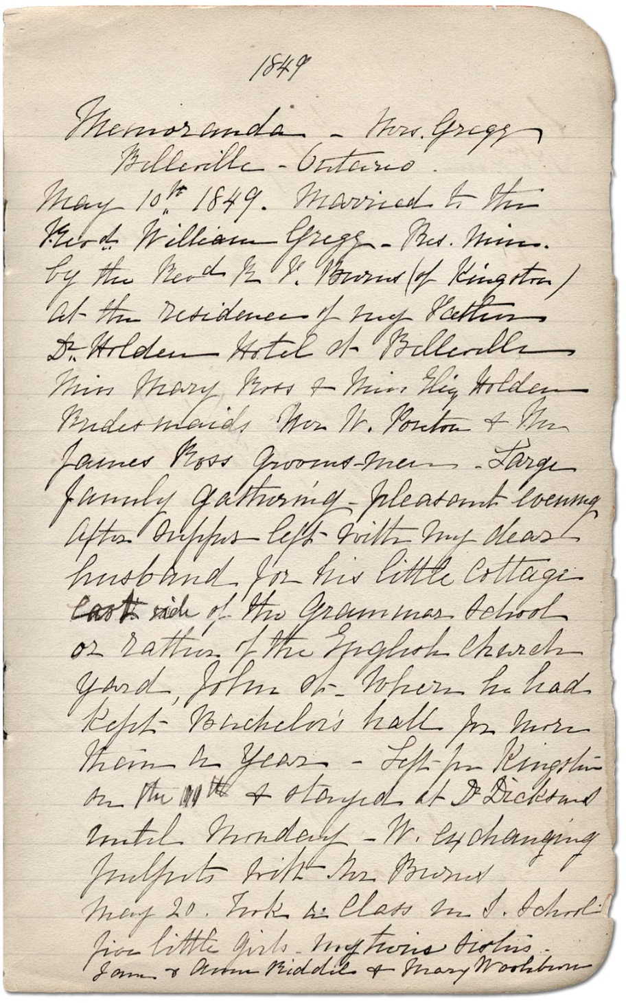
Page from Pheobe Gregg's Diary, 1849
Gregg family fonds
Reference Code: F 712, MU 1158
Archives of Ontario

Beatrice with Lady Edgar and Marjorie Edgar (1880)
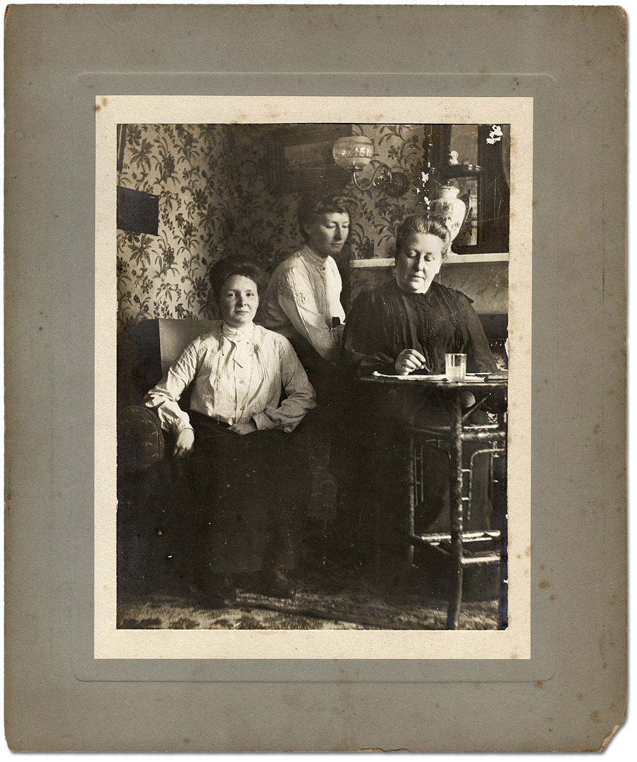
Beatrice with Lady Edgar and Marjorie Edgar, ca. 1880
James Edgar family fonds
Reference Code: F 65
Archives of Ontario, I0028039

Two Girls (1900)
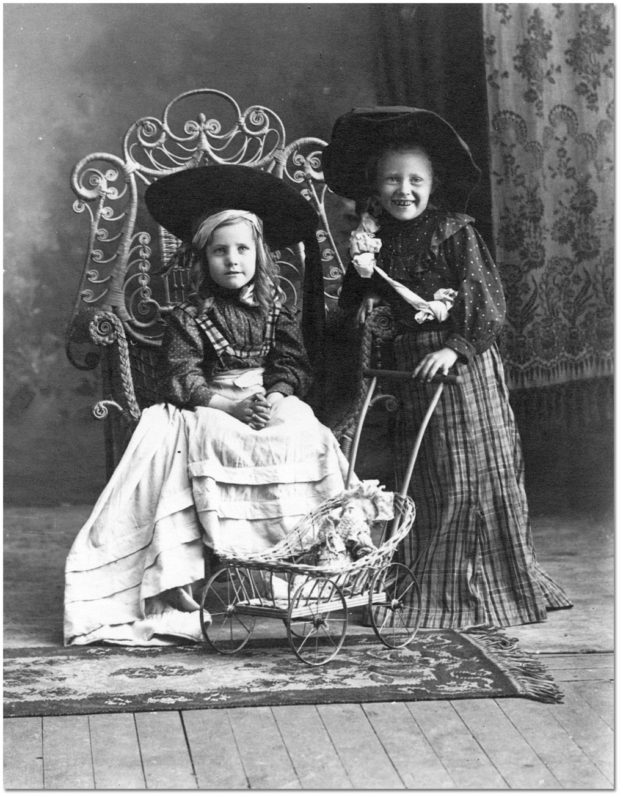
Two girls with doll carriage, ca. 1900
George Irwin fonds
Reference Code: C 119-1-0-0-61
Archives of Ontario, I0014287

Phoebe Gregg (1855)
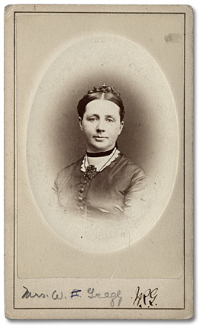
Phoebe Gregg, ca. 1855
Gregg family fonds
Reference Code: F 712, MU 1157
Archives of Ontario, I0028074

Family Portrait (1900)
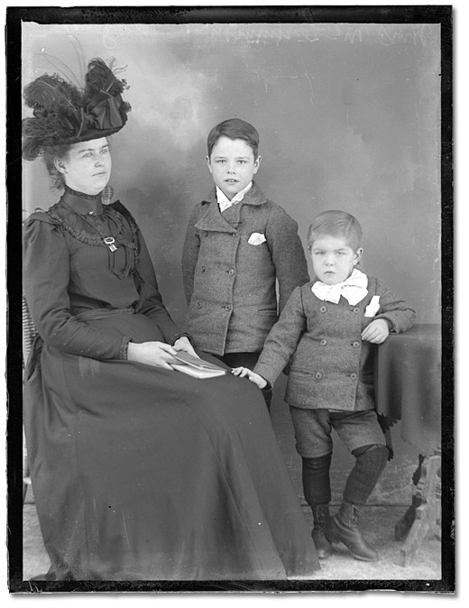
Family Portrait, ca. 1900
Bartle Brothers fonds
Reference Code: C 2-10232-1527
Archives of Ontario, I0002492

Beatrice Ironing (1906)
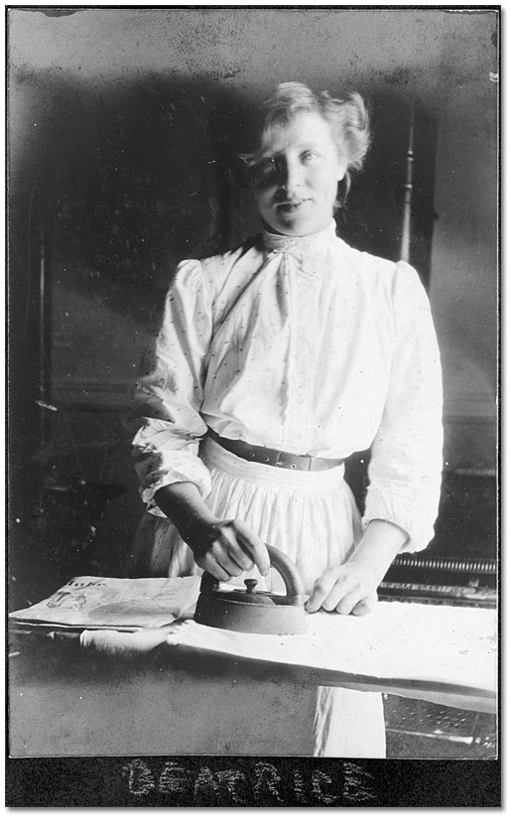
Domestic servant, Beatrice, ironing, 1906
M. O. Hammond fonds
Reference Code: F 1075-9-0-13, S 9572
Archives of Ontario, I0028034

The Canadian Pocket Diary (1866)
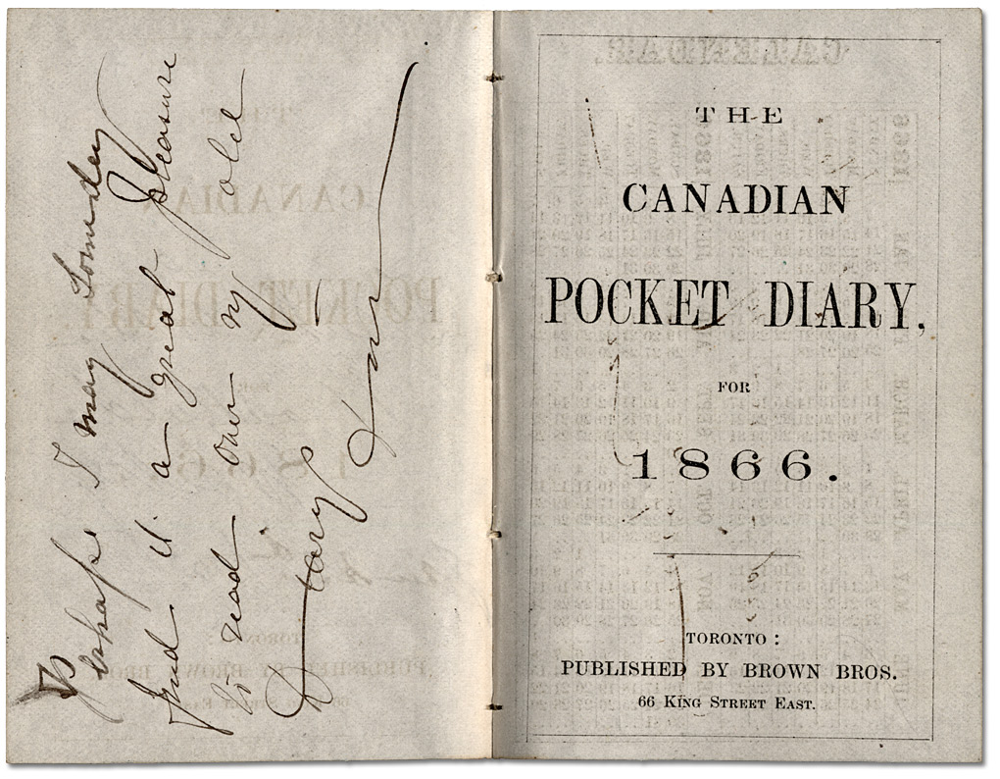
The Canadian Pocket Diary, 1866
Frances Milne fonds
Reference Code: F 763, MU 866
Archives of Ontario

Martha Hastie’s Diary
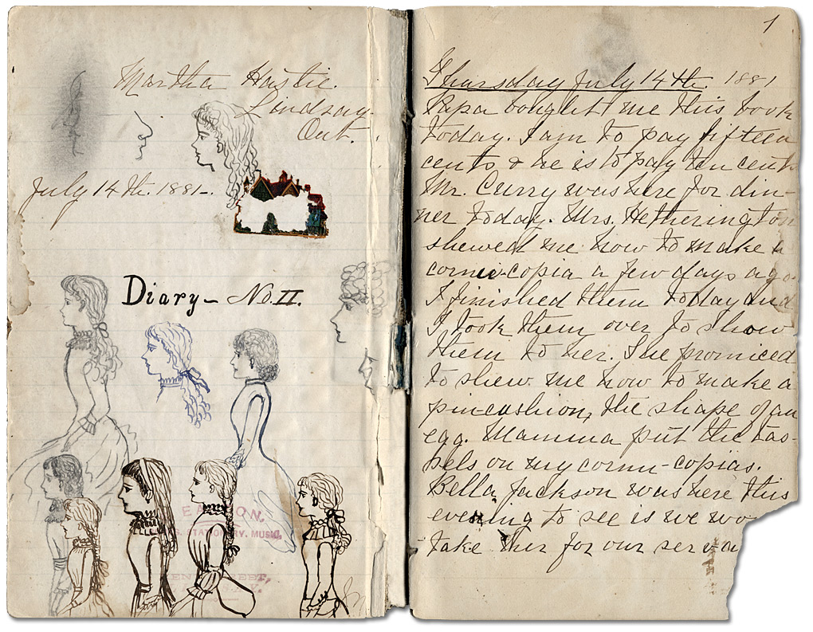
Martha Hastie’s self-portraits and first diary entry, July 14, 1881
William Mack family fonds
Reference Code: F 40 Series C, MU 3300
Archives of Ontario

Excerpt from Hastie’s diary:

“I have heard so many say that our school-days are the very best time of our life & I think it is very true for I will hate when I have to stop going to school. I have always liked going to school so much.”
(November 29, 1883)

Bessie Gregg with Senior Class in Mission School (1880)
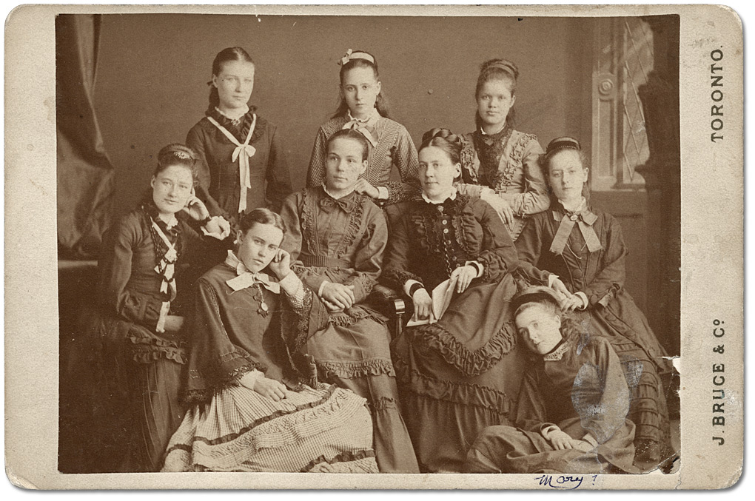
Bessie Gregg (teacher) with senior class in Mission School, ca. 1880
J. Bruce & Co. Photographers
Gregg family fonds
Reference Code: F 712, MU 1157
Archives of Ontario, I0028071

Four Young Women on a Porch (1900)
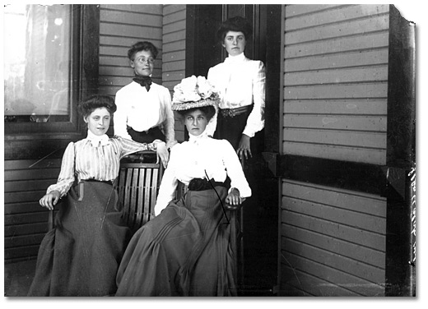
Four Young Women on a Porch, ca. 1900
Frank Wright fonds
Reference Code: C 171-1-0-0-5
Archives of Ontario, I0014407

Murphy Family and Friends on Toronto Island (ca. 1900)

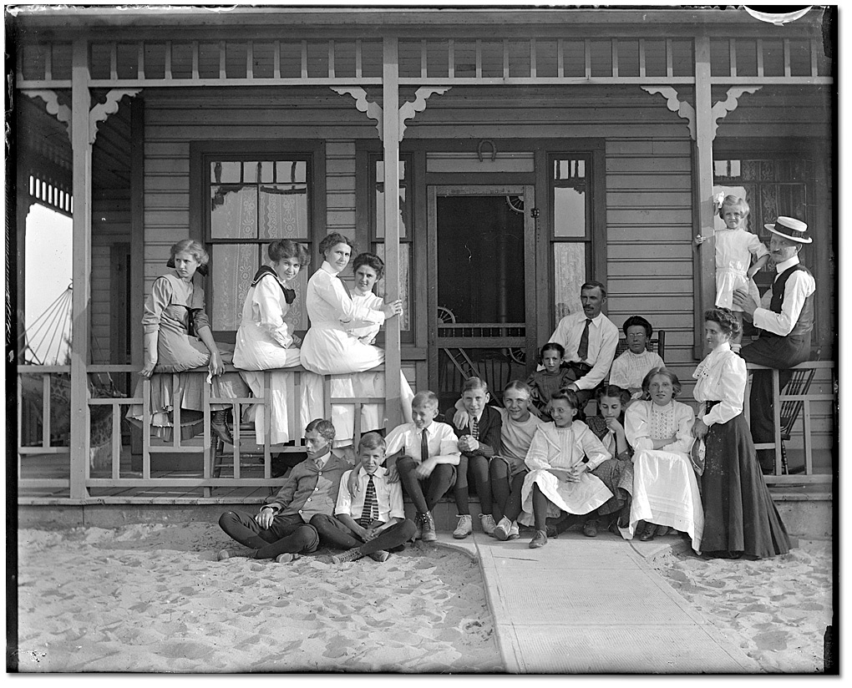
Murphy family and friends at Hanlan's Point, Toronto Island, ca. 1900
Rowley Murphy collection
Reference Code: C 59-1-0-7-1
Archives of Ontario, I0013699

Looking for Evidence

Historians use primary sources as clues for understanding the past. Be a historian.
Identify what you know about this primary source, what you can guess about this primary source, and what you would still like to know about this primary source.

What do you know about this primary source?
- Do you know what who is in this primary source? Is their name attached? What is it?
- Do you know how old this person is? Can you guess? How old do you think they are? What is your evidence?
- Do you know if this person is rich or poor? What do you think? What is your evidence?
- Do you know if this person works? Do you know what they do? Are there clues to help you guess?
- Do you know when this primary source was created? When?
- Do you know who created this primary source? Who?
- What else do you want to know about the person in this primary source?

Day-by-Day Facebook Page

