# Lesson Resource Kit - Centennial Ontario:

# Conflict, Change, and Identity in 1967

Grade 10: Canadian History since World War I

## Introduction

Designed to fit into teachers’ practice, this resource kit provides links, activity suggestions, primary source handouts and worksheets to assist you and your students in applying, inquiring, and understanding Canada between 1945 and 1982.

| This image is a digitized version of the cover of a booklet, titled "Front cover of Confederation Train itinerary," dated circa 1965 and featuring an illustrated train on a blue field. | Front cover of Confederation Train itinerary, ca. 1965  Project files of the Centennial Planning Branch, RG 5-52-89  Archives of Ontario, I0073509 |
| --- | --- |

## Topic

Ontario during the 1960s

## Sources

* [Mirror, Mirror... Looking back through the eyes of the CFPL news camera](http://www.archives.gov.on.ca/en/explore/online/cfpl/index.aspx) online exhibit
* Use the Archives of Ontario’s online exhibit about the CFPL television station:
* As a learning resource for yourself
* As sites to direct your students for inquiry projects
* As places to find and use primary sources related to the curriculum

## Themes that can be addressed

* Immigration
* Canadian identity
* The civil rights movement
* Citizenship

## Curriculum

Strand D. Canada, 1945-1982

| *Overall Expectations* | *Historical Thinking Concepts* | *Specific Expectations* |
| --- | --- | --- |
| D1. Describe some key social, economic, and political events, trends,  and developments in Canada between 1945 and 1982, and assess their significance for different groups in Canada. | Historical Significance; Continuity and Change | D1.1, D1.2, D1.3, D1.4 |
| D2. Analyse some key experiences of and interactions between  different communities in Canada, as well as interactions between Canada and the international community, from 1945 to 1982 and the changes that resulted from them. | Continuity and Change; Historical Perspective | D2.1, D2.2, D2.3. D2.4, D2.5 |
| D3. analyse how significant events, individuals, and groups, including Aboriginal peoples, Québécois, and immigrants, contributed to the development of identity, citizenship, and heritage in Canada between 1945 and 1982. | Historical Significance; Cause and Consequence | D3.1, D3.3, D3.6 |

## Assignment & Activity Ideas

### Gather information & discuss

* Studying the past can seem daunting to a student, if only because they may feel they don’t know where to start. Beginning with a group discussion about the 1960s, to identify big themes and issues of the decade (especially in Canada) will give all students a similar basis of knowledge before they begin their study.
* Ask your students to brainstorm what they know about the 1960s using the “1960s – What do I know?” worksheet provided in this kit.
* Once students have made a list of what they do know about the 1960s, have them brainstorm a list of what they don’t know about Ontario during that decade.
  + Have students read the “Secondary Source: 1960s Ontario Timeline” handout included in this lesson kit.

### Alternative History Collage

* Have students examine the Centennial history timeline distributed to students across Canada in 1967, using the “Primary Source – Centennial History Collage” handout provided in this kit. Have students try to identify historical moments, groups, and individuals depicted, working individually or in groups.
* Following reading, have a discussion in the class to unpack the collage and what it tells us about how Canadian history was depicted in 1967.
  + Key questions could include: who is represented in this timeline collage? Who is left out? What does this collage tell the viewer about Canadian history? How could this timeline be more representative and balanced?
  + For context, have students read the “Secondary Source: 1960s Ontario Timeline” handout included in this lesson kit.
* Ask students to create their own alternative timeline collage, using reproductions of primary sources, secondary sources, artistic renderings, and other materials.

### Creating new Primary and Secondary Sources

* For many students, their families may not have been in Canada during the Centennial. Introduce the use of interviewing and oral history to students so that they can record their own families’ histories.
* Ask students to select a family member alive in 1967 for an interview, using the “Oral History Interview” worksheet.
* Have students annotate their interview subjects answers with other primary and secondary sources, to be kept as an historical resource in your school’s library!

### 1967-2017 Video Comparisons

* Have students visit the [Mirror, Mirror... Looking back through the eyes of the CFPL news camera](http://www.archives.gov.on.ca/en/explore/online/cfpl/index.aspx) online exhibit on the Archives of Ontario’s website, to watch the following videos:
  + [Racial Discrimination in Housing Applications](http://www.archives.gov.on.ca/en/explore/online/cfpl/videos/1961/7.aspx)
  + [Unemployment Touches Nation With Panic](http://www.archives.gov.on.ca/en/explore/online/cfpl/videos/1961/5.aspx)
  + [Increased Immigration Leads to the Opening of a New Court of Canadian Citizenship](http://www.archives.gov.on.ca/en/explore/online/cfpl/videos/1960/1.aspx)
  + [Streeters React to John Glenn's Successful Trip Into Space](http://www.archives.gov.on.ca/en/explore/online/cfpl/videos/1962/11.aspx)
  + [Minister Speaks out Against Sunday Movies](http://www.archives.gov.on.ca/en/explore/online/cfpl/videos/1962/12.aspx)
  + [Peace Movement Begins as Protesters Draw Attention to the Threat from Nuclear Weapons](http://www.archives.gov.on.ca/en/explore/online/cfpl/videos/1962/4.aspx)
  + [U.S. President John F. Kennedy Assassinated - Londoners React](http://www.archives.gov.on.ca/en/explore/online/cfpl/videos/1963/10.aspx)
  + [The Public Reacts to Anti-Smoking Announcement by Surgeon General of the United States](http://www.archives.gov.on.ca/en/explore/online/cfpl/videos/1964/2.aspx)
  + [Londoners travel to Ottawa and Selma Alabama in Support of the Civil Rights Movement](http://www.archives.gov.on.ca/en/explore/online/cfpl/videos/1965/4.aspx)
  + [Woodstock High School Student Appeals for the Right to Wear Long Hair](http://www.archives.gov.on.ca/en/explore/online/cfpl/videos/1966/12.aspx)
  + [Centennial Celebrations Look to the Past in Art and Music](http://www.archives.gov.on.ca/en/explore/online/cfpl/videos/1967/2.aspx)
  + [CFPL News Goes to Expo '67 in Montreal](http://www.archives.gov.on.ca/en/explore/online/cfpl/videos/1967/5.aspx)
  + [Centennial Caravan Provides a 45 Minute Time Tunnel Through Canada's History](▪%09http:/www.archives.gov.on.ca/en/explore/online/cfpl/videos/1967/7.aspx)
* Have students use the “Primary Source – CFPL News Footage Notes” included in this lesson kit to take notes on the videos watched.
* Once students have watched the videos and taken notes on their observations, ask them to create 2-3 video shorts depicting important moments during the current decade with an impact on Ontarians’ lives.
* Share the videos online, and tag @ArchivesOntario!

### Connect with the Archives of Ontario!

* Use social media to share your students’ work with the Archives, either by setting up an account for your class or by using your institutions Twitter, Facebook, YouTube, or Flickr accounts.
* Use [#FamilyTies150](https://twitter.com/hashtag/FamilyTies150?src=hash) to connect your students’ work to other Archives of Ontario sesquicentennial social media content; [#Ontario150](https://twitter.com/hashtag/Ontario150?src=hash) and [#Canada150](https://twitter.com/hashtag/Canada150?src=hash) are also being used by many organizations to mark the anniversary online.
* Staff at the Archives of Ontario can also share your students’ work with our audiences and provide feedback directly to your class!
  + Please contact staff at the Archives of Ontario at [reference@ontario.ca](mailto:reference@ontario.ca) if you’re interested connecting with staff.

# Handouts & Worksheets

Exploration through the Archives 6

1960s – What do I know? 7

Secondary Source – 1960s Ontario Timeline 8

Primary Source – New Immigrants to Ontario in 1967 10

Primary Source – Ontario Folk Arts Festival 11

Primary Source – Portraits from the Past 12

Primary Source – Centennial History Collage 13

Primary Source – CFPL News Footage Notes 14

Oral History Interview 15

Marking Rubric 16

##### Exploration through the Archives

Over the course of a lifetime, most people accumulate a variety of records.

Taken together, these records can provide a fascinating view into someone’s life and into the past.

Like a detective investigating a case, a researcher using these records can get a sense of what a place looked like, what people were thinking, what life was like, and what happened and why.

Some examples of records that a historian may look at are:

* birth, death, and marriage records
* letters or diaries
* photographs, sketches, and paintings
* court records
* audio, video and film records

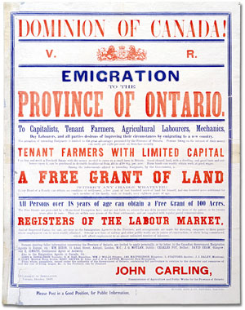 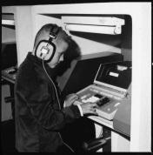 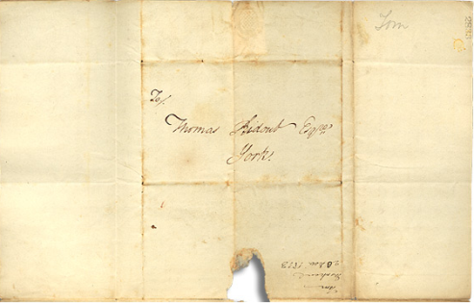

An **archive** is a place where these records and historical documents are preserved and made available for research. The **Archives of Ontario** collects and preserves records relevant to the history of Ontario.

Using primary sources from the Archives of Ontario’s collections, you too can be an investigator exploring the past and understanding the present.

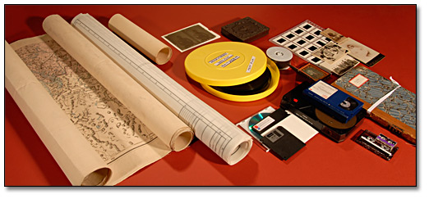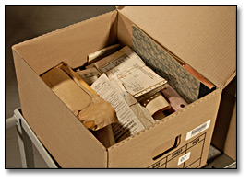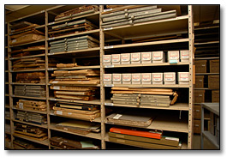

##### 1960s – What Do I Know?

| Topic | What do I know? | Where did I get this information? |
| --- | --- | --- |
| Music in the 1960s   * *What types of music were popular in the 1960s?* * *Which musicians were popular in the 1960s?* * *Was this different than before?* |  |  |
| Fashion in the 1960s   * *What did people wear?* * *How did they style their hair?* * *Was this different than before?* |  |  |
| Technology in the 1960s   * *What new technology became available in the 1960s?* * *What technology was not yet available in the 1960s?* |  |  |
| Important People in the 1960s   * *Who are some key Canadian figures in the 1960s?* * *Who are some key non-Canadian figures in the 1960s?* |  |  |
| Ontario in the 1960s   * *Who lived in Ontario in the 1960s?* * *How did living in Ontario change during the 1960s?* |  |  |

##### Secondary Source: 1960s Ontario Timeline

| **Year** | **Event / Development** |
| --- | --- |
| 1960 | The “Sixties Scoop” begins, as Indigenous children across Ontario (and Canada) are systematically removed from their families by child welfare authorities (or “scooped up”), and placed in foster homes or residential schools. This practice continues until the 1980s. |
| 1960 | The *Canadian Bill of Rights* is approved by the federal government. |
| 1960 | Canadian Voice for Women for Peace anti-nuclear group is founded. |
| 1960 | Indigenous peoples recognised by the “Indian Register” (known as “Status Indians”) gain the right to vote in Canadian federal elections. |
| 1960 | The National Art Gallery opens in Ottawa. |
| 1961 | Poet Pauline Johnson becomes the first individual Canadian woman to appear on a Canadian postage stamp. |
| 1961 | Canadian Medical Association concludes that cigarette smoking causes cancer. |
| 1962 | Immigration Minister Ellen Fairclough introduces new regulations which mostly eliminate racial discrimination in Canadian immigration policy |
| 1962 | Canada becomes the third nation in space, with the launch of satellite *Alouette I*. |
| 1962 | Canada's last criminal execution takes place in Toronto. |
| 1962 | The *Ontario Human Rights Code* is enacted, initially prohibiting discrimination in employment, housing, and access to services and facilities on grounds such as race, ethnicity, and religion. |
| 1962 | The Cuban Missile Crisis takes place; Ontarians prepare for the possibility of a Soviet-led nuclear attack on North American soil by conducting safety drills, assembling emergency kits, and building shelters. |
| 1963 | First Black Member of Provincial Parliament Leonard Braithwaite (MPP for Etobicoke, Ontario) is elected. |
| 1964 | Canadians are issued Social Insurance cards for the first time. |
| 1965 | Minimum wage in Ontario is raised to $1.00/hour (equivalent of $7.63/hr in 2016). |
| 1965 | The Hydro-Electric Power Commission of Ontario inadvertently causes a major power blackout across North America. |
| 1965 | Canada gets a new red-and-white, maple leaf flag. |
| 1965 | Klu Klux Klan activity is reported in Amherstburg, Ontario. |
| 1966 | The CBC introduces some colour television broadcasts. |
| 1966 | Death of Chanie Wenjack, an Anishinaabe boy from Ogoki Post, who ran away from a residential school near Kenora, Ontario, and subsequently died from hunger and exposure to the harsh weather. His death sparks national attention and the first inquest into the treatment of Indigenous children in Canadian residential schools. |
| 1967 | Centennial celebrations of the 100th anniversary of Confederation begin. |
| 1967 | GO Transit begins operating commuter trains in the Greater Toronto Area. |
| 1967 | Pizza Pizza chain of restaurants is established in Toronto. |
| 1967 | The National Indian Brotherhood (NIB) is established in Canada. |
| 1967 | “Love-in” gathering held at Queen’s Park in Toronto, attended by more than 4,000 people. |
| 1967 | Toronto's Caribana Festival is founded. |
| 1967 | The following schools are founded: Algoma University (Sault Ste. Marie), Algonquin College (Ottawa), Conestoga College (Kitchener), Confederation College (Thunder Bay), Durham College (Durham Region), Fanshawe College (London), Fleming College (Peterborough), George Brown College (Toronto), Georgian College (Barrie), Humber College (Toronto), Loyalist College (Belleville), Niagara College (Welland), Seneca College (Toronto), Sheridan College (Oakville), and University of Toronto Mississauga (Mississauga). |
| 1967 | Expo '67 in Montréal operates from April to October; thousands of Ontarians travel to Quebec to attend the fair. |
| 1967 | "Points System" introduced to Canadian immigration process, under which each applicant was awarded points for age, education, ability to speak English or French, and demand for that particular applicant's job skills. |
| 1967 | “O Canada” becomes the national anthem. |
| 1968 | Civil rights leader Dr. Martin Luther King, Jr., is assassinated in Memphis, Tennessee; Ontarians mourn at memorial gatherings held across the province. |
| 1968 | The *Royal Commission on the Status of Women* is created to recommend steps that might be taken by the federal government to ensure equal opportunities with men and women in all aspects of Canadian society. |
| 1968 | Pierre Elliott Trudeau is elected as Canada’s 15th Prime Minister. |
| 1969 | Section 251 of the *Criminal Code of Canada* is passed by Parliament, decriminalizing abortion and birth control under certain circumstances. |
| 1969 | The Ontario Science Centre opens in Toronto. |
| 1969 | English and French are both recognized as the official languages of Canada by the federal government. |
| 1969 | Ministry of Indian Affairs releases a “White Paper” that proposes to abolish the Department of Indian Affairs, and eliminate special status for Indian peoples and lands. It is strongly opposed by Indigenous leaders who say its language of equality masks an assimilation agenda. |
| 1969 | Homosexuality is decriminalized in Canada, introduced by Trudeau’s omnibus bill *The Criminal Law Amendment Act, 1968-69*. |

##### Primary Source – New Immigrants to Ontario in 1967

| Country of Origin | Total Arrivals in Ontario, 1967 | Country of Origin | Total Arrivals in Ontario, 1967 |
| --- | --- | --- | --- |
| Algeria | 6 | Malta | 589 |
| Argentina | 365 | Mexico | 167 |
| Australia | 1,833 | Morocco | 73 |
| Austria | 1,491 | Netherlands | 2,137 |
| Belgium | 418 | New Zealand | 356 |
| Bermuda | 94 | Northern Ireland | 1,657 |
| Brazil | 344 | Norway | 139 |
| Bulgaria | 14 | Pakistan | 337 |
| Ceylon (Sri Lanka) | 65 | Philippines | 1,523 |
| China | 2,284 | Poland | 982 |
| Czechoslovakia | 87 | Portugal | 6,514 |
| Denmark | 498 | Romania | 32 |
| England | 24,415 | Saudi Arabia | 6 |
| Egypt | 355 | Scotland | 10,448 |
| Estonia | 1 | South Africa | 786 |
| Finland | 584 | Spain | 459 |
| France | 1,326 | Sweden | 408 |
| Germany | 6,277 | Switzerland | 1,390 |
| Greece | 6,187 | Syria | 46 |
| Hungary | 352 | Tunisia | 1 |
| Iceland | 4 | Turkey | 187 |
| India | 1,740 | USSR | 165 |
| Iran | 31 | United States | 7,011 |
| Republic of Ireland | 1,330 | Wales | 674 |
| Israel | 1,043 | Yugoslavia | 1,541 |
| Latvia | 1 | Africa, *not elsewhere specified* (n.e.s.) | 439 |
| Lebanon | 403 | Asia, n.e.s. | 1,082 |
| Lesser British Isles | 37 | Central America, n.e.s. | 27 |
| Italy | 19,612 | Europe, n.e.s. | 3 |
| Luxembourg | 20 | South America, n.e.s. | 1,007 |
| Japan | 397 | West Indies, n.e.s. | 5,023 |
| **TOTAL** |  |  | **116,850** |

*Source: 1967 Immigration Statistics, Department of Manpower and Immigration, Canada Immigration Division. Ottawa,1967. Library and Archives Canada (accessed Aug. 22, 2016).*

##### Primary Source – Ontario Folk Arts Festival

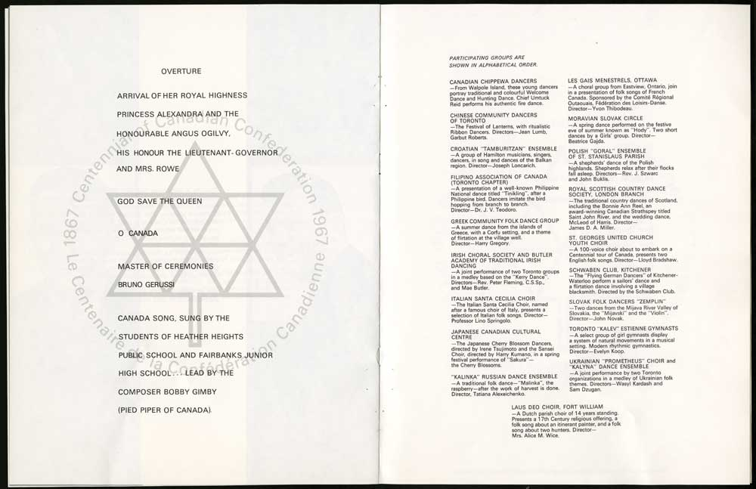

*Ontario Folks Arts Festival* programme, 16 May 1967

Project files of the Centennial Planning Branch, RG 5-52-107

Archives of Ontario, I0073518

##### Primary Source – Portraits from the Past

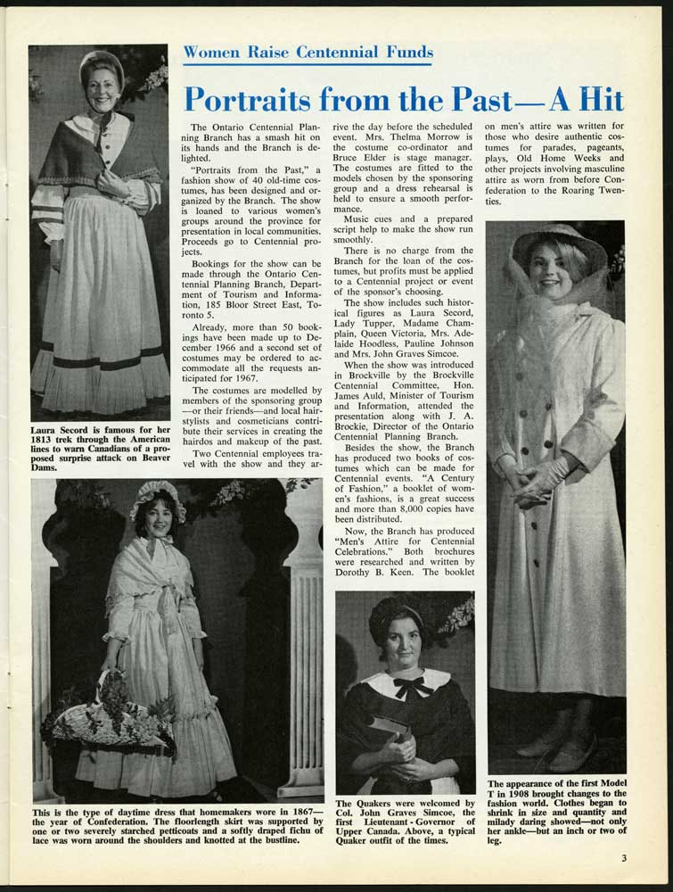

*Portraits from the Past* promotional photo, 1966

Centennial Ontario newsletter, June 1966, page 3

Archives of Ontario Library Collection, I0073525

##### Primary Source – Centennial History Collage

In 1966, the Government of Canada distributed Centennial packages to students across the country – they included the historical collage below (here broken into four parts).

**Look at the collage: can you identify the historical moments, place, and peoples depicted?**

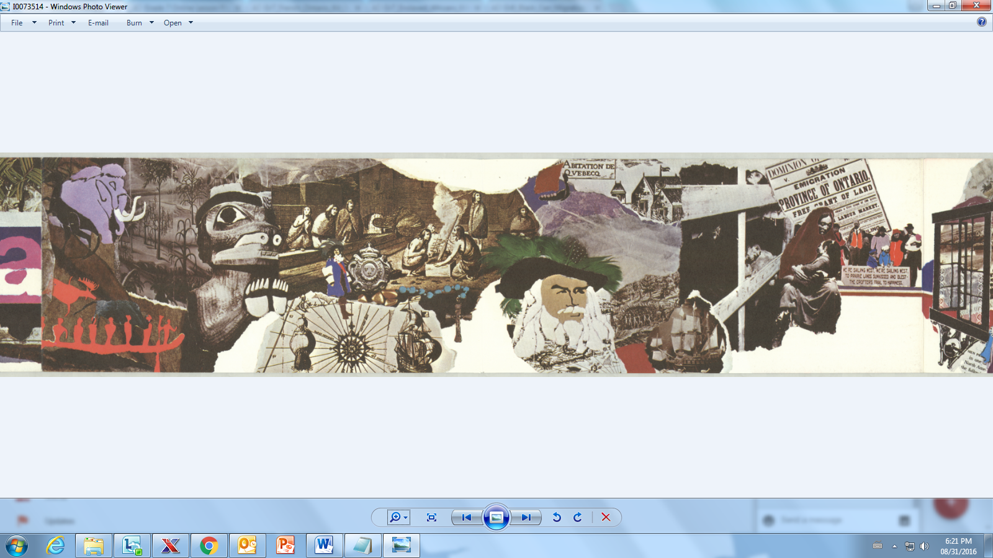

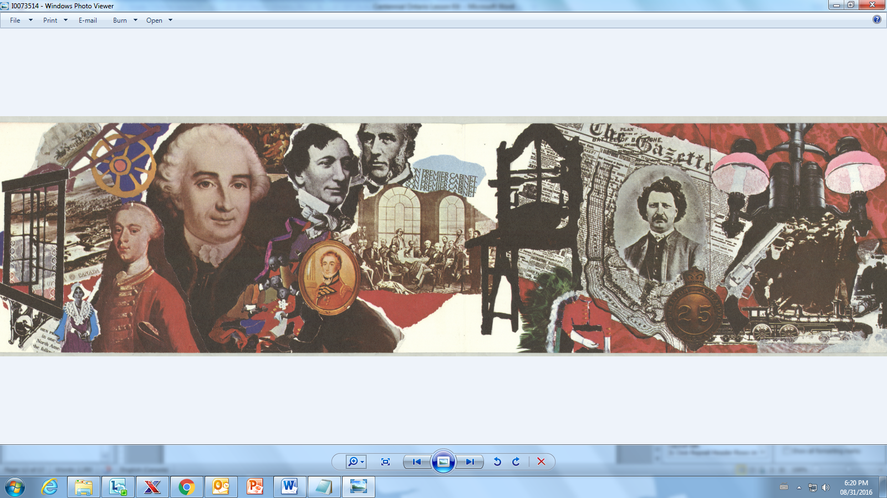

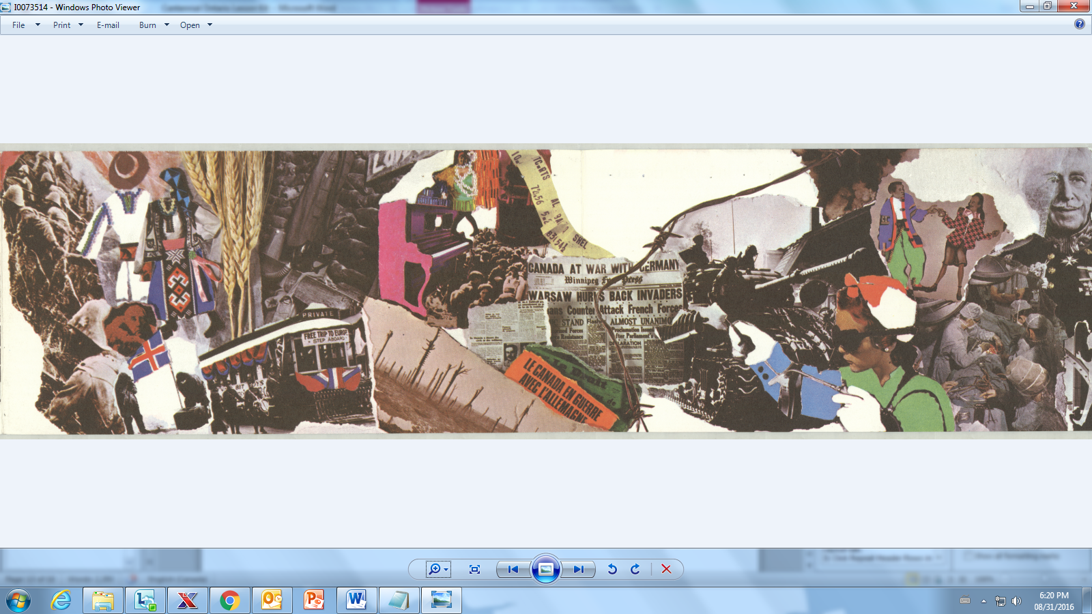

*Confederation Train Brochure*, [1964-1967]

Project files of the Centennial Planning Branch, RG 5-52-82

Archives of Ontario, I0073514

##### Primary Source – CFPL News Footage Notes

Watch the CFPL Television news clips available on the Archives of Ontario’s website, and make observation notes for 3 of the videos.

| ****Video Title**** | ****Notes****  *(what is being said/shown?)* | ****Names, Dates, & Places**** Mentioned in the video |
| --- | --- | --- |
|  |  |  |
|  |  |  |
|  |  |  |

**If you were asked to create short videos depicting important moments for Ontarians in the current decade, which historical moments or important people would you show?**

##### 

##### Oral History Interview Worksheet

Name: _____________________________ Date: __________________________

Ask a family member who was alive in 1967 if you can interview them with the following questions:

| Question | Response |
| --- | --- |
| Where did you live in 1967? Describe that place. |  |
| How old were you in 1967? |  |
| Did you live with your family in 1967? If so, in what kind of place did you live? |  |
| What was your role in 1967? (ie: did you go to work? did you go to school?) |  |
| What special holidays did your family celebrate at that time? |  |
| Do you remember how your family celebrated holidays at that time? |  |
| Did you ever celebrate national holidays? If so, which ones? |  |
| How did national holidays or anniversaries make you feel at that time?  Did you enjoy celebrating them? If so – why? If not – why not? |  |
| Has the way you celebrate or mark holidays changed since 1967? If so – how? |  |
| Were you in Canada in 1967? If so – did you participate in any Centennial anniversary activities or events? |  |

*Interview questions have been adapted from* Colouring in the Leaves *by M.J. Rutherford Smith, & from the Ontario Genealogical Society*