Lesson Resource Kit - Family Ties: Ontario at the Time of Confederation
Grade 8: History and Geography

Introduction
Designed to fit into teachers’ practice, this resource kit provides links, activity suggestions, primary source handouts and worksheets to assist you and your students in applying, inquiring, and understanding Canada between 1850 and 1914.

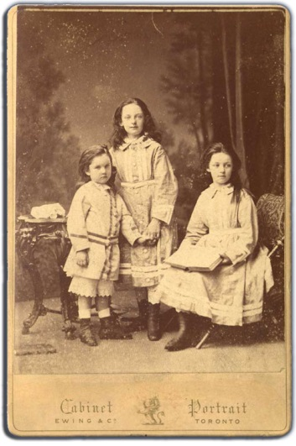 | George, Margaret, and Catherine Brown, ca. 1874  George Brown family fonds  F 21-10-0-1  Archives of Ontario, I0073596

Topic
Ontario during the Era of Confederation

Sources
- Meet the Browns online exhibit
- The Black Canadian Experience in Ontario 1834-1914: Flight, Freedom, Foundation online exhibit
- Documents from the Front: The American Civil War and Fenian Raids in the 1860s online exhibit
- Family Ties: Ontario Turns 150 onsite exhibit (Sept. 2016 to May 2018)
- Use the Archives of Ontario’s online and onsite exhibits:
- As a learning resource for yourself
- As sites to direct your students for inquiry projects
- As places to find and use primary sources related to the curriculum

Themes that can be addressed
- Confederation
- Immigration
- Political change
- Ontario’s Indigenous peoples
- Canada-US relations
- Residential schools in Ontario
- The Underground Railroad

Curriculum
Strand D. Canada, 1945-1982
Strand A. Creating Canada, 1850–1890
Overall Expectations | Historical Thinking Concepts | Specific Expectations
A1. Application: Colonial and Present-day Canada | Continuity and Change; Historical Perspective | A1.1, A1.2, A1.3
A2. Inquiry: From New France to British North America | Historical Perspective;  Historical Significance | A2.1, A2.2, A2.4, A2.5, A2.6
A3. Understanding Historical Context: Events and Their Consequences | Historical Significance;  Cause and Consequence | A3.4, A3.5

Assignment & Activity Ideas

Gather information & discuss
- Studying the past can seem daunting to a student, if only because they may feel they don’t know where to start. Beginning with a group discussion about the 1860s, to identify big themes and issues of the decade (especially in Canada) will give all students a similar basis of knowledge before they begin their study.
- Ask your students to brainstorm what they know about the 1860s using the “1860s – What do I know?” worksheet provided in this kit.
  - Once students have identified what they know about Ontario at the time of Confederation, make a class list of what they don’t know about that time period, and of what your students want to know about the 1860s.

Ontario’s Peoples: Different Perspectives on Confederation
- Have students examine the primary sources provided on the “Family Profile” handouts.
- Ask students to pick a family for further in-depth research; using secondary sources, including the Archives of Ontario’s online exhibits, students should gather more information about the circumstances in which their chosen family lived.
  - Students can also use the “Confederation-Era Ontario Timeline” handout included in this lesson kit as a secondary source.
- Have students complete the “Impacts of Confederation” worksheet provided in this lesson kit.
- Ask students to share their responses from the worksheet with the class, and discuss as a group the ways in which different people in Ontario experienced the Era of Confederation.

Keeping in Touch – Then and Now
- Ask students to read through the letter written by Rose Goble provided in this lesson kit. Discuss the letter as a class to ensure comprehension.
- Using the “Writing – Then and Now” worksheet, have students translate the contents of the letter into social media posts – the worksheet provides space for 140-character tweets, but encourage students to get creative and imagine Rose’s letter as a post on any social media platform of their choosing (ie: Snapchat, Instagram, Facebook, Vine, etc.).
- Share your student’s work online via a class social media account, and connect with the Archives of Ontario by using the hashtag #FamilyTies150 with each post!
  - Please contact the Archives of Ontario by emailing reference@ontario.ca if you wish to share your students’ work with staff directly.

Handouts & Worksheets

Exploration through the Archives 5
1860s – What Do I Know? 6
Family Group Profile: The Browns 7
Family Group Profile - The McCurdys 8
Family Group Profile: The Wolvertons 9
Family Group Profile: The Families of Shingwauk 10
Secondary Source: Confederation-Era Ontario Timeline 11
Impacts of Confederation Worksheet 13
Primary Source – Rose Goble’s Letter 14
Writing – Then and Now 15
Marking Rubric 16

Exploration through the Archives

Over the course of a lifetime, most people accumulate a variety of records.
Taken together, these records can provide a fascinating view into someone’s life and into the past.
Like a detective investigating a case, a researcher using these records can get a sense of what a place looked like, what people were thinking, what life was like, and what happened and why.
Some examples of records that a historian may look at are:
- birth, death, and marriage records
- letters or diaries
- photographs, sketches, and paintings
- court records
- audio, video and film records

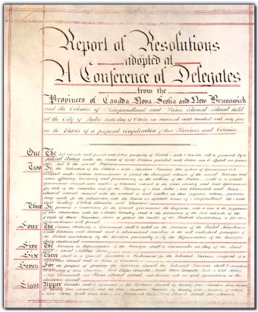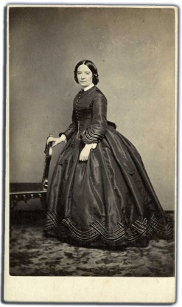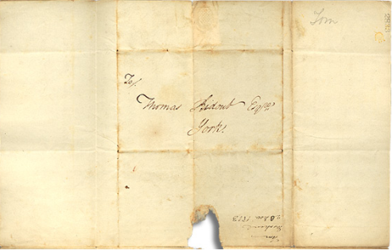

An archive is a place where these records and historical documents are preserved. The Archives of Ontario collects and preserves records with relevance to the history of Ontario.
Using primary sources from the Archives of Ontario’s collections, you too can be an investigator exploring the past and understanding the present.
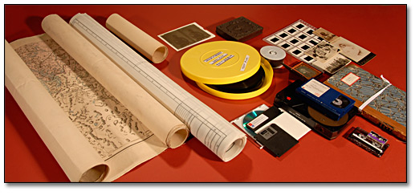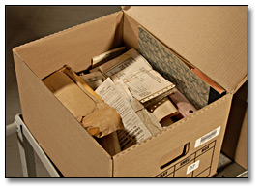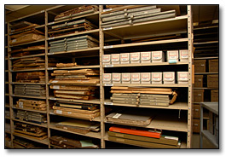

1860s – What Do I Know?
Topic | What do I know? | Where did I get this information?
Travel in the 1860s
- How did people travel in the 1860s?
- Was this different than before?
Fashion in the 1860s
- What do I think people wore?
- How did they style their hair?
- Was this different than before?
Technology in the 1860s
- What new technology became available in the 1860s?
- What technology was not yet available in the 1860s?
Ontario in the 1860s
- Who lived in Ontario in the 1860s?
- How did living in Ontario change during the 1860s?

Family Group Profile: The Browns
Members of this family include:
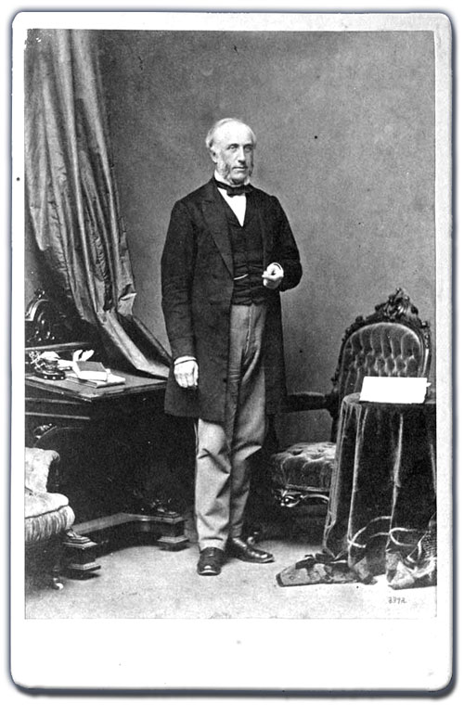 | 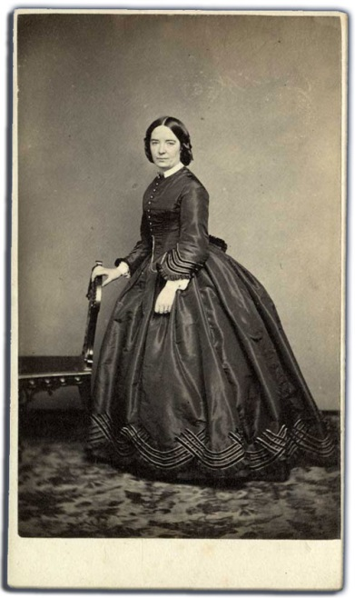 | 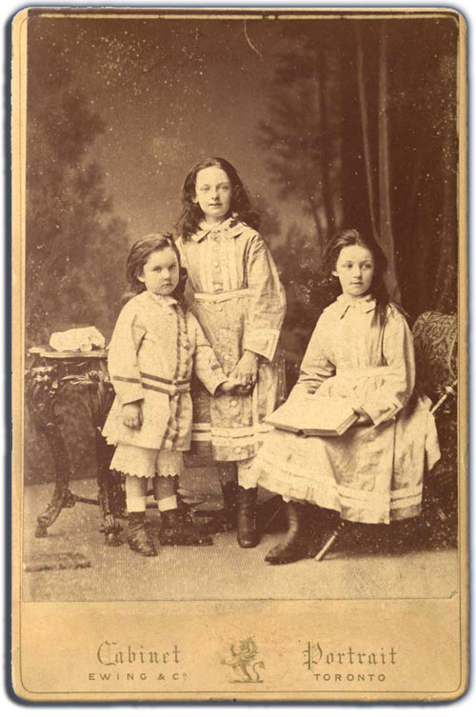
George Brown, ca. 1860s  Archives of Ontario, I0073663 | Anne Brown, ca. 1860s  Archives of Ontario, I0073602 | George, Margaret, and Catherine Brown, ca. 1874  Archives of Ontario, I0073596
- Born: 1818, Scotland  - Occupation: publisher and politician (Liberal)  - Spouse: Anne Brown  - Beliefs: Christian (Presbyterian)  - Emigrated to Canada West in 1843  - Began publishing The Globe newspaper in 1844  - Elected as a Member of Parliament in 1851  - Served as Premier of Canada West in 1859  - Owned a home in downtown Toronto and a farm in Brantford, Ontario  - Died after being shot by an ex-Globe employee in 1880  - Called a “Father of Confederation” | - Born: 1827, Scotland  - Occupation: mother and housewife  - Spouse: George Brown  - Beliefs: Christian (Presbyterian)  - Emigrated to Canada West in 1862  - Spoke German and French  - Provided advice to George in letters on handling matters of Parliament  - Often labelled a “Mother of Confederation”  - Returned to Scotland following the death of George | - Margaret born in 1864, Catherine born in 1866, and George born in 1869  - Place of birth: Toronto  - Occupations:  - Margaret – mother and housewife  - Catherine – mother and housewife  - George – publisher and Member of Parliament  - Beliefs: Christian (Presbyterian)  - Educated privately at home  - Wrote regular letters to their parents during childhood  - Margaret and Catherine were two of the first women to graduate from University of Toronto in 1885
The Archives of Ontario holds letters, cards, invitations, passports, tickets, programmes, photographs, and newspaper articles from the Browns.
Why do you think these are the primary sources we have available for this family?

Family Group Profile - The McCurdys
Members of this family include:
 | 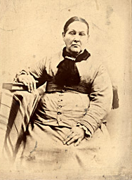 | 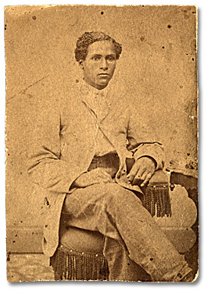
Nasa McCurdy, ca. 1850s  Archives of Ontario, I0024780 | Permelia McCurdy,  ca. 1880s  Archives of Ontario, I0024814 | George D. McCurdy,  ca. late 1860s  Archives of Ontario, I0024777
- Born: 1816 in Pennsylvania  - Occupation: carpenter  - Beliefs: Christian  - Spouse: Permelia McCurdy  - Emigrated to Amherstburg in Canada West by 1856  - Active in local efforts to help refugee slaves arriving from the United States (the Underground Railroad)  - Built his own wooden home in Amherstburg | - Born: 1821 in Pennsylvania  - Occupation: mother and housewife  - Beliefs: Christian  - Spouse: Nasa McCurdy  - Emigrated to Amherstburg in Canada West before 1856, likely because of the U.S. Fugitive Slave Act of 1850 | - Born 1851  - Occupation: steward, baker, politican, activist  - Parents: Nasa and Permelia McCurdy  - Siblings:  - Beliefs: Christian  - Worked as Chief Steward for the Pittsburgh Steamship Company
“My family has had a history for more than 150 years of involvement in the human-rights movement. … It dates back to at least when my great-great grandfather (Nasa McCurdy) was an agent in the Underground Railroad.”
-Howard J. McCurdy,
descendant of Nasa and Permelia McCurdy
to the Windsor Star, 2012

The Archives of Ontario holds photographs, census records, and some secondary-source notes about the McCurdys. There are also descendants of the family alive today who can provide information about their ancestors.
Why do you think these are the primary sources we have available for this family?

Family Group Profile: The Wolvertons
Members of this family include:
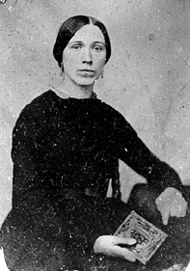 | 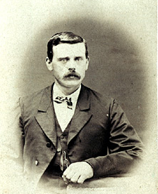 | 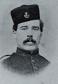
Rose (Wolverton) Goble, 1858  Archives of Ontario, I0052368 | Alonzo Wolverton, ca. 1860s  Archives of Ontario, I0073503 | Newton Wolverton ca. 1864  Archives of Ontario, I0073498
- Born: Wolverton, Upper Canada in 1834  - Spouse: Jasper Goble  - Siblings: Alfred, Daniel, Alonzo, Jasper, Newton, and Melissa  - Occupation: mother and housewife  - Religion: Christian (Baptist)  - Grew up in Wolverton Hall  - Married Jasper Goble in 1858  - Moved to Goble’s Corners (near Woodstock, Canada West)  - Wrote letters to her siblings, directing the family’s affairs  - Wrote about current political and social events in letters | - Born: 1841 in Wolverton  - Siblings: Alfred, Daniel, Jasper, Newton, Rose, and Melissa  - Occupation: soldier, miller  - Religion: Christian (Baptist)  - Grew up in Wolverton Hall  - Educated in Cleveland, Ohio  - Enlisted in the Union Army during the American Civil War in 1861  - Captured and held prisoner by the Confederate Army in 1864  - Served as second lieutenant in the 9th U. S. Colored Artillery | - Born: 1846 in Wolverton  - Siblings: Alfred, Daniel, Alonzo, Jasper, Rose, and Melissa  - Occupation: soldier, teacher  - Religion: Christian (Baptist)  - Grew up in Wolverton Hall  - Educated in Cleveland, Ohio  - Enlisted in the Union Army during the American Civil War in 1861 at age 15  - Served in the militia guarding the Canada East border in with the United States during the Fenian Raids of 1866  - Taught math at Woodstock College  - Taught in Texas, Manitoba, and British Columbia
The Archives of Ontario holds pictures, letters, certificates, maps, and family history notes about the Wolvertons.
Why do you think these are the primary and secondary sources
we have available for this family?

Family Group Profile: The Families of Shingwauk
Members of this community included:
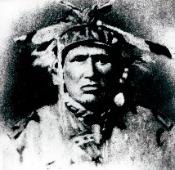 | 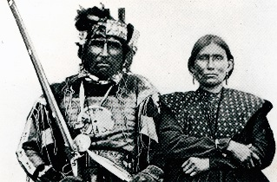 | 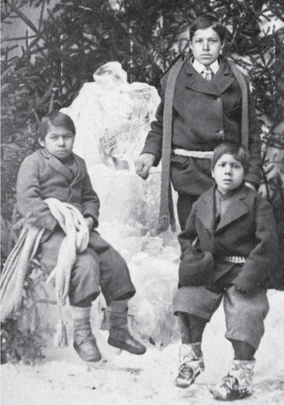
Chief Shingwaukonse,  ca. 1850  Shingwauk Residential Schools Centre Archive, 2011-017/001(002) | Chief Augustin Shingwauk (with his wife Jeanne Pewandak), ca. 1880  Shingwauk Residential Schools Centre Archive, 2011-017/001(007) | Benjamin Pine and Jacob Erskine with David Nahwegahbowh,  ca. 1870s  Shingwauk Residential Schools Centre Archive, 2010-048/001(043)
- Born: near Lake Superior, 1773  - Occupation: Anishinaabe leader of Garden River First Nation  - Children: Augustine, Buhgwujjenene, John Askin, and George Messino  - Beliefs: traditional Anishinaabe and Christian (Anglican)  - Emerged as a leader of Ojibwe warriors during the War of 1812  - In 1832 he travelled to York (Toronto) to secure support for education in his community  - Worked to establish an Indigenous-led school – a “teaching wigwam” - for his community, to merge traditional and settler knowledge  - Signed the Robinson Huron Treaty of 1850 | - Born: Garden River, 1800  - Occupation: Anishnaabe leader and advocate  - Son of Chief Shingwaukonse  - Siblings: Buhgwujjenene, John Askin, and George Messino  - Beliefs: traditional Anishinaabe and Christian (Anglican)  - Became a Chief of the Garden River First Nation ca. 1854  - Worked with Rev. Edward Francis Wilson to open the Shingwauk Industrial Home in 1873, a school initially planned with Chief Shingwaukonse’s vision in mind | - Born: Pine and Erskine were from Garden River First Nation, while Nahwegahbowh was from Sheguiandah First Nation on Manitoulin Island  - Occupation: students at the Shingwauk Industrial Home in the 1870s  - Pine ran away from the school once, but was returned and spent eight and a half years at Shingwauk  - Nahwegahbowh was trained as a bootmaker at the school  - In 1883, Pine left the school to work as a teacher  - In 1877 Erskine was taken from the school by his mother and began working as a labourer
The Shingwauk Residential Schools Centre archive holds photographs, diaries, church records, oral histories, and notes about the families connected to the Shingwauk Industrial Home.
Why do you think that these are the primary sources we have available for this community?

Secondary Source: Confederation-Era Ontario Timeline
Year | Event / Development
1850 | The Fugitive Slave Act is passed in the United States, stating that all escaped slaves were, when captured, to be returned to their masters and that officials and citizens of free states had to cooperate in this law; many free Black American citizens are targeted by slave catchers abusing the law. Thousands of Black Americans flee north to Canada West to evade capture, joining existing towns or establishing their own communities, including Buxton, Elgin, and Amherstburg.
1851 | Formation of Canadian Anti-Slavery Society.
1853 | Mary Ann Shadd Cary launches the Provincial Freeman in Chatham, Ontario, becoming the first Black woman in North America to publish her own newspaper.
1854 | The first Canadian baseball team – the Young Canadians – is formed in Hamilton, Ontario.
1855 | The American canal at Sault Ste. Marie completed this year, which opened Lake Superior to American and Canadian navigation.
1855 | The Separate Schools Act is passed in the United Province of Canada, strengthening the system of publicly-funded Catholic schools in Canada West.
1856 | The Grand Trunk Railway opens between Sarnia and Montreal, increasing the flow of goods and people across Southern Ontario and trade links with the American Midwest. Towns along its route swell in importance and population.
1857 | An Act to Encourage the Gradual Civilization of Indian Tribes in this Province, and to Amend the Laws Relating to Indians is passed in Upper Canada, permanently disenfranchising all Indigenous peoples, and placing them in a separate legal category from other Canadian citizens.
1861-1865 | The Civil War is fought in the United States; over 40,000 people from British North America enlist to fight in the conflict (the majority for the Union Army).
1861 | Toronto’s first streetcar route starts operation. Streetcars are pulled by horses and operate from the Yorkville Town Hall to St. Lawrence Market.
1863 | American President Abraham Lincoln authorizes the inclusion of Black soldiers in the Union Army during the Civil War; hundreds of Black Canadians enlist as soldiers for the Union , most to fight for the end of slavery in the United States.
1864 | A government of Liberals and Conservatives - the “Great Coalition” - is formed to pursue a union of the British North American colonies; the Charlottetown Conference is held to persuade the representatives to endorse the Canadian plan for a broader federal union. A conference in Quebec City draws up the Quebec Resolutions, a plan for this union.
1864 | First cheese factory in Canada opens in Ingersoll, Ontario.
1865 | Ottawa becomes the permanent seat of the federal government in Canada, chosen by Queen Victoria.
1865 | When American President Abraham Lincoln is assassinated, Canadians publicly mourn his tragic death. In Toronto, businesses close, and crowds attend memorial services.
1866 | Canadian militia defeat the Fenians, a group of Irish-Americans organized in 1859 to oppose British presence in Ireland , who attempted to invade British North America through the Niagara Peninsulia at Ridgeway.
1867 | The Parliament of the United Kingdom passes the British North America Act, forming the Dominion of Canada.
1867 | Under the British North America Act, Indigenous peoples and land reserved for them were made a federal responsibility, as was their settler-imposed education.
1867 | Under the British North America Act, voters must be male, 21 years of age or more, and a British subject by birth or naturalization.
1867-1871 | A Liberal-Conservative coalition government rules the new Province of Ontario under Premier John Sandfield Macdonald.
1868 | Thomas D'Arcy McGee, one of the fathers of Confederation, becomes Canada's first assassination victim at the hands of a Fenian sympathizer in Ottawa.
1869 | The Canadian Parliament agrees to buy Rupert's Land - a vast trading territory stretching across modern-day Québec, Ontario, Manitoba, Saskatchewan, Alberta, Nunavut, and the Northwest Territories, then claimed by the Hudson's Bay Company - for $1.5 million. The purchase occurred despite the ongoing habitation of much of this territory by diverse Indigenous peoples.
1869 | The Act for Gradual Enfranchisement of Indian is passed, requiring Indigenous peoples to meet a long list of conditions in order to apply for citizenship.
1872 | The Dominion Lands Act is passed, which granted cheap and free land to settlers, an immigration policy targeting emigrants from Central Europe.
1872 | The Ontario Legislature passes the Married Women’s Property Act, which gives a married woman the right to her own earnings, free from her husband’s control.
1875 | Construction of the Canadian Pacific Railway begins at Fort William, Ontario.
1876 | The Indian Act is passed, giving greater authority to the Department of Indian Affairs to intervene in Indigenous peoples’ lives, and to make sweeping policy decisions such as determining who was an “Indian,” managing Indigenous lands, resources and moneys, and promoting settler ideals of "civilization."
1876 | The Toronto Women’s Literary Society is founded by Dr. Emily Stowe. It is an important moment for the suffrage movement in Canada, as its name disguises its real purpose of obtaining equal rights for women.

Impacts of Confederation Worksheet
Your Chosen Family Group:
Where did your chosen family group live in Ontario?
How would this have changed their experience of the Era of Confederation?
Did all members of your chosen family group have the right to vote, hold property, serve in the military, and sign legal documents?
If not, why?
How were the lives of your chosen family group impacted by the American Civil War?
(look for direct *and* indirect impacts)
How were the lives of your chosen family group impacted by establishment of residential schools?
(look for direct *and* indirect impacts)
How were the lives of your chosen family group impacted by the American Fugitive Slave Act?
(look for direct *and* indirect impacts)
Do you think your chosen family group benefitted from the creation of the Dominion of Canada? In what ways?

Primary Source – Rose Goble’s Letter
Letter from Rose Goble to Alonzo Wolverton, 17 November 1864  Lois Darroch fonds, F 4354-6-0-37  Archives of Ontario,  F 4354-6-0-37_001 to F 4354-6-0-37_005 | Excerpts from this letter:  “What a hard time you had of it among those rebels tis well it did not last long or you could not have survived it. I was very anxious to hear from you for we … wondered what had become of you. It was such a relief to get your letter.”  “Just now is an interesting time in Canadian Politics. A Delegation of all the Provinces have been in Session some time, (and are through now) conferring about a Union of all the Provinces, both Canadas, New Brunswick, Nova Scotia, Newfoundland & Prince Edward’s Island under one Chief Governor. The result will not be made public until each individual Legislation has been conferred with.”  “Various names have been proposed for the New Confederation. Arcadia, Acadia, Stadacona, New Britain, Britannica, Borelia, Tuponia, Quebec and Canada, are among those proposed.”

Writing – Then and Now
Using this worksheet, rewrite Rose Goble’s letter as tweets with only 140 characters! How would you say what she writes in your own words on social media?

Tweet # 1:

Tweet #2

Marking Rubric
Criteria | Level 1 | Level 2 | Level 3 | Level 4
Knowledge and Understanding  Interpret and communicate ideas and feelings drawn from primary and secondary sources | Demonstrates a limited understanding of the elements of drama and the historical details from the research. | Demonstrates some understanding of the elements of drama and the historical details from the research. | Demonstrates a considerable understanding of the elements of drama and the historical details from the research. | Demonstrates a thorough understanding of the elements of drama and the historical details from the research.
Thinking/Inquiry  Write in role in various forms, showing understanding of the complexity of a dramatic situation. | Analyzes and uses primary source material for the drama sequence with limited effectiveness. | Analyzes and uses primary source material for the drama sequence with some effectiveness. | Analyzes and uses primary source material for the drama sequence with considerable effectiveness. | Analyzes and uses primary source material for the drama sequence with a high degree of effectiveness.
Communication  Create drama pieces, selecting and using a variety of techniques. | Creates with limited effectiveness, a drama composition based on the themes and issues explored | Creates with some effectiveness, a drama composition based on the themes and issues explored | Creates with considerable effectiveness, a drama composition based on the themes and issues explored | Creates with a high degree of effectiveness, a drama composition based on the themes and issues explored
Application  Dramatize material that they have researched from primary sources, and use it effectively in presenting scenes | Presents a drama sequence based on improvisational work and primary sources with limited effectiveness and insight. | Presents a drama sequence based on improvisational work and primary sources with some effectiveness and insight. | Presents a drama sequence based on improvisational work and primary sources with considerable effectiveness and insight. | Presents a drama sequence based on improvisational work and primary sources with a high degree of effectiveness and insight.

