# Letters from the Depression

Grade 10: Canadian History Since World War I

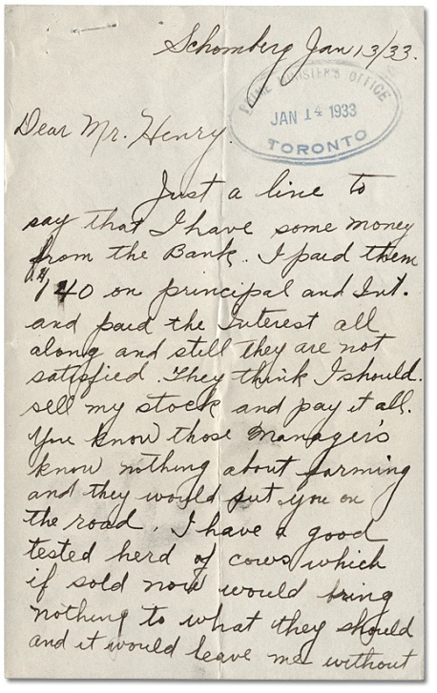  
Letter to the Premier, January 13, 1933

Premier George S. Henry correspondence

Reference Code: RG 3-9-0-391

## Overview

All of the Archives of Ontario lesson plans have two components:

* The first component introduces students to the concept of an archive and why the Archives of Ontario is an important resource for learning history
* The second component is content-based and focuses on the critical exploration of a historical topic that fits with the Ontario History and Social Studies Curriculum for grades 3 to 12. This plan is specifically designed to align with the Grade 10: Canadian History Since World War I curricula.

We have provided archival material and an activity for you to do in your classroom. You can do these lessons as outlined or modify them to suit your needs.

**In this plan**, students will read original letters written to Ontario Premier George S. Henry during the Depression to understand the hardships faced by families. Following comprehensive and analytical questioning and discussion, students will write a newspaper article using the letters as evidence. This lesson is designed to assist students in developing a sense of historical perspective for people who lived through the Great Depression.

## Curriculum Connections

**Overall Expectations – Academic (CHC2D)**

Communities: Local, National, and Global

* analyse the impact of external forces and events on Canada and its policies since 1914;

Social, Economic, and Political Structures

* analyse how changing economic and social conditions have affected Canadians since 1914;
* analyse the changing responses of the federal and provincial governments to social and economic pressures since 1914.

Methods of Historical Inquiry and Communication

* formulate questions on topics and issues in the history of Canada since 1914, and use appropriate methods of historical research to locate, gather, evaluate, and organize relevant information from a variety of sources;
* interpret and analyse information gathered through research, employing concepts and approaches appropriate to historical inquiry;
* communicate the results of historical inquiries, using appropriate terms and concepts and a variety of forms of communication.

**Overall Expectations – Applied (CHC2P)**

Communities: Local, National, and Global

* describe some of the major local, national, and global forces and events that have influenced Canada’s policies and Canadian identity since 1914;

Social, Economic, and Political Structures

* explain changing economic conditions and patterns and how they have affected Canadians;
* assess the changing role and power of the federal and provincial governments in Canada since 1914.

Methods of Historical Inquiry and Communication

* formulate questions on topics and issues in the history of Canada since 1914, and use appropriate methods of historical research to locate, gather, evaluate, and organize relevant information from a variety of sources;
* interpret and analyse information gathered through research, employing concepts and approaches appropriate to historical inquiry;
* communicate the results of historical inquiries, using appropriate terms and concepts and a variety of forms of communication.

## Getting Organized

To prepare for this lesson, you can:

* Make overheads or create a PowerPoint with the introductory information found on **Overhead 1: Exploration Through the Archives and Overhead 2: Research Question.**
* Print out and make copies of the four **primary sources** for each group of four students
* Make copies of the following handouts for each student: **Student Worksheet: Reading Comprehension, Student Worksheet: Primary Source Overview, and Assignment Sheet: Reporting from the Great Depression.**

## Lesson Plan

This lesson is designed to be completed in one class, however it can be expanded for two or three classes based on your choice of extension activities:

* + - * Begin by introducing the concept of an archive and how the Archives of Ontario can help answer research questions related to history. See **Overhead 1: Exploration Through the Archives** to introduce this to your students and the following text to prepare yourself:

Over the course of a lifetime, most people accumulate a variety of records. It starts with a birth certificate and expands into awards, bank statements, receipts, letters, photographs – anything that documents important events and relationships in one’s life. These records comprise an individual’s personal archives. Governments, businesses, schools, associations and organizations of all types do the same, keeping records as evidence of their activities and accomplishments.

These documents provide a fascinating view into the past. Like a detective investigating a case, a researcher using these records can get a sense of what a place looked like, what people were thinking, what life was like, and what happened and why. Anyone with an interest in the past, whether it is delving into local history, tracing a family tree, or probing decisions and events, will find answers in archives.

Some examples are:

* + - * letters, manuscripts, diaries often from famous people
      * notes or recordings of interviews
      * photographs, sketches and paintings
      * birth, death and marriage records
      * land registries, titles to property, and maps
      * court records
      * architectural plans and engineering drawings
      * audio, video and film records

Archives are important resources for answering our questions about the past. Records may be used to settle legal claims, they may clarify family history, they are grist for historians, and they impart to filmmakers and authors a sense of the ways things were. Whatever the reason, archives have a story to tell.

The first step is to identify your research question and what you are hoping to find in the Archives to provide support to that question.

Following this introduction, use **Overhead 2: Research Question** to introduce the lesson’s research question, the archival collection that the class will be using to answer this question, and the directions for the activity.

Find attached the primary sources, handouts, and rubric for facilitating this activity

* + - * Students should be organized into small groups of four and given a set of primary source letters. Each student in the group can read one letter and use **Student Worksheet: Reading Comprehension** to take notes about the content and tone of the letter.
      * Encourage students to share the content of the letters in their group and use **Student Worksheet: Primary Source Overview** to take notes about the other letters in the primary source set
      * Reconvene as a class and have a discussion about what students discovered in the primary sources. Identify overarching themes as well as unique attributes of the primary sources and how they enhanced students’ understanding of the Great Depression in Ontario.
      * For homework, ask students to take the role of a reporter during the 1930s and write a newspaper story about hardships during the Great Depression. Ask them to use information as well as quotes from the letters to support their claims and their suggested response from the Premier’s office. Use **Assignment Sheet: Reporting from the Great Depression** to outline the assignment.

# Handouts & Worksheets

Overhead 1: Exploration through the Archives! 6

Overhead 2: Research Question 7

Student Worksheet: Reading Comprehension 8

Student Worksheet: Primary Source Overview 9

Primary Source 1: Letter: Schomburg, Ontario January 1933 10

Primary Source 2: Letter: Toronto, Ontario January 1933 11

Primary Source 3: Letter: Toronto, Ontario February 1933 12

Primary Source 4: Letter: Cache Bay, Ontario February 1933 13

Assignment Sheet: Reporting from the Great Depression 14

Marking Rubric 15

### Overhead 1: Exploration through the Archives!

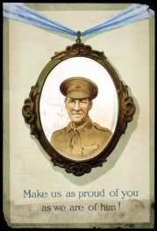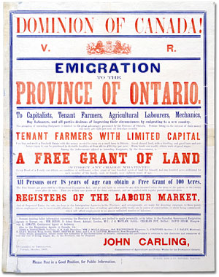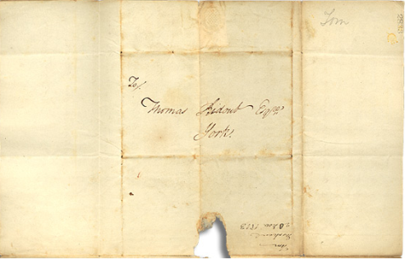

Over the course of a lifetime, most people accumulate a variety of records.

Taken together, these records can provide a fascinating view into someone’s life and into the past.

Like a detective investigating a case, a researcher using these records can get a sense of what a place looked like, what people were thinking, what life was like, and what happened and why.

Some examples of records that a historian may look at are:

* Birth, death, and marriage records
* letters or diaries
* photographs, sketches, and paintings
* court records
* audio, video and film records

An **archive** is a place where these records and historical documents are preserved. The **Archives of Ontario** collects and preserves records with relevance to the history of Ontario.

Using primary sources from the Archives of Ontario’s collections, you too can be an investigator exploring the past and understanding the present.

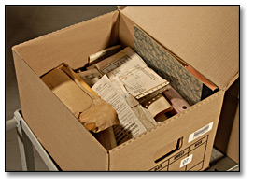 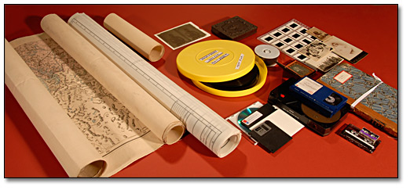 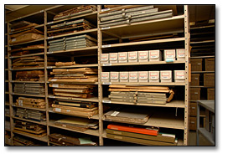

### Overhead 2: Research Question

To begin using the records found at an archive, it is best to begin with a *research question* that can guide your search. For this lesson, your research question could be:

**In what ways did the economic crash affect ordinary Canadians?**

The Archives of Ontario have identified a “fonds” or record collection, to help you answer that question. Today you’ll be working with the **Premier George S. Henry correspondence collection.**

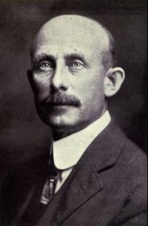

George Stewart Henry

10th Premier of Ontario, 1930-1934

Ministry of Agriculture, Food and Rural Affairs

**Directions**

1. In your group, read all four letters written to Premier Henry in 1933.
2. Take notes on the letters.
3. Use these notes to write a newspaper article as a reporter in 1934.

### Student Worksheet: Reading Comprehension

Take notes about your letter to share with your group

**Letter Date**:____________________________________________________________

______________________________________________________________________

**WHO** is writing the letters? Who are they writing it to?___________________________

______________________________________________________________________

______________________________________________________________________

______________________________________________________________________

**WHAT** is the purpose for the letter? What does the letter writer want or need?________

______________________________________________________________________

______________________________________________________________________

______________________________________________________________________

**WHEN** is the letter writer writing? Is it after a specific event in their life?_____________

______________________________________________________________________

______________________________________________________________________

______________________________________________________________________

**WHERE** is the letter coming from?__________________________________________

______________________________________________________________________

______________________________________________________________________

**WHY** would letter writing be an effective or ineffective way to communicate their circumstances? Do you think they would have been successful in their request? Why or why not?______________________________________________________________

______________________________________________________________________________________________________________________________________________________________________________________________________________________________________________________________________________________________________________________________________________________________

**HOW** does this letter make you feel about the letter writer’s circumstances? _________

______________________________________________________________________________________________________________________________________________________________________________________________________________________________________________________________________________________________________________________________________________________________

### Student Worksheet: Primary Source Overview

*Use this worksheet to take notes about the other three letters your group members read*.

**Letter 1**

Who:____________________________________________________________________

What:____________________________________________________________________

________________________________________________________________________

Where:___________________________________________________________________

Why:____________________________________________________________________

________________________________________________________________________

How:____________________________________________________________________

**Letter 2**

Who:____________________________________________________________________

What:____________________________________________________________________

________________________________________________________________________

Where:___________________________________________________________________

Why:____________________________________________________________________

________________________________________________________________________

How:____________________________________________________________________

**Letter 3**

Who:____________________________________________________________________

What:____________________________________________________________________

________________________________________________________________________

Where:___________________________________________________________________

Why:____________________________________________________________________

________________________________________________________________________

How:____________________________________________________________________

### Primary Source 1: Letter: Schomburg, Ontario January 1933

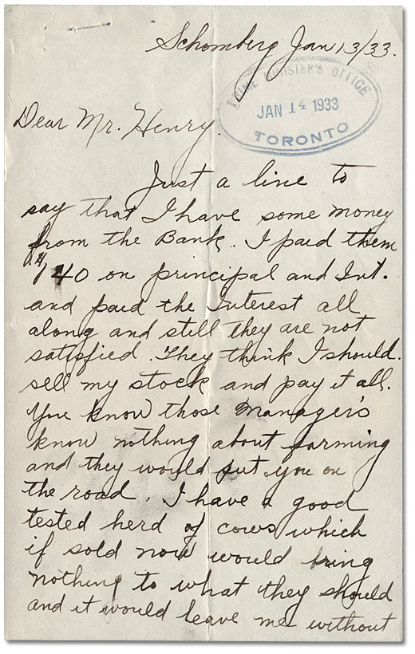 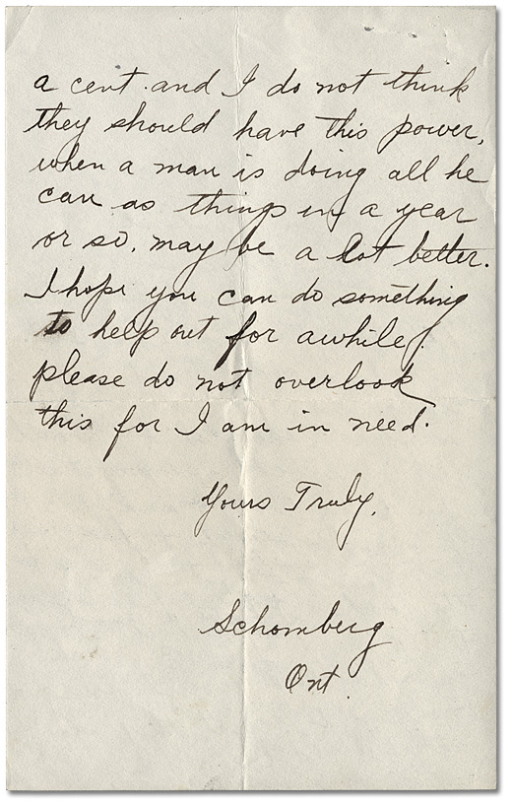

Letter to the Premier, January 13, 1933

Premier George S. Henry correspondence

Reference Code: RG 3-9-0-391

Schomberg, January 13, 1933

Dear Mr. Henry.

Just a line to say that I have some money from the Bank. I paid them $140 on principal and int. and paid the interest all along and still they are not satisfied. They think I should I should sell my stock and pay it all. You know those manager’s (sic) know nothing about farming and they would put you on the road. I have a good tested herd of cows which if sold now would bring nothing to what they should and it would leave me without a cent and I do not think they should have this power, when a man is doing all he can as things in a year or so may be a lot better. I hope you can do something to help me out for awhile, please do not overlook this for I am in need.

Yours Truly,

[Name Omitted for the Protection of Privacy], Schomberg, Ont.

### Primary Source 2: Letter: Toronto, Ontario January 1933

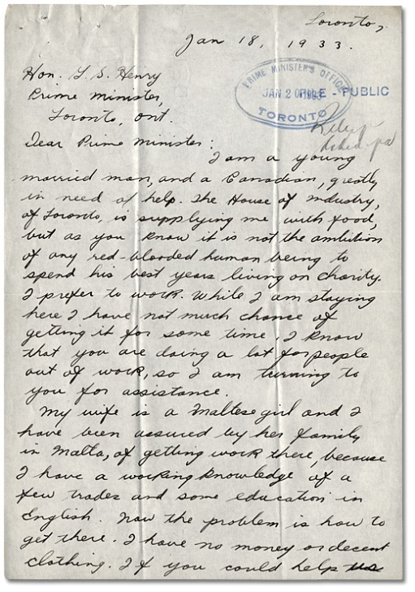 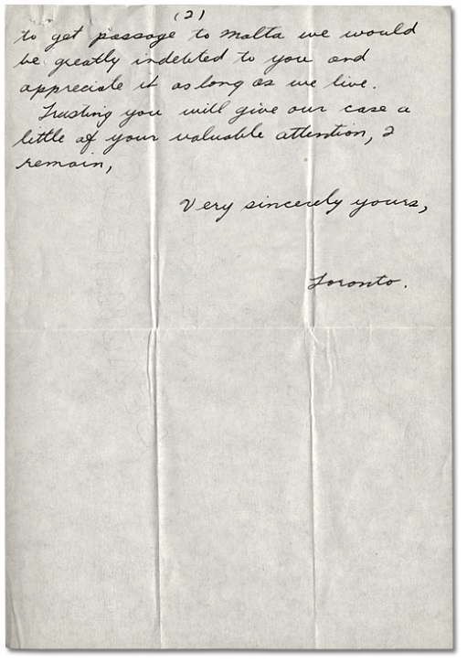

Letter to the Premier, January 18, 1933, Premier George S. Henry correspondence

Reference Code: RG 3-9-0-391

Archives of Ontario

Hon. G.S. Henry

Prime Minister

Toronto, Ont.

Dear Prime Minister,

I am a young married man, and a Canadian, greatly in need of help. The House of Industry, at Toronto, is supplying me with food, but as you know it is not the ambition of any red-blooded human being to spend his best years living on charity. I prefer to work. While I am staying here I have not much chance of getting it for some time. I know that you are doing a lot for people out of work, so I am turning to you for assistance.

My wife is a Maltese girl and I have been assured by her family in Malta, of getting work there, because I have a working knowledge of a few trades and some education in English. Now the problem is how to get there. I have no money or decent clothing. If you could help us to get passage to Malta we would be greatly indebted to you and appreciate it as long as we live.

Trusting you will give our case a little of your valuable attention, I remain,

Very sincerely yours,

[Name Omitted for Protection of Privacy], Toronto

### Primary Source 3: Letter: Toronto, Ontario February 1933

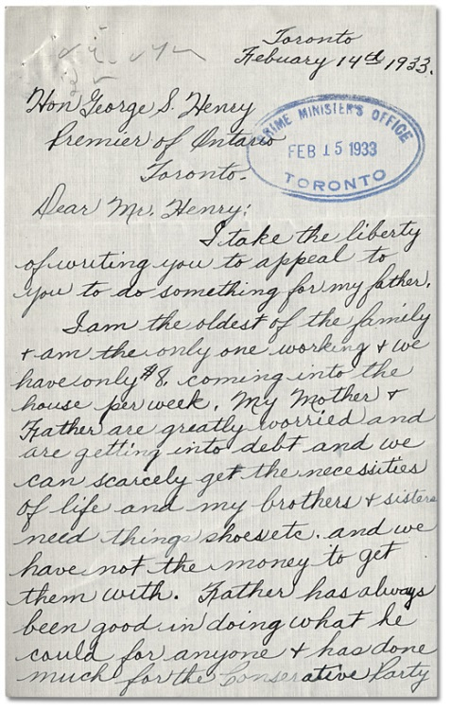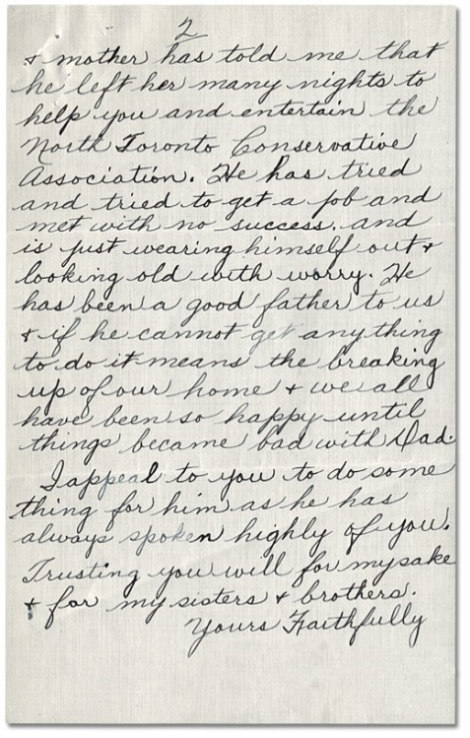

Letter to the Premier, February 14, 1933, Premier George S. Henry correspondence

Reference Code: RG 3-9-0-391

Archives of Ontario

Toronto

February 14, 1933

Dear Mr. Henry:

I take the liberty of writing you to appeal to you to do something for my father.

I am the oldest of the family + am the only one working + we have only $8 coming into the house per week. My Mother + Father are greatly worried and are getting into debt and we can scarcely get the necessities of life and my brothers + sisters need things shoes etc. and we have not the money to get them with. Father has always been good in doing what he could for anyone + has done much for the Conservative Party + mother has told me that he left her many nights to help you and entertain the North Toronto Conservative Association. He has tried and tried to get a job and met with no success and is just wearing himself out + looking old with worry. He has been a good father to us + if he cannot get anything to do it means the breaking up of our home + we all have been so happy until things became bad with Dad.

I appeal to you to do something for him as he has always spoken highly of you. Trusting you will for my sake + for my sisters + brothers.

Yours Faithfully

[Name Omitted for Protection of Privacy]

### Primary Source 4: Letter: Cache Bay, Ontario February 1933

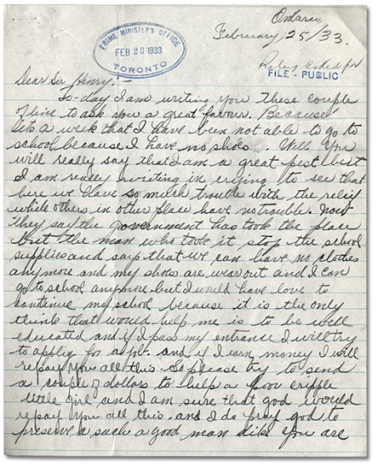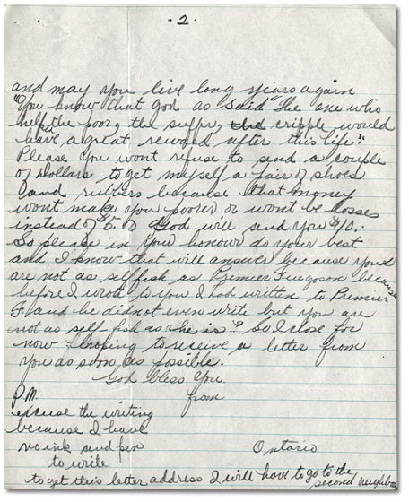

Letter to the Premier, February 25, 1933, Premier George S. Henry correspondence

Reference Code: RG 3-9-0-391

Archives of Ontario

Cache Bay, Ontario

February 25, 1933

Dear Sir Henry-

To-day I am writing you these couple of line (sic) to ask you a great favour. Because it’s a week that I have been not able to go to school because I have no shoes. Will you will really say that I am a great pest but I am really writing in crying to see that here we have so much trouble with relief while other in other place (sic) have no trouble. Now they say the government has took (sic) the place but the man who tooke (sic) stop the school supplies and says that we can have no clothes anymore but I would have love to sometime (sic) my school because it is the only think (sic) that would help me is to be well educated and if I pass my entrance I will try to apply for a job. And if I earn money I will repay you all this. So please try to send a couple of dollars to help a poor cripple little girl and I am sure that god would repay you all this. And I do pray god to preserve such a man like you are and may you live long years again. You know that god as said “The one who helped the poor, the suffer, the cripple would have a great reward after life.” Please you wont refuse to send a couple of Dollars to get myself a pair of shoes and rubbers because that money wont make you poorer or wont be lost instead of $5.00 God will send you $10. So please in your honour do your best and I know that will answer because you are not as selfish as Premier Ferguson because before I wrote to you I had written to Premier F and he did not even write but you are not as self-fish as he is. So I close for now hoping to receive a letter from you as soon as possible.

God bless you

P.S. Excuse the writing because I have no ink and pen to write

To get this letter address I will have to go to the second neighbour

### Assignment Sheet: Reporting from the Great Depression

Image: Black and white clip art illustration of a young boy holding folded newspapers for sale.

**Imagine you are a reporter in 1934.** Write an article about how the stock market crash of 1929 continues to have an affect on Canadians in the 1930s.

Use the primary source letters as inspiration and reference for this article.

Use secondary sources to fill in details about the economic situation in whole.

Your article should include:

* The date
* A headline
* A by-line
* An opening paragraph of 25-40 words that provides the most important and interesting news first and answers the who, what, where, when of the main topic.
* 3-5 short paragraphs of 30-40 words each with a different idea and fact. This is where you can include quotes and personal details.
* Details are given in order of importance, with the least important details at the end of the article, this allows reader's to skim over the start of the article to gain the essential facts before deciding to read on.
* At the end of a newspaper article the facts and opinions are summarised, detailing the issue or event.

Your article should be about 250 words long.

Due Date: _____________________________________________________________

### Marking Rubric

| **Criteria** | **Level 1** | **Level 2** | **Level 3** | **Level 4** |
| --- | --- | --- | --- | --- |
| ***Knowledge and Understanding***  Student demonstrates understanding of social and economic conditions experienced during the Depression. | Limited understanding of the source materials as they relate to various experiences of Depression in Canada. | Some understanding though lacking in completeness, clarity and integration of the source materials as they relate to various experiences of the Depression in Canada. | Clear and comprehensive understanding of the source materials as they relate to various experiences of the Depression in Canada. | A clear, comprehensive, balanced and well integrated understanding of the source materials as they relate to various experiences of the Depression in Canada. |
| ***Thinking/Inquiry***  Student demonstrates an ability to analyze critically pieces of evidence presented within the letters. | Unclear perspective and very limited understanding of the social and economic context of the Depression. | Some limited understanding of the source materials and a moderately effective organization of the analysis. | A clear critical position evident in all aspects of the work, with effective presentation of the analysis. | A critical analysis presented with a high degree of insight and clarity and resulting in a precise and persuasive interpretation |
| ***Communication***  Student writes effectively for the purpose (specifically, analyzing and critiquing the letters). | Language and organization of data that demonstrates lack of sensitivity to the social and economic context. | Somewhat effective use of language and organization of the analysis but with limitation. | Consistent and effective use of language and clear organization of the analysis. | Precise use of language, clarity of organization and good stylistic control, illustrating a good understanding of the conventions of written communication. |
| ***Application***  Student makes personal imaginative connections with people who lived through the Depression. | Little personal or imaginative identification with the hardships that people faced during the Depression. | Some awareness of personal or imaginative connections with people living during the Depression. | Effective, personalized understanding of what people suffered during the Depression. | High degree of identification with people living during the Depression and full imaginative connection with that time and place. |