# Post-War Life: Girls, boys, and their toys

Grade 10: Canadian History Since World War I

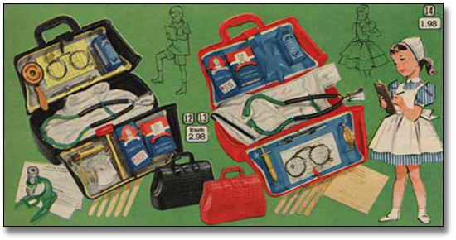

## Overview

All of the Archives of Ontario lesson plans have two components:

* The first component introduces students to the concept of an archive and why the Archives of Ontario is an important resource for learning history
* The second component is content-based and focuses on the critical exploration of a historical topic that fits with the Ontario History and Social Studies Curriculum for grades 3 to 12. This plan is specifically designed to align with the Grade 10: Canadian History Since World War I curricula.

We have provided archival material and an activity for you to do in your classroom. You can do these lessons as outlined or modify them to suit your needs. Feedback or suggestions for other lesson plans are welcome.

**In this plan**, students will use images from post-war toy catalogues to think about gender expectations during the post-war period, and use this discussion as an entry point for learning about the 1960s women’s movement. The Archives of Ontario thanks Sears Canada for giving permission to use images from the T. Eaton Company fonds held at the Archives of Ontario for the online exhibit this plan is based on.

## Curriculum Connections

**Overall Expectations – Academic (CHC2D)**

Change and Continuity

* analyse changing demographic patterns and their impact on Canadian society since 1914;

Citizenship and Heritage

* analyse the contributions of various social and political movements in Canada since 1914;

Social, Economic, and Political Structures

* analyse how changing economic and social conditions have affected Canadians since 1914;

Methods of Historical Inquiry and Communication

* formulate questions on topics and issues in the history of Canada since 1914, and use appropriate methods of historical research to locate, gather, evaluate, and organize relevant information from a variety of sources;
* interpret and analyse information gathered through research, employing concepts and approaches appropriate to historical inquiry;
* communicate the results of historical inquiries, using appropriate terms and concepts and a variety of forms of communication.

**Overall Expectations – Applied (CHC2P)**

Change and Continuity

* explain some major ways in which Canada’s population has changed since 1914;

Citizenship and Heritage

* describe the impact of significant social and political movements on Canadian society;

Social, Economic, and Political Structures

* explain changing economic conditions and patterns and how they have affected Canadians;

Methods of Historical Inquiry and Communication

* formulate questions on topics and issues in the history of Canada since 1914, and use appropriate methods of historical research to locate, gather, evaluate, and organize relevant information from a variety of sources;
* interpret and analyse information gathered through research, employing concepts and approaches appropriate to historical inquiry;
* communicate the results of historical inquiries, using appropriate terms and concepts and a variety of forms of communication.

## Getting Organized

To prepare for this lesson, you can:

* Make overheads or create a PowerPoint with the introductory information found on: Overhead 1: Exploration through the Archives and Overhead 2: Post-War Toys: Research Question
* Print out and make copies of Eaton’s Post-War Toy Catalogue – Page 1 & Page 2 and Student Handout: Girl Toys, Boy Toys, Both? for each group of students
* Prepare your introductory information for the women’s movement that will follow this lesson

## Lesson Plan

* This lesson is designed as a one class bridge between the 1950s baby boom and the 1960s social movements. Run as designed or modify to suit your needs:
* Begin by introducing the concept of an archive and how it can help answer research questions related to history.
* See **Overhead 1:** **Exploration Through the Archives** to introduce this to your students and the following text to prepare yourself:

Over the course of a lifetime, most people accumulate a variety of records. It starts with a birth certificate and expands into awards, bank statements, receipts, letters, photographs – anything that documents important events and relationships in one’s life. These records comprise an individual’s personal archives. Governments, businesses, schools, associations and organizations of all types do the same, keeping records as evidence of their activities and accomplishments.

These documents provide a fascinating view into the past. Like a detective investigating a case, a researcher using these records can get a sense of what a place looked like, what people were thinking, what life was like, and what happened and why. Anyone with an interest in the past, whether it is delving into local history, tracing a family tree, or probing decisions and events, will find answers in archives.

Some examples are:

- letters, manuscripts, diaries often from famous people

- notes or recordings of interviews

- photographs, sketches and paintings

- birth, death and marriage records

- land registries, titles to property, and maps

- court records

- architectural plans and engineering drawings

- audio, video and film records

Archives are important resources for answering our questions about the past. Records may be used to settle legal claims, they may clarify family history, they are grist for historians, and they impart to filmmakers and authors a sense of the ways things were. Whatever the reason, archives have a story to tell.

The first step is to identify your research question and what you are hoping to find in the Archives to provide support to that question.

* + - * Following this introduction, use **Overhead 2: Post-war Toys – Research Question**  to introduce the lesson’s research question and the archival collection that the class will be using to explore this question.
      * Organize students into small groups and ask them to use the Venn diagram provided on **Student Handout: Girl Toys, Boy Toys, Both?** to take notes on the attributes of gendered toys found on the **Eaton’s Post-War Toy Catalogue – Page 1** & **2** handouts. What did the toys encourage young children to do? Are there toys that are designed for both girls and boys? Are the gender lines more or less rigid than today? Ask them to think about what kinds of activities children would be expected to partake in while playing with those toys, what the differences would be for girls’ and boys’ activities, and why people would find this limiting as they grew up.
      * Reconvene as a class and have a large class discussion about the notes they took on post-war toys. Discuss the baby boom and the larger kid-centric culture that privileged traditional gender roles. Use this discussion as a bridge into discussion of the women’s movement.

## Extension/Accommodation

* Have toy catalogue changed much? Encourage students to make their own toy catalogue mimicking or challenging the Eaton’s toy catalogue.
* Use the class discussion as a point of entry into a formal debate about the influence of toys on one’s adult life.

# Handouts & Worksheets

Overhead 1: Exploration through the Archives! 6

Post-War Toys: Research Question 7

Eaton’s Post-War Toy Catalogue – Page 1 8

Eaton’s Post-War Toy Catalogue – Page 2 9

Student Handout: Girl Toys, Boy Toys, Both? 10

### Overhead 1: Exploration through the Archives!

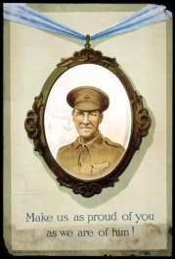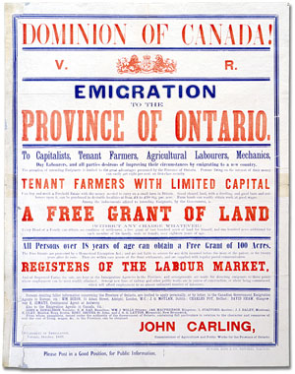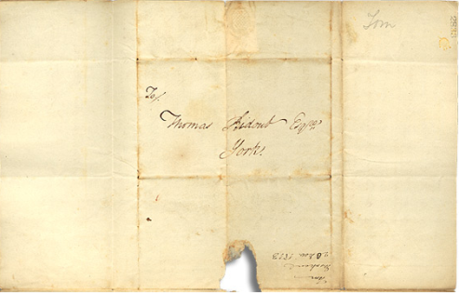

Over the course of a lifetime, most people accumulate a variety of records.

Taken together, these records can provide a fascinating view into someone’s life and into the past.

Like a detective investigating a case, a researcher using these records can get a sense of what a place looked like, what people were thinking, what life was like, and what happened and why.

Some examples of records that a historian may look at are:

* Birth, death, and marriage records
* letters or diaries
* photographs, sketches, and paintings
* court records
* audio, video and film records

An **archive** is a place where these records and historical documents are preserved. The **Archives of Ontario** collects and preserves records with relevance to the history of Ontario.

Using primary sources from the Archives of Ontario’s collections, you too can be an investigator exploring the past and understanding the present.

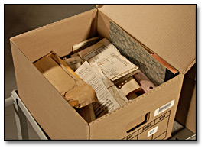 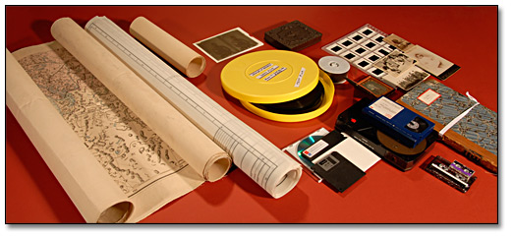 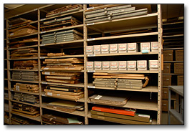

### Post-War Toys: Research Question

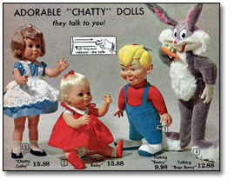

To begin using the records found at an archive, it is best to begin with a *research question* that can guide your search. For this lesson, your research question could be:

**What were the gender expectations of children in the post-World War II era?**

This question can help you think about:

* Did these expectations have an impact on the 1960s woman’s movement?

The Archives of Ontario have identified a “fond,” or record collection, to help you answer that question. Today you’ll be working with **The T. Eaton Company fonds.**

### Eaton’s Post-War Toy Catalogue – Page 1

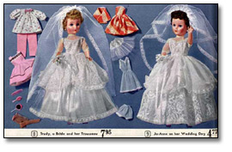

Eaton's Christmas Catalogue, 1962

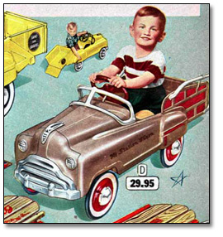

Eaton's Christmas Catalogue, 1956



Eaton's Christmas Catalogue, 1956

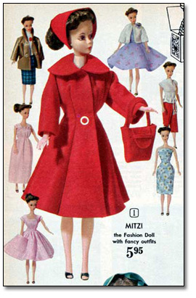

Eaton's Christmas Catalogue, 1962

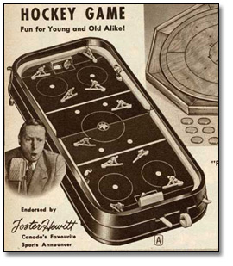

Eaton's Fall and Winter Catalogue, 1940-41

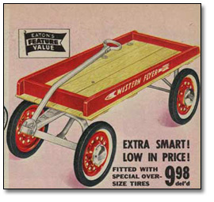

Eaton's Christmas Catalogue, 1956

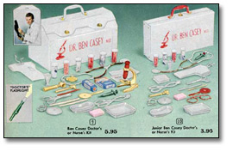

Eaton's Christmas Catalogue, 1962

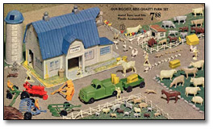

Eaton's Christmas Catalogue, 1962

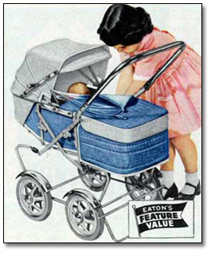

Eaton's Christmas, 1956

Acknowledgements The Archives of Ontario thanks Sears Canada for giving permission to use images from the T. Eaton Company fonds held at the Archives of Ontario.

### Eaton’s Post-War Toy Catalogue – Page 2

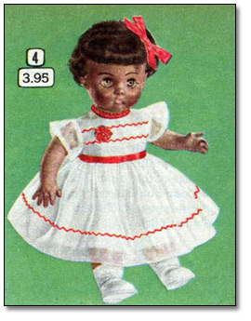

Eaton's Christmas Catalogue, 1956

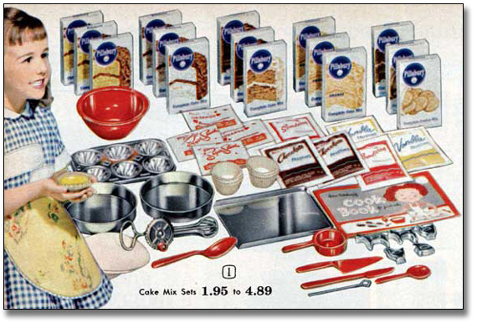

Eaton's Christmas Catalogue, 1962

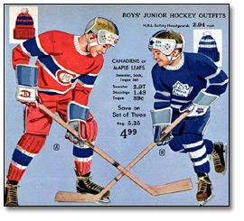

Eaton's Christmas Catalogue, 1962

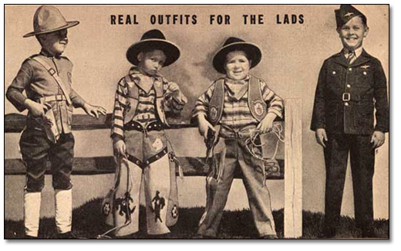

Eaton's Fall and Winter Catalogue, 1940-41

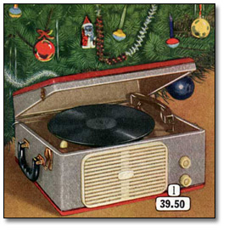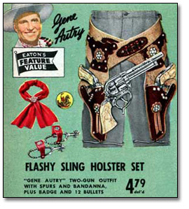

Eaton's Christmas Catalogue, 1956

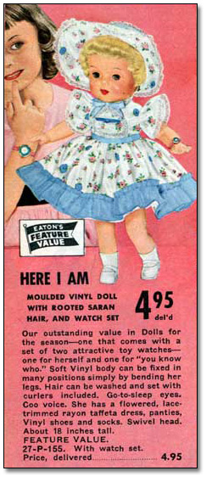

Eaton's Christmas, 1956

Acknowledgements The Archives of Ontario thanks Sears Canada for giving permission to use images from the T. Eaton Company fonds held at the Archives of Ontario.

### Student Handout: Girl Toys, Boy Toys, Both?

Look at the pictures on the Eaton’s Toy Catalogue pages. Which toys were intended for girls? Which ones were intended for boys? Are there toys that are designed for both girls and boys?

Think about which toys in the catalogues were intended for each gender, and list them in the chart below:

| **GIRLS** | **BOTH** | **BOYS** |
| --- | --- | --- |
| Blank space for student work | Blank space for student work | Blank space for student work |

**Based on these notes, what can you guess were the expectations for girls and boys during this period?**