# Evaluating Wartime Posters: Were They Good Propaganda?

Grade 10: Canadian History Since World War I

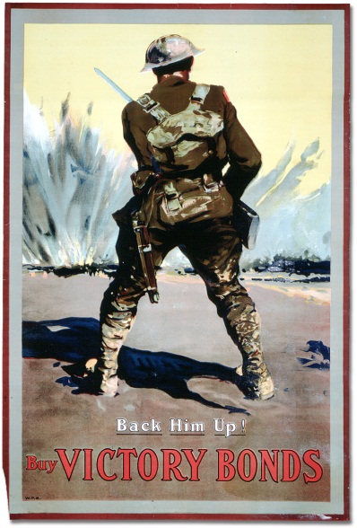

## Overview

**All of the Archives of Ontario lesson plans have two components:**

* The first component introduces students to the concept of an archive and why the Archives of Ontario is an important resource for learning history
* The second component is content-based and focuses on the critical exploration of a historical topic that fits with the Ontario History and Social Studies Curriculum for grades 3 to 12. This plan is specifically designed to align with the Grade 10: Canadian History Since World War I curricula.

We have provided archival material and an activity for you to do in your classroom. You can do these lessons as outlined or modify them to suit your needs. Feedback or suggestions for other lesson plans are welcome.

**In this plan**, students will look at posters from World War I, develop criteria about what makes an effective piece of propaganda, and use these criteria to look critically at three posters of their choice. Students will be able to use their skills of inquiry, research, and communication in working through this lesson while also learning from.

## Curriculum Connections

**Overall Expectations – Academic (CHC2D)**

Communities: Local, National, and Global

* explain how local, national, and global influences have helped shape Canadian identity;
* analyse the impact of external forces and events on Canada since 1914;

Methods of Historical Inquiry and Communication

* formulate questions on topics and issues in the history of Canada since 1914, and use appropriate methods of historical research to locate, gather, evaluate, and organize relevant information from a variety of sources;
* interpret and analyse information gathered through research, employing concepts and approaches appropriate to historical inquiry;
* communicate the results of historical inquiries, using appropriate terms and concepts and a variety of forms of communication.

**Overall Expectations – Applied (CHC2P)**

Communities: Local, National, and Global

* describe some of the major local, national, and global forces and events that have influenced Canada’s policies and Canadian identity since 1914;
* evaluate Canada’s participation in war and contributions to peacekeeping and security.

Methods of Historical Inquiry and Communication

* formulate questions on topics and issues in the history of Canada since 1914, and use appropriate methods of historical research to locate, gather, evaluate, and organize relevant information from a variety of sources;
* interpret and analyse information gathered through research, employing concepts and approaches appropriate to historical inquiry;
* communicate the results of historical inquiries, using appropriate terms and concepts and a variety of forms of communication.

## Getting Organized

**To prepare for this lesson, you can:**

* Make overheads or create a PowerPoint with the introductory information found on: **Overhead 1: FAQs - Propaganda in World War I, Overhead 2: Exploration Through the Archives**, and **Overhead 3: Evaluating Wartime Posters - Research Question.**
* Print out the twenty **World War I: Primary Source Posters**, preferably in colour. Put the posters around the classroom to make a poster ‘gallery’ where students can walk about and look at the posters on their own
* Print out **Student Worksheet: World War I Posters Notes** for each student and **Student Worksheet: World War 1 Poster Analysis** for each group of students.

## Lesson Plan

This lesson can be completed in one class or expanded and completed across a week:

* + - * Begin by talking about propaganda: what it is, how it is/was used, and what students think are the elements of effective propaganda. Ask students if they can think of any propaganda examples of today or in the past. Use **Overhead 1: FAQs - Propaganda in World War I** to discuss the role of propaganda in World War I.
      * Follow this discussion by introducing the concept of an archive and how it can help answer research questions related to history. See **Overhead 2: Exploration Through the Archives** to introduce this to your students and the following text to prepare yourself:

Over the course of a lifetime, most people accumulate a variety of records. It starts with a birth certificate and expands into awards, bank statements, receipts, letters, photographs – anything that documents important events and relationships in one’s life. These records comprise an individual’s personal archives. Governments, businesses, schools, associations and organizations of all types do the same, keeping records as evidence of their activities and accomplishments.

These documents provide a fascinating view into the past. Like a detective investigating a case, a researcher using these records can get a sense of what a place looked like, what people were thinking, what life was like, and what happened and why. Anyone with an interest in the past, whether it is delving into local history, tracing a family tree, or probing decisions and events, will find answers in archives.

Some examples are:

- letters, manuscripts, diaries often from famous people

- notes or recordings of interviews

- photographs, sketches and paintings

- birth, death and marriage records

- land registries, titles to property, and maps

- court records

- architectural plans and engineering drawings

- audio, video and film records

Archives are important resources for answering our questions about the past. Records may be used to settle legal claims, they may clarify family history, they are grist for historians, and they impart to filmmakers and authors a sense of the ways things were. Whatever the reason, archives have a story to tell.

The first step is to identify your research question and what you are hoping to find in the Archives to provide support to that question.

* + - * Following this introduction, use **Overhead 3: Evaluating Wartime Posters - Research Question** to introduce the lesson’s research question, the archival collection that the class will be using to answer this question, and the directions for the activity.

Find attached the primary sources, handouts, and rubric for facilitating this activity

* + - * Allow students to explore the gallery of World War I posters you created. Ask students to take notes about elements about the posters they liked, didn’t like, and that they found surprising and/or shocking on **Student Worksheet: World War I Posters Notes.**
      * When students have completed the gallery walk, reconvene as a class and have a discussion about the different elements they noted on their worksheet. Use this discussion to create criteria about the effectiveness of propaganda and model the application of these criteria on one poster you selected before the discussion. Encourage the class to refine or expand the criteria to best suit the analysis.
      * After modelling the application of criteria, organize students into small groups and ask them to apply these criteria to three posters of their choice. Encourage them to use **Student Worksheet: World War 1 Poster Analysis** for this activity.

Twenty posters are provided so there could be up to six groups who all get three posters. Visit the Archives of Ontario’s online exhibit **Canadian Posters from the First World War** if more examples are needed.

## Extension/Accommodation

This activity can be extended in the next class by having a class discussion or debate comparing the top poster choices from all the groups.

Activity can also be expanded by asking students to create their own propaganda posters based on the successful elements they tracked on their **Poster Analysis** worksheet.

This activity can also lead into a discussion about the use of criteria for making judgements. If different criteria were used, would the students had different answers? What would influence how criteria is chosen and applied?

For more academic classes, this activity can also lead into a three paragraph essay on the most effective elements of a propaganda poster.

# Handouts & Worksheets

FAQs: Propaganda in World War I 6

Overhead 1: Exploration through the Archives! 7

Evaluating Wartime Posters 8

Student Worksheet: World War I Posters Notes 9

Student Worksheet: World War 1 Poster Analysis 10

Primary Source Posters – “Be Yours to Hold It High!” 11

Primary Source Posters – “Come On! Let's Finish the Job” 12

Primary Source Posters – “Back Him Up!” 13

Primary Source Posters – “Yours Not to Do or Die” 14

Primary Source Posters – “Kultur vs. Humanity” 15

Primary Source Posters – “Pave the way to Victory” 16

Primary Source Posters – “Re-establish Him” 17

Primary Posters – “If Ye Break Faith” (English and French versions) 18

Primary Source Posters – “Stick it Canada” 19

Primary Source Posters – “G-Bye Mary” 20

Primary Source Posters – “Show Our Boys Again!” 21

Primary Source Posters – “Here's Your Chance” 22

Primary Source Posters – “Send More Men” 23

Primary Source Posters – “You Are No Exception” 24

Primary Source Posters – “To the Women of Canada” 25

Primary Source Posters – “Bushmen and Sawmill Hands Wanted” 26

Primary Source Posters – “Canadiens français” 27

Primary Source Posters – “The Thin Khaki Line” 28

Primary Source Posters – “Can't you see?” 29

Primary Source Posters – “Canada's Victory Bonds” 30

Marking Rubric 31

### FAQs: Propaganda in World War I

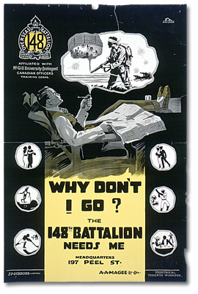

✪ **What is Propaganda?**

* Propaganda is a specific type of message aimed at serving an agenda. In the case of WWI, the Canadian government used propaganda posters to spread particular ideas or points of view to citizens of Canada.

✪ **Why did the government use propaganda in World War I?**

✪ **What sort of messages did they hope to get across?**

* The government used propaganda to:
  + Justify their involvement in the war to their population
  + Recruit soldiers
  + Raise money to fund the military campaign
  + Encourage people to conserve resources on the home front

✪Why did the government use posters as propaganda?

* The government used posters as propaganda because:
  + Television had not yet been invented
  + Not everyone owned or had access to a radio
  + Posters were the most effective means of getting a message across to a large audience

✪How many posters were produced?

* Hundreds of thousands of propaganda posters were printed. These posters were posted on billboards, store windows, factory walls, and anywhere else where people gathered.

### Overhead 1: Exploration through the Archives!

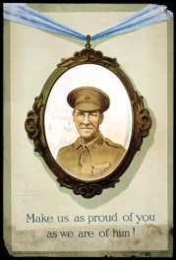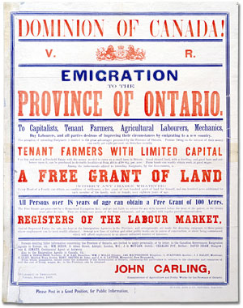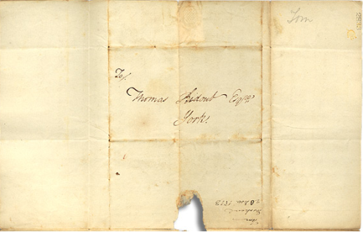

Over the course of a lifetime, most people accumulate a variety of records.

Taken together, these records can provide a fascinating view into someone’s life and into the past.

Like a detective investigating a case, a researcher using these records can get a sense of what a place looked like, what people were thinking, what life was like, and what happened and why.

Some examples of records that a historian may look at are:

* Birth, death, and marriage records
* letters or diaries
* photographs, sketches, and paintings
* court records
* audio, video and film records

An **archive** is a place where these records and historical documents are preserved. The **Archives of Ontario** collects and preserves records with relevance to the history of Ontario.

Using primary sources from the Archives of Ontario’s collections, you too can be an investigator exploring the past and understanding the present.

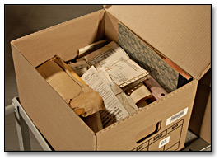 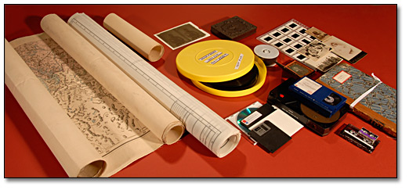 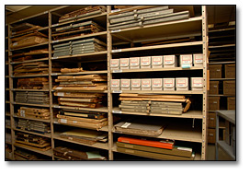

### Evaluating Wartime Posters

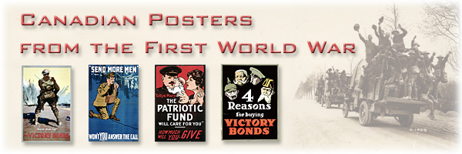

**Research Question:**

**What made for an effective propaganda poster during World War I?**

The Archives of Ontario have identified a record collection that includes records to help you answer that question:

**The Archives of Ontario’s War Poster Collection**

*There are approximately 500 posters in the Ontario Archives’ collection. Many of them can be found in the Archives of Ontario poster collection (C 233).*

**Directions:**

1. Look at World War I propaganda posters and take notes about your impressions
2. As a class, develop criteria for determining effectiveness for propaganda posters and apply these criteria to one poster
3. In small groups, apply these criteria to three other posters and determine the best, most effective piece of propaganda

### Student Worksheet: World War I Posters Notes

| Poster I **liked** the best: | Poster that best appealed to my **emotions**: | Poster I thought had the best use of **colour**: |
| --- | --- | --- |
| Because: | Because: | Because: |
| Poster that **would not** have caught my eye: | Poster that would have **discouraged** me from supporting the war effort: | Poster that best appealed to **patriotism**: |
| Because: | Because: | Because: |
| Poster that would make me to give **money**: | Poster I thought had the best **text**: | Poster I liked the **least**: |
| Because: | Because: | Because: |

**Other posters to mention:**

### Student Worksheet: World War 1 Poster Analysis

In your group, use this worksheet to apply evaluative criteria to three World War I propaganda posters.

**What makes a good piece of propaganda?**

**What are three criteria to judge the effectiveness of a propaganda poster?**

(Write this criteria in the space provided in the chart below)

Poster Analysis:

| Criteria | Poster | Analysis |
| --- | --- | --- |
|  |  |  |
|  |  |  |
|  |  |  |

Best Poster: ___________________________________________________________

Because:__________________________________________________________________________________________________________________________________________________________________________________________________________

### World War I: Primary Source Posters – “Be Yours to Hold It High!”

This is a war poster advertising victory bonds. On the poster are three characters, a worker, a soldier and the personification of Victory. The worker is holding a hammer and is wearing blue work clothes. The soldier carries a flag draped in a wreath. Victory is holding a torch, has large white wings and is draped in white fabric. Behind them is a field of poppies, with several white crosses marking gravesites. 

The text reads: "Be yours to hold it high!, Buy Victory Bonds!"   
Be Yours to Hold It High! [Canada], [between 1914 and 1918], F. L. Nicolet   
Archives of Ontario War Poster Collection  
Reference Code: C 233-2-0-1-7  
Archives of Ontario, I0016146

### World War I: Primary Source Posters – “Come On! Let's Finish the Job”

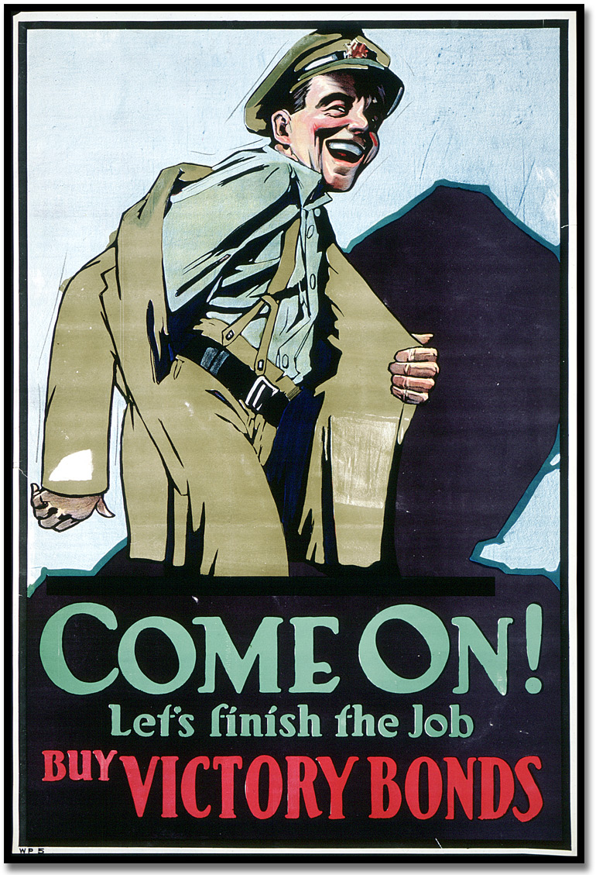  
Come On! Let's Finish the Job [Canada], [ca. 1918]  
Arthur Keelor  
Archives of Ontario War Poster Collection  
Reference Code: C 233-2-0-1-8  
Archives of Ontario, I0016147

### World War I: Primary Source Posters – “Back Him Up!”

Colour illustrated poster showing a soldier in an army uniform with a helmet and gun, charging into battle. Ahead of him are explosions. 

The text reads: "Back Him Up! Buy Victory Bonds".  
Back Him Up! Buy Victory Bonds [Canada], [ca. 1918]  
Creator unknown  
Archives of Ontario War Poster CollectionReference Code: C 233-2-0-1-11  
Archives of Ontario, I0016140

### World War I: Primary Source Posters – “Yours Not to Do or Die”

Colour illustrated poster, showing a group of soldiers in army uniforms about to charge into battle. They are standing with their guns drawn, leaning forward about to move. 

The text reads: "Yours not to do and die, yours but to go and buy, Victory Bonds 1918".   
Yours Not to Do or Die [Canada], [ca. 1918]  
Creator unknown  
Archives of Ontario War Poster Collection  
Reference Code: C 233-2-0-1-5  
Archives of Ontario, I0016144

### World War I: Primary Source Posters – “Kultur vs. Humanity”

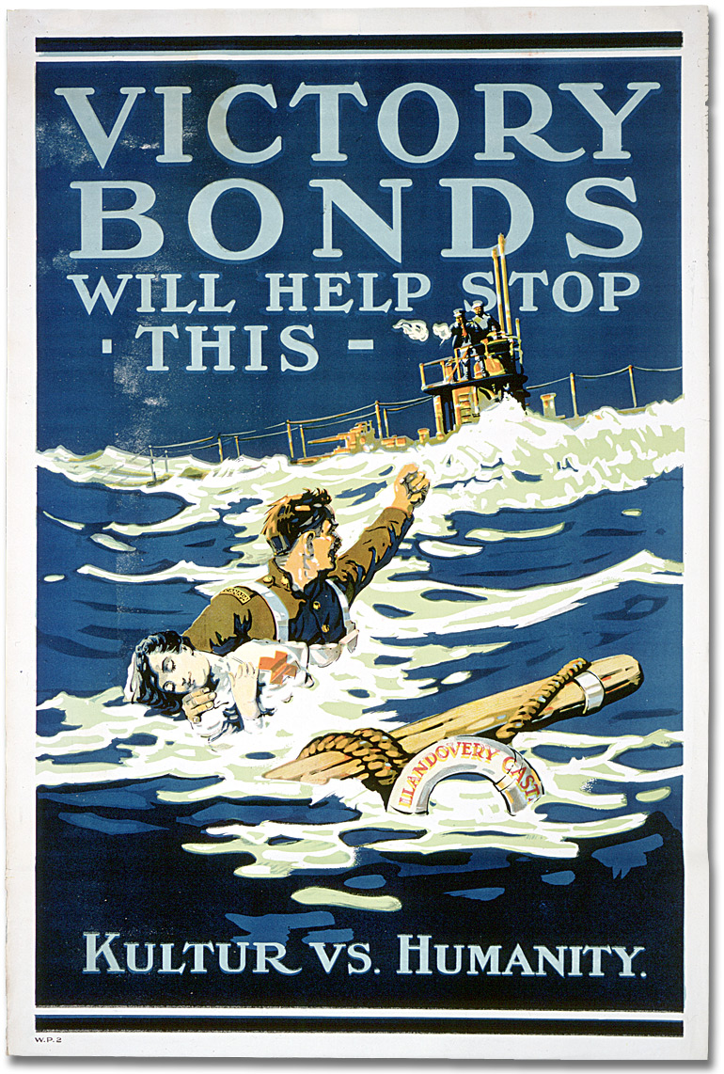  
Victory Bonds Will Help Stop This - [Kultur](http://www.archives.gov.on.ca/english/on-line-exhibits/posters/popups/pu_kultur.aspx) vs. Humanity [Canada], [ca. 1918]  
Creator unknown  
Archives of Ontario War Poster Collection  
Reference Code: C 233-2-0-1-19  
Archives of Ontario, I0016157

### World War I: Primary Source Posters – “Pave the way to Victory”

Colour illustrated poster, showing three trucks carrying multiple soldiers, driving down the street. The street is paved with individual victory bonds. The soldiers are celebrating and raising their helmets in exclamation. 

The text reads: "Pave the way to Victory, Buy Victory Bonds". The implication of this poster is that purchasing victory bonds will help win the war.  
Pave the way to Victory - Buy Victory Bonds [Canada], [ca. 1918]  
Creator unknown  
Archives of Ontario War Poster Collection  
Reference Code: C 233-2-0-1-26  
Archives of Ontario, I0016164

### World War I: Primary Source Posters – “Re-establish Him”

Colour illustrated poster showing a soldier, in his military uniform, looking out of two windows. The window on his left shows a factory while the window on his right shows a farm. 

The text reads: "Re-establish him, it's up to us, Buy Victory Bonds". This poster implies that buying victory bonds will help soldiers find jobs and re-integrate into society after the war.  
Re-establish Him [Canada], [ca. 1919]  
F. L. Nicolet  
Archives of Ontario War Poster Collection  
Reference Code: C 233-2-0-1-210

Archives of Ontario, I0016145

### World War I: Primary Posters – “If Ye Break Faith”

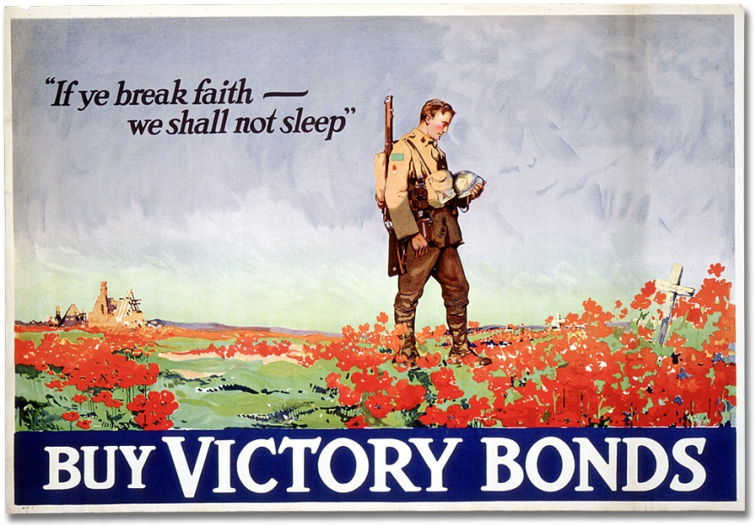

If Ye Break Faith - We Shall Not Sleep [Canada], [ca. 1918], F. L. Nicolet  
Archives of Ontario War Poster Collection  
Reference Code: C 233-2-0-1-16a  
Archives of Ontario, I0016153

Colour illustrated poster showing a soldier standing, with his helmet in his hands, in a field of red poppies.

The French text reads: "Pour que la terre leur soit légère; Souscrivons à l'Emprunt de la Victoire" [Translation: "So that the earth may lie lightly on them; Buy Victory Bonds"]

Pour que la terre leur soit legere [Canada], [ca. 1918], F. L. Nicolet  
Archives of Ontario War Poster Collection  
Reference Code: C 233-2-0-1-16b  
Archives of Ontario, I0016154

### World War I: Primary Source Posters – “Stick it Canada”

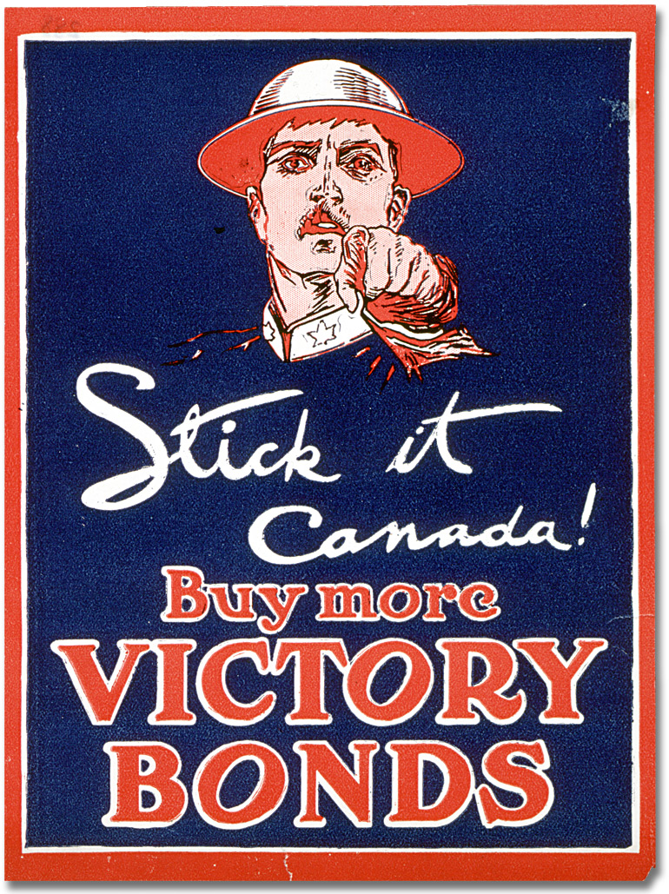  
Stick it Canada, Buy more Victory Bonds [Canada], [between 1914 and 1918]  
Creator unknown  
Archives of Ontario War Poster Collection  
Reference Code: C 233-2-0-1-288  
Archives of Ontario, I0016354

### World War I: Primary Source Posters – “G-Bye Mary”

Colour illustrated poster, showing a soldier holding an infant, next to a woman clasping her hands. 

The text reads: "'G-bye [goodbye] Mary, the Patriotic Fund will care for you' How much will you give". This poster implies that money donated to the Canadian Patriotic Fund will go towards supporting soldiers' widows and their children.  
G-Bye Mary, the Patriotic Fund Will Care for You [Canada], [between 1914 and 1918]  
Creator unknown  
Archives of Ontario War Poster Collection  
Reference Code: C 233-2-0-5-268  
Archives of Ontario, I0016186

### World War I: Primary Source Posters – “Show Our Boys Again!”

Colour illustrated poster for the Canadian Red Cross Patriotic Fund. There is a red cross on a white background, surrounded by red borders. 

The text reads: "Show our boys again! 3 millions, 3 days, patriotic, Canadian Red Cross".   
Show Our Boys Again! [Canada], [between 1914 and 1918]  
Creator unknown  
Archives of Ontario War Poster Collection  
Reference Code: C 233-2-0-2-35

Archives of Ontario, I001637

### World War I: Primary Source Posters – “Here's Your Chance”

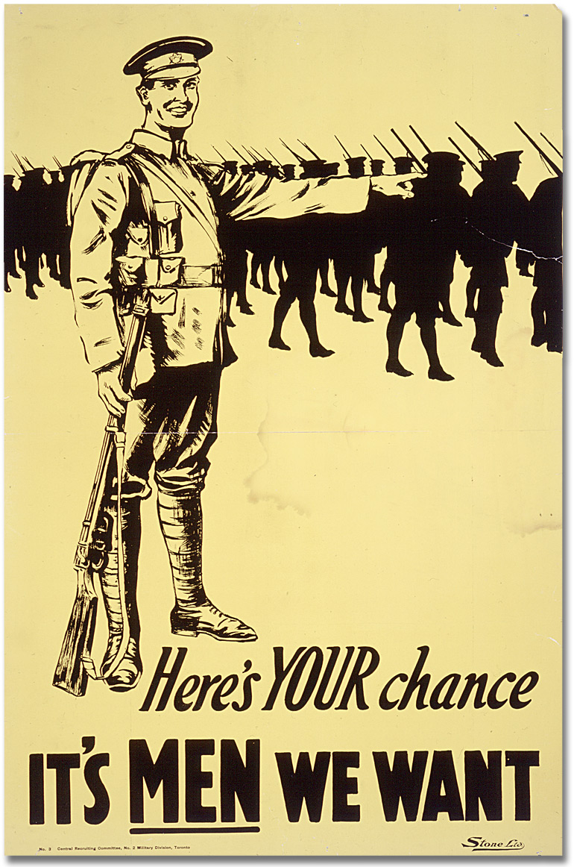  
Here's Your Chance - It's Men We Want [Canada], [between 1914 and 1918]  
Creator unknown  
Archives of Ontario War Poster Collection  
Reference Code: C 233-2-0-4-200

Archives of Ontario, I0016180

### World War I: Primary Source Posters – “Send More Men”

Colour illustrated poster, showing a soldier calling for reinforcements by telephone. He is wearing an army uniform, bent on one knee and holding a field telephone. In the background, there is a forest with gas slowly moving towards the soldier. 

The text reads: "Send more men, won't you answer the call". The poster calls metaphorically for men in Canada to join the army and support the war effort.  
'Send More Men' - Won't You Answer the Call [Canada], [between 1914 and 1918]  
Creator unknown  
Archives of Ontario War Poster Collection  
Reference Code: C 233-2-0-4-203  
Archives of Ontario, I0016181

### World War I: Primary Source Posters – “You Are No Exception”

Colour illustrated poster, showing the silhouette of a man in civilian's clothing, holding his hand to his temple in thought. 

The poster text reads: "I should go BUT!!!" and "You are no exception, Join now". This poster encourages civilian men to join the army.  
You Are No Exception - Join Now [Canada], [between 1914 and 1918]  
Creator unknown  
Archives of Ontario War Poster Collection  
Reference Code: C 233-2-0-4-199

Archives of Ontario, I0016179

### World War I: Primary Source Posters – “To the Women of Canada”

Colour illustrated poster, directed towards women in Canada,  encouraging them to encourage men to enlist in the armed forces. 

The poster features a list of reasons as to why women should encourage the men in their life to enlist. The text is surrounded by a red and black border. 

The poster text reads: "To the Women of Canada, 1. You have read what the Germans have done in Belgium. Have you thought what they would do if they invaded this Country? 2. Do you realize that the safety of your home and children depends on our getting more men NOW? 3. Do you realize that the one word "GO" from you may send another man to fight for our King and Country? 4. When the War is over and someone asks your husband or your son what he did in the great War, is he to hang his head because you would not let him go? Won't you help and send a man to enlist today?"  
To the Women of Canada [Canada], [between 1914 and 1918]  
Creator unknown  
Archives of Ontario War Poster Collection  
Reference Code: C 233-2-0-4-263  
Archives of Ontario, I0016138

### World War I: Primary Source Posters – “Bushmen”

Colour illustrated poster showing a logger sawing through the trunk of a tree in a snowy valley. In the background, we see a sleigh with five logs being pulled through the snow by two horses. 

The poster text reads: "Bushmen and sawmill hands wanted, join the 224th Canadian Forestry Battalion, Alexander McDougall, Lt. Col., Headquarters 43 Bank St. Ottawa."  
Bushmen and Sawmill Hands Wanted [Canada], [between 1914 and 1918]  
Creator unknown  
Archives of Ontario War Poster Collection  
Reference Code: C 233-2-0-4-196

Primary Source Posters

Archives of Ontario, I0016176

### World War I: Primary Source Posters – “Canadiens français”

Colour illustrated poster, featuring a uniformed soldier gesturing with his outstretched hand towards the poster text. 

The poster text reads: "Canadiens français, enrolez-vous au 150ieme Carabiners Mont Royal; Sous le commandement du Lt. Colonel H. Barré; Un regiment d'élite compose d'hommes de choix, et commande par des officiers d'experience revenus du front de la guerre; Bureau de recrutement, arsenal du 65ieme Regiment, coin avenue de Pins et rue Henri Julien, Montreal."

[Translation: "French Canadians, enlist in the 150th Carabiners Mont Royal; An elite regiment composed of men of choice, and commanded by experienced officers returned from the front lines; Recruitment office, 65th Regiment Arsenal, corner of Pine Avenue and Henri Julien Street, Montreal."  
Canadiens français [Canada], [between 1914 and 1918]  
Creator unknown  
Archives of Ontario War Poster Collection  
Reference Code: C 233-2-0-4-197  
Archives of Ontario, I0016177

### World War I: Primary Source Posters – “The Thin Khaki Line”

Colour illustrated poster featuring the silhouette of a soldier, amongst a line of soldiers with weapons drawn. The soldier does not have a helmet on and is holding his gun in charging stance. 

The poster text reads: "The Thin Khaki Line keep the Fate of Belgium from your Hearth and Home, Get into Khaki Now!"   
The Thin Khaki Line [Canada], [between 1914 and 1918], Creator unknown  
Archives of Ontario War Poster Collection  
Reference Code: C 233-2-0-4-267  
Archives of Ontario, I0016184

### World War I: Primary Source Posters – “Can't you see?”

Colour illustrated poster, showing a soldier, with a bloody bandage wrap around his head, carrying a gun at the edge of a trench. Behind him, the British the Union Jack flag flies. 

The poster text reads: "Can't you see? You must buy Victory Bonds."

Can't you see? You must buy victory bonds [Canada], [between 1914 and 1918]

Creator: Alex McLaren.

Archives of Ontario War Poster Collection

Reference Code: C 233-2-12

Archives of Ontario,

### World War I: Primary Source Posters – “Canada's Victory Bonds”

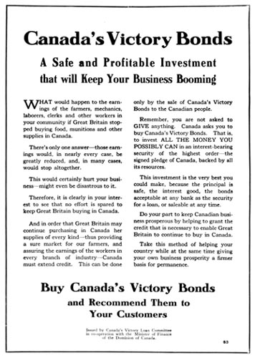

Canada's Victory Bonds - A safe and profitable investment that will keep your business booming [Canada], [between 1914 and 1918], Creator: Creator unknown.

Archives of Ontario War Poster Collection.

Reference Code: C 233-2-1

Archives of Ontario, I0016203

### Marking Rubric

| **Criteria** | **Level 1** | **Level 2** | **Level 3** | **Level 4** |
| --- | --- | --- | --- | --- |
| Knowledge and Understanding  The student demonstrates understanding of how propaganda works. | Limited understanding of the source materials in terms of their effectiveness as propaganda | Some understanding of the source materials in terms of their effectiveness as propaganda | A good, reasonably comprehensive understanding of the source materials in terms of their effectiveness as propaganda | A clear, comprehensive, balanced and well integrated understanding of the source materials in terms of their effectiveness as propaganda |
| Thinking/Inquiry  The student demonstrates the ability to analyze the effectiveness of posters presented in the exhibit. | Unclear perspective and limited analysis of the posters. | Somewhat effective organization and interpretation of the posters but with limited analysis of the posters | A clear and critical position that is evident in all aspects of the work, resulting in an effective analysis | A critical analysis presented with a high degree of ability and clarity resulting in a precise and persuasive analysis |
| Communication  The student writes effectively for the purpose, using clear and persuasive language to present the analysis. | Imprecise and inconsistent use of language, with poorly organized ideas. | Somewhat effective use of language, with fairly clearly organized ideas. | Effective use of language, with clearly organized ideas | Precise, consistent and effective use of language, with clearly organized ideas. |
| Application  The student makes personal imaginative connections with the material presented in the exhibit. | Little understanding of the principles of effective propaganda and difficulty in applying them creatively | Some understanding of the principles of effective propaganda and an ability to use at least some of them in a creative way | Good grasp of the principles of effective propaganda and a well developed ability to apply those principles creatively | Excellent grasp of the principles of effective propaganda and a highly evolved ability to apply those principles creatively. |