# The James Bay Treaty Turns 100

Grade 12: Canada: History, Identity, and Culture

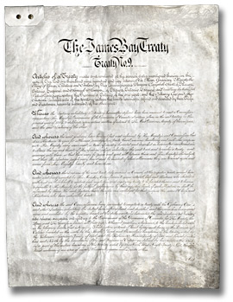

## Overview

All of the Archives of Ontario lesson plans have two components:

* The first component introduces students to the concept of an archive and why the Archives of Ontario is an important resource for learning history
* The second component is content-based and focuses on the critical exploration of a historical topic that fits with the Ontario History and Social Studies Curriculum for grades 3 to 12. This plan is specifically designed to align with the Grade 12: Canada: History, Identity, and Culture curricula.

We have provided archival material and an activity for you to do in your classroom. You can do these lessons as outlined or modify them to suit your needs. Feedback or suggestions for other lesson plans are welcome.

**In this plan**, students will create the negotiation of a fictional agreement involving the sharing of territory by two groups with very different interests and culture. The exercise is designed to encourage students to think about issues that affected or have arisen around the James Bay Treaty and to apply what they have learned to the negotiation of an analogous agreement in a modern-day context.

## Curriculum Connections

### Overall Expectations

Communities: Local, National, and Global

* Describe the characteristics of Aboriginal communities before and after contact with Europeans and analyse the significant effects of the interactions between Aboriginal communities and the colonizers
* Analyse the principal characteristics of the French and English colonial experience in Canada

Change and Continuity

* Assess changes in Canada’s rural-agricultural and urban-industrial communities

Citizenship and Heritage

* Analyse the evolution of citizenship in Canada
* Evaluate the claim that Canada is a just society, by examining issues related to human rights

Social, Economic, and Political Structures

* Analyse changes in Canadian social programs and policies over time
* Evaluate the impact of Canada’s national and international economic policies on Canadian identity and sovereignty
* Describe the nature of the Canadian political system and the groups and individuals who have contributed to its development

Methods of Historical Inquiry and Communication

* Use methods of historical inquiry to locate, gather, evaluate, and organize research materials from a variety of sources
* Interpret and analyse information gathered through research, employing concepts and approaches appropriate to historical inquiry
* Communicate the results of historical inquiries, using appropriate terms and concepts and a variety of forms of communication

# Lesson Plan

This lesson is designed as a two to three class arc with an essay being assigned at the end; however, this lesson can be expanded or condensed based on modifications.

Begin by introducing the concept of an archive and how the Archives of Ontario can help answer research questions related to history.

See **Overhead 1: Exploration Through the Archives** to introduce this to your students and the following text to prepare yourself:

*Over the course of a lifetime, most people accumulate a variety of records. It starts with a birth certificate and expands into awards, bank statements, receipts, letters, photographs – anything that documents important events and relationships in one’s life. These records comprise an individual’s personal archives. Governments, businesses, schools, associations and organizations of all types do the same, keeping records as evidence of their activities and accomplishments.*

*These documents provide a fascinating view into the past. Like a detective investigating a case, a researcher using these records can get a sense of what a place looked like, what people were thinking, what life was like, and what happened and why. Anyone with an interest in the past, whether it is delving into local history, tracing a family tree, or probing decisions and events, will find answers in archives.*

*Some examples are:*

* *Letters, manuscripts, diaries often from famous people*
* *Notes or recordings of interviews*
* *Photographs, sketches and paintings*
* *birth, death and marriage records*
* *land registries, titles to property, and maps*
* *court records*
* *architectural plans and engineering drawings*
* *audio, video and film records*

*Archives are important resources for answering our questions about the past. Records may be used to settle legal claims, they may clarify family history, they are grist for historians, and they impart to filmmakers and authors a sense of the ways things were. Whatever the reason, archives have a story to tell.*

*The first step is to identify your research question and what you are hoping to find in the Archives to provide support to that question.*

Following this introduction, provide background information on the James Bay Treaty in a lecture format; specifically:

* + The main parties to the treaty: Aboriginal peoples (Cree and Ojibway) and federal (Canada) and provincial (Ontario) governments.
  + The particular political and economic context of northern Ontario at the beginning of the 20th century (e.g., the expansion of railways northward, the beginning of intensive northern resource exploitation and the expansion of settlement from the south).
  + The responsibilities of the governments under the Royal Proclamation of 1763 to negotiate and surrender from Aboriginal inhabitants before developing those lands.

## Using the Handouts & Worksheets

Students should then familiarize themselves with the James Bay Treaty. The Archives of Ontario’s website provides an online exhibit on the James Bay Treaty.

Students can either read this exhibit during a special computer lab period, as a homework assignment, or on handouts provided with this lesson. If you’d prefer students read this information in class, see **Handouts & Worksheets**:

* + - * **James Bay Treaty, 1905-06 – Introduction**
      * **James Bay Treaty No. 9 – Peoples & Events Shaping the Treaty**
      * **James Bay Treaty No. 9 – Expedition of 1905-1906**
      * **James Bay Treaty No. 9 – Developing the Treaty Relationships**
      * **The James Bay Treaty, Treaty No. 9**
      * **The James Bay Treaty, Treaty No. 9 – Transcript**
      * Ask students to use **Student Worksheet – Reading the James Bay Treaty** to aid them with their reading. The **Reading the James Bay Treaty – ANSWER KEY** can help you with evaluation.
      * After the introduction and discussion of the James Bay Treaty, encourage students to think about issues that affected or have arisen around the Treaty and to apply what they have learned to the negotiation of an analogous agreement in a modern-day context.
      * Divide the class into four groups and provide each student with a **Student In-class Assignment** handout. Two groups will act out the Ecosystem scenario and receive **the Fictional Negotiation 1 – Ecosystem Agreement** and the other group with act out the Tourism scenario and receive the **Fictional Negotiation 2 – Tourism Agreement.**
      * Assign roles to each group. One group per scenario should be assigned the Nation-to-Nation model, as per the First Nations during James Bay negotiations, and the other on the Two Governments Model, as per the federal and provincial governments.
      * In their small groups, have students discuss their positions for negotiation. Reconvene as a class and have a discussion about how the exercise has increased understanding or appreciation of James Bay agreement and of the issues, past and present, relating to it.
      * Following this discussion, provide students with **Student Assignment: Negotiation, Compare and Contrast**, which instructs students to the written component of this lesson. In this assignment, students should compare and contrasts the basic elements of the James Bay Treaty to the fictional agreement(s) reached in class.

# Handouts & Worksheets

Exploration through the Archives 7

Student Handout: James Bay Treaty, 1905-06 Introduction 8

Peoples and Events Shaping Treaty No. 9 10

The Treaty No. 9 Expdition of 1905-1906 12

Developing the Treaty Relationship, 1905-2005 17

Student Handout: The James Bay Treaty, Treaty No. 9 21

Student Handout: The James Bay Treaty (No. 9) – Transcript 28

Student Worksheet – Reading the James Bay Treaty 36

Student In-class Assignment: 37

Student In-class Assignment: Fictional Negotiation 1 – Ecosystem Agreement 38

Student In-class Assignment: Fictional Negotiation 2 – Tourism Agreement 40

Student Assignment: Negotiation, Compare and Contrast 42

Reading the James Bay Treaty – ANSWER KEY 43

Marking Rubric 44

### Exploration through the Archives

Over the course of a lifetime, most people accumulate a variety of records.

Taken together, these records can provide a fascinating view into someone’s life and into the past.

Like a detective investigating a case, a researcher using these records can get a sense of what a place looked like, what people were thinking, what life was like, and what happened and why.

Some examples of records that a historian may look at are:

* Birth, death, and marriage records
* Letters or diaries
* Photographs, sketches, and paintings
* Court records
* Audio, video and film records

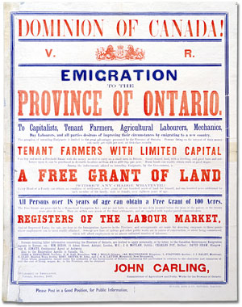Poster encouraging men to enlist in the Canadian Armed Forces during the First World War, featuring an illustrated oval portrait a soldier. Text reads: "Make us as proud of you as we are of him!"
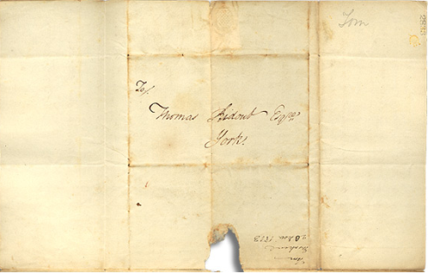

An **archive** is a place where these records and historical documents are preserved. The **Archives of Ontario** collects and preserves records with relevance to the history of Ontario.

Using primary sources from the Archives of Ontario’s collections, you too can be an investigator exploring the past and understanding the present.

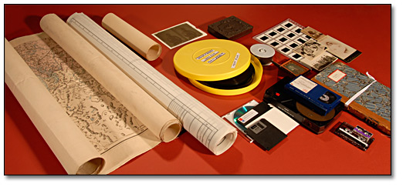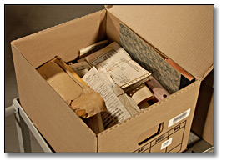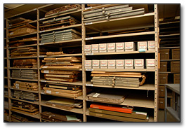

### Student Handout: James Bay Treaty, 1905-06 Introduction

[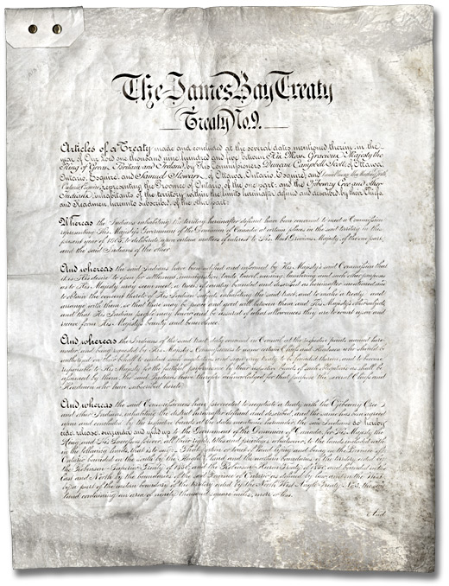](http://www.archives.gov.on.ca/english/on-line-exhibits/james-bay-treaty/big/p01_james_bay_treaty.aspx)

The beginning of the 20th century was an era of change for Aboriginal communities in northern Ontario.

Cree and Ojibway (now the Nishnawbe Aski Nation) are the original inhabitants of the James Bay watershed. Their traditional cultures and economies were tied to a seasonal cycle of semi-nomadic movement to harvest natural resources.

As long as fish and game were plentiful, Cree and Ojibway returned to the same general locations for summer and winter activities.

In the mid-1880s, the Canadian and Ontario governments promoted railroad construction, mining, and immigrant settlement into more northern regions of Ontario.

There was increased competition for resources and by 1900 Cree and Ojibway were experiencing economic disturbances and local declines in traditional harvesting and trade.

The Governments needed clear title to lands in order to proceed with mining licenses, railway construction, and sales of lands to settlers.

The Nishnawbe Aski Nation needed economic security, protection and assurance of regulated development and settlement. There was readiness among both parties to enter into a treaty.

#### The James Bay Treaty (Treaty No. 9):

One of a series of treaties negotiated between the Government of Canada and the Aboriginal inhabitants of Canada according to the Royal Proclamation of 1763 – was signed in various communities of northern Ontario between 1905 and 1906.

It was the first treaty in Ontario to include a provincial commissioner. Basically, the treaty involved a large land cession by Cree and Ojibway to Canada, in return for monetary payments, rights and privileges.

Since the treaty, Aboriginal groups have been centralized on Reserves but retain rights to trap for furs and to hunt and fish for food on lands outside their Reserves.

Government administration on Reserves is present in the schools, training programs, medical facilities, housing and social assistance services. Each band has its own elected council that administers local affairs. Band councils are affiliated in the James Bay Treaty No. 9 political organization — Nishnawbe Aski Nation — which seeks increased input and influence on federal and provincial government administrations within the terms of the treaty.

Created on vellum, with hand-drawn calligraphy, the Treaty shows the scars of being folded, packed, and portaged during the two summers required for its signing. While a century old, the James Bay Treaty is a living document which is still being interpreted today.

### Page title banner, featuring the first page of the James Bay Treaty and the title "Peoples and Events Shaping Treaty No. 9" overlaid on a photograph showing the James Bay area in the early 20th century.

The ancestors of the present-day **[Nishnawbe Aski-Nation](http://www.archives.gov.on.ca/english/on-line-exhibits/james-bay-treaty/popups/pu_nishnawbe.aspx)** occupied what is now northern Ontario for thousands of years before Europeans. The Aboriginal peoples in the region are mainly Cree and Ojibway.

Historically, the Cree lived mainly in the Hudson Bay and James Bay lowlands, while the Ojibway lived mainly in the interior. Cree and Ojibway societies were well adapted to the ecological conditions on the lands they occupied.

Traditional life followed yearly cycles of population dispersal and regrouping. In summer, people lived in larger camps located near shorelines, to access fisheries, waterfowl, and game.

| [Dancing and feasting lodge, Sandy Lake, 1956 John Macfie  Reference Code: C 330-14-0-0-66  Archives of Ontario, I0012447](http://www.archives.gov.on.ca/english/on-line-exhibits/james-bay-treaty/big/big_01_dancing_lodge.aspx) | Collecting wild fruits and plants supplemented dietary needs. In summer months, Ojibway and Cree leaders held political councils, and people travelled for trade, social and ceremonial purposes. At the coming of winter, people dispersed into smaller groups of extended families and removed to hunting grounds in the interior.  At left: Dancing and feasting lodge, Sandy Lake, 1956; John Macfie; Reference Code: C 330-14-0-0-66; Archives of Ontario, I0012447 |
| --- | --- |
| In addition to archaeological sites, rock paintings provide visually striking evidence of Aboriginal occupation. Aboriginal pictographs depict various aspects of life, and of spiritual relationships to animals and places.  At right: Indian pictograph site in Ferris Lake,  Mond Township between Mattagami Lake  and Matachewan, September 26, 1958: John Macfie; Reference Code: C 330-14-0-0-189b; Archives of Ontario, I0012818 | Indian pictograph site in Ferris Lake, Mond Township between Mattagami Lake and Matachewan, September 26, 1958 |
| [Photograph of a drawing entitled, A fur trade canoe on the Mattawa River, Ontario, pictured by Frances Hopkins](http://www.archives.gov.on.ca/english/on-line-exhibits/james-bay-treaty/big/big_03_fur_trade.aspx)  Photograph of a drawing entitled, A fur trade canoe on the Mattawa River, Ontario, pictured by Frances Hopkins; Reference Code: S 18096; Archives of Ontario, I0014668 | Between about 1670 and 1880, the fur trade defined the main basis of Aboriginal contact with Euro-Canadians. After 1821, the Hudson’s Bay Company gained a near trade monopoly in northern Ontario. This led the Company to play a key practical role in the making of Treaty No.9. Moose Factory was one of the oldest and most important centres of the fur trade in what is now northern Ontario. Originally founded in 1673, Moose Factory acted as a regional administrative, supply and shipping centre for other posts built on the tributaries of the Moose River. |
| The construction of the Canadian Pacific Railway in 1885 near the highest point of land defining the Hudson and James Bay watershed (and the southern boundary of Treaty No.9) signalled the beginning of a new phase of contact. Aboriginal people began to press the government for a treaty. Many of these people had relatives south of this boundary, who were signatories to the Robinson Treaties of 1850. The Ojibway and Cree north of the height of land wished to obtain economic security in the advent of impending Euro-Canadian settlement and development | .Photographer unknown, possibly Bernard Rogan Ross or Charles G. Horetzky Captain Traill Smith photograph collection Black and white print Reference Code: F 2179-2-0-0-22 Archives of Ontario, I0005078  View of the old Factory House in Moose Factory, [ca. 1867]; Photographer unknown; Captain Traill Smith photograph collection; Reference Code: F 2179-2-0-0-22; Archives of Ontario, I0005078 |
| [The Village of Haileybury, September 6, 1905 Duncan Campbell Scott fonds Reference Code: C 275-1-0-3 (S 7587) Archives of Ontario, I0010739](http://www.archives.gov.on.ca/english/on-line-exhibits/james-bay-treaty/big/big_05_haileybury.aspx)  The Village of Haileybury, September 6, 1905  Duncan Campbell Scott fonds; Reference Code: C 275-1-0-3 (S 7587); Archives of Ontario, I0010739 | By the early 1900s, several hamlets and small villages had been built along the rail line and in other areas near the height of land.  In the late 1890s, plans were made to extend railways and hydro-electric stations north of the James Bay watershed. At this time, the Dominion government began consultations with Ontario concerning a potential treaty agreement with the Aboriginal inhabitants of the region. |

### Page title banner, featuring the first page of the James Bay Treaty and the title "The Treaty No. 9 Expdition of 1905-1906" overlaid on a photograph showing the James Bay area in the early 20th century.

* Treaty making to permit settlement of Aboriginal lands by Euro-Canadians has a long history in what is now Ontario. In 1763, a Royal Proclamation defined protocols by which the British Crown could negotiate treaty agreements with Aboriginal Nations.
* Between 1763 and 1905, several agreements were negotiated for lands located increasingly north and west of what is now southern Ontario. These treaties reflected the general progression of Euro-Canadian settlement and development.

[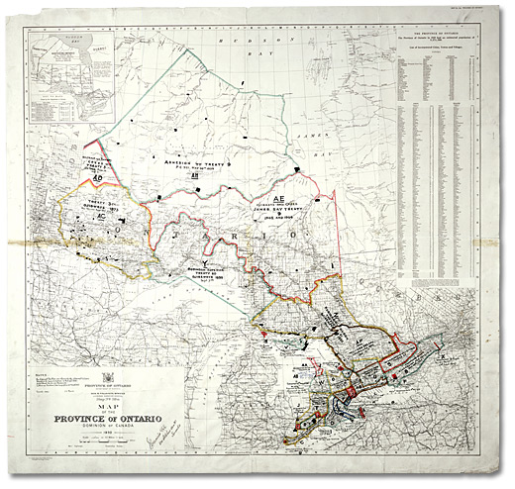](http://www.archives.gov.on.ca/english/on-line-exhibits/james-bay-treaty/big/big_06_treaty_map.aspx)

[Map showing Indian treaties in Ontario] James L. Morris, [base] Map of the province of  
Ontario: Dominion of Canada. Map No. 20a. Ontario: Department of Surveys, 1931  
J. L. Morris fonds; Reference Code: F 1060-1-0-51, Folder 1, map 14, 13356 (63/5)   
Archives of Ontario, I0022329

* The map above shows the main treaty areas in Ontario. Before 1905, three main treaties were negotiated with Aboriginal Nations north of Lakes Huron and Superior (the Robinson Treaties of 1850), and west of Lake Superior to the Lake of the Woods (Treaty 3, in 1873).
* After Confederation, a series of ‘numbered’ treaties came to feature standard sets of provisions. In exchange for lands, Aboriginal signatories received monetary compensation (a one-time gratuity followed by perpetual annuities), reserve lands, and recognized hunting and fishing rights.
* As the ninth Treaty in this series, the James Bay Treaty got its name from the fact that its original territory was defined by river systems draining into James Bay, up to and including the Albany River - at the time the northern boundary of Ontario.

| James Bay Treaty (Treaty No. 9) [page 5]  James Bay Treaty (Treaty No. 9) [page 5]  Miscellaneous collection  Reference Code: F 775, (1905) Item 13  Archives of Ontario | At left: a page from the original Treaty No. 9 document, showing signatures  Some Aboriginal leaders signed by touching a pen as an ‘X’ mark was inscribed next to their names, while others signed in syllabic writing. |
| --- | --- |

* Treaty No. 9 was made over two summers in 1905-1906. Three Commissioners represented the Crown: Duncan Campbell Scott, Samuel Stewart, and Daniel G. MacMartin.
  + The Treaty No.9 Expedition also included two police constables and a doctor.
* Between 1905 and 1906, the Commission travelled through the Treaty No.9 territory, explaining the Treaty to Aboriginal leaders assembled at fourteen Hudson’s Bay Company posts.
* The Company outfitted the Commission with canoes and supplies, and provided experienced guides, many of whom were Aboriginal voyageurs who worked fur brigades along particular river systems.

The photograph below shows the Treaty No.9 Commission at Fort Albany near James Bay in 1905:

[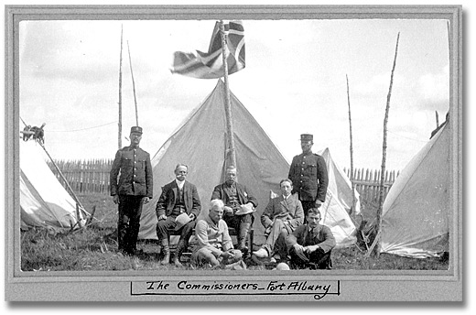](http://www.archives.gov.on.ca/english/on-line-exhibits/james-bay-treaty/big/big_07_treaty_sign.aspx)

The James Bay Treaty signing party at Fort Albany.   
Standing: Joseph L. Vanasse (L), James Parkinson (R) of NWMP.   
Seated: Commissioners Samuel Stewart (L), Daniel George MacMartin, Duncan Campbell Scott (R)   
Foreground: HBC Chief Trader Thomas, August 3, 1905   
Duncan Campbell Scott fonds  
Reference Code: C 275-2-0-1 (S 7546)  
Archives of Ontario, I0010627

* At the time, Ojibway and Cree societies were steeped in oral tradition. As few Aboriginal leaders spoke fluent English, the Commissioners relied on fur trade post employees fluent in Ojibway and Cree to interpret the purpose and terms of Treaty No.9.
* The Treaty No.9 expedition on the Abitibi River. Experienced Aboriginal canoe men were at times required to guide the expedition through challenging rapids.

En-Route -- Abitibi River, [ca. 1905]
Duncan Campbell Scott fonds.
Reference Code: C 275-2-0-2 (S 7569)
Archives of Ontario, I0010557


En-Route -- Abitibi River, [ca. 1905]

Duncan Campbell Scott fonds.

Reference Code: C 275-2-0-2 (S 7569)

Archives of Ontario, I0010557

* After signing ceremonies at each post, Crown and Aboriginal representatives celebrated the agreement by holding a feast and making formal speeches pledging to uphold the terms and spirit of the Treaty.
* In following photographs, a feast is being prepared after the first Treaty No.9 agreement is concluded at Osnaburgh House trade post, on Lake St. Joseph (Albany River).

| [Photo: Chief Moonias waiting for the Treaty signing ceremony, Fort Hope, July 19, 1905 Chief Moonias waiting for the Treaty signing ceremony, Fort Hope, July 19, 1905 Duncan Campbell Scott fonds Reference Code: C 275-1-0-6 (S 7528) Archives of Ontario, I0010653](http://www.archives.gov.on.ca/english/on-line-exhibits/james-bay-treaty/big/big_09_chief_moonias.aspx) | At left: Chief Moonias waiting for the Treaty signing ceremony, Fort Hope, July 19, 1905  Duncan Campbell Scott fonds  Reference Code: C 275-1-0-6 (S 7528)  Archives of Ontario, I0010653 |
| --- | --- |
| [Preparing the feast to be held after the James Bay Treaty signing ceremony, Osnaburgh House, July 12, 1905 Duncan Campbell Scott fonds Reference Code: C 275-1-0-2 (S 7518) Archives of Ontario, I0010715](http://www.archives.gov.on.ca/english/on-line-exhibits/james-bay-treaty/big/big_10_treaty_feast.aspx) | At left: Preparing the feast to be held after the James Bay Treaty signing ceremony,  Osnaburgh House, July 12, 1905  Duncan Campbell Scott fonds  Reference Code: C 275-1-0-2 (S 7518)  Archives of Ontario, I0010715 |
| [The Hudson's Bay Company post, Moose Factory. Note the Commissioner's annuities tent in the background, August 10, 1905 Duncan Campbell Scott fonds. Reference Code: C 275-1-0-3 (S 7551) Archives of Ontario, I0010731](http://www.archives.gov.on.ca/english/on-line-exhibits/james-bay-treaty/big/big_11_hudson_bay.aspx) | At left: The Hudson's Bay Company post, Moose Factory. [Note the Commissioner's annuities tent in the background, August 10, 1905]  Duncan Campbell Scott fonds. Reference Code: C 275-1-0-3 (S 7551) Archives of Ontario, I0010731 |
| Chief Michel Baptiste and wife, at the Fort Metachewan signing ceremony, July 20, 1906  Duncan Campbell Scott fonds.  Reference Code: C 275-1-0-5 (S 7658)  Archives of Ontario, I0010708 | At left: Chief Michel Baptiste and wife, at the Fort Metachewan signing ceremony, July 20, 1906  Duncan Campbell Scott fonds.  Reference Code: C 275-1-0-5 (S 7658)  Archives of Ontario, I0010708 |

### Page title banner, featuring the first page of the James Bay Treaty and the title " Developing the Treaty Relationship, 1905-2005" overlaid on a photograph showing the James Bay area in the early 20th century.

* Ontario’s northern boundary was extended from the Albany River to its present location in 1912. As interest in resource development expanded north of this river in the 1920s, Treaty No.9 was extended by formal adhesions in 1929-1930.
* These Treaty adhesions were also held at Hudson’s Bay Company posts, but the Treaty Commission reached these locations by air travel.

[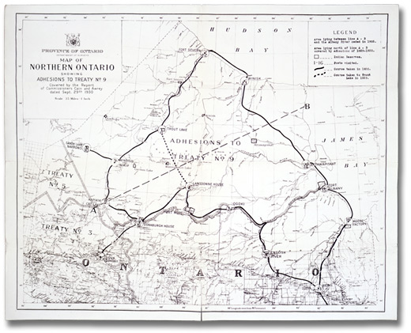](http://www.archives.gov.on.ca/english/on-line-exhibits/james-bay-treaty/big/big_13_treaty_map.aspx)

Map of Northern Ontario showing adhesions to Treaty No. 9 covered by the Report of   
Commissioners Cain and Awrey. Map 30. Ontario: Department of Surveys, 29 Sept. 1930   
J. L. Morris fonds  
Reference Code: F 1060 Folder 3, map 30, AO 6907  
Archives of Ontario, I0021544

* Following the Treaty, reserve lands for Aboriginal signatories were surveyed, and the population gradually moved into centralized communities (Reserves).
* Beginning in the 1940s, airstrips were built to serve the needs of remote First Nation communities.
* Many First Nation communities began receiving increasing government services at this time.
* In several communities today, air travel continues to be the main vehicle for transporting people and goods to and from larger, urbanized centres.

[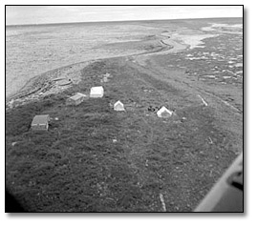](http://www.archives.gov.on.ca/english/on-line-exhibits/james-bay-treaty/big/big_14_hunting_camp.aspx)

Cree hunting/fishing camp on James Bay near Fort Albany, August, 1963

James Bay Ontario, Northern

John Macfie

Reference Code: C 330-8-0-0-14

Archives of Ontario, I0000193

* Centralized community life required First Nations people to make lifestyle adjustments. Some individuals gained employment in wage labour at local and regional levels, while others continued traditional, land-based activities.
* Hunting and fishing, from community homes and from campsites on the land remain highly valued today, both for cultural and economic reasons.

| Photo: Woman at Fort Severn mending a gill net, 1955 | At left: Woman at Fort Severn mending a gill net, 1955  John Macfie  Reference Code: C 330-13-0-0-106  Archives of Ontario, I0000433  Birch trees provided construction materials for many basic tools of traditional life, including canoes.The bark was also used to cover traditional lodges. |
| --- | --- |
| Photo: William Moore peeling white birch bark from a felled tree, to be used for baskets, 1958 | At left: William Moore peeling white birch bark from a felled tree, to be used for baskets, 1958  John Macfie  Reference Code: C 330-14-0-0-115  Archives of Ontario, I0012661 |

* Throughout the 20th century, several Euro-Canadian settlements established in the Treaty No. 9 territory grew into urban communities.
* First established as a mining settlement, Timmins had become a small city by the 1960s, as shown by this 1968 photograph.

| At right: Mattagami River West of Timmins,  Northern Ontario Aerial Hwy. 101  Reference Code: RG 14-151-1  Archives of Ontario, l0021536 | [Photo: Matagami River West of Timmins, Northern Ontario Aerial Hwy. 101](http://www.archives.gov.on.ca/english/on-line-exhibits/james-bay-treaty/big/big_17_matagami_river.aspx) |
| --- | --- |

* In the early 1970s the First Nations began to organize themselves politically to represent their collective needs and concerns to the Federal and Ontario governments.
* In 1973, the more than 45 First Nation communities of Treaty No. 9 created an umbrella organization called the Grand Council Treaty No. 9 to this end.
* Now known as the Nishnawbe-Aski Nation, the organization seeks to build on the relationship with the Crown created by Treaty No. 9.
* Treaty Day, commemorating the signing of Treaty No.9 by ancestors of First Nation communities, is a symbolically important yearly confirmation of the ongoing treaty relationship.

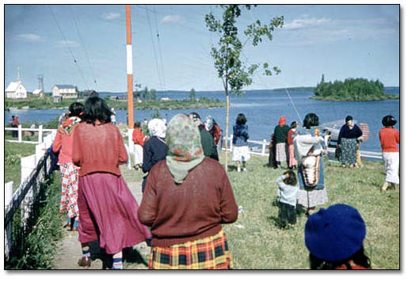

Members of the Fort Hope Band watching a floatplane arrive  
at the dock at Lansdowne House at Treaty Time, June, 1956   
John Macfie   
Reference Code: C 330-14-0-0-95   
Archives of Ontario, I0012712

### Student Handout: The James Bay Treaty, Treaty No. 9

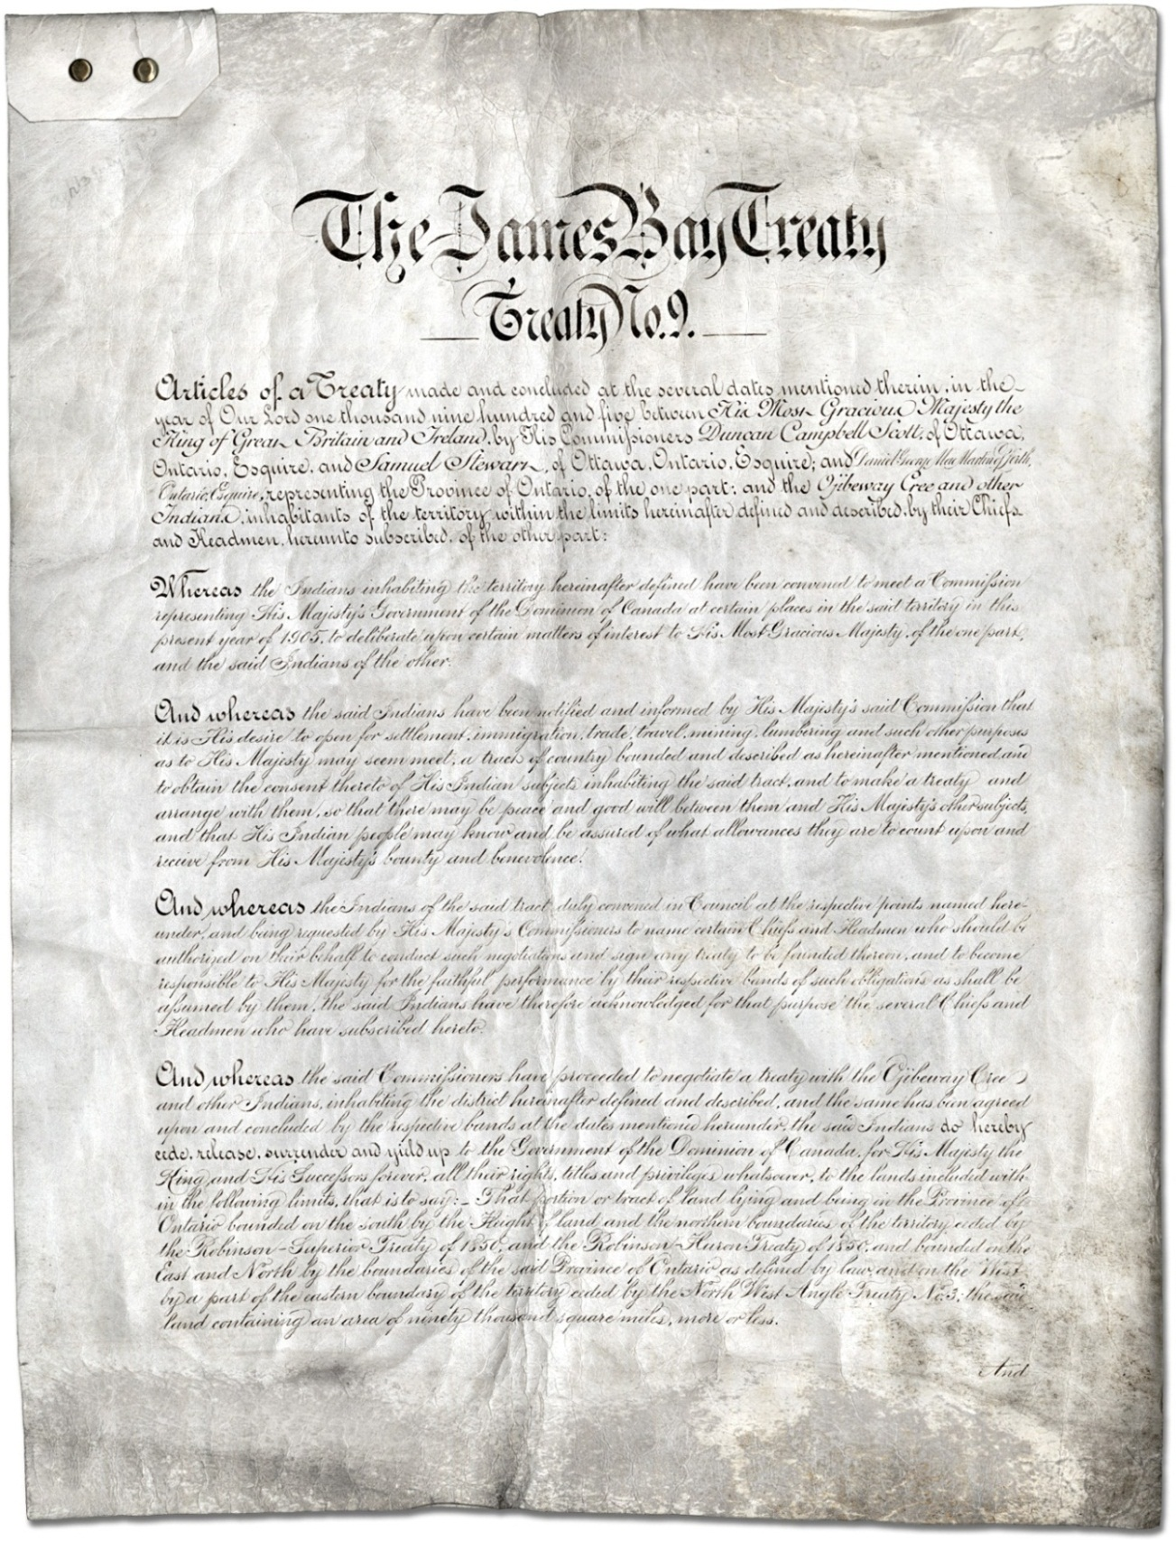  
James Bay Treaty (Treaty No. 9) [page 1]  
Miscellaneous collection  
Reference Code: F 775, (1905) Item 13  
Archives of Ontario

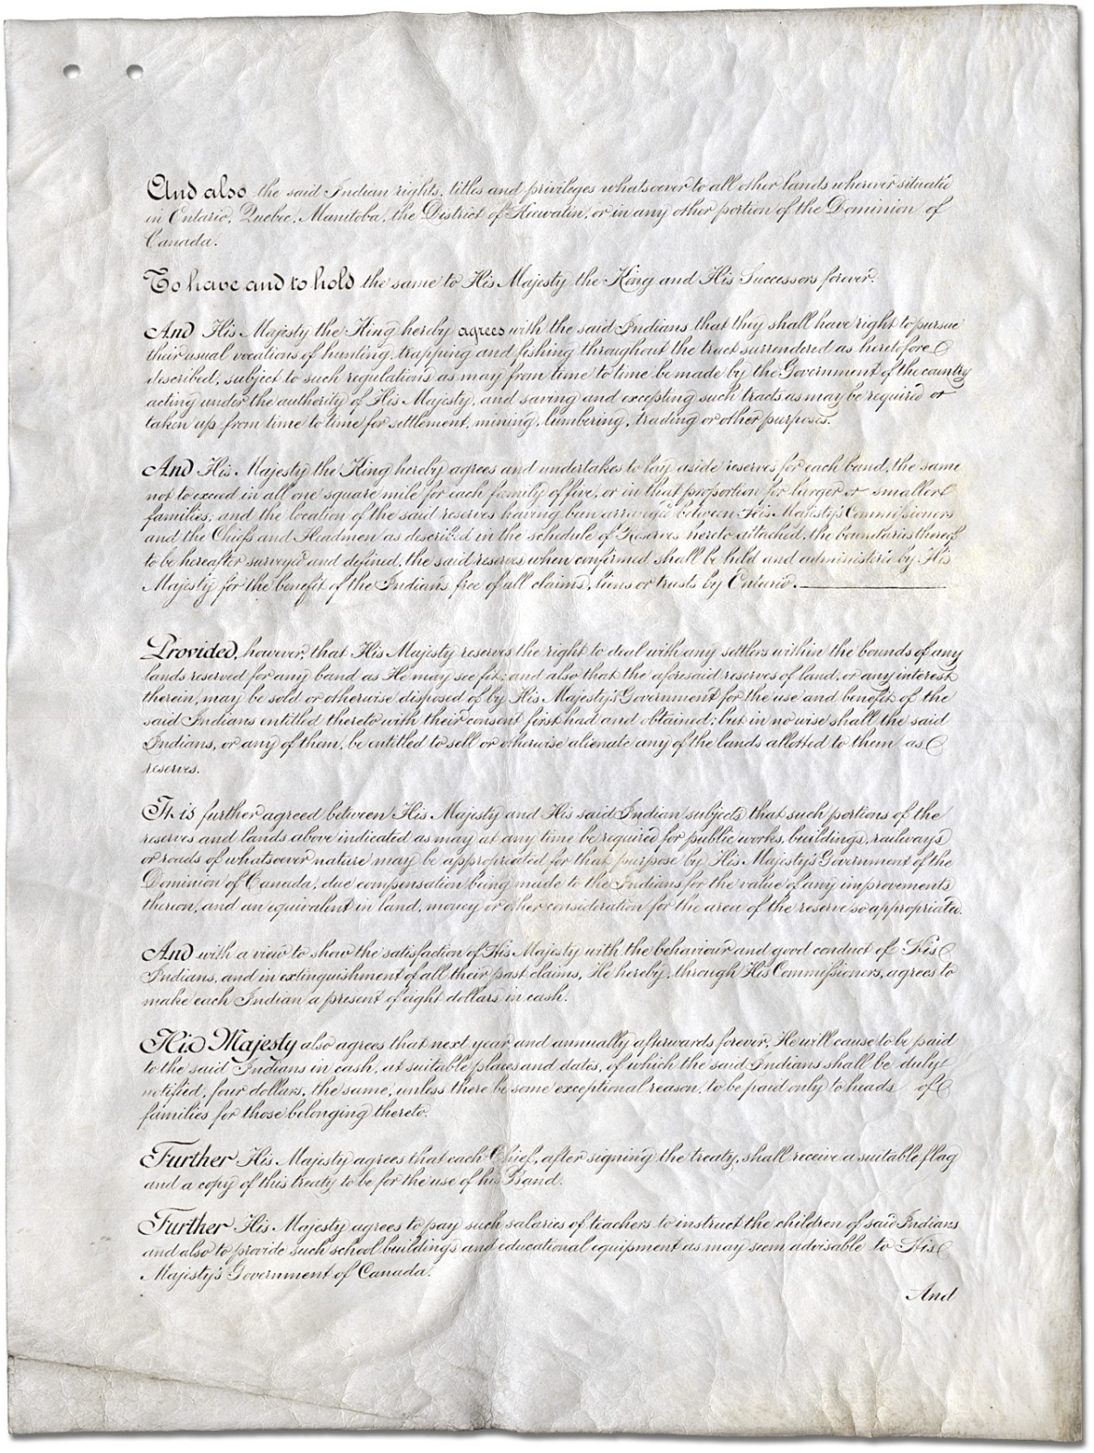  
James Bay Treaty (Treaty No. 9) [page 2]  
Miscellaneous collection  
Reference Code: F 775, (1905) Item 13  
Archives of Ontario

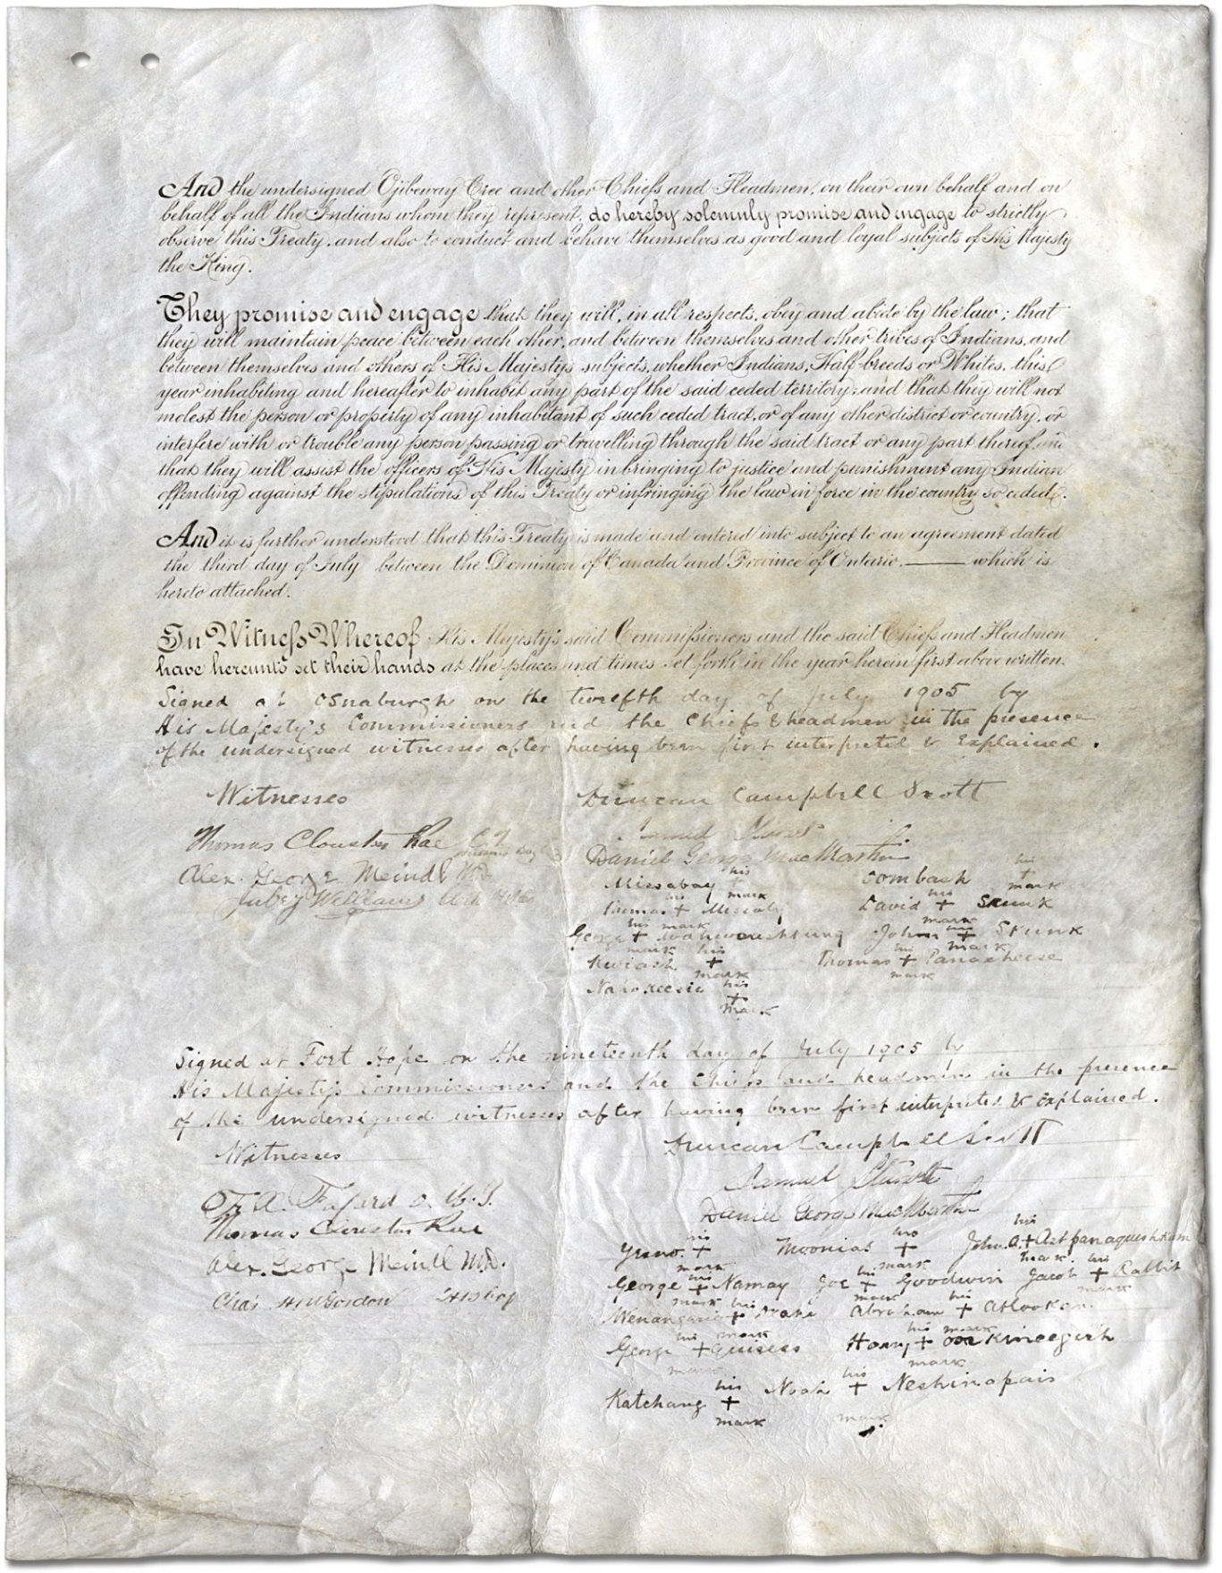  
James Bay Treaty (Treaty No. 9) [page 3]  
Miscellaneous collection  
Reference Code: F 775, (1905) Item 13  
Archives of Ontario

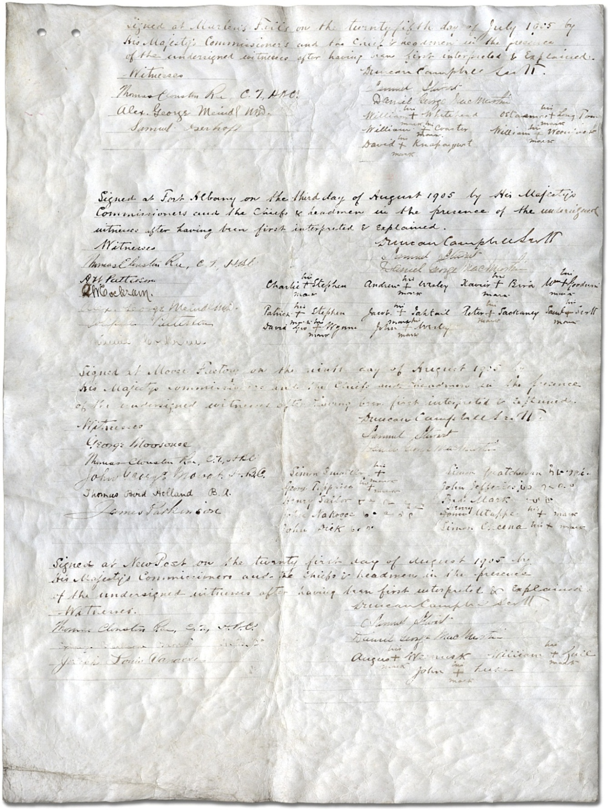  
James Bay Treaty (Treaty No. 9) [page 4]  
Miscellaneous collection  
Reference Code: F 775, (1905) Item 13  
Archives of Ontario

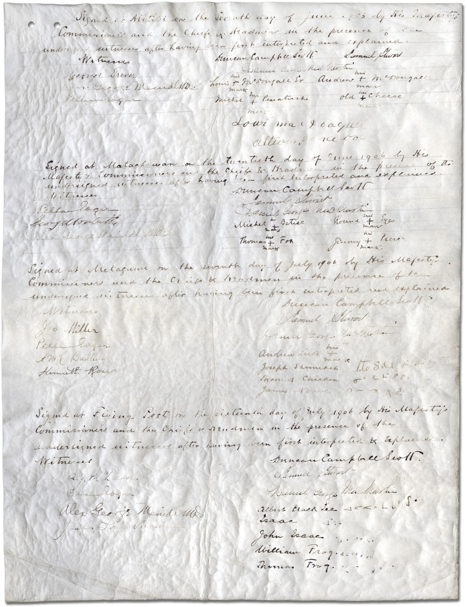  
James Bay Treaty (Treaty No. 9) [page 5]  
Miscellaneous collection  
Reference Code: F 775, (1905) Item 13  
Archives of Ontario

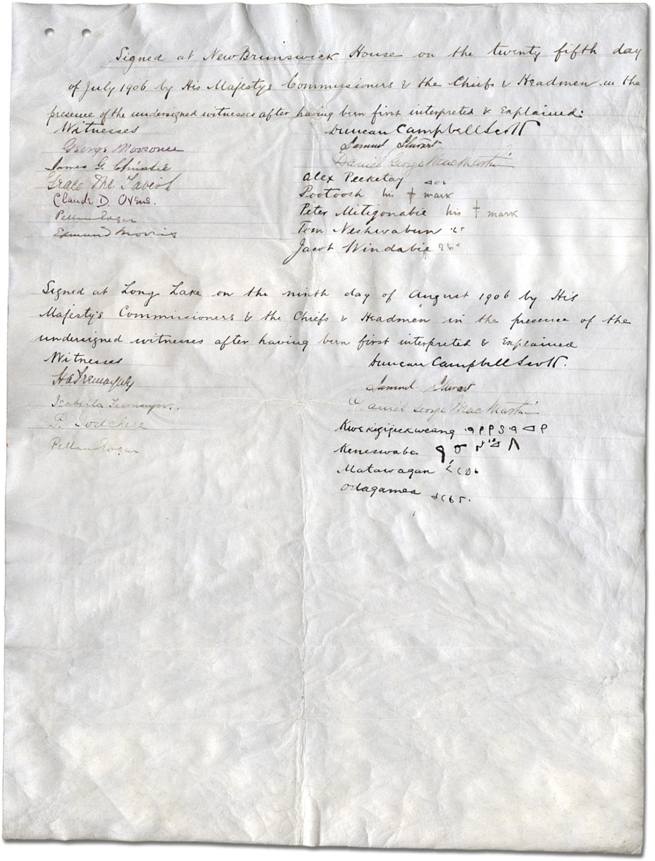  
James Bay Treaty (Treaty No. 9) [page 6]  
Miscellaneous collection  
Reference Code: F 775, (1905) Item 13  
Archives of Ontario

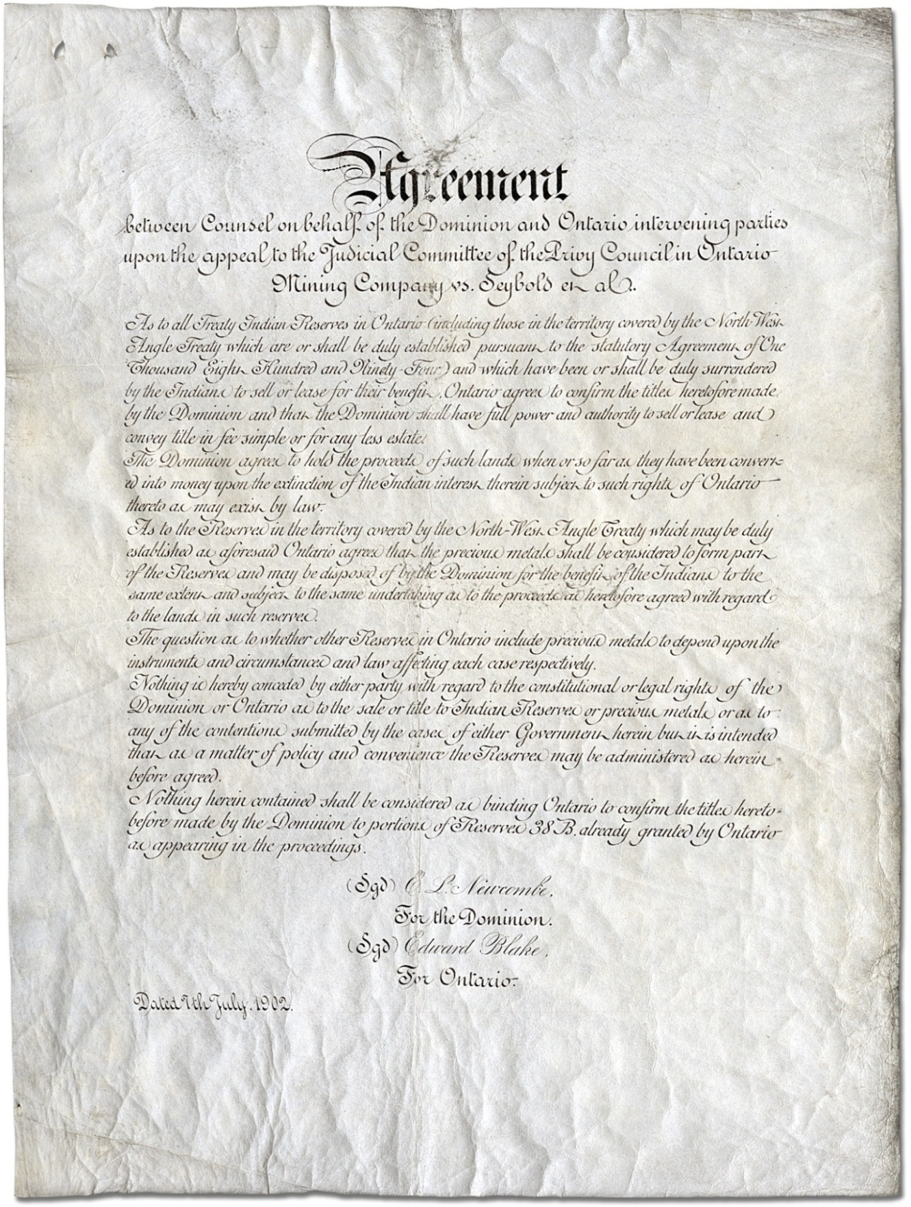  
James Bay Treaty (Treaty No. 9) [page 7]  
Miscellaneous collection  
Reference Code: F 775, (1905) Item 13  
Archives of Ontario

### Student Handout: The James Bay Treaty (No. 9) – Transcript

#### James Bay Treaty - Treaty No. 9 – Articles

**ARTICLES OF A TREATY** made and concluded at the several dates mentioned therein, in the year of Our Lord one thousand and nine hundred and five, between His Most Gracious Majesty the King of Great Britain and Ireland, by His Commissioners, Duncan Campbell Scott, of Ottawa, Ontario, Esquire, and Samuel Stewart, of Ottawa, Ontario, Esquire; and Daniel George MacMartin, of Perth, Ontario, Esquire, representing the province of Ontario, of the one part; and the Ojibeway, Cree and other Indians, inhabitants of the territory within the limits hereinafter defined and described, by their chiefs, and headmen hereunto subscribed, of the other part: --

**Whereas**, the Indians inhabiting the territory hereinafter defined have been convened to meet a commission representing His Majesty's government of the Dominion of Canada at certain places in the said territory in this present year of 1905, to deliberate upon certain matters of interest to His Most Gracious Majesty, of the one part, and the said Indians of the other.

**And whereas**, the said Indians have been notified and informed by His Majesty's said commission that it is His desire to open for settlement, immigration, trade, travel, mining, lumbering, and such other purposes as to His Majesty may seem meet, a tract of country, bounded and described as hereinafter mentioned, and to obtain the consent thereto of His Indian subjects inhabiting the said tract, and to make a treaty and arrange with them, so that there may be peace and good-will between them and His Majesty's other subjects, and that His Indian people may know and be assured of what allowances they are to count upon and receive from His Majesty's bounty and benevolence.

**And whereas**, the Indians of the said tract, duly convened in council at the respective points named hereunder, and being requested by His Majesty's commissioners to name certain chiefs and headmen who should be authorized on their behalf to conduct such negotiations and sign any treaty to be found thereon, and to become responsible to His Majesty for the faithful performance by their respective bands of such obligations as shall be assumed by them, the said Indians have therefore acknowledged for that purpose the several chiefs and headmen who have subscribed hereto.

**And whereas**, the said commissioners have proceeded to negotiate a treaty with the Ojibeway, Cree and other Indians, inhabiting the district hereinafter defined and described, and the same has been agreed upon, and concluded by the respective bands at the dates mentioned hereunder, the said Indians do hereby cede, release, surrender and yield up to the government of the Dominion of Canada, for His Majesty the King and His successors for ever, all their rights titles and privileges whatsoever, to the lands included within the following limits, that is to say: That portion or tract of land lying and being in the province of Ontario, bounded on the south by the height of land and the northern boundaries of the territory ceded by the Robinson-Superior Treaty of 1850, and the Robinson-Huron Treaty of 1850, and bounded on the east and north by the boundaries of the said province of Ontario as defined by law, and on the west by a part of the eastern boundary of the territory ceded by the Northwest Angle Treaty No. 3; the said land containing an area of ninety thousand square miles, more or less.

**And also**, the said Indian rights, titles and privileges whatsoever to all other lands wherever situated in Ontario, Quebec, Manitoba, the District of Keewatin, or in any other portion of the Dominion of Canada.

**To have and to hold** the same to His Majesty the King and His successors for ever.

**And** His Majesty the King hereby agrees with the said Indians that they shall have the right to pursue their usual vocations of hunting, trapping and fishing throughout the tract surrendered as heretofore described, subject to such regulations as may from time to time be made by the government of the country, acting under the authority of His Majesty, and saving and excepting such tracts as may be required or taken up from time to time for settlement, mining, lumbering, trading or other purposes.

**And** His Majesty the King hereby agrees and undertakes to lay aside reserves for each band, the same not to exceed in all one square mile for each family of five, or in that proportion for larger and smaller families; and the location of the said reserves having been arranged between His Majesty's commissioners and the chiefs and headmen, as described in the schedule of reserves hereto attached, the boundaries thereof to be hereafter surveyed and defined, the said reserves when confirmed shall be held and administered by His Majesty for the benefit of the Indians free of all claims, liens, or trusts by Ontario.

**Provided**, however, that His Majesty reserves the right to deal with any settlers within the bounds of any lands reserved for any band as He may see fit; and also that the aforesaid reserves of land, or any interest therein, may be sold or otherwise disposed of by His Majesty's government for the use and benefit of the said Indians entitled thereto, with their consent first had and obtained; but in no wise shall the said Indians, or any of them, be entitled to sell or otherwise alienate any of the lands allotted to them as reserves.

**It is** further agreed between His said Majesty and His Indian subjects that such portions of the reserves and lands above indicated as may at any time be required for public works, buildings, railways, or roads of whatsoever nature may be appropriated for that purpose by His Majesty's government of the Dominion of Canada, due compensation being made to the Indians for the value of improvements thereon, and an equivalent in land, money or other consideration for the area of the reserve so appropriated.

**And** with a view to show the satisfaction of His Majesty with the behaviour and good conduct of His Indians, and in extinguishment of all their past claims, He hereby, through His commissioners, agrees to make each Indian a present of eight dollars in cash.

**His Majesty** also agrees that next year, and annually afterwards for ever, He will cause to be paid to the said Indians in cash, at suitable places and dates, of which the said Indians shall be duly notified, four dollars, the same, unless there be some exceptional reason, to be paid only to the heads of families for those belonging thereto.

**Further**, His Majesty agrees that each chief, after signing the treaty, shall receive a suitable flag and a copy of this treaty to be for the use of his band.

**Further**, His Majesty agrees to pay such salaries of teachers to instruct the children of said Indians, and also to provide such school buildings and educational equipment as may seem advisable to His Majesty's government of Canada.

**And** the undersigned Ojibeway, Cree and other chiefs and headmen, on their own behalf and on behalf of all the Indians whom they represent, do hereby solemnly promise and engage to strictly observe this treaty, and also to conduct and behave themselves as good and loyal subjects of His Majesty the King.

**They promise and engage** that they will, in all respects, obey and abide by the law; that they will maintain peace between each other and between themselves and other tribes of Indians, and between themselves and others of His Majesty's subjects, whether Indians, half-breeds or whites, this year inhabiting and hereafter to inhabit any part of the said ceded territory; and that they will not molest the person or property of any inhabitant of such ceded tract, or of any other district or country, or interfere with or trouble any person passing or travelling through the said tract, or any part thereof, and that they will assist the officers of His Majesty in bringing to justice and punishment any Indian offending against the stipulations of this treaty, or infringing the law in force in the country so ceded.

**And** it is further understood that this treaty is made and entered into subject to an agreement dated the third day of July, nineteen hundred and five, between the Dominion of Canada and Province of Ontario, which is hereto attached.

**In witness whereof**, His Majesty's said commissioners and the said chiefs and headmen have hereunto set their hands at the places and times set forth in the year herein first above written.

Signed at Osnaburg on the twelfth day of July, 1905, by His Majesty's commissioners and the chiefs and headmen in the presence of the undersigned witnesses, after having been first interpreted and explained.

#### ****Witnesses:****

| THOMAS CLOUSTON RAE, C.T., Hudsons Bay Co. ALEX. GEORGE MEINDL, M.D. JABEZ WILLIAMS, Commis, H. B. Co. | DUNCAN CAMPBELL SCOTT. SAMUEL STEWART. DANIEL GEORGE MACMARTIN. MISSABAY, his x mark  THOMAS his x mark MISSABAY. GEORGE his x mark WAHWAASHKUNG. KWIASH, his x mark. NAHOKEESIC, his x mark  OOMBASH, his x mark  DAVID his x mark SKUNK. JOHN his x mark SKUNK THOMAS his x mark PANACHEESE |
| --- | --- |

Signed at Fort Hope on the nineteenth day of July, 1905, by His Majesty's commissioners and the chiefs and headmen in the presence of the undersigned witnesses, after having been first interpreted and explained.

**Witnesses:**

| F.X. FARARD, O.M.I.  THOMAS CLOUSTON RAE.  ALEX. GEORGE MEINDL. M.D.  CHAS. H.M. GORDON,H. B. Co. | YESNO, his x mark  DANIEL GEORGE MACMARTIN SAMUEL STEWART. DUNCAN CAMPBELL SCOTT. GEORGE his x mark NAMAY. WENANGASIE his x mark DRAKE. GEORGE his x mark QUISEES. KATCHANG, his x mark  MOONIAS, his x mark  JOE his x mark GOODWIN. ABRAHAM his x mark ATLOOKAN. HARRY his x mark OOSKINEEGISH. NOAH his x mark NESHINAPAIS JOHN A. his x mark ASHPANAQUESHKUN. JACOB his x mark RABBIT. |
| --- | --- |

Signed at Marten Falls on the twenty-fifth day of July, 1905, by His Majesty's commissioners and the chief and headmen in the presence of the undersigned witnesses, after having been first interpreted and explained.

**Witnesses:**

| THOMAS CLOUSTON RAE, C.T., H. B. Co.  ALEX GEORGE MEINDL, M.D.  SAMUEL ISERHOFF. | DUNCAN CAMPBELL SCOTT. SAMUEL STEWART. DANIEL GEORGE MACMARTIN. WILLIAM his x mark WHITEHEAD. WILLIAM his x mark COASTER. DAVID his x mark KNAPAYSWET. OSTAMAS his x mark LONG TOM. WILLIAM his x mark WEENJACK |
| --- | --- |

Signed at Fort Albany on the third day of August, 1905, by His Majesty's commissioners and the chiefs and headmen in the presence of the undersigned witnesses, after having been first interpreted and explained.

**Witnesses:**

| THOMAS CLOUSTON RAE,  C.T. H. B. Co.  G.W. COCKRAM.  A.W. PATTERSON.  ALEX. GEORGE MEINDL, M.D.  JOSEPH PATTERSON.  MINNIE COCKRAM. | DUNCAN CAMPBELL SCOTT.  SAMUEL STEWART.  DANIEL GEORGE MACMARTIN.  CHARLIE his x mark STEPHEN.  PATRICK his x mark STEPHEN.  DAVID GEO. his x mark WYNNE.  ANDREW his x markWESLEY.  JACOB his x mark TAHTAIL.  JOHN his x markWESLEY.  XAVIER his x mark BIRD.  PETER his x mark SACKANEY  WM. his x mark GOODWIN.  SAML. his x mark SCOTT. |
| --- | --- |

Signed at Moose Factory on the ninth day of August, 1905, by His Majesty's commissioners and the chiefs and headmen in the presence of the undersigned witnesses, after having been first interpreted and explained.

**Witnesses:**

| GEORGE MOOSONEE.  THOMAS CLOUSTON RAE, C.T.  JOHN GEORGE MOWAT,  H. B. Co.  THOMAS BIRD HOLLAND, B.A.  JAMES PARKINSON. | DUNCAN CAMPBELL SCOTT.  SAMUEL STEWART.  DANIEL GEORGE MACMARTIN.  SIMON his x mark SMALLBOY.  GEORGE his x mark TAPPAISE.  HENRY SAILOR, Signed in Cree syllabic  JOHN NAKOGEE, Signed in Cree syllabic  JOHN DICK, Signed in Cree syllabic  SIMON QUATCHEWAN, Signed in Cree syllabic  JOHN JEFFRIES, Signed in Cree syllabic  FRED MARK, Signed in Cree syllabic  HENRY UTAPPE,  his x mark  SIMON CHEENA,  his x mark |
| --- | --- |

Signed at New Post on the twenty-first day of August, 1905, by His Majesty's commissioners and the chiefs and headmen in the presence of the undersigned witnesses, after having been first interpreted and explained.

**Witnesses:**

| THOMAS CLOUSTON RAE, C.T., H. B. Co.  SYDNEY BLENKARNE BARRETT,  H. B. Co.  JOSEPH LOUIS VANASSE. | DUNCAN CAMPBELL SCOTT.  SAMUEL STEWART.  DANIEL GEORGE MACMARTIN.  ANGUS his x mark WEENUSK.  JOHN his x mark LUKE.  WILLIAM his x mark GULL. |
| --- | --- |

Signed at Abitibi on the seventh day of June, 1906, by His Majesty's commissioners and the chiefs and headmen in the presence of the undersigned witnesses, after having been first interpreted and explained.

**Witnesses:**

| GEORGE DREVER.  ALEX. GEORGE MEINDL, M.D.  PELHAM EDGAR. | DUNCAN CAMPBELL SCOTT.  SAMUEL STEWART.  LOUIS his x mark MCDOUGALL.  ANDREW his x mark MCDOUGALL.  OLD his x mark CHEESE.  MICHEL his x mark PENATOUCHE.  LOUI MACDOUGALL.  ANTOINE PENATOUCHE. |
| --- | --- |

Signed at Matachewan on the twentieth day of June, 1906, by His Majesty's commissioners and the chiefs and headmen in the presence of the undersigned witnesses, after having been first interpreted and explained.

**Witnesses:**

| PELHAM EDGAR.  GEORGE NOMTEITH.  ALEX. GEORGE MEINDL, M.D. | DUNCAN CAMPBELL SCOTT.  SAMUEL STEWART.  DANIEL GEORGE MACMARTIN.  MICHEL his x mark. BATISE.  ROUND his x mark EYES  THOMAS his x mark FOX.  JIMMY his x mark PIERCE. |
| --- | --- |

Signed at Mattagami on the seventh day of July, 1906, by His Majesty's commissioners and the chiefs and headmen in the presence of the undersigned witnesses, after having been first interpreted and explained.

**Witnesses:**

| JOS. MILLER.  PELHAM EDGAR.  A.M.C. BANTING  KENNETH ROSS. | DUNCAN CAMPBELL SCOTT.  SAMUEL STEWART.  DANIEL GEORGE MACMARTIN.  ANDREW his x markLUKE.  JOSEPH SHEMEKET Signed in syllabic characters.  THOMAS CHICKEN Signed in syllabic characters.  JAMES NEVUE Signed in syllabic characters. |
| --- | --- |

Signed at Flying Post on the sixteenth day of July, 1906, by His Majesty's commissioners and the chiefs and headmen in the presence of the undersigned witnesses, after having been first interpreted and explained.

**Witnesses:**

| A.J. MCLEOD.  PELHAM EDGAR.  ALEX. GEORGE MEINDL, M.D.  JOSEPH LOUIS VANASSE. | DUNCAN CAMPBELL SCOTT.  SAMUEL STEWART.  DANIEL GEORGE MACMARTIN.  ALBERT BLACK ICE Signed in syllabic characters.  JOHN ISSAC Signed in syllabic characters.  WILLIAM FROG Signed in syllabic characters.  THOMAS FROG Signed in syllabic characters. |
| --- | --- |

Signed at New Brunswick House on the twenty-fifth day of July, 1906, by His Majesty's commissioners and the chiefs and headmen in the presence of the undersigned witnesses, after having been first interpreted and explained.

**Witnesses:**

| GEORGE MONSONEE.  JAMES G. CHRISTIE.  GRACE MCTAVISH.  CLAUDE D. OWENS  PELHAM EDGAR.  EDMUND MORRIS. | DUNCAN CAMPBELL SCOTT.  SAMUEL STEWART.  DANIEL GEORGE MACMARTIN.  ALEX. PEEKETAY Signed in syllabic characters.  POOTOOSH,  his x mark.  PETER MITIGONABIE, his x mark  TOM NESHWABUN Signed in syllabic characters.  JACOB WINDABAIE Signed in syllabic characters. |
| --- | --- |

Signed at Long Lake on the ninth day of August, 1906, by His Majesty's commissioners and the chiefs and headmen in the presence of the undersigned witnesses, after having been first interpreted and explained.

**Witnesses:**

| H.A. TREMAYNE.  ISABELLA TREMAYNE.  P. GODCHERE.  PELHAM EDGAR. | DUNCAN CAMPBELL SCOTT.  SAMUEL STEWART.  DANIEL GEORGE MACMARTIN.  KWAKIGIGICKWEANG Signed in syllabic characters.  KENESWABE Signed in syllabic characters.  MATAWAGAN Signed insyllabic characters.  ODAGAMEA Signed in syllabic characters. |
| --- | --- |

### Student Worksheet – Reading the James Bay Treaty

Identify the main provisions of the treaty as written in the original text by completing the worksheet below:

| **Provision** | **Text of the James Bay Treaty - Treaty No. 9** |
| --- | --- |
| Title (surrender of territory) |  |
| Reserve lands |  |
| Rights of the inhabitants (and limitations) |  |
| Rights of the government |  |
| Compensation |  |
| Responsibilities of the government |  |
| Responsibilities of the inhabitants |  |

### Student In-class Assignment:

#### Negotiating an agreement along the lines of the James Bay Treaty, 1905-06

Your assignment begins after reading about the James Bay Treaty and to consider the issues involved in reaching an agreement to share lands and natural resources by two groups of people with very different interests, goals, cultures and languages. Your class will re-enact the treaty negotiation by dividing into groups similar to those who participated in the James Bay Treaty, but existing in a modern-day situation.

You will negotiate a fictional agreement by incorporating the basic elements of the James Bay Treaty. You will be assigned to participate in one of two fictional settings for your negotiation and take one of the following two positions:

##### TEAM 1- Nation-to-Nation Model

Nishnawbe Aski Nation views the treaty negotiations as nation-to-nation (between equals). Cree and Ojibway representatives were interested in securing a guarantee that, as the original occupiers of James Bay Treaty territory, they would have ongoing access to lands and resources. They also sought to gain protection against the growing presence of developers and settlers.Proposed

##### TEAM 2 - Two Governments Model

Treaty No. 9 is the first treaty in Ontario in which both the provincial and federal governments were full negotiators. Canada was interested in nation-building, especially through railway construction across the country. Canada also had a parental type of responsibility to protect the interests and well-being of Aboriginal peoples (Department of Indian Affairs). Ontario was interested in resource development (e.g., minerals, lumber) and settlement possibilities in the northern part of the province.

##### Terms

Your team will appoint representatives to present respective proposals to the class. The terms of the agreement proposed by each team should include similar types of provisions identified in the treaty text worksheet. You should translate the historical treaty provisions into a modern context appropriate to the fictional agreement your negotiating team hopes to achieve.

##### Negotiations

The class will discuss if and how the proposals from each team differ, conflict, and/or agree with each other. The class will enter into verbal negotiations, emphasizing the need to agree on provisions that are fair, practical and flexible in the long-term. Your goal is to reach a final agreement that is satisfactory to both teams.

### Student In-class Assignment: Fictional Negotiation 1 – Ecosystem Agreement

#### TEAM 1 - Local Environmental Group

##### Roles

* An environmental group composed of the young-adult generation of a people who have ancient settlements in a unique and biologically diverse river ecosystem.
* Community life is based on traditional activities such as fishing, waterfowl hunting, animal breeding and harvesting of vegetation that grows on the river’s flood-plains.
* In recent decades, a scientific research economy has developed to study ecology, ornithology, geology, biology, etc. Local people have been hired as guides, research assistants, etc., to support these research activities.

##### Issues

* The river’s ecosystem and natural resources are increasingly disturbed by cutting of new shipping channels, by pollution from nearby urban sewage and industrial waste, by reduction of flood-plains due to damming, and by commercial forestry.
* The local environmental group has expressed concerns and sought legal

measures to stall future development.

##### Objectives

* To ensure that protective steps are taken to preserve the habitats of flora and fauna in the ecosystem and to promote continued scientific research,
* to get financial assistance for large-scale land reclamation projects, and
* to gain rights of consultation in the management of all future commercial activity.

#### TEAM 2 - Regional Government and Industry

##### Roles

* Representatives of the regional government responsible for the river ecosystem and CEOs of forestry and shipping industries.

##### Issues

* The regional government wants to expand urban development into the ecosystem area to accommodate growing populations resulting from new industries moving into the region.
* Forestry and shipping firms are allied in developing a more efficient lumber export industry along the river system because it is the most obvious route of transport.

##### Objectives

* Government officials want the right to regulate access to the ecosystem area (including access by developers and by protest groups), while balancing economic growth with environmental concerns.
* Forestry and shipping CEOs want the right to pursue commercially viable development and transportation schemes.

### Student In-class Assignment: Fictional Negotiation 2 – Tourism Agreement

#### TEAM 1 - Islanders

##### Roles

* The inhabitants of an island where people live mainly from fishing ventures and land-based activities such as small-scale market gardening.
* The majority of the population identify as “islanders” with a distinct culture and language.
* The island is politically independent but its economy depends on a trade network operated by “mainlander” fishing and export companies.

##### Issues

* The island economy is increasingly disturbed by cruise ships anchoring in fishery areas and by mainland tour companies arranging for extended shore stops.
* In recent years, the local island government has been unable to control the type and increase of tourist activity.

##### Objectives

* To secure mainland assistance to protect island fisheries and to regulate the location, type and size of tourism operations.
* Islanders demand input into where resorts are developed in order to limit damage to market-garden lands, and into cruise ship routes in order to prevent damage to major fishing waters.
* Islanders also want a share in the economic benefits of tourism development.

#### TEAM 2 - Mainland Government and Industry

##### Roles

* Representatives of the mainland government and of foreign tourism development firms.

##### Issues

* The mainland government is seeking ways to diversify the regional economy beyond the inter-island trade network, and to formalize political ties with islands in the area.
* Tourism firms have expressed strong interest in developing resorts on the island, linked to airports and seaports on the mainland

##### Objectives

* Mainland government officials want rights to construct and control air/seaports on the island in order to promote and regulate tourist travel at a regional level.
* Tourism developers want to lease prime waterfront properties on the island and rights to build resorts on those properties.

### Student Assignment: Negotiation, Compare and Contrast

Written Assignment:Based on your reading of the James Bay Treaty and the in-assignment, write a report that compares and contrasts the basic elements of the James Bay Treaty to the final fictional agreement reached by your team.

Your report should address the following three questions:

1. How are negotiating positions of the parties to the fictional agreement similar to and/or different from those of the James Bay Treaty negotiations?
2. How are the terms of the fictional agreement similar to and/or different from those of the James Bay Treaty?
3. From a community perspective, how are the potential effects of the fictional agreement similar to and/or different from the effects of the James Bay Treaty over the past 100 years?

Due Date: _______________________

### Reading the James Bay Treaty – ANSWER KEY

|  |  |
| --- | --- |
| **Provision** | **Text of the James Bay Treaty - Treaty No. 9** |
| **Title (surrender of territory)** | …the said Indians do hereby cede, release, surrender and yield up to the government of the Dominion of Canada, for His Majesty the King and His successors for ever, all their rights titles and privileges whatsoever, to the lands included within the following limits…. |
| **Reserve lands** | And His Majesty the King hereby agrees and undertakes to lay aside reserves for each band, the same not to exceed in all one square mile for each family of five…. |
| **Rights of the inhabitants (and limitations)** | …the said Indians that they shall have the right to pursue their usual vocations of hunting, trapping and fishing throughout the tract surrendered…  …the aforesaid reserves of land, or any interest therein, may be sold or otherwise disposed of by His Majesty's government for the use and benefit of the said Indians entitled thereto, with their consent first had and obtained…  …but in no wise shall the said Indians, or any of them, be entitled to sell… |
| **Rights of the government** | …such portions of the reserves and lands above indicated as may at any time be required for public works, buildings, railways, or roads of whatsoever nature may be appropriated… |
| **Compensation** | His Majesty…agrees to make each Indian a present of eight dollars in cash. His Majesty also agrees that next year, and annually afterwards for ever, He will cause to be paid to the said Indians in cash…four dollars…. |
| **Responsibilities of the government** | His Majesty agrees to pay such salaries of teachers to instruct the children of said Indians, and also to provide such school buildings and educational equipment as may seem advisable… |
| **Responsibilities of the inhabitants** | And the undersigned Ojibway, Cree and other chiefs and headmen, on their own behalf and on behalf of all theIndians whom they represent, do hereby solemnly promise and engage to strictly observe this treaty, and also to conduct and behave themselves as good and loyal subjects of His Majesty the King.  …that they will, in all respects, obey and abide by the law; that they will maintain peace… |

### Marking Rubric

|  |  |  |  |  |
| --- | --- | --- | --- | --- |
| **Criteria** | **Level 1** | **Level 2** | **Level 3** | **Level 4** |
| Knowledge and Understanding  Student understands the basic elements of the James Bay Treaty | Limited understanding of the treaty and the issues arising from it. | Some understanding of the treaty and the issues arising from it. | Clear and comprehensive understanding of the treaty and the issues arising from it. | A clear, comprehensive, balanced and well integrated understanding of the treaty and the issues arising from it. |
| Thinking/Inquiry  Student demonstrates the ability to research and analyze critically the negotiation process, terms and effects of the James Bay Treaty | Unclear perspective and analysis that shows little understanding of the issues. | Somewhat effective organization and interpretation of the issues. | A clear and critical position in all aspects of the work, with good understanding of the issues. | A critical analysis presented with a high degree of ability and clarity resulting in a precise and persuasive interpretation of the issues. |
| Communication  Student is well organized and articulate, discussing the issues both orally and in writing and addressing all questions in clear and logical language | There is a lack of clarity and limited logic.  Incomplete work | Somewhat logical use of language.  Mostly complete work | Reasonably clear and logical use of language.  Work is complete | Clear, precise and logical use of language  Work is outstanding. |
| Application  Student applies and transfers knowledge as well as makes connection between various and familiar contexts | Student applies and transfers knowledge as well as makes connection between various and familiar contexts with a limited degree of effectiveness. | Student applies and transfers knowledge as well as makes connection between various and familiar contexts with some degree of effectiveness. | Student applies and transfers knowledge as well as makes connection between various and familiar contexts with a considerable degree of effectiveness. | Student applies and transfers knowledge as well as makes connection between various and familiar contexts with a high degree of effectiveness. |