# Political Cartoons and Foreign Pressures:

**Continuity and Change**

Grade 12: Canada: History, Identity, and Culture

[Commentary on the growing fear that the proposed free-trade agreement with the United States would lead to Canada's annexation] 


[Commentary on the growing fear that the proposed free-trade agreement with the United States would lead to Canada's annexation]

Newton McConnell fonds

Reference Code: C 301 1678

Archives of Ontario, I0005972

## Overview

All of the Archives of Ontario lesson plans have two components:

* The first component introduces students to the concept of an archive and why the Archives of Ontario is an important resource for learning history
* The second component is content-based and focuses on the critical exploration of a historical topic that fits with the Ontario History and Social Studies Curriculum for grades 3 to 12. This plan is specifically designed to align with the Grade 12: Canada: History, Identity, and Culture curricula.

We have provided archival material and an activity for you to do in your classroom. You can do these lessons as outlined or modify them to suit your needs. Feedback or suggestions for other lesson plans are welcome.

**In this plan,** students will analyze political cartoons and learn about pivotal debates in Canadian foreign policy history, while comparing the past issues and debates to current Canadian government policies. This lesson is based on six political cartoons by Newton McConnell. The purpose of this lesson plan is to make students aware that in the early 20th century Canada was facing both American intent on expanding its economic resource base, and a British Empire demanding assistance with its naval program.

## Curriculum Connections

**Overall Expectations**

Communities: Local, National, and Global

* evaluate Canada’s changing role on the international stage

Change and Continuity

* analyse how Canada’s relationships with France, Britain, and the United States have influenced Canada’s identity and culture

Social, Economic, and Political Structures

* evaluate the impact of Canada’s national and international economic policies on Canadian identity and sovereignty
* describe the nature of the Canadian political system and the groups and individuals who have contributed to its development

Methods of Historical Inquiry and Communication

* use methods of historical inquiry to locate, gather, evaluate, and organize research materials from a variety of sources
* interpret and analyse information gathered through research, employing concepts and approaches appropriate to historical inquiry
* communicate the results of historical inquiries, using appropriate terms and concepts and a variety of forms of communication.

## Lesson Plan

This lesson is designed for one class plus homework, but it can be lengthened or shortened based on your students’ needs.

Begin by introducing the concept of an archive and how the Archives of Ontario can help answer research questions related to history. See **Overhead 1: Exploration Through the Archives** to introduce this to your students and the following text to prepare yourself:

Over the course of a lifetime, most people accumulate a variety of records. It starts with a birth certificate and expands into awards, bank statements, receipts, letters, photographs – anything that documents important events and relationships in one’s life. These records comprise an individual’s personal archives. Governments, businesses, schools, associations and organizations of all types do the same, keeping records as evidence of their activities and accomplishments.

These documents provide a fascinating view into the past. Like a detective investigating a case, a researcher using these records can get a sense of what a place looked like, what people were thinking, what life was like, and what happened and why. Anyone with an interest in the past, whether it is delving into local history, tracing a family tree, or probing decisions and events, will find answers in archives.

Some examples are:

* letters, manuscripts, diaries often from famous people
* notes or recordings of interviews
* photographs, sketches and paintings
* birth, death and marriage records
* land registries, titles to property, and maps
* court records
* architectural plans and engineering drawings
* audio, video and film records

Archives are important resources for answering our questions about the past. Records may be used to settle legal claims, they may clarify family history, they are grist for historians, and they impart to filmmakers and authors a sense of the ways things were. Whatever the reason, archives have a story to tell.

The first step is to identify your research question and what you are hoping to find in the Archives to provide support to that question.

* + - * Following this introduction, create a research question as a class that ties in past foreign policy with current foreign policy. Identify some major themes in foreign policy over the last 100 years and identify factors that would encourage similar concerns and different concerns.
      * Ask students to visit each of the six research stations that includes a political cartoon and accompanying questions
      * Once students have viewed all six cartoons, have a brief discussion to check for understanding and then ask students to pick one cartoon.
      * Students should be encouraged to write a two page summary and analysis of their chosen cartoon, exploring what the cartoon is about and whether it is artistically effective
      * As an extension activity, ask students to choose a similar issue in the present and draw an editorial cartoon that illustrates elements of both continuity and change and a one page summary that discusses their choices

# Handouts & Worksheets

Overhead 1: Exploration through the Archives! 5

Primary Source 1: Wilfrid Laurier and William Taft (ca. 1911) 6

Primary Source 2: Caricatures of Uncle Sam (ca. 1911) 7

Primary Source 3: “Looking our way” 8

Primary Source 4: 9

Primary Source 6: Two Generals and the Canadian Navy (ca. 1910) 10

Primary Source 5: “Premier Borden sees a real dog-of-war” (ca. 1913) 11

Marking Rubric 12

### Overhead 1: Exploration through the Archives!

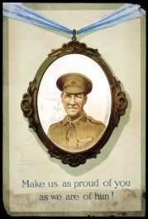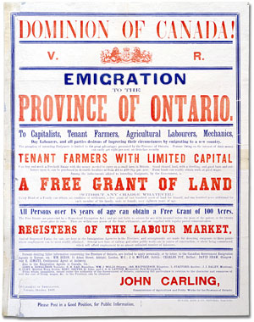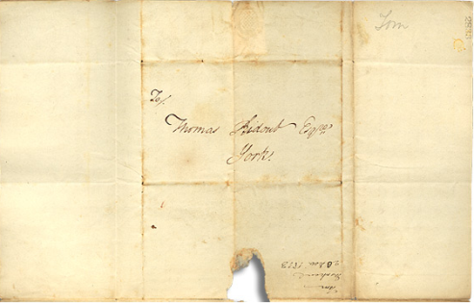

Over the course of a lifetime, most people accumulate a variety of records.

Taken together, these records can provide a fascinating view into someone’s life and into the past.

Like a detective investigating a case, a researcher using these records can get a sense of what a place looked like, what people were thinking, what life was like, and what happened and why.

Some examples of records that a historian may look at are:

* Birth, death, and marriage records
* letters or diaries
* photographs, sketches, and paintings
* court records
* audio, video and film records

An **archive** is a place where these records and historical documents are preserved. The **Archives of Ontario** collects and preserves records with relevance to the history of Ontario.

Using primary sources from the Archives of Ontario’s collections, you too can be an investigator exploring the past and understanding the present.

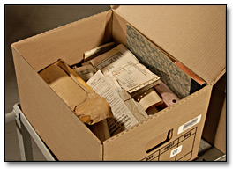 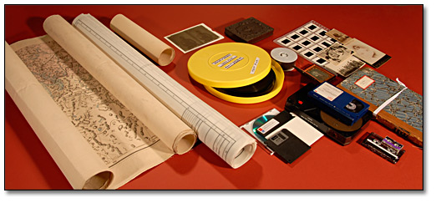 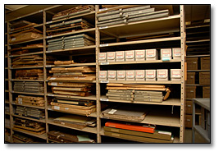

### Primary Source 1: Wilfrid Laurier and William Taft (ca. 1911)

Image: Black and white illustrated political cartoon showing a Wilfred Laurier climbing a tree (labelled 'Fruit Tree of Canada's Industry" while being chased by two dogs (one of which is labelled 'Canadian popular opinion). In the background, American President William Taft can be seen climbing over a brick wall towards Laurier, the tree, and dogs. [

Caricatures of Wilfrid Laurier and William Taft and commenting on the proposed 1911 Reciprocity agreement between Canada and the United States].


Wilfrid: Hi Bill! I'm afraid I shan't be able to deliver the goods

[Caricatures of Wilfrid Laurier and William Taft and commenting on the proposed 1911 Reciprocity agreement between Canada and the United States], [ca. 1911]

Newton McConnell fonds

Reference Code: C 301 2506

Archives of Ontario, I0005940

1. What political event or idea is the cartoon referring to? How do you know?
2. Who or what is being depicted or referred to?
3. How are the people/objects described or depicted? (Are the characters or objects drawn in such a way as to be comical/serious/other?)
4. How is the text used in the cartoon? (Are certain labels affixed to the people/objects? Are there captions? Or speech bubbles?)
5. What is the message of the cartoon? In other words, what is the artist trying to “say”?
6. Is he or she supporting an idea/person, or criticizing an idea/person?
7. Is the message effectively conveyed?

### Primary Source 2: Caricatures of Uncle Sam (ca. 1911)

Image: Black and white illustrated political cartoon, depicting the character of Uncle Sam knocking down a stone wall (lablled "US Tariff Wall") with a mallet.

[Caricatures of Uncle Sam destroying Canada's protectionist trade barriers] 


Uncle Sam: ‘I’ll get that Canadian raw material if I

have to wreck the whole damned wall!’

[Caricatures of Uncle Sam destroying Canada's protectionist trade barriers]

Newton McConnell fonds, [ca. 1911]

Reference Code: C 301 21202

1. What political event or idea is the cartoon referring to? How do you know?
2. Who or what is being depicted or referred to?
3. How are the people/objects described or depicted? (Are the characters or objects drawn in such a way as to be comical/serious/other?)
4. How is the text used in the cartoon? (Are certain labels affixed to the people/objects? Are there captions? Or speech bubbles?)
5. What is the message of the cartoon? In other words, what is the artist trying to “say”?
6. Is he or she supporting an idea/person, or criticizing an idea/person?
7. Is the message effectively conveyed?

### Primary Source 3: “Looking our way”

Image: Black and white illustrated political cartoon depicting two tigers - a large tiger labelled "Annexation," and asmall tiger labelled "Reciprocity." Both tigers are looking at various bones on the ground, labelled "Philippines," "Puerto Rico," "Texas," New Mexico," and Louisiana."

[Commentary on the growing fear that the proposed free-trade agreement with the United States would lead to Canada's annexation] 


Looking Our Way

[Commentary on the growing fear that the proposed free-trade agreement with the United States would lead to Canada's annexation]

Newton McConnell fonds

Reference Code: C 301 1678

Archives of Ontario, I0005972

1. What political event or idea is the cartoon referring to? How do you know?
2. Who or what is being depicted or referred to?
3. How are the people/objects described or depicted? (Are the characters or objects drawn in such a way as to be comical/serious/other?)
4. How is the text used in the cartoon? (Are certain labels affixed to the people/objects? Are there captions? Or speech bubbles?)
5. What is the message of the cartoon? In other words, what is the artist trying to “say”?
6. Is he or she supporting an idea/person, or criticizing an idea/person?
7. Is the message effectively conveyed?

### Primary Source 4:

**Caricatures of Laurier and British John Bull (1905-1914)**

Image: Black and white illustrated political cartoon, which depicts John Bull holding up a coat, labelled "Imperial Unity Suit," while a large moth with the face of Wilfred Laurier (wings lablled with his name) flies away.

[Caricatures of Laurier and British John Bull. Commentary on Sir Wilfrid Laurier and the conflicts surrounding imperial relations with Britain], [between 1905 and 1914] 


The moth in the family wardrobe.

[Caricatures of Laurier and British John Bull. Commentary on Sir Wilfrid Laurier and the conflicts surrounding imperial relations with Britain], [between 1905 and 1914]

Newton McConnell fonds

Reference Code: C 301

Archives of Ontario, I0005926

1. What political event or idea is the cartoon referring to? How do you know?
2. Who or what is being depicted or referred to?
3. How are the people/objects described or depicted? (Are the characters or objects drawn in such a way as to be comical/serious/other?)
4. How is the text used in the cartoon? (Are certain labels affixed to the people/objects? Are there captions? Or speech bubbles?)
5. What is the message of the cartoon? In other words, what is the artist trying to “say”?
6. Is he or she supporting an idea/person, or criticizing an idea/person?
7. Is the message effectively conveyed?

### Primary Source 6: Two Generals and the Canadian Navy (ca. 1910)

Image: Black and white illustrated political cartoon showing two men in First World War-era military uniforms facing each other and standing amidst rubble from a building. Two men can be seen in the distance, arguing in the ruins of a building. 

[Caricatures of Invading General, Officer talking and two statesmen arguing whether they shall contribute Dreadnoughts to Britain or build a Canadian Navy.]


“Invading General: What are those men doing up there by those Parliament Building ruins?

Officer: Two statesmen, General, arguing whether they shall contribute Dreadnoughts to Britain or build a Canadian Navy.

Newton McConnell fonds

Reference Code: C 301, 568

Archives of Ontario, I0008933

1. What political event or idea is the cartoon referring to? How do you know?
2. Who or what is being depicted or referred to?
3. How are the people/objects described or depicted? (Are the characters or objects drawn in such a way as to be comical/serious/other?)
4. How is the text used in the cartoon? (Are certain labels affixed to the people/objects? Are there captions? Or speech bubbles?)
5. What is the message of the cartoon? In other words, what is the artist trying to “say”?
6. Is he or she supporting an idea/person, or criticizing an idea/person?
7. Is the message effectively conveyed?

### Primary Source 5: “Premier Borden sees a real dog-of-war” (ca. 1913)

Image: Black and white illustrated political cartoon, showing Robert Borden looking at a large bull dog (labelled "British Navy") being brought towards him by John Bull. A small dog, labelled "Laurier Navy," can be seen cowering behind Borden's legs.

[Caricature of Sir Robert Borden, John Bull, and a bull-dog representing the British Navy commenting on the 1913 Naval Aid Bill which contribute money to the British navy's building program]

Premier Borden sees a real dog-of-war

[Caricature of Sir Robert Borden, John Bull, and a bull-dog representing the British Navy commenting on the 1913 Naval Aid Bill which contribute money to the British navy's building program], [ca. 1913]

Newton McConnell fonds

Reference Code: C301 3323

Archives of Ontario, I0005929

1. What political event or idea is the cartoon referring to? How do you know?
2. Who or what is being depicted or referred to?
3. How are the people/objects described or depicted? (Are the characters or objects drawn in such a way as to be comical/serious/other?)
4. How is the text used in the cartoon? (Are certain labels affixed to the people/objects? Are there captions? Or speech bubbles?)
5. What is the message of the cartoon? In other words, what is the artist trying to “say”?
6. Is he or she supporting an idea/person, or criticizing an idea/person?
7. Is the message effectively conveyed?

### Marking Rubric

| **Criteria** | **Level 1** | **Level 2** | **Level 3** | **Level 4** |
| --- | --- | --- | --- | --- |
| **Knowledge and Understanding**  Knowledge and understanding of the historical content studied in class and present-day context of each issue. Research is appropriate and incorporated into the report. | Demonstrates a limited knowledge and understanding of the historical content and context of the issues. Limited use of research to support analysis. | Demonstrates some knowledge and understanding of the historical content and context of the issues. Some use of research to support analysis. | Demonstrates considerable knowledge and understanding of the historical content and context of the issues. Considerable use of research to support analysis. | Demonstrates an excellent knowledge and understanding of the historical content and context of the issues. Research is appropriate and incorporated into the report. |
| **Thinking/Inquiry**  Uses critical thinking and analytical skill to identify and discuss the various complex factors affecting each issue | Demonstrates limited critical thinking and analytical skill when identifying and discussing the various factors affecting each issue. | Demonstrates some critical thinking and analytical skill when identifying and discussing the factors affecting each issue | Demonstrates considerable critical thinking and analytical skill when identifying and discussing the various factors affecting each issue. | Demonstrates excellent critical thinking and analytical skill when identifying and discussing the various factors affecting each issue |
| **Communication**  Expression and organization of information and ideas is clear and concise, and flows in a logical manner | The report is not written in a clear, concise, or logical manner | The report is written in a somewhat clear, concise, and logical manner | The report is written in a clear, concise, and logical manner | The report is written in a very clear, concise, and logical manner |
| **Application**  Student is able to apply the concept of Continuity and Change to complex issues, drawing meaningful conclusions. | Applies the concepts of Continuity to Change to the issues with a limited degree of effectiveness | Applies the concepts of Continuity to Change to the issues with some degree of effectiveness | Applies the concepts of Continuity to Change to the issues with a considerable degree of effectiveness | Applies the concepts of Continuity to Change to the issues with a high degree of effectiveness |