# Tweeting the Past

Grade 7: British North America

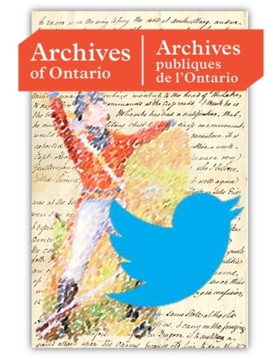

## Overview

All of the Archives of Ontario lesson plans have two components:

* The first component introduces students to the concept of an archive and why the Archives of Ontario is an important resource for learning history
* The second component is content-based and focuses on the critical exploration of a historical topic that fits with the Ontario History and Social Studies Curriculum for grades 3 to 12. This plan is specifically designed to align with the Grade 7: British North America curricula.

We have provided archival material and an activity for you to do in your classroom. You can do these lessons as outlined or modify them to suit your needs. Feedback or suggestions for other lesson plans are welcome.

**This plan** provides seven lesson suggestions for using the Ely Playter Twitter feed in your classroom. [Click here to access the twitter feed for @ElyPlayter1812](http://twitter.com/ElyPlayter1812).

The Twitter feed is an exciting project commemorating the War of 1812 by publishing 140 character messages directly from the diaries of Ely Playter, a militia man and lay preacher during the War of 1812. Using new media to explore primary sources with your students can introduce your students to historical inquiry in exciting ways and complement your unit on British North America.

## Curriculum Connections

This plan meets the following expectations for Grade 7: British North America:

***Overall Expectations***

* Explain and outline the causes, events, and results of the War of 1812
* Identify some themes and personalities from the period, and explain their relevance to contemporary Canada

***Specific Expectations***

*Knowledge and Understanding*

- explain key characteristics of life in English Canada from a variety of perspectives

*Inquiry/Research and Communication Skills*

* Formulate questions to facilitate research on specific topics
* Analyse, synthesize, and evaluate historical information
* Construct and use a wide variety of graphs, charts, diagrams, maps, and models to organize and interpret information
* Communicate the results of inquiries for specific purposes and audiences, using media works, oral presentations, written notes and reports, drawings, tables, charts, and graphs
* Use appropriate vocabulary to describe their inquiries and observations.

## Getting Organized

To prepare for using or clicking here on the [twitter feed for @ElyPlayter1812](http://twitter.com/ElyPlayter1812) in your class, you can:

* Visit the Archives of Ontario’s webpage on Ely Playter and read background on this special commemorative 1812 project
* Explore by clicking here on the  [twitter feed for @ElyPlayter1812](http://twitter.com/ElyPlayter1812) on your own. Read all the way back to the beginning. Get a feeling of the language and tone that Playter uses. Pick your favorites and create a model of the assignment you will give your class.
* Do a web search on how other teachers use Twitter in their classroom. See for example, Jeff Kurtz's blog post “[by clicking here on the blog "Twittering About Learning: Using Twitter in an Elementary School Classroom](http://www.essentialschools.org/resources/451)” on the Coalition of Essential Schools’ website. See also Dr. Kevin Kee, Canada Research Chair in Humanities Computing at Brock University, blog post, [by clicking here on the blog “You’re teaching Grade 7 history?”](http://kevinkee.ca/niagara-1812/youre-teaching-grade-7-history/)

## Lesson Suggestions

[Clicking here on twitter feed for @ElyPlayter1812](http://twitter.com/ElyPlayter1812) will provide you with Tweets that were published from Ely Playter’s diary spanning the beginning to the end of the war. Follow as a class or use the suggestions below to enhances your students’ learning experience.

With any lesson, begin by introducing the concept of an archive and how it can help answer research questions related to history. See **Overhead 1: Exploration Through the Archives!** to introduce this to your students (see page 5) and the following text to prepare yourself:

Over the course of a lifetime, most people accumulate a variety of records. It starts with a birth certificate and expands into awards, bank statements, receipts, letters, photographs – anything that documents important events and relationships in one’s life. These records comprise an individual’s personal archives. Governments, businesses, schools, associations and organizations of all types do the same, keeping records as evidence of their activities and accomplishments.

These documents provide a fascinating view into the past. Like a detective investigating a case, a researcher using these records can get a sense of what a place looked like, what people were thinking, what life was like, and what happened and why. Anyone with an interest in the past, whether it is delving into local history, tracing a family tree, or probing decisions and events, will find answers in archives.

Some examples are:

-letters, manuscripts, diaries often from famous people

-notes or recordings of interviews

-photographs, sketches and paintings

-birth, death and marriage records

-land registries, titles to property, and maps

-court records

-audio, video and film records

Archives are important resources for answering our questions about the past. Records may be used to settle legal claims, they may clarify family history, they are grist for historians, and they impart to filmmakers and authors a sense of the ways things were. Whatever the reason, archives have a story to tell.

The first step is to identify your research question and what you are hoping to find in the Archives to provide support to that question.

## Tweeting Significance

* As a class, create a timeline of the War of 1812 and display it in your classroom.
* In your next class, have a discussion about historical significance. What makes something historically significant? Who decides? Would significance be the same for everyone? See The Historical Thinking Project for exemplars on [Establishing Historical Significance - click here to access this page.](http://historicalthinking.ca/concept/historical-significance)
* Create a chart with up to three pieces of criteria for establishing significance and display the chart under the timeline.
* At the end of each day or week, have a discussion about the  [[click here] twitter feed for @ElyPlayter1812](http://twitter.com/ElyPlayter1812) tweets and rate the significance of each one. Have the students plot the tweets that have been judged as ‘significance’ on the class’ War of 1812 timeline.

## Tweet Perspective

* Follow  [[click here] the twitter feed for@ElyPlayter1812](http://twitter.com/ElyPlayter1812) and have daily or weekly recap discussions about the events he is Tweeting.
* Discuss Playter’s unique perspective and how his Tweets only tell one story from his point of view.
* As a class, in small groups, or individually, encourage students to write Tweets from another perspective about the same events.
* Students could Tweet from one of the main players in the War of 1812 such as Laura Secord, Tecumseh, or Brock or an imagined character such as Player’s wife, an American solider, or an Ojibwa Elder.

## Tweeting Continuity and Change

* Introduce [Twitter [by clicking here]](http://twitter.com/), to your class and discuss the limitations and possibilities of this social media: instantaneous but public, expressive but 140 characters, able to meet new people but invites marketing and promotions.
* [Click here to access the twitter feed for@ElyPlayter1812](http://twitter.com/ElyPlayter1812) over the course of a week or month and have a discussion about how the limitations and possibilities play out in this feed.
* As a class, pick one current event and use Playter’s example to Tweet about this event.
* Continue to follow Playter’s feed and keep track of moments of continuity and change in writing about current events and conflict.

## Complete the Tweet

* Visit [and click here for the Twitter feed for @ElyPlayter1812](http://twitter.com/ElyPlayter1812) once a week and as a class read and discuss Playter’s Tweets.
* Ask students to keep a journal to make notes about their favourite Tweets each week. Students could write their journal entry at home for homework or during class.
* At the end of the month, or the end of the year, ask students to pick three of their favorite Tweets from their journals and complete the diary entry that the Tweet could have come from. Diary entries should be no more than one paragraph and allude to the broader context of life in British North America.

## Question the Tweet

* After reviewing [and clicking here for the Twitter feed for @ElyPlayter1812](http://twitter.com/ElyPlayter1812) Tweets as a class, encourage students to build more context and practice writing research question by having them fill out a 5WH about what else they want to learn
* Emphasize that one source never tells the whole story. Encourage students to think about Who else was there, What else was going on, When in the day was the Tweet written, Where was Playter when he was writing, Why was this an important moment to record, How does Player respond to the events around him?

## Graphic Tweets

* For homework, or a special computer lab period, ask students to look through the whole Twitter feed [and clicking here to visit the the Twitter feed for @ElyPlayter1812](http://twitter.com/ElyPlayter1812) choose three to five Tweets
* Ask students to create a War of 1812 graphic narrative/comic strip and only use the chosen Tweets as text.

## Fair Tweets

* Have you ever run a Heritage Fair in your school, class, or Board? This is a perfect opportunity to begin!
* The [Ontario Heritage Fairs Association - click here to access this guide -](http://www.ohhfa.ca/)  “is a multi-media learning initiative developed to increase public awareness and interest in Canadian history.”
* In a similar manner as a science fair, students are encouraged to create presentations about one aspect of history beginning with a research question and use primary sources as evidence to explore possible answers to that question
* [Click here to visit the Twitter feed for @ElyPlayter1812](http://twitter.com/ElyPlayter1812) which can act as extensive fodder for one or more Heritage Fairs project. Encourage students to explore the feed on their own to get inspiration for their project.

# Worksheets & Handouts

Overhead 1: Exploration through the Archives 6

### Overhead 1: Exploration through the Archives!

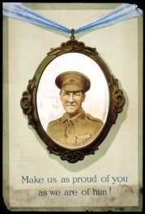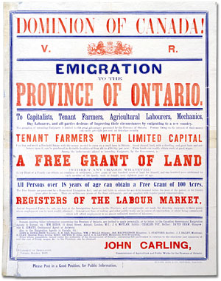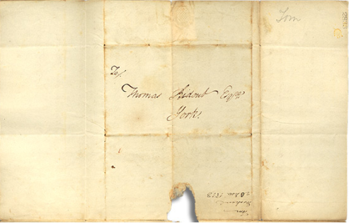

Over the course of a lifetime, most people accumulate a variety of records.

Taken together, these records can provide a fascinating view into someone’s life and into the past.

Like a detective investigating a case, a researcher using these records can get a sense of what a place looked like, what people were thinking, what life was like, and what happened and why.

Some examples of records that a historian may look at are:

* Birth, death, and marriage records
* letters or diaries
* photographs, sketches, and paintings
* court records
* audio, video and film records

An **archive** is a place where these records and historical documents are preserved. The **Archives of Ontario** collects and preserves records with relevance to the history of Ontario.

Using primary sources from the Archives of Ontario’s collections, you too can be an investigator exploring the past and understanding the present.

