# Anne Langton—Gentlewoman, Pioneer Settler and Artist

Grade7: British North America

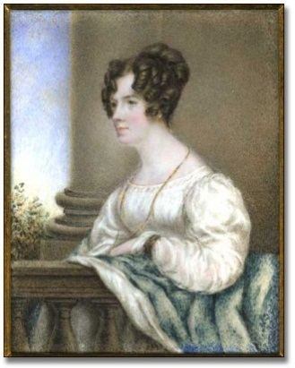

## Overview

All of the Archives of Ontario lesson plans have two components:

* The first component introduces students to the concept of an archive and why the Archives of Ontario is an important resource for learning history
* The second component is content-based and focuses on the critical exploration of a historical topic that fits with the Ontario History and Social Studies Curriculum for grades 3 to 12. This plan is specifically designed to align with the Grade 7: British North America curricula.

We have provided archival material and an activity for you to do in your classroom. You can do these lessons as outlined or modify them to suit your needs. Feedback or suggestions for other lesson plans are welcome.

**In this plan**, students will explore primary sources from the life of Anne Langton’s and use this material to write a first-person letter sharing their experiences as a settler in Upper Canada.

## Curriculum Connections

This plan meets the following expectations for Grade 7: British North America:

**Overall Expectations**

* Explain the origins of English settlement in British North American after the fall of New France, describe the migration and settlement experiences of various groups of settlers, and outline the causes, events, and results of the War of 1812
* Use a variety of resources and tools to gather, process, and communicate information about the beginnings and development of the new British colonies.

**Specific Expectations**

Knowledge and Understanding

* Outline the reasons for early settlement of English Canada
* Explain key characteristics of life in English Canada from a variety of perspectives)

Inquiry/Research and Communication Skills

* Use a variety of primary and secondary sources to locate relevant information about how early settlers met the challenges of the new land
* Analyse, synthesize, and evaluate historical information
* Communicate the results of inquiries for specific purposes and audiences, using media works, oral presentations, written notes and reports, drawings, tables, charts, and graphs

Application

* Illustrate the historical development of their community using a variety of formats

## Getting Organized

To prepare for this lesson, you can:

* Make overheads or create a PowerPoint presentation with the introductory information found on: **Overhead 1: Exploration Through the Archives!** and **Overhead 2: Anne Langton: Research Question. Overhead 3: Anne Langton: Who is she?** can be an overhead or be made into a handout.
* Make copies of the primary resources, one set per group of students.
* Print and make copies of **Student Handout: Anne Langton Notes Page** and **Student Handout: Anne Langton Assignment** for each student
* Visit the Archives of Ontario’s online exhibit on Anne Langton to learn more information about Anne’s life and experience in Canada.

* All resources can be found at the end of this lesson

# Lesson Plan

This lesson can be completed across two classes or expanded to be completed across five classes.

* Begin by introducing the concept of an archive and how it can help answer research questions related to history.
* See **Overhead 1: Exploration Through the Archives!** to introduce this to your students and the following text to prepare yourself:

Over the course of a lifetime, most people accumulate a variety of records. It starts with a birth certificate and expands into awards, bank statements, receipts, letters, photographs – anything that documents important events and relationships in one’s life. These records comprise an individual’s personal archives. Governments, businesses, schools, associations and organizations of all types do the same, keeping records as evidence of their activities and accomplishments.

These documents provide a fascinating view into the past. Like a detective investigating a case, a researcher using these records can get a sense of what a place looked like, what people were thinking, what life was like, and what happened and why. Anyone with an interest in the past, whether it is delving into local history, tracing a family tree, or probing decisions and events, will find answers in archives.

Some examples are:

- letters, manuscripts, diaries often from famous people

- notes or recordings of interviews

- photographs, sketches and paintings

- birth, death and marriage records

- land registries, titles to property, and maps

- court records

- architectural plans and engineering drawings

- audio, video and film records

Archives are important resources for answering our questions about the past. Records may be used to settle legal claims, they may clarify family history, they are grist for historians, and they impart to filmmakers and authors a sense of the ways things were. Whatever the reason, archives have a story to tell.

The first step is to identify your research question and what you are hoping to find in the Archives to provide support to that question.

* Following this introduction, use **Overhead 2: Research Question** to introduce the lesson’s research question:

**What was settlement like for a gentlewoman artist in British North America?**

* Introduce that the Archives of Ontario have identified a collection that include letters, paintings, sketches, and diary entries that can help your students answer this question. This collection is: The John Langton family fonds.
* A “Fond” is a group of records created by a single individual or a group. In this fond, we have pulled out seven primary sources that can help with research. With these records, students can explore:

**What Anne Langton expressed about her emigration and**

**settlement experience in British North America.**

**If a student was in her place, what would they communicate back home?**

Find attached the primary sources, handouts, and rubric for facilitating this activity

* + - * Use **Overhead 3: Anne Langton: Who is she?** to introduce Anne Langton and her family to your class. Use this overhead as an entry point for talking about how her life fits into what else you have covered about Upper Canada in the early 19th century.
      * Arrange students into six small groups and give each group of students a set of primary sources on one of the following three topics:
* Emigration, 1837
* Settlement, 1837-1852
* Peterborough and Toronto, 1852-1859
  + - * Ask students to take notes on the **Student Handout: Anne Langton Notes Page**, which will be the basis for a letter they will write from the perspective of Anne Langton or her brother, John. Give students the **Student Handout: Anne Langton Assignment** as an assignment page for starting the letter
      * Either individually or as a group, have students write a first-person letter reflecting on emigration and settlement experiences. Have students hand them in, present them to the class, or mail to the Archives of Ontario!

# Handouts & Worksheets

Overhead 1: Exploration through the Archives! 6

Overhead 2 - Anne Langton Research Question 7

Anne Langton: Who is she? 8

Student Handout: Anne Langton Notes Page 9

Student Handout: Anne Langton Assignment 10

Anne Langton Primary Source 1 11

Anne Langton Primary Source 2 12

Anne Langton Primary Source 3 13

Anne Langton Primary Source 4 14

Anne Langton Primary Source 3 21

Marking Rubric 23

### Overhead 1: Exploration through the Archives!

Over the course of a lifetime, most people accumulate a variety of records.

Taken together, these records can provide a fascinating view into someone’s life and into the past.

Like a detective investigating a case, a researcher using these records can get a sense of what a place looked like, what people were thinking, what life was like, and what happened and why.

Some examples of records that a historian may look at are:

* birth, death, and marriage records
* letters or diaries
* photographs, sketches, and paintings
* court records
* audio, video and film records

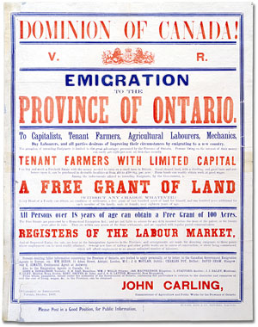Colour poster featuring an illustrated portrait of a soldier in a First World War-era uniform. Text below reads: "Make us as proud of you as we are of him!"
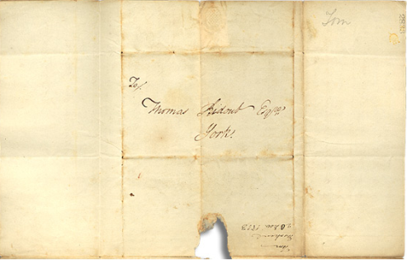

An **archive** is a place where these records and historical documents are preserved. The **Archives of Ontario** collects and preserves records with relevance to the history of Ontario.

Using primary sources from the Archives of Ontario’s collections, you too can be an investigator exploring the past and understanding the present.

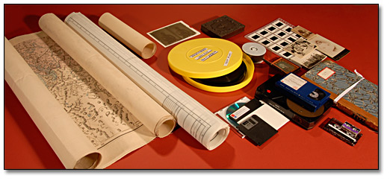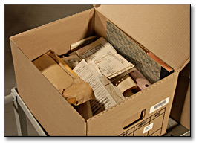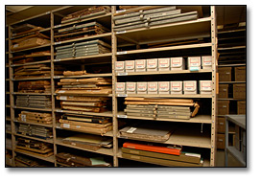

### Overhead 2 - Anne Langton Research Question

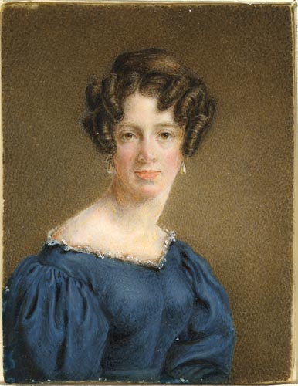

To begin using the records found at an archive, it is best to begin with a research question that can guide your search. For this lesson, your research question could be:

**What was settlement like for a gentlewoman artist in British North America?**

The Archives of Ontario have identified a “fond,” or record collection, to help you answer that question. Today you’ll be working with **The John Langton family fonds.**

Directions:

1. In your groups, look at the primary sources about Anne Langton’s emigration and settlement experiences
2. Take notes about what you learnt about her and her experiences
3. Pretend to be her or her brother John and write a letter to Britain sharing your settlement experiences

### Anne Langton: Who is she?

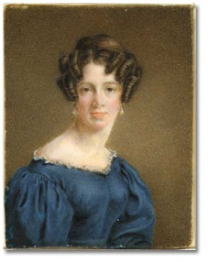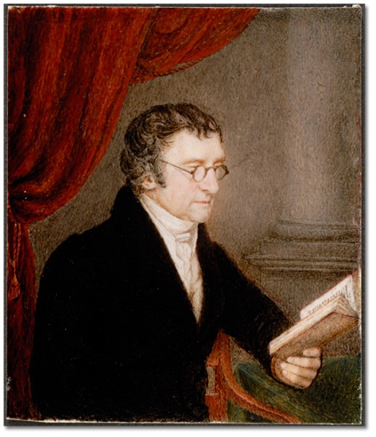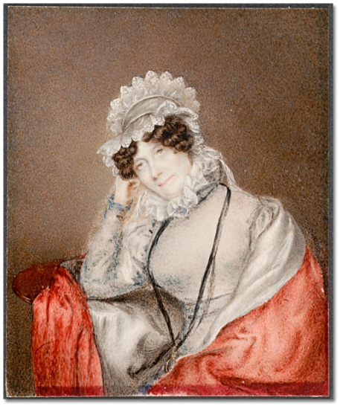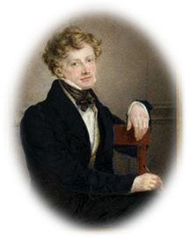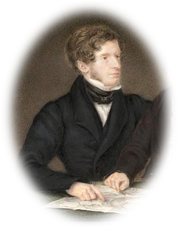

Anne Langton was a gentlewoman who lived in Britain with her

father Thomas, mother Ellen, and her two bothers William & John

| Painted landscape view of the American Falls at Niagara Falls.  American Fall, Niagara, [ca. 1854]  Anne Langton  Reference Code: F 1077-8-1-2-31  Archives of Ontario, I0008403 | * In 1833, her brother John moved to Upper Canada and wanted his sister and parents to join him. * In 1837 Anne, her parents, and her aunt made the voyage to Canada, stopping in New York * Upon arriving in Ontario, they settled in Sturgeon Lake, just outside of Peterborough, and lived in the small log cabin John built until their bigger, two-storey house was ready * The family was very prominent in the community and in 1851 John was elected to the Provincial Legislature for Peterborough and District * John owned several mills in Peterborough and their family became quite financially comfortable. * John moved up in government, eventually becoming Auditor of Upper and Lower Canada in 1851. Because of his new role, the family moved to Toronto where John was closer to the government. * Anne lived with John, his wife Lydia, and their children during this time. She sketched, wrote letters and diaries, and entertained her other nieces and nephews when they came to visit. |
| --- | --- |

**How are the Langton family’s experiences the same or different from other Canadian settlers you have heard about?**

### Student Handout: Anne Langton Notes Page



Imagine what it was like journeying across the Atlantic Ocean in a wooden sailing ship and leaving everything familiar to go and clear the land for farming in the middle of Canadian forest.

Anne Langton was one of those settlers, and she left us valuable records consisting of letters, journals and paintings that tell us about her journey, life on a pioneer farm and the changes in Upper Canada in the years leading up to Confederation.

Look carefully at the images and diary entries provided and try to imagine yourself in the picture either as someone journeying across the ocean by sailing ship, settling in the wilderness, or moving into town after years on a wilderness farm.

**Topic of your research:**

* Emigration, 1837
* Settlement, 1837-1852
* Peterborough and Toronto, 1852-1859

**What did you see in the pictures you looked at?**

Blank space for student’s answer.

Blank space for student’s answer.

Blank space for student’s answer.

**What did you read about in the letters or diaries?**

Blank space for student’s answer.

Blank space for student’s answer.

**How did you respond to the questions provided?**

### **Student Handout: Anne Langton Assignment**

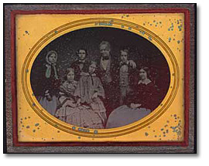

Langton, William and family, [ca. 1855]

Langton family papers

Ambrotype

Reference Code: F 1077-11-0-6

Archives of Ontario, I0008506

Imagine yourself in Anne or John’s place. Your job is to tell people in England about your experiences as a settler in Upper Canada.

Tell them why the fields are full of stumps. Tell your friends about the inn you stayed on your journey or the fine house you are building to replace your first log cabin. Tell them about the difference between city life and rural life.

Don’t be afraid to use your imagination in composing your letter.

**Remember to include:**

* Date
* Address
* Greeting
* Content – three paragraphs!
* Closing and Signature

Notes:

### Anne Langton Primary Source 1

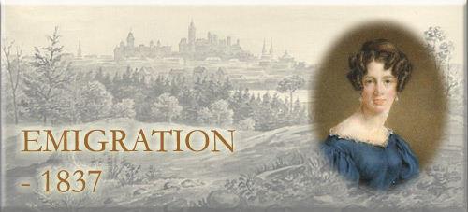

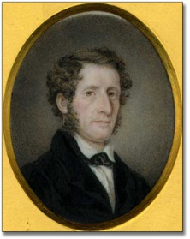

**The Expectations of Settlement**

In 1834, Anne sketched this picture of what she imagined John’s farm looked like.

She would not see the farm for another three years

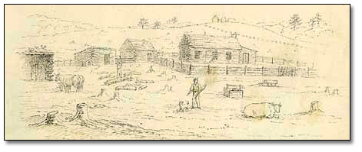

John Langton's cabin with surrounding buildings, 1834

Anne Langton

Graphite on cream wove paper

Reference Code: F 1077-9-1-17

Archives of Ontario, I0008465

Question to think about:

**Do you think that Anne had a realistic idea about what life on an Upper Canadian farm would look like?**

### Anne Langton Primary Source 2



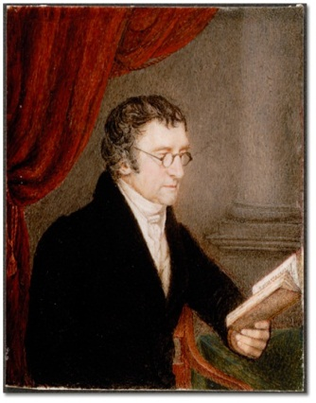

**The family travelled to New York before coming to Canada**

Anne’s father wrote about the difficulties of travel in his diary:

“Yesterday was a trying day. We were going before the wind about fourteen miles an hour, with a rolling sea that occasioned many trifling and laughable accidents [...] We were not without our share in the mischances of the day. Whilst we were sitting quietly in the ladies' room, our room nearly turned topsy-turvy, and the egg-basket having been compelled to part with the remains of its cargo, the eggs were tossed backwards and forwards till the carpet was quite ready to put in the frying pan, where it would have made a delicious and magnificent omelet. The state of the room was not discovered till your mother was going to bed, about eleven o'clock, and a long purification had then to be commenced”

- Thomas Langton

Question to think about:

**Thomas laughed about this incident, but he could have very annoyed too. Have you ever has a laughable time while travelling?**

### Anne Langton Primary Source 3



**Arriving on the Farm**

“... on the fifteenth of August, 1837, we reached our new home. How anxiously we looked for it as we were being rowed up Sturgeon Lake; but it does not come into sight until you are quite close to it. Certainly my brother had fixed upon one of the most attractive spots, where a creek finds its way into the lake in almost a bay, for a beautiful point of land projects into the water on one side, and the ground rises considerably at a little distance from the lake. There on the hill stood our still unfinished house ... There was nothing to dishearten in the aspect of things, and we had had it fully described to us. The only thing that did startle me was the extreme roughness of the ground. My fear was for my old people. I felt as if there was no spot where they could take a little turn without stumbling upon a stone, or catching their feet in a root.”

- Anne Langton, Blythe, Sturgeon Lake, 1837

Question to think about:

**Anne saw both good and bad things about her new home. What are some positives and what are some negative that she wrote about?**

### Anne Langton Primary Source 4



**Arriving on the Farm**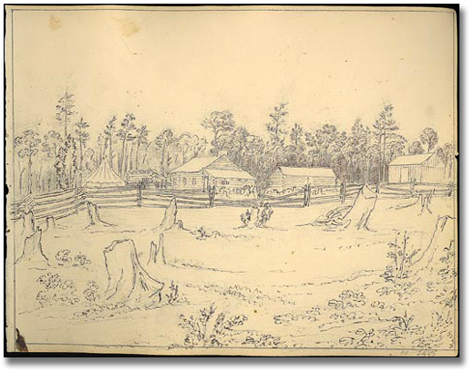

End view of John's house, Canada,1837   
Anne Langton   
Reference Code: F 1077-8-1-4-19  
Archives of Ontario, I0008042

Question to think about:

**If this was your first view of your new home, would you feel excited or scared?**Anne Langton Primary Source 1

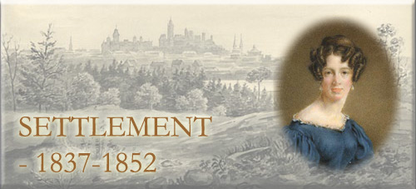

**The House**

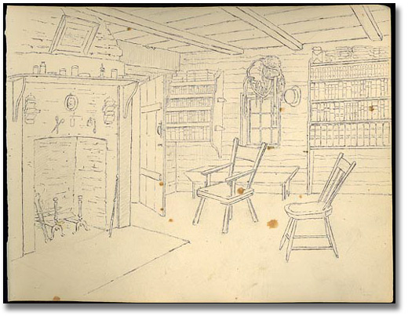

“At last ... after all delays and disappointments, our long journey is accomplished. John looked very proud when he handed his mother into his little mansion. His arrangements for our accommodation are very snug ... My mother and I sleep in the larger bedroom behind, Aunt Alice in the small one John used to occupy at first. My father has the hammock put up every night in the sitting-room, and John himself has a tiny apartment curtained off by a sail from the ante-room. Here we expect to make ourselves comfortable for perhaps a couple of months, or maybe more, if as many unexpected delays occur as have occurred in the preparations at ‘the big house,’ as our future habitation is elegantly denominated.”

- Anne Langton, letter 22 August, 1837

Question to think about:

**Draw a picture of each person and where they’d sleep. Anne seemed very positive about this arrangement. Where do you think you’d sleep if you were there and how would you feel?**Anne Langton Primary Source 2



**The House**

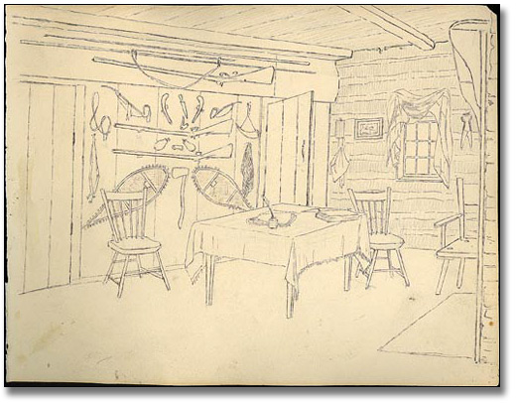

**Interior of John's house** [looking north], 1837  
Anne Langton   
Reference Code: F 1077-8-1-4-20  
Archives of Ontario, I0008043

Question to think about:

**What room do you this this is? What activities do you think took place in this room?**Anne Langton Primary Source 3



**Community Life**

Communities are built by people like. Anne Langton. She did work through her local church, educated young people, and created the first library in the area.

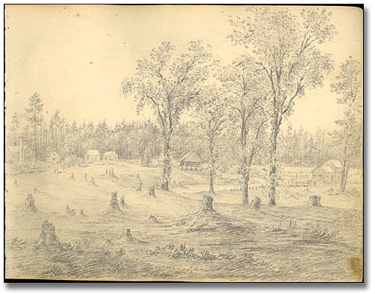

Church at Fenelon Falls, Ontario, 1837   
Anne Langton   
Reference Code: F 1077-8-1-4-17  
Archives of Ontario, I0008040

Question to think about:

**In this picture the community looks very sparse. What buildings would you build and how would you contribute to the community life if you were a settler?** Anne Langton Primary Source 4



**Landscape**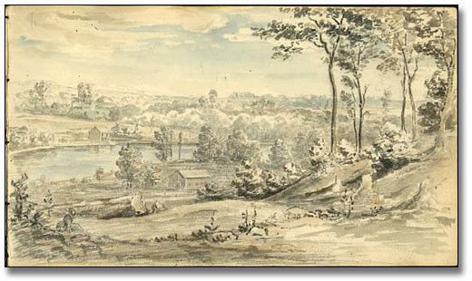

On the Otonabee near Peterborough, [ca. 1852]  
Anne Langton   
Reference Code: F 1077-8-1-2-27  
Archives of Ontario, I0008399

Question to think about:

**Anne painted this picture fifteen years after she arrived to Canada. What do you think she is expressing about her home in this picture?**Anne Langton Primary Source 1

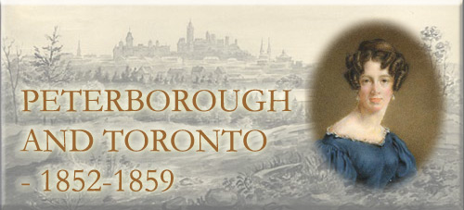

**House**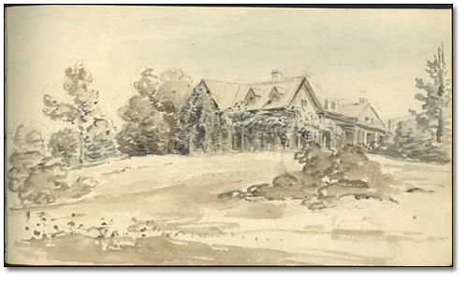

**Blythe farm**, Ontario, [ca. 1851]  
Anne Langton   
Reference Code: F 1077-8-1-2-53  
Archives of Ontario, I0008417

Question to think about:

**Fifteen years after arriving to Canada, the Langton family lived in this house. How is this house different from the previous picture of their home?**Anne Langton Primary Source 2



**Growth of Business**

John Langton built and brought flour mills in Peterborough.

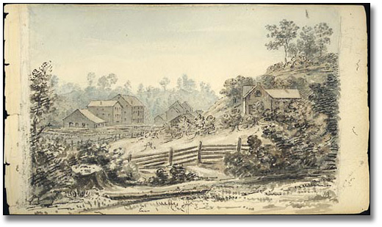[Blythe] Mills near Peterboro, [ca. 1852]  
Anne Langton   
Reference Code: F 1077-8-1-2-28  
Archives of Ontario, I0008400

Question to think about:

**What kinds of businesses do you think would be important to invest in after coming to a new country**?

### Anne Langton Primary Source 3



**Langton’s Move to Toronto**

To be closer to the government where John now worked, the family moved to Toronto in 1857.

“In the spring of 1857, we moved up to Yorkville, and here, besides breathing purer air, we were brought into very agreeable society. Many of the Professors connected to the University were residents, and also families belonging to the Civil Service who, moving like ourselves with Government, were numbered amongst our associates as long as we remained connected with it"

- Anne Langton

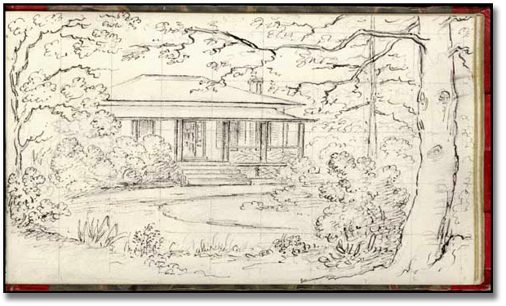

[Langton Family] Home at Yorkville, Toronto, [1857 or 1858]

Anne Langton

Reference Code: F 1077-8-1-2-50

Archives of Ontario, I0011267

Question to think about:

**What difference in the Toronto “society” would the Langton family encountered that they may not had in Peterborough?** Anne Langton Primary Source 4



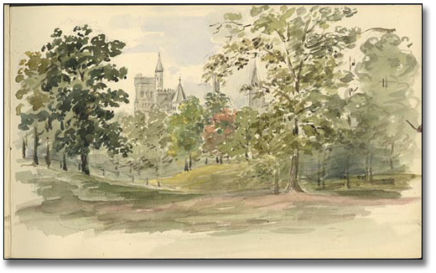

**University College**, Toronto, [ca. 1879]  
Anne Langton   
Reference Code: F 1077-8-1-1-10  
Archives of Ontario, I0008009

Question to think about:

**How does this urban landscape of Toronto differ from the more rural landscape of Peterborough?**

### Marking Rubric

|  |  |  |  |  |
| --- | --- | --- | --- | --- |
| **Criteria** | **Level 1** | **Level 2** | **Level 3** | **Level 4** |
| *Knowledge and Understanding*  The student demonstrates understanding of the emigration experience. | Limited understanding of the source materials as they relate to the pioneer experience in Upper Canada. | Some understanding—though lacking in completeness, clarity and integration—of the source materials as they relate to the pioneer experience in Upper Canada. | Clear and comprehensive understanding of the source materials as they relate to the pioneer experience in Upper Canada. | A clear, comprehensive, balanced and well integrated understanding of the source materials as they relate to the pioneer experience in Upper Canada. |
| *Thinking/Inquiry*  The student demonstrates the ability to analyze critically the data presented within the exhibit. | Unclear perspective and limited understanding of the historical and geographical context. | Somewhat effective organization and interpretation of data but with limited understanding of the source materials. | A clear and critical position that is evident in all aspects of the work, with effective presentation of the research data. | A critical analysis presented with a high degree of ability and clarity resulting in a precise and persuasive interpretation. |
| *Communication*  The student writes effectively for the purpose, using clear and persuasive language that elicits a positive response. | Language and organization of data that demonstrates lack of sensitivity to the historical and geographical context. | Somewhat effective use of language and organization of data but with limited understanding of the research. | Consistent and effective use of language and clear organization of data transporting the reader into a clearly conceived time and place. | Precise use of language, clarity of organization and good stylistic control, illustrating a good understanding of the conventions of written communication. |
| *Application*  The student makes personal imaginative connections with the pioneers in Upper Canada. | Little personal identification with the hardships that settlers faced in Upper Canada, how they lived and how their society evolved. | Some thoughtful and appropriate acknowledgement of personal connections to themes within the exhibit. | Effective understanding and identification with pioneers in Upper Canada. | High degree of identification with the pioneers and understanding of the challenges they faced. |