Human-Animal Connections Lesson Kit

Developed by the Archives of Ontario

Grade Level: 4-6
Subject Area: Science and Technology
Time Required: 2 classes or 2-2.5 hours

In this Lesson Kit:

Lesson Overview 2
Specific Expectations 2
Materials/Resources: 3
Lesson/Activity: 3
Background/Preparation 3
Activation and Discussion 3
Animal Relationships in Students’ Lives 4
Extension Activity: Habitats and Systems 5
Summative: 5
Assessment 7
Appendix I: Worksheets and Resources 9
Habitats and Systems Worksheet 10
Animal Relationships 1 11
Animal Relationships 2 12
Animal Relationships 3 13
Animal Relationships 4 14

Lesson Overview

Summary: students will examine where human understanding of animals originates, and use primary source evidence to demonstrate their knowledge of animal-human connections and impacts within their own lives.

Key Question: why is it important to discuss human and animal relationships?

Themes:

- Habitats and Communities
- Biodiversity
- Interactions in the Environment
- Interrelationships
- Impact

Fundamental Concepts:

- Identify systems and interactions
- Understand sustainability and stewardship

- Analyze continuity and change

Specific Expectations

After this lesson, students in grade 4 will:

- 3.4 Demonstrate an understanding of a community as a group of interacting species sharing a common habitat.
- 3.6 Identify animals that are carnivores, herbivores, or omnivores.
- 3.10 Describe ways in which humans are dependent on natural habitats and communities.

After this lesson, students in grade 6 will:
- 1.2 Assess the benefits that human societies derive from biodiversity and the problems that occur when biodiversity is diminished.
- 2.3 Use scientific inquiry/research skills to compare characteristics of organisms within the plan or animal kingdoms.
- 2.4 Use appropriate science and technology vocabulary in oral and written communication.
- 3.5 Describe interrelationships within species, between species, and between species and their environment, and explain how these interrelationships sustain biodiversity.

Materials/Resources:

- Blank paper for student drawings (small) and final poster (large)
- Writing and drawing tools for students
- Blackboard, whiteboard, or chart paper (with writing tool)
- Projector and screen to show images to the class
- Worksheets and resources provided in this lesson kit:
  - Habitats and Systems worksheet
  - Animal Relationships handouts (1-4)

Lesson/Activity:

Summary: Students will analyze humans’ relationships with other animals in Ontario, using primary sources to assess how we understand other species and theorize how this impacts our habitats and communities.

Background/Preparation

- Students should be familiar with animal species native to Ontario.
- Students should be familiar with the following vocabulary: habitat, species, behaviour, carnivore, herbivore, omnivore, producer, consumer, decomposer, and relationship.

Activation and Discussion

- As a class, create a list of words to describe each of the following animals: horse, bear, fish, bird, or dog.

Depending on the grade level and class size, you can have students write their words for each animal on a chart in the appropriate field as shown below (ie: “barks” would fall under “sounds like,” while “fast” would fall under “moves like”):

Looks Like | Sounds Like
Moves Like | Acts Like

Other descriptors could include:

  - Bears – furry, big, hunters, dangerous, cuddly, brown, white, etc.
  - Fish – scaly, fast, delicious, smelly, slimy, curious, finned, wet, etc.
  - Birds – feathered, beautiful, loud, delicious, friendly, clawed, etc.
  - Dogs – friendly, fast, furry, loud, cute, vicious, etc.
  - Horses – fast, tall, brown, spotted, strong, heavy, hoofed, useful, etc.

- Once students have described the animal, challenge them to identify how they chose these words by asking “how do you know this is true?”

Discuss, as a class, where we learn about animals and the different ways we gather information about their appearance, behaviours, and attributes.

Possible sources of information could include: zoos, aquariums, museums, farms, pets, books, movies, television, social media, toys, etc.

Emphasize the importance of eyewitness or primary source information – information gathered by someone who has been in direct contact with an animal (ie: owned a pet dog, swam with dolphins, fed pigeons, etc.).

Animal Relationships in Students’ Lives

- Using a projector or printed copies, show the class each of the “Animal Relationships 1-4” images found in Appendix I of this lesson kit.

- As a class, discuss all four images using the following questions:
  - What is happening in this image?
  - What kind of relationship is shown?

- Pass out a blank sheet of paper and drawing tools to each student.

- Ask each student to draw an animal in their lives. This could be a pet, but could also be from any aspect of their lives. It should, however, be an animal they have encountered in person.

  - Some students may choose to draw animals they have eaten as food. This is also an important human-animal relationship!

- Once students have completed their drawings, ask the class the following question: How do you know how to behave with different animals?

Discuss how we learn to work with some animals, live with different animals, and eat others.

- Depending on the age and experiences of students in the class, guide the discussion so that students hear from several classmates – this discussion will build on the questions asked during the activation.

- The goal is to recognize that we learn how to interact with different animal species through information (from families, communities, media, etc.), and so there are many different perspectives on human relationships with other animals. These perspectives reveal that humans impact other animals and their habitats in many different ways.

Extension Activity: Habitats and Systems

- Pass out a copy of the “Habitats and Systems” worksheet found in Appendix I of this lesson kit to each student.

- Ask students to choose an animal from the five presented in the “Animal Relationships” activity.

- Have students answer the questions on the worksheet using primary and secondary source information (ie: their own experience, textbook, library resources, internet sources, etc.).

  - This worksheet can be assigned as take-home work, or incorporated into time in a library or computer lab.

- Once students have completed their worksheets, discuss their findings as a class.

  - Write the last three questions from the “Habitats and Systems” worksheet on a whiteboard, blackboard, or large sheet of paper.
  - Working as a class, ask students to share their answers, and write them next to the corresponding question on the whiteboard, blackboard, or sheet of paper.
  - As you work, point out to students the growing list of ways in which human and animal lives are interconnected.
  - Ask students: why do humans and animals impact each other in some ways, but not others? Where do our relationships come from?

Summative:

Finally, bring the discussion back to the initial activity by asking: do you think human and animal relationships change over time? How and why?
Draw on students’ research for the “Habitats and Systems” worksheet, and work together to explore where their understanding of animals starts. Guiding questions could include:
- How did humans learn to live with animals?
- Do you think humans living 500/1000/10,000 years ago had the same relationships with animals as you do today? Why or why not?
- Why is it important to talk about our relationships with animals?

Assessment
Categories | Level 1 | Level 2 | Level 3 | Level 4
Knowledge and Understanding: subject-specific content acquired in each course (knowledge), and the comprehension of its meaning and significance (understanding)
 | The student:
Knowledge of content  (ie: facts, terms, definitions) | -demonstrates limited knowledge of content | -demonstrates some knowledge of content | -demonstrates considerable knowledge of content | -demonstrates thorough knowledge of content
Understanding of content  (ie: concepts, ideas, theories, and/or technologies) | -demonstrates limited understanding of content | -demonstrates some understanding of content | -demonstrates considerable understanding of content | -demonstrates thorough understanding of content
Thinking and investigation: the use of critical and creative thinking skills and inquiry, research, and problem-solving skills and/or processes
 | The student:
Use of initiating and planning skills and strategies  (ie: formulating questions, identifying the problem, developing hypotheses, selecting strategies and resources, developing plans) | -uses initiating and planning skills and strategies with limited effectiveness | -uses initiating and planning skills and strategies with some effectiveness | -uses initiating and planning skills and strategies with considerable effectiveness | -uses initiating and planning skills and strategies with a high degree of effectiveness
Use of processing skills and strategies  (ie: performing and recording, gathering evidence and data, observing, manipulating materials and using equipment safely, solving equations, proving) | -uses processing skills and strategies with limited effectiveness | -uses processing skills and strategies with some effectiveness | -uses processing skills and strategies with considerable effectiveness | -uses processing skills and strategies with a high degree of effectiveness
Use of critical/creative thinking processes and strategies  (ie: analysing, interpreting, problem solving, evaluating, forming and justifying conclusions on the basis of evidence) | -uses critical/creative thinking processes, skills, and strategies with limited effectiveness | -uses critical/creative thinking processes, skills, and strategies with some effectiveness | -uses critical/creative thinking processes, skills, and strategies with considerable effectiveness | -uses critical/creative thinking processes, skills, and strategies with a high degree of effectiveness
Communication: the conveying of meaning through various forms
 | The student:
Expression and organization of ideas and information (ie: clear expression, logical organization) in oral, visual, and written forms | -expresses and organizes ideas and information with limited effectiveness | -expresses and organizes ideas and information with some effectiveness | -expresses and organizes ideas and information with considerable effectiveness | -expresses and organizes ideas and information with a high degree of effectiveness
Communication for different audiences and purposes (ie: to inform, to persuade) in oral, visual, and written forms | -communicates for different audiences with limited effectiveness | -communicates for different audiences with some effectiveness | -communicates for different audiences with considerable effectiveness | -communicates for different audiences with a high degree of effectiveness
Use of conventions, vocabulary, and terminology of the discipline (ie: symbols, formulae, scientific notation, SI units) | -uses conventions, vocabulary, and terminology of the discipline with limited effectiveness | -uses conventions, vocabulary, and terminology of the discipline with some effectiveness | -uses conventions, vocabulary, and terminology of the discipline with considerable effectiveness | -uses conventions, vocabulary, and terminology of the discipline with a high degree of effectiveness
Application: the use of knowledge and skills to make connections within and between various contexts
 | The student:
Application of knowledge and skills  (ie: concepts and processes, scientific investigation skills) in familiar contexts | -applies knowledge and skills in familiar contexts with limited effectiveness | -applies knowledge and skills in familiar contexts with some effectiveness | -applies knowledge and skills in familiar contexts with considerable effectiveness | -applies knowledge and skills in familiar contexts with a high degree of effectiveness
Transfer of knowledge and skills  (ie: concepts and processes, scientific investigation skills) to new contexts | -transfers knowledge and skills to new contexts with limited effectiveness | -transfers knowledge and skills to new contexts with some effectiveness | -transfers knowledge and skills to new contexts with considerable effectiveness | -transfers knowledge and skills to new contexts with a high degree of effectiveness
Making connections between science, technology, society, and the environment (ie: assessing the impact of science on technology, people and other living things, and the environment) | -makes connections between science, technology, society, and the environment with limited effectiveness | -makes connections between science, technology, society, and the environment with some effectiveness | -makes connections between science, technology, society, and the environment with considerable effectiveness | -makes connections between science, technology, society, and the environment with a high degree of effectiveness

Appendix I: Worksheets and Resources

Habitats and Systems Worksheet

Chosen Animal: ________________________________________
Question | Answer
Is your animal a producer, consumer, or decomposer?
Is your animal a carnivore, herbivore, or omnivore?

Where does your animal live?

Describe their habitat.

What specific features of their habitat help your animal to survive?

How does your animal help or support humans?

How does human activity hurt your animal?

How does human activity help your animal?

Animal Relationships 1

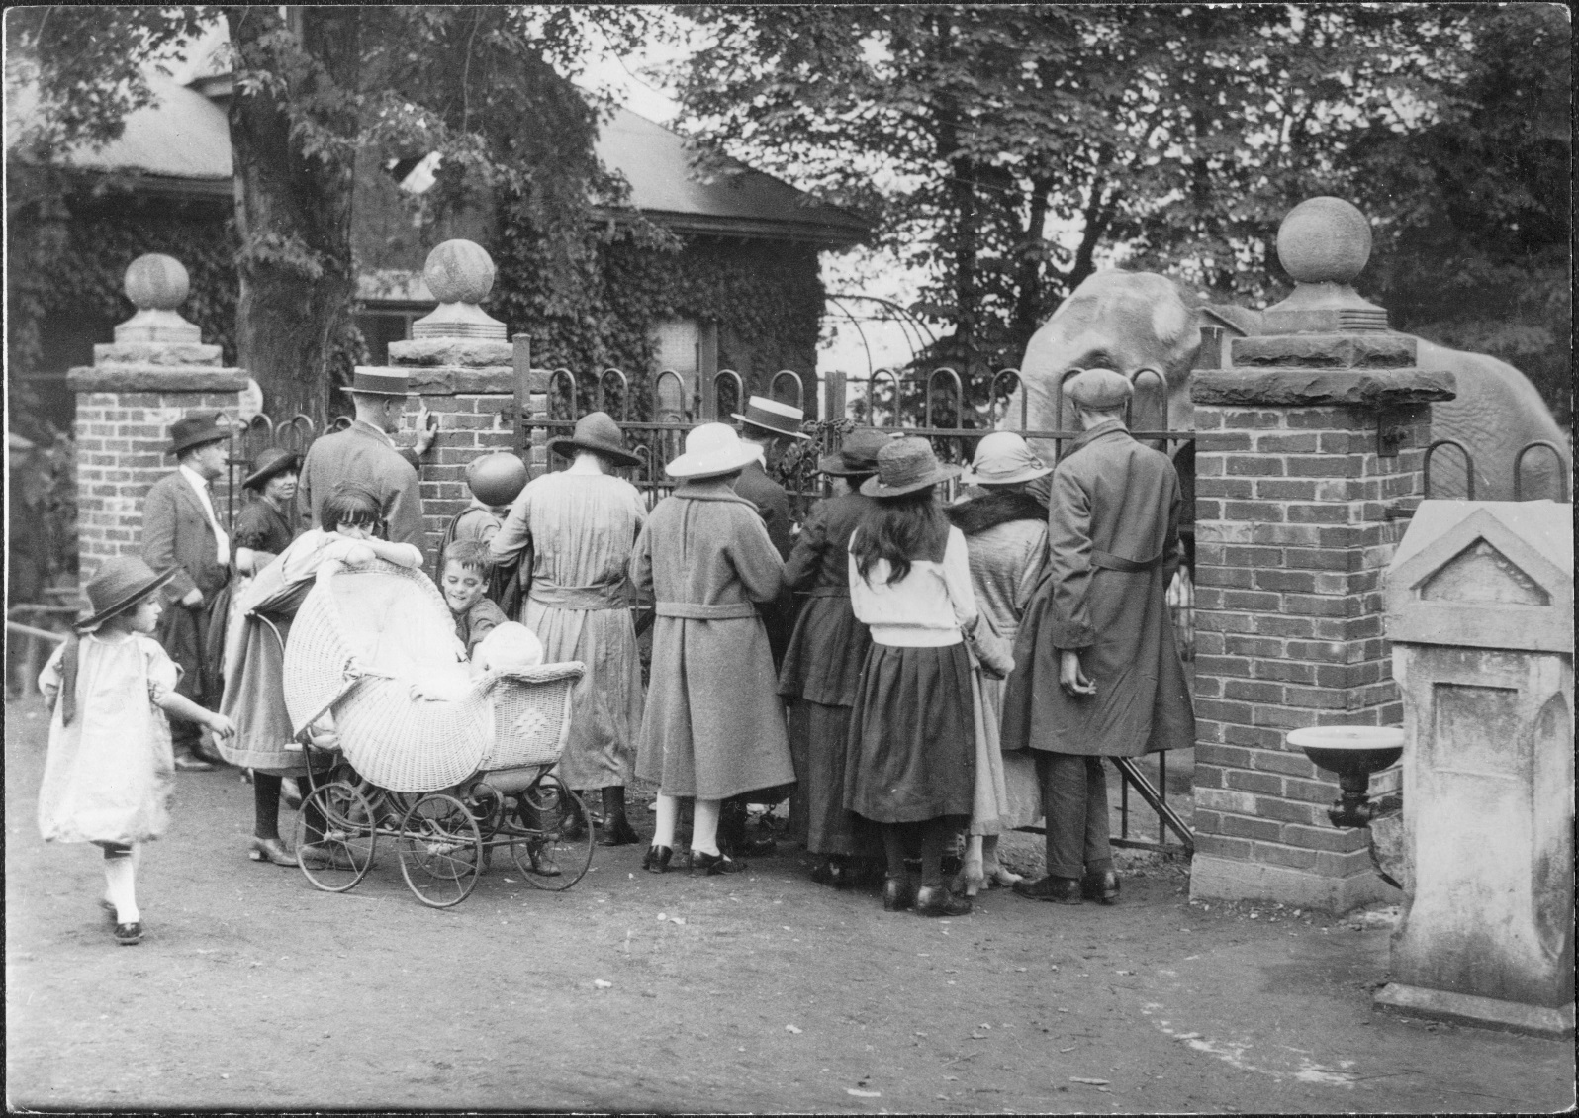
The elephants at the Riverdale Zoo, Toronto, 1923
Photographer: John Boyd
Archives of Ontario, I0003651

Animal Relationships 2

People with vision loss and guide dogs in front of CNIB national office, May 14, 1981
Collection: The Globe and Mail
Archives of Ontario, I0054219

Animal Relationships 3

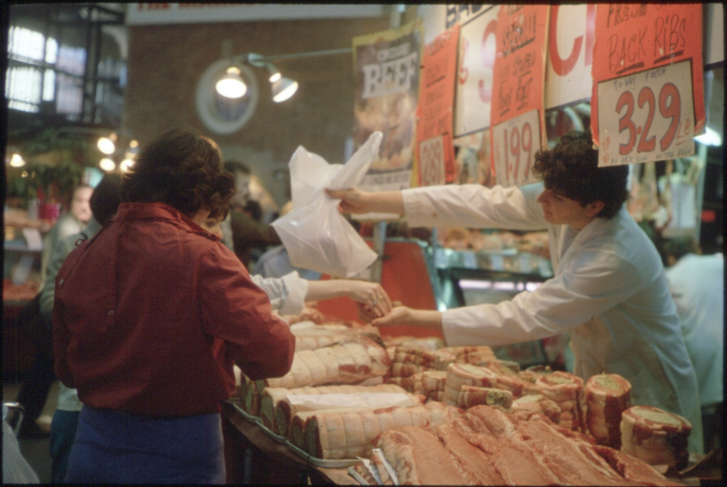

Butcher, St. Lawrence Market, Toronto, ca. 1975
Creator: Ministry of Transportation
Reference Code: RG 14-151-3
Archives of Ontario, I0005826

Animal Relationships 4

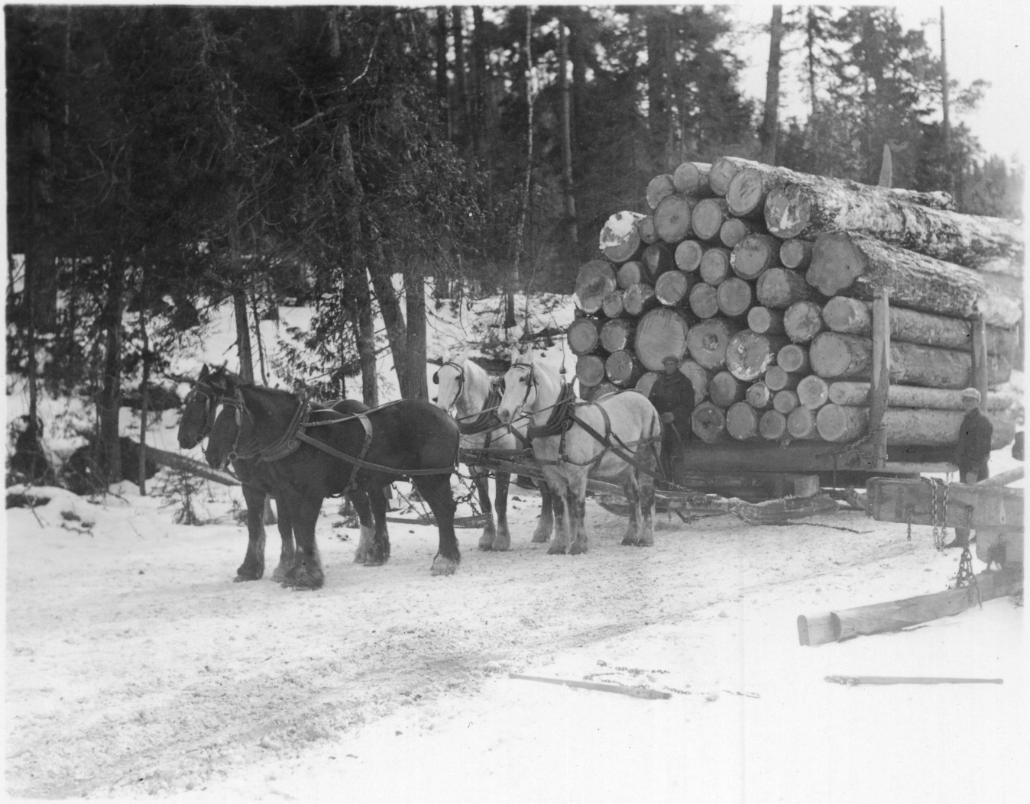

Horses pulling a sleigh loaded with pine logs near Flanders, Ontario, ca. 1920
Creator: Ministry of Education Audio-Visual Education Branch
Archives of Ontario, I0004037

