# “Don’t Worry, Keep Your Feet Warm” – The Spanish Flu in Ontario

Developed by the Archives of Ontario

Grade Level: 10-12

Subject Area: Canadian History since World War I

Time Required: 3-4 classes or 3-5 hours

Lesson Overview 2

Expectations 2

Lesson/Activity: 3

Background/Preparation 3

Activation and Discussion: 3

Talking about the Spanish Flu: 4

Influenza Group Discussion 5

Activity 5

Materials/Resources: 6

Assessment: 7

Appendix I: Information about the Spanish Flu in Ontario 9

Background Information 9

Framing the Pandemic 9

Spread of the Flu 10

Response by Government and the Public 12

Impact of the Pandemic 13

Appendix II: Lesson Worksheets and Resources 14

Communication Breakdown – Primary Source Analysis 16

Primary Source: Newspaper Clipping 17

Primary Source: Edward G.R. Ardagh’s Diary 18

Primary Source: Edward G.R. Ardagh’s Diary 19

Primary Source: Edward G.R. Ardagh’s Diary 20

Primary Source: Edward G.R. Ardagh’s Diary 21

Primary Source: Edward G.R. Ardagh’s Diary 22

Primary Source: Influenza Precautions Poster 23

## Lesson Overview

Summary: students will study how information about the Spanish Flu epidemic was created, shared, and understood by Ontarians from 1918-21, focusing on themes of communication, media literacy, and crisis narratives.

Key Question: how can primary sources help us interpret the 1918 Spanish Flu outbreak in Ontario?

Themes:

* Canada & the Global Community
* Discover Your Community
* Health & Wellness
* Media & Communications
* Peace & Conflict
* War and the Canadian Experience

Historical Thinking Concepts:

* Use *primary source* evidence
* Identify *continuity and change*
* Take *historical perspectives*

## Expectations

After this lesson, students will:

* Identify some major developments in science during this period, and assess their significance for different groups in Canada.
* Select and organize relevant evidence and information on aspects of Canadian history since 1914 from a variety of primary and secondary sources, ensuring that their sources reflect multiple perspectives.
* Assess the credibility of sources and information relevant to their investigations.
* Interpret and analyze evidence and information relevant to their investigations, using various tools, strategies, and approaches appropriate for historical inquiry.

## Lesson/Activity:

Summary: Students will analyze primary sources connected to the Spanish Flu outbreak in Ontario in 1918, and share their findings. They will then create their own communications piece to share information about another major outbreak event.

### Background/Preparation

* Students should be familiar with Canada’s involvement in World War I.
* Students should be familiar with the communications technology of the era.
* Students should have experience using primary source materials.
* Teacher preparation: read “Background Information” in Appendix I of this kit.

### Activation and Discussion:

1. Begin with a question for students to discuss, either as a class or in small groups:

**Which of the following had the highest Canadian mortality rate during World War I?**

* Died while serving in the Canadian military or as a nurse
* Died of Spanish Flu
* Canadians at the front killed by disease or accident
* Died in the Halifax Explosion
* Canadian civilians who died due to enemy action
* Canadians who died while serving in the British Flying Services
* Died while serving in the Canadian navy
* Killed by firing squad for desertion

1. Have students discuss their theories for 5-10 minutes, walking around to each group to listen to their theories.
2. Pass out a set of paper slips to each group, cut from the “Causes of Death during the First World War” sheet in Appendix II of this lesson kit.
3. Have students them put the strips in order, from most to least deaths caused.
4. Once students have determined their order, write the actual number of fatalities for each on the board. Discuss - which group came closest?[1]

* Died while serving in the Canadian military or as a nurse: 51,748
* Died of Spanish Flu: 50,000
* Canadians at the front killed by disease or accident: 7,796
* Died in the Halifax Explosion: 2,000
* Canadian civilians who died due to enemy action: 1,963
* Canadians who died while serving in the British Flying Services: 1,388
* Died while serving in the Canadian navy: 150
* Killed by firing squad for desertion: 21

1. Hold a group discussion using the following questions:

**To what extent have Canadians forgotten the Pandemic of 1918?**

**How is it possible to “forget” such a major event in Canadian history?**

### Talking about the Spanish Flu:

1. Divide the students into three groups.
2. Group A - pass out copies of Edward G.R. Ardagh’s diary, and have students read the entries from October 1918.
3. Group B – pass out *The Toronto World* clipping handout, and have students read the article from 1918.
4. Group C – pass out the “Influenza Precautions” poster, and have students read through the guidelines for health care professionals.
5. Once the students have had 5-10 minutes to examine their primary source, pass out a “Communication Breakdown – Primary Source Analysis” worksheet; give students time (15-20 minutes) to complete the worksheet.
   * Worksheets can be done independently or as a group, depending on students’ needs and abilities.
6. Have each group summarize their findings for the class:

* How did the creator of your primary source talk about the Flu?
* Did they seem concerned about the spread of influenza?

1. As a class, make a list of information shared in the three primary sources – separated into “Public Information” and “Private Experience.”
   * Write students’ suggestions for each category on a chart or board.
   * Discuss, as a class – based on these primary sources, were there any differences between public information (ie: news reports and official publications) and private experiences (ie: letters and diaries)?

### Influenza Group Discussion

As each group shares their analysis of their primary source, check in with the class to track their understanding of the communication methods, tone, and perspectives apparent in each source.

Questions could include the following:

* How was this information shared? Who is the intended audience?
* What are the advantages/drawbacks of this form of communication?
* What does this primary source tell us about peoples’ attitudes towards influenza?

Finally, bring the discussion back to the initial activating question – how is it possible to “forget” such a major historical event? Ask students:

* Did the primary sources they examined provide any explanation as to why the 1918 Spanish Flu outbreak is considered “forgotten?”
* How do the ways we communicate influence our understanding of the past?
* How did the methods of communication available in 1918 impact knowledge of and study of the Spanish Flu pandemic?

### Activity

Summary: students will gather information about a contemporary or historical outbreak of disease, showing the different primary and secondary sources available to help us understand the event.

Goal: students will demonstrate knowledge of different means of contemporary and historical communication, analyzing their impact on how we interpret the past.

Instruction:

* Students can work independently or in small groups as needed.
* Ask students to research major disease outbreaks, both past and present, using online and in-person resources (ie: internet and school library). Students should then choose a single event for their focus.
* Outbreak events chosen could include:
  + Black Death (worldwide), 1347-1353
  + Great Plague (London, England), 1665-1666
  + Measles and smallpox (North America), 1634-1640
  + Plague (Persia), 1772
  + Cholera (Asia, Europe), 1816-1826
  + Influenza (worldwide), 1889-1890
  + Bubonic plague (Harbin, China), 1910-1912
  + Asian flu (worldwide), 1957-1958
  + HIV/AIDS (worldwide), 1960-present
  + SARS (worldwide), 2002-2003
  + Cholera (Haiti), 2010-present
  + Measles (Congo), 2011-present
  + Swine flu (India), 2015-present
* Have students create a display (ie: poster board, collage, video compilation, etc.) of primary sources available from the outbreak of their choice.
* In their display, students should answer the following questions:
  + What kinds of primary sources are available to document the event?
  + What are the unknowns? (ie: are there gaps in the primary source information available, and what questions do they leave us?)
  + Is the chosen outbreak event better-known than the 1918 Spanish Flu pandemic? Why or why not?

Summative: as a group, discuss how future historians will understand major health events from the early 21st century. Will there be the same gaps in information and understanding? Why or why not?

## Materials/Resources:

* Paper for printing activity sheets
* Blackboard, whiteboard, or chart paper (with writing tool)
* Handouts and worksheet provided in this lesson kit:
  + Causes of Death during the First World War
  + Communication Breakdown – Primary Source Analysis worksheet
  + Primary Source: Newspaper Clipping Handout
  + Primary Source: Edward G.R. Ardagh’s Diary Handout (5 pages)
  + Primary Source: “Influenza Precautions” Handout

## Assessment:

|  |  |  |  |  |
| --- | --- | --- | --- | --- |
| Categories | Level 1 | Level 2 | Level 3 | Level 4 |
| Knowledge and Understanding: subject-specific content acquired in each grade (knowledge), and the comprehension of its meaning and significance (understanding) | | | | |
|  | The student: | | | |
| **Knowledge of content**  (ie: facts, terms, definitions) | -demonstrates limited knowledge of content | -demonstrates some knowledge of content | -demonstrates considerable knowledge of content | -demonstrates thorough knowledge of content |
| **Understanding of content**  (ie: concepts, ideas, theories, and/or technologies) | -demonstrates limited understanding of content | -demonstrates some understanding of content | -demonstrates considerable understanding of content | -demonstrates thorough understanding of content |
| Thinking: the use of critical and creative thinking skills and/or processes | | | | |
|  | The student: | | | |
| **Use of planning skills**  (ie: focusing research, gathering information, organizing an inquiry, asking questions) | -uses planning skills with limited effectiveness | -uses planning skills with some effectiveness | -uses planning skills with considerable effectiveness | -uses planning skills with a high degree of effectiveness |
| **Use of processing skills**  (ie: interpreting, analyzing, synthesizing, and evaluating evidence and information; detecting point of view and bias) | -uses processing skills with limited effectiveness | -uses processing skills with some effectiveness | -uses processing skills with considerable effectiveness | -uses processing skills with a high degree of effectiveness |
| **Use of critical/creative thinking processes**  (ie: applying concepts of disciplinary thinking, problem-solving, and decision-making processes) | -uses critical/creative thinking processes with limited effectiveness | -uses critical/creative thinking processes with some effectiveness | -uses critical/creative thinking processes with considerable effectiveness | -uses critical/creative thinking processes with a high degree of effectiveness |
| Communication: the conveying of meaning through various forms | | | | |
|  | The student: | | | |
| **Expression and organization** of ideas and information (ie: clear expression, logical organization) in oral, visual, and written forms | -expresses and organizes ideas and information with limited effectiveness | -expresses and organizes ideas and information with some effectiveness | -expresses and organizes ideas and information with considerable effectiveness | -expresses and organizes ideas and information with a high degree of effectiveness |
| **Communication for different audiences** **and purposes** (ie: to inform, to persuade) in oral, visual, and written forms | -communicates for different audiences with limited effectiveness | -communicates for different audiences with some effectiveness | -communicates for different audiences with considerable effectiveness | -communicates for different audiences with a high degree of effectiveness |
| **Use of conventions** (ie; conventions of form, map conventions), vocabulary, and terminology of the discipline in oral, visual, and written forms | -uses conventions, vocabulary, and terminology of the discipline with limited effectiveness | -uses conventions, vocabulary, and terminology of the discipline with some effectiveness | -uses conventions, vocabulary, and terminology of the discipline with considerable effectiveness | -uses conventions, vocabulary, and terminology of the discipline with a high degree of effectiveness |
| Application: the use of knowledge and skills to make connections within and between various contexts | | | | |
|  | The student: | | | |
| **Application of knowledge and skills**  (ie: concepts, procedures, and/or technologies) in familiar contexts | -applies knowledge and skills in familiar contexts with limited effectiveness | -applies knowledge and skills in familiar contexts with some effectiveness | -applies knowledge and skills in familiar contexts with considerable effectiveness | -applies knowledge and skills in familiar contexts with a high degree of effectiveness |
| **Transfer of knowledge and skills**  (ie: concepts, procedures, and/or technologies) to new contexts | -transfers knowledge and skills to new contexts with limited effectiveness | -transfers knowledge and skills to new contexts with some effectiveness | -transfers knowledge and skills to new contexts with considerable effectiveness | -transfers knowledge and skills to new contexts with a high degree of effectiveness |
| **Making connections** within and between various contexts  (ie: past, present, and future; environmental; social; cultural; spatial; personal; multidisciplinary) | -makes connections within and between various contexts with limited effectiveness | -makes connections within and between various contexts with some effectiveness | -makes connections within and between various contexts with considerable effectiveness | -makes connections within and between various contexts with a high degree of effectiveness |

# Appendix I: Information about the Spanish Flu in Ontario

## Background Information

### Framing the Pandemic

A pandemic occurs when a disease spreads around the world, while an epidemic refers to widespread disease within a specific area or community. In Canada, influenza has appeared in epidemic proportions several times since the mid-19th century. Since Confederation in 1867, five flu pandemics have affected Canada: the 1890 Russian flu, the 1918 Spanish Flu, the 1957 Asian flu, the 1968 Hong Kong flu and the 2009 H1N1 pandemic.[2]

The most damaging epidemic of influenza — for Canada and the world — appeared during the First World War (1914-1918). The Allies of World War I called this outbreak the “Spanish Flu,” as the pandemic received greater media attention only after it moved from France to Spain in the fall of 1918. Spain was not involved in the war and had not imposed wartime censorship, so many Canadians first heard about the global impact of the flu through Spanish news media.[3]

Canada's population of roughly 8 million saw about 2 million cases of influenza, with Ontario alone reporting about 10,000 deaths.[4] It is, however, likely that the number of influenza-related deaths was underreported, especially within isolated Indigenous communities in Northern Ontario with unreliable access to government-provided health care services.[5]

For decades following the First World War, study of the Pandemic was often rolled into the greater narrative of World War I, and overlooked the Flu’s impact on individuals. For many years, the most readily-accessible primary source materials on the Spanish Flu were official publications, regulations, and statistics; personal papers and family histories which mentioned the Pandemic wouldn’t come to light for many years. A sort of “public amnesia” around influenza seemed to take hold, likely due the trauma involved as well as the overwhelming sense of loss.[6] It wasn't until the late 1990s that scholars from different disciplines began to re-examine the Pandemic with new perspectives, methods, and sources. What had been buried in histories of the First World War was unearthed, and personal, intimate remembrances of survivors were brought into focus. The Canadian historical narrative had long focused on the mortality rate and widespread impact of the Flu, but was now being challenged by stories of survival by families and individuals - showing that there were many diverse experiences of the Pandemic.[7] Historian Esyllt Jones writes that it is "among the most marginalized of flu’s victims that influenza occupies a firmer footing in historical memory."[8]

Symptoms of the influenza virus were not much different from the common flu today: an initial chill, fever, body aches and pains, congested airways, coughing, a high body temperature, and an elevated heartrate.[9] However, without having developed a reliable vaccine or antibiotics, doctors and other caregivers in 1918 were often unable to stop the illness from weakening the patient's immune system and exposing them to other viruses.

### Spread of the Flu

Several factors made it easy for the virus to spread throughout Ontario during the fall of 1918: medical and nursing staff across the province had been depleted due to the war effort, while news media censorship enabled by the War Measures Act of 1914 meant that news outlets did not report regularly on the mounting death toll from the pandemic, leaving most Canadians in the dark as to the full scale of the illness.[10]

For many years, it was assumed that the Spanish Flu was brought into Canada by troops returning from Europe. However, recent scholarship shows that influenza was likely spread first through American military camps from an initial outbreak in Haskell, Kansas, and then landed in Canadian army camps via a contingent of Polish troops being trained at Niagara-on-the-Lake in Ontario.[11] These Polish-born troops had been recruited throughout the U.S., and were being trained by the Canadian military to form a new Polish national army; their arrival in Canada, however, also brought the influenza which had been spreading throughout American military facilities during the summer of 1918. Prime Minister Borden’s 1918 decision to deploy the Siberian Expeditionary Force to Vladivostok in Russia meant that as thousands of soldiers were mobilized to ships in British Columbia, influenza was effectively spread westwards across the entire country.[12]

The disease was carried into Northern Ontario by passengers using the Transcontinental Railway, which had only recently been completed in 1913. The small size and relative isolation of communities throughout the Northern half of the province meant that there was little to stop the illness spreading once it arrived in a settlement.

The impact of influenza on Indigenous peoples throughout the province was devastating – the illness was unfamiliar to those using traditional healing throughout First Nations, Inuit, and Métis communities, and spread quickly through families living on reservations who were dependent on the federal government’s piece-meal approach to Indigenous health care.[13] At residential schools throughout Ontario, Indigenous children caught influenza due to unsanitary conditions and poor health care, yet the total number of Spanish Flu-related deaths at these institutions will likely never be known due to school administrators’ consistent failure to accurately report student deaths.[14]

Unlike most strains of influenza, which are dangerous for those with reduced immunity (e.g., the elderly, the very young and those with pre-existing conditions), the 1918 Spanish Flu tended to kill the young and healthy. Pneumonia, contracted by a patient weakened by the influenza, was the major cause of death.[15]

During the early days of the pandemic, authorities focused on averting a public panic but there was disagreement amongst various levels of government and the military on how best to combat the illness.[16] On September 30, the Ontario provincial board of health declared that the flu was less dangerous than measles or scarlet fever, and the public was advised to simply avoid crowded streetcars, large gatherings, and anyone showing symptoms.[17] Many municipal health authorities, though, felt this approach minimized the real danger of influenza and one even expressed that “anyone who goes into a crowded streetcar and coughs is worse than the German Kaiser.”[18]

The Canadian military continued to enlist soldiers into the fall of 1918, despite calls from civilians and politicians to slow conscription efforts which would surely expose healthy new recruits to the influenza spreading through military facilities.[19] The Spanish Flu spread across the country, reaching its peak in October 1918 with thousands of reported cases across Ontario. Given that many died of secondary infections due to an immune system weakened by the Flu, calculating the total number of Spanish Flu deaths involves a level of uncertainty.[20]

### Response by Government and the Public

In attempting to halt the spread of the disease, many municipal governments across Ontario shut down non-essential services.

Municipalities soon enforced stronger control measures, closing schools, seminaries, Sunday schools, dance halls, billiard and pool rooms, bowling alleys, theatres, halls, and all manner of places for public gatherings to halt the spread of the virus. Public meetings were prohibited in some areas, while other municipalities sought to control public funerals, utensils in restaurants, use of common towels or drinking vessels, and the number of passengers allowed in elevators.

As hospitals filled and overextended medical staff fell ill, women were asked to volunteer to care for patients.[21] Organizations ranging from the Imperial Order Daughters of the Empire to local politically-affiliated women’s clubs mobilized to offer nursing training. The values of the overwhelmingly white, middle-class, Christian membership of these women’s groups would play a major role in public health reform in Canada in years to come.[22]

Schools and church basements became makeshift kitchens where volunteers prepared food baskets for home delivery. Private car owners were urged to lend their vehicles to those delivering food and other nursing services. Neighbourhood groups collected clean sheets and night clothing for those confined to bed.

On November 11, 1918, though, it was impossible to convince Ontarians to stay home. Despite continued concerns about public gatherings and pleas from politicians to wait until December, people all over the province took to the streets to celebrate the Armistice and the end of the Great War.

### Impact of the Pandemic

The epidemic brought not only death but social and economic disruption as well. The loss of so many Canadians had a profound social and economic impact on a country that had already suffered 61,000 war dead.[23] The death toll of influenza on the home front significantly reduced the Canadian workforce, left thousands of families without a primary wage earner, and orphaned thousands of children.[24] Changes to attitudes on public health, preventative medicine, and health care administration focused social and political attention on the lack of a coordinated health system in Canada.

The inability of all three levels of government to prevent the spread of Spanish Flu across the country led to a major shift in approaches to public health in Canada, beginning with the establishment of the federal Department of Health in 1919. In Ontario, the Provincial Board of Health was replaced with the larger, more robust Department of Health in 1924, which actively oversaw the provision of mental and physical health services throughout the province.[25] The old policies of preventing epidemics by strict quarantines and medical policing of Canadian borders were quickly replaced by programs intended to address underlying social problems and to change behaviours seen as encouraging the spread of disease.[26]

The shift from disease management to disease prevention laid a foundation for the universal health care system Canada would enact in the decades to come.

The Spanish Flu strain, although decreasingly virulent, remained active in Canada until the mid-1920s. It has since been identified as an H1N1 virus.

# 

# Appendix II: Lesson Worksheets and Resources

**“Causes of Death during the First World War” Sheet**

Print out a copy of this page for each group of students, and cut the chart into paper strips so that each of the causes is separated.

|  |  |
| --- | --- |
| Died while serving in the  Canadian military  or as a nurse at the front lines | Canadian civilians who died  due to enemy action |
| Died while serving in the  Canadian navy | Canadians who died while serving in the British Flying Services |
| Died of Spanish Flu | Died in the Halifax Explosion |
| Killed by firing squad for desertion | Canadians at the front  killed by disease or accident |

Source: Cook, Tim and William Stewart. “War Losses (Canada),” in *1914-1918-online. International Encyclopedia of the First World War*, ed. by Ute Daniel, Peter Gatrell, Oliver Janz, Heather Jones, Jennifer Keene, Alan Kramer, and Bill Nasson, Issued by Freie Universität Berlin, 2017. Accessed on June 5, 2018 at <https://encyclopedia.1914-1918-online.net/article/war_losses_canada>.

## Communication Breakdown – Primary Source Analysis

Source Title:

Date:

|  |  |
| --- | --- |
| **Topic** | **Notes** |
| Content  *Describe what is being discussed or shown in your primary source.* |  |
| Connections  *Does your primary source mention any other historically significant events, people, or places?*    *List them here.* |  |
| Audience  *Who do you think was the intended audience of this communication?* |  |
| Perspective  *Do you think everyone experienced the influenza epidemic the way it’s described in your chosen primary source?*  *Why or why not?* |  |
| Inquiry  *What further questions do you have about the Spanish Flu?* |  |

## Primary Source: Newspaper Clipping

|  |  |
| --- | --- |
| Photo of newspaper clipping, titled "Outbreak of 'Flu' Shows no Signs of Being Checked" - transcription of article at right. | Clipping from *The Toronto World*, October 19, 1918  University of Toronto Faculty of Pharmacy collection,  F 4363-12  Archives of Ontario  OUTBREAK OF “FLU”  SHOWS NO SIGNS OF BEING CHECKED  -------  Five Hundred Deaths Have Occurred in Two Weeks.  -------  ONE IN THOUSAND  -------  License Board Asks Druggists to Fill Prescriptions for Spirits.  -------  For two weeks the “flu” and pneumonia has raged in the city with a constantly increasing mortality. Since the epidemic reached serious proportions – just two weeks ago – there have been 501 deaths, mostly of young people in about equal proportions as to sex, or one to every thousand of the city’s population. Of this number forty-two occurred at the Base Hospital and are now subjects of an investigation by a coroner’s jury. On Saturday, when the city clerk’s office closed at one o’clock, thirty-one deaths from “flu” and 19 from pneumonia were reported. The largest number of cases reported on any one day since the outbreak was 73, on October 15. Saturday’s deaths included three at the Base Hospital.  **Draft Women for Nurses**  An alderman said on Saturday that the medical health department should draft women for “flu” nurses out of the parliament buildings in the park, out of the big stores, factories, offices, school teachers, etc., and pay them not only their wages but an extra allowance from the city or province. He would put all the names in each establishment in a box and draft t­­en per cent. to serve as nurses up to the amount required.  Owing to the present crisis caused by influenza, the registrar of the College of Pharmacy, W. B. Graham, has been requested by the Ontario License Board to advise all druggists to waive their objections to keeping liquor, and in the interests of the public put up all doctors’ prescriptions for 6 ounces, which they are allowed to do under the Ontario Temperance Act. This is done to relieve the public from the strain of having to stand in line for hours at a liquor vendor’s, when many of them are ill and in no condition to stand the exposure. The license board believes that in doing this they will be aiding the fight against the “flu” germ, in that people can get liquor at a nearby druggists, rather instead of having to make a long trip to a vendor’s, and run the risk of unnecessary exposure.  Mayor Church, in a letter to the attorney-general in connection with the deaths at the Base Hospital, demands that everything de done and says he intends holding the chief coroner responsible. The city pays him $1500 a year. |

## Primary Source: Edward G.R. Ardagh’s Diary

Page 1 of 5

Edward G.R. Ardagh (1879-1967) was a Professor of Applied Chemistry at the University of Toronto in the early 20th century; his career was devoted to mathematical, physical and chemical sciences and he focused more specifically on industrial research. He kept a daily diary throughout his career, which is held in the Archives of Ontario’s collections.

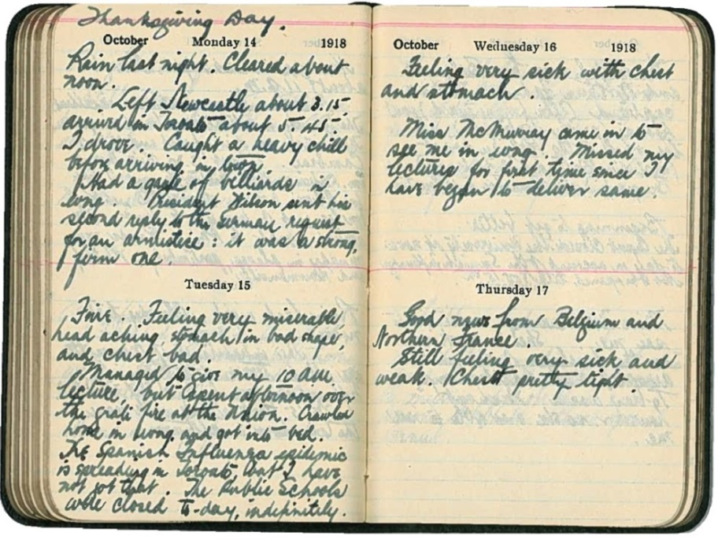

Diary entries of Edward G.R. Ardagh for Oct. 14-17, 1918

Ardagh family fonds, F 784-1

Archives of Ontario

|  |  |
| --- | --- |
| Thanksgiving Day  October Monday 14 1918  Rain last night. Cleared about noon.  Left Newcastle about 3.15, arrived in Toronto about 5.45. I drove. Caught a heavy chill before arriving in town. Had a game of billiards in evng. President Wilson sent his second reply to the German request for an armistice: it was a strong, firm one. | October Wednesday 16 1918  Feeling very sick with chest and stomach.  Miss McMurray came in to see in evng. Missed my lecture for first time since I have begun to deliver same. |
| Tuesday 15  Fair. Feeling very miserable, head aching, stomach in bad shape, and chest bad.  Managed to give my 10 am lecture, but spent afternoon over the grate fire at the Union. Crawled home in evng. and got into bed. The Spanish Influenza epidemic is spreading in Toronto, but I have not got that. The Public Schools were closed to-day, indefinitely. | Thursday 17  Good news from Belgium and Northern France.  Still feeling very sick and weak. Chest pretty tight. |

## Primary Source: Edward G.R. Ardagh’s Diary

Page 2 of 5

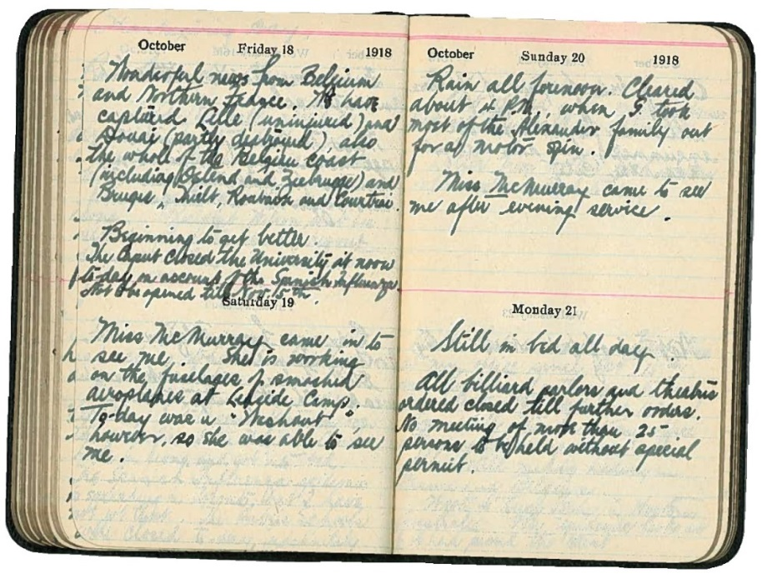

Diary entries of Edward G.R. Ardagh for Oct. 18-21, 1918

Ardagh family fonds, F 784-1

Archives of Ontario

|  |  |
| --- | --- |
| October Friday 18 1918  Wonderful news from Belgium and Northern France. We have captured Lille (uninjured) and Douai (partly destroyed), also the whole of the Belgian coast (including Ostend and Zeebrugge) and Bruges, Tielt, Roubaix and Courtrai.  Beginning to get better.  The Caput closed the University at noon tod-day on account of the Spanish Influenza. Not to be opened till Nov. 15th. | October Sunday 20 1918  Rain all forenoon. Cleared about 4 P.M., when G. took most of the Alexander family out for a motor spin.  Miss McMurray came to see me after evening service. |
| Saturday 19  Miss McMurray came in to see me. She is working on the fuselages of smashed aeroplanes at Leaside Camp. To-day was a “washout” however, so she was able to see me. | Monday 21  Still in bed all day.  All billiard parlors and theatres ordered closed till further orders. No meeting of more than 25 persons to be held without special permit. |

## Primary Source: Edward G.R. Ardagh’s Diary

Page 3 of 5

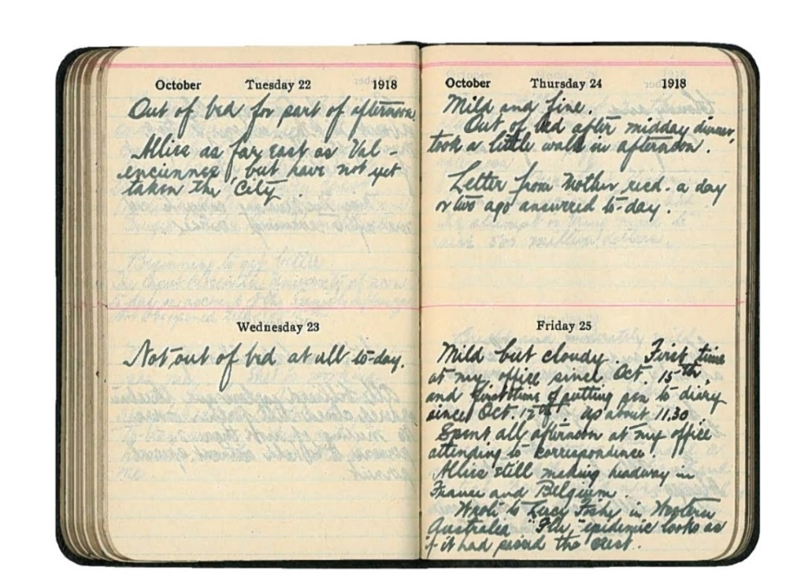

Diary entries of Edward G.R. Ardagh for Oct. 22-25, 1918

Ardagh family fonds, F 784-1

Archives of Ontario

|  |  |
| --- | --- |
| October Tuesday 22 1918  Out of bed for part of afternoon.  Allies as far east as Val – encienne, but have not yet taken the city. | October Thursday 24 1918  Mild and fine.  Out of bed after midday dinner, took a little walk in afternoon.  Letter from Mother recd. a day or two ago answered to-day. |
| Wednesday 23    Not out of bed at all to-day. | Friday 25  Mild but cloudy. First time at my office since Oct. 15th and first time of putting pen to diary since Oct. 12th. Up about 11.30.  Spent all afternoon at my office attending to correspondence.  Allies still making headway in France and Belgium.  Wrote to Lucy Fisher in Northern Australia. “Flu” epidemic looks as it if had passed the crest. |

## Primary Source: Edward G.R. Ardagh’s Diary

Page 4 of 5

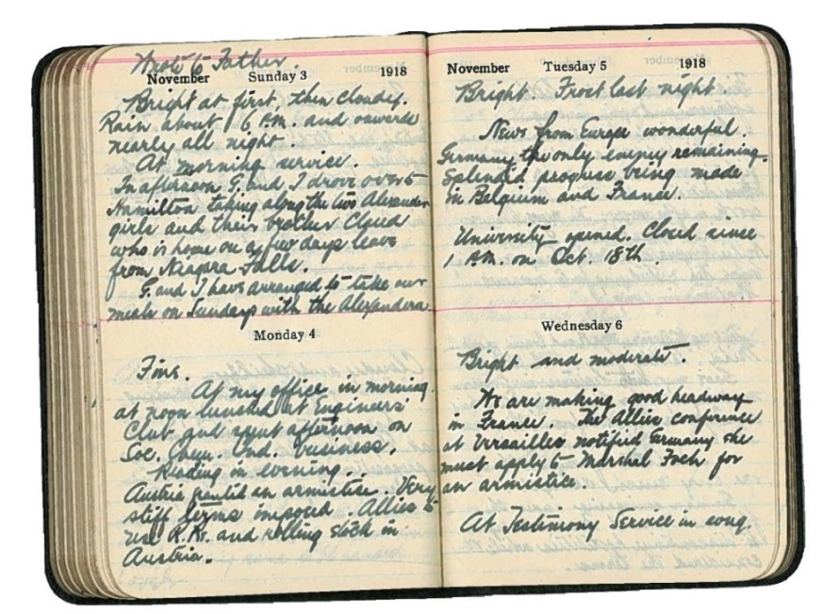

Diary entries of Edward G.R. Ardagh for Nov. 3-6, 1918

Ardagh family fonds, F 784-1

Archives of Ontario

|  |  |
| --- | --- |
| Wrote to Father.  November Sunday 3 1918  Bright at first, then cloudy.  Rain about 6 P.M. and onwards nearly all night.  At morning service.  In afternoon, G. and I drove out to Hamilton taking along the two Alexander girls and their brother Claude who is home on a few days leave from Niagara Falls.  G. and I have arranged to take our meals on Sundays with the Alexanders. | November Tuesday 5 1918  Bright. Frost last night.  News from Europe wonderful. Germany the only enemy remaining. Splendid progress being made in Belgium and France.  University opened. Closed since 1 P.M. on Oct. 18th. |
| Monday 4    Fine.  At my office in morning, at noon lunched at Engineers’ Club and spent afternoon on Soc. Chem. Ind. business.  Reading in evening.  Austria granted an armistice. Very stiff terms imposed. Allies to use R.Rs. and rolling stock in Austria. | Wednesday 6  Bright and moderate.  We are making good headway in France. The Allies conference at Versailles notified Germany she must apply to Marshal Foch for an armistice.  At Testimony Service in evng. |

## Primary Source: Edward G.R. Ardagh’s Diary

Page 5 of 5

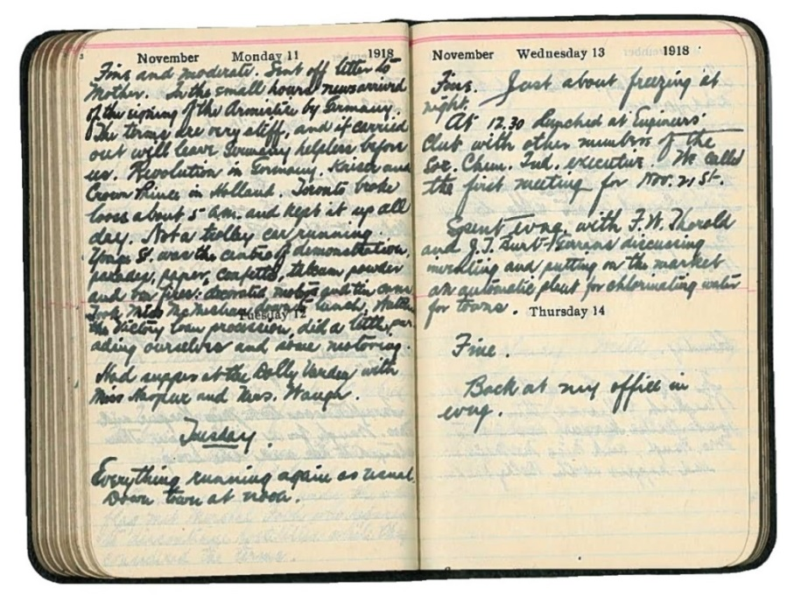

Diary entries of Edward G.R. Ardagh for Nov. 11-14, 1918

Ardagh family fonds, F 784-1

Archives of Ontario

|  |  |
| --- | --- |
| November Monday 11 1918  Fine and moderate. Sent off letter to mother. In the small hours news arrived of the signing of the Armistice by Germany. The terms are very stiff, and if carried out will leave Germany helpless before us. Revolution in Germany. Kaiser and Crown Prince in Holland. Toronto broke loose about 5 a.m. and kept it up all day. Not a trolley car running.  Yonge St. was the centre of demonstrations, parades, paper, confetti, talcum powder and bon fires; [unknown] and tin cans. Took Miss McMurray down to lunch, watched the Victory Loan procession, did a little parading ourselves and some restoring. Had supper at the Dolly Varden with Miss Harper and Mrs. Waugh. | November Wednesday 13 1918  Fine. Just about freezing at night.  At 12.30 lunched at Engineers’ Club with other members of the Soc. Chem. Ind. executive. We called the first meeting for Nov. 21st.  Spent time with F. W. Thorold and J.J. Burt/Gerrans discussing modeling and putting on the market an automatic plant for chlorinating water for towns. |
| Tuesday 12  Everything running again as usual.  South train at noon. | Thursday 14  Fine.  Back at my office in evng. |

## Primary Source: Influenza Precautions Poster

Poster entitled "INFLUENZA Precautions: Warning to Health Authorities," containing information and instructions to recognize and treat the flu illness.

Influenza poster, October 12, 1918  
Secretary of the Board of Health and Chief Medical Officer of Health subject files  
Reference Code: RG 62-4-9-450a.1, Archives of Ontario, I0055101

1. Source: Cook, Tim and William Stewart. “War Losses (Canada),” in *1914-1918-online. International Encyclopedia of the First World War*, ed. by Ute Daniel, Peter Gatrell, Oliver Janz, Heather Jones, Jennifer Keene, Alan Kramer, and Bill Nasson, Issued by Freie Universität Berlin, 2017. Accessed on June 5, 2018 at <https://encyclopedia.1914-1918-online.net/article/war_losses_canada>.
2. James-Abra, Erin, Janice Dickin, and Patricia G. Bailey. “Influenza Epidemics and Pandemics” in *The Canadian Encyclopedia*. Published September 29, 2009. Accessed on May 1, 2018, at <https://www.thecanadianencyclopedia.ca/en/article/influenza/>.
3. Ibid.
4. Registrar General, Province of Ontario. *Report Relating to the Registration of Births, Marriages, and Deaths in the Province of Ontario*, 1918. Toronto: A.T. Wilgress, 1919.
5. Kelm, Mary-Ellen. “What kind of Government is this?” (p1) for Defining Moments Canada. Published in 2018. Accessed July 10, 2018 at <https://definingmomentscanada.ca/wp-content/uploads/2018/06/First_Peoples.pdf>.
6. Bristow, Nancy (2017) as cited in Scheinberg, Ellen, “Piecing Together a Pandemic: Unearthing Elusive, Eclectic & Authentic Stories of the Flu” for ActiveHistory.ca, February 1, 2018. Accessed on August 27, 2018 at <http://activehistory.ca/2018/02/piecing-together-a-pandemic-unearthing-elusive-eclectic-authentic-stories-of-the-flu/>.
7. Jones, Esyllt. “What is Forgotten? Influenza’s Reverberations in Post-War Canada” for ActiveHistory.ca on January 20, 2018. Accessed on August 27, 2018 at <http://activehistory.ca/2018/01/what-is-forgotten-influenzas-reverberations-in-post-war-canada/>.
8. Ibid.
9. Belyea, Andrew. "The Spanish Influenza: Exploring Kingston's Deadly Epidemic of 1918” for the Museum of Health Care at Kingston. Published on November 7, 2017. Accessed on May 24, 2018 at <https://issuu.com/museumofhealthcare/docs/andrew_belyea_2017>.
10. Basen, Ira. “Why Canadian media embraced censorship during WWI” for CBC News. Published August 1, 2014. Accessed May 5, 2018 at <https://www.cbc.ca/news/why-canadian-media-embraced-censorship-during-wwi-ira-basen-1.2722786>.
11. Humphries, Mark Osborne. *The Last Plague: Spanish Influenza and the Politics of Public Health in Canada*. Toronto: University of Toronto Press, 2013, pp. 95.
12. Ibid., pp. 102.
13. Kelm, pp. 1.
14. Ibid., pp. 3.
15. “Bacterial Pneumonia Caused Most Deaths in 1918 Influenza Pandemic," for National Institutes of Health. Published on August 19, 2008. Accessed on May 24, 2018 at <https://www.nih.gov/news-events/news-releases/bacterial-pneumonia-caused-most-deaths-1918-influenza-pandemic>.
16. Humphries, pp. 147.
17. Bradburn, ibid.
18. Bradburn, ibid.
19. Humphries, pp. 138.
20. Earn, David. “How Many People Died from Influenza in 1918?” for Defining Moments Canada. Published in 2018. Accessed on August 27, 2018 at <https://definingmomentscanada.ca/wp-content/uploads/2018/06/Pandemic_by_Numbers.pdf>.
21. Bradburn, ibid.
22. Humphries, pp. 156.
23. “The Cost of Canada’s War.” Canadian War Museum, 2018. Accessed on July 10, 2018 at <https://www.warmuseum.ca/firstworldwar/history/after-the-war/legacy/the-cost-of-canadas-war/>.
24. James-Abra, Dickin, and Bailey, ibid.
25. MacTaggart, Hazel I. *Publications of the Government of Ontario, 1901-1955*. Toronto: University of Toronto Press, 1964.
26. Humphries, pp. 154.