# What is an Archive?

**archive**  
Pronunciation: *är-*secondarystress*k*imacr*v*

Function: noun  
**1:**a place in which public records or historical documents are preserved;also:the material preserved -- usually used in plural, as in “let’s visit the archives!”  
**2:**a collection of information

Function: verb  
Inflected Form(s): **ar·chived**;**ar·chiv·ing**  
**1:**to file or collect in or as if in an archive, as in “I’ve archived the letters”

Over the course of a lifetime, most people accumulate a variety of records. Taken together, these records can provide a view into someone’s life and into the past.

Like a detective investigating a case, a researcher using these records can get a sense of what a place looked like, what people were thinking, what life was like, and what happened and why. Historians use these records as **primary sources** for writing about and understanding the past.

Some examples of primary source that a historian may use are:

* birth, death, and marriage records
* letters or diaries
* photographs, sketches, and paintings
* court records
* audio, video and film records

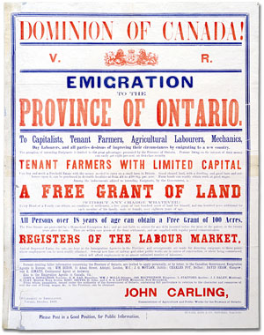Poster encouraging men to enlist in the Canadian Armed Forces during the First World War, featuring an illustrating oval portrait of a soldier. Text below reads "Make us as proud of you as we are of him!"
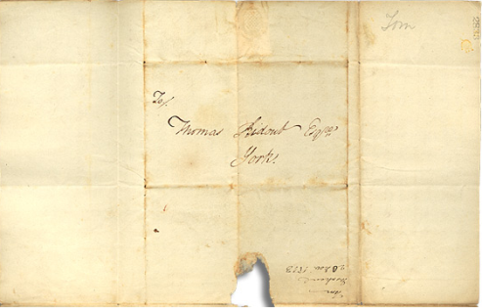

An **archive** is a place where these records and historical documents are preserved. The **Archives of Ontario** collects and preserves records with relevance to the history of Ontario.

# The Archives of Ontario

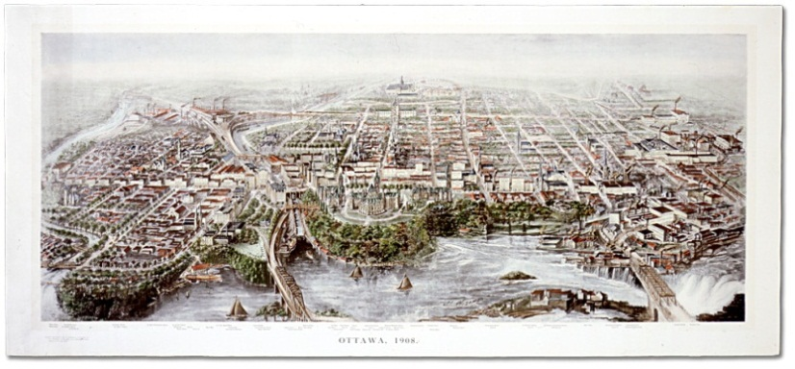

The Archives of Ontario is the **largest** provincial archive in Canada, with a collection that dates back to 1729, and reflects all aspects of public and private life in Ontario.

The core of the Archives’ collection is made up of Ontario government records. Stacked up, these documents alone would be 100 kilometres high—taller than 192 CN Towers.

| **Ontario Government Records** | The majority of the records in the collections of the Archives were created by the government of Ontario.  These records date from the late eighteenth century to the present day. They document political and legal decisions, the evolution of provincial administration, the interaction between the government and its citizens, and provide key evidence of the rights and responsibilities of Ontarians. |
| --- | --- |
| **Private Sector Records** | Since 1903, the Archives of Ontario has been acquiring records from the private sector.  The Archives holds the records of over 2600 private individuals, businesses, clubs and associations, labour and political organizations. These records include paper files, diaries, photographs, maps, architectural records, sound recordings and moving images.  These collections can range in size from one or two items to thousands of items that occupy hundreds of metres of shelf space. |
| **Genealogical Records** | The Archives of Ontario holds many important sources for researching family history in Ontario. There is no single finding aid or database for this type of research. |
| **Vital Statistics** | By far our most popular records are historical registrations of births, marriages and deaths. |
| **Special Collections** | These collections can include photographs, cartographic records, architectural records, caricatures and cartoons, posters, sound and moving images, and the Government of Ontario Art Collection. |

# The Archives in Action

People use the Archives of Ontario for different reasons. This map is a good example. This patent plan of Seneca Township from 1842 can be used in many different ways by different people.

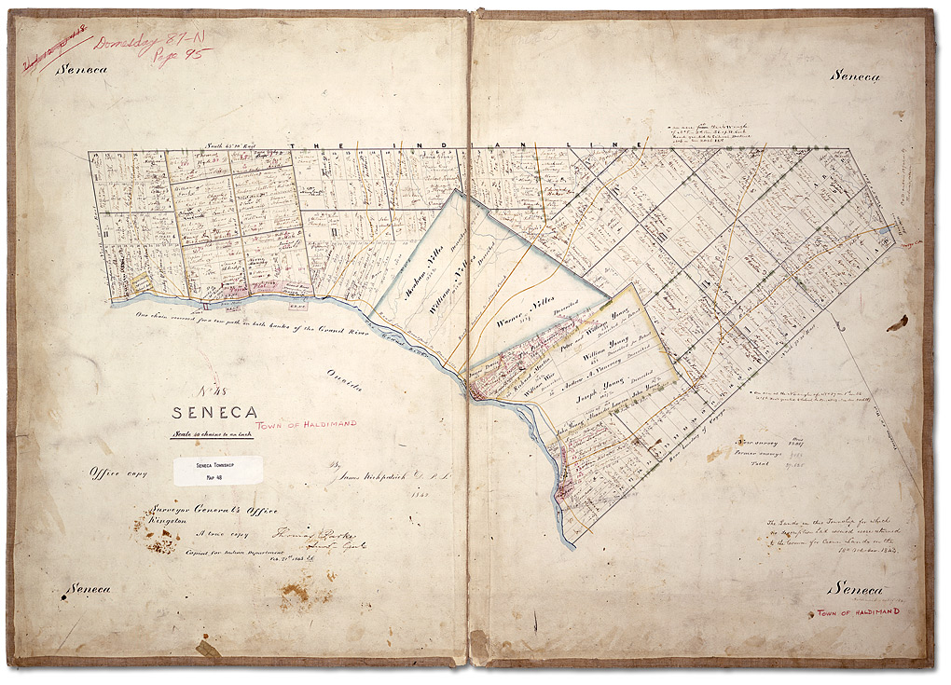

Patent plan of Seneca Township  
Patent plans  
Reference Code: RG 1-100, C-51  
Archives of Ontario

Who do you think could use this map?_______________________________________

________________________________________________________________________________________________________________________________________________________________________________________________________________

For What purposes could this map be used?__________________________________

______________________________________________________________________________________________________________________________________________________________________________________________________________________________________________________________________________________

# The Archives in Action

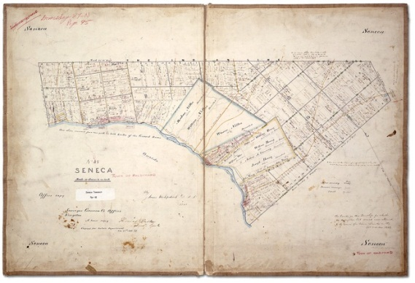

We’ve identified some ways people could use this map when they visit us in the Reading Room.

**Can you think of any others?**

**Genealogists** research family history and collect documentary evidence of family events. They would use this patent plan to:

* connect an individual to a particular lot of land
* map out a person’s relationship to surrounding families
* help prove an ancestor’s status as a patentee or original owner of a lot.

**Students** like you can learn directly from primary source materials by appreciating the context for historic events. A student would use the map to understand:

* how land was granted
* see a visual representation of the settlement of Ontario.

**First Nations people** use archives to examine evidence of traditions and especially to provide legal right to lands or native status. This map might show original reserve boundaries.

**Property-owners** may need to research the history of their land or building and determine boundaries. Maps can be used to:

* show the size and shape of the original lot.
* show who lived on the land.

**Archaeologists** collect evidence to support conservation of an area as historically important and will plan excavation activities using evidence of early settlements. Maps such as this can be used to:

* locate early and important settlements.
* identify areas with historical significance that should be preserved.

**Environmental engineers** gather information about plots of land for corporate clients or environment groups. Maps can be used to:

* uncover past uses of land that may impact on new development; for example, church reserves, industrial use, mining rights, or historical significance.