# Introduction to the Archives of Ontario for Teachers

The Archives of Ontario is the largest provincial archive in Canada, with a collection that dates back to 1729, and reflects all aspects of public and private life in Ontario.

As teachers, you’ve seen students’ excitement when they are able to use primary sources. The Archives of Ontario’s extensive holdings can provide the **thrill of discovery** for your students.

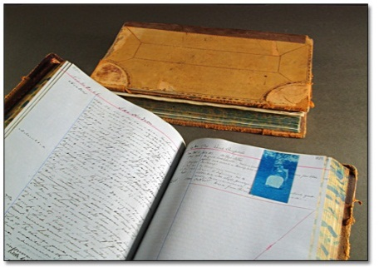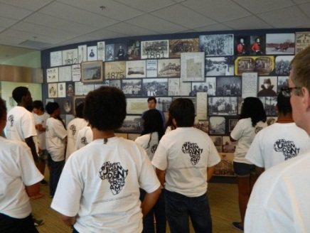

The Archives of Ontario offers four different types of educational programmes to support the use of archival material in your class:

* Onsite workshops
* Online lesson plans
* Travelling workshops
* Onsite and travelling professional development for teachers

We also provide general resources to navigate the Archives of Ontario. [Visit our website](http://www.ontario.ca/archives) to explore:

* Archives Descriptive Database
* Visual Database
* Research Guides and Tools

Visit our facility to use and explore our specially designed Reading Room, exhibit space, and classroom. We are conveniently located on the York University campus:

| This picture is a map of the York University Campus to help researchers find the Archives of Ontario | Archives of Ontario  134 Ian Macdonald Boulevard  Toronto, Ontario, Canada, M7A 2C5  **Contact us** for more information about how we can support your teaching at reference@ontario.ca or 1-800-668-9933. |
| --- | --- |