The War of 1812: Loyalty and Treason in Upper Canada

Grade 12: Canada: History, Identity, and Culture

## Overview

All of the Archives of Ontario lesson plans have two components:

* The first component introduces students to the concept of an archive and why the Archives of Ontario is an important resource for learning history
* The second component is content-based and focuses on the critical exploration of a historical topic that fits with the Ontario History and Social Studies Curriculum for grades 3 to 12. This plan is specifically designed to align with the Grade 12: Canada: History, Identity, and Culture curricula.

We have provided archival material and an activity for you to do in your classroom. You can do these lessons as outlined or modify them to suit your needs. Feedback or suggestions for other lesson plans are welcome.

**This purpose of the lesson plan** is for students to gain a better understanding of the political and social climate during the War of 1812, specifically focusing on the Government’s attempt to prevent and punish deserters and those who actively aided the Americans. Students will use a number of skills, including interpretation and analysis, critical thinking, research, and communication to examine the War of 1812 and the effects it had on the economic, social, and political life of Upper Canada. This lesson can bridge into a discussion about Canada’s evolving identity and culture and the policies and practices that influenced its development at this early stage of Canada’s history.

## Curriculum Connections

**Overall Expectations**

*Communities: Local, National, and Global*

* analyse the principal characteristics of the French and English colonial experience in Canada

*Change and Continuity*

* analyse how Canada’s relationships with France, Britain, and the United States have influenced Canada’s identity and culture

*Citizenship and Heritage*

* evaluate the claim that Canada is a just society, by examining issues related to human rights

*Social, Economic, and Political Structures*

* analyse changes in Canadian social programs and policies over time
* evaluate the impact of Canada’s national and international economic policies on Canadian identity and sovereignty
* describe the nature of the Canadian political system and the groups and individuals who have contributed to its development

*Methods of Historical Inquiry and Communication*

* use methods of historical inquiry to locate, gather, evaluate, and organize research materials from a variety of sources
* interpret and analyse information gathered through research, employing concepts and approaches appropriate to historical inquiry
* communicate the results of historical inquiries, using appropriate terms and concepts and a variety of forms of communication.

## Lesson Plan

This lesson is designed for two classes, however it can be lengthened or shortened based on your students’ needs.

* + - * Begin by introducing the concept of an archive and how the Archives of Ontario can help answer research questions related to history. See **Overhead 1: Exploration Through the Archives** to introduce this to your students and the following text to prepare yourself:

Over the course of a lifetime, most people accumulate a variety of records. It starts with a birth certificate and expands into awards, bank statements, receipts, letters, photographs – anything that documents important events and relationships in one’s life. These records comprise an individual’s personal archives. Governments, businesses, schools, associations and organizations of all types do the same, keeping records as evidence of their activities and accomplishments.

These documents provide a fascinating view into the past. Like a detective investigating a case, a researcher using these records can get a sense of what a place looked like, what people were thinking, what life was like, and what happened and why. Anyone with an interest in the past, whether it is delving into local history, tracing a family tree, or probing decisions and events, will find answers in archives.

Some examples are:

* + letters, manuscripts, diaries often from famous people
  + notes or recordings of interviews
  + photographs, sketches and paintings
  + birth, death and marriage records
  + land registries, titles to property, and maps
  + court records
  + architectural plans and engineering drawings
  + audio, video and film records

Archives are important resources for answering our questions about the past. Records may be used to settle legal claims, they may clarify family history, they are grist for historians, and they impart to filmmakers and authors a sense of the ways things were. Whatever the reason, archives have a story to tell.

The first step is to identify your research question and what you are hoping to find in the Archives to provide support to that question.

* + - * Following this introduction, discuss the possible aftereffects of the War of 1812 and the measures the government may have taken to quell any further disruption. Does the end justify the means? Provide students with **Student Handout: Loyalty and Treason** to introduce the lesson’s topic
      * Arrange students into groups of three and provide each group of students with a document set from Station A, B, and C. Note: this activity can also be run as a jigsaw.
      * Allow students to work in their small groups reading each group of sources, answering the attached questions, and having a discussion about what they have discovered.
      * In the following class, break students into two camps and lead a debate about whether the measures for Treason were just or too harsh.
      * Follow with a written assignment summarizing their findings.

## Extension

This lesson can bridge into a discussion about Canada’s evolving identity and culture and the policies and practices that influenced its development at this early stage of Canada’s history.

# Handouts & Worksheets

Overhead 1: Exploration through the Archives! 5

Student Handout: Loyalty and Treason 6

Station A: Legislation – Questions 7

Station A: Legislation – Introduction 8

Station A: Legislation – Resource 1 9

Station A: Legislation – Resource 2 10

Station A: Legislation – Resource 3 11

Station B: Trials – Questions 12

Station A: Trials – Introduction 13

Station B: Trials – Resource 1 14

Station B: Trials – Resource 2 15

Station B: Trials – Resource 3 16

Station C: The Aftermath – Questions 17

Station C: Aftermath – Introduction 18

Station C: Aftermath – Resource 1 19

Station C: Aftermath – Resource 2 20

Station C: Aftermath – Resource 3 21

Marking Rubric 22

### Overhead 1: Exploration through the Archives!

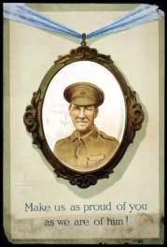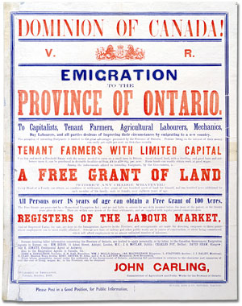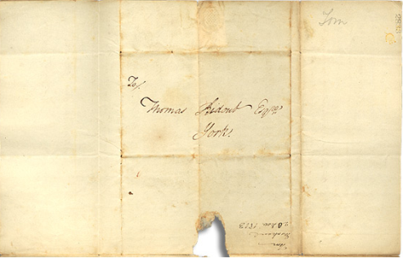

Over the course of a lifetime, most people accumulate a variety of records.

Taken together, these records can provide a fascinating view into someone’s life and into the past.

Like a detective investigating a case, a researcher using these records can get a sense of what a place looked like, what people were thinking, what life was like, and what happened and why.

Some examples of records that a historian may look at are:

* Birth, death, and marriage records
* letters or diaries
* photographs, sketches, and paintings
* court records
* audio, video and film records

An **archive** is a place where these records and historical documents are preserved. The **Archives of Ontario** collects and preserves records with relevance to the history of Ontario.

Using primary sources from the Archives of Ontario’s collections, you too can be an investigator exploring the past and understanding the present.

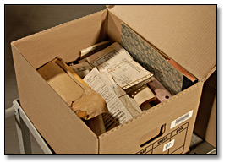 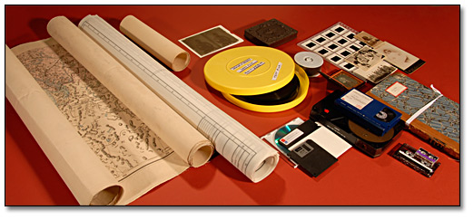 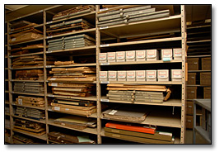

### Student Handout: Loyalty and Treason

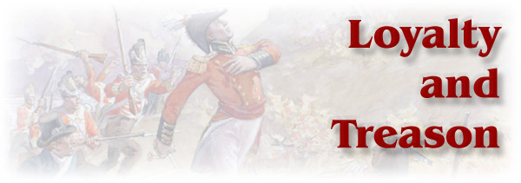

Wartime in Upper Canada, which had a mixed population of loyalists and more recent American immigrants, posed problems for individuals and the government. General Brock began the war pessimistic about the loyalty of a significant part of the population and doubts remained about the reliability of the newcomers throughout the war. The level of political disaffection or pro-American sentiment in the province is difficult to measure. The refusal of the Legislative Assembly to suspend Habeas Corpus early in the war has been interpreted as disloyal or a principled stand against arbitrary government, depending on the view of the writer.

There is no doubt that some residents actively helped American forces when parts of Upper Canada were under military occupation. Joseph Wilcocks and his Canadian Volunteers fought on the American side at Fort Erie (Wilcocks was killed during the attack on the siege works in September). Others left the province during the war for the United States, possibly out of loyalty to that country, possibly to avoid militia service or possibly to avoid the destruction visited by both sides along the border areas.

Loyalty to the British connection and support for the military effort was also part of the wartime reality. The role of the militia in the defence of Upper Canada has been the subject of debate for decades. However, many served and a number were killed or disabled and provisions were made for widows and orphans pensions through public and private sources.

Those who came through the war able-bodied were eligible for land grants, in part obtained through the seizure of lands of those found to have been disloyal. Loyal service was also marked through personal advancement, as the subsequent careers of John Beverley Robinson, John Strachan, William Hamilton Merritt, the Ridouts and the Nelles' attest to, at least in part.

*This information can be found on the Archives of Ontario’s on-line exhibit on the War of 1812.*

### Station A: Legislation – Questions



Section header which reads "Legislation" in red letters.

**Document: Cap. IX Statute of Upper Canada (1814)**

* What does this document say about people who left Upper Canada during the War of 1812 without permission? Who did they need permission from to leave? What was their punishment for leaving?
* How do you think we define the term ‘alien’ today? Is it the same as the Government of Upper Canada defined it in 1814?

**Document: Kingston Gazette Article (1815)**

* Was the Sedition Act of 1804 strengthened or weakened by the Act as described in the article? Give evidence to support your answer.

**Document: Alien Act Records, Gore District (1816-1817)**

* What is an inquisition?
* Who was being charged at this inquisition?
* What were the charges against him? What legislation supported these charges?

### Station A: Legislation – Introduction

On March 14, 1814, the Legislature of Upper Canada passed three acts as emergency measures. The first limited the right to habeas corpus applications for those accused of treason; the second provided for trials for treason and related charges in districts outside the area where the alleged offences occurred; the third act, and the one that had the greatest impact, was the Alien Act which made it an offence for anyone to have left the province after July 1812 for the United States.

Special Commissioners were appointed under the Act to investigate individuals accused under its terms. The Commissions had the authority to declare the individual an alien and thus ineligible to hold land in Upper Canada.

The passage of these acts and the subsequent "Bloody Assize" at Ancaster was the direct result of the reverses suffered by the British in the Niagara and Western Districts during 1813.

Those inclined to support the invaders were in a position to do so, and many personal scores were settled through the destruction of property of those who were loyal or by the kidnapping of active militia officers.

Many of the prisoners tried at Ancaster had been captured in a raid by militia under the command of Colonel Bostwick on a party of U.S. troops and Canadian irregulars near London.

The near anarchy in the region west of the Grand River after Proctor's defeat at Moraviantown made it impossible to hold the trials in that area as would be the normal procedure. It was also feared that Justices of the Peace friendly or sympathetic to the accused would grant bail, allowing them to slip over the border or behind enemy lines.

Special Commissioners were appointed under the Act to investigate individuals accused under its terms. The Commissions had the authority to declare the individual an alien and thus ineligible to hold land in Upper Canada.

The passage of these acts and the subsequent "Bloody Assize" at Ancaster was the direct result of the reverses suffered by the British in the Niagara and Western Districts during 1813.

Those inclined to support the invaders were in a position to do so, and many personal scores were settled through the destruction of property of those who were loyal or by the kidnapping of active militia officers.

Many of the prisoners tried at Ancaster had been captured in a raid by militia under the command of Colonel Bostwick on a party of U.S. troops and Canadian irregulars near London.

The near anarchy in the region west of the Grand River after Proctor's defeat at Moraviantown made it impossible to hold the trials in that area as would be the normal procedure. It was also feared that Justices of the Peace friendly or sympathetic to the accused would grant bail, allowing them to slip over the border or behind enemy lines.

### Station A: Legislation – Resource 1

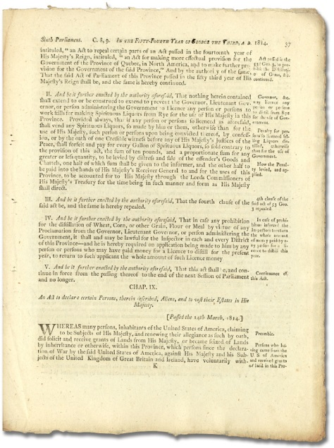

**Cap. IX Statute of Upper Canada (1814)**

An Act to declare certain Persons, therein described, Aliens,

and to vest their Estates in His Majesty.  
Statutes of Upper Canada, 54 George III, Cap IX, 1814  
Archives of Ontario

**CHAP. IX.**

*An Act to declare certain Persons, therein described, Aliens, and to vest their Estates in His Majesty*

[Passed the 14th March 1814]

WHEREAS many persons, inhabitants of the United States of America, claiming to be subjects of His Majesty, and renewing their allegiance as such by oath, did solicit and receive grants of Lands from His Majesty, or became seized of Lands by inheritance or otherwise, within this Province, which persons since the declaration of War by the said United States of America, against his Majesty and his Subjects of the United Kingdom of Great Britain and Ireland, have voluntarily with-drawn themselves from their said allegiance, and the defence of the said Province: Be it therefore enacted by the King’s Most Excellent Majesty, by and with the advice and consent of the Legislative Council… Voluntarily withdrew themselves from this Province into the said United States, without licence granted under the authority of the Governor, Lieutenant Governor or person administering the Government of this Province, shall be taken and considered to be Aliens born and incapable of holding Lands within this Province.

Extract from the Statutes of Upper Canada, 54 George III, Cap. IX, 1814

Textual Record (Microfilm B 91)

Archives of Ontario

### Station A: Legislation – Resource 2

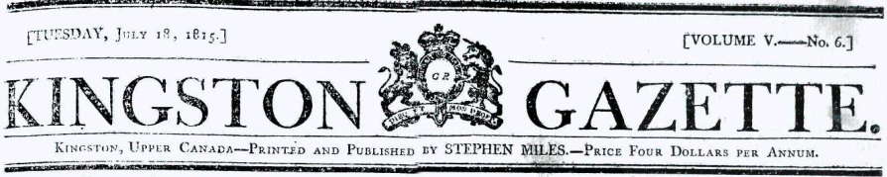

| Newspaper article titled Uper Canada. | **Upper Canada.**  GEORGE the THIRD by the Grace of God of the United Kingdom of Great Britain and Ireland King, Defender of the Faith.  “WHEREAS it has been presented to us, that diverse persons who withdrew from the protection of our Government immediately previous to the late declaration of War by the United States of American, or during actual Hostilities, are about to return to our Province of Upper Canada; We have thought fit by and with the advice of our Executive Council to call upon the members of the Legislative and Executive Councils, the Judges and others Commissioned to carry into effect the provisions of a certain Statute made and passed in the forty fourth year of our Reign, entitled “An Act for better securing this Province against all seditious attempts or designs to disturb the tranquility thereof,” to be vigilant in the execution of their duty, under the authority of the above recited Act.”  *The Sedition Act of 1804 provided for the expulsion from the province, on very slight grounds, of anyone who had not been a resident six months or taken the oath of allegiance.  Kingston Gazette, July 18, 1815. |
| --- | --- |

### Station A: Legislation – Resource 3

**Alien Act Records, Gore District**

**UPPER CANADA DISTRICT OF GORE**

AN INQUISITION indented taken at the Township of Ancaster in the said District, on the Ninth day of June in the Year of Our Lord One Thousand Eight Hundred and Seventeen before us Richard and George Commissioners of our said Lord the King, by virtue of the Commission of the said Lord King, under the Great Seal of this Province of Upper-Canada, Sealed bearing date at York the thirtieth day of December 1816 last past, to use directed and to this Inquisition annexed, to enquire on the behalf of the said Lord the King, of certain things, articles, and circumstances in the same Commission specified by the oath of [names of jurors] good and lawful men of the District aforesaid, who being sworn and charged of and upon the Premises on their oath say that John Wagstaff in the Commission aforesaid named, formerly an inhabitant of the United States of America, claiming to be a subject of our said Lord the King, and renewing his allegiance as such by oath did since the first day of July, One Thousand Eight Hundred and Twelve, and before the conclusion of the late war with the said United States of America, voluntarily withdraw himself from our Province of Upper-Canada into the said United States of America, without licence granted under the authority of the Governor, Lieutenant Governor, of Person administering the Government of the same: - And the Jurors aforesaid upon their oath aforesaid, do further say that the said John Wagstaff was on the said first day of July, One Thousand Eight Hundred and Twelve, seized in his Demesne, as of fee, of and in a certain parcel of Tract of Land situate in the Township of Town of Niagara in the District aforesaid, known and described as follows, that is to say, being Lot Number 16 in the Concession of the said Township, containing about thirty acres. The lot or lots in the Town of Niagara in the Niagara District. And the Jurors aforesaid, upon their oath aforesaid, further say that the said John Wagstaff had no other Lands, Tenements, or Hereditaments within the Province aforesaid, to the knowledge of the same Jurors.

In Testimony whereof as well the said Commissions as the Jurors aforesaid, to this Inquisition their seals have caused to be set, the day and year first above said.

[Names of Jurors]

Alien Act Records

Gore District, 1816-1817

Envelope 1, Reference Code RG 22-144, Box 1

Archives of Ontario

### Station B: Trials – Questions



Section header which reads "Trials" in red letters.


**Document: Order reciting the sentence under the Treason Act (1814)**

* What is treason?
* Do you think the punishment described in this document fits the crime? Why?

**Document: York Gazette Article (1814)**

* What was this article reporting on?
* What were the results of the news the article was reporting on? Did they match with the sentence of the Treason Act? Why?

### Station A: Trials – Introduction

Section header which reads "Trials" in red letters.


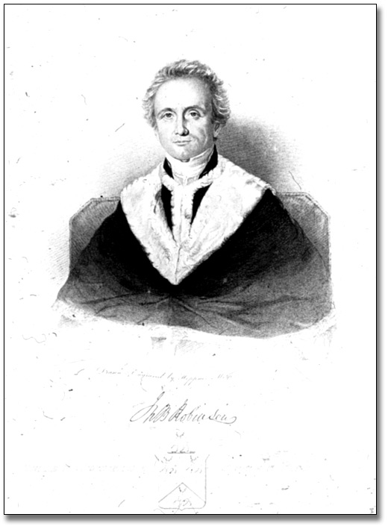

Sir John Beverly Robinson, Chief Justice, Upper Canada, [ca. 1840]

Hoppner Meyer

Archives of Ontario documentary art collection

Reference Code: C 281-0-0-0-143

Archives of Ontario, I0003072

John Beverley Robinson served as the Acting Attorney General through most of the War of 1812. He took the lead in prosecuting those accused of High Treason at Ancaster in the Spring of 1814 and secured the conviction of 15 men. All were sentenced to hang, but 7 were eventually commuted to deportation. The remaining 8 were sentenced to be executed by hanging at Ancaster in July.

It is unclear whether the full rigour of the sentence against the eight condemned men was carried out. Of the seven whose death sentences were reprieved, one escaped and two died in custody before they could be deported from Upper Canada.

### Station B: Trials – Resource 1

**Order reciting the sentence under the Treason Act**

“[the prisoners shall be] hanged by the neck, but not until they be dead, to be cut down alive, and their entrails to be taken out and burnt before their faces, and their heads cut off and their bodies divided into four quarters and their heads and quarters disposed of at the King's pleasure…”

Extract from a copy of the order reciting the sentence under the Treason Act, 1814

Pre-Confederation Correspondence of the Attorney General

Reference Code: RG 4-1, box 2

Archives of Ontario

### Station B: Trials – Resource 2

**Letter from J. B. Robinson to Captain Loring (1814)**

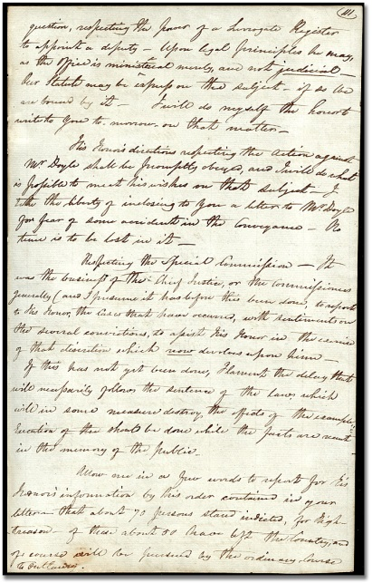

Extract from a copy of a letter from J. B. Robinson to Captain Loring, Secretary to Gordon Drummond, June 19, 1814

John Beverley Robinson family fonds

Reference Code: F 44, box MU 5911

Archives of Ontario

Allow me in a few words to report for his Honors information by his order contained in your letter in that about 70 person stand indicted for high treason, of these about 50 have left the Country and of course will be pursued by the ordinary course of outlawry….[goes on to describe the acts which led to the guilty verdicts]…John Dunham…was one of the ringleaders of the rebels in the London District, who carried several militia officers, and inhabitants, prisoners to Buffalo - his house was their headquarters…Dalton Lindsay, George Peacock, Benjamin Simmonds - three of the rebels in the service of the enemy in the District of London in Nov. last, making prisoners of our militia officers…and advancing to destroy Dover and take the public Stores there, were taken in open rebellion by Col. Bostwick's party of volunteer militia….Aaron Stevens -- A man formerly in the confidence of the government, of respectable family and property, convicted of having acted as a spy for the enemy - going for that purpose to Burlington, when General Vincent commanded there, surveying the works and garrison and conveying the intelligence to Gen'l Boyd for a large pecuniary reward. He was, besides, constantly with the enemy when they possessed Fort George, and often seen with them in arms.

### Station B: Trials – Resource 3

**York Gazette (1814)**

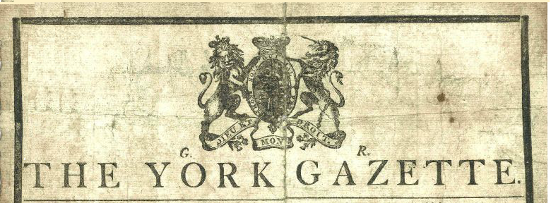

**DISAFFECTION PUNISHED: THE ANCASTER TRIALS**

PROCLAMATION July 25, 1814.

His Honor Lieutenant General DRUMMOND, President, administering the Province of Upper Canada, communicates thus publicly to the Inhabitants of this Colony, the results of the Proceedings at Ancaster, in the District of Niagara on Monday the 23rd day of May last, for the Trial of Persons charged with High Treason.

Of those, eight (the principal offenders, if guilt like theirs admitted of discrimination) suffered the execution of the awful sentence of the law, at Burlington, in the District of Niagara, on Wednesday, the 20th day of July instant. The remaining seven are reprieved until his Majesty’s Royal Pleasure shall be known.”

Extracts of an article in the York Gazette, December 24, 1814.

Bowler, Arthur. The War of 1812.

“Canadian History Through the Press Series”

Ed. David P. Gagan and Anthony W. Rasporich. Toronto: Holt, Rinehart and Winston of Canada, Limited, 1973. Pages 74-75.

Archives of Ontario Library

### Station C: The Aftermath – Questions



Section header which reads "Aftermath" in red letters.

**Document: Treason Poster (1821)**

* What was the purpose of this poster? Why would the Government of Upper Canada published these names and send them out to districts to display?
* What were people required to do if they knew of any other people guilty of these crimes?

**Document: High Treason Records, K.V. Benajah Mallory (1814)**

* What is an indictment?
* Who was being charged at this indictment?
* What were the charges against him? What legislation supported these charges?
* What was the punishment for these charges?

**Document: Extract from a copy of a letter from Edward McMahon… (1814)**

* What was Edward McMahon writing about in his letter to Thomas Merritt?
* Do you think this punishment was fair for those involved? Why?
* Do you think it was necessary for the Government of Upper Canada to carry out a punishment such as this? Why?

### Station C: Aftermath – Introduction

Section header which reads "Aftermath" in red letters.

The authorities reacted to invasion and treason by contemplating punishment of the families of those executed or declared outlaw, though there is no documentary proof that the order was carried out. The severity of an order like this shows the depths of feeling in the province after two years of war and the kind of extraordinary measures the authorities were willing to take in the interests of security.

### Station C: Aftermath – Resource 1

**Treason Poster (1812)**

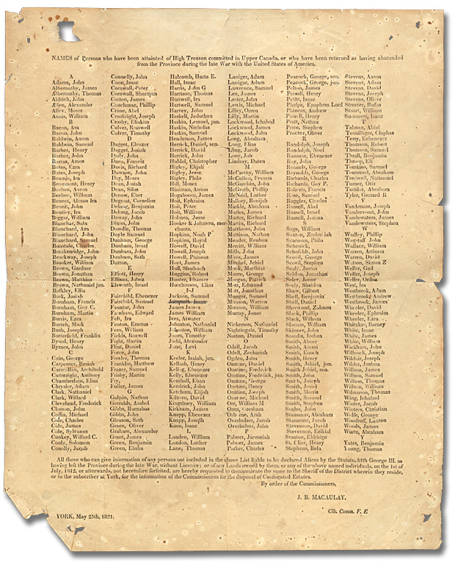

Treason Poster, 1821

Newcastle District Clerk of the Peace high treason in War of 1812 poster

Reference Code: RG 22-3782

Archives of Ontario

This poster lists all those convicted at Ancaster of High Treason, those outlawed but not captured for trial for serving with American forces and all those who's property was forfeited through the proceedings of the Special Commissions under the Alien Act.

The broadsheet would have been distributed to judicial and local officials, so far as is known this copy sent to the Clerk of the Peace for the Newcastle District is the only one to survive.

### Station C: Aftermath – Resource 2

**High Treason Records (1814)**

Upper Canada, Home District, To Wit.

George the Third, by the Grace of God of the United Kingdom of Great Britain and Ireland, King, Defender of the Faith.

To our Justices lately assigned by Letters Patent under the Great Seal of our Province of Upper Canada, to inquire by the oath of good and lawful Men of the District of Niagara, according to the form of the Statute in such case made and provided, of all High Treasons, misprision of High Treason, and Treasonable Practices in the said District of Niagara, or District of London committed, and also to deliver the Gaols of the said Districts of the Prisoners therein, for the offences aforesaid confined – and to every one them,

GREETINGS: -

We being willing for certain reasons, that all and singular indictments of whatsoever High Treasons whereof Benajah Mallory [?] of the Township of Bradford in the District of London gentleman is indicted before you as is said, be certified before us, together with the Proceedings had before you thereupon, do command you, and every of you, that you, or some, or one you, do send under your Seals, or the Seal of one of you, before us on Monday the [?] day of February Term next, whatsoever we shall then be in Upper Canada, all and singular the said Indictments, with all proceedings thereupon, and all things touching the same, by whatsoever name in the said Benajah Mallory according to the law and custom of England, and the laws of this Province we shall see fit to be done.

Witness the Honorable Thomas Scott, Chief Justice at York,

this nineteenth day of November in the fifty fifth year of our Reign.

High Treason Records (1814)

K.V. Benajah Mallory, 1814

Reference Code RG 22-143-0-1, Box 1

Archives of Ontario

### Station C: Aftermath – Resource 3

**Letter from Edward McMahon to Thomas Merritt (1814)**

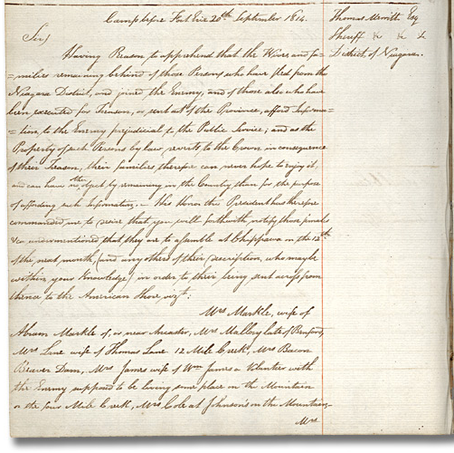

Letter from Edward McMahon to Thomas Merritt Sheriff of the Niagara District, September 20, 1814

Sir Gordon Drummond fonds

Reference Code: F 955

Archives of Ontario

September 20, 1814

Sir,

Having reason to apprehend that the Wives and families remaining behind of those persons who have fled from the Niagara District and joined the enemy, and of those also who have been executed for Treason, or sent out of the Province, afford Information to the Enemy prejudicial to the Public Service; and as the Property of such persons by law reverts to the Crown in consequence of their Treason, their families therefore can never hope to enjoy it and can have no other object by remaining in the Country than for the purpose of affording such Information. His Honor the President has therefore commanded me to desire that you will forthwith notify those females etc. under mentioned that they are to assemble at Chippawa on the 12th of the next month (and any others of their description who may be within your knowledge) in order to their being sent across from thence to the American…

Extract from a copy of a letter from Edward McMahon to Thomas Merritt Sheriff of the Niagara District, September 20, 1814

Sir Gordon Drummond Fonds

Reference Code F 955

Archives of Ontario

### Marking Rubric

| **Criteria** | **Level 1** | **Level 2** | **Level 3** | **Level 4** |
| --- | --- | --- | --- | --- |
| ***Knowledge and Understanding***  The student understands the social and political context of loyalty and treason in Upper Canada. | Limited understanding of the source materials as they relate to the social and political context of Upper Canada. | Some understanding—though lacking in clarity and integration—of the source materials as they relate to the social and political context of Upper Canada. | Clear and comprehensive understanding of the source materials as they relate to the social and political context of Upper Canada. | A clear, comprehensive, and balanced understanding of the source materials as they relate to the social and political context of Upper Canada. |
| ***Thinking/Inquiry***  The student demonstrates the ability to analyze critically the data presented within the exhibit and to situate it within a larger social and political context. | Unclear perspective and analysis that shows little understanding of the historical context. | Somewhat effective organization and interpretation of data but with limited understanding of the historical context. | A clear, critical position that is evident in all aspects of the work, with good understanding of the historical context. | A critical analysis presented with ability and clarity resulting in a precise and persuasive interpretation of the historical context. |
| ***Communication***  The student writes and speaks effectively, using terminology correctly from the source materials and using language effectively to convey conclusions. | Use of language and imagined details demonstrating little understanding of or sensitivity to the historical context and poorly reasoned support for conclusions. | Somewhat effective use of language but with limited sensitivity to another time and place and only limited persuasiveness in the presentation of conclusions. | Effective use of language, a well conceived time and place and reasonable arguments to support conclusions. | Lively, engaging and appropriate use of language to present well reasoned and persuasive conclusions. |
| ***Application***  The student, having interpreted the materials, is able to arrive at an independent evaluation of official actions. | Little awareness of the facts or of the results of official actions and their appropriateness or relevance. | Basic acknowledgement of the facts and some sense of the positive and negative results of official action. | Thoughtful understanding and appropriate evaluation of the official position and the impact of actions taken. | Developed, thoughtful and well-articulated evaluation of the facts, the official position regarding traitors and the impact of actions taken. |