| **Archives of Ontario** |  |
| --- | --- |
| Research Guide 224  Patient and Health Practitioner Records  Last Updated: February 2023 | |

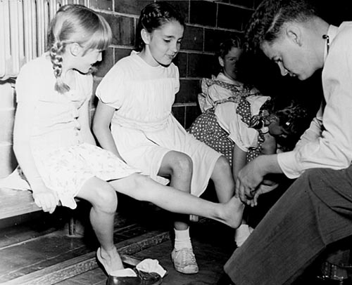

Doctor attending to girls, West Toronto YWCA, [195-?]

F 974-6-0-39, I0009476

Young Women's Christian Association of Metropolitan Toronto fonds

In this Guide 2

The Records 2

Accessing Patient Records – Record Restrictions 2

Patient Records 3

General Hospitals 3

Private Hospitals 3

Psychiatric Hospitals 3

Tuberculosis Hospitals 4

Centres for Developmentally and Emotionally Disabled Individuals 5

Records of Physicians, Nurses and Other Healthcare Practitioners 6

Physicians’ Records 6

Lists and Directories of Physicians 7

Healthcare Practitioners 7

Nurses 7

How do I get to the online descriptions? 8

Contact us 8

In this Guide

This research guide will help you find, and access patient records and records related to health practitioners in the Archives of Ontario collection.

*Note: All record descriptions mentioned in this guide are available in our online Archives and Information Management System (AIMS), unless noted otherwise. You will find the database in the “Access Our Collections” section of our website. Consult the “How do I get to the online descriptions” section at the end of the guide for more information.

The Records

Most of the patient records in the Archives of Ontario collection are from Psychiatric Hospitals, Tuberculosis hospitals, or Centres for Developmentally and Emotionally Disabled Individuals.

The Archives of Ontario also holds a variety of records from Physicians, Nurses, and other Healthcare practitioners. We have many historical collections of records created by physicians from the 1700s to the 1900s. We also hold lists and directories of physicians and healthcare providers, and records from some Ontario nursing schools.

Accessing Patient Records – Record Restrictions

Access to most patient files is restricted by the Freedom of Information and Protection of Privacy Act. Check the Restrictions on Access and How to order these records sections of a record group description for information on which restrictions apply.

In order to access restricted files, you must make a Freedom of Information request. You can find more information about the access request process in [our guide to Freedom of Information and Protection of Privacy](http://www.archives.gov.on.ca/en/access/documents/customer_service_guide_109_freedom_of_information.pdf), and you can find [the access request form on this page](http://www.forms.ssb.gov.on.ca/mbs/ssb/forms/ssbforms.nsf/FormDetail?OpenForm&ACT=RDR&TAB=PROFILE&SRCH=&ENV=WWE&TIT=on00089&NO=ON00089E).

You can generally access unrestricted patient records in the Archives of Ontario Reading Room by using our self-service microfilm or by contacting a reference archivist and requesting the relevant containers before your visit.

Patient Records

General Hospitals

The Archives has the records of Cornwall General Hospital. They include patient records. [Click here to access the online description for the records of the Cornwall General Hospital (F 1396, 1897 to 1980)](https://aims.archives.gov.on.ca/scripts/mwimain.dll/144/DESCRIPTION_WEB/WEB_DESC_DET?SESSIONSEARCH&exp=sisn%20979).

**NOTE: Patient records from other Ontario hospitals usually remain in the custody of the hospital.**

* Contact the hospital in question for information on accessing patient records. When hospitals close, they generally transfer their records to the succeeding institution. Please note that most older patient records have been destroyed.

The Archives also has operational records from the Wellesley Central Hospital. [Click here to access the online description for the records of the Wellesley Central Hospital (F 4475, 1942 to 1999, predominant 1983 to 1998).](https://aims.archives.gov.on.ca/scripts/mwimain.dll/144/DESCRIPTION_WEB/WEB_DESC_DET?SESSIONSEARCH&exp=sisn%2014180)

Private Hospitals

The Archives holds records from various privately owned hospitals that have been closed:

[Click here to access the online description for patients’ medical records from closed private hospitals (RG 10-232, 1949 to 2002).](https://aims.archives.gov.on.ca/scripts/mwimain.dll/144/DESCRIPTION_WEB/WEB_DESC_DET?SESSIONSEARCH&exp=sisn%209402)

[Click here to access the online description for regional offices hospital and related programs operational records, which includes patient files (RG 10-386, 1965 to 2000).](https://aims.archives.gov.on.ca/scripts/mwimain.dll/144/DESCRIPTION_WEB/WEB_DESC_DET?SESSIONSEARCH&exp=sisn%2015787)

Psychiatric Hospitals

Patient records from psychiatric hospitals may include case files, casebooks, admission registers and discharge registers.

Click on the name of a psychiatric hospital in the table below to access its record creator description. You can find a list of all record series created by the hospital at the bottom of the description page.

You can also access the record creator descriptions by searching our Archives and Information Management System (AIMS), “Archives Repository”, Advance Search for patient records and other types of records, or an Organization Search for the name of the hospital. The Archives and Information Management System (AIMS), “Archives Repository” can be found in the “Accessing Our Collections” section of our website.

|  |  |
| --- | --- |
| **Psychiatric Hospital** | **Date range of patient records** |
| [Brockville Psychiatric Hospital](https://aims.archives.gov.on.ca/scripts/mwimain.dll/144/ORGANIZATION_VAL/WEB_ORG_DET_OPAC?SESSIONSEARCH&exp=ORG_ID%20O443) | 1894 to 1982 |
| [Goderich Psychiatric Hospital](https://aims.archives.gov.on.ca/scripts/mwimain.dll/144/ORGANIZATION_VAL/WEB_ORG_DET_OPAC?SESSIONSEARCH&exp=ORG_ID%20O2554) | 1962 to 1976 |
| [Hamilton Psychiatric Hospital](https://aims.archives.gov.on.ca/scripts/mwimain.dll/144/ORGANIZATION_VAL/WEB_ORG_DET_OPAC?SESSIONSEARCH&exp=ORG_ID%20O500) | 1833 to 2013 |
| [Kingston Psychiatric Hospital](https://aims.archives.gov.on.ca/scripts/mwimain.dll/144/ORGANIZATION_VAL/WEB_ORG_DET_OPAC?SESSIONSEARCH&exp=ORG_ID%20O519) | 1855 to 1997 |
| [London Psychiatric Hospital](https://aims.archives.gov.on.ca/scripts/mwimain.dll/144/ORGANIZATION_VAL/WEB_ORG_DET_OPAC?SESSIONSEARCH&exp=ORG_ID%20O527) | 1867 to 1996 |
| [Lakeshore Psychiatric Hospital](https://aims.archives.gov.on.ca/scripts/mwimain.dll/144/ORGANIZATION_VAL/WEB_ORG_DET_OPAC?SESSIONSEARCH&exp=ORG_ID%20O522) | 1890 to 1964 |
| [North Bay Psychiatric Hospital](https://aims.archives.gov.on.ca/scripts/mwimain.dll/144/ORGANIZATION_VAL/WEB_ORG_DET_OPAC?SESSIONSEARCH&exp=ORG_ID%20O3460) | 1921 to 2003 |
| [Penetanguishene Mental Health Centre](https://aims.archives.gov.on.ca/scripts/mwimain.dll/144/ORGANIZATION_VAL/WEB_ORG_DET_OPAC?SESSIONSEARCH&exp=ORG_ID%20O881) | 1902 to 2008 |
| [Queen Street Mental Health Centre](https://aims.archives.gov.on.ca/scripts/mwimain.dll/144/ORGANIZATION_VAL/WEB_ORG_DET_OPAC?SESSIONSEARCH&exp=ORG_ID%20O894) | 1841 to 1986 |
| [St. Thomas Psychiatric Hospital](https://aims.archives.gov.on.ca/scripts/mwimain.dll/144/ORGANIZATION_VAL/WEB_ORG_DET_OPAC?SESSIONSEARCH&exp=ORG_ID%20O2550) | 1939 to 1975 |
| [Whitby Psychiatric Hospital](https://aims.archives.gov.on.ca/scripts/mwimain.dll/144/ORGANIZATION_VAL/WEB_ORG_DET_OPAC?SESSIONSEARCH&exp=ORG_ID%20O954) | 1920 to 2003 |

The Psychiatric In-Patients Master Index Cards (RG 10-320) were created by the Office of the Inspector of Prisons and Public Charities and its successors. These master index cards were created and maintained for every patient admitted to a psychiatric hospital in Ontario from ca 1870-1975, and were used as a way to track the movement of psychiatric patients within the psychiatric hospital system. [Click here to access the archival description for RG 10-320.](https://aims.archives.gov.on.ca/scripts/mwimain.dll/144/DESCRIPTION_WEB/WEB_DESC_DET?SESSIONSEARCH&exp=sisn%2010398)

The records of the Inspector of Asylums, Prisons and Public Charities, 1868 to 1935 (RG 63) contain admission records, admission and death notices, commitment and discharge registers, patient estate records and other records for asylums throughout the province. Click here to access the record creator description page for the [Inspector of Asylums, Prisons and Public Charities](https://aims.archives.gov.on.ca/scripts/mwimain.dll/144/ORGANIZATION_VAL/WEB_ORG_DET_OPAC?SESSIONSEARCH&exp=ORG_ID%20O1438).

Tuberculosis Hospitals

Patient records from Ontario tuberculosis hospitals are generally limited to case files. Click on the record series titles in the table below to access the online archival description pages.

|  |  |  |
| --- | --- | --- |
| **Record Series Title** | **Reference Code** | **Date Range** |
| [Belleville Chest Clinic patient files](https://aims.archives.gov.on.ca/scripts/mwimain.dll/144/DESCRIPTION_WEB/WEB_DESC_DET?SESSIONSEARCH&exp=sisn%2011116) | RG 10-265 | 1958 to 1961 |
| [Brant Sanatorium (Brantford) Patient Case Files](https://aims.archives.gov.on.ca/scripts/mwimain.dll/144/DESCRIPTION_WEB/WEB_DESC_DET?SESSIONSEARCH&exp=sisn%2011290) | RG 10-157 | 1913 to 1958 |
| [Fort William Sanatorium (Thunder Bay) patient case files](https://aims.archives.gov.on.ca/scripts/mwimain.dll/144/DESCRIPTION_WEB/WEB_DESC_DET?SESSIONSEARCH&exp=sisn%2010373) | RG 10-96 | 1935 to 1941 |
| [Homewood Sanitarium fonds](https://aims.archives.gov.on.ca/scripts/mwimain.dll/144/DESCRIPTION_WEB/WEB_DESC_DET?SESSIONSEARCH&exp=sisn%20980) | F 1398 | 1883 to 1944 |
| [North Bay Chest Clinic patient files](https://aims.archives.gov.on.ca/scripts/mwimain.dll/144/DESCRIPTION_WEB/WEB_DESC_DET?SESSIONSEARCH&exp=sisn%2011327) | RG 10-168 | 1943 to 1958 |
| [St. Lawrence Sanatorium (Cornwall) patient case files](https://aims.archives.gov.on.ca/scripts/mwimain.dll/144/DESCRIPTION_WEB/WEB_DESC_DET?SESSIONSEARCH&exp=sisn%2010602) | RG 10-94 | 1937 to 1961 |

The series in the table below are not described online*.* Please speak with a reference staff about finding and using these records.

|  |  |  |
| --- | --- | --- |
| **Record Series Title** | **Reference Code** | **Date Range** |
| Freeport Sanatorium (Kitchener) Patient Case Files | RG 10-146 | 1922 to 1954 |
| Hamilton Chest Clinic Patient Case Files | RG 10-205 | 1940 to 1958 |
| Royal Ottawa Sanatorium Patient Case Files | RG 10-93 | 1908 to 1958 |
| St. Mary’s on the Lake Sanatorium (Haileybury) Patient Files | RG 10-95 | 1933 to 1940, 1943 to 1957 |

Centres for Developmentally and Emotionally Disabled Individuals

Patient records from centres for developmentally and emotionally disabled individuals are generally limited to case files.

Click on the name of an institution in the table below to access its record creator description. You can find a list of all record series created by the hospital at the bottom of the description page.

You can also access the record creator descriptions by searching our Archives and Information Management System (AIMS), “Archives Repository”, Advance Search for patient records and other types of records, or an Organization Search for the name of the institution by searching our [Archives and Information Management System (AIMS), "Archives Repository"](http://aims.archives.gov.on.ca) . The Archives holdings can be found in the “Accessing Our Collections” section of our website.

|  |  |
| --- | --- |
| **Name of Institution** | **Date Range of Patient Records** |
| [D’Arcy Place, Cobourg](https://aims.archives.gov.on.ca/scripts/mwimain.dll/144/ORGANIZATION_VAL/WEB_ORG_DET_OPAC?SESSIONSEARCH&exp=ORG_ID%20O2410) | 1920 to 1967, 1992 to 1999 |
| [Huronia Regional Centre, Orillia](https://aims.archives.gov.on.ca/scripts/mwimain.dll/144/ORGANIZATION_VAL/WEB_ORG_DET_OPAC?SESSIONSEARCH&exp=ORG_ID%20O2411) | 1863 to 1997 |
| [Muskoka Regional Centre, Gravenhurst](https://aims.archives.gov.on.ca/scripts/mwimain.dll/144/ORGANIZATION_VAL/WEB_ORG_DET_OPAC?SESSIONSEARCH&exp=ORG_ID%20O2412) | 1910 to 1992 |
| [Oxford Regional Centre, Woodstock](https://aims.archives.gov.on.ca/scripts/mwimain.dll/144/ORGANIZATION_VAL/WEB_ORG_DET_OPAC?SESSIONSEARCH&exp=ORG_ID%20O2413) | 1913 to 1995 |
| [Southwestern Regional Centre](https://aims.archives.gov.on.ca/scripts/mwimain.dll/144/ORGANIZATION_VAL/WEB_ORG_DET_OPAC?SESSIONSEARCH&exp=ORG_ID%20O3870) | 1896 to 1993, predominantly 1961 to 1973 |
| [Surrey Place Centre, Toronto](https://aims.archives.gov.on.ca/scripts/mwimain.dll/144/DESCRIPTION_WEB/WEB_DESC_DET?SESSIONSEARCH&exp=sisn%2011940)* | 1966 to 1978 |

* There is no record creator authority for this institution. You can find the patient records in record group RG 29-94 – Surrey Place residents’ files.

The record series for other institutions in the table below are not described online. Please speak with a reference staff about finding and using these records.

| Record Series Title | Reference Code | Date Range |
| --- | --- | --- |
| Aldergrove Children’s Centre (Etobicoke) Case Files | RG 29-158 | 1977 |
| Durham House Child and Family Centre (Whitby) Client Case Files | RG 29-160 | 1975 to 1992 |
| Northwest Regional Centre Residents/Clients Files | RG 29-146 | 1935 to 1977 |
| Regional Children’s Centre (Thunder Bay) Regional Children’s Centre Case Files | RG 29-76 | 1970 to 1977 |
| St. Lawrence Regional Centre (Brockville) Resident’s/Client’s Medical, Individual Assessment and Program files | RG 29-148 | 1975 to 1977 |
| St. Thomas Adult Rehabilitation and Training Centre | RG 29-128 | 1975 to 1985 |

Records of Physicians, Nurses and Other Healthcare Practitioners

Physicians’ Records

The Archives has the records of over 50 prominent Ontario physicians, ranging from the late 1700s to the late 1970s.

Our collections of physician records consist of physical records that can be accessed in the Archives of Ontario Reading Room. You should request the records a few business days in advance of your visit to the Archives, as they may be held in offsite storage.

If you are not able to visit the Archives of Ontario, you can use any available online listings to identify specific files that you are interested in receiving copies of. You can speak with a Reference Archivist to order copies of these files. For further information, [click here to access our customer service guide 105 for information about our reproduction services and fees.](http://www.archives.gov.on.ca/en/access/documents/customer_service_guide_105_reproduction_services_and_fees.pdf).

The table below lists the some of the physicians’ records we hold. Click on the name of a collection to access the online archival description. This is not an exhaustive list. To search for other physicians’ records in the Archives of Ontario collection, [click here to access the Archives and Information Management System (AIMS), "Archives Repository"](http://aims.archives.gov.on.ca), then search for the physician’s name.

| Collection Title | Reference Code | Date Range |
| --- | --- | --- |
| [A.L.W. Webb fonds](https://aims.archives.gov.on.ca/scripts/mwimain.dll/144/DESCRIPTION_WEB/WEB_DESC_DET?SESSIONSEARCH&exp=sisn%201188) | F 1368 | 1862 to 1914 |
| [Angus Cattanach family fonds](https://aims.archives.gov.on.ca/scripts/mwimain.dll/144/DESCRIPTION_WEB/WEB_DESC_DET?SESSIONSEARCH&exp=sisn%20783) | F 512 | 1821 to 1918 |
| [Anson Buck collection](https://aims.archives.gov.on.ca/scripts/mwimain.dll/144/DESCRIPTION_WEB/WEB_DESC_DET?SESSIONSEARCH&exp=sisn%20514) | F 295 | 1900 to 1940 |
| [Ardagh family fonds](https://aims.archives.gov.on.ca/scripts/mwimain.dll/144/DESCRIPTION_WEB/WEB_DESC_DET?SESSIONSEARCH&exp=sisn%20633) | F 784 | 1835 to 1965 |
| [Cairncross & Lawrence Limited fonds](https://aims.archives.gov.on.ca/scripts/mwimain.dll/144/DESCRIPTION_WEB/WEB_DESC_DET?SESSIONSEARCH&exp=sisn%201011) | F 1385 | 1893 to 1939 |
| [Charteris family fonds](https://aims.archives.gov.on.ca/scripts/mwimain.dll/144/DESCRIPTION_WEB/WEB_DESC_DET?SESSIONSEARCH&exp=sisn%20629) | F 710 | 1825 to 1932 |
| [Clifford Hugh Smylie fonds](https://aims.archives.gov.on.ca/scripts/mwimain.dll/144/DESCRIPTION_WEB/WEB_DESC_DET?SESSIONSEARCH&exp=sisn%20194) | F 677 | 1957 |
| [Crites and Thompson family fonds](https://aims.archives.gov.on.ca/scripts/mwimain.dll/144/DESCRIPTION_WEB/WEB_DESC_DET?SESSIONSEARCH&exp=sisn%201170) | F 859 | 1855 to 1890 |
| [G. Stacy fonds](https://aims.archives.gov.on.ca/scripts/mwimain.dll/144/DESCRIPTION_WEB/WEB_DESC_DET?SESSIONSEARCH&exp=sisn%201191) | F 1365 | 1897 to 1903 |
| [George Gwynne Bird fonds](https://aims.archives.gov.on.ca/scripts/mwimain.dll/144/DESCRIPTION_WEB/WEB_DESC_DET?SESSIONSEARCH&exp=sisn%201008) | F 1380 | 1800 to 1956 |
| [H. Townley Douglas collection](https://aims.archives.gov.on.ca/scripts/mwimain.dll/144/DESCRIPTION_WEB/WEB_DESC_DET?SESSIONSEARCH&exp=sisn%20533) | F 336 | 1816 to 1965 |
| [J.B. Coleridge fonds](https://aims.archives.gov.on.ca/scripts/mwimain.dll/144/DESCRIPTION_WEB/WEB_DESC_DET?SESSIONSEARCH&exp=sisn%201189) | F 1367 | 1909 to 1913 |
| [James C. Goodwin collection](https://aims.archives.gov.on.ca/scripts/mwimain.dll/144/DESCRIPTION_WEB/WEB_DESC_DET?SESSIONSEARCH&exp=sisn%201187) | F 1376 | 1813 to 1953 |
| [James Richardson family fonds](https://aims.archives.gov.on.ca/scripts/mwimain.dll/144/DESCRIPTION_WEB/WEB_DESC_DET?SESSIONSEARCH&exp=sisn%20579) | F 329 | 1783 to 1920 |
| [John Rolph fonds](https://aims.archives.gov.on.ca/scripts/mwimain.dll/144/DESCRIPTION_WEB/WEB_DESC_DET?SESSIONSEARCH&exp=sisn%20606) | F 91 | 1808 to 1940 |
| [L. Bruce Robertson fonds](https://aims.archives.gov.on.ca/scripts/mwimain.dll/144/DESCRIPTION_WEB/WEB_DESC_DET?SESSIONSEARCH&exp=sisn%201007) | F 1374 | ca. 1850 to 1930 |
| [McLaren Pharmacy fonds](https://aims.archives.gov.on.ca/scripts/mwimain.dll/144/DESCRIPTION_WEB/WEB_DESC_DET?SESSIONSEARCH&exp=sisn%201012) | F 1386 | 1865 to 1960 |
| [Solomon Jones fonds](https://aims.archives.gov.on.ca/scripts/mwimain.dll/144/DESCRIPTION_WEB/WEB_DESC_DET?SESSIONSEARCH&exp=sisn%20787) | F 521 | 1787-1843, 1926 |
| [Thomas Walton family fonds](https://aims.archives.gov.on.ca/scripts/mwimain.dll/144/DESCRIPTION_WEB/WEB_DESC_DET?SESSIONSEARCH&exp=sisn%20625) | F 706 | 1816-1948 |
| [W.R. Bowns fonds](https://aims.archives.gov.on.ca/scripts/mwimain.dll/144/DESCRIPTION_WEB/WEB_DESC_DET?SESSIONSEARCH&exp=sisn%201190) | F 1366 | 1856-1872 |
| [William Philp family fonds](https://aims.archives.gov.on.ca/scripts/mwimain.dll/144/DESCRIPTION_WEB/WEB_DESC_DET?SESSIONSEARCH&exp=sisn%201198) | F 986 | 1850-1931 |

Speak to a reference archivist about accessing and using the Joshua Brown Family fonds, 1841 to 1990 (F 1176).

Lists and Directories of Physicians

The A.D. Campbell fonds (F 1382) includes biographical sketches of physicians in Waterloo County from 1824 to 1924 and Campbell’s index cards listing physicians in Upper Canada to 1867. [Click here to access the online description for F 1382](https://aims.archives.gov.on.ca/scripts/mwimain.dll/144/DESCRIPTION_WEB/WEB_DESC_DET?SESSIONSEARCH&exp=sisn%2023549)

The annual publication *Ontario Medical Registers, 1867 to 1954* (there are some gaps) has directories of physicians and surgeons who practiced in Ontario. They are available on self-service microfilm reels MS 7155 and MS 7156 in the Archives Reading Room. [Click here to access the online description for the Ontario Medical Registers, 1867 to 1954](https://aims.archives.gov.on.ca/scripts/mwimain.dll/144/BIBLIO_WEB/WEB_BIBLIO_DET?SESSIONSEARCH&exp=001%2015031).

Healthcare Practitioners

The Archives holds the Ontario Health Insurance Plan Practitioners Registry Catalogue, 1977 to 1991 (RG 30-20). The catalogue lists all practitioners who are participants in the OHIP plan. Speak with a reference staff about accessing and using these records.

The Archives also holds administrative records from the Ontario College of Pharmacists. [Click here to access the online description for the records of the Ontario College of Pharmacists (F 4616, 1845 to 2005).](https://aims.archives.gov.on.ca/scripts/mwimain.dll/144/DESCRIPTION_WEB/WEB_DESC_DET?SESSIONSEARCH&exp=sisn%2020384)

Nurses

The Archives has records for the following nursing schools. Click the name of a record group to access the online archival description:

* [College of Nurses of Ontario administrative records (F 4687-1)](https://aims.archives.gov.on.ca/scripts/mwimain.dll/144/DESCRIPTION_WEB/WEB_DESC_DET?SESSIONSEARCH&exp=sisn%2024111)
* [Cornwall General Hospital, 1898 to 1969 (F 1396)](https://aims.archives.gov.on.ca/scripts/mwimain.dll/144/DESCRIPTION_WEB/WEB_DESC_DET?SESSIONSEARCH&exp=sisn%20979)
* [Public health nursing staff files, 1927 to 1935](https://aims.archives.gov.on.ca/scripts/mwimain.dll/144/DESCRIPTION_WEB/WEB_DESC_DET?SESSIONSEARCH&exp=sisn%205899) (RG 10-30)

The Archives also holds records from the Registered Nurses Association of Ontario. [Click here to access the online description for the records of the Registered Nurses Association of Ontario (F 2168, 1899 to 1996).](https://aims.archives.gov.on.ca/scripts/mwimain.dll/144/DESCRIPTION_WEB/WEB_DESC_DET?SESSIONSEARCH&exp=sisn%209309)

How do I get to the online descriptions?

1. On our website’s main page, click on “Access Our Collections”, and click on “Archives and Information Management System”, as shown in the image below:

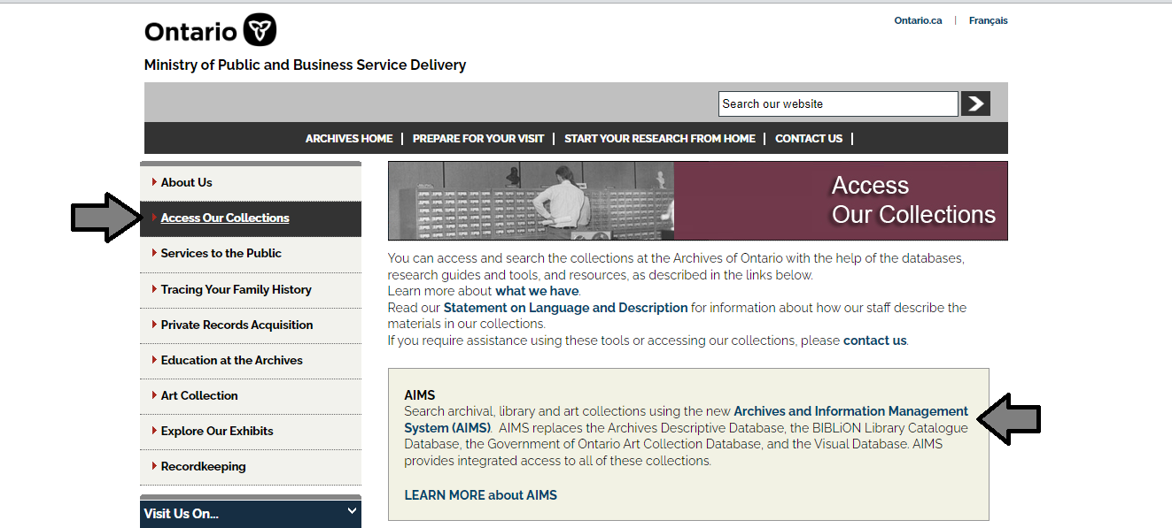

1. In the Archives and Information Management System (AIMS), click on “Archives repository (only)” button:

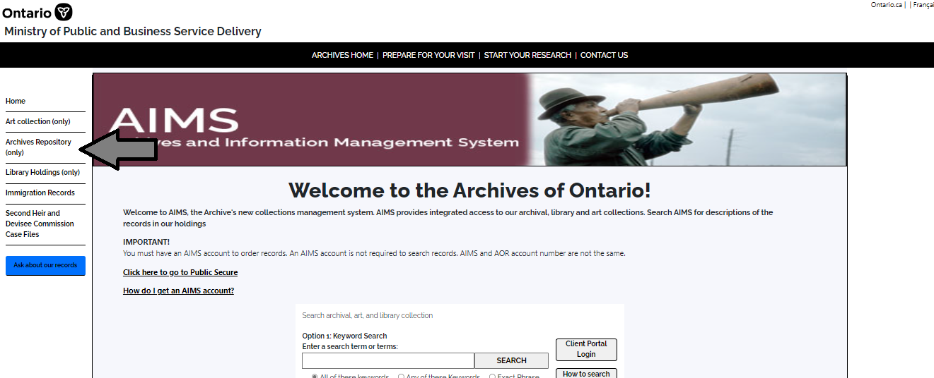

1. On the “Welcome to the Archival Collection” search page, click “Advanced Search”:

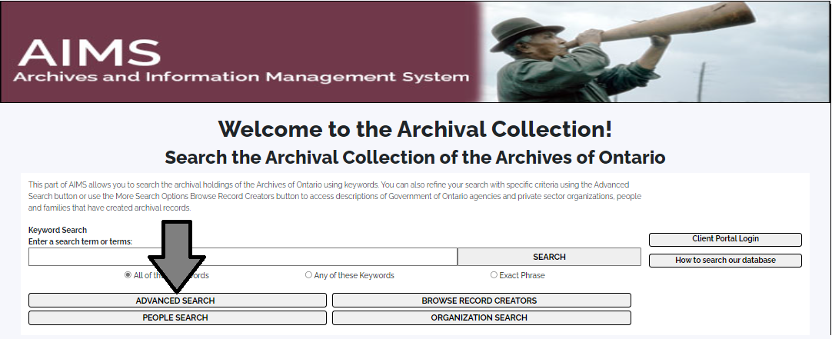

1. On the “Archives Advanced Search” page enter the reference code (that’s the number starting with C, F or RG) in the Reference Code field and click “Search” (at the bottom of the page.

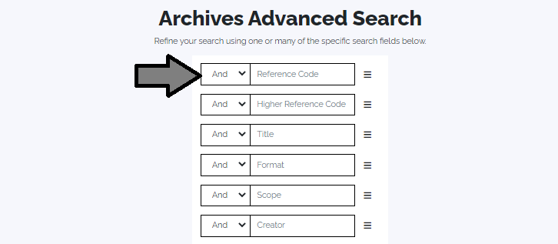

Contact us

Although unable to do your research for you, our reference archivists are waiting to assist you.  You may telephone or write to them by mail or email or — best of all — visit the Archives of Ontario.

**Telephone: 416-327-1600 Toll free (Ontario): 1-800-668-9933**

**Email:**[Click here to email the Archives of Ontario](mailto:reference@ontario.ca). The e-mail address is [reference@ontario.ca](mailto:reference@ontario.ca) 

**Address: Archives of Ontario, 134 Ian Macdonald Blvd., Toronto, ON M7A 2C5**

**Website**

Visit our website for information about our collections and our services, our online exhibits and education programs, and links to our social media accounts. [Click here to visit our website](http://www.ontario.ca/archives).  The website is [www.ontario.ca/archives](http://www.ontario.ca/archives).

**Customer Service and Research Guides**

Our guides contain information about our services, freelance researchers available to do research for you, and some of our most popular records.  [Click here to view our guides](http://www.archives.gov.on.ca/en/access/research_guides.aspx).  To find the “Research Guides and Tools” on our website, click on “Access our Collections”.

______________________________________________________________________

© King's Printer for Ontario, 2023

This information is provided as a public service.  Last update is shown at the beginning of this guide.  Readers should where possible verify the information before acting on it.