| **Archives of Ontario** | Ontario Logo |
| --- | --- |
| Research Guide 205  Ontario Land Records Index  Last Updated: February 2023 | |

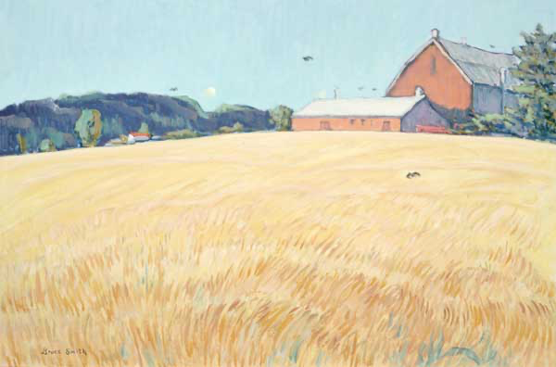

Smith, Bruce, Keswick Farm, circa 2002,

Government of Ontario Art Collection, Acc.. 100214 (gift from the artist)

In this guide 2

Where do I find the Ontario Land Records Index and the records it indexes? 2

What do I need to get started? 3

How do I use the Index? 3

Are there related records? 3

How do I get online information about the Ontario Land Records Index? 4

Contact us 6

# In this guide

This guide provides information on the Ontario Land Records Index.

The Ontario Land Records Index provides a reference to documents about individuals who:

* were authorized to locate on a piece of Crown Land (they did not always become the owner)
* leased or purchased land from the Canada Company
* were parts of groups of immigrants from Ireland whom Peter Robinson helped get land in the Peterborough area
* were offered land after 1901 for service during Fenian Raids (1860s) or the Boer War (1899 to 1902).

The Index covers the period from the 1780’s to the 1920’s. It is arranged into two sets of microfiches, arranged alphabetically:

* by person’s NAME
* by TOWNSHIP, TOWN or CITY, then by concession and lot number

*Please note: this guide contains links to information found in our online Microfilm Interloan Catalogue.  On our website, this catalogue is found under “Access Our Collections”.  If you are using a print copy of this guide, go to page 4 for more information on how to find this information.

# Where do I find the Ontario Land Records Index and the records it indexes?

You can view Ontario Land Records Index in our reading room. It is located in two binders, one for each set of microfiche. You can also view the records it indexes, on microfilm. You do not need to order the Index or the microfilm in advance.

You can also borrow the Index and the microfilm (except for microfilm of Peter Robinson records) through libraries that offer interloan services. Some Ontario public libraries have a copy of the index.

# What do I need to get started?

You need a name or a location, and an approximate date.

# How do I use the Index?

The document “How to Use the Ontario Land Records Index” contains the following:

* a list of the microfiche
* examples of entries in the Index
* an explanation of the codes found in the Index
* lists of microfilm for records indexed on the microfiche

You will find this document: in the Reading Room in the binders that contain the microfiche; and on our Research Guides and Tools webpage under “Land Records”.

# Are there related records?

See the guides below for more information about records indexed on the microfiche, and other land records. On our website, you will find the “Research Guides and Tools” page under “Access Our Collections”.

* [click here to view research guide 215, Early Land Records, from the 1780s to the 1850s](http://www.archives.gov.on.ca/en/access/documents/research_guide_215_grant_to_patent.pdf)
* [click here to view research guide 225, Crown Land Records](http://www.archives.gov.on.ca/en/access/documents/research_guide_225_resources_for_researching_land_records.pdf)
* [click here to view research guide 231, Finding Land Registration Records](http://www.archives.gov.on.ca/en/access/documents/research_guide_231_finding_land_registration_records.pdf)

# How do I get online information about the Ontario Land Records Index?

1. On our website’s main page, click on “Access our Collections”, as shown in the image below:

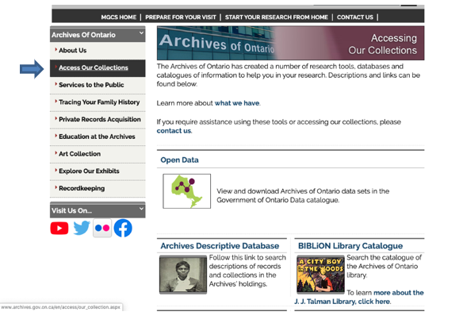

1. Scroll down and click on “Microfilm Interloan Catalogue””:

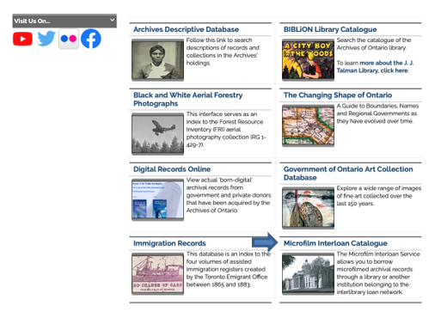

1. Scroll down and click on Ontario Land Records Index on Microfiche”:

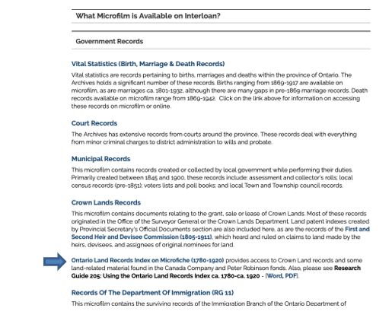

# Contact us

Although unable to do your research for you, our reference archivists are waiting to assist you.  You may telephone or write to them by mail or email or — best of all — visit the Archives of Ontario.

**Telephone: 416-327-1600 Toll free (Ontario): 1-800-668-9933**

**Email:** [Click here to email the Archives of Ontario](mailto:reference@ontario.ca).  The e-mail address is [reference@ontario.ca](mailto:reference@ontario.ca)

**Address: Archives of Ontario, 134 Ian Macdonald Blvd., Toronto, ON M7A 2C5**

**Website**

Visit our website for information about our collections and our services, our online exhibits and education programs, and links to our social media accounts. [Click here to visit our website](http://www.archives.gov.on.ca/).  The website is [www.archives.gov.on.ca/](http://www.archives.gov.on.ca/)

**Customer Service and Research Guides**

Our guides contain information about our services, freelance researchers available to do research for you, and some of most popular records.  [Click here to view our guides](http://www.archives.gov.on.ca/en/access/research_guides.aspx).  To find the “Research Guides and Tools” on our website, click on “Access our Collections”.

______________________________________________________________________

© King’s Printer for Ontario, 2023

This information is provided as a public service.  Last update is shown at the beginning of this guide.  Readers should where possible verify the information before acting on it.