| **Archives of Ontario** |  |
| --- | --- |
| Research Guide 209  Municipal Records  Last Updated: March 2023 | |

This photograph is; Fire brigade on street outside Cornwall Town Hall, C 130-1-0-8-9
Marsden Kemp Fonds 


Fire brigade on street outside Cornwall Town Hall

C 130-1-0-8-9

Marsden Kemp Fonds

In this guide 2

Where do I find these records? 2

What do I need to get started? 2

The Records 3

Are there related records? 4

Books and online resources about municipalities 4

Courts of General Sessions of the Peace records 5

Provincial Government records 5

Table 1: Municipalities with Records at the Archives of Ontario 6

How do I get to the online descriptions? 19

Contact us 20

# In this guide

This guide has information on municipal records at the Archives of Ontario and how to access them.

*Please note: this guide contains links to information found in our online Archives Descriptive Database.  On our website, this database is found under “Access Our Collections”.  If you are using a print copy of this guide, go to page 19 for more information on how to find the online descriptions.

# Where do I find these records?

We have records from some municipalities, from the early 1800s to the 1970s. You will need to visit the Archives to view most of them.  Please contact us in advance to request them.  Some of the records are on microfilm and you do not need to order them in advance (with some exceptions). Libraries that offer interloan services may also borrow some of the reels for you. [Click here to view our Microfilm Interloan Catalogue](http://www.archives.gov.on.ca/en/microfilm/index.aspx). On our website, you will find the catalogue under “Access our Collections”.

Some of the records described in this guide are microfilm copies produced by Family Search. Local libraries or archives may have a copy of the microfilm. Digital copies of some of these reels are available on the Family Search website, [www.familysearch.org](http://www.familysearch.org).

Local archives, public libraries or historical societies may also have municipal records. For records from the 1970s to present, contact the municipality first.

For general information about a municipality and its history, we suggest you contact local archives, public libraries or historical societies. Our library includes some published local histories. To search the library collections, [click here to view Library Holdings](https://aims.archives.gov.on.ca/scripts/mwimain.dll/177129001?unionqueryform&application=UNION_VIEW&language=144&aux_sessid=AO_SHARE&searchform=%5bAO_ASSETS%5dhtml/library.html&AUX_SESSID=AO_SHARE). On our website, you will find this database under “Access our Collections”.

# What do I need to get started?

You need to know:

* What the name of the municipality was **at the time**
* What county, district or regional municipality the local municipality you are looking for is part of now, and **at the time**

You may also need to know which level of municipal government created the records you are looking for.

When you are looking for municipal records, keep in mind that:

* A municipality’s name and the county or district it is part of may have changed.
* A Township, city, town or village may have the same name as the county or district it is part of (for example, York Township and York County).
* A city, town or village may have the same name as the Township it was separated from (for example, Guelph Township and City of Guelph).
* Municipalities in different parts of the province may share the same name (for example, Hamilton Township (Northumberland County) and City of Hamilton, Town of Simcoe (Norfolk County) and Simcoe County)
* Many municipalities have ceased to exist as a result of mergers, especially since the mid-1990s.

# The Records

See Table 1 on page 5 of this guide for a list of municipalities with records we have.

Municipal records may include:

* Council minutes and by-laws
* Municipal census records
* Assessment records
* Financial and administrative records
* Records on statute labour (an early form of work on roads and other public projects, in lieu of property taxes)
* Records of municipal boards

Ontario has two levels of municipal governments. Most local municipalities (also known as lower-tier municipalities) are part of an upper-tier municipality. Local and upper-tier municipalities have their own areas of responsibilities. The division of responsibilities is different from one place to another.

Local municipalities are known as:

* Cities
* Municipalities
* Villages
* Towns
* Townships

Upper-tier municipalities are known as:

* Counties
* Municipalities
* Regional Municipalities

Some cities and towns (local municipalities) are “separate”, meaning they are not part of an upper-tier municipality. There is no upper-tier municipality in the northern districts, except Muskoka District. Since 1990, some upper-tier municipalities have been merged with the local municipalities on their territory.

We also have records from local and upper-tier governments that no longer exist. They are:

* Districts: They existed from 1792 to 1849 and they were the original units for municipal and court administration in Ontario. They were replaced with the counties. They were different from today’s northern districts.
* Improvement Districts: They existed in unorganized territories (areas with no Township council) and provided services similar to those of a local municipality. They had a Board of Trustees appointed by the Minister of Municipal Affairs and Housing instead of an elected council.
* Police Villages: They were managed by non-elected Boards of Police with limited powers for public order and maintenance for a specific area within a Township. They were created by county by-laws. Police Villages often became villages.

# Are there related records?

See the guides below for information on some of the records created by municipalities and how to view them:

* [Click here to view Research Guide 220, Census records](http://www.archives.gov.on.ca/en/access/documents/research_guide_220_census_records.pdf)
* [Click here to view Research Guide 221, Directories, Telephone Books and Voters Lists](http://www.archives.gov.on.ca/en/access/documents/research_guide_221_directories_voter_lists.pdf)

## 

On our website, you will find the “Research Guides and Tools” page under “Access Our Collections”.

## Books and online resources about municipalities

You can use the following publications to find previous names for a municipality and the county or district it was part of. You can view them in our reading room and at some public libraries:

* Municipal Records in Ontario: History and Guide by Fraser Dunford (Ontario Genealogical Society, 2005) has information on municipal records and how to research them. It includes a list of Townships, with change in borders, amalgamations and changes of county.
* The annual Municipal Directory, produced by the Association of Municipal Managers, Clerks and Treasurers of Ontario (AMCTO), includes an historical overview of amalgamations and name changes[.](http://www.amcto.com/home.asp)
* The Gazetteer of Ontario can help you find a municipality and where it is located.
* Places in Ontario by Nick and Helma Mika and Place Names of Ontario by Alan Rayburn are reference books on the history of various Ontario place names.

Our online resource “The Changing Shape of Ontario” includes information on counties, early and current districts, regional municipalities and municipal restructuration in the 1990s. It also includes maps of Ontario, from the 1950s. [Click here to view "The Changing Shape of Ontario"](http://www.archives.gov.on.ca/en/maps/index.aspx). On our website, you will find this resource under “Access Our Collections”.

## Courts of General Sessions of the Peace records

Until 1841, the Courts of General Sessions of the Peace were responsible for local administration. This included local property assessment and taxation and the issuing of local licenses. [To view information about these courts and their records at the Archives, click here](https://aims.archives.gov.on.ca/scripts/mwimain.dll/673318017?unionqueryform&application=UNION_VIEW&language=144&aux_sessid=AO_SHARE&searchform=%5bAO_ASSETS%5d/html/archival.html&AUX_SESSID=AO_SHARE), or, in the Archives' Archives Descriptive database, click “Advanced Search” and then click “Search Records Creators”.

Published indexes or transcriptions exist for some of the records from these courts. For information on those available at the Archives, [click here to search Library Holdings using keywords "sessions of the peace" and the name of the District](https://aims.archives.gov.on.ca/scripts/mwimain.dll/673318018?unionqueryform&application=UNION_VIEW&language=144&aux_sessid=AO_SHARE&searchform=%5bAO_ASSETS%5dhtml/library.html&AUX_SESSID=AO_SHARE). On our website, you will find the Library Holdings under “Search the Archival Collection”.

## Provincial Government records

The Ministry of Municipal Affairs and Housing and its predecessors were responsible for administrative and financial support to municipalities and the laws regarding municipal governments. [To view information about the Ministry of Municipal Affairs and Housing and its predecessors and their records at the Archives, click here](https://aims.archives.gov.on.ca/scripts/mwimain.dll/673318019?unionqueryform&application=UNION_VIEW&language=144&aux_sessid=AO_SHARE&searchform=%5bAO_ASSETS%5d/html/archival.html&AUX_SESSID=AO_SHARE), or, in the Archives Descriptive database, click “Advanced Search” then click “Search Records Creators”.

For information about Ministry records on municipal land planning and use and how to view them, [click here to view Research Guide 214, Municipal land use planning](http://www.archives.gov.on.ca/en/access/documents/research_guide_214_municipal_land_use.pdf).

The Ontario Municipal Board heard applications and appeals on municipal and planning matters. For information about hearings and how to view the records, [click here to view Research Guide 208, Ontario Municipal Board hearing records](http://www.archives.gov.on.ca/en/access/documents/research_guide_208_records_of_OMB_hearings.pdf).

# Table 1: Municipalities with Records at the Archives of Ontario

The table below lists all municipalities with records we have, along with the reference code for their records. The following reference codes appear in the list below, in descriptions of records, on microfilm copies or in published materials:

* **F** (example: F 1565 Township of Brunel fonds[1]) – means original records we have or microfilm we created.
* **D** (example: D 115 Village of Ayr diffusion material) – means records at other institutions available on microfilm in our reading room. Family Search filmed those records. We do not have the originals.
* **RG 21 –** This is an older reference code for all municipal records we have. We no longer use this reference code but it may appear on microfilm or in published materials.

Note: For some municipalities, there are both F and D reference codes, meaning separate sets of records. Records from local municipalities may also be part of the records of the county or districts they belonged too.

1. You will find information on the records for each municipality in the “Advanced Search page, in the Archives Repository. Click here to view the "[Archives Advanced Search](https://aims.archives.gov.on.ca/scripts/mwimain.dll/218442514?GET&FILE=%5bAO_ASSETS%5dhtml/advancedsearchArchives.html) " page, then enter the reference code.

Table 1: Municipalities with records at the Archives of Ontario

| **Municipality Name** | **Archival Reference Code** |
| --- | --- |
| Acton (Town) | D 97 |
| Adelaide (Township) | D 98 |
| Admaston (Township) | D 99 |
| Ailsa Craig (Village) | D 100 |
| Albemarle (Township) | D 102 |
| Albion (Township) | D 103 |
| Aldborough (Township) | D 104 |
| Alfred (Township) | F 1510 |
| Alice and Fraser (Township) | D 101 |
| Alvinston (Village) | D 105 |
| Amabel (Township) | D 106 |
| Amaranth (Township) | F 1513  D 478 |
| Ameliasburgh (Township) | F 1514 |
| Amherst Island (Township) | F 1515 |
| Amherstburg (Town) | D 107 |
| Ancaster (Township) | D 108 |
| Anderdon (Township) | D 109 |
| Arran (Township) | D 110 |
| Artemesia (Township) | F 1520  D 404 |
| Arthur (Township) | D 111 |
| Arva-London (Township) | D 405 |
| Athol (Township) | F 1522 |
| Augusta (Township) | F 1523 |
| Aurora (Town) | D 113 |
| Aylmer (Town) | D 114 |
| Ayr (Village) | D 115 |
| Bagot and Blythfield (Township) | F 1527 |
| Bathurst District | F 1528 |
| Bathurst (Township) (Lanark County) | D 406 |
| Bathurst (Township) (Lennox and Addington County) | F 1529  D 406 |
| Bayham (Township) | D 117 |
| Beamsville (Town) | D 118 |
| Beaverton (Village) | F 1532 |
| Belle River (Town) | D 120 |
| Belleville (City) | F 1535 |
| Bentinck (Township) | D 121 |
| Bertie (Township) | F 1537  D 407 |
| Beverly (Township) | D 123 |
| Biddulph (Township) | D 124 |
| Blanshard (Township) | D 127 |
| Blenheim (Town) | D 128 |
| Blenheim (Township) | D 481 |
| Bolton (Village) | F 1545  D 408 |
| Bonfield (Township) | F 1546 |
| Bosanquet (Township) | D 130 |
| Bothwell (Town) | D 131 |
| Bowmanville (Town) | F 1549 |
| Brampton (City) | D 132 |
| Brant County | F 1551 |
| Brant (Township) | F 1552  D 409 |
| Brantford (City) | D 133 |
| Brantford (Township) | F 1554  D 410 |
| Bridgeburg (Town) | F 1555  D 411 |
| Brock (Township) | F 1557 |
| Brockton (Village) | D 412 |
| Brockville (Town) | F 1558 |
| Bromley (Township) | F 1559 |
| Brooke (Township) | D 134 |
| Brougham (Township) (Dufferin County) | D 479 |
| Brougham (Township) (Durham County) | D 484 |
| Bruce County | F 1562 |
| Bruce (Township) | D 136 |
| Brudenell and Lyndoch (Township) | F 1564 |
| Brunel (Township) | F 1565 |
| Burford (Township) | F 1566 |
| Burleigh and Anstruther (Township) | F 1567 |
| Burlington (Town) | D 137 |
| Caistor (Township) | F 1569 |
| Caistor (Township) | D 138 |
| Caledonia (Town) | D 413 |
| Caledonia (Village) | F 1572 |
| Cameron Improvement District | F 1573 |
| Campbellford (Town) | F 1574 |
| Canborough (Township) | F 1575  D 414 |
| Cannington (Village) | F 1576 |
| Caradoc (Township) | D 141 |
| Carleton County | D 140 |
| Carrick (Township) | D 142 |
| Cartwright (Township) | F 1580 |
| Cayuga (Village) | F 1581 |
| Chaffey (Township) | F 1582 |
| Charlottenburgh (Township) | F 1583 |
| Charlotteville (Township) | D 143 |
| Chatham (Township) | D 144 |
| Chinguacousy (Township) | D 145 |
| Chippewa (Village) | D 146 |
| Chatham (City) | F 1585  D 416 |
| Clarke (Township) | F 1589 |
| Clifton (Town) | D 417 |
| Clinton (Township) | D 147 |
| Cobalt (Town) | F 1592 |
| Cobourg (Town) | F 1593 |
| Colborne (Village) | F 1594 |
| Colchester (Township) | D 150 |
| Collingwood (Township) | D 151 |
| Conmee (Township) | F 1597 |
| Cornwall (Township) | F 1599 |
| Courtright (Village) | F 1601 |
| Cramahe (Township) | F 1602 |
| Crowland (Township) | F 1603  D 418 |
| Crystal Beach (Village) | F 1604 |
| Culross (Township) | D 154 |
| Dalhousie and Sherbrooke (Townships) | D 155 |
| Darlington (Township) | F 1608 |
| Dawn (Township) | D 156 |
| Delaware (Township) | D 157 |
| Delhi (Town) | D 158 |
| Derby (Township) | D 159 |
| Dereham (Township) | F 1613  D 422 |
| Dover (Township) | F 1614  D 419 |
| Drayton (Village) | D 160 |
| Dresden (Town) | D 161 |
| Drummond (Township) | F 1617 |
| Dundalk (Village) | F 1618 |
| Dundas (Town) | D 162 |
| Dunn (Township) | F 1620  D 420 |
| Dunnville Town | F 1621  D 421 |
| Dunwich (Township) | D 164 |
| Durham (Town) | D 165 |
| Dutton (Village) | D 166 |
| East Camden (Township) | F 1625 |
| East Flamborough (Township) | D 167 |
| East Garafraxa (Township) | F 1627 |
| East Gwillimbury (Township) | F 1628 |
| East Hawkesbury (Township) | F 1629 |
| East London (Village) | D 168 |
| East Luther (Township) | F 1631 |
| East Nissouri (Township) | F 1632 |
| East Oxford (Township) | F 1633 |
| East Sandwich (Township) | D 169 |
| East Toronto (Village) | D 122 |
| East Whitby (Township) | F 1635 |
| East Williams (Township) | F 1636  D 423 |
| East Zorra (Township) | D 170 |
| Eastern District | F 1638 |
| Eastnor (Township) | D 171 |
| Egremont (Township) | D 172 |
| Ekfrid (Township) | D 173 |
| Elderslie (Township) | D 174 |
| Elgin County | F 1643 |
| Elizabethtown (Township) | F 1644 |
| Ellice (Township) | D 176 |
| Elma (Township) | D 177 |
| Elmira (Village) | D 178 |
| Embro (Village) | F 1649 |
| Enniskillen (Township) | D 180 |
| Eramosa (Township) | D 181 |
| Ernestown (Township) | F 1652 |
| Esquesing (Township) | D 183 |
| Essex County | F 1654 |
| Essex (Town) | D 184 |
| Etobicoke (Township) | D 182 |
| Euphemia (Township) | D 185 |
| Euphrasia (Township) | D 186 |
| Exeter (Town) | D 187 |
| Fenelon (Township) | F 1660 |
| Fergus (Town) | D 188 |
| Fitzroy (Township) | F 1662 |
| Fonthill (Village) | F 1664 |
| Forest (Town) | D 192 |
| Fort Erie (Town) | F 1666  D 431 |
| Front of Leeds and Lansdowne (Township) | F 1668 |
| Frontenac County | F 1669 |
| Gainsborough (Township) | F 1670 |
| Galt (City) | D 195 |
| Gananoque (Town) | F 1672 |
| Goergian Bay (Township) | F 4708 (Contact us for information on these records and how to view them) |
| Georgina (Township) | D 196 |
| Glanford (Township) | D 432 |
| Glencoe (Village) | D 197 |
| Glenelg (Township) | D 198 |
| Gloucester (Township) | D 199 |
| Goderich (Town) | D 200 |
| Gore District | F 1679 |
| Gosfield (Township) | D 201 |
| Goulbourn (Township) | D 202 |
| Grantham (Township) | D 203 |
| Grattan (Township) | F 1683 |
| Gravenhurst (Town) | F 1684 |
| Greenock (Township) | D 433 |
| Grey County | F 1686 |
| Griffith and Matawatchan (Township) | F 1687 |
| Grimsby (Town) | D 434 |
| Grimsby (Township) | F 1689 |
| Grimsby (Village) | F 1688 |
| Guelph (City) | D 205 |
| Guelph (Township) | D 435 |
| Hagersville (Village) | F 1692  D 427 |
| Haldimand County | F 1693 |
| Halton County | F 1695 |
| Hamilton (City) | D 206 |
| Hamilton (Township) | F 1697 |
| Harriston (Town) | F 1698 |
| Harwich (Township) | F 1699 |
| Hastings County | F 1700 |
| Hespeler (Town) | F 1701 |
| Hibbert (Township) | D 208 |
| Hillier (Township) | F 1703 |
| Hilton (Township) | F 1704 |
| Holland Landing (Village) | F 1706 |
| Holland (Township) | D 209 |
| Home District | D 210 |
| Houghton (Township) | F 1709  D 436 |
| Howard (Township) | F 1710  D 428 |
| Hullett (Township) | F 1711 |
| Humberstone (Township) | D 212 |
| Humphrey (Township) | F 1713 |
| Huntley (Township) | D 213 |
| Huntsville (Town) | F 1715 |
| Huron County | F 1716 |
| Huron District | F 1718  D 480 |
| Ingersoll (Town) | F 1719  D 437 |
| Jarvis (Village) | F 1720 |
| Johnstown District | F 1721 |
| Kennebec (Township) | F 1723 |
| Kent County | D 429 |
| Keppel (Township) | D 215 |
| Kincardine (Township) | D 217 |
| King (Township) | D 218 |
| Kingsville (Town) | D 219 |
| Kinloss (Township) | D 220 |
| Kitchener (City) | D 221 |
| Kitley (Township) | F 1732 |
| Lanark County | F 1734 |
| Lanark (Village) | D 223 |
| Lancaster (Township) | F 1737 |
| LaSalle (Town) | F 1738 |
| Leamington (Town) | F 1739 |
| Leeds and Grenville County | F 1740 |
| Lincoln County | F 1741 |
| Lindsay (Township) | D 224 |
| Listowel (Town) | D 225 |
| Lobo (Township) | D 226 |
| Lochiel (Township) | F 1745 |
| Logan (Township) | D 227 |
| London (City) | D 193 |
| London District | D 485 |
| London (Township) | D 228 |
| Longueuil (Township) | F 1750 |
| L'Orignal (Village) | F 1751 |
| Loughborough (Township) | F 1752 |
| Louth (Township) | D 229 |
| Lucan (Village) | D 230 |
| Maidstone (Township) | D 232 |
| Malahide (Township) | D 233 |
| Malden (Township) | D 234 |
| Manvers (Township) | F 1759 |
| March (Township) | D 235 |
| Mariposa (Township) | F 1761 |
| Markham (Township) | D 236 |
| Markham (Village) | D 237 |
| Marlborough (Township) | D 238 |
| Maryborough (Township) | D 239 |
| Marysburgh (Township) | F 1766 |
| Matachewan (Township) | F 1767 |
| Matilda (Township) | F 1768 |
| McGillivray (Township) | D 240 |
| McKillop (Township) | F 1771 |
| McNab (Township) | F 1772 |
| Meaford Town | D 241 |
| Melancthon (Township) | D 242 |
| Merritton (Village) | D 243 |
| Mersea (Township) | D 244 |
| Metcalfe (Township) | D 245 |
| Middleton (Township) | F 1779  D 452 |
| Milton (Town) | F 1780  D 453 |
| Minto (Township) | F 1781 |
| Mitchell (Town) | D 247 |
| Mono (Township) | F 1785 |
| Montague (Township) | F 1786 |
| Moore (Township) | F 1787  D 487 |
| Mornington (Township) | D 248 |
| Morrison (Township) | F 1789 |
| Moulton & Sherbrooke (United Townships) | D 250 |
| Moulton (Township) | F 1791  D 438 |
| Mount Forest (Town) | D 251 |
| Mulmur (Township) | D 252 |
| Muskoka (Township) | F 1795 |
| Napanee (Town) | D 59 |
| Nassagaweya (Township) | F 1796  D 439 |
| Newboro (Village) | F 1799  D 454 |
| Newbury (Village) | D 454 |
| Newark (Township) | F 1138-1 |
| Newcastle District | F 1800 |
| Newcastle (Village) | F 1801 |
| Newmarket (Town) | F 1803 |
| Niagara District | F 1138-1  F 1804 |
| Niagara (Town) | F 1138-1  F 1805 |
| Niagara (Township) | F 1138-1  F 1806  D 441 |
| Niagara Falls (City) | D 256 |
| Niagara-on-the-Lake (Town) | D 440 |
| Nichol (Township) | D 257 |
| Norfolk County | F 1811 |
| Normanby (Township) | D 258 |
| North Cayuga (Township) | F 1813  D 415 |
| North Colchester (Township) | D 259 |
| North Dorchester (Township) | D 261 |
| North Dumfries (Township) | D 262 |
| North Easthope (Township) | D 263 |
| North Fredericksburgh (Township) | F 1819 |
| North Gosfield (Township) | D 264 |
| North Gower (Township) | D 265 |
| North Grimsby (Township) | F 1822  D 425 |
| North Gwillimbury (Township) | D 426 |
| North Marysburgh (Township) | F 1824 |
| North Monaghan (Township) | F 1825 |
| North Norwich (Township) | F 1826  D 442 |
| North Oxford (Township) | F 1827  D 445 |
| North Plantagenet (Township) | F 1828  D 455 |
| North Tilbury (Township) | D 266 |
| North Toronto (Village) | D 255 |
| North Walsingham (Township) | F 1830  D 472 |
| Northumberland and Durham Counties | F 1831 |
| Norwich (Township) | D 456 |
| Norwich (Village) | F 1833 |
| Oakland (Township) | D 267 |
| Oakville (Town) | F 1835  D 443 |
| Oil Springs (Village) | D 268 |
| Oneida (Township) | F 1837 |
| Onondaga (Township) | D 269 |
| Ontario County | F 1839 |
| Ontario, York and Peel United Counties | D 459 |
| Orangeville (Town) | F 1840 |
| Orford (Township) | D 271 |
| Orillia (Town) | F 1842 |
| Osgoode (Township) | D 457 |
| Oshawa (Town) | F 1844 |
| Osnabruck (Township) | F 1845 |
| Osprey (Township) | D 444 |
| Otonabee (Township) | F 1847 |
| Ottawa (City) | D 274 |
| Ottawa District | F 1849 |
| Oxford County | F 1850 |
| Pakenham (Township) | F 1851 |
| Paris (Town) | D 275 |
| Parkdale (Village) | D 270 |
| Parkhill (Town) | D 276 |
| Peel (Township) | D 277 |
| Pelee (Township) | F 1855 |
| Pelham (Township) | F 1856 |
| Pembroke (Town) | F 1857 |
| Percy (Township) | F 1858 |
| Perry (Township) | F 1859 |
| Perth (Town) | F 1861 |
| Petrolia (Town) | F 1863 |
| Pickering (Township) | F 1864 |
| Pickering (Village) | D 63 |
| Picton (Town) | F 1865 |
| Pilkington (Township) | D 280 |
| Pittsburgh (Township) | F 1867 |
| Plympton (Township) | D 281 |
| Point Edward (Village) | F 1869 |
| Port Colborne (Town) | D 282 |
| Port Dalhousie (Town) | D 283 |
| Port Dover (Town) | F 1872  D 460 |
| Port Elgin (Town) | D 461 |
| Port Hope (Town) | F 1874 |
| Port Perry (Village) | F 1875 |
| Port Rowan (Village) | F 1876 |
| Port Stanley (Village) | D 285 |
| Port Sydney (Village) | F 1878 |
| Prescott and Russell County | F 1879 |
| Preston (Town) | F 1880 |
| Prince Edward County | F 1881 |
| Proton (Township) | F 1883 |
| Puslinch (Township) | D 286 |
| Rainham (Township) | F 1885  D 462 |
| Raleigh (Township) | F 1886 |
| Ramsay (Township) | F 1887 |
| Reach (Township) | F 1888 |
| Rear of Leeds and Lansdowne (Township) | F 1889 |
| Renabie Improvement District | F 1890 |
| Richmond Hill (Town) | D 287 |
| Rochester (Township) | F 1893  D 463 |
| Romney (Township) | D 288 |
| Roxborough (Township) | D 289 |
| Russell (Township) | F 1896 |
| Ryde (Township) | F 1897 |
| St. Catharines (City) | D 290 |
| St. Edmunds (Township) | D 464 |
| St. Mary's (Town) | D 291 |
| St. Thomas (City) | D 292 |
| St. Vincent (Township) | D 293 |
| Saltfleet (Township) | F 1902  D 446 |
| Sandwich South (Town) | D 466 |
| Sandwich (Town) | D 465 |
| Sarnia (City) | F 1904 |
| Sarnia (Township) | D 294 |
| Scarborough (Township) | D 296 |
| Scott (Township) | F 1908 |
| Scugog (Township) | F 1909 |
| Seneca (Township) | F 1910  D 467 |
| Seymour (Township) | F 1911 |
| Sherbrooke (Township) | F 1912  D 468 |
| Sherbrooke South (Township) | D 469 |
| Shuniah (Township) | F 1913 |
| Simcoe (Town) | D 447 |
| Snowdon (Township) | F 1916 |
| Sombra (Township) | D 298 |
| Sophiasburgh (Township) | F 1919 |
| South Cayuga (Township) | F 1920 |
| South Colchester (Township) | D 301 |
| South Dorchester (Township) | D 302 |
| South Dumfries (Township) | F 1923 |
| South Easthope (Township) | D 304 |
| South Gosfield (Township) | F 1925  D 424 |
| South Grimsby (Township) | F 1926 |
| South Marysburgh (Township) | F 1927 |
| South Monaghan (Township) | F 1928 |
| South Norwich (Township) | F 1929  D 458 |
| South Plantagenet (Township) | F 1930 |
| South Sandwich (Township) | F 1931 |
| South Sherbrooke (Township) | F 1932 |
| South Walsingham (Township) | F 1933 |
| Southampton (Town) | D 306 |
| Southwold (Township) | D 307 |
| Stafford (Township) | F 1936 |
| Stamford (Township) | D 308 |
| Stephen (Township) | D 486 |
| Stephenson (Township) | F 1938 |
| Stisted (Township) | F 1939 |
| Stoney Creek (Village) | F 1940 |
| Stormont, Dundas and Glengarry County | F 1941 |
| Storrington (Township) | F 1942 |
| Stouffville (Village) | F 1943 |
| Stratford (City) | D 309 |
| Strathroy (Town) | D 310 |
| Streetsville (Town) | F 1946 |
| Sturgeon Point (Village) | F 1947 |
| Sudbury (Town) | F 1948 |
| Sullivan (Township) | F 1949 |
| Talbot District | F 1951 |
| Teeswater (Village) | D 313 |
| Thamesville (Village) | D 314 |
| Thorah (Township) | F 1954 |
| Thornbury (Town) | D 315 |
| Thorold (Town) | D 316 |
| Thorold (Township) | D 317 |
| Timmins (Town) | F 1958 |
| Tisdale (Township) | F 1959 |
| Toronto (City) | F 1961  D 318 |
| Toronto Gore (Township) | D 319 |
| Toronto (Township) | F 1962 |
| Townsend (Town) | D 448 |
| Townsend (Township) | F 1964 |
| Trafalgar (Township) | F 1965 |
| Trenton (Town) | F 1966 |
| Tuckersmith (Township) | D 320 |
| Tyendinaga (Township) | F 1968 |
| Usborne (Township) | D 321 |
| Uxbridge (Town) | F 1970 |
| Uxbridge (Township) | F 1971 |
| Vaughan (Township) | D 322 |
| Vespra (Township) | F 1974 |
| Victoria County | F 1975 |
| Vienna (Village) | D 324 |
| Wainfleet (Township) | F 1978  D 449 |
| Walkerton (Town) | F 1979 |
| Walkerville (Town) | D 325 |
| Wallace (Township) | D 471 |
| Wallaceburg (Town) | D 326 |
| Walpole (Township) | F 1982 |
| Walsingham (Township) | F 1983 |
| Warwick (Township) | D 323 |
| Waterdown (Village) | D 327 |
| Waterford (Town) | F 1986 |
| Waterford (Village) | D 473 |
| Waterloo (City) | F 1987 |
| Waterloo County | F 1988 |
| Waterloo (Township) | F 1989  D 450 |
| Watford (Village) | D 330 |
| Welland County | F 1991 |
| Welland (Town) | F 1992 |
| Wellesley (Town) | D 332 |
| Wellington County | F 1994 |
| Wentworth County | F 1995 |
| West Flamborough (Township) | D 334 |
| West Garafraxa (Township) | D 335 |
| West Gwillimbury (Township) | F 1998 |
| West Hawkesbury (Township) | F 1999  D 483 |
| West London (Township) | D 482 |
| West Luther (Township) | D 430 |
| West Nissouri (Township) | D 337 |
| West Oxford (Township) | F 2002 |
| West Sandwich (Township) | F 2003 |
| West Tilbury (Township) | D 338 |
| West Toronto Junction (Township) | D 470 |
| West Zorra (Township) | F 2006  D 477 |
| Western District | F 2007 |
| Westmeath (Township) | F 2088 |
| Westminster (Township) | D 340 |
| Weston (Town) | D 341 |
| Westport (Village) | F 2010 |
| Whitby (Town) | F 2011 |
| Whitby (Township) | F 2012 |
| Whitchurch (Township) | F 2013 |
| Williams (Township) | F 2015  D 339 |
| Williamsburgh (Township) | F 2016 |
| Wilmot (Township) | D 342 |
| Windham (Township) | D 343 |
| Windsor (City) | D 344 |
| Wolfe Island (Township) | F 2020 |
| Wolford (Township) | F 2021 |
| Woodbridge (Village) | D 345 |
| Woodhouse (Township) | F 2023  D 475 |
| Woodstock (City) | F 2024  D 451 |
| Woolwich (Township) | D 346 |
| Worthington (Township) | F 2026 |
| Wyoming (Village) | D 347 |
| Yarmouth (Township) | D 348 |
| York County | F 2074 |
| York (Township) | D 349 |
| Yorkville (Village) | D 476 |

# How do I get to the online descriptions?

1. On our website’s main page, click on “Access Our Collections”, and click on “Archives and Information Management System”, as shown in the image below:

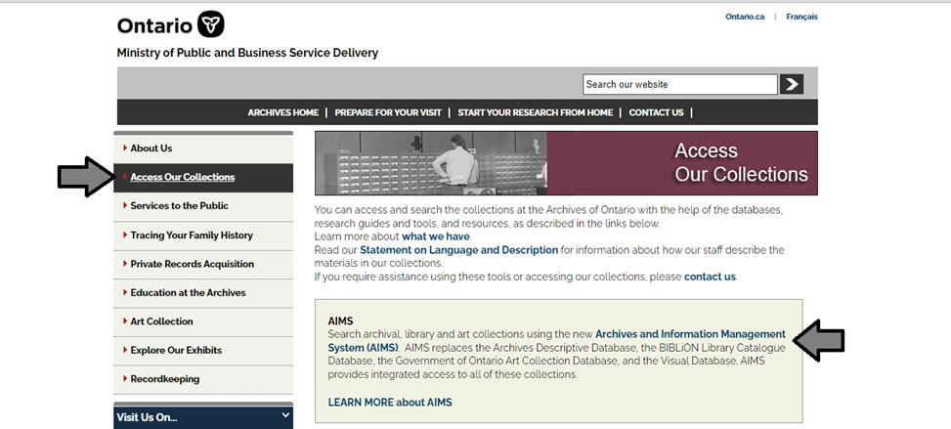

1. In the Archives and Information Management System (AIMS), click on “Archives repository (only)” button:

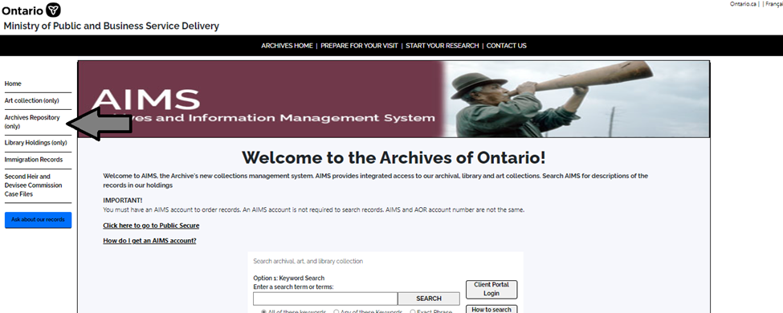

1. On the “Welcome to the Archival Collection” search page, click “Advanced Search”.

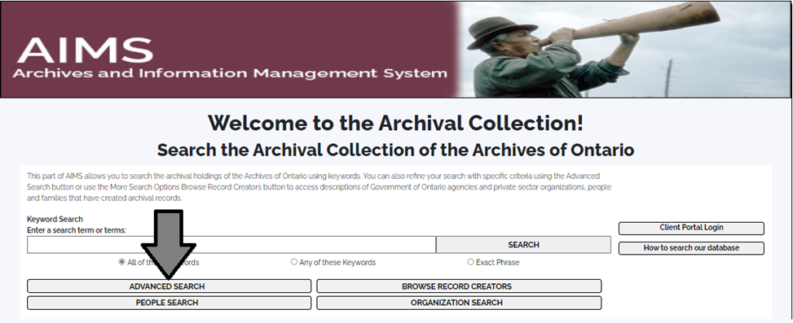

1. On the “Archives Advanced Search” page enter the reference code (that’s the number starting with C, F or RG) in the Reference Code field and click “Search” (at the bottom of the page.

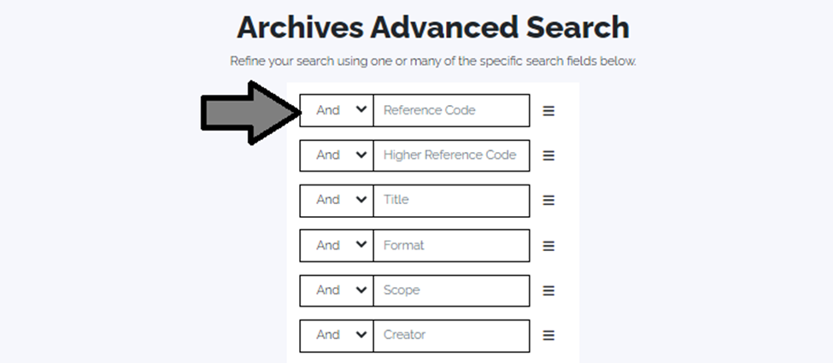

# Contact us

Although unable to do your research for you, our reference archivists are waiting to assist you.  You may call or write to them by mail or email or — best of all — visit the Archives of Ontario.

**Telephone: 416-327-1600 Toll free (Ontario): 1-800-668-9933**

**Email:** [Click here to email the Archives of Ontario](mailto:reference@ontario.ca).  The e-mail address is [reference@ontario.ca](mailto:reference@ontario.ca)

**Address: Archives of Ontario, 134 Ian Macdonald Blvd., Toronto, ON M7A 2C5**

**Website**

Visit our website for information about our collections and our services, our online exhibits and education programs, and links to our social media accounts. [Click here to visit our website](http://www.archives.gov.on.ca/).  The website is [www.archives.gov.on.ca/](http://www.archives.gov.on.ca/).

**Customer Service and Research Guides**

Our guides contain information about our services, freelance researchers available to do research for you, and some of our most popular records.  [Click here to view our Guides](http://www.archives.gov.on.ca/en/access/research_guides.aspx).  To find the “Research Guides and Tools” on our website, click “Access our Collections”.

______________________________________________________________________

© King's Printer for Ontario, 2023

This information is provided as a public service.  Last update is shown at the beginning of this guide.  Readers should where possible verify the information before acting on it.

1. A fonds is the records created, received or accumulated by a person, family, organization, business or office through their activities and operations.