| **Archives of Ontario** |  |
| --- | --- |
| Research Guide 214  Municipal Land Use Planning  Last Updated: March 2023 | |

Photograph is: New City Hall, Ottawa, 1959, RG 65-35-3, 11764-X3520
Tourism promotion photographs


New City Hall, Ottawa, 1959

RG 65-35-3, 11764-X3520

Tourism promotion photographs

In this guide 2

Where do I find these records? 3

What do I need to get started? 3

The Records 3

1. Legislation and regulation 3

2. Policy and program development 4

3. Approval of municipal plans and zoning by-laws 4

4. Planning of new communities 5

5. Urban renewal 5

6. Planning-related research 6

7. Support to municipalities and local planning authorities 6

Are there related records? 6

How do I get to the online descriptions? 7

Contact us 8

# In this guide

This guide has information on records of the Ministry of Municipal Affairs and Housing (and its predecessors) about its role in municipal land use planning and related activities.

Provincial involvement in land planning at the municipal level started in 1912. The Government then required municipalities to submit plans of residential or industrial subdivisions to the Ontario Railway and Municipal Board for review and approval. Government involvement increased and priorities changed over the years. The Department of Planning and Development (the first predecessor to the Ministry of Municipal Affairs and Housing) was created in 1944. Government involvement has decreased since the 1980’s.

*Please note: this guide contains links to information found in our online Archives Descriptive Database.  On our website, this database is found under “Access Our Collections”.  If you are using a print copy of this guide, go to page 6 for more information on how to find the online descriptions.

# Where do I find these records?

You will need to visit the Archives to view the records described in this guide.  Please contact us in advance to request them.  Library materials may be available at public libraries.

Some of the records are subject to the Freedom of Information and Protection of Privacy Act. This information is included in the online descriptions. Contact us for information on how to request access to those records.

Records after the years mentioned in this guide and in online descriptions are with the Ministry of Municipal Affairs and Housing. For contact information, visit the Ministry website, <https://www.ontario.ca/page/ministry-municipal-affairs-housing>.

# What do I need to get started?

If you are looking for planning records pertaining to a given municipality or project, you will need the name of the municipality, and the name and years of the project.

# The Records

The information about the records we have is arranged by the following planning function or activity:

* Legislation and regulation
* Policy and program development
* Approval of municipal plans and zoning by-laws
* Planning of new communities
* Urban renewal
* Planning-related research
* Support to municipalities and local planning authorities

## Legislation and regulation

Laws affecting local land use planning include the Municipal Act, the Planning Act, and the Ontario Municipal Board Act. The records listed below document the development of these acts and related regulations, and how the Government dealt with legal issues related to those acts.

* Community planning legislation and legal opinion files, 1968 to 2001: for information about these records and how to view them, [click here to view the description for RG 19-90](https://aims.archives.gov.on.ca/scripts/mwimain.dll/144/DESCRIPTION_WEB/WEB_DESC_DET?SESSIONSEARCH&exp=sisn%202582)
* Correspondence files on the municipal Planning Act, 1972 to 1994: for information about these records and how to view them, [click here to view the description for RG 19-105](https://aims.archives.gov.on.ca/scripts/mwimain.dll/144/DESCRIPTION_WEB/WEB_DESC_DET?SESSIONSEARCH&exp=sisn%202589)
* Legislation relating to municipal affairs and housing, 1948 to 2008: for information about these records and how to view them, [click here to view the description for RG 19-39](https://aims.archives.gov.on.ca/scripts/mwimain.dll/144/DESCRIPTION_WEB/WEB_DESC_DET?SESSIONSEARCH&exp=sisn%202175)
* Records pertaining to the review of the Planning Act, 1972 to 1982: for information about these records and how to view them, [click here to view the description for RG 19-152](https://aims.archives.gov.on.ca/scripts/mwimain.dll/144/DESCRIPTION_WEB/WEB_DESC_DET?SESSIONSEARCH&exp=sisn%202624)

## Policy and program development

The records listed below document policies and programs the Ministry of Municipal Affairs and Housing developed regarding land use planning:

* Community planning provincial project files, 1974 to 1981: for information about these records and how to view them, [click here to view the description for RG 19-94](https://aims.archives.gov.on.ca/scripts/mwimain.dll/144/DESCRIPTION_WEB/WEB_DESC_DET?SESSIONSEARCH&exp=sisn%202585)
* Municipal land use policy records development records, 1980 to 2009: for information on these records and how to view them, [click here to view the description for RG 19-165](https://aims.archives.gov.on.ca/scripts/mwimain.dll/144/DESCRIPTION_WEB/WEB_DESC_DET?SESSIONSEARCH&exp=sisn%203722)
* Municipal planning policy closed committee files,1987 to 1990: for information on these records and how to view them, [click here to view the description for RG 19-170](https://aims.archives.gov.on.ca/scripts/mwimain.dll/144/DESCRIPTION_WEB/WEB_DESC_DET?SESSIONSEARCH&exp=sisn%208085)

## Approval of municipal plans and zoning by-laws

Since 1912, the Ontario Municipal and Railway Board (later named the Ontario Municipal Board, now the Local Planning Appeal Tribunal) has had to power to either approve or hear appeals from municipal plans and zoning by-laws. This role has varied over time.

At various times, the Ministry of Municipal Affairs and Housing (and its predecessors) has been directly involved in approving municipal plans. It has also issued zoning orders for municipalities without an official plan.

The records below document this government role:

* Adopted municipal plans working files, 1944 to 1998: for information about these records and how to view them, [click here to view the description for RG 19-86](https://aims.archives.gov.on.ca/scripts/mwimain.dll/144/DESCRIPTION_WEB/WEB_DESC_DET?SESSIONSEARCH&exp=sisn%2012780)
* Minister of Affairs consent to convey land files,1974 to 1980: for information about these records and how to view them, [click here to view the description for RG 19-163](https://aims.archives.gov.on.ca/scripts/mwimain.dll/144/DESCRIPTION_WEB/WEB_DESC_DET?SESSIONSEARCH&exp=sisn%203519)
* Minister’s zoning orders and amendment files, 1969 to 2000: for information about these records and how to view them, [click here to view the description for RG 19-82](https://aims.archives.gov.on.ca/scripts/mwimain.dll/144/DESCRIPTION_WEB/WEB_DESC_DET?SESSIONSEARCH&exp=sisn%202580)
* Municipal official plans and amendments approved by the Minister,1945 to 2009: for information about these records and how to view them, [click here to view the description for RG 19-87](https://aims.archives.gov.on.ca/scripts/mwimain.dll/144/DESCRIPTION_WEB/WEB_DESC_DET?SESSIONSEARCH&exp=sisn%202581)
* Municipal subdivision files, 1945 to 1966: for information about these records and how to view them, [click here to view the description for RG 19-83](https://aims.archives.gov.on.ca/scripts/mwimain.dll/144/DESCRIPTION_WEB/WEB_DESC_DET?SESSIONSEARCH&exp=sisn%201398)

For information about hearings of the Ontario Municipal Board, and how to view hearing records, [click here to view Research Guide 208, Ontario Municipal Board hearings](https://view.officeapps.live.com/op/view.aspx?src=http%3A%2F%2Fwww.archives.gov.on.ca%2Fen%2Faccess%2Fdocuments%2Fresearch_guide_208_records_of_OMB_hearings.DOCX&wdOrigin=BROWSELINK). To find this and other guides on our website, click on “Access Our Collections” and scroll down to the Research Guides and Tools page.

## Planning of new communities

The provincial government has supported the development of new communities. It has either provided advice to municipalities, or lead projects itself. The records below document this government role, and specific projects:

* Haldimand-Norfolk community planning files, 1968 to 1975: for information about these records and how to view them, [click here to view the description for RG 19-64](https://aims.archives.gov.on.ca/scripts/mwimain.dll/144/DESCRIPTION_WEB/WEB_DESC_DET?SESSIONSEARCH&exp=sisn%202573)
* New townsite planning and development files, 1954 to 1978: for information about these records and how to view them, [click here to view the description for RG 19-63](https://aims.archives.gov.on.ca/scripts/mwimain.dll/144/DESCRIPTION_WEB/WEB_DESC_DET?SESSIONSEARCH&exp=sisn%202572)
* North Pickering planning and development files,1971 to2006: for information about these records and how to view them, [click here to view the description for RG 19-166](https://aims.archives.gov.on.ca/scripts/mwimain.dll/144/DESCRIPTION_WEB/WEB_DESC_DET?SESSIONSEARCH&exp=sisn%203725)
* Townsend (Haldimand County) community planning records,1976 to 1984: for information about these records and how to view them, [click here to view the description for RG 43-27](https://aims.archives.gov.on.ca/scripts/mwimain.dll/144/DESCRIPTION_WEB/WEB_DESC_DET?SESSIONSEARCH&exp=sisn%202699)

## Urban renewal

The records below document government involvement in efforts to renew urban downtown and industrial areas affected by economic changes:

* Main Street Revitalization Loan Program files,1992 to 1993: for information about these records and how to view them, [click here to view the description for RG 19-172](https://aims.archives.gov.on.ca/scripts/mwimain.dll/144/DESCRIPTION_WEB/WEB_DESC_DET?SESSIONSEARCH&exp=sisn%2010468)
* Records of the maintenance of property study, 1969 to 1970: for information and these records and how to view them, [click here to view the description for RG 19-65](https://aims.archives.gov.on.ca/scripts/mwimain.dll/144/DESCRIPTION_WEB/WEB_DESC_DET?SESSIONSEARCH&exp=sisn%202574)
* Urban Renewal program files, 1955 to 1989: for information about these records and how to view them, [click here to view the description for RG 19-69](https://aims.archives.gov.on.ca/scripts/mwimain.dll/144/DESCRIPTION_WEB/WEB_DESC_DET?SESSIONSEARCH&exp=sisn%202577)

## Planning-related research

The records below document research by the Ministry of Municipal Affairs and Housing on issues related to land use planning:

* Community planning, research and special studies files,1946 to 1976: for information about these records and how to view them, [click here to view the description for RG 19-61](https://aims.archives.gov.on.ca/scripts/mwimain.dll/144/DESCRIPTION_WEB/WEB_DESC_DET?SESSIONSEARCH&exp=sisn%202571)
* Flood plan criteria and management evaluation study records, 1974 to 1979: for information and these records and how to view them, [click here to view the description for RG 19-167](https://aims.archives.gov.on.ca/scripts/mwimain.dll/144/DESCRIPTION_WEB/WEB_DESC_DET?SESSIONSEARCH&exp=sisn%206848)
* Records of studies, committees and task forces relating to local planning, 1965 to 1993: for information about these records and how to view them, [click here to view the description for RG 19-104](https://aims.archives.gov.on.ca/scripts/mwimain.dll/144/DESCRIPTION_WEB/WEB_DESC_DET?SESSIONSEARCH&exp=sisn%202588)

## Support to municipalities and local planning authorities

The records below document government support to local planners. This took the forms of technical and legal advice, training, and financial support:

* Community planning correspondence files, 1944 to 1990: for information about these records and how to view them, [click here to view the description for RG 19-77](https://aims.archives.gov.on.ca/scripts/mwimain.dll/144/DESCRIPTION_WEB/WEB_DESC_DET?SESSIONSEARCH&exp=sisn%202579)
* Community Planning Study Grant program files,1972 to 1993: for information about these records and how to view them, [click here to view the description for RG 19-91](https://aims.archives.gov.on.ca/scripts/mwimain.dll/144/DESCRIPTION_WEB/WEB_DESC_DET?SESSIONSEARCH&exp=sisn%202583)
* Municipal community planning files,1946 to 2007: for information about these records and how to view them, [click here to view the description for RG 19-95](https://aims.archives.gov.on.ca/scripts/mwimain.dll/144/DESCRIPTION_WEB/WEB_DESC_DET?SESSIONSEARCH&exp=sisn%202423)
* Northeastern Ontario planning project files, 1950 to 1975: for information about these records and how to view them, [click here to view the description for RG 19-100](https://aims.archives.gov.on.ca/scripts/mwimain.dll/144/DESCRIPTION_WEB/WEB_DESC_DET?SESSIONSEARCH&exp=sisn%202586)
* Northwestern Ontario planning project files, 1950 to 1983: for information about these records and how to view them, [click here to view the description for RG 19-102](https://aims.archives.gov.on.ca/scripts/mwimain.dll/144/DESCRIPTION_WEB/WEB_DESC_DET?SESSIONSEARCH&exp=sisn%202587)

# Are there related records?

Other Government of Ontario of Ontario have been or are involved in the planning process. These include the Ministry of the Environment, the Ministry of Natural Resources and Forestry, the Ministry of Transportation and their predecessors. For information about these ministries and their records, [click here to search the Archival Collection](https://aims.archives.gov.on.ca/scripts/mwimain.dll/322051054?unionqueryform&application=UNION_VIEW&language=144&aux_sessid=AO_SHARE&searchform=%5bAO_ASSETS%5d/html/archival.html&AUX_SESSID=AO_SHARE). In the database, choose the “Search by Records Creators” advances search option.

Records we have from various municipalities may include zoning by-laws and land use planning records. For information about municipal records that we have, [click here to view Research Guide 209, Municipal records](http://www.archives.gov.on.ca/en/access/documents/research_guide_209_municipal_records.pdf). To find this and other guides on our website, click on “Access Our Collections” and scroll down to the Research Guides and Tools page.

Our library holds issues of Municipal World, a periodical publication on municipal issues in Ontario, including planning. We have all issues from 1891 to present. To view it at the Archives, request it using the title, the year you want, and call number Period M. You will find a digital copy of all issues at <https://www.municipalworld.com/>.

# How do I get to the online descriptions?

1. On our website’s main page, click on “Access Our Collections”, and click on “Archives and Information Management System”, as shown in the image below:

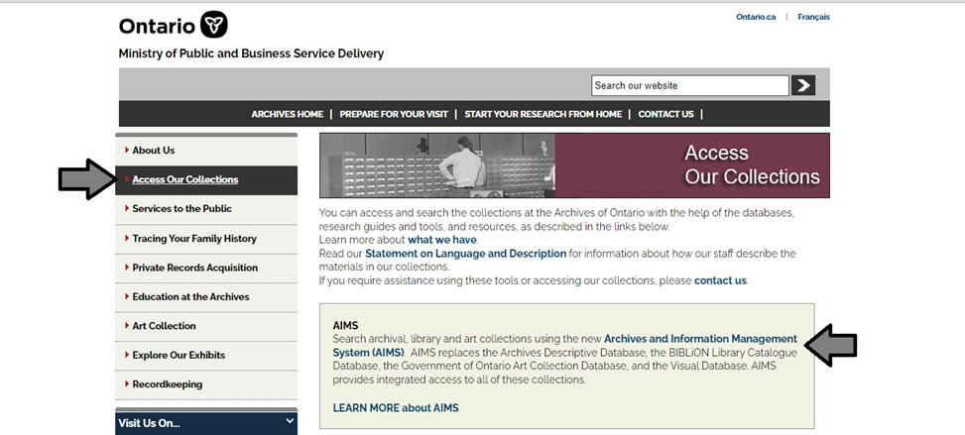

1. I In the Archives and Information Management System (AIMS), click on “Archives repository (only)” button:

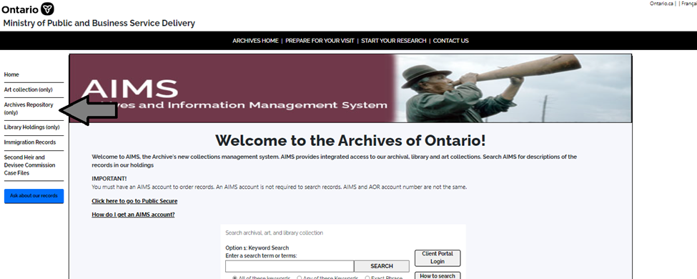

1. On the “Welcome to the Archival Collection” search page, click “Advanced Search”.

T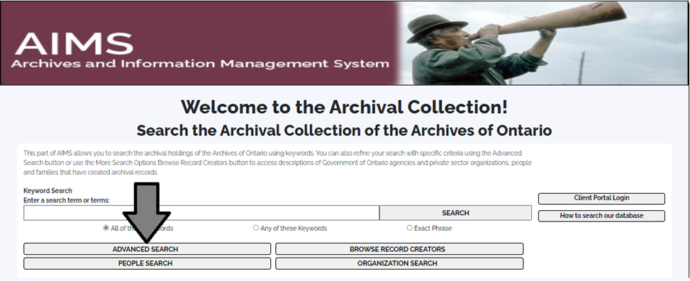

1. On the “Archives Advanced Search” page enter the reference code (that’s the number starting with C, F or RG) in the Reference Code field and click “Search” (at the bottom of the page.

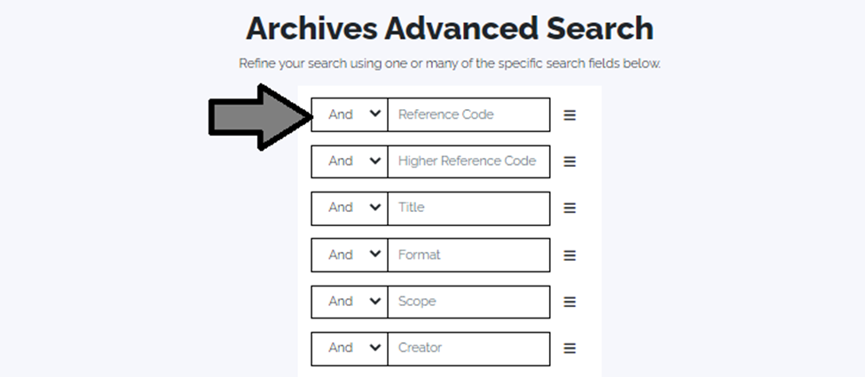

# Contact us

Although unable to do your research for you, our reference archivists are waiting to assist you.  You may call or write to them by mail or email or — best of all — visit the Archives of Ontario.

**Telephone: 416-327-1600 Toll free (Ontario): 1-800-668-9933**

**Email:** [Click here to email the Archives of Ontario](mailto:reference@ontario.ca).  The e-mail address is [reference@ontario.ca](mailto:reference@ontario.ca)

**Address: Archives of Ontario, 134 Ian Macdonald Blvd., Toronto, ON M7A 2C5**

**Website**

Visit our website for information about our collections and our services, our online exhibits and education programs, and links to our social media accounts. [Click here to visit our website](http://www.archives.gov.on.ca/).  The website is [www.archives.gov.on.ca/](http://www.archives.gov.on.ca/).

**Customer Service and Research Guides**

Our guides contain information about our services, freelance researchers available to do research for you, and some of most popular records.  [Click here to view our guides](http://www.archives.gov.on.ca/en/access/research_guides.aspx).  To find the “Research Guides and Tools” on our website, click on “Access our Collections”.

______________________________________________________________________

© King's Printer for Ontario, 2023

This information is provided as a public service.  Last update is shown at the beginning of this guide.  Readers should where possible verify the information before acting on it.