| **Archives of Ontario** | Ontario Logo |
| --- | --- |
| Research Guide 215  Early Land Records from the 1780s to the 1850s  Last Updated: March 2023 | |

Image is Mr. Cartwright's mill on the Appanee River; Bay of Quinte, Elizabeth Simcoe fonds, F 47-11-1-0-160, Simcoe Family fonds


Mr. Cartwright's mill on the Appanee River; Bay of Quinte  
Elizabeth Simcoe fonds  
F 47-11-1-0-160  
Simcoe Family fonds

In this guide 2

Where do I find these records? 3

What do I need to get started? 3

The Records 4

1. Documenting the process – the Ontario Land Records Index and related records 4

2. Surveying the land 4

3. Crown Land records 5

4. Promoters of land settlement – Thomas Talbot and Peter Robinson 6

4.1 Thomas Talbot and the Talbot Tract 6

4.2 Peter Robinson and the Peterborough and Ottawa areas 7

5. Private land developers – the Canada Company 8

5.1 Registers of sales and contracts, 1827 to 1926 8

5.2 Remittance books, 1843 to 1846 9

6. Documenting private land transactions – the land registration system 9

7. Maps and plans 9

7.1 Township survey plans 9

7.2 Patent plans 10

7.3 Other maps and plans 10

How do I get to the online descriptions? 10

Contact us 12

# In this guide

This guide has information on Archives of Ontario records about land ownership from the 1780’s to the 1850’s.

The land that we now call Ontario is the traditional territory and present-day home of many Indigenous peoples. Anishinaabe, Haudenosaunee, Cree and many other nations have lived and worked on this land long before the initial arrival of French and British explorers in the 17th century.

After the American Revolution, people wishing to remain under British sovereignty migrated to present-day Ontario in the 1780’s. They were followed by Americans attracted by free land granting policies. French-Canadians people had already occupied land in around current-day Windsor. After the end of the Napoleonic Wars in 1815, British military veterans and other people, mostly from the British Isles, joined this first groups of immigrants.

Following treaties with Aboriginal nations, the Crown (the British and local governments) transferred ownership to individuals or companies Initially, it granted most of this land for free (except for administrative fees). From the 1820’s on, most of the Crown land was sold rather than granted. Iindividuals or companies also supported settlement initiatives. A land registry system was set up to document private transactions

*Please note: this guide contains links to information found in our online Archives Descriptive Database.  On our website, this database is found under “Access Our Collections”.  If you are using a print copy of this guide, go to page 10 for more information on how to find the online descriptions.

This guide also includes links to our Microfilm Interloan Catalogue. [Click here to view our Microfilm Interloan Catalogue](http://www.archives.gov.on.ca/en/microfilm/index.aspx). On our website, this catalogue is found under “Access Our Collections”.

# Where do I find these records?

Many of the records mentioned in this guide are on microfilm, and you do not need to order them in advance to view them in our reading room. Libraries that offer interloan services may also borrow most of the reels for you.

Some of the records are microfilm copies of records held by Library and Archives Canada. Those reels are not available through interloan. Some of these records are available online. The Library and Archives Canada website is [www.collectionscanada.gc.ca](https://library-archives.canada.ca/eng).

Some records are not on microfilm. You will need to request them in advance to view them in our reading room. You may also obtain copies if there is sufficient information to locate and retrieve those records.

# What do I need to get started?

You need the name of the person you are looking for, a location (township, concession and lot) for the land they lived on, and when they started living there or became the owner.

# The Records

## Documenting the process – the Ontario Land Records Index and related records

The Ontario Land Records Index (OLRI) is two sets of microfiche (by individual and by location) provides information about settlers who:

* Got involved in the process leading to the grant or purchase of Crown land
* Rented or purchased land from the Canada Company (a London, England, based company that received, then sold over half a million acres of land, mostly in and near Huron County)
* Came to the Peterborough area at the initiative of Peter Robinson, a politician involved in the movement of Irish emigrants to Upper Canada (the town of Peterborough was named after him).
* Were offered land after 1901 for service during Fenian Raids (1860s) or the Boer War (1899 to 1902).

Information on the OLRI covers the period from the 1780’s to the 1920’s. It includes the settler’s name, a township, lot and concession, the type of transaction, and a reference to a source document. Crown land records indexed in the OLRI were for the most part, created at the time land was granted or sold.

Records indexed in the OLRI they include:

* Schedules and land rolls (listings of land granted)
* Registers of fiats and warrants (administrative documents issued to order various government offices to process a grant)
* Registers of locations and assignments (documents issued to individuals to confirm a grant and the land being granted)
* Descriptions of the land being granted
* Lease and sale registers

You can search Ontario Land Records Index (OLRI) in our reading room. The records it indexes are on microfilm, also in our reading room. Local libraries that offer interloan services can borrow the microfiche and most of the microfilm reels for you.

For information on how to use the Index and find the related microfilm, [click here to view Guide 205, Ontario Land Records Index](http://www.archives.gov.on.ca/en/access/documents/research_guide_205_land_records.pdf). On our website, you will find this and other research guides on the “Research Guides and Tools” page, under “Access our Collections”.

## Surveying the land

Following the signing of a treaty with Indigenous peoples, the Office of the Surveyor General surveyed the land and divided it into townships. Each township was further divided into concessions and lots. Regular size for a lot was 200 aces (approximately 0.8 km2).

Crown land surveyors were directed to keep a diary and a field book that documented vegetation cover, topography, soil type and remarks on the suitability of the land for agriculture. We have most of the early diaries, field notes and reports. For information on these records and how to access,  [click here to view the description for RG 1-59.](https://aims.archives.gov.on.ca/scripts/mwimain.dll/144/DESCRIPTION_WEB/WEB_DESC_DET?SESSIONSEARCH&exp=sisn%206188). The Ministry of Natural Resources and Forestry has other diaries, field notes and survey records, including recent ones. For information, visit the website of the Office of the Surveyor General, <https://www.ontario.ca/page/office-surveyor-general>

We also have the instructions the Office of the Surveyor General to surveyors. You may view them on microfilm MS 30, in our reading room only.

## Crown Land records

After a treaty had been signed with Indigenous people, land that had been transferred was conserved Crown Lands. The Commissioner of Crown Lands (later Department of Lands and Forests) managed it and granted or sold land to individuals or companies.

Initially, the Crown transferred land to individuals by granting it. After the 1820’s, sales became the norm, although grants were made to people qualified as indigent, and later to veterans of the Fenian Raids and Boer War.

Land grants were done through the following process:

1. Individuals who wanted to receive land submitted a petitionto the Executive Council or the Department of Crown Lands (in early years, a local Land Board may have also been involved).
2. If the petition was accepted, an Order-in-Council granting a piece of land was issued, and the requester received a location ticket or certificate listing the township, concession and lot.

At that point various government departments (including the Executive Council, Surveyor General, Commissioner of Crown Lands, Attorney General, Provincial Secretaries) issued documents to confirm what piece of land was being granted.

Receiving a grant did not make the individual the owner of the piece of land. They had to pay administrative fees and meet certain other requirements. Fees and requirements varied overtime, and some groups (Loyalists, their families, and some military and militia veterans) were exempt from the fees. Grantees could also assign (sell or transfer) their rights.

1. Once all requirements had been met, the Crown issued a patenttransferring ownership.

To summarize the granting process:

1. **Petition** (Settler applies for land) (Petition approved) **→** 2. Land **granted** to settler **→** 3. **Patent** (Requirements met $) (Ownership transferred to settler)

To settle issues that resulted from grantees dying, transferring their rights or not completing the process to obtain patents, the government of Upper Canada created two Heir and Devisee Commissions (1797 to 1804 and 1805 to 1911).

Sales of Crown Land were usually done by appointed Crown Land Agents, through public sales. In many cases, payment was through instalments, or the buyer first rented the land with part of the rent going towards the purchase price. Most of the same documents created during the grant process were also used to document sales, and the buyer received a patent once the final payment had been made.

Some of the Crown Land records are indexed in the Ontario Land Records Index.

For more information about Crown Land records, [click here to view research guide 225, Crown Land records](http://www.archives.gov.on.ca/en/access/documents/research_guide_225_resources_for_researching_land_records.pdf).

## Promoters of land settlement – Thomas Talbot and Peter Robinson

Individuals assisted the Crown by promoting settlement and managing parts of the granting process in some areas of the province. Main promoters were Thomas Talbot, in southwestern Ontario and Peter Robinson in the Peterborough and Ottawa areas.

### Thomas Talbot and the Talbot Tract

Colonel Thomas Talbot, a veteran from the British Army, was put in charge of approximately one-half-million acres (2000 km2) in present-day Norfolk, Elgin, Middlesex, Kent, and Essex counties, an area known as the “Talbot Tract”. Between 1802 and 1837, Talbot helped approximately 6000 acquire land in that area.

Although Talbot controlled most aspects of the land granting process in the area entrusted to him, the land was still considered Crown Land and the government issued patents once the granting process was completed. The Crown took back land management in the Talbot Tract in 1837.

We have township and town plans Talbot used to document his land grants. Talbot pencilled the names of the persons as he located on the lots. Often, he erased or scratched out this information when he rejected or replaced individuals he had previously located. For information about these plans and how to access them, [click here to view the description for F 501-1](https://aims.archives.gov.on.ca/scripts/mwimain.dll/144/DESCRIPTION_WEB/WEB_DESC_DET?SESSIONSEARCH&exp=sisn%208285).

We also have a register with information on leases in ten townships where Talbot oversaw settlement: Aldborough, Bayham, Charlotteville, Dunwich, London, Malahide, Southwold, Townsend, Woodhouse and Yarmouth. For information about this register and how to access it, [click here to view the description for F 501-2](https://aims.archives.gov.on.ca/scripts/mwimain.dll/144/DESCRIPTION_WEB/WEB_DESC_DET?SESSIONSEARCH&exp=sisn%208286).

### Peter Robinson and the Peterborough and Ottawa areas

In 1823, the British government began a program to help poor individuals from southern Ireland to immigrate to Canada. The government of Upper Canada appointed Peter Robinson to supervise the arrival and settlement of these immigrants.

In 1823, Robinson helped locating a first group of immigrants, mostly in the townships of Ramsay and Pakenham (Lanark County) and Goulbourn and Huntley (Carleton County, now part of Ottawa). A larger group of immigrants was brought over in 1825, locating in townships in the Peterborough area, mainly in Douro, Otonabee, Asphodel, Smith, Emily, Ennismore and Ops Townships.

Immigrants received free transportation to Upper Canada, provisions during the voyage and for an additional year following their location on the land, and the tools and utensils required for settlement. Each male immigrant between the ages of 18 and 45 was to receive a location ticket for 70 acres (0.2 km2) of land and they could buy another 30 acres at a later date.

We have correspondence Peter Robinson received from 1825 to 1836, from government officials, immigrants and other people. For information about these records and how to access them,  [click here to view the description for F 61](https://aims.archives.gov.on.ca/scripts/mwimain.dll/144/DESCRIPTION_WEB/WEB_DESC_DET?SESSIONSEARCH&exp=sisn%20598).

We also microfilm copies of the records below. Originals are with the Peterborough Centennial Museum and Archives. Some of these records are indexed in the Ontario Land Records Index.

* lists of immigrants by ship (1823)
* embarkation cards for 1825
* alphabetical lists of immigrants by township, giving birthplace in Ireland
* lists of tools, livestock and clothing given
* applications from intended immigrants, arranged alphabetically and often with letters of recommendation.

You may view these records in our reading room, on microfilm **MS 12, reels 1 to 3**. There is a finding aid at the start of reel 1. The Peterborough Centennial Museum and Archives website is <https://www.peterborough.ca/en/explore-and-play/museum-and-archives.aspx>.

Peter Robinson immigrants are also documented in Crown Land records. For information about records specific to them, and how to access them,

* [click here to view the description for RG 1-162, Fiats for land grants – Peter Robinson settlers, 1833 to 1862](https://aims.archives.gov.on.ca/scripts/mwimain.dll/144/DESCRIPTION_WEB/WEB_DESC_DET?SESSIONSEARCH&exp=sisn%207220)
* [click here to view the description for RG 1-84, Returns of settlers in the Newcastle District, circa 1836 to 1869](https://aims.archives.gov.on.ca/scripts/mwimain.dll/144/DESCRIPTION_WEB/WEB_DESC_DET?SESSIONSEARCH&exp=sisn%206818)
* [click here to view the description for RG 1-163, records relating to the Peter Robinson settlers, circa 1823 to 1835](https://aims.archives.gov.on.ca/scripts/mwimain.dll/144/DESCRIPTION_WEB/WEB_DESC_DET?SESSIONSEARCH&exp=sisn%207223)

For more information on searching Crown land records, [click here to view research guide 225, Crown Land records](http://www.archives.gov.on.ca/en/access/documents/research_guide_225_resources_for_researching_land_records.pdf).

## Private land developers – the Canada Company

The Canada Company was created in London, U.K.in 1825, In 1827, it purchased land in Upper Canada from the Crown:

* approximately 1.4 million acres (5.6 million km2) of Crown Reserve land in various part of the province; this was land that had been sent aside to provide revenue for the Crown and that had not been leased or sold yet
* approximately 1.1 million acres (4.5 million km2) of land in current-day Huron, Lambton and Middlesex Counties, known as the Huron Tract.

Part of the purchase price was in the form of infrastructure work in the Huron Tract (surveys, roads, bridges, mills, port facilities).

The Canada Company offered its land for sale and promoted it in the British Isles as well as European countries. In many cases, purchasers first rented their lot, with part of the money going towards the final purchase cost. The Canada Company was also involved in exploiting natural resources in the Huron Tract. It sold its remaining land in 1951, and it ceased to exist in 1953.

Canada Company records in our collection include land records, maps and plans, correspondence, as well as financial and administrative records. For more information on these records and how to access them, contact us to get the finding aid for F 129, in digital format. Also see below for information about registers of sales and contracts, and remittance books.

### Registers of sales and contracts, 1827 to 1926

Canada Company’s registers include the following about land leases and sales:

* name of the person leasing or buying the piece of land
* township, concession and lot of the piece of land leased or sold
* the amount and date of payments
* a reference to the deed transferring ownership

You may view the registers on microfilm in our reading room, and libraries that offer interloan services can borrow the reels for you. [Click here to view a microfilm list in the Microfilm Interloan Catalogue](http://www.archives.gov.on.ca/en/microfilm/canco.aspx#history). These records are indexed in the Ontario Land Records Index.

### Remittance books, 1843 to 1846

The Canada Company offered a free money remittance service, which allowed people in Upper Canada to send money to families and friends in the United Kingdom or receive money. We have remittance books for the years 1843 to 1846. They include the name of the individuals sending and receiving the money, their location in Upper Canada or the United Kingdom, the amount of money and transaction dates. Some entries include additional information on the sender and recipient.

You can view the remittance books on microfilm **MS 959, reel 1**, in our reading room. The books are index in Ruth Holt and Margaret William’s [Genealogical Extractions and Index of the Canada Company Remittance Books](http://ao.minisisinc.com/scripts/mwimain.dll/144/ARCH_BIBLIO/WEB_DETAIL_REPORT/RECORD_ID+8539?SESSIONSEARCH), 1843-1847 (Weston, Ont.: R. Holt, 1990). There is a copy on the genealogy publication bookshelves, in our reading room,

## Documenting private land transactions – the land registration system

Upper Canada set up a process for registering private land transactions (transactions other than Crown grants or sales), in 1795. Parties to the transaction could file the deed (the transaction document) with the local Registry Office (one in each county and northern district, two in some). Registration of private transactions became mandatory in 1846.

For information about land registration records, [click here to view research guide 231, Land registration records](http://www.archives.gov.on.ca/en/access/documents/research_guide_231_finding_land_registration_records.pdf). On our website, you will find this and other research guides under “Access Our Collection”.

## Maps and plans

Our collections include maps and plans showing surveys, initial townships, concessions and lots, roads, and geographical features. Some include names of landowners.

### Township survey plans

Early survey plans of townships show the lot and concession gridlines. Often, plans were used as office or working copies and other information was written on them. Often, occupants’ names were written over the survey grids.

We have survey plans produced by the Office of the Surveyor General and other government offices. For information about these records and how to access them:

* [click here to view the description for C 277, Township plan collection](https://aims.archives.gov.on.ca/scripts/mwimain.dll/144/DESCRIPTION_WEB/WEB_DESC_DET?SESSIONSEARCH&exp=sisn%2089).
* [click here to view the description for RG 1-470, Ministry of Natural Resources township survey plans](https://aims.archives.gov.on.ca/scripts/mwimain.dll/144/DESCRIPTION_WEB/WEB_DESC_DET?SESSIONSEARCH&exp=sisn%207474).

### Patent plans

When land was granted or sold, the name of the grantee or buyer was also written down on a plan of the township, called a “Patent Plan”. Information was later updated or changed as required, in some cases up to the 1970’s. For many townships, there may be plans that cover only part of the township, or various versions of the plans.

You may view a digital copy of most, but not all the patent plans on our website. For information on viewing the digitized patent plans, [click here to view our Digital Patent Plan webpage](http://www.archives.gov.on.ca/en/about/patent-plans.aspx). On our website, you will find this page under “Access Our Collection”.

**How do I find the plans that have not been digitized?**

For more information about the patent plans, and a complete list, [click here to view the description for RG 1-100](https://aims.archives.gov.on.ca/scripts/mwimain.dll/144/DESCRIPTION_WEB/WEB_DESC_DET?SESSIONSEARCH&exp=sisn%206438). You can also:

* [click here to search the Archival Collection by files or items](https://aims.archives.gov.on.ca/scripts/mwimain.dll/522075080?unionqueryform&application=UNION_VIEW&language=144&aux_sessid=AO_SHARE&searchform=%5bAO_ASSETS%5d/html/archival.html&AUX_SESSID=AO_SHARE) (or click on “Advanced Search” page then enter the reference code (that’s the number starting with C, F or RG) in the Reference Code field and click “Search” (at the bottom of the page.
* enter reference code RG 1-100 and the name of the township or town

### Other maps and plans

In addition to maps created as part of the surveying and land granting process, our collection includes various maps that document land use and occupancy.

Joan Winnearl’s book Mapping Upper Canada, 1780-1867: An Annotated Bibliography of Manuscript and Print Maps (Toronto: University of Toronto Press, 1991) lists maps and plans produced between 1780 and Confederation (1867). To view this volume in our reading room, speak to a reference archivist at the reference desk.

# How do I get to the online descriptions?

1. On our website’s main page, click on “Access Our Collections”, and click on “Archives and Information Management System”, as shown in the image below:

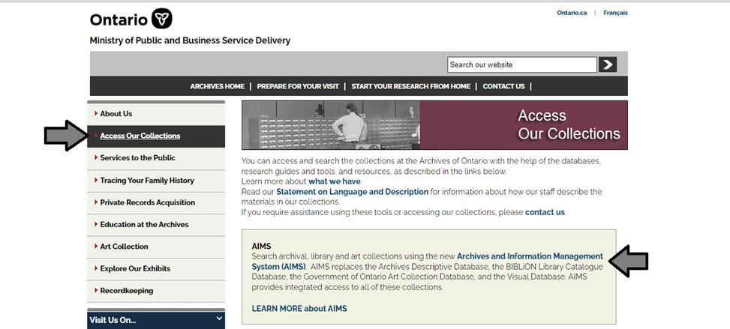

1. In the Archives and Information Management System (AIMS), click on “Archives repository (only)” button

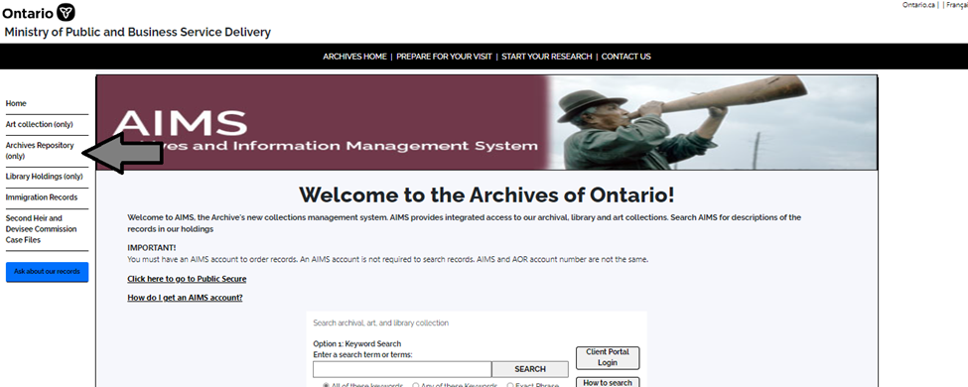

1. On the “Welcome to the Archival Collection” search page, click “Advanced Search”:

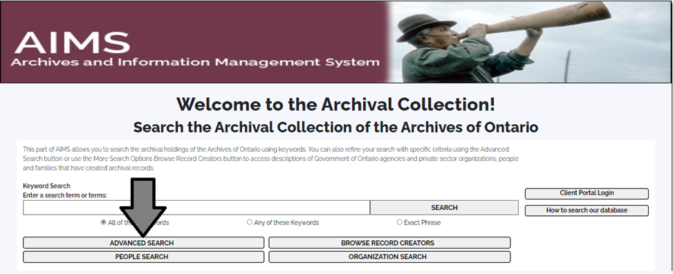

1. On the “Archives Advanced Search” page enter the reference code (that’s the number starting with C, F or RG) in the Reference Code field and click “Search” (at the bottom of the page).

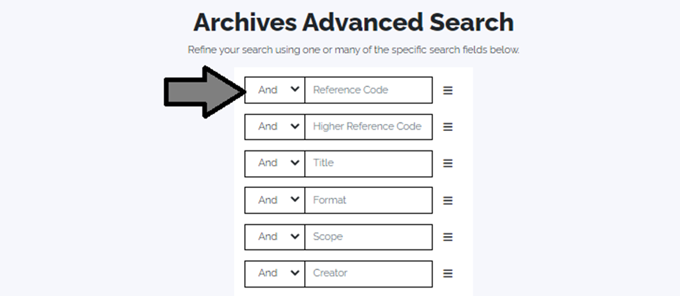

# Contact us

Although unable to do your research for you, our reference archivists are waiting to assist you.  You may telephone or write to them by mail or email or — best of all — visit the Archives of Ontario.

**Telephone: 416-327-1600 Toll free (Ontario): 1-800-668-9933**

**Fax:416-327 to 1999**

**Email:** [Click here to email the Archives of Ontario](mailto:reference@ontario.ca).  The e-mail address is [reference@ontario.ca](mailto:reference@ontario.ca)

**Address: Archives of Ontario, 134 Ian Macdonald Blvd., Toronto, ON M7A 2C5**

**Website**

Visit our website for information about our collections and our services, our online exhibits and education programs, and links to our social media accounts. [Click here to visit our website](http://www.archives.gov.on.ca/). The website is [www.archives.gov.on.ca/](http://www.archives.gov.on.ca/).

**Customer Service and Research Guides**

Our guides contain information about our services, freelance researchers available to do research for you, and some of most popular records.  [Click here to view our guides](http://www.archives.gov.on.ca/en/access/research_guides.aspx).  To find the “Research Guides and Tools” on our website, click on “Access our Collections”.

______________________________________________________________________

© King's Printer for Ontario, 2023

This information is provided as a public service.  Last update is shown at the beginning of this guide.  Readers should where possible verify the information before acting on it.