| **Archives of Ontario** |  |
| --- | --- |
| Research Guide 218  Partnership and Benevolent Society  Registration Records  Last Updated: September 2023 | |

Photograph is :The old cobbler 
W.H. Moss, photographer [circa 1920]
F 4436-0-0-0-182, William H. Hammond fonds


The old cobbler

W.H. Moss, photographer [circa 1920]

F 4436-0-0-0-182

William H. Hammond fonds

**In this guide 2**

**Where do I find these records? 3**

**What do I need to get started? 3**

**The Records 3**

1. Partnership and sole proprietorship declarations 3

1.1 Partnership and sole proprietorship declarations, 1870 to 1975 3

1.2 Partnership and sole proprietorship declarations, 1973 to 1991 4

2. Benevolent Society records 4

**Are there related records? 5**

**How do I get to the online descriptions? 5**

**Contact us 7**

# In this guide

This guide has information on Archives of Ontario records that document the registration of partnerships and the incorporation of benevolent societies.

A partnership is a business where the co-owners are responsible for the assets and debts of the business (for example, if the business goes bankrupt, the co-owners may also go bankrupt). Partners in a limited partnership have various levels of involvements and liabilities in the business. A sole proprietorship is similar, with only one owner. Today, registration records for partnerships and sole proprietorships are called business licences.

Unlike a corporation, a partnership or sole proprietorship cannot include the words or abbreviations “Corp.”, “Corporation”, “Inc.”, “Incorporée”, “Incorporated” “Limited”, “Limitée”, “Ltd”, “Ltée.”in its name. It tends to be smaller than a corporation.

Benevolent societies were mutual assistance organizations. They provided various social and economic services to their members, including collective insurance. These societies included the Ancient Order of Foresters, the Canadian Order of Foresters, the Chosen Friends of the Grand Council of Ontario, the Loyal True Blue Associations, the Knights of Pythias, the Oddfellows Independent Order Lodge and many others.

*Please note: this guide describes Government of Ontario records about the registration of partnerships and sole proprietorships and the incorporation of benevolent societies. These records do not include financial, administrative, product or employee information,

*Please note: this guide contains links to information found in our online Archives Information Management System (AIMS).  On our website, this database is found under “Access Our Collections”.  If you are using a print copy of this guide, go to page 5 for more information on how to find the online descriptions.

# Where do I find these records?

We have:

* Partnership and sole proprietorship declarations (the documents used to register them) and related indexes, from 1870 to 1991
* Incorporation and regulatory records for benevolent societies, from 1870 to 1969

You will need to visit the Archives to view these records. Some of these records are on microfilm, and you do not need to order them in advance. You will need to make arrangements in advance to view the other records. In some cases, you will be able to request copies from a distance,

Service Ontario has the records after the dates above. For more information, contact:

Service Ontario   
Business Registration Service   
Mailing: 393 University Ave., Suite 200, Toronto ON M5G 2M2   
Counter Services: 2nd Flr, 375 University Ave., Toronto ON   
Telephone: 416-314-8880   
Fax: 416-314-4806   
Toll Free Phone (Ontario only): 1-800-361-3223   
TDD Phone: 416-314-0843   
Website: [www.serviceontario.ca](http://www.serviceontario.ca/)

# What do I need to get started?

You need to know the name of the partnership, sole proprietorship or benevolent society, and the date it was created. For sole partnerships and sole proprietorships before 1975, you also need to know the location; for those years, a partner’s name can also help you to find the records you are looking for.

# The Records

## Partnership and sole proprietorship declarations

Partnerships and sole proprietorships were registered by filing a **declaration**. The declaration includes basic information about the partners or proprietor, such as a name and address, the name and address of the business, and brief information about the type of business activity (for example, corner store or dance studio). Declarations for partnerships and proprietorships are filed together, as well as declarations of business names.

### 1.1 Partnership and sole proprietorship declarations, 1870 to 1975

Declarations were filed with the local registry office in the county or district were the business was located. Please note that at various times separate offices existed for parts of Toronto. We have the records for all offices except Thunder Bay District.

Records we have include:

* the registrations
* index books, by name of business and name of partner/proprietor: each index covers a number of years, and is arranged fist by the first letter in the name, then in chronological order; the entries include the date and the declaration number
* copybooks, containing an official transcript of the declaration

Please note: Although this was not mandatory, some partners and proprietors submitted a declaration when their business was dissolved. If there was a change in the partnership, some declared the dissolution, then submitted a new declaration for the changed partnership. Entries in the indexes do not refer to subsequent declarations, so you may want to check the indexes from the time of the initial declaration to 1975.

Most of the indexes and some of the copybooks are on microfilm.

For information on how to access these records, [click here to view the description for RG 55-17, Expired partnership and sole proprietorship registrations, pre-1975, then scroll down and link on the link for the office you are looking for](https://aims.archives.gov.on.ca/scripts/mwimain.dll/144/DESCRIPTION_WEB/WEB_DESC_DET?SESSIONSEARCH&exp=sisn%209265).

### 1.2 Partnership and sole proprietorship declarations, 1973 to 1991

Beginning in 1973, partnership and sole proprietorships declarations had to be renewed every five years, or the partnership would be deemed to no longer exist. For example, a partnership that existed from 1976 to 1989 was declared in 1976, then again in 1981 and 1986. Business that existed on January 1, 1873 had to file a new declaration before December 31, 1974).

The format changed as well. Declarations for 1973 to 1991 are on sets of two cards (more if there were a large number of partners), one with the information on the business and the other(s) with the information on the partners/proprietor. The cards are arranged by year then in alphabetical order by business name for the whole province.

The declarations for 1973 to 1982 are on microfiche, in a cabinet in our reading room. The declarations for 1983 to 1991 are on microfilm, also in the reading room. For a list of the microfilm, [click here to access the description for RG 55-16, Expired partnership and sole proprietorship registrations, 1973-](https://aims.archives.gov.on.ca/scripts/mwimain.dll/144/DESCRIPTION_WEB/WEB_DESC_DET?SESSIONSEARCH&exp=sisn%209210). Please note: The registrations for 1983 to 1989 were filmed in reverse order, from Z to A instead of A to Z.

## Benevolent Society records

Benevolent societies and their lodges (local sections) incorporated by filing documentation with the local Clerk of the Peace or with the County (or District) Court.

You may find incorporation documentation in the Benevolent Society corporation files. Those files contain a certificate of incorporation, and a copy of the society’s by-laws. A few incorporation records are found in court records. To view information about these records and how to access them:

* [Click here to view the description for RG 55-7, Benevolent societies corporation files, 1874 to 1969](https://aims.archives.gov.on.ca/scripts/mwimain.dll/144/DESCRIPTION_WEB/WEB_DESC_DET?SESSIONSEARCH&exp=sisn%209039)
* [Click here to view the description for RG 22-1876, Essex County Clerk of the Peace Incorporation Declarations, 1874](https://aims.archives.gov.on.ca/scripts/mwimain.dll/144/DESCRIPTION_WEB/WEB_DESC_DET?SESSIONSEARCH&exp=sisn%207649)
* [Click here to view the description for RG 22-4988, Stormont, Dundas and Glengarry United Counties Clerk of the Peace Incorporation Declarations, 1881 to 1897](https://aims.archives.gov.on.ca/scripts/mwimain.dll/144/DESCRIPTION_WEB/WEB_DESC_DET?SESSIONSEARCH&exp=sisn%207688)
* [Click here to view the description for RG 22-5818, York County Court Incorporation of Benevolent and Friendly Societies records, 1873 to 1898](https://aims.archives.gov.on.ca/scripts/mwimain.dll/144/DESCRIPTION_WEB/WEB_DESC_DET?SESSIONSEARCH&exp=sisn%201742)
* [Click here to view the description for RG 22-5880, York County Clerk of the Peace Incorporation of Benevolent and Friendly Societies records, 1870 to 1907](https://aims.archives.gov.on.ca/scripts/mwimain.dll/144/DESCRIPTION_WEB/WEB_DESC_DET?SESSIONSEARCH&exp=sisn%201456)

Regulatory files of the Inspector of Insurance Companies and its successor, the Superintendent of Insurance, also contains information about the incorporation and regulation of benevolent societies. To view information about these records and how to access them, [click here to view the description for RG 82-1, Regulatory records of the Superintendent of Insurance, 1870-1962](https://aims.archives.gov.on.ca/scripts/mwimain.dll/144/DESCRIPTION_WEB/WEB_DESC_DET?SESSIONSEARCH&exp=sisn%201974).

# Are there related records?

We have the records of some benevolent societies. They may include constitutions and by-laws, minutes of the society’s governing body and committees, lists of beneficiaries, and publications. To view information about these records and how to access them, [click here to search the AIMS and enter the name of the society in the search bar.](https://aims.archives.gov.on.ca/scripts/mwimain.dll?logon&application=union_view&language=144&file=%5bao_assets%5dhtml/home.html)

We also have government records that document the incorporation and dissolution of corporations. If the records mentioned in this guide do not include information about the benevolent society you are looking for, there may be information in these corporation records. For more information, [click here to view research guide 217, Corporation records of the Government of Ontario](http://www.archives.gov.on.ca/en/access/documents/research_guide_217_government_corporation_records.pdf). On our website, you will find this and other research guides and tools under “Access Our Collection”.

# How do I get to the online descriptions?

1. On our website’s main page, click on “Access Our Collections”, and click on “Archives and Information Management System”, as shown in the image below:

 A screenshot of AIMS web page

 

1. In the Archives and Information Management System (AIMS), click on “Archives repository (only)” button:

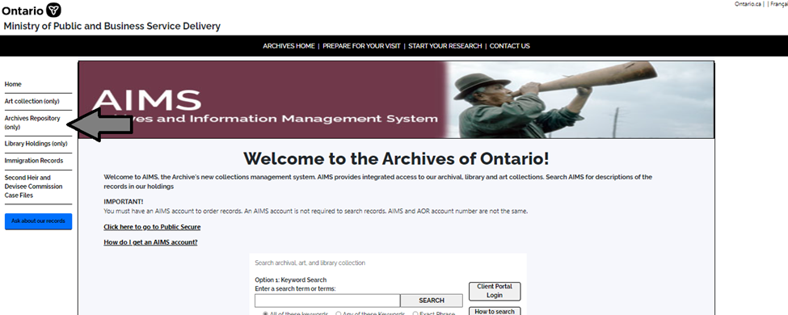

1. On the “Welcome to the Archival Collection” search page, click “Advanced Search”:

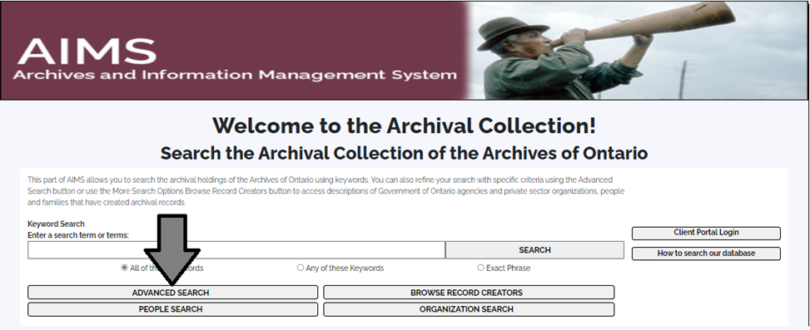

1. On the “Archives Advanced Search” page enter the reference code (that’s the number starting with C, F or RG) in the Reference Code field and click “Search” (at the bottom of the page.

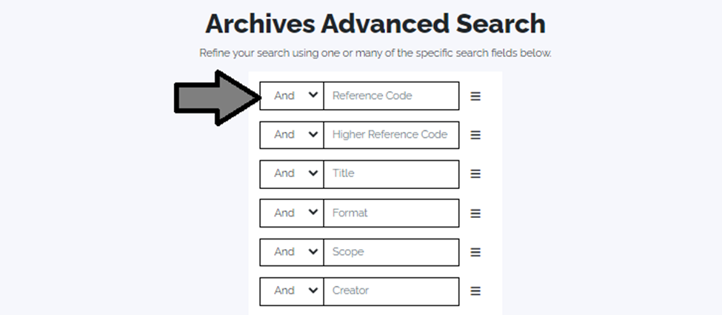

# Contact us

Although unable to do your research for you, our reference archivists are waiting to assist you.  You may call or write to them by mail or email or — best of all — visit the Archives of Ontario.

**Telephone: 416-327-1600 Toll free (Ontario): 1-800-668-9933**

**Email:** [Click here to email the Archives of Ontario](mailto:reference@ontario.ca).  The e-mail address is [reference@ontario.ca](mailto:reference@ontario.ca)

**Address: Archives of Ontario, 134 Ian Macdonald Blvd., Toronto, ON M7A 2C5**

**Website**

Visit our website for information about our collections and our services, our online exhibits and education programs, and links to our social media accounts. [Click here to visit our website](http://www.archives.gov.on.ca/).  The website is [www.archives.gov.on.ca/](http://www.archives.gov.on.ca/).

**Customer Service and Research Guides**

Our guides contain information about our services, freelance researchers available to do research for you, and some of most popular records.  [Click here to view our guides](http://www.archives.gov.on.ca/en/access/research_guides.aspx).  To find the “Research Guides and Tools” on our website, click on “Access our Collections”.

______________________________________________________________________

© King's Printer for Ontario, 2023

This information is provided as a public service.  Last update is shown at the beginning of this guide.  Readers should where possible verify the information before acting on it.