| **Archives of Ontario** | Ontario Logo |
| --- | --- |
| Research Guide 220  Census Records  Last Updated: February 2023 | |

Photograph is: Overhead view of crowd scene, 1926, F 229-308-0-807, I0020435, T. Eaton Co. fonds


Overhead view of crowd scene, 1926

F 229-308-0-807, I0020435

T. Eaton Co. fonds

In this guide 2

Where do I find these records? 2

The Records 3

Pre to 1851 Census Records 3

Early District and Township Censuses 3

1842 Census of Canada West (Ontario) 4

Militia Muster Rolls 4

Post to 1851 Census Returns 4

Censuses of Canada 4

Finding Aids for Post to 1851 Census Returns 5

How do I get to the online descriptions? 6

Contact us 7

# In this guide

This guide will help you find and use census records at the Archives of Ontario. Censuses collect varied information on as many individuals and/or households as possible, making them useful sources for historical research. Since individuals will often appear in multiple censuses, you can compare census entries as a way of tracking changes in their life.

Starting in 1793, districts and municipalities in Upper Canada were mandated to conduct annual censuses. Colony-wide censuses were carried out in Canada West (current-day Ontario, south of the Muskoka and Haliburton areas) in 1842, 1851 to 1852 and 1861.

The federal government conducted a Canada-wide census every ten years from 1871 to 1951. Starting in 1956, they began conducting censuses every 5 years.

Please note: Census records after 1921 are not available to the public.

*Please note: this guide contains links to information found in our online Archives Information Management System (AIMS).  On our website, this database is found under “Access Our Collections”.  If you are using a print copy of this guide, go to page 5 for more information on how to find the online descriptions.

This guide also includes links to our Microfilm Interloan Catalogue. [Click here to view our Microfilm Interloan Catalogue](http://www.archives.gov.on.ca/en/microfilm/index.aspx). On our website, this catalogue is found under “Access Our Collections”.

# Where do I find these records?

Some of the records mentioned in this guide are on microfilm, and you do not need to order them in advance to view them in our reading room. Libraries that offer interloan services may also borrow most of the reels for you.

Some of the records are microfilm copies of records held by Library and Archives Canada. Those reels are not available through interloan. Those records are available online. The Library and Archives Canada website is [www.collectionscanada.gc.ca](http://www.collectionscanada.gc.ca).

Some records are not on microfilm. You will need to request them in advance to view them in our reading room. You may also obtain copies if there is sufficient information to locate and retrieve those records.

# The Records

## Pre to 1851 Census Records

Pre to 1851 census records often only contain statistical information with no names listed or list only the names of family heads of household. All censuses except for Talbot District are on self-service microfilm or microfiche, and you can access the microfilm in our Reading Room or through our Microfilm Interloan Service. [Click here for more information about our Microfilm Interloan Service.](http://www.archives.gov.on.ca/en/microfilm/index.aspx).

### Early District and Township Censuses

The Archives of Ontario holds pre to 1851 Census records for the districts and townships listed in the table on the next page. Census records from district collections are further divided into individual townships. Most townships won’t have census records for the entire date range. Click on the reference code for the collection in Table 1 below to access its online archival description. You can find more detailed listings of the records organized by township in the Finding Aid section of the online description.

Table 1: Early District and Township Censuses

| **District/Township Collection** | **Reference Code** | **Date Range** | **Self-Service Microfilm Reel(s)** |
| --- | --- | --- | --- |
| District of Gore | [Click here to view the description for F 1679](https://aims.archives.gov.on.ca/scripts/mwimain.dll/144/DESCRIPTION_WEB/WEB_DESC_DET?SESSIONSEARCH&exp=sisn%201537) | 1824 to 1848 | MS 700 Reels 1 to 5 |
| Districts of Huron, Johnstown, and Newcastle index* | [Click here to view the description for D 351](https://aims.archives.gov.on.ca/scripts/mwimain.dll/144/DESCRIPTION_WEB/WEB_DESC_DET?SESSIONSEARCH&exp=sisn%207176) | 1848, 1850 | See microfiche in Inventory D 351 |
| District of Johnstown | [Click here to view the description for F 1721](https://aims.archives.gov.on.ca/scripts/mwimain.dll/144/DESCRIPTION_WEB/WEB_DESC_DET?SESSIONSEARCH&exp=sisn%201564) | 1796 to 1861 | MS 2546 to MS 2556 |
| District of Newcastle | [Click here to view the description for F 1800](https://aims.archives.gov.on.ca/scripts/mwimain.dll/144/DESCRIPTION_WEB/WEB_DESC_DET?SESSIONSEARCH&exp=sisn%201595) | 1803 to 1850 | MS 16 Reels 1 to 9 |
| District of Niagara | [Click here to view the description for F 1804](https://aims.archives.gov.on.ca/scripts/mwimain.dll/144/DESCRIPTION_WEB/WEB_DESC_DET?SESSIONSEARCH&exp=sisn%201598) | 1828 | MS 181 |
| District of Ottawa | [Click here to view the description for F 1849](https://aims.archives.gov.on.ca/scripts/mwimain.dll/144/DESCRIPTION_WEB/WEB_DESC_DET?SESSIONSEARCH&exp=sisn%201621) | Circa 1810 to 1838 | MS 116 Reels 1 and 2 |
| Talbot District | [Click here to view the description for F 1951](https://aims.archives.gov.on.ca/scripts/mwimain.dll/144/DESCRIPTION_WEB/WEB_DESC_DET?SESSIONSEARCH&exp=sisn%201685) | 1842 | No microfilm - order folder F805520 |
| Western District | [Click here to view the description for F 2007](https://aims.archives.gov.on.ca/scripts/mwimain.dll/144/DESCRIPTION_WEB/WEB_DESC_DET?SESSIONSEARCH&exp=sisn%201718) | 1824 to 1848 | MS 390 Reel 1 |
| Township of Binbrook | These records are copies of microfilm, and do not have an associated archival collection. | 1837 to 1839 | GS 1436 |
| Township of Blanshard | These records are copies of microfilm and do not have an associated archival collection. | 1848, 1850 | GS 539 |

*This record is an index of the 1848 and 1850 censuses for these districts. The Archives of Ontario holds some of the associated census records.

The Archives has microfilmed aggregate census and assessment returns for Upper Canada and Canada West, 1824 to 1850. They contain population statistics for all townships and municipalities, but no information about individuals. You can access these records in our Reading Room on self-serve microfilm reel MS 180. The returns can also be found in the *Journals of the Legislative Assembly*.

### 1842 Census of Canada West (Ontario)

You can access the 1842 census of Canada West (Ontario) in a searchable database on the Library and Archives Canada website. [Click here to access the Library and Archives Canada Census of 1842, Canada West page.](https://www.bac-lac.gc.ca/eng/census/1842-canada-west/Pages/about-census.aspx)

We also have this census on microfilm. You can find microfilm listings in the binder *Ontario Census Returns, 1842 to 1901* (available in the Reading Room).

### Militia Muster Rolls

Militia muster rolls served as countywide or provincewide censuses of the adult male population. [For more information on military records, click here to access Research Guide 226: Militia and Military Records](http://www.archives.gov.on.ca/en/access/research_guides.aspx).

## Post to 1851 Census Returns

### Censuses of Canada

Census records for the 1851, 1861, 1871, 1881, 1891, 1901, 1911, and 1921 censuses are available in searchable online databases on the Library and Archives Canada website. [Click here to access the Library and Archives Canada census records page.](https://www.bac-lac.gc.ca/eng/census/Pages/census.aspx#g)

We have microfilm copies of the personal census returns for Ontario/Canada West for 1851 to 1852, 1861, 1871, 1881, 1891 and 1901 and the 1861 and 1871 agricultural census returns for Ontario/Canada West. The returns are arranged by county, then by town and township. We also have microfilm copies of the 1871 census returns for Quebec, New Brunswick and Nova Scotia.

We do not have a microfilmed copy of the 1911 and 1921censuses.

You can find microfilm listings for post to 1851 census in the binder *Ontario Census Returns, 1842 to 1901*, which is available in the Reading Room’s Genealogy Reference Area. This binder is an annotated abstract of Thomas A. Hillman's Catalogue of Census Returns on Microfilm, 1666 to 1891, which is available in most libraries.

The personalreturns usually recorded a person's age, country of birth and origin, religion and occupation. The type and the amount of information vary from one census to another. The agriculturalreturns recorded the concession and lot, buildings and livestock owned by farmers.

### **Finding Aids for Post to 1851 Census Returns**

The *Toronto Census Aid* (located in the Reading Room), lists the reels for the census returns of each Toronto ward and includes maps showing ward limits at the time of each census.

1851

* The census for **Bruce, Grey, Lennox & Addington, and Wellington Counties** is indexed in Renie A. Rumpel’s *Index to the 1851 Census of Canada West (Ontario)*. This index is available in the Archives’ Reading Room’s Genealogy Reference Area.

1852

* The Middlesex County Census of 1852 is on diffusion microfiche, [click here for D 22 – Census returns for Canada West / Ontario diffusion microfilm](https://aims.archives.gov.on.ca/scripts/mwimain.dll/144/DESCRIPTION_WEB/WEB_DESC_DET?SESSIONSEARCH&exp=sisn%207856) and [D 350 Middlesex County Census of 1852 diffusion microfiche](https://aims.archives.gov.on.ca/scripts/mwimain.dll/144/DESCRIPTION_WEB/WEB_DESC_DET?SESSIONSEARCH&exp=sisn%207168).

1861

* The 1861 census for **Lennox and Addington County** is indexed in Linda Corupe's *Index to the 1861 Census of Lennox and Addington Co.* It is available in the Archives Reading Room.

1871

* [Click here for the Index to the 1871 Census of Ontario](https://aims.archives.gov.on.ca/scripts/mwimain.dll/144/BIBLIO_WEB/WEB_BIBLIO_DET?SESSIONSEARCH&exp=001%20986) / general editor, Bruce S. Elliott that includes indexes to several counties and districts, links also to the Library and Archives Canada, Census of Canada for 1871 searches.
* A surname index (head of households) for the 1871 census forall of Ontario has been published by the Ontario Genealogical Society. It is available in the Archives’ Reading Room (Genealogy Reference Area) and online through Library and Archives Canada. [Click here to access the page for this index on Library and Archives Canada's website](https://www.bac-lac.gc.ca/eng/census/1871-on/Pages/about-census.aspx).

# How do I get to the online descriptions?

1. On our website’s main page, click on “Access Our Collections”, and click on “Archives and Information Management System”, as shown in the image below:

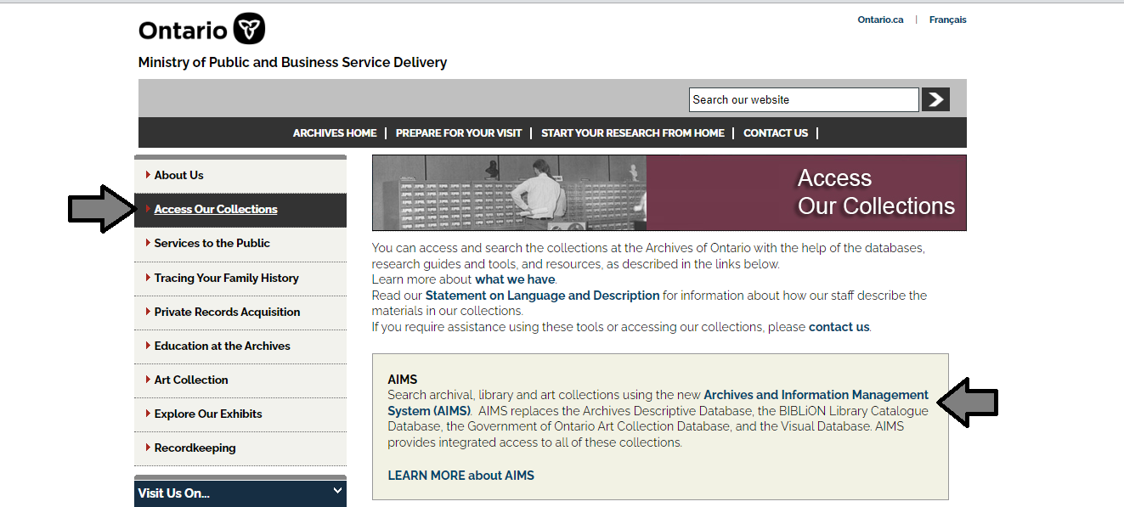

1. In the Archives and Information Management System (AIMS), click on “Archives repository (only)” button:

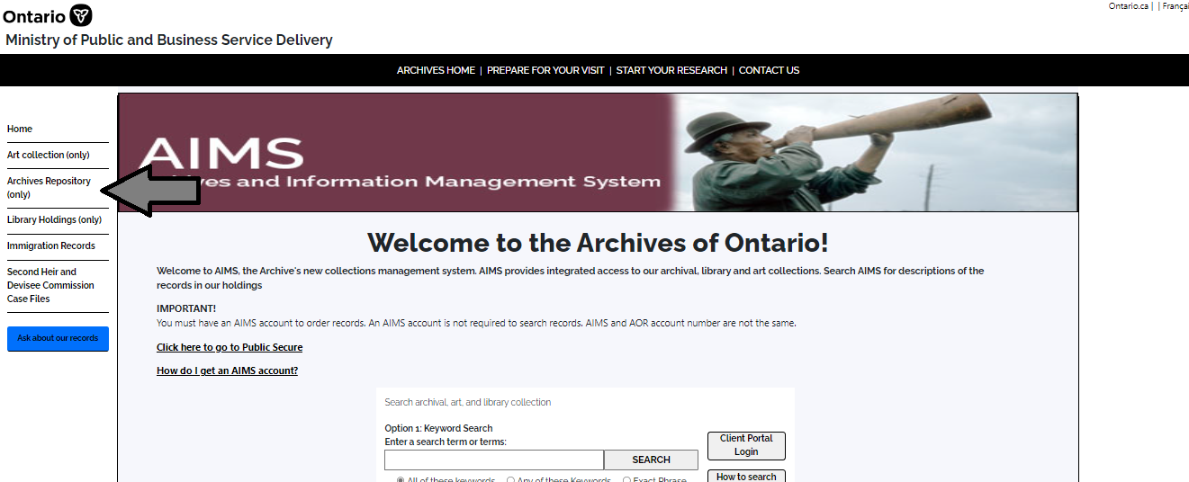

1. On the “Welcome to the Archival Collection” search page, click “Advanced Search”:

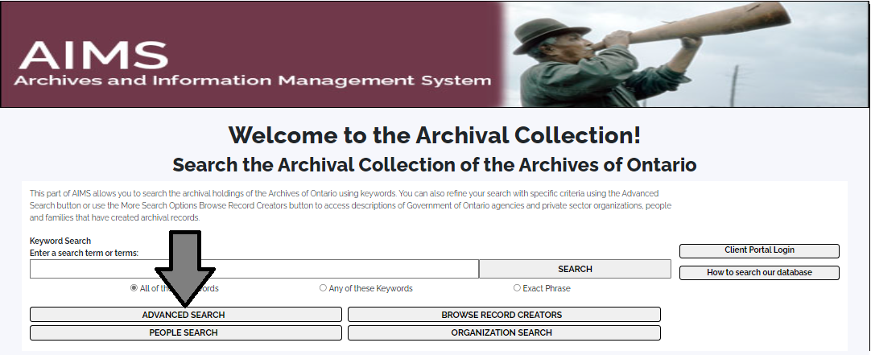

1. On the “Archives Advanced Search” page enter the reference code (that’s the number starting with C, F or RG) in the Reference Code field and click “Search” (at the bottom of the page.

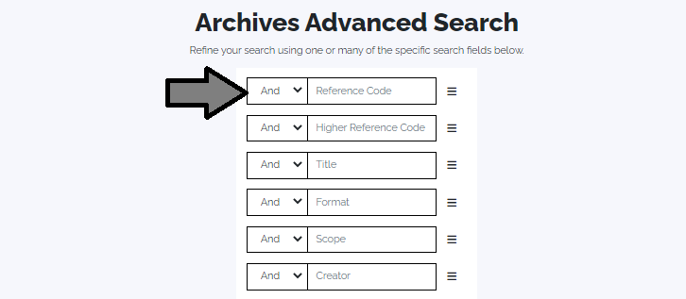

# Contact us

Although unable to do your research for you, our reference archivists are waiting to assist you.  You may call or write to them by mail or email or — best of all — visit the Archives of Ontario.

**Telephone: 416-327 to 1600 Toll free (Ontario): 1-800-668-9933**

**Email:**[Click here to email the Archives of Ontario](mailto:reference@ontario.ca). The e-mail address is [reference@ontario.ca](mailto:reference@ontario.ca) 

**Address: Archives of Ontario, 134 Ian Macdonald Blvd., Toronto, ON M7A 2C5**

**Website**

Visit our website for information about our collections and our services, our online exhibits and education programs, and links to our social media accounts. [Click here to visit our website](http://www.ontario.ca/archives).  The website is [www.ontario.ca/archives](http://www.ontario.ca/archives).

**Customer Service and Research Guides**

Our guides contain information about our services, freelance researchers available to do research for you, and some of our most popular records.  [Click here to view our guides](http://www.archives.gov.on.ca/en/access/research_guides.aspx).  To find the “Research Guides and Tools” on our website, click on “Access our Collections”.

______________________________________________________________________

© King's Printer for Ontario, 2023

This information is provided as a public service.  Last update is shown at the beginning of this guide.  Readers should where possible verify the information before acting on it.