| **Archives of Ontario** |  |
| --- | --- |
| Research Guide 222  Genealogy Collections and Published Genealogies  Last Updated: March 2023 | |

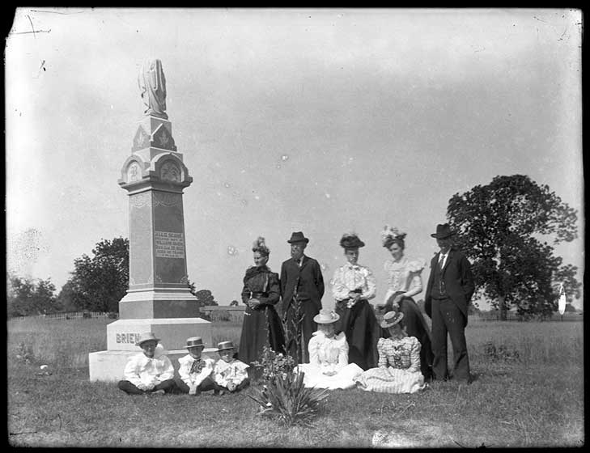

[Men, women, and children standing and sitting next to Brien family tombstone], J.C. Smith, Archives of Ontario F 4700-0-0-0-238, Image Number I0054201

In this Guide 2

The Records 2

Archives of Ontario Genealogical and Biographical Research Files 2

Biography and Genealogy Index 2

Genealogies Collection 2

Published Genealogies 3

How do I get to the online descriptions? 3

Contact Us 5

# In this Guide

This research guide provides information about genealogy collections and published genealogies held by the Archives of Ontario.

*Please note: this guide contains links to information found in our online Archives and Information Management System (AIMS). On our website, this database is found under “Access our Collections.” If you are using a print copy of this guide, go to page 3 for more information on how to find the online descriptions.

# The Records

## Archives of Ontario Genealogical and Biographical Research Files

These files contain information on a limited number of families in Ontario that Archives of Ontario staff have researched. The Archives no longer collects this information.

A description for these records is available in our online Archives and Information Management System (AIMS). [Click here to access description for RG 17-21: Archives of Ontario genealogical and biographical research files](https://aims.archives.gov.on.ca/scripts/mwimain.dll/144/DESCRIPTION_WEB/WEB_DESC_DET?SESSIONSEARCH&exp=sisn%201894).

## Biography and Genealogy Index

This card catalogue is a name index to a variety of genealogical sources and biographical information on individuals and families. The Index has not been updated for many years. You can find some explanatory cards at the start of the index. You can access this index on microfiche in the Reading Room.

## Genealogies Collection

This collection contains genealogies completed by private individuals and donated to the Archives prior to the 1970s. [Click here to access the description for F 277: Genealogies collection](https://aims.archives.gov.on.ca/scripts/mwimain.dll/144/DESCRIPTION_WEB/WEB_DESC_DET?SESSIONSEARCH&exp=sisn%20731).

Most of the genealogies are available on self-service microfilm in the Archives' Reading Room and through the Microfilm Interloan Service. [Click here for more information on our Microfilm Interloan Service](http://www.archives.gov.on.ca/en/microfilm/index.aspx).

## Published Genealogies

The Archives holds a small number of published genealogies in our library collection. You can usually locate them by searching in AIMS, Library Holdings by the name of the family. [Click here to search "Library Holdings".](http://aims.archives.gov.on.ca)

The Archives no longer collects published genealogies, but the Toronto Public Library holds some genealogies and local history collections at various branches. [Click here for more information on researching genealogy at the Toronto Public Library.](https://www.torontopubliclibrary.ca/history-genealogy/) Other local libraries and archives may also have published genealogies.

# How do I get to the online descriptions?

1. On our website’s main page, click on “Access Our Collections”, and click on “Archives and Information Management System”, as shown in the image below:

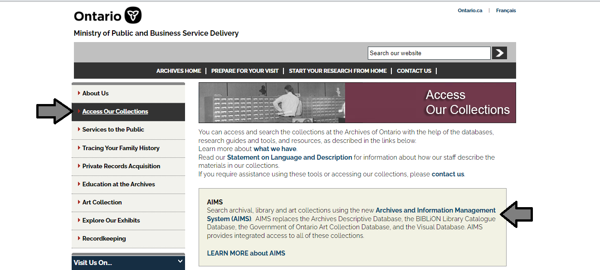

1. In the Archives and Information Management System (AIMS), click on “Archives repository (only)” button:

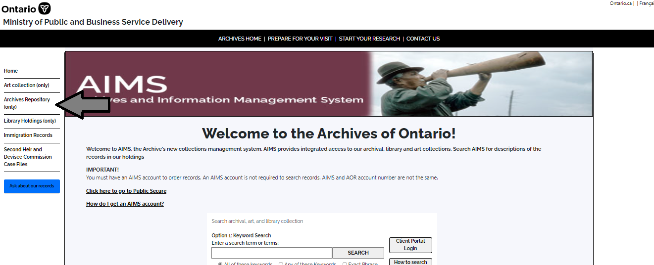

1. On the “Welcome to the Archival Collection” search page, click “Advanced Search”:

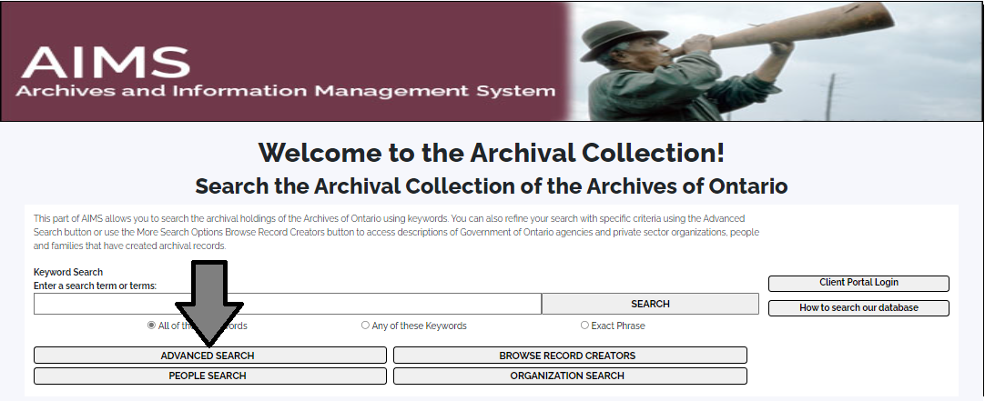

1. On the “Archives Advanced Search” page enter the reference code (that’s the number starting with C, F or RG) in the Reference Code field and click “Search” (at the bottom of the page.

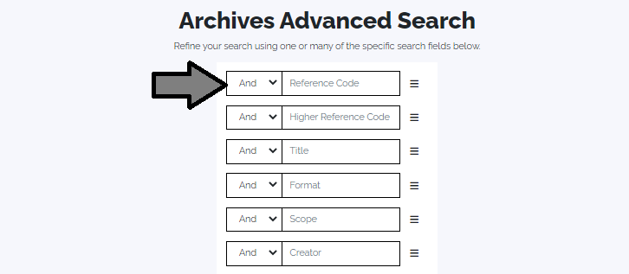

# Contact Us

Although unable to do your research for you, our reference archivists are waiting to assist you. You may call or write to them by mail or email or — best of all — visit the Archives of Ontario.

**Telephone:416-327-1600 Toll free (Ontario): 1-800-668-9933**

**Email:** [Click here to email the Archives of Ontario](mailto:reference@ontario.ca).  The e-mail address is [reference@ontario.ca](mailto:reference@ontario.ca)

**Address: Archives of Ontario, 134 Ian Macdonald Blvd., Toronto, ON M7A 2C5**

**Website**

Visit our website for information about our collections and our services, our online exhibits and education programs, and links to our social media accounts. [Click here to visit our website](http://www.ontario.ca/archives).  The website is [www.ontario.ca/archives](http://www.ontario.ca/archives).

**Customer Service and Research Guides**

Our guides contain information about our services, freelance researchers available to do research for you, and some of most popular records.  [Click here to view our guides](http://www.archives.gov.on.ca/en/access/research_guides.aspx).  To find the “Research Guides and Tools” on our website, click on “Access our Collections”.

______________________________________________________________________  
© King's Printer for Ontario, 2023

This information is provided as a public service.  Last update is shown at the beginning of this guide.  Readers should where possible verify the information before acting on it.