| **Archives of Ontario** |  |
| --- | --- |
| Research Guide 223  Guardianship and Adoption Records  Last Updated: February 2023 | |

Photograph is: Family group posing in front of house, between 1898 and 1920
Marsden Kemp, C 130-5-0-0-105


Family group posing in front of house, between 1898 and 1920  
Marsden Kemp  
C 130-5-0-0-105

In this guide 2

What is the difference between guardianship and adoption? 2

Where do I find these records? 2

Guardianships Records 2

Adoption Records 3

What do I need to get started? 3

The Records 3

Guardianship records 3

If you do not find records about a guardianship 4

Are there related records? 5

How do I get to the online descriptions? 5

Contact us 7

Table 1: Guardianship records 8

# In this guide

This research guide has information about guardianships and related records at the Archives of Ontario and offers information on agencies to contact about adoption records.

*Please note: this guide contains links to information found in our online Archives and Information Management System (AIMS).  On our website, this database is found under “Access Our Collections”.  If you are using a print copy of this guide, go to page 5 for more information on how to find the online descriptions.

This guide also includes links to our Microfilm Interloan Catalogue. [Click here to view our Microfilm Interloan Catalogue](http://www.archives.gov.on.ca/en/microfilm/index.aspx). On our website, this catalogue is found under “Access Our Collections”.

## What is the difference between guardianship and adoption?

Guardianship is a legal process where minor persons become the ward of people who are not their natural parents. The guardian is legally responsible for them until adulthood, but they do not legally become part of the family.

Adoption is a legal process where minor persons become the lawful children of persons who are not their natural parents, with the same inheritance rights as children born to those persons.

Please note: Many early guardianship records include the word adoption, in error.

# Where do I find these records?

## Guardianships Records

We have guardianship records from the 1820’s to the 1970’s (varies by county or district).

Most guardianship records are not on microfilm. You will need to request them in advance to view them in our reading room. You may also obtain copies if there is enough information to locate and retrieve those records.

Some of these records are also on microfilm, and you do not need to order them in advance to view them in our reading room. Libraries that offer interloan services may also borrow most of these reels for you.

The Ontario Court of Justice or Family Court may have guardianship records after the years in our collections. You will find contact information for the local courthouses on the Ministry of the Attorney General’s website, at <https://www.attorneygeneral.jus.gov.on.ca/english/courts/Court_Addresses/>.

## Adoption Records

Until 1921, adoptions were very rare in Ontario and could only be done threw a statute (act) of the provincial legislature. For information on how to find these and other provincial statutes, [click here to view Research Guide 207, Researching Bills and Statutes](http://www.archives.gov.on.ca/en/access/research_guides.aspx). To find this and other research guides on our website, [www.ontario.ca/archives](http://www.ontario.ca/archives), click on “Access Our Collections”.

We **do not** have records of adoptions after 1921. For information on how to search Ontario adoptions from 1921 to present, visit the Ontario government’s adoption search webpage, <https://www.ontario.ca/page/search-adoption-records>.

# What do I need to get started?

To find records of a guardianship, or a pre-1921 adoption, you need:

* the names of the persons involved
* when the event took place

For guardianship records, you also need to know where it took place.

# The Records

## Guardianship records

Guardianships first appeared with the Guardianship Act of 1827. A person (usually a family friend or relative) could apply to a Probate or Surrogate Court judge to be appointed a child’s guardian, to safeguard the child's "property, person and education" until maturity. While the child was often said to be "adopted", they had no claim on their guardian's name or estate. The number of guardianships decreased after adoption was made easier in 1921.

The following courts dealt with guardianships:

* the province-wide Probate Court existed from 1793 to 1859; it dealt with some guardianships as well as estates in more than one district or worth more than 5 pounds.
* the local Surrogate Courts existed from 1793 to 1985; after 1859, they were the only courts dealing with guardianships and estates.

The records below include information about guardianships. See Table 1 at the end of this guide for information on how to access them. Courts may have records after the years we have.

Registers: Registers contain basic information about guardianship applications. This information usually limited to the names of the people involved, the date of the application, and whether the judge granted it. The registers are usually indexed by the child’s name.

We have registers from the 1790’s to the 1930’s, and some after those years (varies by county or district). Some registers only document guardianship, other also include information about probate or administration of successions. Registers after the years we have are with the courthouses.

Guardianship books: Some courts created guardianship books containing information about the guardianship application. Some of the books recorded bonds posted by applicants

Guardianship files: These files exist for some courts. They contain the documents filed with the court in support of the application. Table 1 at the end of this guide includes the counties or districts with guardianship files filed separately from the estate files, and the years for those files.

For other counties and years, guardianship files may have been filed together with estate files documenting successions. For information on searching those files, [click here to view Research Guide 206, How to Find a Will in Court Records](http://www.archives.gov.on.ca/en/access/research_guides.aspx). To find this and other research guides on our website, click on “Access Our Collections” then click on “Research Guides and Tools”.

## If you do not find records about a guardianship

Wills may include parents’ intents regarding the rearing and guardianship of minor children. For information on searching for wills, [click here to view research guide 206, How to Find a Will in Court Records](http://www.archives.gov.on.ca/en/access/research_guides.aspx).

People could also become guardians by filing a deed poll with the Local Registry Office. Deed polls were statements of the person’s intent or actions. We do not have these records

In many cases, parents made informal arrangements with relatives or friends for the care of their children. Children formally awarded a guardian had no more public support than those left in the care of relatives of friends. In informal arrangements, no official records were ever created.

# Are there related records?

If a guardianship involved a change to the child’s name, the birth registration was annotated with the new name. When all birth registrations were re-indexed in the 1950’s, these registrations were indexed under the new name.

For information about these and other birth registrations, and how to search them, [click here to view our Ontario births page](http://www.archives.gov.on.ca/en/tracing/birth_registrations.aspx). To find this page on our website, click on “Tracing Your Family History” then click on “Ontario Vital Statistics”.

In the case of an adoption, the original birth registration was annotated. In most cases, the adoptive parents also re-registered the birth under child’s new name, and the original registration was sealed. For information about accessing those records, see the “Where do I find these records” section of this guide.

# How do I get to the online descriptions?

1. On our website’s main page, click on “Access Our Collections”, and click on “Archives and Information Management System”, as shown in the image below:

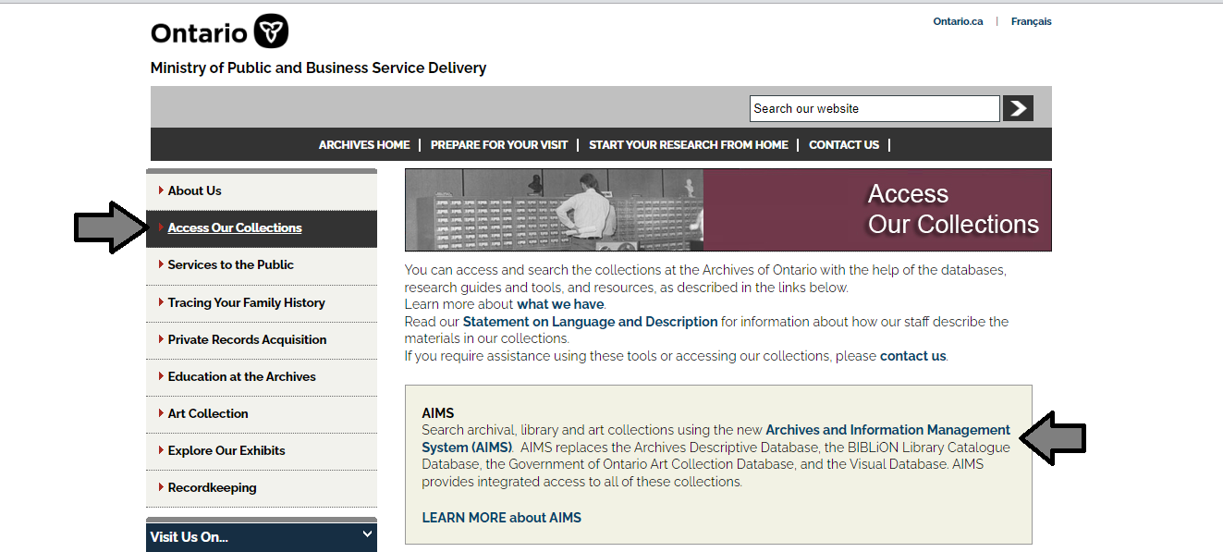

1. In the Archives and Information Management System (AIMS), click on “Archives repository (only)” button:

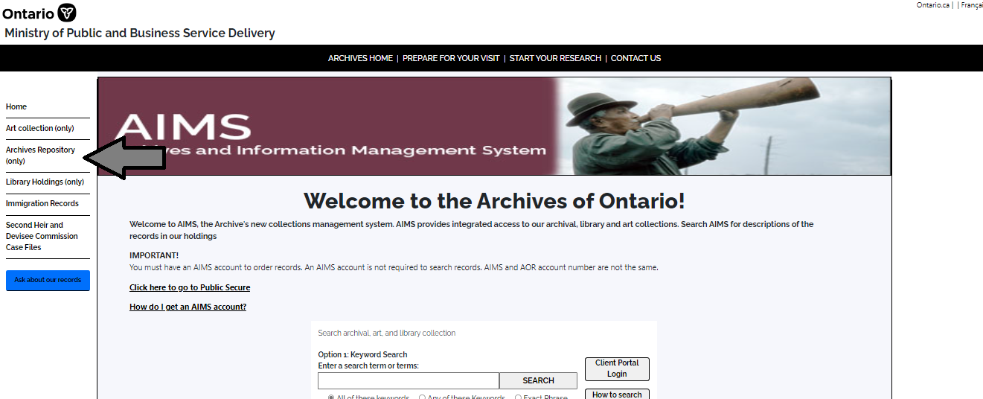

1. On the “Welcome to the Archival Collection” search page, click “Advanced Search”:

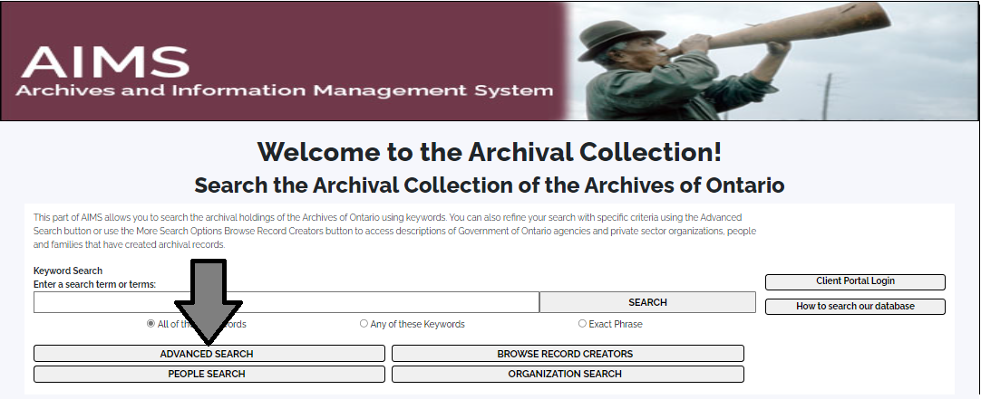

1. On the “Archives Advanced Search” page enter the reference code (that’s the number starting with C, F or RG) in the Reference Code field and click “Search” (at the bottom of the page.

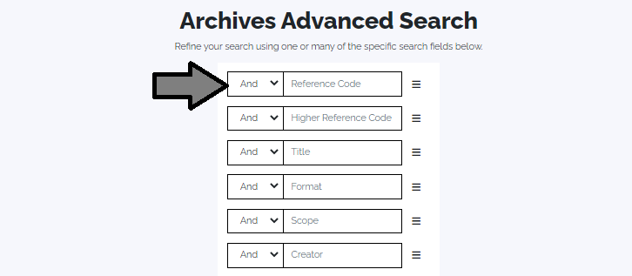

# Contact us

Although unable to do your research for you, our reference archivists are waiting to assist you.  You may telephone or write to them by mail or email or — best of all — visit the Archives of Ontario.

**Telephone: 416-327-1600 Toll free (Ontario): 1-800-668-9933**

**Email:**[Click here to email the Archives of Ontario](mailto:reference@ontario.ca). The e-mail address is [reference@ontario.ca](mailto:reference@ontario.ca) 

**Address: Archives of Ontario, 134 Ian Macdonald Blvd., Toronto, ON M7A 2C5**

**Website**

Visit our website for information about our collections and our services, our online exhibits and education programs, and links to our social media accounts. [Click here to visit our website](http://www.ontario.ca/archives).  The website is [www.ontario.ca/archives](http://www.ontario.ca/archives).

**Customer Service and Research Guides**

Our guides contain information about our services, freelance researchers available to do research for you, and some of our most popular records.  [Click here to view our guides](http://www.archives.gov.on.ca/en/access/research_guides.aspx).  To find the “Research Guides and Tools” on our website, click on “Access our Collections”.

______________________________________________________________________

© King's Printer for Ontario, 2023

This information is provided as a public service.  Last update is shown at the beginning of this guide.  Readers should where possible verify the information before acting on it.

# Table 1: Guardianship records

**How to use this table and access guardianship records**

**Guardianship registers:**

See the online series descriptions for information about these records and how to access them

If there are no guardianship registers for a county/district: Other court registers may contain entries about guardianships, as well as probates and administrations (for succession).

**Other Court Registers**:

To find registers on microfilm, Click here to consult the Microfilm Interloan catalogue to find the microfilm reel number you need, or see the **User's Guide to Surrogate Courts and Surrogate Clerk Microfilm Reels** binder in the Reading Room.

Some of the microfilm are also digitized and available on the FamilySearch website, [click here to access our Digitized Microfilm Collections webpage for more information](http://www.archives.gov.on.ca/en/access/digitized_microfilm_collections_on_familysearch.aspx). To find this information on our website, click on “Access our Collections” then click on the “Digitized Microfilm” page.  The FamilySearch website is [www.familysearch.org](http://www.familysearch.org).

To find original registers (no microfilm), [click here to search the Archives and Information Management System (AIMS), "Archives Repository" by groups of archival records, then enter the name of the county/district and the words Surrogate and Register*](http://aims.archives.gov.on.ca).

**Guardianship books and Guardianship files:**

See the online series descriptions for information about these records and how to access them.

If there are no separate guardianship files for a county/district: Guardianship files may be filed with estate files. For information on how to search these files, [click here to Research Guide 206, How to find a Will in Court Records](http://www.archives.gov.on.ca/en/access/research_guides.aspx).

| **County or District** | **Guardianship Registers** | **Court Registers** | **Guardianship Books** | **Guardianship Files** |
| --- | --- | --- | --- | --- |
| Court of Probate (province-wide, until 1859) | There are no separate guardianship registers | [Click here to view the description and microfilm list for RG 22-254](https://aims.archives.gov.on.ca/scripts/mwimain.dll/144/DESCRIPTION_WEB/WEB_DESC_DET?SESSIONSEARCH&exp=sisn%203910) | We do not have guardianship books | We do not have separate guardianship files |
| Algoma | [Click here to view the description for RG 22-332, 1904 to 1923](https://aims.archives.gov.on.ca/scripts/mwimain.dll/144/DESCRIPTION_WEB/WEB_DESC_DET?SESSIONSEARCH&exp=sisn%204393) | **1860 to 1928**: On microfilm, in the Archives’ Reading Room only  **1929 to 1966**: Originals are at the Archives  **1967 to present**: Contact the courthouse | [Click here to view the description for RG 22-332, 1904 to 1923](https://aims.archives.gov.on.ca/scripts/mwimain.dll/144/DESCRIPTION_WEB/WEB_DESC_DET?SESSIONSEARCH&exp=sisn%204393) | [Click here to view the description for RG 22-381, 1863 to 1903](https://aims.archives.gov.on.ca/scripts/mwimain.dll/144/DESCRIPTION_WEB/WEB_DESC_DET?SESSIONSEARCH&exp=sisn%204440) |
| Brant | [Click here to view the description for RG 22-1177, 1892 to 1950's](https://aims.archives.gov.on.ca/scripts/mwimain.dll/144/DESCRIPTION_WEB/WEB_DESC_DET?SESSIONSEARCH&exp=sisn%206570) | **1853 to 1903**: On microfilm, in the Archives’ Reading Room and through interloan  **1903 to 1931**: On microfilm, in the Archives’ Reading Room only  **1931 to 1944**: Originals are at the Archives  **1945 to present**: Contact the courthouse | We do not have guardianship books | [Click here to view the description for RG 22-327, 1902 to 1958](https://aims.archives.gov.on.ca/scripts/mwimain.dll/144/DESCRIPTION_WEB/WEB_DESC_DET?SESSIONSEARCH&exp=sisn%204391) |
| Bruce | There are no separate guardianship registers | **1867 to 1930**: On microfilm, in the Archives’ Reading Room and through interloan  **1931 to 1950**: Originals are at the Archives  **1951 to present**: Contact the courthouse | [Click here to view the description for RG 22-1224, 1867 to 1982](https://aims.archives.gov.on.ca/scripts/mwimain.dll/144/DESCRIPTION_WEB/WEB_DESC_DET?SESSIONSEARCH&exp=sisn%206557) | [Click here to view the description for RG 22-285, 1867 to 1910 and 1959 to 1976](https://aims.archives.gov.on.ca/scripts/mwimain.dll/144/DESCRIPTION_WEB/WEB_DESC_DET?SESSIONSEARCH&exp=sisn%204088) |
| Carleton | There are no separate guardianship registers | **1842 to 1931**: On microfilm, in the Archives’ Reading Room and through interloan  **1932 to 1974**: Originals are at the Archives  **1975 to present**: Contact the courthouse | We do not have guardianship books | [Click here to view the description for RG 22-1362, 1906 to 1966](https://aims.archives.gov.on.ca/scripts/mwimain.dll/144/DESCRIPTION_WEB/WEB_DESC_DET?SESSIONSEARCH&exp=sisn%206298) |
| Cochrane | There are no separate guardianship registers | Contact the courthouse | We do not have guardianship books | [Click here to view the description for RG 22-1420, 1923 to 1964](https://aims.archives.gov.on.ca/scripts/mwimain.dll/144/DESCRIPTION_WEB/WEB_DESC_DET?SESSIONSEARCH&exp=sisn%2014493) |
| Dufferin | [Click here to view the description for RG 22-349, 1894 to 1943](https://aims.archives.gov.on.ca/scripts/mwimain.dll/144/DESCRIPTION_WEB/WEB_DESC_DET?SESSIONSEARCH&exp=sisn%204428) | **1881 to 1906**: On microfilm, in the Archives’ Reading Room and through interloan  **1906 to 1931**: On microfilm, in the Archives’ Reading Room only  **1932- to present**: Contact the courthouse | We do not have guardianship books | [Click here to view the description for RG 22-350, 1881 to 1943](https://aims.archives.gov.on.ca/scripts/mwimain.dll/144/DESCRIPTION_WEB/WEB_DESC_DET?SESSIONSEARCH&exp=sisn%204429) |
| Elgin | There are no separate guardianship registers | **1859 to 1901**: On microfilm, in the Archives’ Reading Room and through interloan  **1901 to 1924**: On microfilm, in the Archives’ Reading Room only  **1925- to present**: Contact the courthouse | We do not have guardianship books | We do not have separate guardianship files |
| Essex | There are no separate guardianship registers | **1785 to 1930**: On microfilm, in the Archives’ Reading Room and through interloan  **1931- to present**: Contact the courthouse | We do not have guardianship books | We do not have separate guardianship files |
| Frontenac | [Click here to view the description for RG 22-161, 1832 to 1913 and 1942 to 1962](https://aims.archives.gov.on.ca/scripts/mwimain.dll/144/DESCRIPTION_WEB/WEB_DESC_DET?SESSIONSEARCH&exp=sisn%204447) | **1814 to 1930**: On microfilm, in the Archives’ Reading Room and through interloan  **1931 to 1976**: Originals are at the Archives  **1977- to present**: Contact the courthouse | We do not have guardianship books | We do not have separate guardianship files |
| Grey | There are no separate guardianship registers | **1859 to 1929**: On microfilm, in the Archives’ Reading Room and through interloan  **1930 to 1938**: Originals are at the Archives  **1939- to present**: Contact the courthouse | [Click here to view the description for RG 22-254, 1859 to 1961](https://aims.archives.gov.on.ca/scripts/mwimain.dll/144/DESCRIPTION_WEB/WEB_DESC_DET?SESSIONSEARCH&exp=sisn%203910) | We do not have separate guardianship files |
| Haldimand | There are no separate guardianship registers | **Before 1851**: See Lincoln  **1851 to 1933**: On microfilm, in the Archives’ Reading Room and through interloan  **1933 to 1940**: Originals are at the Archives  **1941- to present**: Contact the courthouse | We do not have guardianship books | We do not have separate guardianship files |
| Haliburton | See Victoria | See Victoria | See Victoria | See Victoria |
| Halton | There are no separate guardianship registers | **1855 to 1930**: On microfilm, in the Archives’ Reading Room and through interloan  **1931 to 1953**: Originals are at the Archives  **1954- to present**: Contact the courthouse | We do not have guardianship books | We do not have separate guardianship files |
| Hastings | [Click here to view the description for RG 22-342, 1846 to 1856](https://aims.archives.gov.on.ca/scripts/mwimain.dll/144/DESCRIPTION_WEB/WEB_DESC_DET?SESSIONSEARCH&exp=sisn%204400) | **1840 to 1930**: On microfilm, in the Archives’ Reading Room only  **1930 to 1958**: Originals are at the Archives  **1959- to present**: Contact the courthouse | [Click here to view the description for RG 22-342, 1846 to 1856](https://aims.archives.gov.on.ca/scripts/mwimain.dll/144/DESCRIPTION_WEB/WEB_DESC_DET?SESSIONSEARCH&exp=sisn%204400) | [Click here to view the description for RG 22-377, 1869 to 1963](https://aims.archives.gov.on.ca/scripts/mwimain.dll/144/DESCRIPTION_WEB/WEB_DESC_DET?SESSIONSEARCH&exp=sisn%204438) |
| Huron | [Click here to view the description for RG 22-299, 1859 to 1966](https://aims.archives.gov.on.ca/scripts/mwimain.dll/144/DESCRIPTION_WEB/WEB_DESC_DET?SESSIONSEARCH&exp=sisn%204438) | **1842 to 1931**: On microfilm, in the Archives’ Reading Room and through interloan  **1931 to 1967**: Originals are at the Archives  **1968- to present**: Contact the courthouse | [Click here to view the description for RG 22-299, 1859 to 1966](https://aims.archives.gov.on.ca/scripts/mwimain.dll/144/DESCRIPTION_WEB/WEB_DESC_DET?SESSIONSEARCH&exp=sisn%204438) | We do not have separate guardianship files |
| Kenora | There are no separate guardianship registers | **1887 to 1938**: On microfilm, in the Archives’ Reading Room and through interloan  **1939- to present**: Contact the courthouse | We do not have guardianship books | We do not have separate guardianship files |
| Kent | [Click here to view the description for RG 22-2693, 1892 to 1924](https://aims.archives.gov.on.ca/scripts/mwimain.dll/144/DESCRIPTION_WEB/WEB_DESC_DET?SESSIONSEARCH&exp=sisn%206734) | **1851 to 1876**: On microfilm, in the Archives’ Reading Room only  **1876 to 1902**: On microfilm, in the Archives’ Reading Room and through interloan  **1902 to 1930**: On microfilm, in the Archives’ Reading Room only  **1931 to 1944**: Originals are at the Archives  **1945- to present**: Contact the courthouse | [Click here to view the description for RG 22-2691, 1859 to 1860](https://aims.archives.gov.on.ca/scripts/mwimain.dll/144/DESCRIPTION_WEB/WEB_DESC_DET?SESSIONSEARCH&exp=sisn%206733) | We do not have separate guardianship files |
| Lambton | [Click here to view the description for RG 22-275, 1892 to 1958](https://aims.archives.gov.on.ca/scripts/mwimain.dll/144/DESCRIPTION_WEB/WEB_DESC_DET?SESSIONSEARCH&exp=sisn%204078) | **Before 1854**: See Essex  **1854 to 1930**: On microfilm, in the Archives’ Reading Room and through interloan  **1931 to 1967**: Originals are at the Archives  **1968- to present**: Contact the courthouse | We do not have guardianship books | [Click here to view the description for RG 22-276, 1860 to 1939 and 1961 to 1980](https://aims.archives.gov.on.ca/scripts/mwimain.dll/144/DESCRIPTION_WEB/WEB_DESC_DET?SESSIONSEARCH&exp=sisn%204079) |
| Lanark | There are no separate guardianship registers | Use guardianship books | [Click here to view the description for RG 22-170, 1875 to 1960 (guardianship books)](https://aims.archives.gov.on.ca/scripts/mwimain.dll/144/DESCRIPTION_WEB/WEB_DESC_DET?SESSIONSEARCH&exp=sisn%203760)  [Click here to view the description for RG 22-2878, 1911 to 1925 (guardianship bond book)](https://aims.archives.gov.on.ca/scripts/mwimain.dll/144/DESCRIPTION_WEB/WEB_DESC_DET?SESSIONSEARCH&exp=sisn%206324) | We do not have separate guardianship files |
| Leeds and Grenville | There are no separate guardianship registers | **1794 to 1901**: On microfilm, in the Archives’ Reading Room only  **1901 to 1906 (volume 9)**: Original is at the Archives  **1906 to 1931**: On microfilm, in the Archives’ Reading Room and through interloan  **1931 to 1936**: Originals are at the Archives  **1937- to present**: Contact the courthouse | We do not have guardianship books | [Click here to view the description for RG 22-181, 1859 to 1986](https://aims.archives.gov.on.ca/scripts/mwimain.dll/144/DESCRIPTION_WEB/WEB_DESC_DET?SESSIONSEARCH&exp=sisn%203783) |
| Lennox and Addington | There are no separate guardianship registers | **1865 to 1906**: On microfilm, in the Archives’ Reading Room only  **1906 to 1933**: On microfilm, in the Archives’ Reading Room and through interloan  **1933 to 1951**: Originals are at the Archives  **1952- to present**: Contact the courthouse | [Click here to view the description for RG 22-251, 1866 to 1905](https://aims.archives.gov.on.ca/scripts/mwimain.dll/144/DESCRIPTION_WEB/WEB_DESC_DET?SESSIONSEARCH&exp=sisn%203907) | [Click here to view the description for RG 22-161, 1832 to 1913 and 1942 to 1962](https://aims.archives.gov.on.ca/scripts/mwimain.dll/144/DESCRIPTION_WEB/WEB_DESC_DET?SESSIONSEARCH&exp=sisn%204447) |
| Lincoln | [Click here to view the description for RG 22-239, 1827 to 1866 and 1922 to 1966](https://aims.archives.gov.on.ca/scripts/mwimain.dll/144/DESCRIPTION_WEB/WEB_DESC_DET?SESSIONSEARCH&exp=sisn%203889) | **1833 to 1902**: On microfilm, in the Archives’ Reading Room and through interloan  **1902 to 1931**: On microfilm, in the Archives’ Reading Room only  **1931 to 1943**: Originals are at the Archives  **1944- to present**: Contact the courthouse | We do not have guardianship books | [Click here to view the description for RG 22-240, 1827 to 1941](https://aims.archives.gov.on.ca/scripts/mwimain.dll/144/DESCRIPTION_WEB/WEB_DESC_DET?SESSIONSEARCH&exp=sisn%203890). |
| Manitoulin | There are no separate guardianship registers | **1888 to 1938**: On microfilm, in the Archives’ Reading Room only  **1939- to present**: Contact the courthouse | [Click here to view the description for RG 22-337, 1891 to 1930](https://aims.archives.gov.on.ca/scripts/mwimain.dll/144/DESCRIPTION_WEB/WEB_DESC_DET?SESSIONSEARCH&exp=sisn%204397) | We do not have separate guardianship files |
| Middlesex | There are no separate guardianship registers | **1839 to 1846**: The registers no longer exist  **1846 to 1900**: On microfilm, in the Archives’ Reading Room and through interloan  **1900 to 1930**: On microfilm, in the Archives’ Reading Room only  **1931 to 1976**: Originals are at the Archives  **1975 to present**: Contact the courthouse | Contact an archivist for information about RG 22-3364, 1860 to 1974 | We do not have separate guardianship files |
| Muskoka | There are no separate guardianship registers | Contact the courthouse | We do not have guardianship books | We do not have separate guardianship files |
| Nipissing | There are no separate guardianship registers | **1895 to 1921**: On microfilm, in the Archives’ Reading Room only  **1922- to present**: Contact the courthouse | We do not have guardianship books | We do not have separate guardianship files |
| Norfolk | There are no separate guardianship registers | **1839 to 1903**: On microfilm, in the Archives’ Reading Room and through interloan  **1903 to 1930**: On microfilm, in the Archives’ Reading Room only  **1931 to 1944**: Originals are at the Archives  **1944- to present**: Contact the courthouse | [Click here to view the description for RG 22-230, 1867 to 1951](https://aims.archives.gov.on.ca/scripts/mwimain.dll/144/DESCRIPTION_WEB/WEB_DESC_DET?SESSIONSEARCH&exp=sisn%203882) | [Click here to view the description for RG 22-231, 1869 to 1943](https://aims.archives.gov.on.ca/scripts/mwimain.dll/144/DESCRIPTION_WEB/WEB_DESC_DET?SESSIONSEARCH&exp=sisn%203884) |
| Northumberland and Durham | There are no separate guardianship registers | **1931 to 1949**: Originals are at the Archives  **1950 to present**: Contact the courthouse | [Click here to view the description for RG 22-193, 1859 to 1899 and 1902 to 1924 (guardianship books)](https://aims.archives.gov.on.ca/scripts/mwimain.dll/144/DESCRIPTION_WEB/WEB_DESC_DET?SESSIONSEARCH&exp=sisn%203806)  [Click here to view the description for RG 22-3753, 1889 to 1899 (guardianship bond books)](https://aims.archives.gov.on.ca/scripts/mwimain.dll/144/DESCRIPTION_WEB/WEB_DESC_DET?SESSIONSEARCH&exp=sisn%206339) | We do not have separate guardianship files |
| Ontario | There are no separate guardianship registers | **Before 1854**: See York County  **1854 to 1902**: On microfilm, in the Archives’ Reading Room and through interloan  **1902 to 1930**: On microfilm, in the Archives’ Reading Room only  **1931 to present**: Contact the courthouse | [Click here to view the description for RG 22-786, 1875 to 1914](https://aims.archives.gov.on.ca/scripts/mwimain.dll/144/DESCRIPTION_WEB/WEB_DESC_DET?SESSIONSEARCH&exp=sisn%203925) | [Click here to view the description for RG 22-371, 1875 to 1944](https://aims.archives.gov.on.ca/scripts/mwimain.dll/144/DESCRIPTION_WEB/WEB_DESC_DET?SESSIONSEARCH&exp=sisn%203926) |
| Oxford | [Click here to view the description for RG 22-222, 1892 to 1932](https://aims.archives.gov.on.ca/scripts/mwimain.dll/144/DESCRIPTION_WEB/WEB_DESC_DET?SESSIONSEARCH&exp=sisn%203876) | **1841 to 1858**: Original is at the Archives  **1853 to 1931**: On microfilm, in the Archives’ Reading Room only  **1931 to 1943**: Originals are at the Archives  **1944 to present**: Contact the courthouse | We do not have guardianship books | [Click here to view the description for RG 22-223, 1919 to 1942](https://aims.archives.gov.on.ca/scripts/mwimain.dll/144/DESCRIPTION_WEB/WEB_DESC_DET?SESSIONSEARCH&exp=sisn%203877) |
| Parry Sound | There are no separate guardianship registers | **1888 to 1932**: On microfilm, in the Archives’ Reading Room only  **1932 to 1944**: Originals are at the Archives  **1945 to present**: Contact the courthouse | We do not have guardianship books | We do not have separate guardianship files |
| Peel | [Click here to view the description for RG 22-4147, 1892 to 1943](https://aims.archives.gov.on.ca/scripts/mwimain.dll/144/DESCRIPTION_WEB/WEB_DESC_DET?SESSIONSEARCH&exp=sisn%203572) | **1867 to 1871**: Original is at the Archives  **1871 to 1934**: On microfilm, in the Archives’ Reading Room only  **1934 to 1976**: Originals are at the Archives  **1977 to present**: Contact the courthouse | [Click here to view the description for RG 22-4138, 1867 to 1967](https://aims.archives.gov.on.ca/scripts/mwimain.dll/144/DESCRIPTION_WEB/WEB_DESC_DET?SESSIONSEARCH&exp=sisn%203549) | [Click here to view the description for RG 22-4139, 1867 to 1960](https://aims.archives.gov.on.ca/scripts/mwimain.dll/144/DESCRIPTION_WEB/WEB_DESC_DET?SESSIONSEARCH&exp=sisn%203546) |
| Perth | There are no separate guardianship registers | **1853 to 1930**: On microfilm, in the Archives’ Reading Room and through interloan  **1931 to 1976**: Originals are at the Archives  **1977 to present**: Contact the courthouse | We do not have guardianship books | We do not have separate guardianship files |
| Peterborough | There are no separate guardianship registers | **1842 to 1930**: On microfilm, in the Archives’ Reading Room only  **1931 to 1939**: Originals are at the Archives  **1940 to present**: Contact the courthouse | We do not have guardianship books | [Click here to view the description for RG 22-247, 1859 to 1939](https://aims.archives.gov.on.ca/scripts/mwimain.dll/144/DESCRIPTION_WEB/WEB_DESC_DET?SESSIONSEARCH&exp=sisn%203898) |
| Prescott and Russell | There are no separate guardianship registers | **1823 to 1934**: On microfilm, in the Archives’ Reading Room only  **1934 to 1948**: Originals are at the Archives  **1940 to present**: Contact the courthouse | We do not have guardianship books | [Click here to view the description for RG 22-186, 1877 to 1890](https://aims.archives.gov.on.ca/scripts/mwimain.dll/144/DESCRIPTION_WEB/WEB_DESC_DET?SESSIONSEARCH&exp=sisn%203788) |
| Prince Edward | There are no separate guardianship registers | **1859 to 1940**: On microfilm, in the Archives’ Reading Room only  **1941 to present**: Contact the courthouse | We do not have guardianship books | [Click here to view the description for RG 22-345, 1864 to 1890](https://aims.archives.gov.on.ca/scripts/mwimain.dll/144/DESCRIPTION_WEB/WEB_DESC_DET?SESSIONSEARCH&exp=sisn%204403) |
| Rainy River | There are no separate guardianship registers | **1909 to 1939**: On microfilm, in the Archives’ Reading Room only  **1940 to present**: Contact the courthouse | We do not have guardianship books | We do not have separate guardianship files |
| Renfrew | There are no separate guardianship registers | **1867 to 1932**: On microfilm, in the Archives’ Reading Room and through interloan  **1933 to 1947**: Missing  **1948 to 1959**: Originals are at the Archives  **1960 to present**: Contact the courthouse | We do not have guardianship books | We do not have separate guardianship files |
| Simcoe | There are no separate guardianship registers | **1843 to 1903**: On microfilm, in the Archives’ Reading Room and through interloan  **1903 to 1931**: On microfilm, in the Archives’ Reading Room only  **1932 to present**: Contact the courthouse | [Click here for the description for RG 22-4877, 1859 to 1949](https://aims.archives.gov.on.ca/scripts/mwimain.dll/144/DESCRIPTION_WEB/WEB_DESC_DET?SESSIONSEARCH&exp=sisn%2024727) | We do not have separate guardianship files |
| Stormont, Dundas and Glengarry | [Click here to view the description for RG 22-200, 1876 to 1947](https://aims.archives.gov.on.ca/scripts/mwimain.dll/144/DESCRIPTION_WEB/WEB_DESC_DET?SESSIONSEARCH&exp=sisn%203829) | **1843 to 1903**: On microfilm, in the Archives’ Reading Room and through interloan  **1903 to 1931**: On microfilm, in the Archives’ Reading Room only  **1932 to present**: Contact the courthouse | [Click here to view the description for RG 22-4977, 1904 to 1949](https://aims.archives.gov.on.ca/scripts/mwimain.dll/144/DESCRIPTION_WEB/WEB_DESC_DET?SESSIONSEARCH&exp=sisn%207110) | We do not have separate guardianship files |
| Sudbury | There are no separate guardianship registers | **1931 to 1958**: Originals are at the Archives  **1960 to present**: Contact the courthouse | We do not have guardianship books | We do not have separate guardianship files |
| Thunder Bay | There are no separate guardianship registers | **1885 to 1932**: On microfilm, in the Archives’ Reading Room and through interloan  **1932 to 1946**: Originals are at the Archives  **1947 to present**: Contact the courthouse | We do not have guardianship books | We do not have separate guardianship files |
| Timiskaming | There are no separate guardianship registers | **1913 to 1935**: On microfilm, in the Archives’ Reading Room only  **1946 to 1959, 1967**: Originals are at the Archives  **1968 to present**: Contact the courthouse | [Click here to view the description for RG 22-5147, 1917 to 1936](https://aims.archives.gov.on.ca/scripts/mwimain.dll/144/DESCRIPTION_WEB/WEB_DESC_DET?SESSIONSEARCH&exp=sisn%207129) | We do not have separate guardianship files |
| Victoria | There are no separate guardianship registers | **Before 1863**: See Peterborough  **1863 to 1931**: On microfilm, in the Archives’ Reading Room only  **1932 to 1955**: Originals are at the Archives  **1956 to present**: Contact the courthouse | We do not have guardianship books | [Click here to view the description for RG 22-282, 1863 to 1971](https://aims.archives.gov.on.ca/scripts/mwimain.dll/144/DESCRIPTION_WEB/WEB_DESC_DET?SESSIONSEARCH&exp=sisn%204086) |
| Waterloo | [Click here to view the description for RG 22-5473, 1909 to 1955](https://aims.archives.gov.on.ca/scripts/mwimain.dll/144/DESCRIPTION_WEB/WEB_DESC_DET?SESSIONSEARCH&exp=sisn%206825) | **1853 to 1902**: On microfilm, in the Archives’ Reading Room and through interloan  **1903 to 1932**: On microfilm, in the Archives’ Reading Room only  **1932 to 1970**: Originals are at the Archives  **1971- to present**: Contact the courthouse | [Click here to view the description for RG 22-215, 1859 to 1910](https://aims.archives.gov.on.ca/scripts/mwimain.dll/144/DESCRIPTION_WEB/WEB_DESC_DET?SESSIONSEARCH&exp=sisn%203851) | We do not have separate guardianship files |
| Welland | [Click here to view the description for RG 22-239, 1827 to 1866 and 1922 to 1966](https://aims.archives.gov.on.ca/scripts/mwimain.dll/144/DESCRIPTION_WEB/WEB_DESC_DET?SESSIONSEARCH&exp=sisn%203889) | See guardianship registers | [Click here to view the description for RG 22-291, 1859 to 1948](https://aims.archives.gov.on.ca/scripts/mwimain.dll/144/DESCRIPTION_WEB/WEB_DESC_DET?SESSIONSEARCH&exp=sisn%204094) | [Click here to view the description for RG 22-292, 1856 to 1939](https://aims.archives.gov.on.ca/scripts/mwimain.dll/144/DESCRIPTION_WEB/WEB_DESC_DET?SESSIONSEARCH&exp=sisn%204095) |
| Wellington | There are no separate guardianship registers | **1840 to 1931**: On microfilm, in the Archives’ Reading Room only  **1932- to present**: Contact the courthouse | We do not have guardianship books | We do not have separate guardianship files |
| Wentworth | [Click here to view the description for RG 22-207, 1859 to 1927](https://aims.archives.gov.on.ca/scripts/mwimain.dll/144/DESCRIPTION_WEB/WEB_DESC_DET?SESSIONSEARCH&exp=sisn%203839) | **1816 to 1901**: On microfilm, in the Archives’ Reading Room only  **1898 to 1930**: On microfilm, in the Archives’ Reading Room and through interloan  **1930 to 1976**: Originals are at the Archives  **1977- to present**: Contact the courthouse | [Click here to view the description for RG 22-207, 1859 to 1927](https://aims.archives.gov.on.ca/scripts/mwimain.dll/144/DESCRIPTION_WEB/WEB_DESC_DET?SESSIONSEARCH&exp=sisn%203839) | [Click here to view the description for RG 22-208, 1859 to 1902](https://aims.archives.gov.on.ca/scripts/mwimain.dll/144/DESCRIPTION_WEB/WEB_DESC_DET?SESSIONSEARCH&exp=sisn%203842) |
| York | There are no separate guardianship registers | **1825 to 1848**: Check the Microfilm Interloan Catalogue for registers available on microfilm in the Archives’ Reading Room and through interloan. Check the *User’s Guide to Surrogate Court Microfilm* for registers available on microfilm in the Archives’ Reading Room only.  **1849 to 1968**: On microfilm, in the Archives’ Reading Room only  **1969**, **1971 to 1974**: Originals are at the Archives  **1975 to present**: Contact the courthouse | We do not have guardianship books | We do not have separate guardianship files |