| **Archives of Ontario** | Ontario Logo |
| --- | --- |
| Research Guide 225  Crown Land Records  Last Updated: February 2023 | |

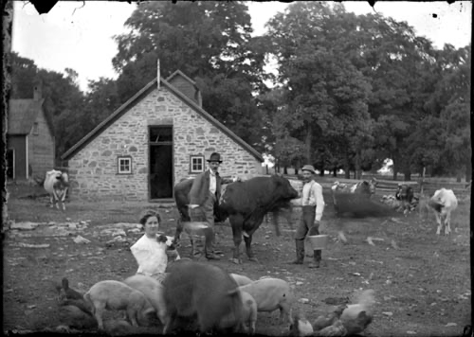

Alexander Macdonell's stone building [and farm], Black Creek, 1903,

C 130-1-0-25-5

Marsden Kempt fonds

In this guide 2

Where do I find these records? 3

What do I need to get started? 3

What was the process to receive land from the Crown? 3

Land grant process 3

Land sale process 4

The Records 4

1. Documenting the process – the Ontario Land Records Index and related records 4

2. Applying for land – the land petitions and the land books 6

2.1 Land petitions 6

2.2 Upper Canada Land Books, 1787 to 1841 7

3. Recording grants and sales – Orders-in-Council, descriptions, Domesday books and patent plans 9

3.1 Orders-in-Council, 1787 to 1873 9

3.2 Descriptions 10

3.3 Domesday Books and patent plans 10

4. Becoming the owner of the land – the land patents 11

5. Settling granting issues – Records of the Heir and Devisee Commissions 12

5.1 First Heir and Devisee Commission records 13

5.2 Second Heir and Devisee Commission records 14

6. Other Crown Land records 16

6.1 First and Second Land Board records 16

6.2 Fenian and South African land grant records, 1901 to 1922 18

6.3 Township Papers and Numeric Land Files 18

6.4 Crown Land correspondence 18

Are there related records? 19

How do I get to the online descriptions? 21

Contact us 22

# In this guide

This guide has information on Archives of Ontario records about the granting or sale of land by the Crown (Government) to individuals.

*Please note: this guide contains links to information found in our online Archives and Information Management System (AIMS).  On our website, this database is found under “Access Our Collections”.  If you are using a print copy of this guide, go to page 21 for more information on how to find the online descriptions.

This guide also includes links to our Microfilm Interloan Catalogue. [Click here to view our .](http://www.archives.gov.on.ca/en/microfilm/index.aspx) On our website, this catalogue is found under “Access Our Collections” on our website, this catalogue is found under “Access Our Collections”.

# Where do I find these records?

Most of the records mentioned in this guide are on microfilm, and you do not need to order them in advance to view them in our reading room. Libraries that offer interloan services may also borrow most of the reels for you. [Click here to view our Microfilm Interloan Catalogue](http://www.archives.gov.on.ca/en/microfilm/index.aspx).

Some of the microfilm are also digitized and available on the FamilySearch website, [click here to access our Digitized Microfilm Collections webpage for more information.](http://www.archives.gov.on.ca/en/access/digitized_microfilm_collections_on_familysearch.aspx)To find this information on our website, click on “Access our Collections” then click on the “Digitized Microfilm” page.  The FamilySearch website is [www.familysearch.org](http://www.familysearch.org).

Some of the reels are copies of records held by Library and Archives Canada. Those reels are not available through interloan. Some of these records are available online. The Library and Archives Canada website is [www.collectionscanada.gc.ca](http://www.collectionscanada.gc.ca).

A few records are not on microfilm. You will need to request them in advance to view them in our reading room. You may also obtain copies if there is sufficient information to locate and retrieve those records.

# What do I need to get started?

 You need the name of the person you are looking for, a location (township, concession and lot) for the land they lived on, and when they started living there or became the owner.

# What was the process to receive land from the Crown?

Initially, the Crown transferred land to individuals by granting it. After the 1820’s, sales became the norm, although grants were made to people qualified as indigent, and later to veterans of the Fenian Raids and Boer War.

### Land grant process

Land grants were done through the following process:

1. Individuals who wanted to receive land submitted a petitionto the Executive Council or the Department of Crown Lands (in early years, a local Land Board may have also been involved).
2. If the petition was accepted, an Order-in-Council granting a piece of land was issued.

At that point various government departments (including the Executive Council, Surveyor General, Commissioner of Crown Lands, Attorney General, Provincial Secretaries) issued documents to confirm what piece of land was being granted. The grantee then received a location ticket or certificate listing the township, concession and lot.

Receiving a grant did not make the individual the owner of the piece of land. They had to pay administrative fees and meet certain other requirements. Fees and requirements varied overtime, and some groups (Loyalists, their families, and some military and militia veterans) were exempt from the fees. Grantees could also assign (sell or transfer) their rights.

1. Once all requirements had been met, the Crown issued a patenttransferring ownership.

To summarize the granting process:

1. **Petition** (Settler applies for land) (Petition approved) **→** 2. Land **granted** to settler **→** 3. **Patent** (Requirements met $) (Ownership transferred to settler)

### Land sale process

Sales of Crown Land were usually done by appointed Crown Land Agents, through public sales. In many cases, payment was through instalments, or the buyer first rented the land with part of the rent going towards the purchase price. Most of the same documents created during the grant process were also used to document sales, and the buyer received a patent once the final payment had been made.

# The Records

## Documenting the process – the Ontario Land Records Index and related records

##### What is the Ontario Land Records Index?

The Ontario Land Records Index (OLRI) is two sets of microfiche (by individual and by location) provides information about settlers who:

* Got involved in the process leading to the grant or purchase of Crown land
* Rented or purchased land from the Canada Company (a London, England, based company that received, then sold over half a million acres of land, mostly in and near Huron County)
* Came to the Peterborough area at the initiative of Peter Robinson, a politician involved in the movement of Irish emigrants to Upper Canada (the town of Peterborough was named after him).
* Were offered land after 1901 for service during Fenian Raids (1860s) or the Boer War (1899 to 1902).

Information on the OLRI covers the period from the 1780’s to the 1920’s. It includes the settler’s name, a township, lot and concession, the type of transaction, and a reference to a source document. Crown land records indexed in the OLRI were for the most part, created at the time land was granted or sold, and they include:

* Schedules and land rolls (listings of land granted)
* Registers of fiats and warrants (administrative documents issued to order various government offices to process a grant)
* Registers of locations and assignments (documents issued to individuals to confirm a grant and the land being granted)
* Descriptions of the land being granted
* Lease and sale registers

##### How do I access and use the Ontario Land Records Index?

You can search Ontario Land Records Index (OLRI) in our reading room. The records it indexes are on microfilm, also in our reading room. Local libraries that offer interloan services can borrow the microfiche and most of the microfilm reels for you.

For information on how to use the Index and find the related microfilm, [click here to view Guide 205, Ontario Land Records Index](http://www.archives.gov.on.ca/en/access/documents/research_guide_205_land_records.pdf). On our website, you will find this and other research guides on the “Research Guides and Tools” page, under “Access our Collections”.

##### Where can I go after the index?

Once you have used the index and found the record on microfilm, copy or write down what you have found, in full. For more information about the document, you found:

* [Click here find the current reference code for the records, using the reference code conversion list](http://www.archives.gov.on.ca/en/microfilm/rg_1_conversion_list.aspx), (on our website, you will find this list on the “Crown Land Records Page”, in the Microfilm Interloan Catalogue, under “Access Our Collections”; there is also a copy in our reading room)
* [Click here to search the Archives and Information Management System (AIMS), Archives Repository using the Advance Search and the current reference code.](http://aims.archives.gov.on.ca)

You can also use the information found in the index to find the patent (see section 4 below).

## Applying for land – the land petitions and the land books

### Land petitions

##### What are land petitions?

Land petitions were submitted by individuals wishing to obtain land from the Crown. They usually contain personal information about the applicant which may include:

* country or place of origin
* family information
* name of parents (if the father was a United Empire Loyalist)
* information about militia or military service
* an oath of allegiance, and
* certificates of good character.

Most petitions were submitted to the Executive Council, although they could also be submitted to the Commissioner of Crown Land after 1826.

##### How do I find a petition?

There are four groups of petitions:

Lower Canada Land Petitions (Petitions submitted before 1791): These petitions are with Library and Archives Canada. We do not have a copy of these records.

The Library and Archives Canada website has a database listing all petitions. The database includes images for some of the petitions. The petitions are digitized on the Heritage Canadiana website, [www.heritage.heritage.canadiana.ca](http://www.heritagecanadianaheritage.ca).

Upper Canada Land Petitions**:** These are the petitions submitted to the Executive Council between 1791 and 1865 (they also include some petitions before 1791).

We have microfilm copies of the petitions and an index, and a finding aid to these records. The original records are with Library and Archives Canada.

For information on how to search Land records in our reading room, [click here to view our pathfinder on petitions for land](http://www.archives.gov.on.ca/en/access/research_guides.aspx). On our website, you will find this and other pathfinders on our research guides and tools page.

The Library and Archives Canada website has a database listing all petitions, and digitized images.

Upper Canada Sundries**:** The Upper Canada Sundries consists of records received by the Office of the Provincial Secretary for Upper Canada, between 1791 and 1841. These included petitions for land.

We have microfilm copies of the sundries and a finding aid. The original records are with Library and Archives Canada. For information on searching the sundries in our reading room, [click here to view the description for D 23](https://aims.archives.gov.on.ca/scripts/mwimain.dll/144/DESCRIPTION_WEB/WEB_DESC_DET?SESSIONSEARCH&exp=sisn%208326).

The Upper Canada Land Petitions database, on the Library and Archives Canada website, includes land petitions from the sundries. The sundries are digitized on the Heritage Canadiana website, [www.heritage.heritage.canadiana.ca](http://www.heritagecanadianaheritage.ca).

Petitions to the Crown Land Department (1827 to 1904): You may view the petition for lands and the related indexes on microfilm in our reading room, and local libraries that offer interloan services may borrow them for you. [Click here for a list of the microfilm in the Microfilm Interloan Catalogue](http://www.archives.gov.on.ca/en/microfilm/crown_land_records_t.aspx#petition).

The petitions asking for land surveys have not been filmed. To view these records, you first need to consult the indexes. Once you have found the reference to a petition for a survey, contact us to arrange to view it or to get a copy.

For information on how to search the petitions and the indexes, [click here to view our pathfinder on petitions for land as part of the information on land records.](http://www.archives.gov.on.ca/en/access/research_guides.aspx) On our website, you will find this and other pathfinders on our research guides and tools page.

##### If I do not find a petition in these records, where can I find it?

Check the **Upper Canada** **Land Books** to find if the Executive Council received a petition. See section 3.1 below for information about these records.

If you know the township, concession and lot the person applied for, the petition may be included in the **Township Papers** or with the **Orders-in-Council**. See below for information about these records.

If you do not find a petition, it may mean that:

* the petition was lost, or
* the individual did not submit a petition (note: that would the case if the person bought the land from the Crown or a private owner)

##### Where can I go after the petitions?

If you have found an Upper Canada land petition, the **Upper Canada** **Land Books** will tell you whether the Executive Council accepted or rejected the petition (see section 2.2 below).  
  
To find out if the petitioner was issued a **Land Patent** and owned land, see section 4

### Upper Canada Land Books, 1787 to 1841

**What are the Land Books?**

The Executive Council recorded its decision to accept or reject a land petition in the Upper Canada Land Books. These records are a good source for information in association with the Upper Canada Land Petitions and can be used to help locate the petition, if the individual’s’ name does not appear on the Land Petition’s Index.

We have a microfilm copy of these records, as well as a published index. The original records are with Library and Archives Canada. There is a digitized copy of the microfilmed land books on the Heritage Canadiana website, [www.heritage.canadiana.ca](http://www.heritagecanadiana.ca).

**How do I find an entry in the Land Books?**

You can find an entry in the Land Books using a published index, or indexes found on microfilm.

* 1. Published index: There a published multi-volume index entitled the Index to the Upper Canada Land Books. In our reading room, you will find it on the genealogical reference shelves in the Reading Room. It is also available at some public libraries.

This is an alphabetical Index that provides you with the following:

* petitioner’s name
* personal information (occupation, marital status etc.)
* residence and location upon application
* date of the minutes (when the decision was made)
* land book and page number and
* petition number (if available).

One you have found an entry in this Index, you can also use it to find the microfilm reel number that matches the volume and page number.

* 1. Index on microfilm: There is an Index by name of petitioner at the start of each Land Book.
  2. Microfilmed index to the Upper Canada Land Petitions: This index includes Land Book entries only for individuals whose petition are not part of the Upper Canada Land Petitions. For more information, [click here to view our pathfinder on petitions for land as part of the information on land records.](http://www.archives.gov.on.ca/en/access/research_guides.aspx).

**How may I view the Land Books?**

You may view the Land Books on microfilm in our reading room. There is also a digitized copy of the microfilm on the Heritage Canadiana website, [www.heritage.canadiana.ca](http://www.canadianaheritage.ca).

##### Where can I go after the Land Books?

For records that describe the land being granted, see sections 3.2 and 3.3 below. To find out if the person was issued a **Land Patent** and owned land, see section 5 below.

## Recording grants and sales – Orders-in-Council, descriptions, Domesday books and patent plans

Once a petition was accepted, the Executive Council recorded its decision in a Land Book. The Lieutenant-Governor issued an Order-in-Council granting land to the petitioner. Various government offices issued fiats and warrants, directing officials to proceed with the next step in granting the land

The Surveyor General identified a lot and provided a description. Once this was done, a location ticket or certificate was given to the grantee or buyer.

### Orders-in-Council, 1787 to 1873

The Lieutenant Governor issued Orders-In-Council authorizing the sale, lease, or free grant of Crown lands. This followed a decision by the Executive Council to accept a petition, or a recommendation of the Surveyor General or the Commissioner of Crown Lands,

The Orders-in-Council may provide information on individuals buying or receiving land. The original petition for land is sometime found with the Order-in-Council.

We have the copy of the Orders-in-Council kept by the Office of Surveyor General and the Commissioner of Crown Land. You can view indexes to these records on microfilm in our reading room, and libraries that offer interloan services can order the reels for you. For information about the indexes and a microfilm list, [click here to view the description for RG 1-50-1](https://aims.archives.gov.on.ca/scripts/mwimain.dll/144/DESCRIPTION_WEB/WEB_DESC_DET?SESSIONSEARCH&exp=sisn%206134). If you find an entry, write down the Order-in-Council number (if there is one), the person’s name, the place and subject (if mentioned), and the date.

The Orders-in-Council are arranged into three types: arranged by name, arranged by place or subject, and arranged by number. You can view most of these records on microfilm in our reading room, and libraries that offer interloan services can order the reels for you. You need to request the Orders-in-Council arranged by number in advance to view them in our reading room or to get a copy; include the name of the person, the date, the number, the box number and reference code RG 1-50-4,

For information about these records and microfilm or box lists;

* [click here to view the description for RG 1-50-2, Orders-in-Council arranged by name](https://aims.archives.gov.on.ca/scripts/mwimain.dll/144/DESCRIPTION_WEB/WEB_DESC_DET?SESSIONSEARCH&exp=sisn%206135)
* [click here to view the description for RG 1-50-3, Orders-in-Council arranged by place or subject](https://aims.archives.gov.on.ca/scripts/mwimain.dll/144/DESCRIPTION_WEB/WEB_DESC_DET?SESSIONSEARCH&exp=sisn%206136)
* [click here to view the description for RG 1-50-4, Orders-in-Council arranged by number](https://aims.archives.gov.on.ca/scripts/mwimain.dll/144/DESCRIPTION_WEB/WEB_DESC_DET?SESSIONSEARCH&exp=sisn%206137).

##### Where can I go after the Order-in-Council?

For records that describe the land being granted or sold, see sections 3.2 and 3.3 below. To find out if the person was issued a **Land Patent** and owned land, see section 5 below.

### Descriptions

Once a grantee or a buyer had been located on a lot, the Office of the Surveyor General produced a description. Descriptions include the property “metes and bounds” (a system measuring real property from recognized landmarks to place it precisely in a description to be used in legal documents like a deed). They may also include information about the grantee or buyer.

We have descriptions for the years 1794 to 1996. They are documented by the type of grant, sale or lease they documents. For information about these records and how to access them, [click here to the description for RG 1-53, Descriptions of land grants, leases, sales, assignments and licenses of occupation](https://aims.archives.gov.on.ca/scripts/mwimain.dll/144/DESCRIPTION_WEB/WEB_DESC_DET?SESSIONSEARCH&exp=sisn%206144).

Some of the descriptions are indexed in the Domesday Books (see below).

### Domesday Books and patent plans

When the Crown granted or sold land, information about the land and the grantee or buyer was entered in books called “Domesday Books”. Entries include the township (or town), concession and lot number, name of grantee or buyer, number of acres, and a description number. We have these books for the years 1801 to 1982. For information about these records and how to access them’ [click here to view the description for RG 1-63](https://aims.archives.gov.on.ca/scripts/mwimain.dll/144/DESCRIPTION_WEB/WEB_DESC_DET?SESSIONSEARCH&exp=sisn%206192).

The name of the grantee or buyer was also written down on a plan of the township, called a “Patent Plan”. Information was later updated or changed as required, in some cases up to the 1970’s. For many townships, there may be plans that cover only part of the township, or various versions of the plans.

You may view a digital copy of most, but not all the patent plans on our website. For information on viewing the digitized patent plans, [click here to view our Digital Patent Plan webpage](http://www.archives.gov.on.ca/en/about/patent-plans.aspx). On our website, you will find this page under “Access Our Collection”.

**How do I find the plans that have not been digitized?**

For more information about the patent plans, and a complete list, [click here to view the description for RG 1-100](https://aims.archives.gov.on.ca/scripts/mwimain.dll/144/DESCRIPTION_WEB/WEB_DESC_DET?SESSIONSEARCH&exp=sisn%206438). You can also:

* [click here to search the Archives Repository by files or items](http://aims.archives.gov.on.ca) (or click on “Advanced Search” in the Database then click on “Search Files and Items”)
* enter reference code RG 1-100 and the name of the township or town

## Becoming the owner of the land – the land patents

##### What are land patents?

The Crown issued land patents to confirm the transfer of ownership to the first owner of a piece of land. They include a description of the land (township, concession and lot), and may include legal restrictions or conditions. They do not contain personal information about the new owner, apart from their name.

The patent itself was given to the owner, and a copy was kept in patent books. We have the patent books from 1793 to 1982, and related indexes from 1793 to 1967.

##### How do I find a land patent?

We have indexes to the patents by name, by township and by district, up to 1967. You may search the indexes up to 1912 on microfilm in our reading room, and libraries that offer interloan services can order the microfilm for you. To arrange to visit us and search the indexes after 1912 (by name only), contact us and request RG 53-56 and the year(s) you are looking for.

The patent books from 1793 to 1867 are on microfilm. You may view the microfilm reels in our reading room only. After 1867:

* Patents books for Indian lands are with Library and Archives Canada. Contact them with the information found in the indexes (liber (book) and folio (page) number, township, lot and concession, and date). For contact information, visit [www.collectionscanada.gc.ca](http://www.collectionscanada.gc.ca).
* For other patents, contact us to arrange to visit us to view them. Request RG 53-1, the liber (book) number and the folio (page) number

For step-by-step instructions on how to find a land patent, [click here to view our Pathfinder to land patents as part of the information related to land records.](http://www.archives.gov.on.ca/en/access/research_guides.aspx) On our website, you will find this and other pathfinders and research guides on the “Research Guides and Tools”, under “Access Our Collections”.

If you want to receive a land patent at home, you need a certified copy of a patent, or you want a land patent after 1967, contact:

Ministry of Natural Resources and Forestry

Patent Clerk, Crown Land Registry

300 Water St 5th Floor South, Peterborough ON K9J 8M5

1-888-551-5552

Web:  <http://www.ontario.ca/environment-and-energy/crown-patents>

E-mail:  [crownlandregistry@ontario.ca](mailto:crownlandregistry@ontario.ca)

##### Where do I go if there is no entry in the indexes to patents?

A patent was issued only once all requirements were met or all payments were made.  This could take years. If there is no entry in the indexes to patent, the township papers (see section 6 below) or the records in the Ontario Land Records Index (see section 1 above) may give a reason why the grant or sale process was not completed.  
  
In some sales, a local Crown land agent issued the patent to the buyer, but did not send a copy to the Commissioner of Crown Lands.  In this case, the abstract index to the deeds from the Land Registry Office will show the patent was issued.  For information on how to access land registry office records, [click here to view Research Guide 231, Land registration records](http://www.archives.gov.on.ca/en/access/research_guides.aspx) . On our website, you will find this and other pathfinders and research guides on the “Research Guides and Tools”, under “Access Our Collections”.

##### Where do I go after the patent books?

Land transactions after the patent had been issued were registered with local Land Registry Offices. For information on how to access land registry office records, [click here to view Research Guide 231, Land registration records](http://www.archives.gov.on.ca/en/access/research_guides.aspx)

## Settling granting issues – Records of the Heir and Devisee Commissions

##### What were the Heir and Devisee Commissions?

Before 1795, individuals authorized to locate on a given piece of land received a location ticket. They could later exchange the ticket for patent a that confirmed they owned the land.

Land Board, local magistrates or other government officials could issue location tickets. Also, many individuals did not complete the process leading to a patent. Others willed or “devised” their rights to the land. Some sold, exchanged or mortgaged their rights. As a result, there was confusion about who was the actual owner or right-holder for some properties.

In 1797 government of Upper Canada set up the Heir and Devisee Commission to settle these issues. It was dissolved in 1804. A second Heir and Devisee Commission was created in 1805 to deal with issues that had not been solved or submitted. That second Commission continued to meet to settle issues pertaining to initial grants until 1896; it was officially abolished in 1911.

Records of the two Commissions may be helpful if you believe or find there were issues as to who was the initial owner of a piece of land. They may also explain why the person who was granted the land was not the one who received the patent.

### First Heir and Devisee Commission records

**How do I find records of the First Heir and Devisee Commission?**

We have microfilm copies of the official records of the Commission. They include minutes and reports, as well as records submitted in support of the claims. The originals are with Library and Archives Canada.

You will find finding aid D 352, which lists the microfilm, on the Diffusion material finding aid cabinet, in our reading room.

You will find a microfilm list of these records on the Library and Archives Canada website. The microfilm is digitized on the Heritage Canadiana website, [www.heritage.canadiana.ca](http://www.heritagecanadiana.ca).

We have other records from the Commission, as well as related records from the Commissioner of Crown Lands, the Surveyor General, and the courts. See table 1 below for a list of these records and click on the link for more information on the records and how to access them.

**Table 1: Records created by or related to the First Heir and Devisee Commission**

| **Title** | **Dates** | **Reference Code** |
| --- | --- | --- |
| Copies of Heir and Devisee Commission Reports Prepared by the Surveyor General | 1797 to 1803 | [Click here to view the description for RG 1-15-2](https://aims.archives.gov.on.ca/scripts/mwimain.dll/144/DESCRIPTION_WEB/WEB_DESC_DET?SESSIONSEARCH&exp=sisn%206085) |
| Eastern District Clerk of the Peace Heir and Devisee Commission Claims Books | 1797 to 1803 | [Click here to view the description for RG 22-610](https://aims.archives.gov.on.ca/scripts/mwimain.dll/144/DESCRIPTION_WEB/WEB_DESC_DET?SESSIONSEARCH&exp=sisn%204597) |
| Heir and Devisee Commission Reports Submitted to the Surveyor General for access | 1802 to 1805 | [Click here to view the description for RG 1-15-1](https://aims.archives.gov.on.ca/scripts/mwimain.dll/144/DESCRIPTION_WEB/WEB_DESC_DET?SESSIONSEARCH&exp=sisn%206084) |
| Memoranda of Undescribed Land Claims and Related Orders Arising out of the First Heir and Devisee Commission | 1803 to 1804 | [Click here to view the description for RG 40-1](https://aims.archives.gov.on.ca/scripts/mwimain.dll/144/DESCRIPTION_WEB/WEB_DESC_DET?SESSIONSEARCH&exp=sisn%207864) |
| Miscellaneous Documents Collected by the First Heir and Devisee Commission | 1796 to 1805 | [Click here to view the description for RG 40-3](https://aims.archives.gov.on.ca/scripts/mwimain.dll/144/DESCRIPTION_WEB/WEB_DESC_DET?SESSIONSEARCH&exp=sisn%207866) |
| Minutes of Search | 1797 to 1806 | [Click here to view the description for RG 1-16-2](https://aims.archives.gov.on.ca/scripts/mwimain.dll/144/DESCRIPTION_WEB/WEB_DESC_DET?SESSIONSEARCH&exp=sisn%206089) |
| Reports on Land Claims Arising out of the First Heir and Devisee Commission | 1797 to 1803 | [Click here to view the description for RG 40-2](https://aims.archives.gov.on.ca/scripts/mwimain.dll/144/DESCRIPTION_WEB/WEB_DESC_DET?SESSIONSEARCH&exp=sisn%207865) |
| [Register of] Original Nominees Claimed Under the First Heir and Devisee Commission | circa 1808 | [Click here to view the description for RG 1-15-3](https://aims.archives.gov.on.ca/scripts/mwimain.dll/144/DESCRIPTION_WEB/WEB_DESC_DET?SESSIONSEARCH&exp=sisn%206086) |
| Schedule Of Descriptions Issued by the Surveyor General’s Office Which Clash with Heir and Devisee Commission Reports | 1797 to 1804 | [Click here to view the description for RG 1-17](https://aims.archives.gov.on.ca/scripts/mwimain.dll/144/DESCRIPTION_WEB/WEB_DESC_DET?SESSIONSEARCH&exp=sisn%206090) |

### Second Heir and Devisee Commission records

**How do I find records of the Second Heir and Devisee Commission?**

We have the Commission’s case files. They may contain:

* Notices of intent to file a claim with the Commission
* Searches done and documents submitted by the Surveyor General (and later the Commissioner of Crown Lands)
* Affidavits and documents submitted by the claimants

The files do not include the Commission’s decisions.

The Second Heir and Devisee Commission Case Files Database lists the case files and gives you the case file number and microfilm reel number. You can search the database by name of claimant, location or date. You may view the microfilm in our reading room, and libraries that offer interloan services may borrow the film for you. This microfilm are also digitized and available on the FamilySearch website, [click here to access our Digitized Microfilm Collections webpage for more information.](http://www.archives.gov.on.ca/en/access/digitized_microfilm_collections_on_familysearch.aspx)To find this information on our website, click on “Access our Collections” then click on the “Digitized Microfilm” page.  The FamilySearch website is [www.familysearch.org](http://www.familysearch.org).

[Click here to search the Second Heir and Devisee Commission Case Files Database, and find more information about the Commission and the records](https://aims.archives.gov.on.ca/scripts/mwimain.dll?logon&application=ARCH_HEIRS&language=144&file=%5bao_assets%5dhtml/heirs.html). On our website, you will find the database under “Access Our Collections”.

The Commission’s decisions are recorded in the Commission’s minutes, 1810 to 1895. For information on these records and how to access them, [click here to view the description for RG 40-6](https://aims.archives.gov.on.ca/scripts/mwimain.dll/144/DESCRIPTION_WEB/WEB_DESC_DET?SESSIONSEARCH&exp=sisn%207869).

We have other records from the Commission, as well as related records from the Commissioner of Crown Lands, the Surveyor General, and the courts. See table 2 below for a list of these records and click on the link for more information on the records and how to access them.

**Table 2: Records created by or related to the Second Heir and Devisee Commission**

| **Title** | **Dates** | **Reference Code** |
| --- | --- | --- |
| Certificates Documenting the Fulfilment of Settlement Duties and the Payment of Fees on Lands Awarded by the Second Heir and Devisee Commission | 1846 to 1848 | [Click here to view the description for RG 40-10](https://aims.archives.gov.on.ca/scripts/mwimain.dll/144/DESCRIPTION_WEB/WEB_DESC_DET?SESSIONSEARCH&exp=sisn%207878) |
| Certificates of Search | 1832 to 1872 | [Click here to view the description for RG 1-16-1](https://aims.archives.gov.on.ca/scripts/mwimain.dll/144/DESCRIPTION_WEB/WEB_DESC_DET?SESSIONSEARCH&exp=sisn%206088) |
| Commissions of Appointment to the Second Heir and Devisee Commission | 1840 to 1879 | [Click here to view the description for RG 40-4](https://aims.archives.gov.on.ca/scripts/mwimain.dll/144/DESCRIPTION_WEB/WEB_DESC_DET?SESSIONSEARCH&exp=sisn%207867) |
| Copies of Heir and Devisee Commission Reports Prepared by the Surveyor General | 1811 to 1868 | [Click here to view the description for RG 1-15-2](https://aims.archives.gov.on.ca/scripts/mwimain.dll/144/DESCRIPTION_WEB/WEB_DESC_DET?SESSIONSEARCH&exp=sisn%206085) |
| Correspondence and Miscellaneous Records of the Second Heir and Devisee Commission | 1805 to 1891 | [Click here to view the description for RG 40-11](https://aims.archives.gov.on.ca/scripts/mwimain.dll/144/DESCRIPTION_WEB/WEB_DESC_DET?SESSIONSEARCH&exp=sisn%207879) |
| Draft Reports of Proceedings of the Second Heir and Devisee Commission | 1857 to 1891 | [Click here to view the description for RG 40-9](https://aims.archives.gov.on.ca/scripts/mwimain.dll/144/DESCRIPTION_WEB/WEB_DESC_DET?SESSIONSEARCH&exp=sisn%207876) |
| Eastern District Clerk of the Peace Heir and Devisee Commission Claims Books | 1806 to 1812 | [Click here to view the description for RG 22-610](https://aims.archives.gov.on.ca/scripts/mwimain.dll/144/DESCRIPTION_WEB/WEB_DESC_DET?SESSIONSEARCH&exp=sisn%204597) |
| Heir and Devisee Commission Reports Submitted to the Inspector General | 1823 to 1840 | [Click here to view the description for RG 1-18](https://aims.archives.gov.on.ca/scripts/mwimain.dll/144/DESCRIPTION_WEB/WEB_DESC_DET?SESSIONSEARCH&exp=sisn%206091) |
| Heir and Devisee Commission Reports Submitted to the Surveyor General | 1802 to 1886 | [Click here to view the description for RG 1-15-1](https://aims.archives.gov.on.ca/scripts/mwimain.dll/144/DESCRIPTION_WEB/WEB_DESC_DET?SESSIONSEARCH&exp=sisn%206084) |
| Indices to Claims Made to the Second Heir and Devisee Commission | [circa 1850 to circa. 1889] | [Click here to view the description for RG 40-12](https://aims.archives.gov.on.ca/scripts/mwimain.dll/144/DESCRIPTION_WEB/WEB_DESC_DET?SESSIONSEARCH&exp=sisn%207880) |
| Individual Fiats for Land Grants – Heir and Devisee Commission | 1812 to 1854 | [Click here to view the description for RG 1-150-1](https://aims.archives.gov.on.ca/scripts/mwimain.dll/144/DESCRIPTION_WEB/WEB_DESC_DET?SESSIONSEARCH&exp=sisn%206517) |
| Lists of Land Claimed under the Second Heir and Devisee Commission | 1805 to 1876 | [Click here to view the description for RG 40-7](https://aims.archives.gov.on.ca/scripts/mwimain.dll/144/DESCRIPTION_WEB/WEB_DESC_DET?SESSIONSEARCH&exp=sisn%207870) |
| Registers of Fiats for Land Grants – Heir and Devisee Commission | [ca. 1800] to 1854 | [Click here to view the description for RG 1-150-2](https://aims.archives.gov.on.ca/scripts/mwimain.dll/144/DESCRIPTION_WEB/WEB_DESC_DET?SESSIONSEARCH&exp=sisn%206518) |
| Reports or Certificates of Search Submitted to the Second Heir and Devisee commission by the Crown Lands Department | 1844 to 1868 | [Click here to view the description for RG 40-8](https://aims.archives.gov.on.ca/scripts/mwimain.dll/144/DESCRIPTION_WEB/WEB_DESC_DET?SESSIONSEARCH&exp=sisn%207872) |
| Western District Heir And Devisee Notices and Land Claims | 1838 to 1858 | [Click here to view the description for RG 22-1899](https://aims.archives.gov.on.ca/scripts/mwimain.dll/144/DESCRIPTION_WEB/WEB_DESC_DET?SESSIONSEARCH&exp=sisn%207655) |

## Other Crown Land records

### First and Second Land Board records

##### First Land Boards

In 1789, four districts were created in what later became Upper Canada (southern Ontario). They were:

* Lunenburg (St. Lawrence River area)
* Mecklenburg (Eastern Lake Ontario area)
* Nassau (Western Lake Ontario and Niagara area)
* Hesse (Lake Erie and Windsor area)

At the same time, a Land Board was created for each district. It oversaw land matters within the district and facilitated settlement by granting certificates of location to people applying for land. In 1794, these land boards were abolished, and land management was centralized through the Executive Council.

Records from these boards includes both documents created before the creation of the bards and submitted to them, and records added after the boards had been abolished.

How do I find records of the first Land Boards? We have the minutes of the Nassau District Land Board, as well as lists of individuals who received certificates for land, and various reports.

For information about these records, including microfilm lists:

* [Click here to view the description for RG 1-177, Nassau District Land Board Minutes, 1788 to 1792](https://aims.archives.gov.on.ca/scripts/mwimain.dll/144/DESCRIPTION_WEB/WEB_DESC_DET?SESSIONSEARCH&exp=sisn%207243) – these minutes have been transcribed in the Third Report of the Bureau of Archives for the Province of Ontario (1905). You can view this report in our reading room on microfilm B97, reel 94, and online on the Internet Archive website, [www.archive.org](http://www.archive.org)
* [Click here to view the description for RG 1-178, Hesse District Land Board records, 1789 to 1794](https://aims.archives.gov.on.ca/scripts/mwimain.dll/144/DESCRIPTION_WEB/WEB_DESC_DET?SESSIONSEARCH&exp=sisn%207244) – these records have been transcribed in the Third Report of the Bureau of Archives for the Province of Ontario (1905). You can view this report in our reading room on microfilm B97, reel 94, and online on the Internet Archive website, [www.archive.org](http://www.archive.org)
* [Click here to view the description for RG 1-30, Schedules, Returns, and Lists of Certificates of Occupation Issued by Magistrates, Surveyors and the First District Land Boards, 1789 to 1816](https://aims.archives.gov.on.ca/scripts/mwimain.dll/144/DESCRIPTION_WEB/WEB_DESC_DET?SESSIONSEARCH&exp=sisn%206105)

Library and Archives Canada has minutes of the Boards, reports and correspondence, instructions and regulations about the operations of the boards, as well as schedules of locations and land. We have a microfilm copy of these records and a finding aid.

For information on how to search these records in our reading room, [click here to view the description for D 359](https://aims.archives.gov.on.ca/scripts/mwimain.dll/144/DESCRIPTION_WEB/WEB_DESC_DET?SESSIONSEARCH&exp=sisn%208308). There is a database listing individuals mentioned on these records, on the Library and Archives Canada website. There is a digitized copy of the microfilmed records on the Heritage Canadiana website, [www.heritage.canadiana.ca](http://www.heritagecanadiana.ca).

##### Where can I go after the the Land Board records?

To find out if the person was issued a **Land Patent** and owned land, see section 5 above.

**Second Land Boards**

New Land Boards were created in 1819 in all districts except Niagara (where all the land had already been granted). They handled applications for lands by immigrants from the United States who could provide a certificate of British birth, and some immigrants who had come after the War of 1812.

The Boards had to record the name, age, and date of entry of the applicants. Applicants had to declare that they had not been granted land by the Crown before, and to swear an oath of allegiance. After paying administrative fees, applicants received a certificate allowing them to settle on a 100-acre lot.

The Boards did not deal with United Empire Loyalists and military claimants. Those had to petition the Executive Council, in York (Toronto). The Boards were abolished on December 31, 1825.

How to I find records of the second Land Boards? We have records about land granted to individuals who applied to the boards. For information about these records and how to access them:

* [Click here to view the description for RG 1-12-2-2, List of locations to emigrants at the late land board, Bathurst District, 1823 to 1824](https://aims.archives.gov.on.ca/scripts/mwimain.dll/144/DESCRIPTION_WEB/WEB_DESC_DET?SESSIONSEARCH&exp=sisn%20812274)
* [Click here to view the description for RG 1-161, Fiats for land grants – Second District Land Boards, 1820 to 1854](https://aims.archives.gov.on.ca/scripts/mwimain.dll/144/DESCRIPTION_WEB/WEB_DESC_DET?SESSIONSEARCH&exp=sisn%207217)
* [Click here to view the description for RG 1-176, Second District Land Boards, returns of locations, 1819 to 1826](https://aims.archives.gov.on.ca/scripts/mwimain.dll/144/DESCRIPTION_WEB/WEB_DESC_DET?SESSIONSEARCH&exp=sisn%207242)

##### Where can I go after the Land Board records?

To find out if the person was issued a **Land Patent** and owned land, see section 5 above.

### Fenian and South African land grant records, 1901 to 1922

In 1901, Ontario passed legislation authorizing land grants to:

* Individuals who had served in military or Ontario-based militia units during the Fenian raids (865, 1866 and 1870) or in the South African War (Boer War, 1899 to 1901), or their heirs
* Individuals who had served as chaplains or nurses, or who had been Red Commissioners or war correspondents during the South African War.

Applicants who submitted proof that they belonged to one of these groups received a location ticket for a 160-acre lot. These lots were located in Northern Ontario.

For information about these records and how to access them, [see the description for RG 1-99](https://aims.archives.gov.on.ca/scripts/mwimain.dll/144/DESCRIPTION_WEB/WEB_DESC_DET?SESSIONSEARCH&exp=sisn%206246).

### Township Papers and Numeric Land Files

The Township Papers (1780’s to 1870’s) and the Numeric Land Files (1853 to 1915) consist of correspondence and miscellaneous records about individual lots received and created by the Surveyor General and the Commissioner (later Department of Crown Lands)

Contents may include copies of petitions, Orders-In-Council, location certificates and tickets, assignments, certificates of settlement duties, plans, correspondence and wills. These records provide useful information on the granting or sale of the lot, particularly in cases where the original petitioner is not the person who later received the patent.

The Township Papers are on microfilm, arranged by township, city or town, then by concession and lot. There are records for many, but not all lots. You can view the microfilm in our reading room, and libraries that provide interloan services can borrow the reels for you.

[Click here to view a microfilm list for the Township Papers, in our Microfilm Interloan Catalogue](http://www.archives.gov.on.ca/en/microfilm/crown_land_township_t.aspx). Some of the microfilm are also digitized and available on the FamilySearch website, [click here to access our Digitized Microfilm Collections webpage for more information.](http://www.archives.gov.on.ca/en/access/digitized_microfilm_collections_on_familysearch.aspx)To find this information on our website, click on “Access our Collections” then click on the “Digitized Microfilm” page.  The FamilySearch website is [www.familysearch.org](http://www.familysearch.org).

For information on the Numeric Land Files and how to search and access them,

[click here to view the description for RG 1-246](https://aims.archives.gov.on.ca/scripts/mwimain.dll/144/DESCRIPTION_WEB/WEB_DESC_DET?SESSIONSEARCH&exp=sisn%207303).

### Crown Land correspondence

Correspondence sent and received by the Surveyor General and the Commissioner of Crown Land and their successors may give you information about issues with specific land grants and sales. Topics may also include land surveys, building and maintenance of rods, forest and mining rights, and overall management of Crown Lands.

There is a partial index to some of the correspondence for the years 1795 to 1868. You can search this index on microfiche, in our reading room only. The index consists of index cards arranged by name of correspondence or topic, arranged alphabetically. The card includes a summary of the document, the date, and a volume number. To find what microfilm has the piece of correspondence you found in the index, [click here to view the description for RG 1-2-4](https://aims.archives.gov.on.ca/scripts/mwimain.dll/144/DESCRIPTION_WEB/WEB_DESC_DET?SESSIONSEARCH&exp=sisn%206045).

See table 3 below for a list of other Surveyor General and Commissioner of Crown Land that document land grants. Click on the link for more information on the records and how to access them.

**Table 3: Correspondence of the Surveyor General and the Commissioner of Crown Lands**

| **Title** | **Dates** | **Reference Code** |
| --- | --- | --- |
| Correspondence and memoranda received by the Surveyor General's Office | 1764 to 1800 | [Click here to view the description for RG 1-1](https://aims.archives.gov.on.ca/scripts/mwimain.dll/144/DESCRIPTION_WEB/WEB_DESC_DET?SESSIONSEARCH&exp=sisn%206040) |
| Correspondence and memoranda received by the Surveyor General relating to surveys and land administration | 1777 to 1905 | [Click here to view the description for RG 1-2](https://aims.archives.gov.on.ca/scripts/mwimain.dll/144/DESCRIPTION_WEB/WEB_DESC_DET?SESSIONSEARCH&exp=sisn%206041) |
| Outgoing correspondence from the Office of the Commissioner of Crown Lands | 1827 to 1874 | [Click here to view the description for RG 1-6](https://aims.archives.gov.on.ca/scripts/mwimain.dll/144/DESCRIPTION_WEB/WEB_DESC_DET?SESSIONSEARCH&exp=sisn%206055) |
| Outgoing correspondence from the Surveyor General's Office | 1792 to 1908 | [Click here to view the description for RG 1-3](https://aims.archives.gov.on.ca/scripts/mwimain.dll/144/DESCRIPTION_WEB/WEB_DESC_DET?SESSIONSEARCH&exp=sisn%206047) |
| Registers of letters received by the Commissioner of Crown Lands | 1837 to 1869 | [Click here to view the description for RG 1-7](https://aims.archives.gov.on.ca/scripts/mwimain.dll/144/DESCRIPTION_WEB/WEB_DESC_DET?SESSIONSEARCH&exp=sisn%206066) |
| Register of memorials, petitions, and letters referred to the Surveyor General's Office by Government House | 1833 to 1836 | [Click here to view the description for RG 1-4](https://aims.archives.gov.on.ca/scripts/mwimain.dll/144/DESCRIPTION_WEB/WEB_DESC_DET?SESSIONSEARCH&exp=sisn%206053) |

# Are there related records?

We also have records from the 1780’s to the 1850’s that document:

* leases and sales of land by the Canada Company, a private company that owned land in western Ontario and throughout the province
* individuals who received assistance in locating in the Peterborough area
* individuals located by Colonel Thomas Talbot in southwestern Ontario

For more information on these and related land records, [click here to view research guide 215, Early Land Records, from the 1780s to the 1850s](http://www.archives.gov.on.ca/en/access/research_guides.aspx)..

Private land transactions after the patent were registered at Land Registry Offices. For more information, [click here to view research guide 231, Land registration records](http://www.archives.gov.on.ca/en/access/research_guides.aspx).

# How do I get to the online descriptions?

1. On our website’s main page, click on “Access Our Collections”, and click on “Archives and Information Management System”, as shown in the image below:

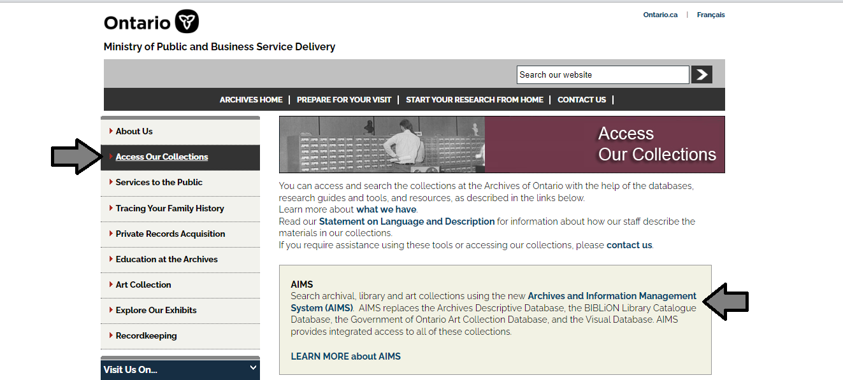

1. In the Archives and Information Management System (AIMS), click on “Archives repository (only)” button:

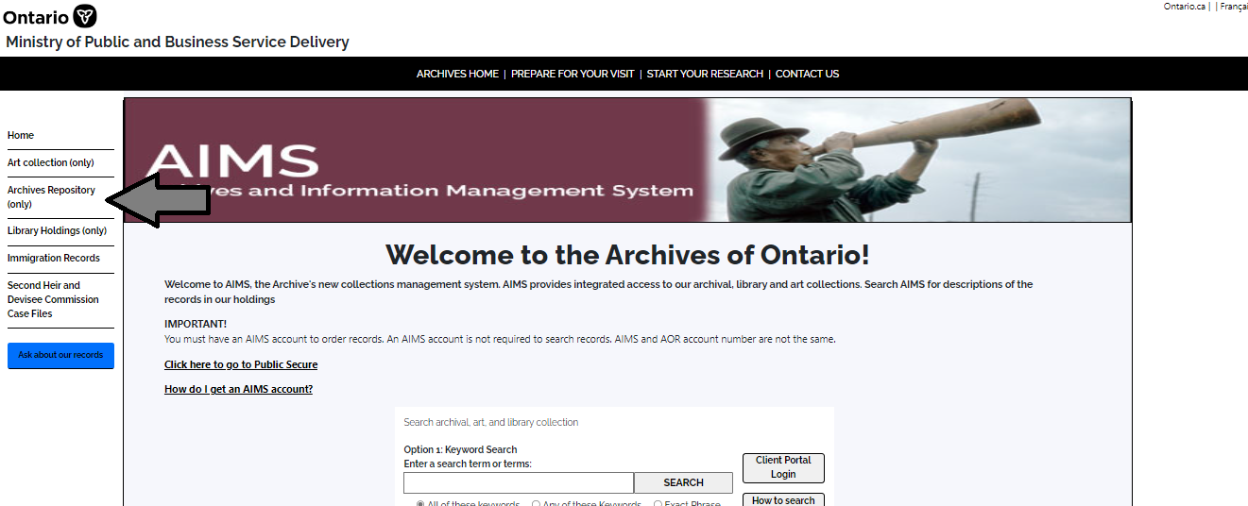

1. On the “Welcome to the Archival Collection” search page, click “Advanced Search”:

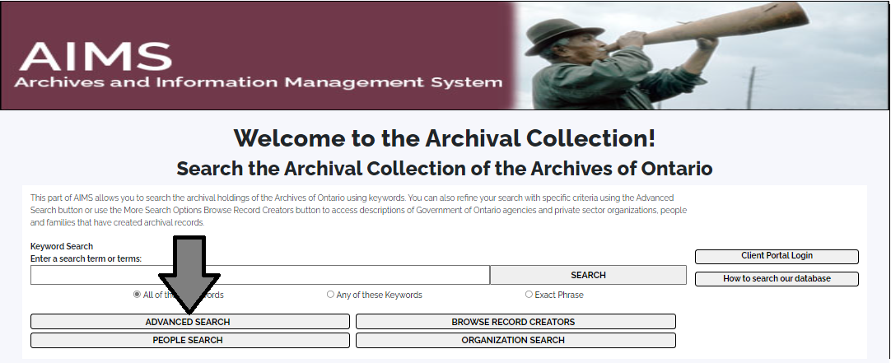

1. On the “Archives Advanced Search” page enter the reference code (that’s the number starting with C, F or RG) in the Reference Code field and click “Search” (at the bottom of the page.

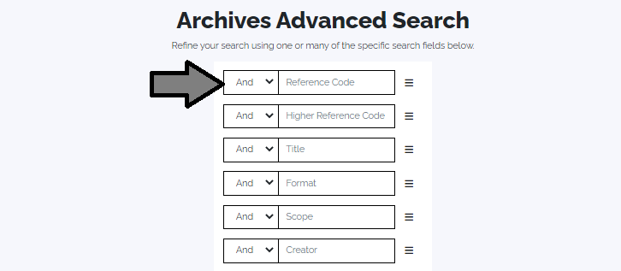

# Contact us

Although unable to do your research for you, our reference archivists are waiting to assist you.  You may telephone or write to them by mail or email or — best of all — visit the Archives of Ontario.

**Telephone: 416-327-1600 Toll free (Ontario): 1-800-668-9933**

**Fax:416-327 to 1999**

**Email:** [Click here to email the Archives of Ontario](mailto:reference@ontario.ca).  The e-mail address is [reference@ontario.ca](mailto:reference@ontario.ca)

**Address: Archives of Ontario, 134 Ian Macdonald Blvd., Toronto, ON M7A 2C5**

**Website**

Visit our website for information about our collections and our services, our online exhibits and education programs, and links to our social media accounts. [Click here to visit our website](http://aims.archives.gov.on.ca).  The website is [aims.archives.gov.on.ca](http://aims.archives.gov.on.ca).

**Customer Service and Research Guides**

Our guides contain information about our services, freelance researchers available to do research for you, and some of most popular records.  [Click here to view our guides](http://www.archives.gov.on.ca/en/access/research_guides.aspx).  To find the “Research Guides and Tools” on our website, click on “Access our Collections”.

______________________________________________________________________

© King's Printer for Ontario, 2023

This information is provided as a public service.  Last update is shown at the beginning of this guide.  Readers should where possible verify the information before acting on it.